Ethan Perdieu
CIT-45100
Assignment 1 – The Case Study Roast Battle
September 7th, 2025

Everbridge

Compliance Claims
https://www.everbridge.com/awards-and-recognition/
Named a Leader in The Forrester WaveTM: Critical Event Management Platforms, Q4 2023.
- Data Breach occurred May 21th, 2023 and May 21
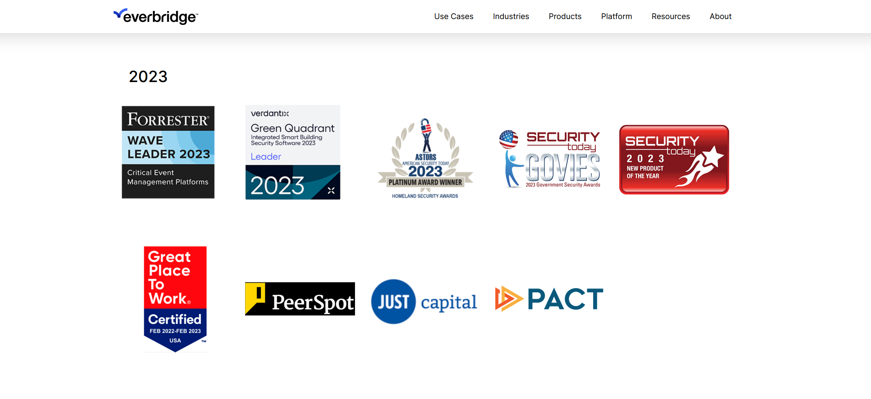

Jeff Young, Vice President of Corporate Communications –
"While our investigation is ongoing and in its early stages, we are aware that the unauthorized party responsible for this activity has accessed a limited number of files on our corporate network containing certain business related data, including instances of admin user and limited other users' contact information, information about the subscribed Everbridge services, and enabled access methods," the company told customers in a breach notification seen by BleepingComputer.

According to SCMedia, Jeff Young downplayed ransomware incidence.
RSOC3 -
https://www.everbridge.com/wp-content/uploads/2023/06/Everbridge-2023-Type-2-SOC-3-Final-Report.pdf

ISO 27001 Certification
https://www.everbridge.com/resource/iso-270012013-certification/

Overview of the Breach
In May of 2023, Everbridge, a company focused on crisis management, dealt with an attacker who was able to access their files. These files contained important user and business data, admin instances, Everbridge service subscriptions and enabled access methods. They were able to infiltrate the system by using information collected in pervious phishing attacks on employees. Everbridge finally released another statement at the end of May stating that MFA will be required on all accounts by June 3rd. They also shared information with each employee on how to guard against phishing attacks. There were no estimates of the data breach fallout costs but on Everbridge’s website it stated that the average cost of a data breach reached $4.88 million.

The clearest security principle that was violated was falling for simple phishing emails. The lack of security measures and practices in place was a clear pitfall. The lack of multi-factor authentication was another simple security protocol that was missing. They seemed to be unclear on how long it took the response team to act; however, the net public statement was not released for a few days. This could show a delay in their response time which could cause an increase in cost.

Gap Analysis
Everbridge’s security framework is designed on the NIST Cybersecurity Framework and the SOC2/ISO 27001 framework. The main failure was the insufficient use of MFA across both Admin and User accounts. Both the NIST and ISO require secure-log on procedures which encompasses MFA. They also failed to enforce the least privileged practices because the attackers were able to access admin and customer details. Lastly, the Phishing training and resistance was a clear gap in the training. Both frameworks require that users are trained against phishing attacks. This also can show another error with their email filtering at Everbridge. This attack clearly could have been prevented if some basic security measures were in place. If Everbridge followed through with what their frameworks claimed to follow, then they would have been secure.

References
Awards and recognition. Everbridge. (2025a, March 28). https://www.everbridge.com/awards-and-recognition/
Data breach impacts Everbridge corporate systems | SC media. SCMedia. (n.d.). https://www.scworld.com/brief/data-breach-impacts-everbridge-corporate-systems
Gatlan, S. (2024, May 30). Everbridge warns of corporate systems breach exposing business data. BleepingComputer. https://www.bleepingcomputer.com/news/security/everbridge-warns-of-corporate-systems-breach-exposing-business-data/
Security Program Framework (technical and organizational). Everbridge. (2025, January 9). https://www.everbridge.com/security-program-framework/

