Ethan Perdieu
Assignment 2: Framework Comparison
CIT-45100
September 9th, 2025

Authorization Boundary Diagram
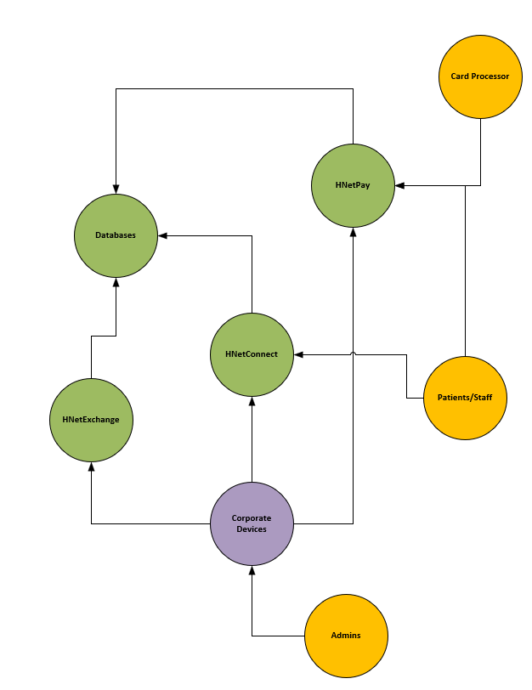

Security Model
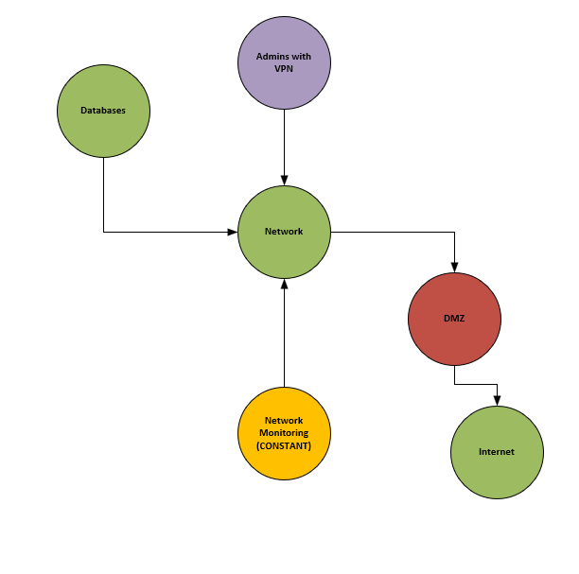

Supply Chain
Logitech MX Master 3S Performance Wireless Mouse (Corporate Mouse in this Scenario)

Sensors:
https://www.pixart.com/products-detail/129/PAW3395DM-T6QU
ARM-based Microcontroller
PAW 3395 Optical Sensor – Pixart Imaging from Taiwan/China

PCB:
Contains resistors and capacitors and radio frequency components
Most likely fabricated in China

Battery:
Lithium-Polymer Pack
Typically manufactured in China with Korea also being a leading manufacturer

Plastic Covering:
https://sybridge.com/know-your-materials-polycarbonate-acrylonitrile-butadiene-styrene-pc-abs/
Injection-mold using PC-ABS
Most likely done in China.

Bluetooth Components:
Broadcom chipset
Most likely sourced from China or Taiwan.

Distribution:
Shipped in Bulk most likely via Cargo Ships
Could be shipped through the air

Supply Chain Risks
The glaring risk I notice is the possible use of counterfeit components. Since these components are extracted from multiple different countries, it is possible for microchips or sensors to be replaced with a cheaper or even a compromised alternative. Lithium batteries also pose a risk due to many scenarios of those batteries exploding or catching on fire. This can happen during the distribution phase or during the manufacturing of the batteries themselves. This brings me to another point being tampering during the distribution phase. If this phase is not monitored, then someone could maliciously plant hardware during the distribution phase.

ISO Control 8.28 Question
When answering if secure principles are used in software development, you must provide hard evidence that validates those secure principles. These can be policies and procedures put in place that reference those secure coding principles. For example, recognizing frameworks such as NIST or OWASP and showing documented error handling. You could also prove that you have adequate training in place by showing programs that you have used. (https://www.securecodewarrior.com/) Another large way to validate the secure principles is showing proof of testing and scan reports. This can be done with analysis tools such as SonarSource (https://www.sonarsource.com/products/sonarqube/). This can prove that vulnerabilities were discovered and were remediated quickly.

NIST ID.RA-09 Question
To authenticate the integrity of both hardware and software prior to acquisition, I would first only purchase from trusted vendors. This can be done by avoiding resellers and purchasing from the original equipment manufacturers. When the hardware comes in, make sure the packaging is secure and free of any tampering. You can then verify that the serial numbers match up based on records kept by the manufacturers. Software can be verified by looking at the digital signature of the software. This software can then be tested in a separate environment from the main network. This allows you to check for any malware or vulnerabilities without compromising your network.

Once again, the Supply chain is a major risk that would need more information on. Since many components are sourced from all over the world, it is unclear if the vendors can prove the authenticity of the parts. Another major concern deals with laptops or any devices that are received for a work scenario. The firmware that is already pre-installed can contain vulnerabilities that are hard to locate.

