Ethan Perdieu
CIT-45100
HW 4 Cybersecurity Awareness Month Theatre
October 19th, 2025

1. Create Cybersecurity Awareness campaign material
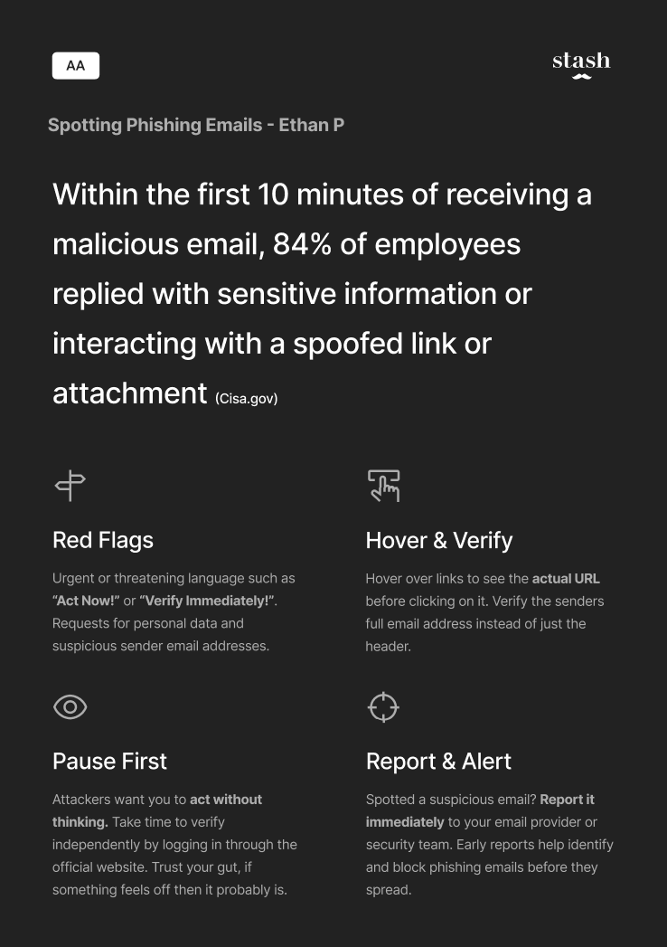
2. Find any campaign material this month and evaluate it. Good, bad, ugly, show
me the worst that you found.

a. Any glaring mistakes or concerns?
I would not say there are any glaring mistakes, but the concern is that over half of the campaign material is used as a graphic that does not add too much to the educational standpoint. The slogan is also broad and does not give actionable steps. This could mean just deleting the email instead of reporting it. The visual setup of the material also draws attention to the wrong portion of the message being the Click Here button rather than the subtext.
b. Missing or incomplete information?
The most obvious missing information from this poster is figuring out how to avoid and recognize phishing attempts. It does not provide guidance on how to verify that the links are bad such as checking sender details or hovering over the links. They could have also added a small example of phishing to help show users what to look for.

c. Bad faith or poor attempt?
I think this campaign material was in good faith but focused too much on avoidance rather than verifying before you click. This seems like a poor attempt at creating real behavioral change and was only made to say they created campaign material. It focuses too much on the visual aspect of it rather than good information.

