Ethan Perdieu
CIT-45100
Project Final
December 19th, 2025

Deliverable 1: Security Control Catalog
A) Control Selection & Design
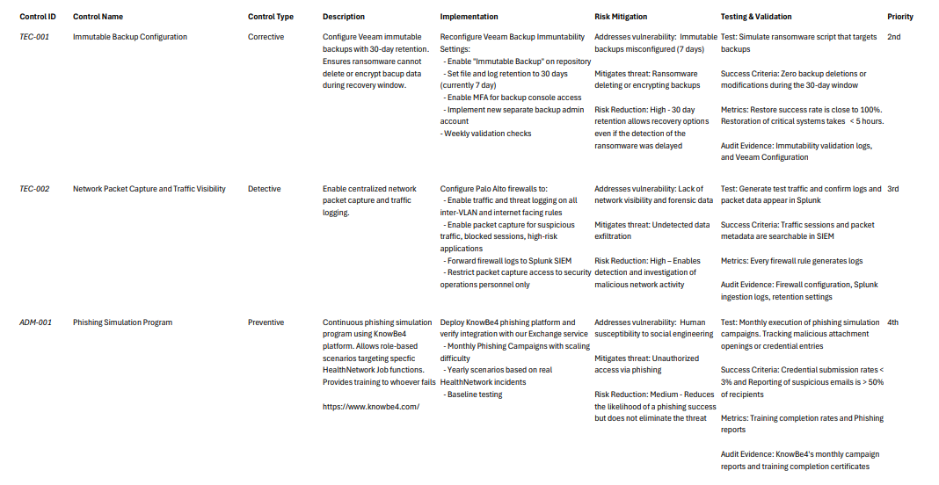
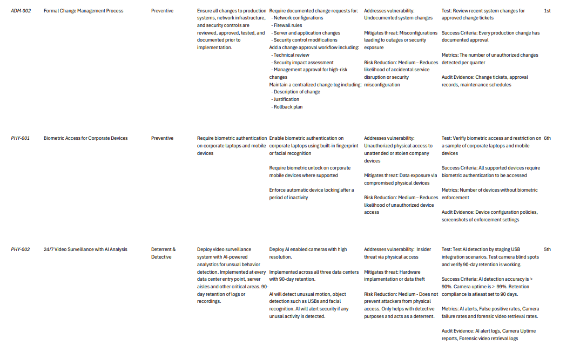
Excel Link: Control Catalog.xlsx

B) Control Interaction Diagram
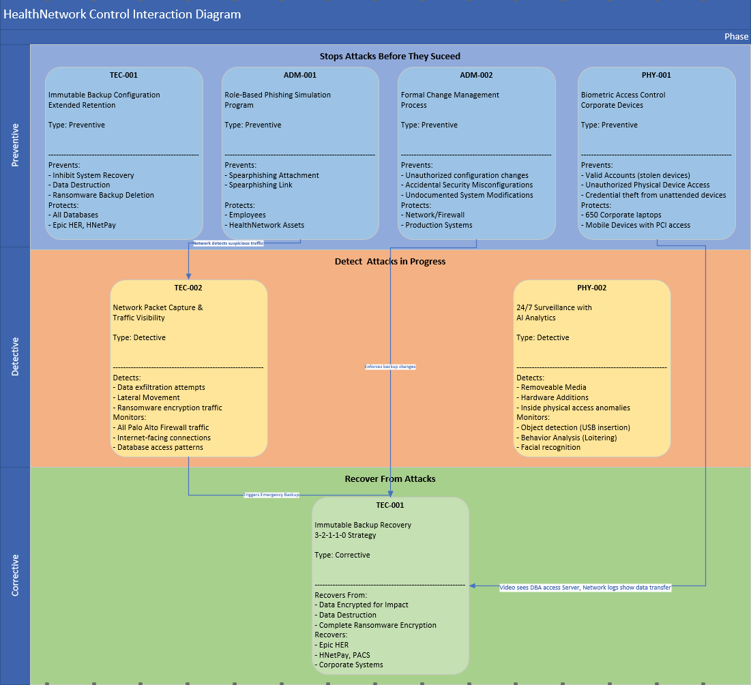

C) Control Gap Analysis
Vulnerability:
Medical devices on same VLANs as workstations – NOT ADDRESSED
Immutable backups misconfigured – ADDRESSED
No network packet capture – ADDRESSED
SIEM Storage 85% full – PARTIAL
Windows Event logs only 7-Day retention – NOT ADDRESSED
No data exfiltration prevention – NOT ADDRESSED

Residual Risk:
Medical Device Compromise – HIGH
Ransomware – MEDIUM
Phishing – LOW
Data Exfiltration – HIGH
Supply Chain Attack – LOW

Assumptions:
TEC-001: Veeam immutability cannot be bypassed even with admin credentials
TEC-002: Network monitoring captures all exfiltration
ADM-001: Users will report suspicious emails
ADM-002: Staff follows change process
PHY-001: Biometric authentication cannot be spoofed
PHY-002: AI accuracy > 85% with false positives at < 10%

Known Limitations:
Human Response Time
- TEC-002 and PHY-002 involve human analysis and response. This can take anywhere from 30-45 minutes which can cause ransomware to spread.

Detection Without Prevention (Data Exfiltration)
- No preventive control that stops data theft, only detective controls. By the time they are detected, and an outside source is notified, the data is already exfiltrated.

No Cloud Security Controls
- There is currently no monitoring for BCK-001 for misconfigurations or activity. Would need Cloud Security Posture Management or identity monitoring in place.

Deliverable 2: Multi-Framework Control Mapping
A) Framework Mapping Matrix
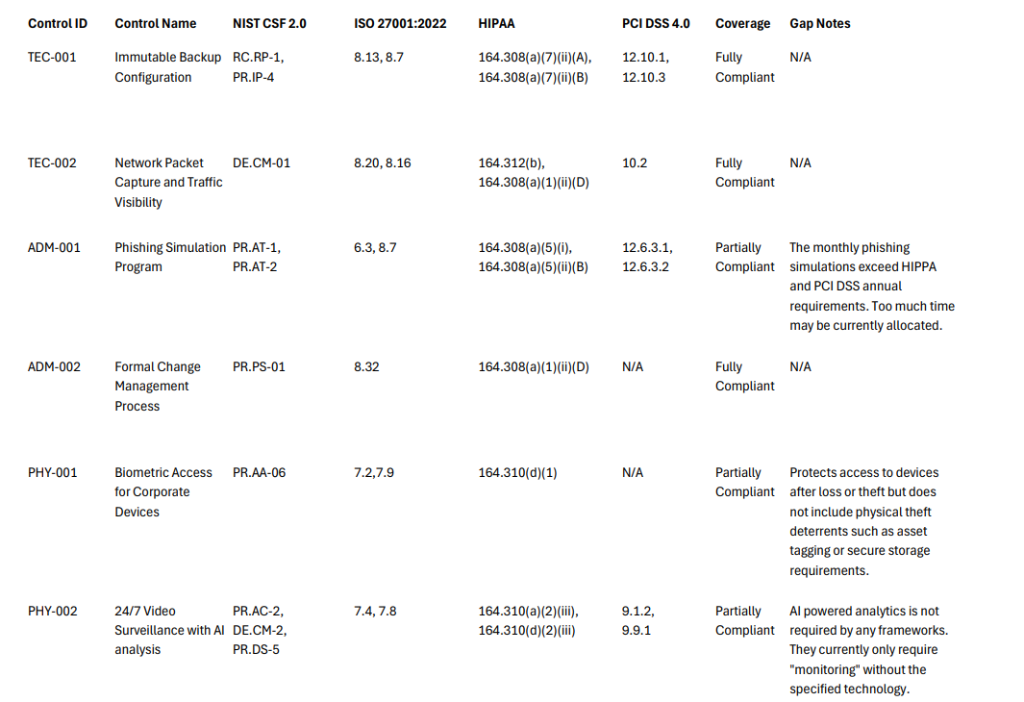
Excel Link: Multi-Framework Control Mapping.xlsx
B) Framework Effectiveness Critique

Which framework is most disconnected from modern threats?
The most disconnected framework currently is the HIPPA Security Rule which was last updated in 2013. HIPPA Requirement 164.308(a)(7)(ii)(A) says “Data backup plan” which only requires the backups exist. This does not mandate immutability or credential isolation. HIPPA Requirement 164.308(a)(5)(ii)(B) states “Malicious software awareness” but has no requirement for phishing simulations or role-based training.

Where do frameworks conflict?
A conflict we noticed was with the Backup Retention Period between the three frameworks. Currently, the frameworks policy is laid out like this:
- PCI DSS 4.0: “At least 3 months” offsite storage
- ISO 27001: “Based on organizational requirements” (No timeframe)
- HIPPA: No specific retention period

Another conflict we noticed was during the Security Awareness Training Frequency section. The framework policy states:
- PCI DSS 12.6.3.1: “At least annually”
- ISO 27001 (6.3): “Regular Updates”
- HIPPA 164.308(a)(5): “Annually”

What security controls are you implementing that NO framework requires?
The main control we are implementing that does not follow any framework is AI-Powered video analytics. Frameworks currently only require:
- PCI DSS 9.1.2: “Physical access controls”
- ISO 27001 (7.4): “Physical security monitoring”
- HIPPA 164.310(a)(2)(iii): “Facility security plan”
This is by far not our most effective control which belongs to TEC-001 Immutable Backups for being the most effective at preventing damage. However, this is a cost-effective control.

If you could only follow ONE framework, which would you choose?
If we could only follow ONE framework, we would choose NIST Cybersecurity Framework 2.0. This focuses more on the outcomes of detecting, responding and recovering rather than just implementing controls. This also can be applied across the industry which adheres to payments (PCI), and general security (ISO).

We would lose a great deal from not following those frameworks. Such as documentation structure from ISO 27001 and the credibility from it. We would lose the Healthcare-specific guidance that HIPPA requires. Finally, we would lose the prescriptive payment security controls needed for HNetPay to operate.

Deliverable 3: Select and Model Your Incident
A) Choose Your Incident Type
Option 1: Ransomware Attack

B) Model the Complete Attack Using MITRE ATT&CK
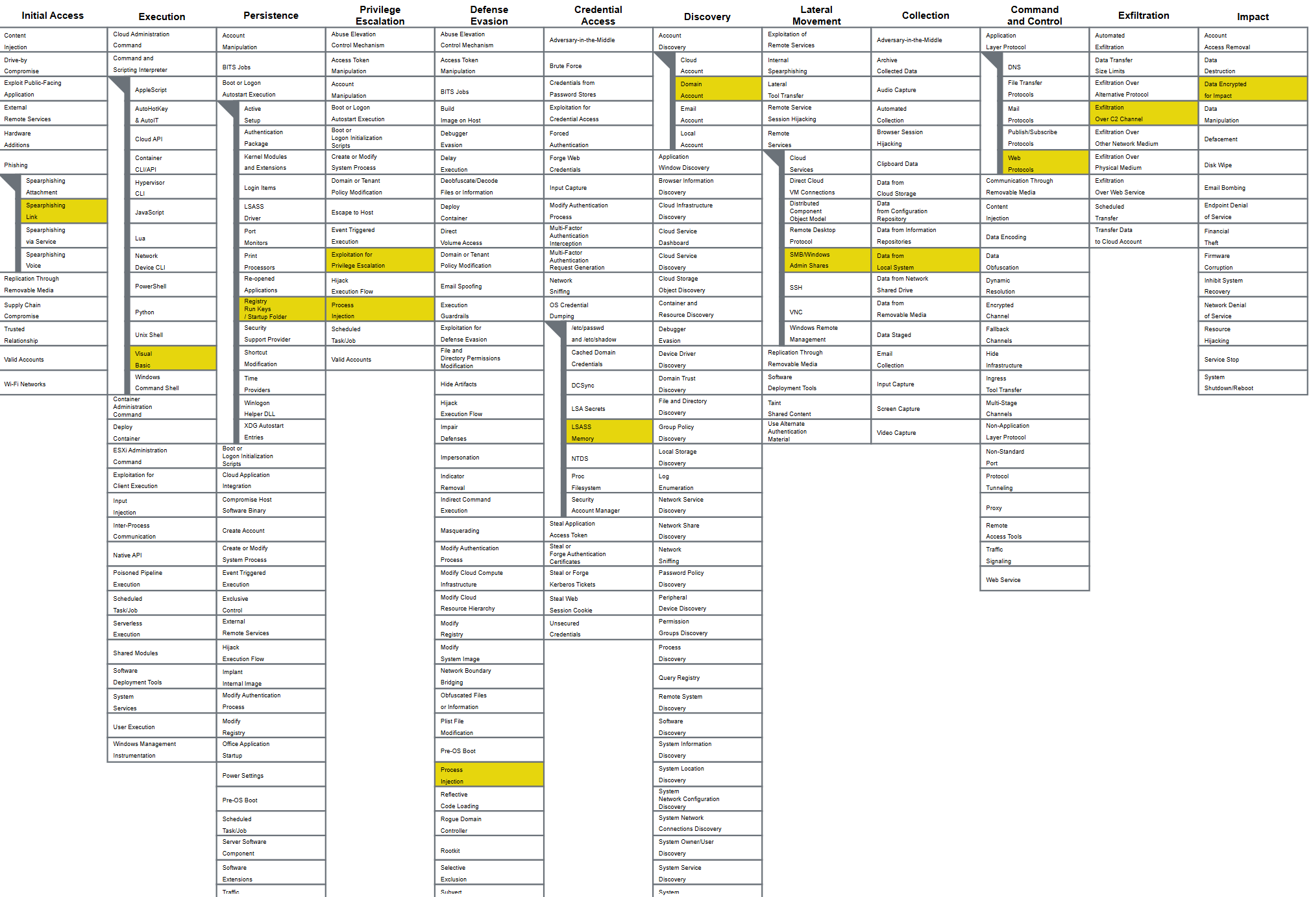
JSON File Link:
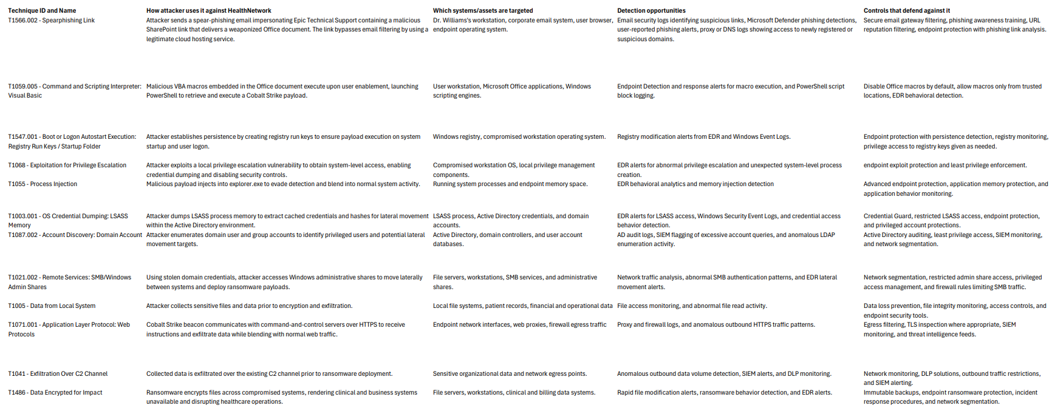
Excel Link: MITRE ATT&CK Technique Breakdowns

C) Why This Attack Would Succeed
Q: Which of HealthNetwork's known vulnerabilities enable this attack?
A: The known vulnerabilities of the HealthNetwork that enabled this attack include medical devices sharing VLANs with workstations, which reflects poor network segmentation, the absence of network packet capture, shadow copy deletion enabled on file servers, Windows event logs retained for only seven days, and SIEM storage that is eighty five percent full. These weaknesses allowed the attack to infiltrate the system while obscuring detection and limiting effective investigation.
Q: Which of your controls would be bypassed? (How?)
A: The Immutable Backup Configuration identified as TEC 001 would be bypassed because it does not prevent ransomware from occurring. This control is designed to protect data recovery rather than stop the initial attack. Control Biometric Access for Corporate Devices identified as PHY 001 would also be bypassed because it is intended to prevent unauthorized physical access to corporate data. In this case the ransomware attack was executed digitally rather than through physical intrusion. The 24/7 Surveillance with AI Analysis identified as PHY 002 would be bypassed because it does not deter or detect ransomware activity occurring within digital systems. The Formal Change Management Process identified as ADM 002 would be bypassed because it addresses a different category of risk. This control focuses on ensuring that system changes are safe and properly tested. In this scenario no system changes were required for the ransomware attack to occur.
Q: What assumptions in your security program does this attack exploit?
A: The assumptions in our security program that this attack exploits are users can reliably identify malicious emails, HTTPS traffic on the network is safe, internal user activity can always be trusted, logs will be available, and backup ensures successful recovery.
Q: Why would your "compliant" security fail against this?
A: Our "compliant" security fails against this because being compliant via frameworks focuses on control presence and documentation but lacks the foresight of real-world attacker behavior and control effectiveness.

Deliverable 4: Incident Response Playbook
Option 3: ERADICATION & RECOVERY Phase
---------------------------------------------------------------------------------------------------------------------
Procedure: Malware Removal
Objective: Removes ransomware components and malicious tooling from infected systems to prevent reinfection.
Prerequisites: Incident has been confirmed as ransomware and Endpoint Detection and Response (EDR) access is available.
Step-by-Step:
1. Isolate infected systems from the main network – Security Operations – 1 Hour
Success criteria: Infected systems are no longer active and can’t communicate externally.
2. Identify malicious processes and artifacts using EDR – Security Operations – 45 minutes
Success criteria: Malicious processes, files, registry entries, and scheduled tasks are identified.
3. Terminate malicious processes and remove persistence mechanisms – Security Operations – 1 hour
Success criteria: Malicious processes are no longer running.
4. Run full endpoint malware scan and memory analysis – Security Operations – 1 hour
Success criteria: Malware scan and memory analysis returns clean results showing no more active threats in the system.

Expected Total Time: 3 hours 45 minutes
Potential Issues:
- Malware may re-establish persistence on the systems
- Malware may evade detection.
Rollback Plan:
- Proceed to system rebuild procedure.
---------------------------------------------------------------------------------------------------------------------

Procedure: System Rebuild
Objective: Completely rebuilds compromised systems from a baseline image to ensure no ransomware remains
Prerequisites: Known-good images available in an isolated repository. Network isolation remains in effect and malware removable was unsuccessful.
Step-by-Step:
1. Document current state for forensic evidence – Security Operations – 1 Hour
Success criteria: Forensic data is captured and stored on an isolated workstation.
2. Verify known-good image integrity is in check and available – Security Operations – 15 Minutes
Success criteria: Confirm image hash matches the baseline (SHA-256)
3. Prioritize systems needed for rebuilding using tier classification – Security Operations – 20 Minutes
Success criteria: Tiers created based on priority. (Immediate, Medium, High)
4. Wipe infected systems and deploy known-good image – Security Operations – 1 Hour per infected system
Success criteria: Systems boot from known good image and system is not under ransomware effect

Expected Total Time: One Week
Potential Issues:
- Known images are outdated, corrupted or unavailable due to legacy systems
- Custom configurations not documented
- Ransomware persists on network, reinfects built system
Rollback Plan:
- Re-isolate system
- Capture new forensic evidence
- Investigate reinfection vector
- Stop rebuilding additional systems until vector is accounted for
---------------------------------------------------------------------------------------------------------------------

Procedure: Data Restoration
Objective: Restore critical business data from immutable backups to systems. Ensure data integrity and minimal data loss while restoring infected files.
Prerequisites: Immutable backups are available and verified uninfected.
Step-by-Step:
1. Identify last known-good backup before infection – Security Operations – 30 Minutes
Success criteria: Backup identified with at least 24 hours before ransomware occurred.
2. Tests restore to isolated environment. – Security Operations – 1 Hour
Success criteria: Test restore completes successfully; Restored files scan clean from malware or ransomware. Applications can access and read restored data.
3. Restore Critical Databases first – Security Operations – 2-4 Hours per database
Success criteria: Epic EHR and HNetExchange databases are back up and communicating
4. Restore File Servers and Drives – Security Operations – 2-3 Hours per File Server
Success criteria: All shared folders restored; File permissions intact; Scan returns clean of ransomware and malware
5. Manually track lost data and corruption – Security Operation – 5 Hours
Success criteria: All lost data is accounted for and efforts to restore them will be started. Logged lost data.

Expected Total Time: 2 Weeks
Potential Issues:
- Backups taken after ransomware access
- Restored databases data is corrupted
- Critical Missing Data
- Performance Degraded after systems are restored
Rollback Plan:
- Keep current restored data online
- Restore from alternate backup
- Compare resources to see which is cleaner
---------------------------------------------------------------------------------------------------------------------

Deliverable 6: Tabletop Exercise Execution & Post-Mortem
A) Tabletop decision making

Decision 1: Network Containment
A) Shut down VLAN 20 - stops attack, kills patient monitoring
B) Keep VLAN 20 up - monitors work, ransomware spreads
C) Selective isolation - try to isolate devices (takes 2+ hours you don't have)

We chose option B which is to keep VLAN 20 up as we feel option A is too risky for patient health and option C would take too long.

Decision 2: Backup Restoration
- 4-day-old immutable backup (clean but missing Epic update + 4 days of patient data)
- Today's backup (may contain dormant ransomware)
- 3-week-old tape backup (definitely clean but massive data loss)

We chose to restore the 4-day-old immutable backup as it seems like the backup with the most amount of clean data that we can currently access.

Decision 3: FBI Evidence Request
FBI agent: "We need all systems preserved in current state for forensic imaging. This will take 24-48 hours. Do not touch anything."
Medical staff: "We have patients. We need EHR access NOW."
Your cyber insurance: "You must demonstrate reasonable recovery efforts."

These requirements conflict. What do you do?

We chose to listen to the FBI agent because they have the highest clearance of oversight and are better equipped to handle the situation than our controls.

Decision 4: Ransom Payment
Factors:
- $1.2M ransom (cyber insurance covers it)
- 2-3 week recovery estimate without payment
- Patient data allegedly exfiltrated (HIPAA breach either way)
- No guaranteed decryption key will work
- Ethical and legal considerations

You have 30 minutes to decide and present recommendation to CEO. What do you recommend?

We chose to present a 2–3-week recovery estimate without recommending payment because it offers the highest likelihood of producing positive results. Paying the 1.2 million ransom does not seem like a good choice because our previous decision to align with the FBI agent means that making that payment could breach our cyber insurance policy and prevent coverage. This outcome would have a significant impact on both the company and the CEO. Patient data disclosure was also not a strong option because as a healthcare organization under attack it can be assumed that patient data may already have been exfiltrated which would make the option redundant. The remaining options appeared too risky and lacked sufficient information to evaluate properly.

Decision 5: Public Communication
"I have information that HealthNetwork suffered a major ransomware attack compromising patient data. Do you have a comment before we publish?"
Your options:
A) "No comment" - looks guilty, they publish speculation
B) Confirm attack - triggers regulatory clocks, stock price impact
C) Minimize - "technical issue, no evidence of data compromise" - potentially false if data was exfiltrated
Legal counsel is split. What do you say?

We chose to confirm the attack because we felt it’s important to get ahead of this since it will come out later anyway. The other options paint a guilty look and could have us lie about serious information which could cause more problems than it solves.

B) Evaluate your controls:
Controls That Would Have Prevented This:
TEC-002: Network Packet Capture and Traffic Visibility
ADM-001: Phishing Simulation Program

Control Network Packet Capture and Traffic Visibility (TEC-002) would have helped prevent this attack because continuous monitoring of network traffic and incoming packets could have identified malicious activity early enough to stop the ransomware from entering the system.

The Phishing Simulation Program (ADM-001) could have helped drastically with preventing the ransomware because it would have prevented the email credentials from ever being entered. This would have eliminated the ransomware threat because of the monthly testing based on security/role level.

Controls That Failed:
TEC-001: Immutable Backup Configuration
PHY-001: Biometric Access for Corporate Devices
PHY:002: 24/7 Surveillance with AI Analysis
ADM-002: Formal Change Management Process

The Immutable Backup Configuration (TEC-001) did not completely fail; however, it did not help in preventing the ransomware from occurring. This did help drastically with defending our backups and with our data recovery efforts.

Control Biometric Access for Corporate Devices (PHY-001) failed in this situation because the control did not and could not have had an impact on the ransomware attack. This control helps prevent unauthorized physical access to corporate data. However, the ransomware attack was carried out digitally.

The 24/7 Surveillance with AI Analysis (PHY-002) is a great control but it once again does not deter the ransomware from occurring. This helps defend our backups that are stored off site but does not help with the current recovery efforts.

Control Formal Change Management Process (ADM-002) failed in this situation because it addresses a different type of data vulnerability than this ransomware attack. This control focuses on implementing safe and tested changes. However, in this scenario no system changes were being introduced for the attack to occur.

Controls That Detected This:
ADM-001: Phishing Simulation Program
TEC-002: Network Packet Capture and Traffic Visibility

The Phishing Simulation Program (ADM-001) could help with detecting the initial email that the attacker sent. This would have been flagged by the recipient and sent to the Cybersecurity team for further analysis.

Control Network Packet Capture and Traffic Visibility (TEC-002) could have helped detect malicious data packets entering the network from the initial phishing email and halted the attack.

Deliverable 7: Framework Critique - When Theory Met Reality

Position A: "Frameworks are necessary but insufficient - we need both compliance AND
security thinking beyond frameworks."
Position B: "Frameworks create more problems than they solve - organizations should design
security programs based on threat models, not checkboxes."
Position C: "Frameworks are useful for immature security programs but become obstacles for
mature ones - know when to outgrow them."

A) Your Analysis Must Address:
1. Where Frameworks Helped Be fair - identify where frameworks actually provided value:
The frameworks that helped prevent worse outcomes consisted of HIPPA, ISO and PCI. HIPPA set us up with a strategy for our Data Backup which led to control TEC-001. Without the mandate stated from section 164.308(a)(7)(ii)(A), the ransomware could cause permanent data loss or the 1.2-million-dollar ransom payment. The ISO 27001 6.8 framework led us to our Change Management control or ADM-002. This is where we implement documented change control procedures which prevent attackers from making unauthorized firewall rule changes to facilitate lateral movement. Finally, PCI DSS helped us create our Structured Playbook for Incident Response Plans. This helped create IR procedures and reduce decision paralysis.
2. Where Frameworks Failed Be critical - identify framework limitations exposed by the
exercise:
The main failure of the framework arises from HIPPA 164.308(a)(5). This is the Security Awareness training which is very vague. There are no requirements to measure effectiveness in place along with no role-based training. Another huge failure was the network segmentation during this attack. PCI DSS “Network Segmentation” 1.3.1 states that HNetPay must be isolated per PCI requirement.

3. Preventive Control Failures:
Something that is not required by frameworks but would have helped is having control in place that deals with Data Loss Prevention. This can block large email attachments or any type of data exfiltration. Another thing that could have been implemented is the use of honeypots. This can be some sort of deception technology that an attacker can trigger.
4. Detective Control Failures:
The detective control that failed was TEC-002 Network Monitoring. Framework NIS says “Network monitored for anomalies” which was being done by Splunk SIEM. There was no baseline for behavior, so it was impossible to target anomalies. With the number of alerts that are generated from these tools (approx. 500 per day), there will always be a human analysis bottleneck. They will have to constantly sieve through the alerts to find the correct anomalies.
5. Response Failures:
A huge response failure was isolating the infected systems. The playbook says, “Immediately disconnect infected systems from network”. In reality, the ransomware continued to spread throughout the ICU. Another response failure was “Preserving Evidence for Forensics”. The FBI requests the systems to be preserved for imaging while other resources need immediate action.
6. Decision-Making Failures:
The security frameworks provided limited guidance for several critical decisions during the ransomware tabletop incident, especially those requiring real-time judgment rather than control validation. While frameworks such as NIST CSF, ISO 27001, and HIPAA define what controls should exist, they do not explain how to adapt those controls in response to attacker behavior or human error during an active incident. Many of the decisions required during the incident relied on judgment that frameworks do not teach, such as determining when to isolate systems versus keeping them online to preserve business continuity, deciding whether to shut down critical services to prevent lateral movement, and prioritizing which systems to recover first when backups were limited. These decisions required weighing incomplete information, attacker dwell time, and operational impact rather than following predefined control requirements. Significant conflicts also emerged between legal, business, and technical priorities. From a technical perspective, immediate system isolation and aggressive containment would reduce attacker movement, but business leadership would be concerned about clinical downtime and patient care disruption. Legal considerations further complicated decision making by raising questions about breach notification timelines, evidence preservation, and regulatory reporting. These competing priorities created tension that frameworks don’t fully address, as they focus on compliance and documentation rather than the complex, high-stress tradeoffs encountered in real-world incident response scenarios.
7. The Compliance Theater Question:
A realization of compliance theater emerged when reviewing HealthNetwork’s security posture in regard to its numerous certifications. Despite being ISO 27001:2022 certified, SOC 2 Type II compliant, HIPAA compliant with quarterly risk assessments, NIST CSF Tier 2 self-assessed, and PCI DSS Level 4 compliant, several known issues reveal controls that appear implemented primarily to satisfy audit requirements rather than to effectively stop an attack. For example, immutable backups were configured for only 7 days instead of 30. While this may technically meet a minimum backup requirement, it significantly weakens ransomware recovery capabilities by limiting restore options and increasing the risk that encrypted backups will overwrite clean copies. Similarly, Windows event logs retained for only 7 days severely restrict the ability to perform forensic analysis, identify attacker dwell time, or trace lateral movement during an incident. This satisfies the existence of logging controls but undermines their operational value. Additionally, allowing SIEM storage to reach 85% capacity demonstrates neglect of a critical detection tool. While log forwarding exists to meet compliance expectations, insufficient storage capacity risks dropped logs or delayed ingestion, effectively blinding security teams during an active attack. These issues collectively illustrate a pattern where controls are present and documented for audits but not maintained or tuned to providing meaningful security outcomes. This gap between compliance and effectiveness highlights how an organization can appear secure on paper while remaining vulnerable in practice.
B) Give Recommendations - How to Fix This:
Different Approach:
Frameworks are designed intentionally to serve a specific purpose: providing a foundational starting point for cybersecurity risk management. Abandoning framework-based compliance would not solve the issues observed, because frameworks were never intended to account for every operational, human, or adversarial variable in real-world attacks. Instead, the problem lies in how organizations utilize these frameworks. Many companies treat frameworks as a checklist for their entire security posture, operating under the assumption that compliance alone equates to security. Once all required controls are documented and implemented at a surface level, security efforts often stagnate. This mindset explains how ransomware attacks can still succeed against organizations that are fully compliant on paper. Frameworks should represent the minimum acceptable baseline for security, not the final objective. A more effective approach is to supplement frameworks with continuous risk-based security practices, such as threat modeling, adversary emulation, tabletop exercises, and ongoing control validation. Security should be measured by operational outcomes, including detection time, response effectiveness, resilience during incidents, and recovery speed, rather than by control existence alone. An effective analogy is to view frameworks like the walls surrounding a castle. The walls provide structure and protection, but they do not stop an attack on their own. Without guards actively monitoring, responding, and adapting to threats, attackers can still climb over the walls and breach the castle. Frameworks establish boundaries, but people, processes, and continuous monitoring are what actually defend the organization. Rather than satisfying regulators solely through documented compliance, organizations can demonstrate security maturity by showing evidence of active monitoring, tested incident response capabilities, and continuous improvement. This approach satisfies regulatory requirements while ensuring that compliance aligns with real-world defensive capability.
Practical Changes for HealthNetwork:
HealthNetwork should shift its security program from a compliance-driven model to a risk-driven and attack-informed approach. Rather than focusing on whether controls exist, the organization should focus on whether those controls are operationally effective during an active incident. HealthNetwork should prioritize continuous control validation and attack simulation. Conducting regular tabletop exercises and phishing simulations would expose gaps in detection, response, and decision-making that aren’t visible through audits alone. Controls such as logging, backups, and segmentation should also be routinely tested under failure conditions to ensure that they function as intended during a real attack. Certain framework requirements should also be deprioritized or minimally implemented when they provide limited defensive value. Things like checklist-based risk assessments that aren’t tied to threat modeling may satisfy auditors, but they consume time and resources that could be better spent improving detection, response, and recovery capabilities. To navigate compliance while remaining secure, HealthNetwork should treat frameworks as a translation layer rather than a goal. Real security activities such as incident response testing, threat hunting, and adversary simulation should be mapped back to framework controls during audits. This approach allows the organization to remain compliant while ensuring that security investments provide meaningful protection against real-world threats.

REFERENCES
[1]
NIST, “Security and Privacy Controls for Information Systems and Organizations,” csrc.nist.gov, Sep. 23, 2020. https://csrc.nist.gov/publications/detail/sp/800-53/rev-5/final
[2]
International Organization for Standardization, “ISO/IEC 27001 standard – information security management systems,” ISO, 2022. https://www.iso.org/standard/27001
[3]
U.S. Department of Health and Human Services, “The Security Rule,” HHS.gov, Oct. 20, 2022. https://www.hhs.gov/hipaa/for-professionals/security/index.html
[4]
NIST, “Cybersecurity Framework,” National Institute of Standards and Technology, 2025. https://www.nist.gov/cyberframework
[5]
PCI Security Standards Council, “Official PCI Security Standards Council Site - Verify PCI Compliance, Download Data Security and Credit Card Security Standards,” Pcisecuritystandards.org, 2023. https://www.pcisecuritystandards.org/
[6]
MITRE, “MITRE ATT&CK,” Mitre.org, 2025. https://attack.mitre.org/
[7]
Cybersecurity and Infrastructure Security Agency, “Known Exploited Vulnerabilities Catalog | CISA,” www.cisa.gov, 2023. https://www.cisa.gov/known-exploited-vulnerabilities-catalog
[8]
P. Cichonski, T. Millar, T. Grance, and K. Scarfone, “Computer security incident handling guide,” Computer Security Incident Handling Guide, vol. 2, no. 2, Aug. 2012, doi: https://doi.org/10.6028/nist.sp.800-61r2.
[9]
CISA, “Stop Ransomware,” www.cisa.gov, 2023. https://www.cisa.gov/stopransomware

