TOPIC

Global COVID-19 cases, deaths, and vaccinations, December 31, 2019-PRESENT

TRACK

Web scraping and leaflet/plotly combo

DATASETS

World Health Organization

<https://covid19.who.int/data>

<https://covid19.who.int/table>

U.S. Census Bureau (for country population)

<https://www.census.gov/data-tools/demo/idb/#/table?COUNTRY_YEAR=2022&COUNTRY_YR_ANIM=2022&ANIM_PARAMS=2019,2022,3&menu=tableViz&TABLE_RANGE=2019,2022&TABLE_YEARS=2019,2020,2021,2022&TABLE_USE_RANGE=Y&TABLE_USE_YEARS=Y&TABLE_STEP=1&TABLE_ADD_YEARS=2022>

DATABASE MANAGER

PgAdmin

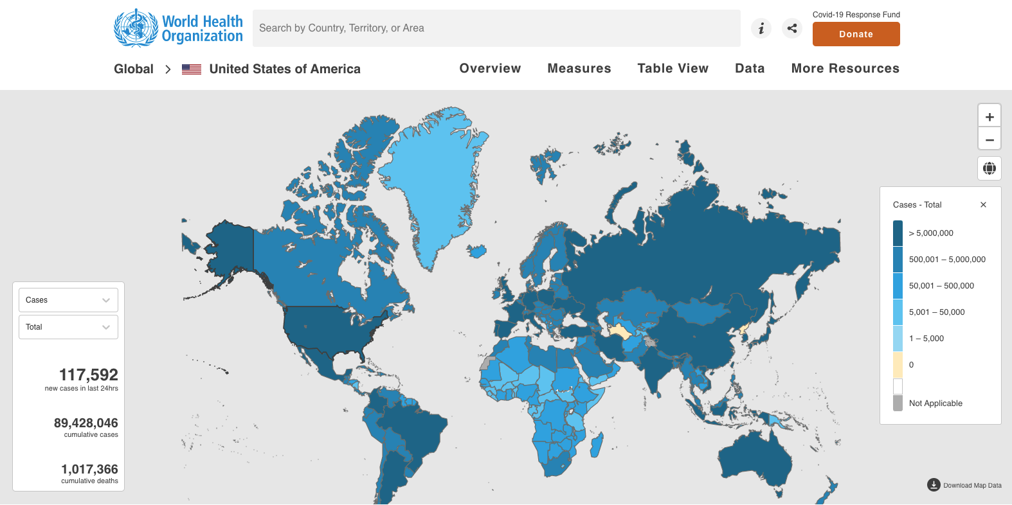INSPIRATION

POSSIBLE JS LIBRARIES

-JQuery

-InfoViz

-JQueryUI

-Bideo.JS