Problem and Hypothesis
This analysis sought to answer a reserach question that could be useful in a variety of industries: Can publicly available data be utilized in a forecasting model to predict the number of cores in computer processors? The possible conclusions are formulated as such:
Null hypothesis: The data cannot be used to produce a model sufficiently accurate in determining core count in processors, such that the mean absolute percent error will be above or equal to 15%Alternate hypothesis: The data can be used to produce a model sufficiently accurate in determining core count in processors, such that the mean absolute percent error will be below 15%
Such a model has a variety of possible uses going forward. To name a few, those developing cores could predict the advancements of competitors, using this information to establish a baseline, those relying on newer technologies could forecast what new resources will come onto the market in the near future, and those harvesting the resources for these processors can predict how demand may increase.

Process Summary
The process began by concatenating the data from the two csv files and condensing the data into yearly aggregates, based on the median number of cores for each year. An exploratory data analysis was then performed to verify that the data had no seasonality or trends. The visualization generated (see below) indicated a generally positive trend.
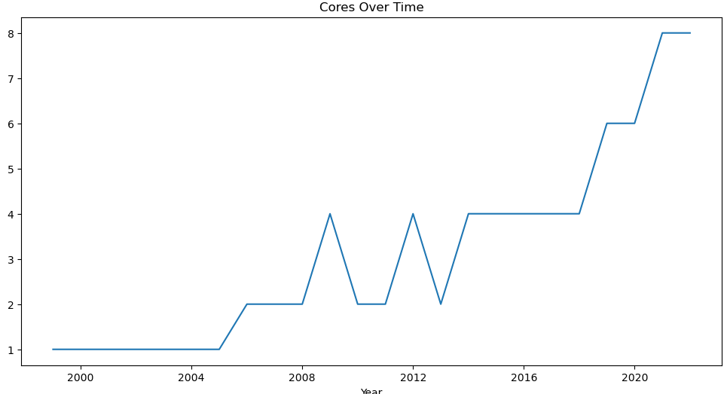
The ADF function confirmed such an analysis, generating a p-value of 0.999. To account for this trend, we differentiated the data, resulting in a p-value of 1.4*10⁻¹², sufficiently low to describe it as insignificant. The visualization of the differentiated data (see below) further confirms the stationarity of data.
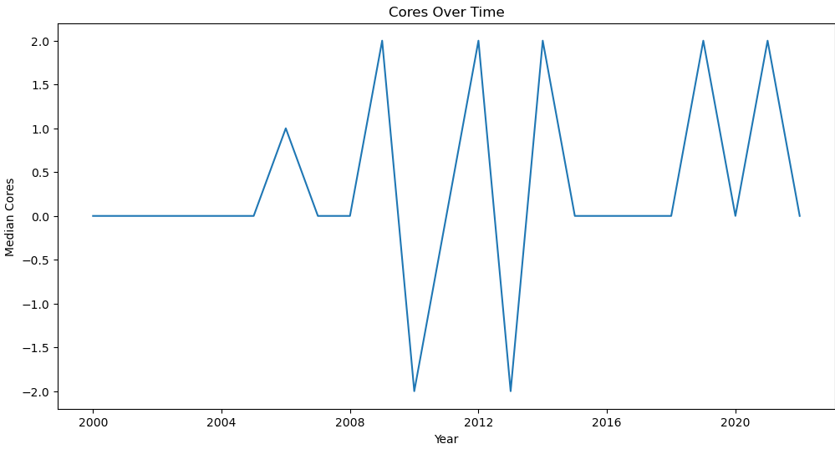

With this differentiation completed, the data is then split into testing and training sets. The next step in the process is to identify the ideal function to use for the analysis, so we calculate the ACF and PACF. The results (visible below) indicate a major decrease after factor 0, indicating that an AR(1) analysis is ideal in analyzing this dataset.
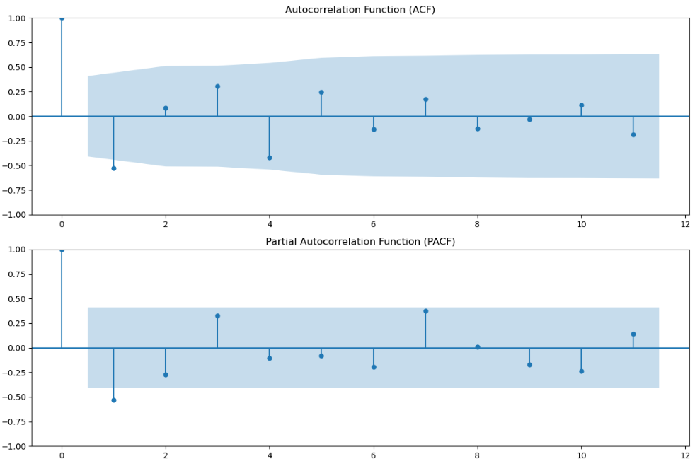
With all the required information collected, we proceed to generate the ARIMA model, fitting it to the training dataset. Once created, we analyze the effectiveness of the model. This is done by undifferentiating the data, then charting the actual vs predicted values produced by the model. For this analysis, we both produce a visualization (see below) and calculate the mean absolute percent error (MAPE).
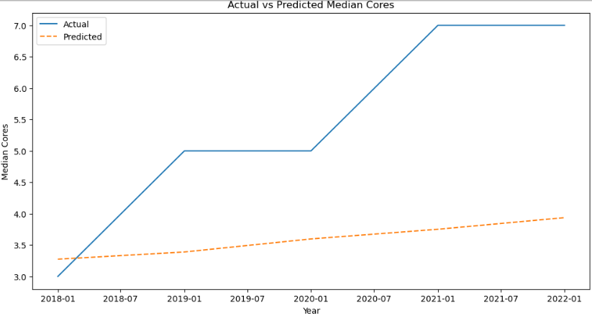
The calculation for MAPE indicates a 31.9% error, and the visualization similarly shows the poor predictive results of the analysis, consistently predicting fewer cores than we see in the actual values.

Findings
As mentioned above, we find that the model has an MAPE of over 30%, more than twice the permissible value to accept the alternate hypothesis. Therefore, we reject the alternate hypothesis and accept the null hypothesis, which states that the publicly available data is not sufficient to produce a model that can accurately predict processor core count.

Limitations
The primary limitation in this dataset relates to the distinct timeframes of this analysis. The dataset does contain 23 years worth of data, but the data does not contain any more information regarding release data other than year. Therefore, when we aggregate the data, as we must for this analysis, we must do so on the basis of year. Having only 23 rows in the dataset after the cleaning and preparation is complete is incredibly limiting in terms of what the analysis can do, especially considering the necessity of splitting the data into training and testing datasets. Ideally, the data would contain month or day values, so that we could create more distinct entries for analysis and have more ability to identify the patterns within the data.
Another limitation on the dataset is that we do not know the purpose of the processors released. Oftentimes, processors are released solely for industrial use, and therefore may have more cores than anticipated, or discount processors are released, with lower capacity (and therefore core count) solely to provide a cheap option that is compatible with new technologies. Having these processors categorized on these criteria would help the analysis, allowing similar types of processors to be grouped, allowing for more effective and useful predictions.

Proposed Actions
Though the model is not effective, there are some actions that we can safely take on the basis of this model. First, we note that the model routinely underestimates the core count of processors, so we can comfortably predict that the core count in processors will grow at a rapid pace. This trend can be used to justify more resource acquisition by the manufacturers, as well as indicating that consumers can continue expecting more growth in processor capacity going forward. Furthermore, the limitations of the model make clear that there are possible actions that can be taken to improve the model, potentially improving performance to such a degree that reliable insights are produced. Therefore, engaging in more thorough data acquisition efforts, which can be used to train a more effective version of the model, would certainly be justified.

Expected Benefits
Given the acceptance of the null hypothesis and the rejection of the alternate hypothesis, the benefits from this analysis do not pertain to the model itself, but instead to how the creation of this model informs future attempts at performing similar analyses in the future. This model makes clear that the growth of cores is not forecasted by linear growth, but, given that the model almost universally underestimates the results, it is possible to perform a similar analysis to investigate whether the growth can effectively be charted by predicting exponential growth. Furthermore, the lack of effective results from the model indicates that more data, or more effectively segmented data, may be required to effectively forecast the number of cores. As such, this model will allow further analyses that may filter on the basis of critical aspects, such as use case (industrial vs personal), integrated graphics cards, or price point. Collecting data that captures this information may be essential for creating an effective model, something that we only know now that the model was created on the basis of the existing, available data. Once the factors that are required to improve the model are identified, this model could be used to predict the new advancements in processor capacity, informing businesses as to the efficacy of new technologies going forward.

