N741 Spring 2018 - Homework 7

Homework 7 - DUE WED April 11, 2018

Erin Ferranti

April 4, 2018

## Homework 7

### Background and Information on HELP Dataset

For homework 7, you will be working with the **HELP** (Health Evaluation and Linkage to Primary Care) Dataset. See complete details posted in Homework 6.

### Variables for Homework 7

For Homework 7, you will focus on these variables from the HELP dataset:

Use these variables from HELP dataset for Homework 07

|  |  |
| --- | --- |
|  | Variable Label |
| age | Age at baseline (in years) |
| female | Gender of respondent |
| pss_fr | Perceived Social Support - friends |
| homeless | One or more nights on the street or shelter in past 6 months |
| pcs | SF36 Physical Composite Score - Baseline |
| mcs | SF36 Mental Composite Score - Baseline |
| cesd | CESD total score - Baseline |
| cesd_gte16 | Indicator of Depression |
| mcs_lt45 | Indicator of Poor Mental Health |

## Homework 7 Assignment

**SETUP** Download and run the “loadHELP.R” R script (included in this Github repo <https://github.com/melindahiggins2000/N741Spring2018_Homework7>) to read in the HELP Dataset “helpmkh.sav”. This script also pulls out the variables you need and creates the dichotomous variable for depression cesd_gte16 **AND** a dichotomous variable to indicate poor mental health (mcs_lt45).

After running this R script, you will have a data frame called h1 you can use to do the rest of your analyses. You can also copy this code into your first R markdown code chunk to get you started on Homework 7 - or begin with this R markdown file for Homework 7.

For Homework 7, the code is provided here for the regression tree and conditional tree and random forest models looking at depression as given by the continuous measure cesd and the dichotomous indicator of depression cesd_gte16.

You can then use this code and adapt it to run through the models again looking at the mental health composite score (mcs) in these subjects and the dichomotous indicator or poor mental health for people with mcs scores < 45, which is the variable mcs_lt45.

### Packages needed for Homework 7

* rpart
* partykit
* party
* tidyverse
* reshape2
* randomForestSRC
* ggRandomForests

library(rpart)  
library(partykit)  
library(reshape2)  
library(party)  
library(tidyverse)  
library(randomForestSRC)  
library(ggRandomForests)

### Regression Tree for CESD

Using the rpart package and the steps we demonstrated in class, the code below:

* fits a regression tree to the cesd based on only the mcs scores from the h1 dataset;
* displays the results
* plots the cross-validated results
* provides a summary of the model fit
* and plots the regression tree

# fit a regression tree model to the cesd as the outcome  
# and using the mcs as the only predictor  
fitcesd <- rpart::rpart(cesd ~ mcs, data = h1)  
rpart::printcp(fitcesd) # Display the results

##   
## Regression tree:  
## rpart::rpart(formula = cesd ~ mcs, data = h1)  
##   
## Variables actually used in tree construction:  
## [1] mcs  
##   
## Root node error: 70788/453 = 156.27  
##   
## n= 453   
##   
## CP nsplit rel error xerror xstd  
## 1 0.340353 0 1.00000 1.00278 0.058722  
## 2 0.063092 1 0.65965 0.68047 0.039449  
## 3 0.053626 2 0.59655 0.64956 0.038794  
## 4 0.013872 3 0.54293 0.59752 0.036902  
## 5 0.010000 4 0.52906 0.58617 0.036590

rpart::plotcp(fitcesd) # Visualize cross-validation results

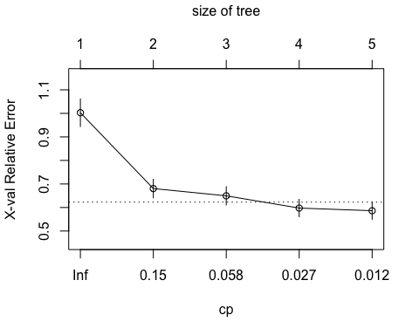

summary(fitcesd) # Detailed summary of fit

## Call:  
## rpart::rpart(formula = cesd ~ mcs, data = h1)  
## n= 453   
##   
## CP nsplit rel error xerror xstd  
## 1 0.34035277 0 1.0000000 1.0027752 0.05872170  
## 2 0.06309226 1 0.6596472 0.6804701 0.03944853  
## 3 0.05362563 2 0.5965550 0.6495597 0.03879410  
## 4 0.01387215 3 0.5429293 0.5975246 0.03690240  
## 5 0.01000000 4 0.5290572 0.5861724 0.03659043  
##   
## Variable importance  
## mcs   
## 100   
##   
## Node number 1: 453 observations, complexity param=0.3403528  
## mean=32.84768, MSE=156.266   
## left son=2 (187 obs) right son=3 (266 obs)  
## Primary splits:  
## mcs < 32.52559 to the right, improve=0.3403528, (0 missing)  
##   
## Node number 2: 187 observations, complexity param=0.06309226  
## mean=24.14973, MSE=112.5979   
## left son=4 (48 obs) right son=5 (139 obs)  
## Primary splits:  
## mcs < 51.3962 to the right, improve=0.2121128, (0 missing)  
##   
## Node number 3: 266 observations, complexity param=0.05362563  
## mean=38.96241, MSE=96.38956   
## left son=6 (140 obs) right son=7 (126 obs)  
## Primary splits:  
## mcs < 22.67163 to the right, improve=0.1480551, (0 missing)  
##   
## Node number 4: 48 observations  
## mean=15.83333, MSE=128.0556   
##   
## Node number 5: 139 observations, complexity param=0.01387215  
## mean=27.02158, MSE=75.12903   
## left son=10 (56 obs) right son=11 (83 obs)  
## Primary splits:  
## mcs < 41.62456 to the right, improve=0.09403377, (0 missing)  
##   
## Node number 6: 140 observations  
## mean=35.37857, MSE=80.77811   
##   
## Node number 7: 126 observations  
## mean=42.94444, MSE=83.60802   
##   
## Node number 10: 56 observations  
## mean=23.78571, MSE=71.52551   
##   
## Node number 11: 83 observations  
## mean=29.20482, MSE=65.72913

# plot tree  
plot(fitcesd, uniform = TRUE, compress = FALSE)  
text(fitcesd, use.n = TRUE, all = TRUE, cex = 0.5)

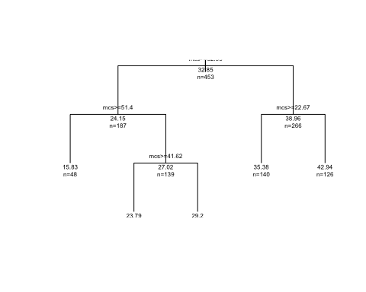

### **PROBLEM 1: Regression Tree for MCS**

Using the code above, fit a regression tree model where the mcs is the outcome and the cesd is the predictor and complete the following:

* fit a regression tree to the mcs based on only the cesd scores from the h1 dataset;
* display the results
* plot the cross-validated results
* provide a summary of the model fit
* and plot the regression tree

fitmcs <- rpart::rpart(mcs ~ cesd, data = h1)  
rpart::printcp(fitmcs)

##   
## Regression tree:  
## rpart::rpart(formula = mcs ~ cesd, data = h1)  
##   
## Variables actually used in tree construction:  
## [1] cesd  
##   
## Root node error: 74512/453 = 164.48  
##   
## n= 453   
##   
## CP nsplit rel error xerror xstd  
## 1 0.325298 0 1.00000 1.00394 0.054589  
## 2 0.081349 1 0.67470 0.69454 0.046675  
## 3 0.066496 2 0.59335 0.67250 0.045907  
## 4 0.012496 3 0.52686 0.56964 0.040475  
## 5 0.010000 4 0.51436 0.56795 0.040228

rpart::plotcp(fitmcs)

summary(fitmcs)

## Call:  
## rpart::rpart(formula = mcs ~ cesd, data = h1)  
## n= 453   
##   
## CP nsplit rel error xerror xstd  
## 1 0.32529813 0 1.0000000 1.0039425 0.05458875  
## 2 0.08134904 1 0.6747019 0.6945380 0.04667491  
## 3 0.06649553 2 0.5933528 0.6725013 0.04590715  
## 4 0.01249609 3 0.5268573 0.5696439 0.04047496  
## 5 0.01000000 4 0.5143612 0.5679456 0.04022839  
##   
## Variable importance  
## cesd   
## 100   
##   
## Node number 1: 453 observations, complexity param=0.3252981  
## mean=31.67668, MSE=164.4847   
## left son=2 (285 obs) right son=3 (168 obs)  
## Primary splits:  
## cesd < 29.5 to the right, improve=0.3252981, (0 missing)  
##   
## Node number 2: 285 observations, complexity param=0.06649553  
## mean=26.06057, MSE=100.1894   
## left son=4 (100 obs) right son=5 (185 obs)  
## Primary splits:  
## cesd < 42.5 to the right, improve=0.17352, (0 missing)  
##   
## Node number 3: 168 observations, complexity param=0.08134904  
## mean=41.20401, MSE=129.2805   
## left son=6 (122 obs) right son=7 (46 obs)  
## Primary splits:  
## cesd < 15.5 to the right, improve=0.2790834, (0 missing)  
##   
## Node number 4: 100 observations  
## mean=20.38941, MSE=43.95751   
##   
## Node number 5: 185 observations  
## mean=29.12606, MSE=103.8029   
##   
## Node number 6: 122 observations  
## mean=37.51566, MSE=103.6988   
##   
## Node number 7: 46 observations, complexity param=0.01249609  
## mean=50.98616, MSE=65.35702   
## left son=14 (26 obs) right son=15 (20 obs)  
## Primary splits:  
## cesd < 9.5 to the right, improve=0.3097046, (0 missing)  
##   
## Node number 14: 26 observations  
## mean=47.04024, MSE=67.29195   
##   
## Node number 15: 20 observations  
## mean=56.11586, MSE=16.28645

### Matrix Scatterplot of Other Variables with CESD

We can use the reshape2 package to basically stack all of the other variables on top of one another and align them with the cesd variable and then use this “melted” dataset with the facet_wrap option with ggplot() to basically get a matrix of scatterplots showing how all of the other variables are associated with the cesd.

I also first remove the variables I don’t need for this next step and create the dataset h1a.

# all vars except the dichotomous cesd_gte16 and mcs_lt45  
h1a <- h1[,1:7]  
  
# Melt the other variables down and link to cesd  
h1m <- reshape2::melt(h1a, id.vars = "cesd")  
  
# Plot panels for each covariate  
ggplot(h1m, aes(x=cesd, y=value)) +  
 geom_point(alpha=0.4)+  
 scale_color_brewer(palette="Set2")+  
 facet_wrap(~variable, scales="free_y", ncol=3)

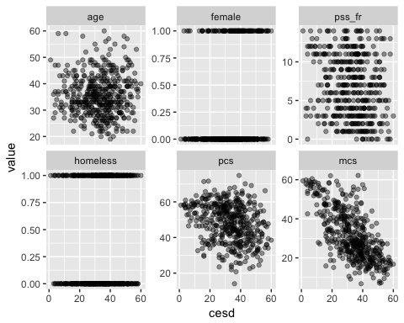

### **PROBLEM 2: Matrix Scatterplot of Other Variables with MCS**

Using the code above as a guide,swap out mcs for cesd and redo the scatterplots compared to the mcs. HINT: You can begin with the data subset h1a, but you will need to modify the code for h1m and for the ggplot() code lines.

h1a <- h1[,1:7]  
h1m <- reshape2::melt(h1a, id.vars = "mcs")  
ggplot(h1m, aes(x=mcs, y=value)) +  
 geom_point(alpha=0.4)+  
 scale_color_brewer(palette="Set2")+  
 facet_wrap(~variable, scales="free_y", ncol=3)

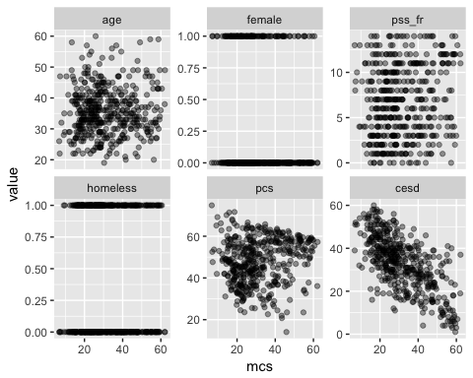

### Regression Tree for CESD with the rest of the variables

Now let’s see what happens when we include the rest of the variables. A “shorthand” notation used in R that can be handy is to simply put in a period “.” indicating use the rest of the variables in the model.

So, the line of code

fitall <- rpart::rpart(cesd ~ ., data = h1a)

basically says to fit a model for cesd from the rest of the variables in the dataset h1a which includes:

* age
* female
* pss_fr
* homeless
* pcs
* mcs

So the period “.” in the model formula cesd ~ . part of the code above indicates that we’re going to put age, female, pss_fr, homeless, pcs, and mcs into the model as predictors.

But the equivalent way to define this model where you list each variable you want in the model is to use the plus + symbol between each variable - so you could also write this code:

fitall <- rpart::rpart(cesd ~ age + female + pss_fr +   
 homeless + pcs + mcs,   
 data = h1a)

So, let’s see what the regression tree for CESD looks like if we try all of these other variables as predictors in the model.

# fit a regression tree with all vars  
fitall <- rpart::rpart(cesd ~ ., data = h1a)  
  
# equivalent code statement without the shorthand  
# using the period for the "rest of the variables"  
# this time each variable to be included is listed  
# individually putting a plus + in between each   
# variable added to the model  
  
fitall <- rpart::rpart(cesd ~ age + female + pss_fr +   
 homeless + pcs + mcs,   
 data = h1a)  
  
# Now let's look at fitall  
rpart::printcp(fitall) # Display the results

##   
## Regression tree:  
## rpart::rpart(formula = cesd ~ age + female + pss_fr + homeless +   
## pcs + mcs, data = h1a)  
##   
## Variables actually used in tree construction:  
## [1] mcs pcs  
##   
## Root node error: 70788/453 = 156.27  
##   
## n= 453   
##   
## CP nsplit rel error xerror xstd  
## 1 0.340353 0 1.00000 1.00229 0.058690  
## 2 0.063092 1 0.65965 0.67623 0.039005  
## 3 0.053626 2 0.59655 0.65189 0.040282  
## 4 0.022423 3 0.54293 0.61068 0.038165  
## 5 0.013872 4 0.52051 0.59373 0.037428  
## 6 0.010032 5 0.50663 0.62082 0.039275  
## 7 0.010000 7 0.48657 0.63772 0.040992

rpart::plotcp(fitall) # Visualize cross-validation results

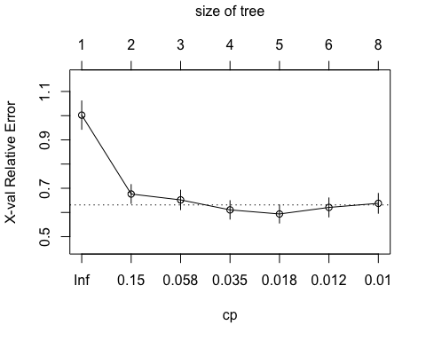

summary(fitall) # Detailed summary of fit

## Call:  
## rpart::rpart(formula = cesd ~ age + female + pss_fr + homeless +   
## pcs + mcs, data = h1a)  
## n= 453   
##   
## CP nsplit rel error xerror xstd  
## 1 0.34035277 0 1.0000000 1.0022928 0.05868956  
## 2 0.06309226 1 0.6596472 0.6762309 0.03900533  
## 3 0.05362563 2 0.5965550 0.6518898 0.04028164  
## 4 0.02242335 3 0.5429293 0.6106781 0.03816514  
## 5 0.01387215 4 0.5205060 0.5937284 0.03742847  
## 6 0.01003176 5 0.5066338 0.6208227 0.03927540  
## 7 0.01000000 7 0.4865703 0.6377186 0.04099246  
##   
## Variable importance  
## mcs pcs pss_fr age female   
## 78 13 5 3 1   
##   
## Node number 1: 453 observations, complexity param=0.3403528  
## mean=32.84768, MSE=156.266   
## left son=2 (187 obs) right son=3 (266 obs)  
## Primary splits:  
## mcs < 32.52559 to the right, improve=0.340352800, (0 missing)  
## pcs < 49.19916 to the right, improve=0.104572600, (0 missing)  
## female < 0.5 to the left, improve=0.032302950, (0 missing)  
## pss_fr < 8.5 to the right, improve=0.029240370, (0 missing)  
## age < 23.5 to the right, improve=0.007589837, (0 missing)  
## Surrogate splits:  
## pcs < 56.1551 to the right, agree=0.634, adj=0.112, (0 split)  
## pss_fr < 10.5 to the right, agree=0.609, adj=0.053, (0 split)  
## age < 21.5 to the left, agree=0.592, adj=0.011, (0 split)  
##   
## Node number 2: 187 observations, complexity param=0.06309226  
## mean=24.14973, MSE=112.5979   
## left son=4 (48 obs) right son=5 (139 obs)  
## Primary splits:  
## mcs < 51.3962 to the right, improve=0.21211280, (0 missing)  
## pcs < 46.0814 to the right, improve=0.07616853, (0 missing)  
## pss_fr < 11.5 to the right, improve=0.03161969, (0 missing)  
## age < 22.5 to the right, improve=0.02449595, (0 missing)  
## female < 0.5 to the left, improve=0.01088789, (0 missing)  
## Surrogate splits:  
## pss_fr < 11.5 to the right, agree=0.765, adj=0.083, (0 split)  
## age < 58.5 to the right, agree=0.754, adj=0.042, (0 split)  
##   
## Node number 3: 266 observations, complexity param=0.05362563  
## mean=38.96241, MSE=96.38956   
## left son=6 (140 obs) right son=7 (126 obs)  
## Primary splits:  
## mcs < 22.67163 to the right, improve=0.14805510, (0 missing)  
## pcs < 40.92127 to the right, improve=0.07769934, (0 missing)  
## pss_fr < 0.5 to the right, improve=0.03572097, (0 missing)  
## female < 0.5 to the left, improve=0.03455917, (0 missing)  
## age < 48.5 to the left, improve=0.01737694, (0 missing)  
## Surrogate splits:  
## pss_fr < 3.5 to the right, agree=0.583, adj=0.119, (0 split)  
## pcs < 64.93552 to the left, agree=0.560, adj=0.071, (0 split)  
## female < 0.5 to the left, agree=0.556, adj=0.063, (0 split)  
## age < 46.5 to the left, agree=0.553, adj=0.056, (0 split)  
## homeless < 0.5 to the right, agree=0.530, adj=0.008, (0 split)  
##   
## Node number 4: 48 observations  
## mean=15.83333, MSE=128.0556   
##   
## Node number 5: 139 observations, complexity param=0.01387215  
## mean=27.02158, MSE=75.12903   
## left son=10 (56 obs) right son=11 (83 obs)  
## Primary splits:  
## mcs < 41.62456 to the right, improve=0.09403377, (0 missing)  
## pcs < 26.8635 to the right, improve=0.07496568, (0 missing)  
## pss_fr < 3.5 to the right, improve=0.02872252, (0 missing)  
## age < 33.5 to the left, improve=0.01948280, (0 missing)  
## homeless < 0.5 to the left, improve=0.01404178, (0 missing)  
## Surrogate splits:  
## pcs < 22.26483 to the left, agree=0.619, adj=0.054, (0 split)  
## pss_fr < 13.5 to the right, agree=0.612, adj=0.036, (0 split)  
##   
## Node number 6: 140 observations, complexity param=0.02242335  
## mean=35.37857, MSE=80.77811   
## left son=12 (80 obs) right son=13 (60 obs)  
## Primary splits:  
## pcs < 44.6562 to the right, improve=0.140359400, (0 missing)  
## pss_fr < 8.5 to the right, improve=0.069217610, (0 missing)  
## age < 38.5 to the left, improve=0.044384950, (0 missing)  
## mcs < 27.62416 to the right, improve=0.021316600, (0 missing)  
## female < 0.5 to the left, improve=0.007874331, (0 missing)  
## Surrogate splits:  
## age < 36.5 to the left, agree=0.686, adj=0.267, (0 split)  
## mcs < 23.7272 to the right, agree=0.621, adj=0.117, (0 split)  
## homeless < 0.5 to the left, agree=0.593, adj=0.050, (0 split)  
## pss_fr < 0.5 to the right, agree=0.579, adj=0.017, (0 split)  
##   
## Node number 7: 126 observations, complexity param=0.01003176  
## mean=42.94444, MSE=83.60802   
## left son=14 (7 obs) right son=15 (119 obs)  
## Primary splits:  
## pcs < 66.88379 to the right, improve=0.06563616, (0 missing)  
## mcs < 18.49567 to the right, improve=0.05724195, (0 missing)  
## female < 0.5 to the left, improve=0.05365277, (0 missing)  
## age < 48.5 to the left, improve=0.03224087, (0 missing)  
## pss_fr < 12.5 to the left, improve=0.02139818, (0 missing)  
##   
## Node number 10: 56 observations  
## mean=23.78571, MSE=71.52551   
##   
## Node number 11: 83 observations  
## mean=29.20482, MSE=65.72913   
##   
## Node number 12: 80 observations  
## mean=32.4625, MSE=73.84859   
##   
## Node number 13: 60 observations  
## mean=39.26667, MSE=63.56222   
##   
## Node number 14: 7 observations  
## mean=33.28571, MSE=117.9184   
##   
## Node number 15: 119 observations, complexity param=0.01003176  
## mean=43.51261, MSE=75.77925   
## left son=30 (59 obs) right son=31 (60 obs)  
## Primary splits:  
## mcs < 18.49567 to the right, improve=0.08082019, (0 missing)  
## female < 0.5 to the left, improve=0.04062765, (0 missing)  
## pcs < 35.99184 to the right, improve=0.03933964, (0 missing)  
## age < 48.5 to the left, improve=0.03130734, (0 missing)  
## pss_fr < 12.5 to the left, improve=0.02626137, (0 missing)  
## Surrogate splits:  
## pcs < 46.51692 to the left, agree=0.672, adj=0.339, (0 split)  
## pss_fr < 8.5 to the left, agree=0.622, adj=0.237, (0 split)  
## age < 31.5 to the right, agree=0.613, adj=0.220, (0 split)  
## homeless < 0.5 to the right, agree=0.571, adj=0.136, (0 split)  
## female < 0.5 to the left, agree=0.521, adj=0.034, (0 split)  
##   
## Node number 30: 59 observations  
## mean=41.01695, MSE=69.67768   
##   
## Node number 31: 60 observations  
## mean=45.96667, MSE=69.63222

plot(fitall, uniform = TRUE, compress = FALSE, main = "Regression Tree for CESD Scores from HELP(h1) Data")  
text(fitall, use.n = TRUE, all = TRUE, cex = 0.5)

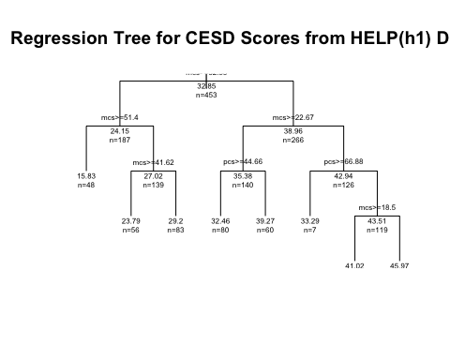

### **PROBLEM 3: Regression Tree for MCS Using Rest of Variables**

Using the code above as a guide, swap out mcs for cesd and redo the regression tree for mcs using the rest of the variables in the data subset h1a.

fitall <- rpart::rpart(mcs ~ ., data = h1a)  
fitall <- rpart::rpart(mcs ~ age + female + pss_fr +   
 homeless + pcs + cesd,   
 data = h1a)  
rpart::printcp(fitall)

##   
## Regression tree:  
## rpart::rpart(formula = mcs ~ age + female + pss_fr + homeless +   
## pcs + cesd, data = h1a)  
##   
## Variables actually used in tree construction:  
## [1] cesd pcs   
##   
## Root node error: 74512/453 = 164.48  
##   
## n= 453   
##   
## CP nsplit rel error xerror xstd  
## 1 0.325298 0 1.00000 1.00299 0.054603  
## 2 0.081349 1 0.67470 0.69227 0.046065  
## 3 0.066496 2 0.59335 0.65589 0.045817  
## 4 0.017717 3 0.52686 0.57035 0.040390  
## 5 0.015767 4 0.50914 0.57429 0.040133  
## 6 0.012496 5 0.49337 0.56878 0.040224  
## 7 0.012258 6 0.48088 0.57643 0.041254  
## 8 0.010000 7 0.46862 0.58657 0.042112

rpart::plotcp(fitall)

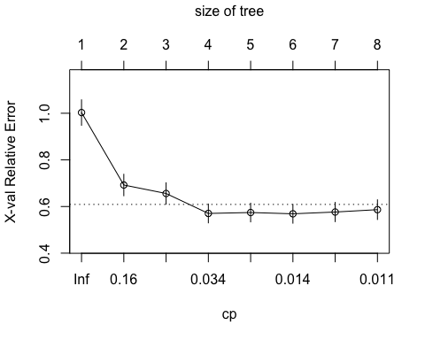

summary(fitall)

## Call:  
## rpart::rpart(formula = mcs ~ age + female + pss_fr + homeless +   
## pcs + cesd, data = h1a)  
## n= 453   
##   
## CP nsplit rel error xerror xstd  
## 1 0.32529813 0 1.0000000 1.0029873 0.05460305  
## 2 0.08134904 1 0.6747019 0.6922747 0.04606538  
## 3 0.06649553 2 0.5933528 0.6558948 0.04581715  
## 4 0.01771736 3 0.5268573 0.5703521 0.04038990  
## 5 0.01576737 4 0.5091399 0.5742899 0.04013284  
## 6 0.01249609 5 0.4933726 0.5687789 0.04022403  
## 7 0.01225792 6 0.4808765 0.5764321 0.04125389  
## 8 0.01000000 7 0.4686186 0.5865664 0.04211233  
##   
## Variable importance  
## cesd pcs age pss_fr   
## 83 14 1 1   
##   
## Node number 1: 453 observations, complexity param=0.3252981  
## mean=31.67668, MSE=164.4847   
## left son=2 (285 obs) right son=3 (168 obs)  
## Primary splits:  
## cesd < 29.5 to the right, improve=0.325298100, (0 missing)  
## pcs < 49.46132 to the left, improve=0.064711670, (0 missing)  
## pss_fr < 10.5 to the left, improve=0.039318510, (0 missing)  
## female < 0.5 to the right, improve=0.014091560, (0 missing)  
## age < 42.5 to the left, improve=0.005473724, (0 missing)  
## Surrogate splits:  
## pcs < 56.34591 to the left, agree=0.669, adj=0.107, (0 split)  
## age < 57.5 to the left, agree=0.631, adj=0.006, (0 split)  
##   
## Node number 2: 285 observations, complexity param=0.06649553  
## mean=26.06057, MSE=100.1894   
## left son=4 (100 obs) right son=5 (185 obs)  
## Primary splits:  
## cesd < 42.5 to the right, improve=0.173520000, (0 missing)  
## pcs < 24.47511 to the right, improve=0.057879990, (0 missing)  
## pss_fr < 10.5 to the left, improve=0.015219690, (0 missing)  
## age < 22.5 to the right, improve=0.005742931, (0 missing)  
## female < 0.5 to the right, improve=0.001903900, (0 missing)  
## Surrogate splits:  
## pss_fr < 0.5 to the left, agree=0.660, adj=0.03, (0 split)  
## pcs < 68.64778 to the right, agree=0.653, adj=0.01, (0 split)  
##   
## Node number 3: 168 observations, complexity param=0.08134904  
## mean=41.20401, MSE=129.2805   
## left son=6 (122 obs) right son=7 (46 obs)  
## Primary splits:  
## cesd < 15.5 to the right, improve=0.279083400, (0 missing)  
## pcs < 62.7532 to the right, improve=0.113215200, (0 missing)  
## pss_fr < 10.5 to the left, improve=0.053187210, (0 missing)  
## age < 48.5 to the left, improve=0.036737610, (0 missing)  
## female < 0.5 to the right, improve=0.007177787, (0 missing)  
## Surrogate splits:  
## age < 58.5 to the left, agree=0.738, adj=0.043, (0 split)  
##   
## Node number 4: 100 observations  
## mean=20.38941, MSE=43.95751   
##   
## Node number 5: 185 observations, complexity param=0.01576737  
## mean=29.12606, MSE=103.8029   
## left son=10 (7 obs) right son=11 (178 obs)  
## Primary splits:  
## pcs < 64.65134 to the right, improve=0.061178900, (0 missing)  
## age < 22.5 to the right, improve=0.031248410, (0 missing)  
## cesd < 37.5 to the right, improve=0.020833690, (0 missing)  
## pss_fr < 10.5 to the left, improve=0.015175680, (0 missing)  
## female < 0.5 to the left, improve=0.004355548, (0 missing)  
##   
## Node number 6: 122 observations, complexity param=0.01771736  
## mean=37.51566, MSE=103.6988   
## left son=12 (10 obs) right son=13 (112 obs)  
## Primary splits:  
## pcs < 63.69606 to the right, improve=0.10434930, (0 missing)  
## age < 47.5 to the left, improve=0.02626159, (0 missing)  
## cesd < 24.5 to the right, improve=0.02348926, (0 missing)  
## female < 0.5 to the right, improve=0.02256241, (0 missing)  
## pss_fr < 2.5 to the right, improve=0.01295167, (0 missing)  
##   
## Node number 7: 46 observations, complexity param=0.01249609  
## mean=50.98616, MSE=65.35702   
## left son=14 (26 obs) right son=15 (20 obs)  
## Primary splits:  
## cesd < 9.5 to the right, improve=0.30970460, (0 missing)  
## pcs < 59.57495 to the right, improve=0.16249370, (0 missing)  
## pss_fr < 11.5 to the left, improve=0.13099300, (0 missing)  
## age < 40 to the left, improve=0.06604375, (0 missing)  
## homeless < 0.5 to the left, improve=0.00873942, (0 missing)  
## Surrogate splits:  
## pss_fr < 11.5 to the left, agree=0.674, adj=0.25, (0 split)  
## pcs < 54.5861 to the left, agree=0.652, adj=0.20, (0 split)  
## age < 46 to the left, agree=0.609, adj=0.10, (0 split)  
## homeless < 0.5 to the left, agree=0.609, adj=0.10, (0 split)  
##   
## Node number 10: 7 observations  
## mean=16.41837, MSE=35.31025   
##   
## Node number 11: 178 observations, complexity param=0.01225792  
## mean=29.6258, MSE=99.89614   
## left son=22 (171 obs) right son=23 (7 obs)  
## Primary splits:  
## pcs < 25.77119 to the right, improve=0.051365510, (0 missing)  
## age < 22.5 to the right, improve=0.029936490, (0 missing)  
## pss_fr < 10.5 to the left, improve=0.022699840, (0 missing)  
## cesd < 37.5 to the right, improve=0.020642200, (0 missing)  
## homeless < 0.5 to the right, improve=0.002448012, (0 missing)  
##   
## Node number 12: 10 observations  
## mean=26.50685, MSE=30.97799   
##   
## Node number 13: 112 observations  
## mean=38.49859, MSE=98.40465   
##   
## Node number 14: 26 observations  
## mean=47.04024, MSE=67.29195   
##   
## Node number 15: 20 observations  
## mean=56.11586, MSE=16.28645   
##   
## Node number 22: 171 observations  
## mean=29.16748, MSE=95.51594   
##   
## Node number 23: 7 observations  
## mean=40.8217, MSE=76.41866

plot(fitall, uniform = TRUE, compress = FALSE, main = "Regression Tree for MCS Scores from Help Data")  
text(fitall, use.n = TRUE, all = TRUE, cex = 0.5)

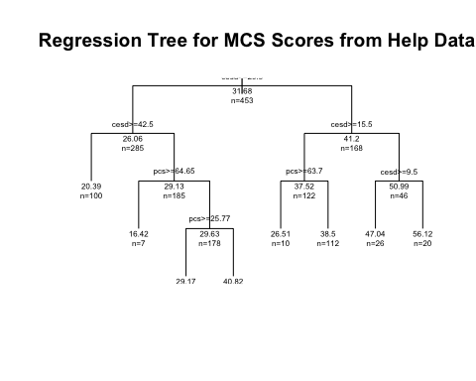

### Regression Tree for CESD Using the party package approach

The party package has better graphics and fits a “conditional” regression tree using the ctree() function. Here is the model approach for the cesd using the rest of the variables in the dataset h1a.

fitallp <- party::ctree(cesd ~ ., data = h1a)  
plot(fitallp, main = "Conditional Inference Tree for CESD")

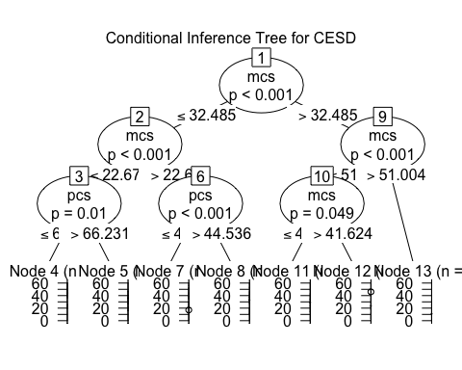

### **PROBLEM 4: Fit a Conditional Regression Tree for MCS**

Using the code above, swap out mcs for cesd to fit a confitional regression tree for mcs predicted by the other variables in the dataset h1a.

fitallp <- party::ctree(mcs ~ ., data = h1a)  
plot(fitallp, main = "Conditional Inference Tree for MCS")

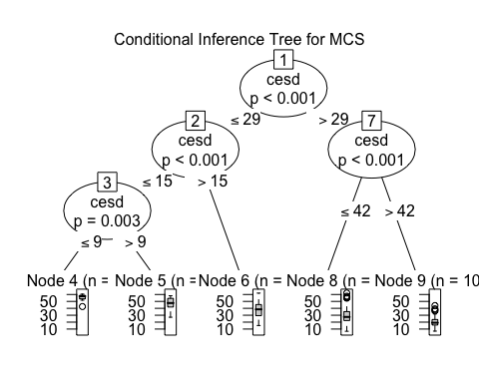

### Logistic Regression of CESD => 16

When the outcome is dichotomous or is a categorical outcome, you can fit a “decision tree” or “classification tree”. One way you’ve already learned last week is fitting a logistic regression model. In fact, logistic regression is a supervised classification modeling approach. Let’s .ee what this looks like for predicting depression (indicated by cesd_gte16 for people with CESD scores => 16). Pay attention to which variables are significant in the resulting logistic regression model.

# begin with a logistic regression - depressed or not  
glm1 <- glm(cesd_gte16 ~ age + female + pss_fr + homeless +   
 pcs + mcs, data = h1)  
summary(glm1)

##   
## Call:  
## glm(formula = cesd_gte16 ~ age + female + pss_fr + homeless +   
## pcs + mcs, data = h1)  
##   
## Deviance Residuals:   
## Min 1Q Median 3Q Max   
## -0.90801 -0.06647 0.02642 0.14484 0.51900   
##   
## Coefficients:  
## Estimate Std. Error t value Pr(>|t|)   
## (Intercept) 1.5529621 0.0948791 16.368 < 2e-16 ***  
## age -0.0018844 0.0016377 -1.151 0.250517   
## female -0.0309994 0.0294192 -1.054 0.292584   
## pss_fr -0.0034492 0.0031460 -1.096 0.273509   
## homeless -0.0045879 0.0250875 -0.183 0.854978   
## pcs -0.0039722 0.0011870 -3.346 0.000888 ***  
## mcs -0.0114878 0.0009709 -11.832 < 2e-16 ***  
## ---  
## Signif. codes: 0 '***' 0.001 '**' 0.01 '*' 0.05 '.' 0.1 ' ' 1  
##   
## (Dispersion parameter for gaussian family taken to be 0.0668409)  
##   
## Null deviance: 41.329 on 452 degrees of freedom  
## Residual deviance: 29.811 on 446 degrees of freedom  
## AIC: 68.939  
##   
## Number of Fisher Scoring iterations: 2

### **PROBLEM 5: Fit a Logistic Regression Model for MCS < 45**

The mental component (or composite) scale of the SF36 instrument is a measure of mental health. The scores are created relative to population norms. The population norm for the mcs of the SF36 is 50 with a standard deviation of 10. A difference of a “half” of a standard deviation - in other words a difference of 5 points - is considered to be clinically meaningful. So, people with MCS scores greater than 55 are considered to have better than average mental health and those with MCS scores less than 45 are considered to have worse than average mental health scores. So, in the dataset h1 above, we included an indicator variable called mcs_lt45 where a value of 1 indicates people with MCS < 45 (“poor mental health”) and a value of 0 (“normal or better than normal mental health”) is for people with MCS scores => 45.

Use the dataset h1 and the code above to fit a logistic regression model for mcs_lt45 based on the predictors of

* age
* female
* pss_fr
* homeless
* pcs
* cesd

Is this model similar to the model for cesd_gte16 or not - what is similar? what is different?

glm1 <- glm(mcs_lt45 ~ age + female + pss_fr + homeless +   
 pcs + cesd, data = h1)  
summary(glm1)

##   
## Call:  
## glm(formula = mcs_lt45 ~ age + female + pss_fr + homeless + pcs +   
## cesd, data = h1)  
##   
## Deviance Residuals:   
## Min 1Q Median 3Q Max   
## -0.96035 -0.10332 0.08078 0.21806 0.62498   
##   
## Coefficients:  
## Estimate Std. Error t value Pr(>|t|)   
## (Intercept) 0.3611168 0.1386939 2.604 0.00953 **   
## age -0.0023080 0.0021130 -1.092 0.27529   
## female 0.0202380 0.0382212 0.529 0.59672   
## pss_fr -0.0036606 0.0040882 -0.895 0.37104   
## homeless 0.0172706 0.0323939 0.533 0.59420   
## pcs 0.0005446 0.0015809 0.344 0.73064   
## cesd 0.0158725 0.0013519 11.741 < 2e-16 ***  
## ---  
## Signif. codes: 0 '***' 0.001 '**' 0.01 '*' 0.05 '.' 0.1 ' ' 1  
##   
## (Dispersion parameter for gaussian family taken to be 0.1114291)  
##   
## Null deviance: 68.424 on 452 degrees of freedom  
## Residual deviance: 49.697 on 446 degrees of freedom  
## AIC: 300.46  
##   
## Number of Fisher Scoring iterations: 2

### Fit a Classification Tree for CESD => 16

We can use the rpart package again to fit a classification tree to the depression indicator cesd_gte16.

fitk <- rpart::rpart(cesd_gte16 ~ age + female + pss_fr +   
 homeless + pcs + mcs,   
 method = "class", data = h1)  
class(fitk)

## [1] "rpart"

# Display the results  
rpart::printcp(fitk)

##   
## Classification tree:  
## rpart::rpart(formula = cesd_gte16 ~ age + female + pss_fr + homeless +   
## pcs + mcs, data = h1, method = "class")  
##   
## Variables actually used in tree construction:  
## [1] age mcs pcs  
##   
## Root node error: 46/453 = 0.10155  
##   
## n= 453   
##   
## CP nsplit rel error xerror xstd  
## 1 0.239130 0 1.00000 1.00000 0.13976  
## 2 0.054348 1 0.76087 0.78261 0.12514  
## 3 0.043478 3 0.65217 0.84783 0.12979  
## 4 0.010000 4 0.60870 0.82609 0.12827

#Visualize the cross-validation results   
rpart::plotcp(fitk)

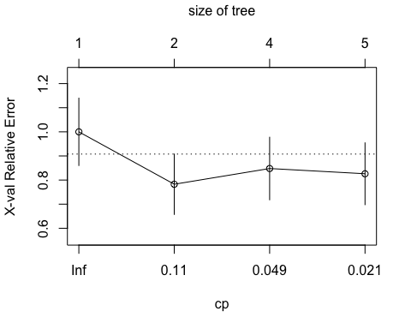

# Get a detailed summary of the splits  
summary(fitk)

## Call:  
## rpart::rpart(formula = cesd_gte16 ~ age + female + pss_fr + homeless +   
## pcs + mcs, data = h1, method = "class")  
## n= 453   
##   
## CP nsplit rel error xerror xstd  
## 1 0.23913043 0 1.0000000 1.0000000 0.1397556  
## 2 0.05434783 1 0.7608696 0.7826087 0.1251447  
## 3 0.04347826 3 0.6521739 0.8478261 0.1297853  
## 4 0.01000000 4 0.6086957 0.8260870 0.1282652  
##   
## Variable importance  
## mcs age pcs pss_fr homeless   
## 84 8 5 1 1   
##   
## Node number 1: 453 observations, complexity param=0.2391304  
## predicted class=1 expected loss=0.1015453 P(node) =1  
## class counts: 46 407  
## probabilities: 0.102 0.898   
## left son=2 (51 obs) right son=3 (402 obs)  
## Primary splits:  
## mcs < 50.02446 to the right, improve=29.4635100, (0 missing)  
## pcs < 49.19916 to the right, improve= 4.2774340, (0 missing)  
## pss_fr < 10.5 to the right, improve= 3.6879600, (0 missing)  
## age < 25.5 to the right, improve= 0.7580753, (0 missing)  
## homeless < 0.5 to the left, improve= 0.1845446, (0 missing)  
## Surrogate splits:  
## age < 58.5 to the right, agree=0.89, adj=0.02, (0 split)  
##   
## Node number 2: 51 observations, complexity param=0.05434783  
## predicted class=0 expected loss=0.3921569 P(node) =0.1125828  
## class counts: 31 20  
## probabilities: 0.608 0.392   
## left son=4 (24 obs) right son=5 (27 obs)  
## Primary splits:  
## pcs < 56.1216 to the right, improve=1.83224400, (0 missing)  
## age < 28.5 to the right, improve=1.68385500, (0 missing)  
## mcs < 52.79105 to the right, improve=0.65918000, (0 missing)  
## homeless < 0.5 to the right, improve=0.11695130, (0 missing)  
## pss_fr < 8.5 to the right, improve=0.09467787, (0 missing)  
## Surrogate splits:  
## mcs < 54.23909 to the left, agree=0.647, adj=0.250, (0 split)  
## homeless < 0.5 to the left, agree=0.588, adj=0.125, (0 split)  
## age < 37.5 to the left, agree=0.569, adj=0.083, (0 split)  
## female < 0.5 to the left, agree=0.569, adj=0.083, (0 split)  
## pss_fr < 12.5 to the right, agree=0.569, adj=0.083, (0 split)  
##   
## Node number 3: 402 observations  
## predicted class=1 expected loss=0.03731343 P(node) =0.8874172  
## class counts: 15 387  
## probabilities: 0.037 0.963   
##   
## Node number 4: 24 observations  
## predicted class=0 expected loss=0.25 P(node) =0.05298013  
## class counts: 18 6  
## probabilities: 0.750 0.250   
##   
## Node number 5: 27 observations, complexity param=0.05434783  
## predicted class=1 expected loss=0.4814815 P(node) =0.05960265  
## class counts: 13 14  
## probabilities: 0.481 0.519   
## left son=10 (20 obs) right son=11 (7 obs)  
## Primary splits:  
## age < 30.5 to the right, improve=2.16719600, (0 missing)  
## mcs < 54.81272 to the right, improve=1.81481500, (0 missing)  
## pcs < 53.12609 to the left, improve=1.21832400, (0 missing)  
## pss_fr < 4.5 to the right, improve=0.72433860, (0 missing)  
## female < 0.5 to the left, improve=0.05291005, (0 missing)  
##   
## Node number 10: 20 observations, complexity param=0.04347826  
## predicted class=0 expected loss=0.4 P(node) =0.04415011  
## class counts: 12 8  
## probabilities: 0.600 0.400   
## left son=20 (12 obs) right son=21 (8 obs)  
## Primary splits:  
## mcs < 55.49419 to the right, improve=1.35000000, (0 missing)  
## pcs < 50.26239 to the right, improve=0.40000000, (0 missing)  
## pss_fr < 6 to the right, improve=0.26666670, (0 missing)  
## homeless < 0.5 to the right, improve=0.14545450, (0 missing)  
## age < 34.5 to the right, improve=0.01758242, (0 missing)  
## Surrogate splits:  
## pss_fr < 4.5 to the right, agree=0.70, adj=0.250, (0 split)  
## age < 44 to the left, agree=0.65, adj=0.125, (0 split)  
## homeless < 0.5 to the left, agree=0.65, adj=0.125, (0 split)  
## pcs < 50.20288 to the left, agree=0.65, adj=0.125, (0 split)  
##   
## Node number 11: 7 observations  
## predicted class=1 expected loss=0.1428571 P(node) =0.01545254  
## class counts: 1 6  
## probabilities: 0.143 0.857   
##   
## Node number 20: 12 observations  
## predicted class=0 expected loss=0.25 P(node) =0.02649007  
## class counts: 9 3  
## probabilities: 0.750 0.250   
##   
## Node number 21: 8 observations  
## predicted class=1 expected loss=0.375 P(node) =0.01766004  
## class counts: 3 5  
## probabilities: 0.375 0.625

# Plot the tree  
plot(fitk, uniform = TRUE,   
 main = "Classification Tree for CESD => 16")  
text(fitk, use.n = TRUE, all = TRUE, cex = 0.8)

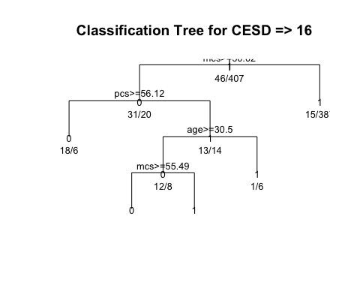

### **PROBLEM 6: Fit a Classification Tree for MCS < 45**

Use the rpart package to fit a classification tree to the poor mental health indicator mcs_lt45.

fitk <- rpart::rpart(mcs_lt45 ~ age + female + pss_fr +   
 homeless + pcs + mcs,   
 method = "class", data = h1)  
class(fitk)

## [1] "rpart"

rpart::printcp(fitk)

##   
## Classification tree:  
## rpart::rpart(formula = mcs_lt45 ~ age + female + pss_fr + homeless +   
## pcs + mcs, data = h1, method = "class")  
##   
## Variables actually used in tree construction:  
## [1] mcs  
##   
## Root node error: 84/453 = 0.18543  
##   
## n= 453   
##   
## CP nsplit rel error xerror xstd  
## 1 1.00 0 1 1.000000 0.098475  
## 2 0.01 1 0 0.011905 0.011892

rpart::plotcp(fitk)

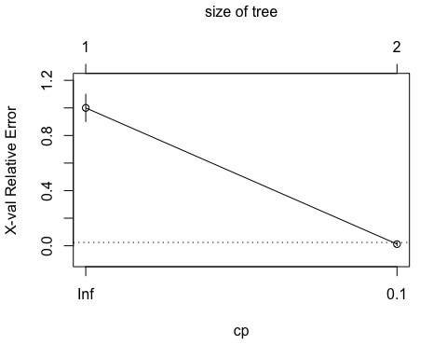

summary(fitk)

## Call:  
## rpart::rpart(formula = mcs_lt45 ~ age + female + pss_fr + homeless +   
## pcs + mcs, data = h1, method = "class")  
## n= 453   
##   
## CP nsplit rel error xerror xstd  
## 1 1.00 0 1 1.00000000 0.09847465  
## 2 0.01 1 0 0.01190476 0.01189161  
##   
## Variable importance  
## mcs age   
## 99 1   
##   
## Node number 1: 453 observations, complexity param=1  
## predicted class=1 expected loss=0.1854305 P(node) =1  
## class counts: 84 369  
## probabilities: 0.185 0.815   
## left son=2 (84 obs) right son=3 (369 obs)  
## Primary splits:  
## mcs < 44.88955 to the right, improve=136.847700, (0 missing)  
## pcs < 49.46132 to the right, improve= 7.907014, (0 missing)  
## pss_fr < 10.5 to the right, improve= 4.386206, (0 missing)  
## female < 0.5 to the left, improve= 1.504589, (0 missing)  
## age < 48.5 to the right, improve= 1.425056, (0 missing)  
## Surrogate splits:  
## age < 57.5 to the right, agree=0.817, adj=0.012, (0 split)  
##   
## Node number 2: 84 observations  
## predicted class=0 expected loss=0 P(node) =0.1854305  
## class counts: 84 0  
## probabilities: 1.000 0.000   
##   
## Node number 3: 369 observations  
## predicted class=1 expected loss=0 P(node) =0.8145695  
## class counts: 0 369  
## probabilities: 0.000 1.000

plot(fitk, uniform = TRUE,   
 main = "Classification Tree for MCS")  
text(fitk, use.n = TRUE, all = TRUE, cex = 0.8)

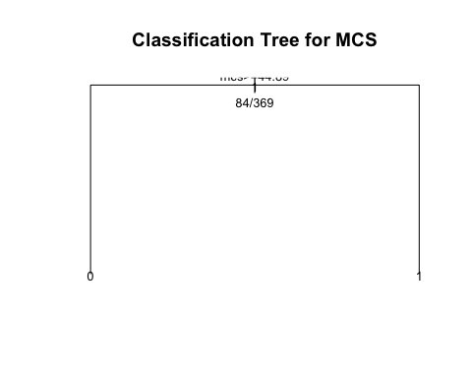

### Fit a Conditional Classification Tree for CESD => 16

Using the party package, we can fit a conditional classification tree using the ctree() function. Let’s do one for the indicator of depression cesd_gte16 given the other variables in the h1 dataset: age, female, pss_fr, homeless, pcs, mcs.

# look at cesd_gte16 with ctree from party  
fitallpk <- party::ctree(cesd_gte16 ~ age + female + pss_fr +   
 homeless + pcs + mcs, data = h1)  
class(fitallpk)

## [1] "BinaryTree"  
## attr(,"package")  
## [1] "party"

plot(fitallpk, main = "Conditional Inference Tree for CESD => 16")

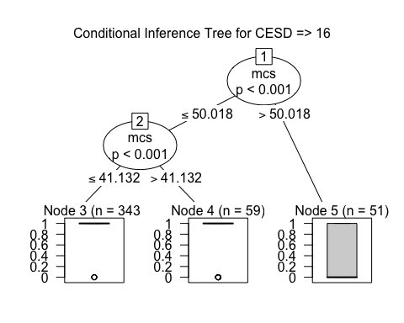

### **PROBLEM 7: Fit a Conditional Classification Tree for MCS < 45**

Using the party package, we can fit a conditional classification tree using the ctree() function. Let’s do one for the indicator of depression mcs_lt45 given the other variables in the h1 dataset: age, female, pss_fr, homeless, pcs, cesd.

fitallpk <- party::ctree(mcs_lt45 ~ age + female + pss_fr +   
 homeless + pcs + cesd, data = h1)  
class(fitallpk)

## [1] "BinaryTree"  
## attr(,"package")  
## [1] "party"

plot(fitallpk, main = "Conditional Inference Tree for MCS")

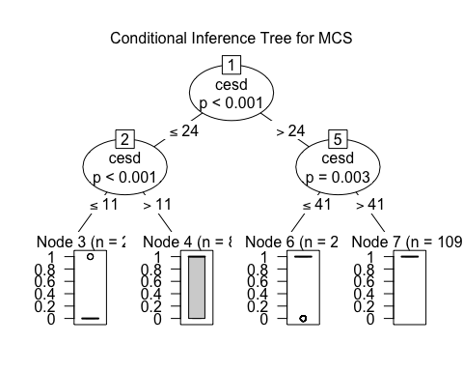

### Recursive Partitioning of Classification Tree for CESD => 16

Here is the code doing the recursive partitioning of CESD => 16 on age, female, pss_fr, homeless, pcs, mcs. We’re also using the partykit package to get prettier graphics for this classification tree.

# Recursive partitioning of CESD => 16 on age,   
# female, pss_fr, homeless, pcs, mcs  
library(rpart)  
whoIsDepressed <- rpart::rpart(cesd_gte16 ~ age + female +   
 pss_fr + homeless + pcs + mcs,  
 data = h1,   
 control = rpart.control(cp = 0.001,  
 minbucket = 20))  
  
whoIsDepressed

## n= 453   
##   
## node), split, n, deviance, yval  
## * denotes terminal node  
##   
## 1) root 453 41.328920 0.8984547   
## 2) mcs>=50.02446 51 12.156860 0.3921569 *  
## 3) mcs< 50.02446 402 14.440300 0.9626866   
## 6) mcs>=41.16363 59 8.949153 0.8135593 *  
## 7) mcs< 41.16363 343 3.953353 0.9883382   
## 14) mcs>=37.05422 38 1.894737 0.9473684 *  
## 15) mcs< 37.05422 305 1.986885 0.9934426   
## 30) pcs>=58.16405 51 1.921569 0.9607843 *  
## 31) pcs< 58.16405 254 0.000000 1.0000000 *

library(partykit)  
# Plot the tree  
plot(partykit::as.party(whoIsDepressed))

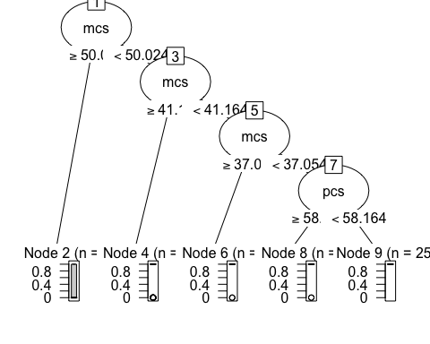

### **PROBLEM 8: Recursive Partitioning of Classification Tree for MCS < 45**

Using the code above to do recursive partitioning of MCS < 45 (mcs_lt45) on age, female, pss_fr, homeless, pcs, cesd. Also use the partykit package to get prettier graphics for this classification tree.

library(rpart)  
whoIsDepressed2 <- rpart::rpart(mcs_lt45 ~ age + female +   
 pss_fr + homeless + pcs + cesd,  
 data = h1,   
 control = rpart.control(cp = 0.001,  
 minbucket = 20))  
  
whoIsDepressed2

## n= 453   
##   
## node), split, n, deviance, yval  
## * denotes terminal node  
##   
## 1) root 453 68.423840 0.8145695   
## 2) cesd< 24.5 113 28.141590 0.4690265   
## 4) cesd< 11.5 29 2.689655 0.1034483 *  
## 5) cesd>=11.5 84 20.238100 0.5952381   
## 10) pcs< 59.00035 64 15.937500 0.5312500   
## 20) pcs>=49.7901 27 6.000000 0.3333333 *  
## 21) pcs< 49.7901 37 8.108108 0.6756757 *  
## 11) pcs>=59.00035 20 3.200000 0.8000000 *  
## 3) cesd>=24.5 340 22.305880 0.9294118   
## 6) cesd< 41.5 231 21.506490 0.8961039   
## 12) pss_fr>=10.5 52 8.076923 0.8076923 *  
## 13) pss_fr< 10.5 179 12.905030 0.9217877   
## 26) pcs>=50.23704 80 8.750000 0.8750000   
## 52) pcs< 54.12466 25 4.560000 0.7600000 *  
## 53) pcs>=54.12466 55 3.709091 0.9272727 *  
## 27) pcs< 50.23704 99 3.838384 0.9595960   
## 54) pss_fr>=4.5 55 3.709091 0.9272727 *  
## 55) pss_fr< 4.5 44 0.000000 1.0000000 *  
## 7) cesd>=41.5 109 0.000000 1.0000000 *

library(partykit)  
# Plot the tree  
plot(partykit::as.party(whoIsDepressed2))

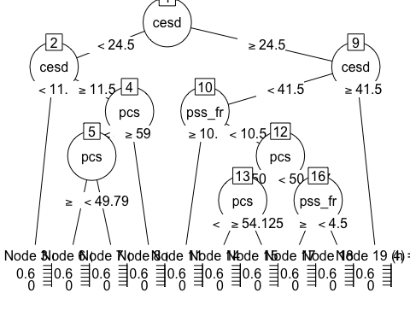

### Scatterplot of recursive partitions for CESD => 16 for MCS and PCS

The code below creates a scatterplot of pcs and mcs where the points are colored by the indication of depression cesd_gte16. The lines have been inserted showing the dividing lines that best separate subjects with depression (CESD => 16) from those without depression (CESD < 16).

# EXTRA CREDIT  
# Graph as partition  
# using the break points shown from the  
# conditional tree  
ggplot(data = h1, aes(x = mcs, y = pcs)) +  
 geom_count(aes(color = cesd_gte16), alpha = 0.5) +  
 geom_vline(xintercept = 50.024) +  
 geom_vline(xintercept = 41.164) +  
 geom_vline(xintercept = 37.054) +  
 geom_segment(x = 37.054, xend = 0, y = 58.164, yend = 58.164) +  
 annotate("rect", xmin = 0, xmax = 100, ymin = 0, ymax = 100, fill = "blue", alpha = 0.1) +  
 ggtitle("CESD => 16 Partitioned By MCS and PCS - Dark Circles Not Depressed")

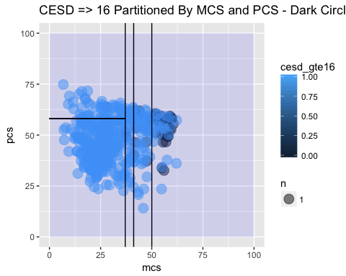

### **EXTRA CREDIT Scatterplot of recursive partitions for MCS < 45 for PCS and CESD**

Using the code above, create a scatterplot of pcs and cesd where the points are colored by the indication of poor mental health mcs_lt45. Play with the geom_vline() or geom_hline() or geom_segment() to insert lines that best separate subjects with poor mental health (MCS < 45) from those with normal to better than average mental health (MCS > 45).

# EXTRA CREDIT - insert code here

### Random Forest Model for CESD

Now let’s use a Random Forest approach for modeling the CESD by the other variables in the dataset:

* age
* female
* pss_fr
* homeless
* pcs
* mcs

And using the code below, we’ll explore how well the model converges and how well it does predicting CESD scores.

h1 <- as.data.frame(h1)  
set.seed(131)  
# Random Forest for the h1 dataset  
fitallrf <- randomForestSRC::rfsrc(cesd ~ age + female +   
 pss_fr + homeless + pcs + mcs,   
 data = h1, ntree = 100,   
 tree.err=TRUE)  
# view the results  
fitallrf

## Sample size: 453  
## Number of trees: 100  
## Forest terminal node size: 5  
## Average no. of terminal nodes: 91.16  
## No. of variables tried at each split: 2  
## Total no. of variables: 6  
## Analysis: RF-R  
## Family: regr  
## Splitting rule: mse  
## % variance explained: 45.53  
## Error rate: 85.3

gg_e <- ggRandomForests::gg_error(fitallrf)  
plot(gg_e)

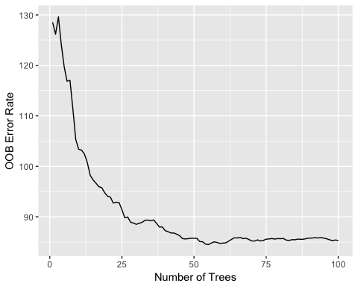

# Plot the predicted cesd values  
plot(ggRandomForests::gg_rfsrc(fitallrf), alpha = 0.5)

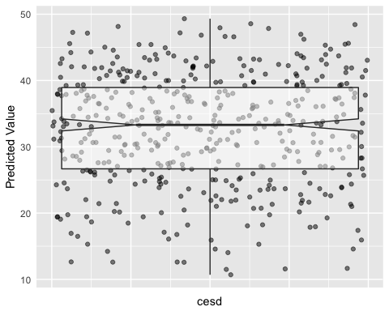

# Plot the VIMP rankins of independent variables  
plot(ggRandomForests::gg_vimp(fitallrf))

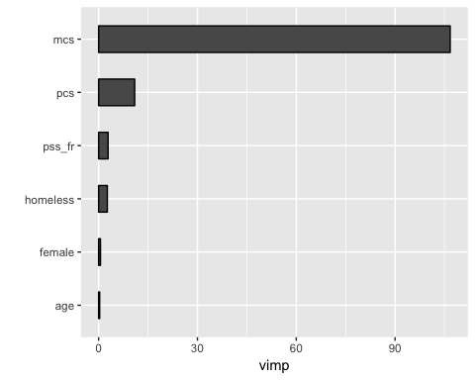

# Select the variables  
varsel_cesd <- randomForestSRC::var.select(fitallrf)

## minimal depth variable selection ...  
##   
##   
## -----------------------------------------------------------  
## family : regr   
## var. selection : Minimal Depth   
## conservativeness : medium   
## x-weighting used? : TRUE   
## dimension : 6   
## sample size : 453   
## ntree : 100   
## nsplit : 0   
## mtry : 2   
## nodesize : 5   
## refitted forest : FALSE   
## model size : 6   
## depth threshold : 5.6833   
## PE (true OOB) : 85.3018   
##   
##   
## Top variables:  
## depth vimp  
## mcs 1.15 NA  
## pcs 1.23 NA  
## pss_fr 1.51 NA  
## age 2.11 NA  
## female 2.64 NA  
## homeless 3.65 NA  
## -----------------------------------------------------------

glimpse(varsel_cesd)

## List of 6  
## $ err.rate : num 85.3  
## $ modelsize : int 6  
## $ topvars : chr [1:6] "mcs" "pcs" "pss_fr" "age" ...  
## $ varselect :'data.frame': 6 obs. of 2 variables:  
## ..$ depth: num [1:6] 1.15 1.23 1.51 2.11 2.64 3.65  
## ..$ vimp : num [1:6] NA NA NA NA NA NA  
## $ rfsrc.refit.obj: NULL  
## $ md.obj :List of 11  
## ..$ order : num [1:6, 1:2] 2.11 2.64 1.51 3.65 1.23 1.15 3.57 6.23 5.37 4.77 ...  
## .. ..- attr(*, "dimnames")=List of 2  
## ..$ count : Named num [1:6] 0.1539 0.0816 0.1107 0.1075 0.091 ...  
## .. ..- attr(*, "names")= chr [1:6] "age" "female" "pss_fr" "homeless" ...  
## ..$ nodes.at.depth : num [1:10000, 1:100] 2 4 7 7 10 14 12 11 9 7 ...  
## ..$ sub.order : NULL  
## ..$ threshold : num 5.68  
## ..$ threshold.1se : num 5.88  
## ..$ topvars : chr [1:6] "age" "female" "pss_fr" "homeless" ...  
## ..$ topvars.1se : chr [1:6] "age" "female" "pss_fr" "homeless" ...  
## ..$ percentile : Named num [1:6] 0.194 0.26 0.141 0.357 0.12 ...  
## .. ..- attr(*, "names")= chr [1:6] "age" "female" "pss_fr" "homeless" ...  
## ..$ density : Named num [1:21] 0.0641 0.0968 0.1314 0.1307 0.1008 ...  
## .. ..- attr(*, "names")= chr [1:21] "0" "1" "2" "3" ...  
## ..$ second.order.threshold: num 10.1

# Save the gg_minimal_depth object for later use  
gg_md <- ggRandomForests::gg_minimal_depth(varsel_cesd)  
# Plot the object  
plot(gg_md)

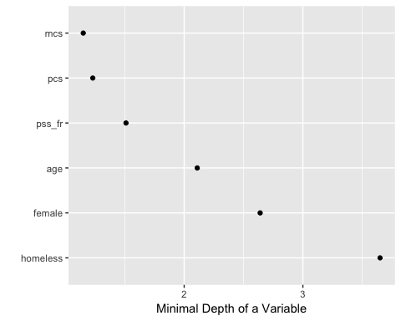

# Plot minimal depth v VIMP  
gg_mdVIMP <- ggRandomForests::gg_minimal_vimp(gg_md)  
plot(gg_mdVIMP)

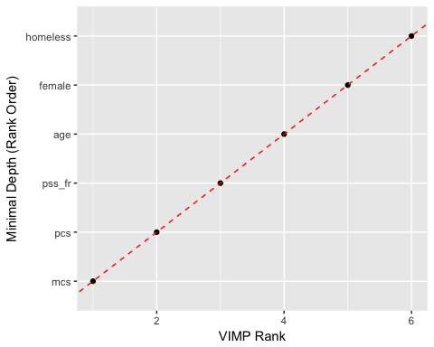

### **PROBLEM 9: Fit a Random Forest Model for MCS**

Now let’s use a Random Forest approach for modeling the MCS by the other variables in the dataset:

* age
* female
* pss_fr
* homeless
* pcs
* cesd

Use the code above to fit the model and explore how well the model converges and how well it does predicting MCS scores.

h1 <- as.data.frame(h1)  
set.seed(131)  
# Random Forest for the h1 dataset  
fitallrf2 <- randomForestSRC::rfsrc(mcs ~ age + female +   
 pss_fr + homeless + pcs + cesd,   
 data = h1, ntree = 100,   
 tree.err=TRUE)  
# view the results  
fitallrf2

## Sample size: 453  
## Number of trees: 100  
## Forest terminal node size: 5  
## Average no. of terminal nodes: 90.85  
## No. of variables tried at each split: 2  
## Total no. of variables: 6  
## Analysis: RF-R  
## Family: regr  
## Splitting rule: mse  
## % variance explained: 48.6  
## Error rate: 84.74

gg_e2 <- ggRandomForests::gg_error(fitallrf2)  
plot(gg_e2)

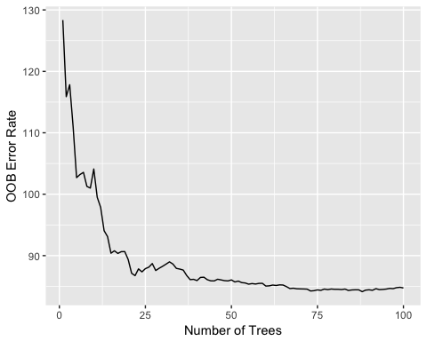

# Plot the predicted mcs values  
plot(ggRandomForests::gg_rfsrc(fitallrf2), alpha = 0.5)

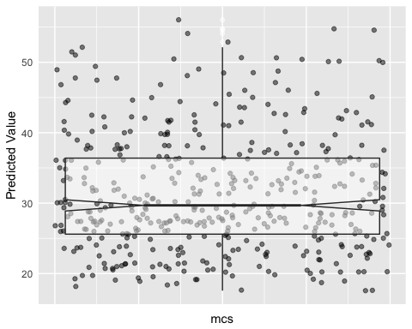

# Plot the VIMP rankins of independent variables  
plot(ggRandomForests::gg_vimp(fitallrf2))

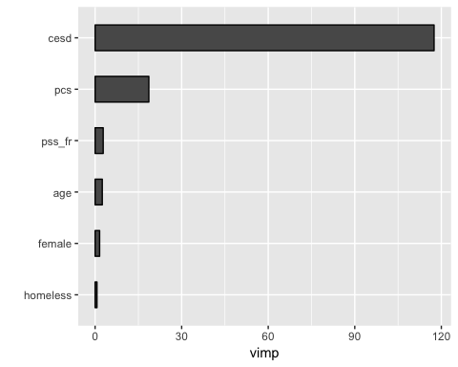

# Select the variables  
varsel_msc <- randomForestSRC::var.select(fitallrf2)

## minimal depth variable selection ...  
##   
##   
## -----------------------------------------------------------  
## family : regr   
## var. selection : Minimal Depth   
## conservativeness : medium   
## x-weighting used? : TRUE   
## dimension : 6   
## sample size : 453   
## ntree : 100   
## nsplit : 0   
## mtry : 2   
## nodesize : 5   
## refitted forest : FALSE   
## model size : 6   
## depth threshold : 5.9024   
## PE (true OOB) : 84.7368   
##   
##   
## Top variables:  
## depth vimp  
## pcs 1.14 NA  
## cesd 1.27 NA  
## pss_fr 1.74 NA  
## age 1.97 NA  
## female 3.18 NA  
## homeless 3.30 NA  
## -----------------------------------------------------------

glimpse(varsel_msc)

## List of 6  
## $ err.rate : num 84.7  
## $ modelsize : int 6  
## $ topvars : chr [1:6] "pcs" "cesd" "pss_fr" "age" ...  
## $ varselect :'data.frame': 6 obs. of 2 variables:  
## ..$ depth: num [1:6] 1.14 1.27 1.74 1.97 3.18 3.3  
## ..$ vimp : num [1:6] NA NA NA NA NA NA  
## $ rfsrc.refit.obj: NULL  
## $ md.obj :List of 11  
## ..$ order : num [1:6, 1:2] 1.97 3.18 1.74 3.3 1.14 1.27 4.04 5.38 5.76 4.64 ...  
## .. ..- attr(*, "dimnames")=List of 2  
## ..$ count : Named num [1:6] 0.1396 0.0918 0.1192 0.0993 0.092 ...  
## .. ..- attr(*, "names")= chr [1:6] "age" "female" "pss_fr" "homeless" ...  
## ..$ nodes.at.depth : num [1:10000, 1:100] 2 4 5 9 10 13 13 13 7 3 ...  
## ..$ sub.order : NULL  
## ..$ threshold : num 5.9  
## ..$ threshold.1se : num 6.1  
## ..$ topvars : chr [1:6] "age" "female" "pss_fr" "homeless" ...  
## ..$ topvars.1se : chr [1:6] "age" "female" "pss_fr" "homeless" ...  
## ..$ percentile : Named num [1:6] 0.172 0.299 0.161 0.303 0.104 ...  
## .. ..- attr(*, "names")= chr [1:6] "age" "female" "pss_fr" "homeless" ...  
## ..$ density : Named num [1:23] 0.0612 0.0906 0.1222 0.1232 0.0981 ...  
## .. ..- attr(*, "names")= chr [1:23] "0" "1" "2" "3" ...  
## ..$ second.order.threshold: num 10.4

# Save the gg_minimal_depth object for later use  
gg_md2 <- ggRandomForests::gg_minimal_depth(varsel_msc)  
# Plot the object  
plot(gg_md2)

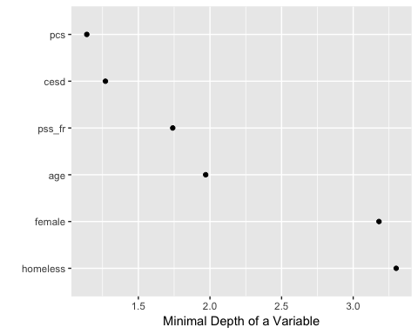

# Plot minimal depth v VIMP  
gg_mdVIMP2 <- ggRandomForests::gg_minimal_vimp(gg_md2)  
plot(gg_mdVIMP2)

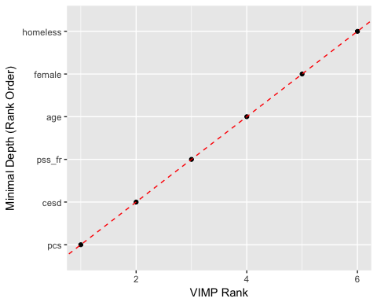

### Create Plots of How Well Each Variable Predicts CESD

Using the code below, we can see how well each variable predicts CESD scores.

#Create the variable dependence object from the random forest  
gg_v <- ggRandomForests::gg_variable(fitallrf)  
  
# Use the top ranked minimal depth variables only, plotted in minimal depth rank order  
xvar <- gg_md$topvars  
  
# Plot the variable list in a single panel plot  
plot(gg_v, xvar = xvar, panel = TRUE, alpha = 0.4) +  
 labs(y="Predicted CESD reading", x="")

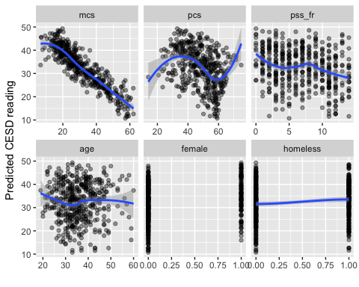

### **PROBLEM 10: Create Plots of How Well Each Variable Predicts CESD**\*

Using the code above, see how well each variable predicts MCS scores given the other variables in the dataset h1.

gg_v2 <- ggRandomForests::gg_variable(fitallrf2)  
  
# Use the top ranked minimal depth variables only, plotted in minimal depth rank order  
xvar2 <- gg_md$topvars  
  
# Plot the variable list in a single panel plot  
plot(gg_v2, xvar2 = xvar2, panel = TRUE, alpha = 0.4) +  
 labs(y="Predicted MSC reading", x="")

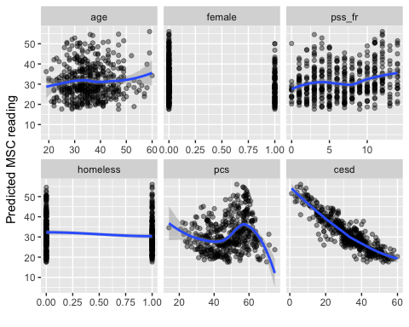 Link to HW: [my github link](https://github.com/epferranti/N741Spring2018_Homework7)

**Use R markdown to complete your homework and show all of your code and output in your final report - Turn in a PDF of your report to Canvas. Include a link to your Github repo for Homework 7**