**It’s a man’s canvas**

# Motivation:

Movies are present in our lives just about anywhere and everywhere these days. In the cinema after a nice dinner, on the go with our phones or as a procrastination tool for the next EPFL homework. There's nothing quite like escaping into a good movie, no matter where or when we choose to do it!

As something that reaches so many people in the world, it is bound to influence our society. With the subject of the gender gap being hotter than ever, the question of how female representation in the movie industry arises.

We want to analyse gender equality not because it is a buzzword or a trendy topic. We believe that on-screen representation has an impact on how we see ourselves and others. Underrepresentation and poor representation can contribute to negative stereotypes and biases. An authentic representation is therefore vital to avoid reinforcement of gender inequalities in society.

Not only on-screen but also off-screen representation is important. When men dominate the film industry, it could lead to some bias for the movie content. It also could perpetuate the idea that men are more suitable and valuable, which have serious consequences for women's careers and opportunities.

# Goal:

In this project we aim to analyse the on and off-screen gender in the movie industry to understand and address the gender gap. This is done by comparing data from different genres, geographical areas and searching for trends.

The results were found based on:

Movie metadata (2012, Freebase)

81’741 Movies

147 Countries

363 Genres.

Character metadata (2012, Freebase)

405’060 Movies

270’257 Male characters

134’803 Female characters

Plot summary (2012, English-language Wikipedia)

42’303 Plots

Character tropes (TV tropes)

72 Character types

501 Instances of those types

Director (2022, IMDb)

47’253 Movies

186’751 Male directors

34’153 Female directors

Writers (2022, IMDb)

49’730 Movies

279’186 Male writers

73’026 Female writers

With this we are ready to analyse the data!

# Which gender dominates the movie canvas?

The simple and short answer is: Men!

But let’s first talk about why this question is important. The ratio of male to female characters can be used as a metric to reflect gender equality in the world of fiction. It goes beyond just counting bodies on a screen. We believe that it speaks to the values and beliefs of the current society. So, let’s dig deeper into that question.

## Time series

In the time series below, we can see that men have always dominated on-screen. We broke down the time series into four periods that show interesting behaviour. In the beginning of the dataset the number of movies is rather low, which causes the variance to be high. Therefore, the dataset should spawn over a longer time, namely from 1908 to 1935 (mean: 0.35, variance: 0.01).

Right around the second world war we saw a decrease in female cast members, from 1935 to 1945. The variance as well as the mean is lower (mean: 0.29, variance: 0.003).

The third period was chosen over a long period between 1945 to 1990 because the variance is rather low (mean: 0.31 variance: 0.0001).

The last period chosen should be representable for the current situation between 1990 to 2013 (mean: 0.34, variance: 0.0002). During this period the number of movies sky rocks, which might be due to the introduction of streaming services. In 2013 the value of female cast member percentage and number of movies within the dataset is unexpected small. Therefore, this value was taken out from the dataset.

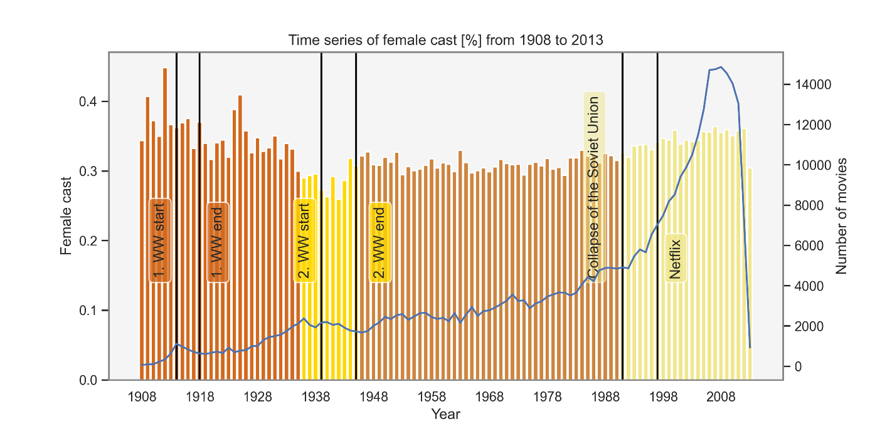

We believe that the dataset of the last period is most suitable to predict how the world of movies will evolve since it is most similar politically and technology wise. By fitting a least squares model with polynomial degree of 2 we found out that in year 2050 the female cast ratio is equivalent to the male cast ratio. So, if the growth rate is equal to 1900 to 2013, we will reach gender equality on screen in almost 15 years!

In the study “It's a Man's (Celluloid) World” (https://womenintvfilm.sdsu.edu/wp-content/uploads/2022/03/2021-Its-a-Mans-Celluloid-World-Report.pdf).

it was shown that 85% of films featured more male than female characters. What about our result?

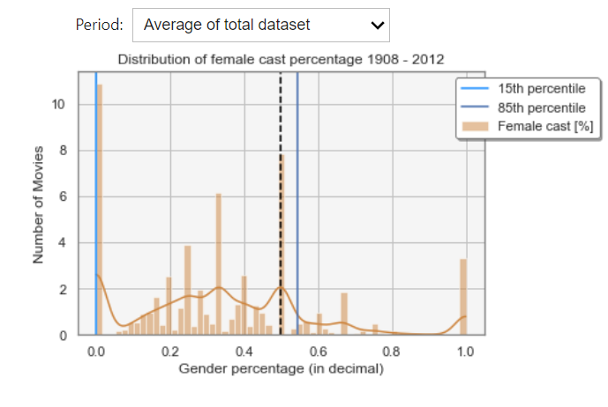

In our dataset this is true for 1935-1945 and 1945-1990.

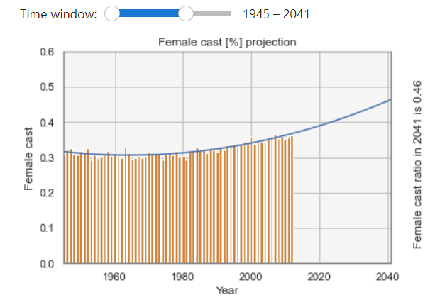 or

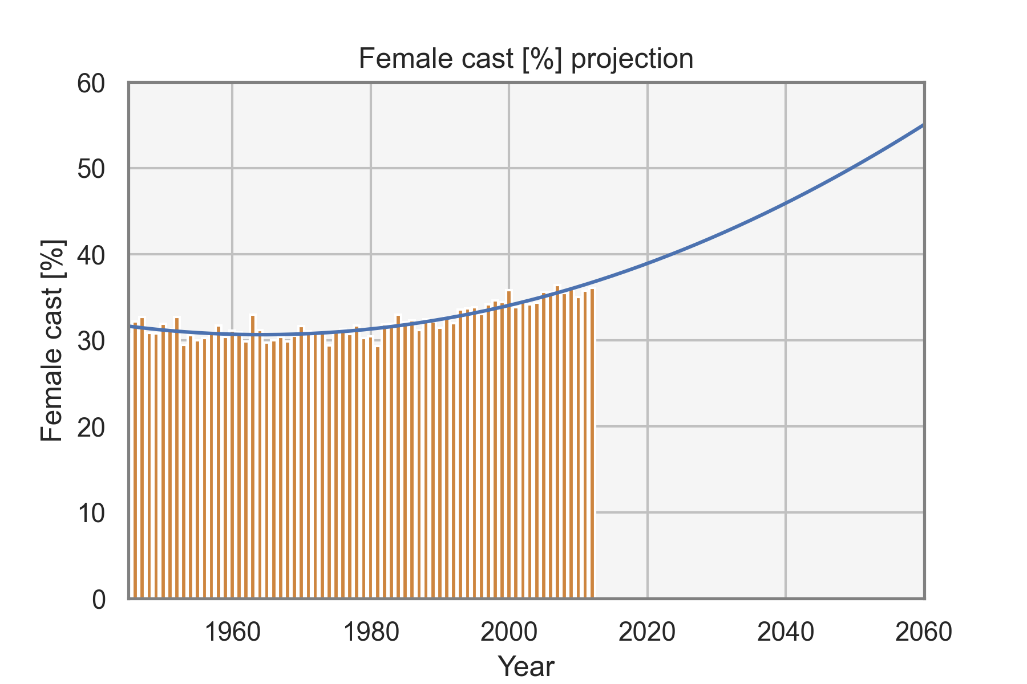

To see how the model prediction is performing we will compare it to the study ‘It’s a Man’s (Celluloid) World' (https://womenintvfilm.sdsu.edu/wp-content/uploads/2022/03/2021-Its-a-Mans-Celluloid-World-Report.pdf).

Feel free to try it for yourself, on the left side of the figure you see the predicted value of the last year.

We chose to compare the year 2020 instead of 2021 since 2021 data is impacted by the Covid pandemic. In the study female characters accounted for 38 % of major characters compared to our 39 % projection. Since our data less than 85% movies featured more male than female characters it is expected that our projection is a bit higher.

We have now seen how the cast gender distribution looks like over time. In the plot below you can explore the respective female cast percentage for the recent 20 most popular genres, the genres that have the highest female respective male percentage at some point in the time and the countries that produce most movies currently.

Try to see if you notice anything interesting. We will talk take a deeper dive in the next few chapters.

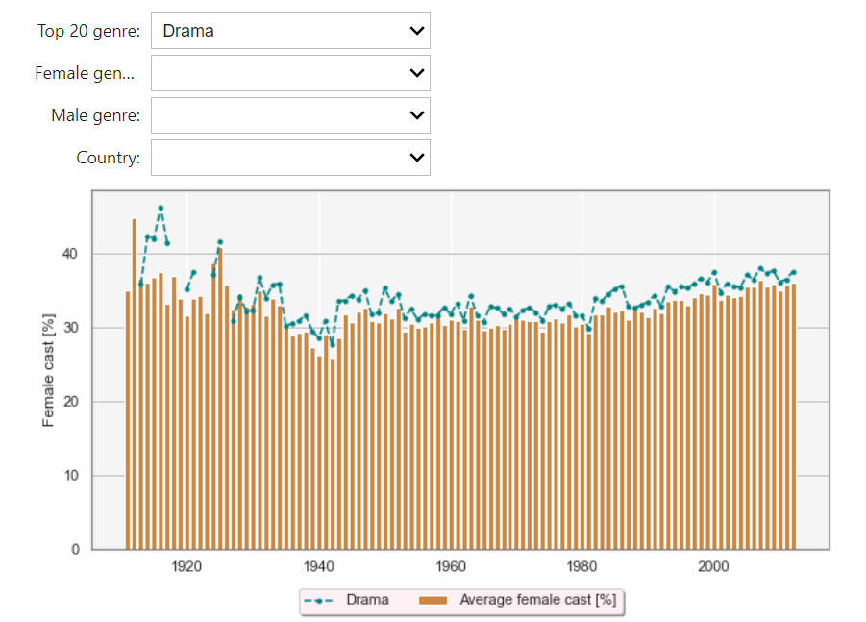

## Gender gap regarding movie genre

We all have encountered a similar situation: Boys get superheroes comics and girls get princess books.

This made us think if there is a similar separation between gender in the movie domain. Do the topics vary between movies with higher female lead? By examining the gender distribution in different genres, we can gain a better understanding of the challenges and obstacles that women in these fields may face.

While analysing gender regarding the gender gap there is the trade-off between searching for the most extreme gender distribution while still choosing representable genres not analysing niche genres. We chose to set a threshold 100 movies. Any genre that has less movies is discarded in this analysis.

Not sure if we should include the most popular genres or if this is already covered with he plot above.

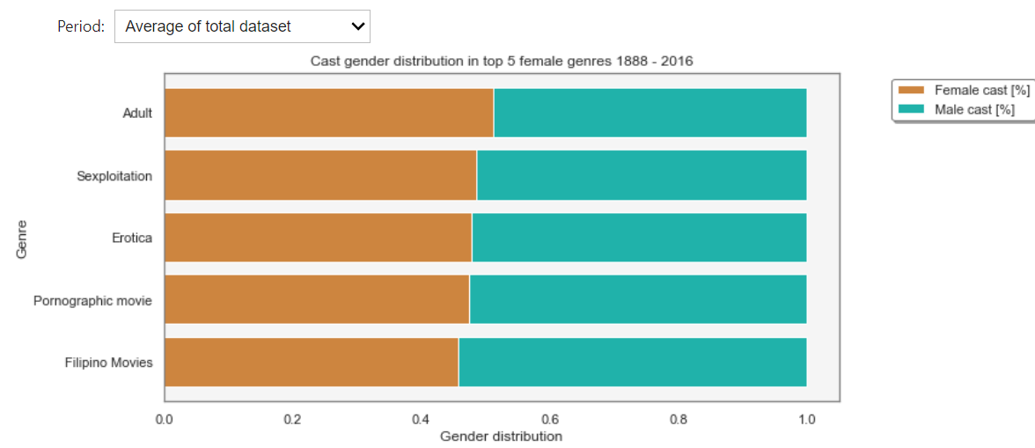

Let’s begin to look at the genre with the highest female cast percentage.

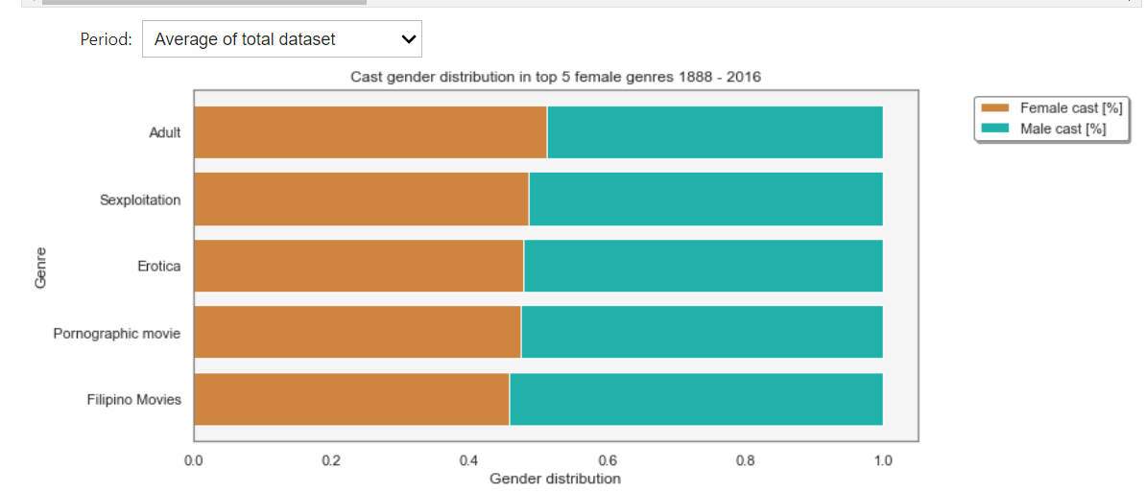

We can see that the genre with the highest female cast ratio changes in each period. Until 1945 women appear most often in comedy, romance and musical. Those genres often cover topics such as relationships, slice of life and family. At first glance it appears that women are more likely to play in light-hearted, feel good movies. Upon reflection they often are emotionally powerful, make us shed some tears while also being uplifting and hopeful. Based on these findings we can say that the top 5 female genres up to 1945 are often tied with emotions.

Some examples are: (We can provide a link or insert video playing the trailer”)

“The Wizard of Oz" A musical about a young girl's journey through a magical land to find her way home

“Gone with the Wind” About a strong-willed woman's tumultuous relationships and survival during the Civil War.

Between 1945-1990, sexual genres began to dominate the actress’s world. During this time the public attitude towards sexuality began to change. The new liberality towards sexuality grew with the counterculture movement of 1960s that caught momentum with the civil right movement. You might recognize this time with “Make love not war”. In addition, technology become more accessible, allowing easier access of explicit content at home.

Movies such as "Deep Throat" pave the way for the mainstream acceptance of erotic movie content.

In the latest period the two genres comedy and melodrama appear again with addition to Filipino movies. The genre ‘Filipino movies’ signifies movies that were produced in the Philippines. Therefore, it is difficult to check what topic this genre covers. We checked with which other genres it appears often. Three from the 5 most co-occurring genres were previously classified with high female percentage such as: Comedy, Romance Film, Romantic drama.

According to the Global Gender Gap Report 2021 is ranked 17th regarding the ‘Global Gender Gap Index’ which is the highest-ranking Asian country. (<https://www3.weforum.org/docs/WEF_GGGR_2021.pdf>)

Does that mean that this country produces movies with higher female cast percentage?

We checked if the other top performing countries according to the study also have their specific genre such as Norwegian movie. Since this is not the case, it is difficult to confirm is Filipino’s movies are in fact better than other countries.

Even for the genres with highest female cast ratio, they do not outnumber men.

Now let’s take a look at the male dominant genres.

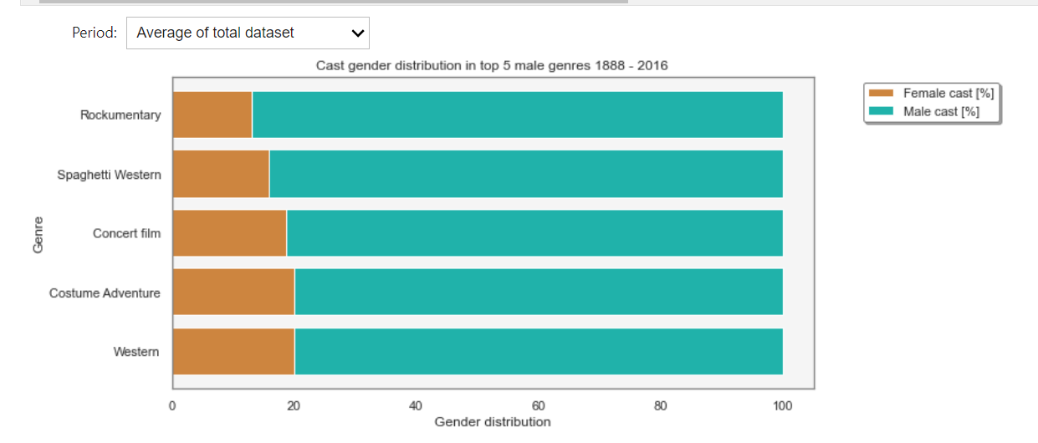

We can quickly see that a lot of genres are related to violence, adrenaline, which fits into the stereotypical interest of men. It might appear apparent that war and western film mostly cover men. But if we take a step back, we need to ask ourselves why we feel this way. While frontline and cowboys are dominated by the male gender the women also lived through this time. They served as nurses and administrators during the first world war, cared for the animals and were involved with ranch sales. For action and adventure movies there is even less a reason why women do not have an equal appearance on screen. This finding might reflect how the society sees the role of a woman.

Both the first and last period war is listed as a genre with the dominant male cast percentage. Even though woman have taken many more active roles on the frontline such as ‘Women Airforce Service Pilots’ the female cast percentage sank.

The fact that documentary, culture & society have such a significant higher male cast percentage might indicate that society evaluate them as more trustworthy and serious.

Chinese movies are listed as a male dominant genre. Upon further research we found out that under the 5 most co-occurring genres are two male dominant genres such as ‘Action’ and ‘Martial Arts Film’

After looking at the data we can conclude that this sentence reflects the findings: “Men have to be strong, and women have to be nurturing.”

We have now encountered country specific genres twice but have not had a clear answer whether the gender gap differs regarding countries. Does that not satisfy you? Us neither, so let’s look at the next chapter.

## Gender gap regarding countries

Not sure if we should keep this graph or if it is redundant with last figure in chapter 1

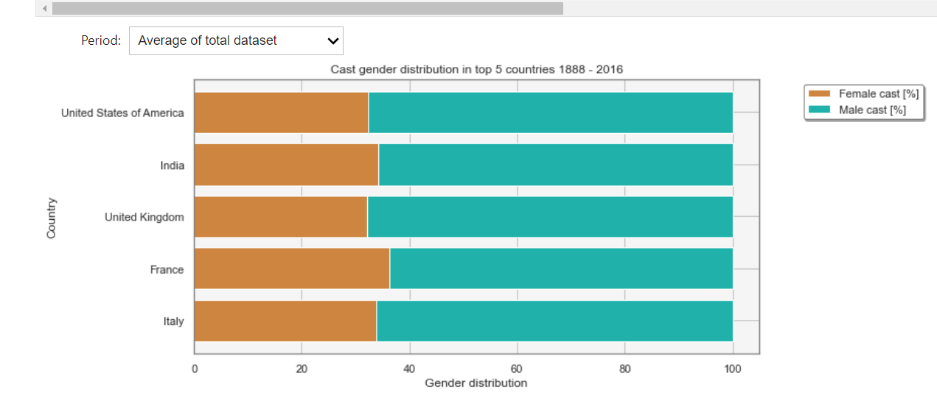

We also set a threshold of 100 movies.

Female

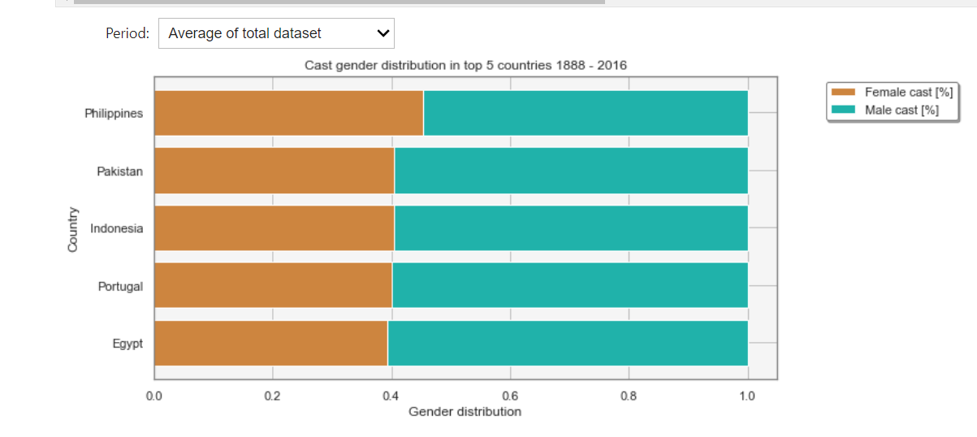

We can see that it does not reflect the finding of the Global Gender Gap Report 2021.

Male: Slavic country tend to have more men

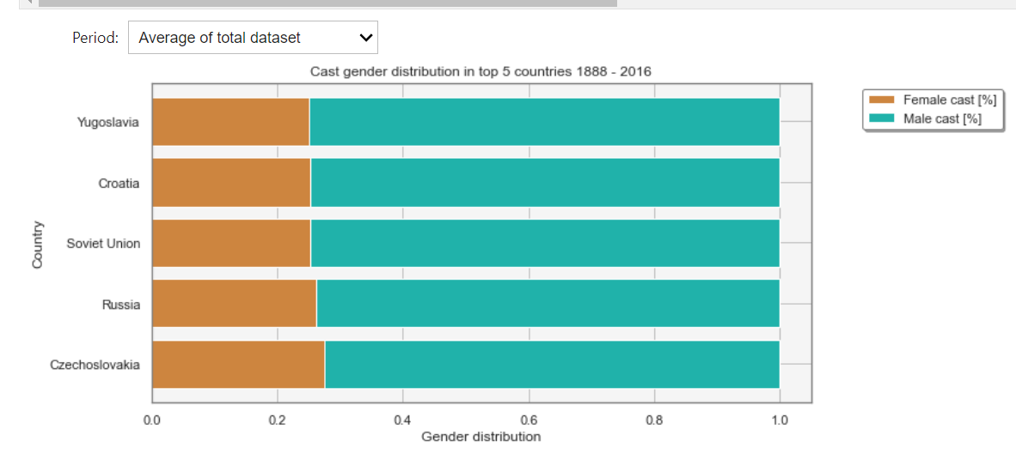

Ein Bild, das Karte enthält.

Overall green -> male dominant

## Off screen gender gap

### Writer

### Director

### Age of actor

# On screen stereotypes

# Notes

Studies:

"Gender Bias Without Borders: An Investigation of Female Characters in Popular Films Across 11 Countries" by the Geena Davis Institute on Gender in Media: This report analyzed the representation of female characters in popular films across 11 countries and found that female characters were less likely to be depicted in leading roles and were more likely to be sexualized or depicted in stereotypical roles.

"The Celluloid Ceiling: Behind-the-Scenes Employment of Women on the Top 100, 250, and 500 Films of 2019" by the Center for the Study of Women in Television and Film: This report analyzed the employment of women in behind-the-scenes roles on the top 100, 250, and 500 films of 2019 and found that women were underrepresented in many key roles, including directing, writing, and producing.

"It's a Man's (Celluloid) World: Portrayals of Male and Female Characters in Top Grossing G-Rated Films" by the Geena Davis Institute on Gender in Media: This study analyzed the representation of male and female characters in top grossing G-rated films and found that male characters were more likely to have leading roles and to be depicted in more active and assertive ways, while female characters were more likely to be depicted in supportive or passive roles.

**Inequalities in the film industry**: With the recent Zurich film festival the subject of gender gap in the film industry was brought up more. Not only are men heavily dominant in the behind-the-scenes roles as directors, writers, and critics but the on-screen roles are also given to men more often. In the study “It's a Man's (Celluloid) World” it was shown that 85% of films featured more male than female characters.

To tackle the problem of inequality it first needs to be understood properly. Therefore, a deeper analysis about diversity and inclusion will be done especially with respect to traditional gender roles, racial or sexual stereotypes and to which kind of people roles are given most to. Different genres will be compared to each other and the change of inequality over time will be studied. To find out if a certain part of the world is more advanced regarding equality movies with different languages will be evaluated. During this step a representative pick of movie samples is important to avoid any artificial skews.

gender equality is not just a buzzword or a trendy topic