Gender disparities have long existed in film industry since its naissance. As something that reaches so many people in the world, movie is bound to influence our society. With the subject being hotter than ever, the question of female representation in the movie industry arises. We want to analyse gender equality not because it is a buzzword or a trendy topic. We believe that on and off-screen representation has an impact on how we see ourselves and others. Underrepresentation can contribute to negative stereotypes and biases. It could also mislead the public that men are more valuable and superior, which has serious consequences for women's careers and opportunities.

In this project, we aim to analyse the on and off-screen gender representation in movie industry to address the gender disparities problem. This is done by comparing data among different genres, geographical areas and time series, plus making prediction and analysing possible stereotypes.

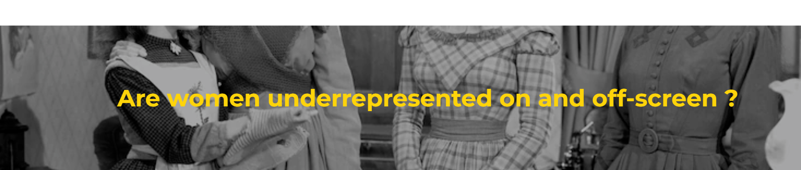

Who dominates the screen?

Men have ALWAYS dominated the screen. The time series were broken down into four periods that show something interesting. At the beginning of movie industry's birth, there were only a few movies.

Right around the second world war, there is a noticeable decrease in female cast ratio from 1935 to 1945. Wars make female situation even worse.

The last period between 1990 to 2013 is representative for the current situation. However, with movie number dramatically booming, female cast ratio is somehow still unexpectedly LOW and NEVER reaches 50%.

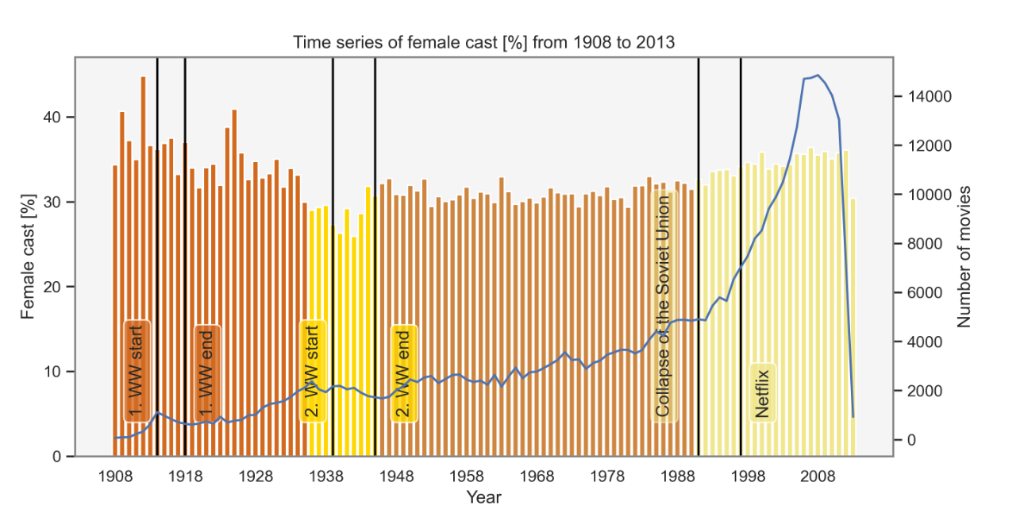

Will tomorrow be better?

Let's look a bit further into future. A prediction was made based on Period 4 above. In year 2050, the female cast ratio will be equivalent to male. To reach gender equality on screen, we need at least 15 years! Unsurprisingly, there is still a LONG way to go for ultimate success.

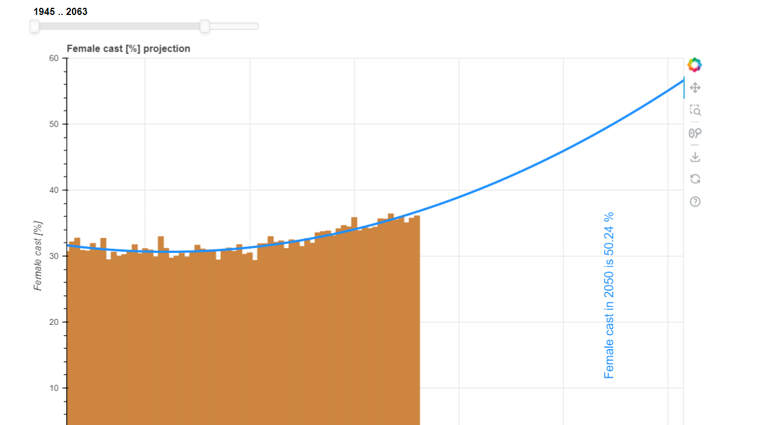

To see how the model prediction is performing we will compare it to the study ‘It’s a Man’s (Celluloid) World' (https://womenintvfilm.sdsu.edu/wp-content/uploads/2022/03/2021-Its-a-Mans-Celluloid-World-Report.pdf).

We chose to compare the year 2020 instead of 2021 since 2021 data is impacted by the Covid pandemic. In the study female characters accounted for 38 % of major characters compared to our 39 % projection.

In order to see why our prediction is higher than what reality show we take a closer look of the dataset. The study has monitored portrayals of girls and women in the top 100 domestic grossing films since 2002 and found that 85% of films featured more male than female characters.

What about our dataset?

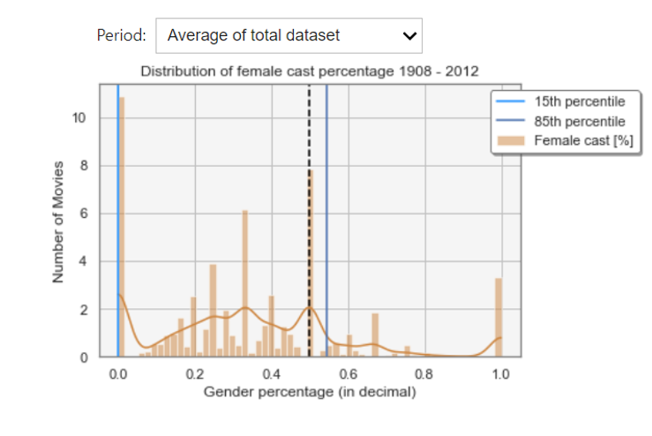

In our dataset this is only true for the two periods 1935-1945 and 1945-1990. For the other two datasets the percentage of films featuring more male than female is lower. We could therefore hypnotise that because the dataset used for training the model had a lower percentage of male dominant movies the prediction is lower than the papers result.

We have now seen how the cast gender distribution looks like over time. In the plot below you can explore the respective female cast percentage for: the recent 20 most popular genres, the genres that have the highest female respective male percentage at some point in the time and the countries that produce most movies currently.

Try to see if you notice anything interesting. We will talk take a deeper dive in the next few chapters.

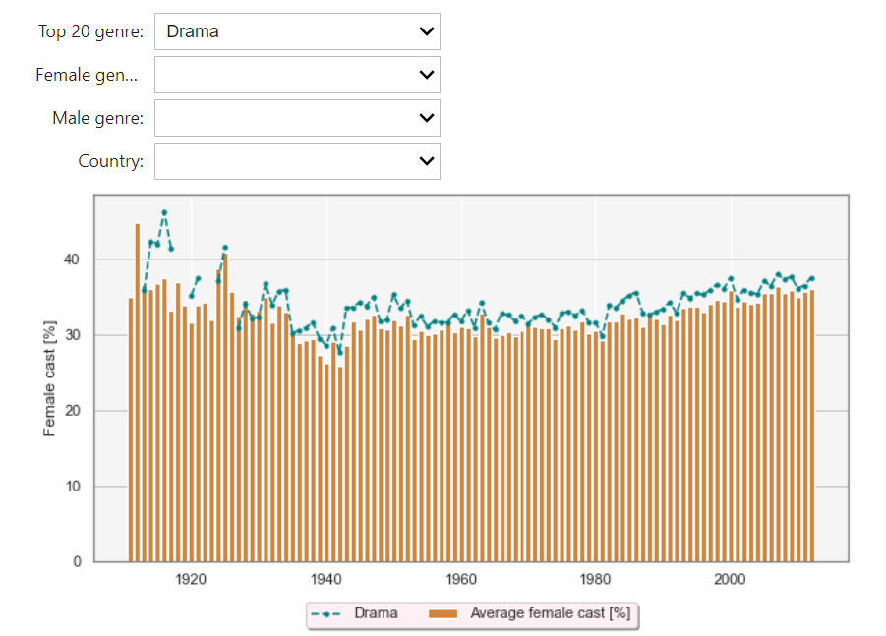

"Stay Young, Ladies!"

It's a tale as old as time: "Men age like fine wine, while women are left to wilt on the vine." There is a stigma that older women are no longer needed.

Actresses are in average 8 years younger than their counterpart. There is a dramatic decline once the "best age of 20" is reached. This could imply that looking young and fitting into today's beauty standard is more important for actresses than actors in movie industry.

Where is the gender-equality paradise?

We are wondering, is there a true gender-equality paradise? Explore the plot below a bit.

Ein Bild, das Karte enthält.

All countries analysed are male-dominant. Comparing the result with the Global Gender Gap Report 2021 from the world economic forum shows that the gender distribution in movies does not represent the gender equality of the corresponding country.

Besides quantitative features, it would be beneficial to check qualitative features that show how the characters are portrayed. This is what we are going to do in later chapters. Nevertheless, representation on screen matters. This is supported by David Gauntlett's Gender and Identity Theory where he states that media can influence our establishment of our own identity – there is always some representations of gender that will appeal to our own sensibilities

Behind-Scene Power

Feminist film critic Laura Mulvey believes that, movie production is in control of men who make decisions that appeal to their own values and interests. She describes a term called 'the male gaze' where female characters are often depicted as attractive rather than having complex characteristics and directs the root of the problem to men being dominant in behind-scene roles. To see if this is true, we also look at female situations in writers and directors.

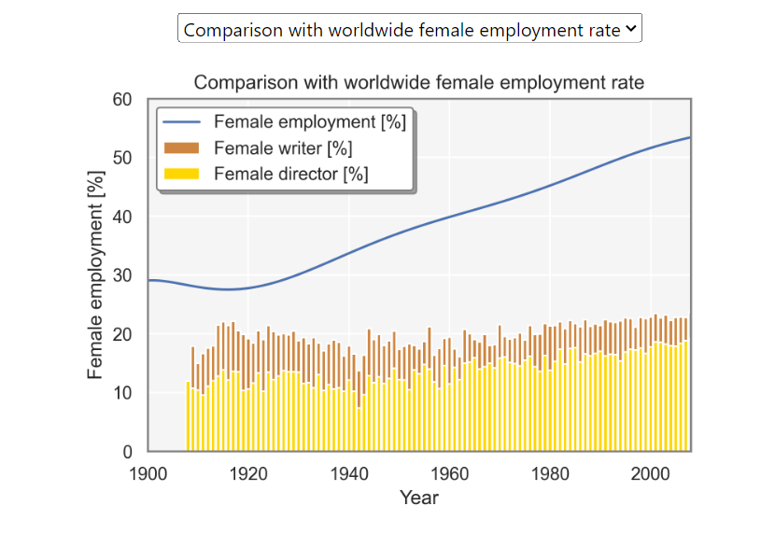

Compared to the growth rate of female employment rate, the female writer and director growth rate is much lower. Fitting a 2-degree least squares model shows that in 2127 the female writer percentage will be equivalent to the male percentage and for the female director equal employment rate will be reached in 2133. Having fewer female voices and perspectives might lead to a more inaccurate portrayal of women and their experiences which can lead to one dimensional portrayal of female characters.

Women's pain is built-in"

The genres dominant by male directors covers a wide range of topics. There are many comedic genres such as “Bloopers & Candid Camera” and “Courtroom Comedy”. Others are action related such as “Prison escape” and “Sci-Fi Thriller”. Male dominant genres such as action have been criticized wildly for sexualizing women. An example are the various studies about male gaze in superhero films.

For the genres dominated by female directors’ societal issues are often in the centre such as queerness, children’s or gender issues. There are also political topics such patriotic films, avant-garde.

Based on these findings there seems to be a trend where women are more likely to be in charge of emotionally charged content compared to men with wilder topics such as action and comedy. The genres for female directors seem to be unavoidably limited to painful and emotional female roles, as a mother, a lover, or a sentimental woman. Those finding are not only a reflection of female behind-scene situation, but also a mirror showing what women have experienced in real world. Women's pain is built in. Before pursuit of self-fulfilment, women must deal with what society has imposed on them - a curse of inborn duty. And their real needs as independent human beings are somehow always neglected.

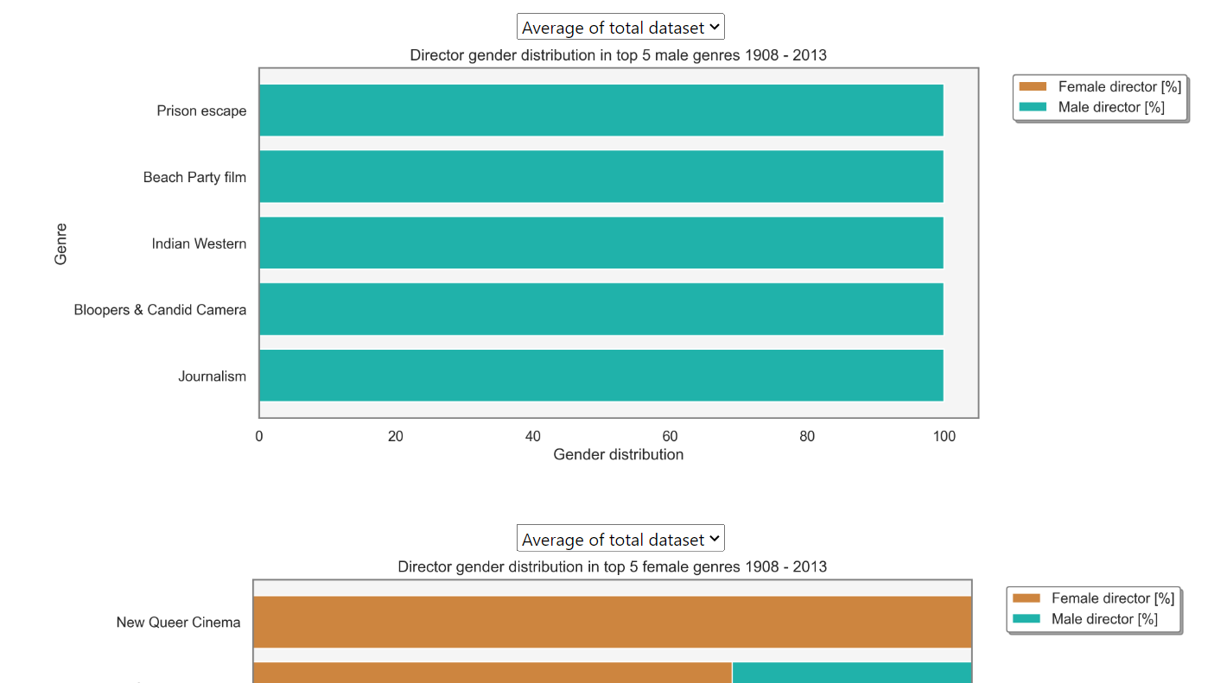

A total of 16 from 358 genres solely have male writers. The topics are very widespread and there is no clear pattern that can be seen. In contrast to the position of director, no clear gender pattern can be seen.

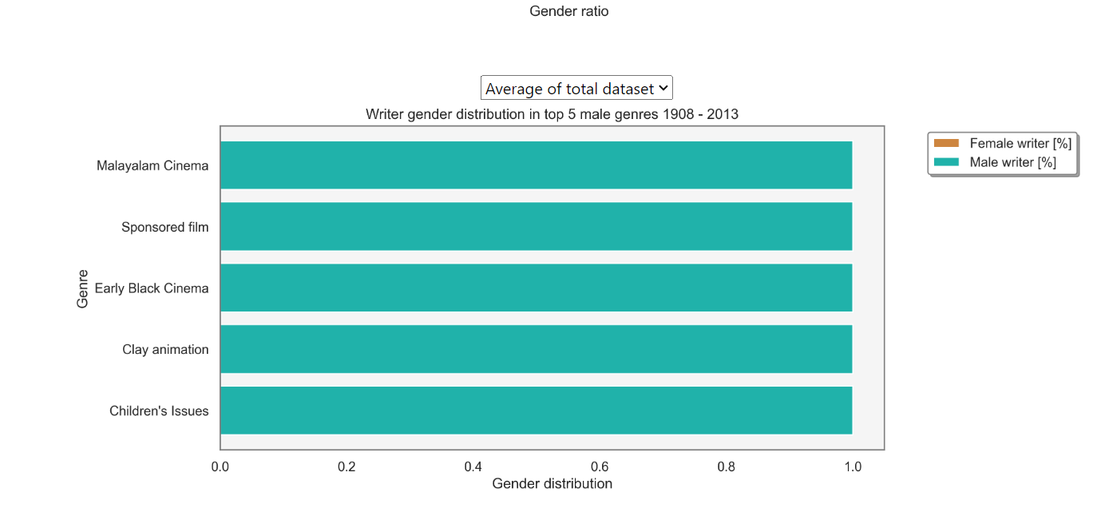

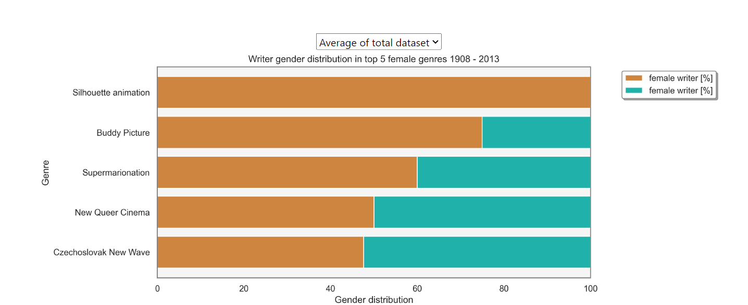

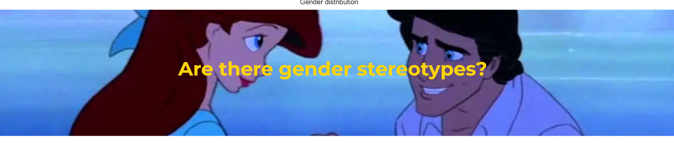

It is important to recognize and challenge stereotypes to promote equality, respect, and mutual understanding. Is there any difference between the portrayal of men and women？ Do topics vary between movies with higher female lead? By examining the gender distribution in different genres, we can gain a better understanding of the challenges and obstacles that women in these fields may face.

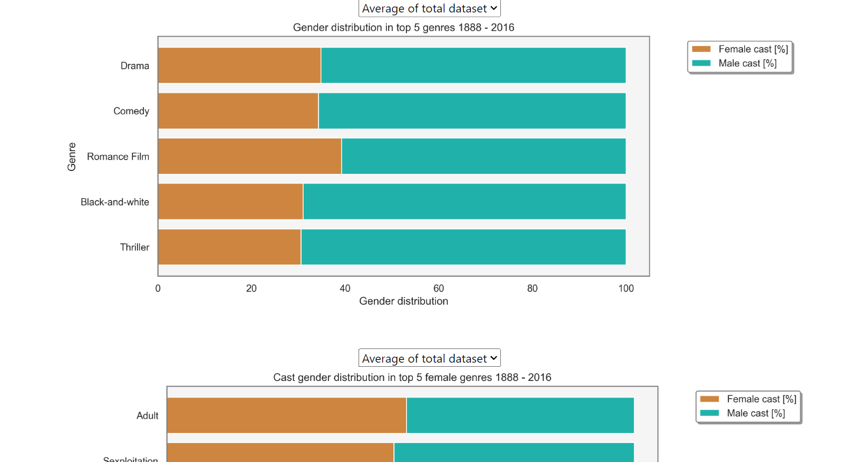

We can see that the genre with the highest female cast ratio changes in each period. Until 1945 women appear most often in comedy, romance and musical. Those genres often cover topics such as relationships, slice of life and family. At first glance it appears that women are more likely to play in light-hearted, feel good movies. Upon reflection they often are emotionally powerful, make us shed some tears while also being uplifting and hopeful. Based on these findings we can say that the top 5 female genres up to 1945 are often tied with emotions.

Some examples are: (We can provide a link or insert video playing the trailer”)

“The Wizard of Oz" A musical about a young girl's journey through a magical land to find her way home

“Gone with the Wind” About a strong-willed woman's tumultuous relationships and survival during the Civil War.

Between 1945-1990, sexual genres began to dominate the actress’s world. During this time the public attitude towards sexuality began to change. The new liberality towards sexuality grew with the counterculture movement of 1960s that caught momentum with the civil right movement. You might recognize this time with “Make love not war”. In addition, technology become more accessible, allowing easier access of explicit content at home.

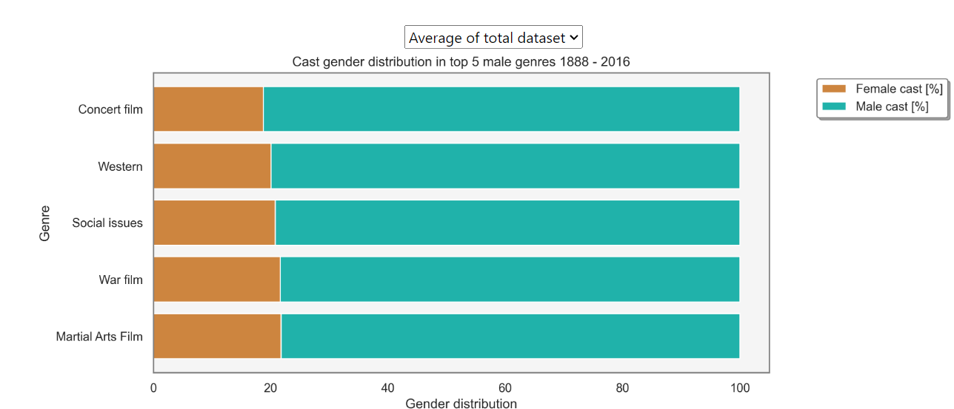

We can quickly see that a lot of genres are related to violence and adrenaline, which fits into the stereotypical interest of men. It might appear apparent that war and western film mostly are dominant by men. But if we take a step back, we need to ask ourselves why we feel this way. While the frontline and western world of cowboys are dominated by the male gender, women also lived through this time. They served as nurses and administrators during the first world war, cared for the animals and were involved with ranch sales. So, to represent all sides of the story, both genders should be taken into account.

For action and adventure movies there is even less a reason why women do not have an equal appearance on screen. This finding might reflect how the society sees the role of a woman and

In both the first and last period war is listed as a genre with the dominant male cast percentage. In the time between those periods women have started taking more active roles on the frontline such as ‘Women Airforce Service Pilots’. Now the movie industry would have been able to solely focus on the frontline, while also including female cast. But compared to the first period, the percentage of women playing in war movies sank.

The fact that documentary, culture & society have such a significant higher male cast percentage might indicate that society evaluate them as more trustworthy and serious or that they prioritize their interest.

After looking at the genre data we can conclude that this sentence reflects the findings: “Men have to be strong, and women have to be nurturing.” This biased view can be harmful for both genders, preventing men to express emotion or vulnerability and not enabling women to take leading positions.