How has creator content strategy evolved to reflect professional monetization approaches?

To answer this question we need to define youtube monetization approaches. Youtube has positionned itself as a video hosting platform that has evolved over the years to allow content creators to make money from the videos that they post. As such, several monetization strategies have been put into place, by youtube as well as other third parties to make content creation, a lucrative activity.

To generate incomes from the videos that they post on youtube’s platform, content creators have multiple options : advertisements displayed sometimes during the video, join Youtube monetization program (YPP) which requires specific criteria for elligibility, affiliation to third parties companies, youtube premium, channel memberships, patronage, merchandise, paid sponsorships, Super features, youtube shorts fund or youtube brandconnect.

<https://www.simplilearn.com/youtube-monetization-tips-on-how-to-monetize-your-channel-article>

YPP unlocks monetization-relevant features for the creators. However, to be able to join the program, a creator must meet certain requirements (<https://support.google.com/youtube/answer/72851?hl=en&co=GENIE.Platform%3DAndroid>) :

- Follow Youtube channel monetization policies

- Live in country/region where the YPP is available

- Have no active Community Guidelines strikes on your channel

- 2-step verificitation turned on your Google account

- Have advanced features access on youtube

- Have Adsense account linked to your account

Furthermore to be elligible for YPP, you must either :

- Get 1000 subscribers with 4000 valid public watch hours in the last 12 months or

- Get 1000 subscribers with 10 million valid public shorts views in the last 90 days

Basically, the key elligibility requirements is to have a minimum of 1000 subscribers demonstrating an engaged audience for your content and an accumulation of 4000 watch hours in the last 12 months , showing popularity and appeal of the channel.

Another important rule is to create an Adsense account. Adsense is the google platform used to promote and sell advertizement via different channels. Basically, the channels make available their ad spaces to advertisers who want to promote their products. They bid to show their ad in your spaces in a real-time auction (source : <https://support.google.com/adsense/answer/6242051?hl=en>). The highest paying ads will be selected to be displayed on your space and the you get paid.

One would expect a professional channel to :

- show consistency in video uploading : average upload, std upload ( higher means inconsistency), upload per month,

- to have a higher subscriber to view ratio (total view / subscriber count),

- to display a higher audience engagement : likes to view ratio, comment to view ratio, average comments, average likes, view std (higher means the audience engagement to your content is not stable) , average views,

- consistency in content duration : average video length, std video length

We downloaded some monetization indicators using the Youtube API:

- has_affiliate_links

- has_sponsorships

_ has_merchandise

- has_memberships

We need to evaluate how channels have evolved towards professionalization using these monetization indicators as target.

So first extract professionalization-relevant metrics and identify channels that show a trend towards professional monetization.

We can then use a clustering algorithm to cluster channels based on these professionalization metrics. Tor each cluster, we calculate the monetization rates and identify which professionalization metrics correlate with monetization.

Put simply, our algorithm to answer this question can be resumed this way:

1. Track professionalization metrics over time

* Upload consistency trends
* Engagement ratio changes (subscriber to view ratio, likes to view ratio, etc…)
* Content consistency patterns (average video length, etc…)

1. Group channels by similar metric trajectories (DTW : Dynamic Time Warping to find similar trajectories in longitudinal data)

DTW calculates distances between time series trajectories to identify similar trajectories. Then we can apply K-medoid or hierarchical clustering algorithm to cluster these trajectories (The DTW package in python also contains these features).

Then we map clusters to monetization status.

1. Compare these trajectory patterns with final monetization status (has sponsorship, has affiliated, has merch)

This analysis will help us identify the common paths leading to monetization, the key metrics that precede monetization, and time patterns in professionalization journey.

DTW is a powerful algorithm to align time series sequences (longitudinal data) and extract patterns.

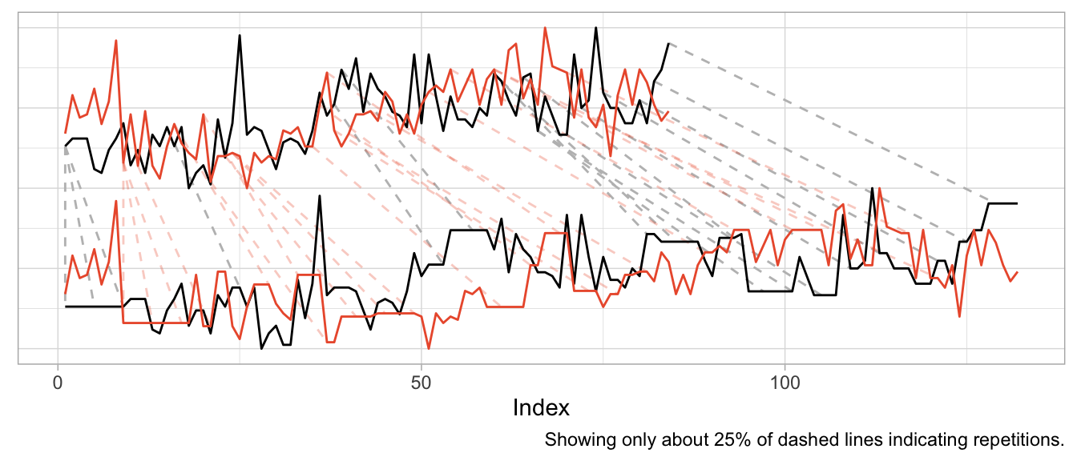

Identify channels that are eligible for YPP (1000 subscribers and 4000 views over the last 12 months) and identify how many of these actually have evolved into a professional monetized channel. For these channels, we need to analyze the professionalization & monetization metrics to identify specific content patterns.