CS-358 project: Sphere
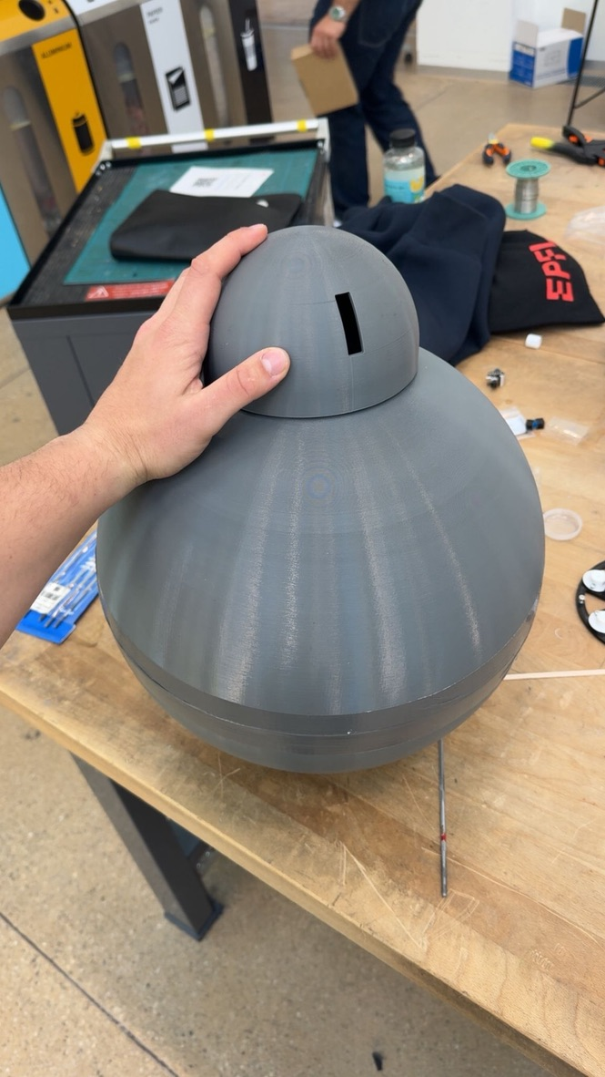
A self-contained spherical robot inspired by BB-8. CS-358 final project, EPFL.

Project overview
This project was developed as part of the CS-358 course at EPFL, with a strong emphasis on real-world applicability, modular hardware/software design, and an engaging user interface.

About the robot
It is a self-contained spherical robot inspired by BB-8 from Star Wars. A 3D-printed shell rolls on the ground, driven from the inside by a small chassis with three omnidirectional wheels. On top of the sphere, a separate "head" is held only by magnets, so it can rotate freely as the sphere moves. The head carries a camera.
The robot:
- Rolls in any direction using 3 omni wheels at 120° spacing, tilted inward at 30° against the inside of the sphere.
- Is driven over Wi-Fi from a browser dashboard.
- Streams live video from the head camera (planned — head firmware is in progress).
- Self-stabilizes with a 9-DOF IMU and a 100 Hz control loop.
- Can be reflashed over Wi-Fi (OTA), so the sphere doesn't have to be opened.

List of materials

Electronic components
- Microcontroller (body) : ESP32 Wemos D1 R32 / UNO32. Runs the control loop and the WebSocket server.
- Camera (head) : XIAO Vision AI Camera from Seeed Studio.
- Motors (×3) : DFRobot FIT0186. 12 V DC gear motors with encoders, one per omni wheel.
- Motor drivers (×3). L298N H-bridge modules. One channel per motor.
- IMU : Adafruit BNO055. 9-DOF with built-in sensor fusion. I²C address 0x28.
- Battery : LiPo, [TODO: capacity/voltage].
- BMS : [TODO: model]. Protects the LiPo.
- Buck converter : LM2596 (or equivalent). 12 V → 5 V for the ESP32.
- Magnets : Neodymium, [TODO: dimensions]. Hold the head onto the sphere.
Hardware wiring diagram:
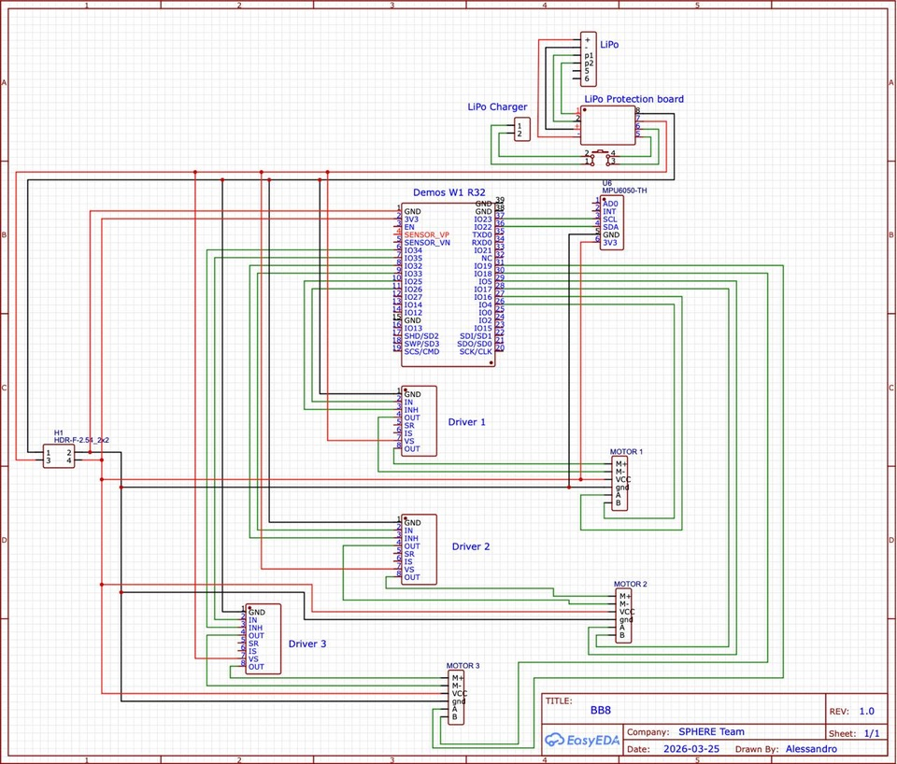

Mechanical parts
- Sphere shell, 35 cm diameter : 3D printed in PETG. Two hemispheres, joined with magnets and tape.
- Internal chassis : laser-cut MDF. Holds the 3 motors at 120°, tilted inward by 30°.
- Omni wheels (×3), ~9.25 cm diameter — 3D printed in PETG.
- Head shell : 3D printed in PETG. Holds the camera and magnets.
- Head-to-sphere contact : 3D-printed bearing cages with metal ball-bearings.

Build the robot

Sphere shell
The sphere is what the wheels push against, so it needs to be round, rigid, and smooth on the inside. Inner radius is ~17.5 cm (35 cm diameter), matching the ROBOT_RADIUS constant in the firmware.
- 3D print the two hemispheres (top and bottom) in PETG on a large-format printer (e.g. Prusa XL).
- [TODO: slicer settings — layer height, walls, infill, supports]
- Sand the inside of each hemisphere until it feels smooth. This is what gives the wheels good grip.
- Only join the two hemispheres at the very end, once the chassis is in place inside.
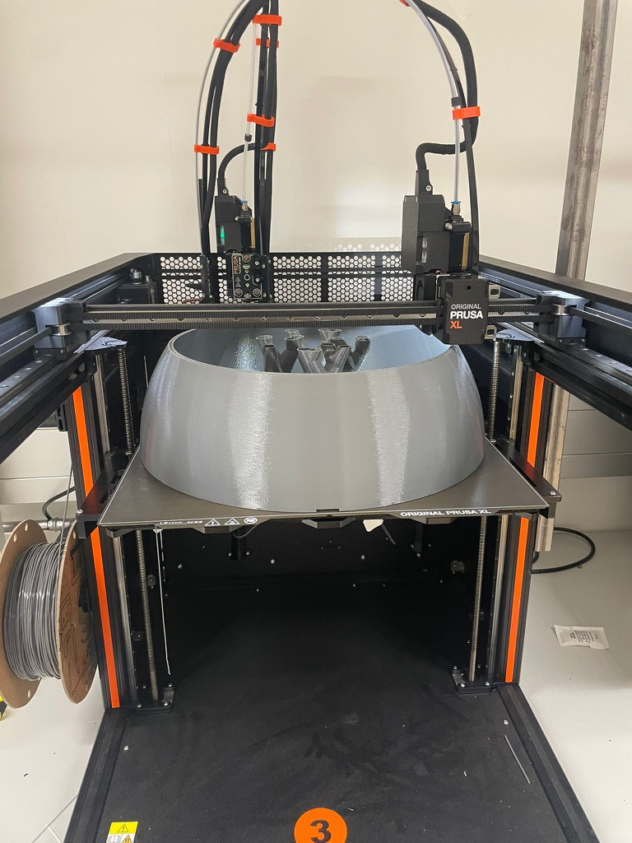
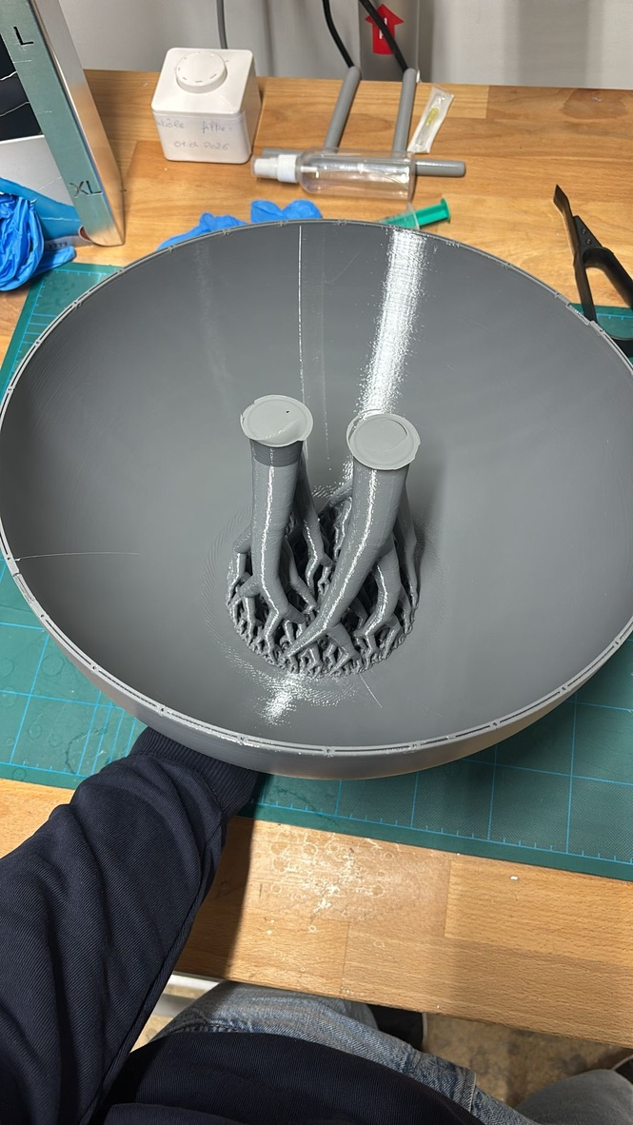

Internal chassis
The chassis holds the three motors at 120° spacing, each tilted inward at 30° from vertical so the wheels press against the inside of the sphere.
- Laser-cut the chassis pieces from MDF.
- Assemble with screws. Test-fit the three motors first — don't glue or screw anything down until they fit cleanly.
- Mount the motors at 0°, 120°, and 240° looking from above (front, back-right, back-left).
- Mount the IMU as far as possible from the head magnets, and as low as possible in the chassis. A low center of mass keeps the robot stable.
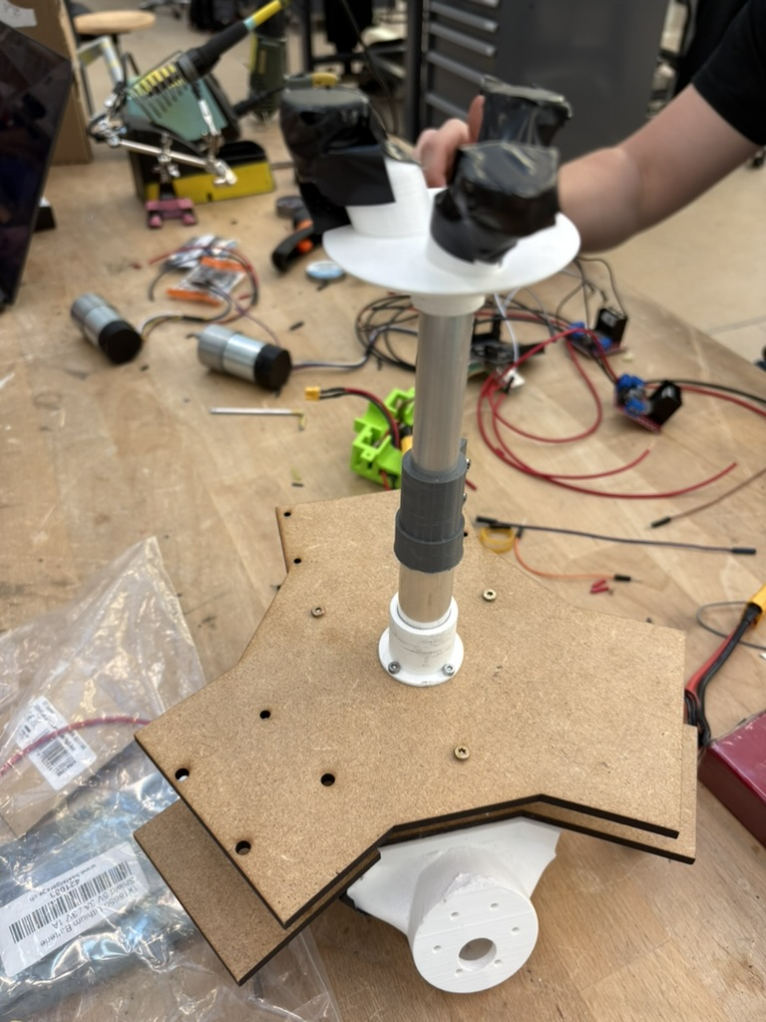

Motors and wheels
- Print the 3 omni-wheel assemblies in PETG. Check that the sub-rollers spin freely.
- Press-fit each wheel onto the motor's D-shaft.
- Check the rolling direction. Motor 0 is at the front, motor 1 back-right, motor 2 back-left. If a motor spins the wrong way, swap fwd/rev in body-firmware/src/config/pins.h rather than rewiring.

Electronics assembly

Motor drivers (L298N)
Motor | ESP32 GPIO (forward) | ESP32 GPIO (reverse)
0 (front) | 14 | 27
1 (back-right) | 16 | 17
2 (back-left) | 25 | 26
Jumper EN HIGH on all three L298N boards. Connect L298N GND to ESP32 GND.

Encoders
Motor | Encoder A | Encoder B
0 | 34 | 35
1 | 2 | 4
2 | 36 | 39

IMU (BNO055)
BNO055 | ESP32
VIN | 3.3 V
GND | GND
SDA | 21
SCL | 22
I²C address 0x28.

Power
LiPo ──┬── BMS ──┬── 12 V ──── L298N supply (×3)
│ │
│ └── LM2596 ── 5 V ── ESP32
│ └── BNO055 + encoders (via ESP32 3.3 V)
└── status LED
Add bulk capacitance (≥ 1000 µF + 0.1 µF ceramic) on the 12 V rail near each L298N. Without it, the motors will brown out the ESP32 every time you accelerate.
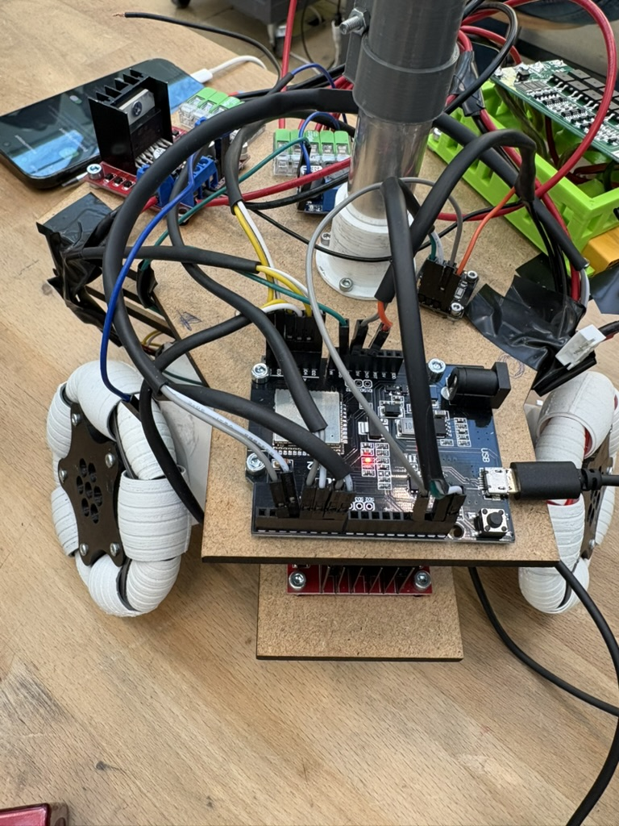
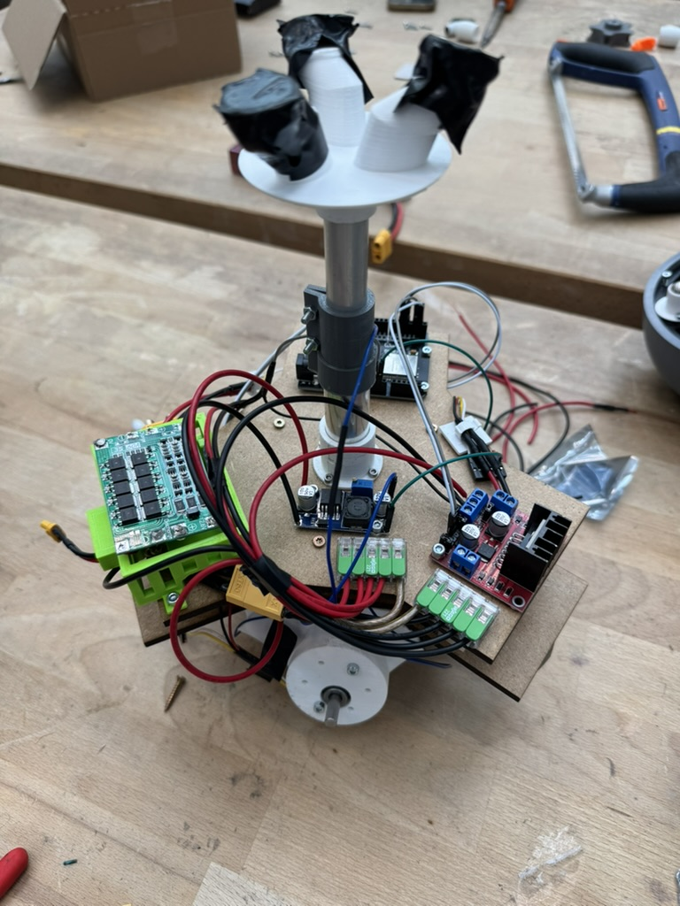

Head and camera
The head houses the XIAO Vision AI Camera and its own small LiPo. It joins the same Wi-Fi as the body but streams video separately.
- 3D print the head shell.
- Mount the camera with the lens facing forward.
- Wire the head LiPo through its own BMS and buck converter to the camera's 5 V input.
[TODO: photo of the head opened]

Magnetic head mount
The head holds onto the sphere with magnets only, there is no mechanical link. That's what lets the head swivel independently while the sphere rolls.
- Press neodymium magnets into the head's underside, alternating polarities.
- Press matching magnets onto the top of the chassis (which sits inside the sphere, just under the head).
- Metal ball-bearings in 3D-printed cages provide low-friction contact between the head and the top of the sphere.
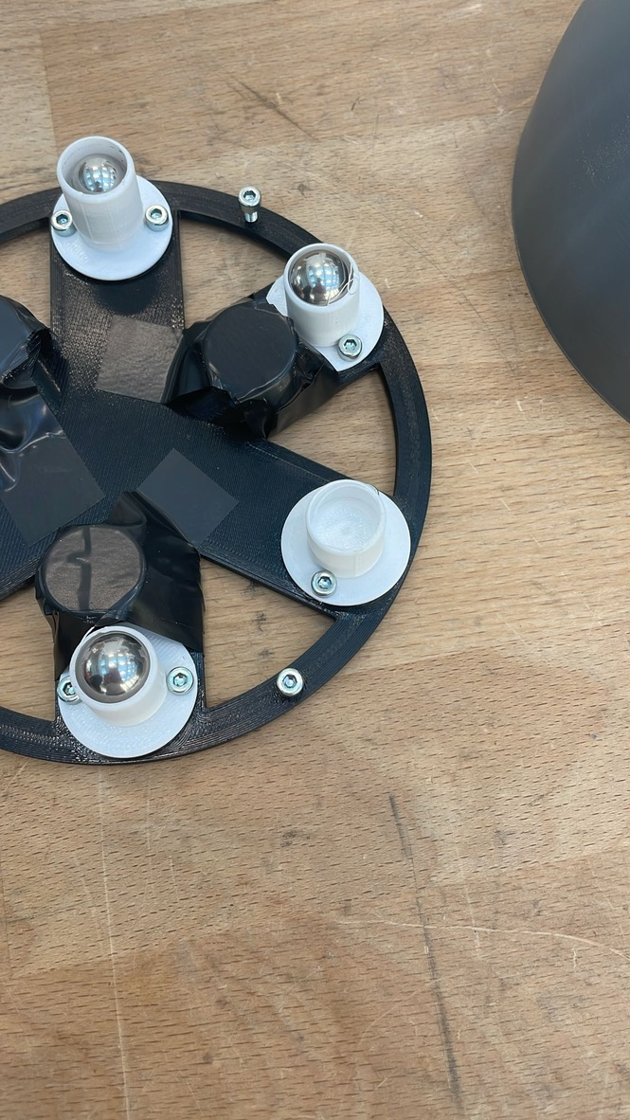

Algorithms

Omni-wheel inverse kinematics
Given a desired body velocity (vx, vy, ω), we compute each wheel's target speed using the geometry of a 120°-spaced, inward-tilted omni layout.
For a wheel at angle θᵢ from the front:
ωᵢ = (1 / (r · cos α)) · [ −sin(θᵢ)·vx − cos(θᵢ)·vy − R·ω ]
where r is the wheel radius, R is the distance from the chassis center to the wheel contact, and α is the wheel tilt.
Our values (from RobotConstants.h):
- r = 0.046225 m (wheel radius — 9.245 cm wheel diameter)
- R = 0.1745 m (robot radius — center to wheel contact)
- α = 30° (wheel tilt from vertical)
- MAX_RPM = 251 (per-wheel saturation)
For our layout (θ₀ = 0°, θ₁ = 120°, θ₂ = 240°):
1 ┌ 0 −1 −R ┐ ┌ vx ┐
[ωᵢ] = ─────────── · │ −√3/2 1/2 −R │ · │ vy │
r · cos(α) └ √3/2 1/2 −R ┘ └ ω ┘
Quick sanity checks:
- Pure forward → motor 0 doesn't spin, motors 1 and 2 spin opposite ways. ✓
- Pure rotation → all three spin in the same direction at the same speed. ✓
- Flat layout (α = 0) → equations match the standard 3-omni textbook case. ✓
Full derivation in code/body-firmware/docs/omni-kinematics-derivation.md.

Per-wheel PID
Each motor has its own PID loop tracking the target speed from the kinematics.
- Input: target RPM from kinematics
- Feedback: actual RPM from the encoder
- Output: PWM duty cycle (−1.0 to +1.0)
- Gains: Kp = 0.005, Ki = 0.002, Kd = 0.0005 (integrator clamped to ±5.0)
- Loop rate: 100 Hz
Code in code/body-firmware/src/control/PID.h.

Tilt-limit controller
The motors are powerful enough that on hard acceleration the chassis can climb the inside of the sphere and flip over. To prevent this, we designed a controller that watches the IMU:
- Active (tilt < 15°) — normal driving.
- Recovery (tilt 15–20°) — coast the motors, ignore the joystick, wait for gravity. Re-engages once tilt drops by ~3°.
- Stopped — brake all motors, reset PIDs.
- Hard cap (tilt > 30°) — brake immediately, regardless of mode.
Status: designed (see controller-discussion.md) but not yet integrated. The current shipping controller is a simple pass-through (PassthroughDrivetrainController), which is fine on flat ground with a careful operator.

Control architecture

How the two ESP32 cores split the work
- Core 0 runs the WebSocket server. It receives vx,vy,omega text frames from the laptop and drops the latest one into a one-slot mailbox (old commands get overwritten, never queued).
- Core 1 runs the 100 Hz control loop. It reads the latest command, reads the IMU, runs the kinematics and the PIDs, and updates the motors.
The pipeline looks like this:
WebSocket frame → mailbox → control loop (100 Hz) → kinematics → 3 × PID → 3 × motor

Safety properties
- Stale commands stop the robot. If no fresh command arrives within 200 ms, the motors ramp smoothly to zero. No jerk, no runaway.
- Watchdog reboot. If the control loop ever hangs, the ESP32 resets itself within 1 second.
- Wi-Fi watchdog. If Wi-Fi has been disconnected for more than 30 s, the ESP32 reboots to reconnect cleanly.
- Safe OTA. Flashing over Wi-Fi first stops accepting commands, so the ramp-to-zero takes effect before the firmware is overwritten.
- Latest command wins. A joystick command from a second ago is worse than no command, so we never queue, we always use the most recent frame.

Communication protocol
The laptop talks to the body ESP32 over WebSocket on the local Wi-Fi.
- The ESP32 is the server, listening on port 80.
- The webapp is the client.

Command format
Plain text, comma-separated:
"vx,vy,omega"
Field | Unit | Meaning
vx | m/s | Forward (positive = forward)
vy | m/s | Strafe (positive = left)
omega | rad/s | Yaw rate (positive = counterclockwise from above)
Extra fields at the end are ignored — that's how we'll add new fields later (e.g. head_tilt) without breaking older clients.

Video stream
The head camera streams video to a small relay server (code/stream-client/relay.ts) running on the laptop. The webapp subscribes to the relay to display the feed.
- Camera → ws://<laptop-ip>:3005/?role=producer
- Browser → ws://<laptop-ip>:3005/
The relay just fans out every frame from the camera to every viewer.

Web app
[TODO: paste a screenshot of the webapp dashboard]

What you can do from the dashboard
- Live camera feed — real-time video from the head.
- Camera status — online / offline / reconnecting.
- Manual control — joystick or keyboard input.
- Emergency stop — immediately sends 0,0,0 and locks input until you resume.
- Telemetry — IMU pose, battery voltage, loop rate.
The webapp is a Next.js app on port 3003. The video relay is a small Node server on port 3005. The video viewer is another Next.js app on port 3004.
Before running it, set your Wi-Fi credentials in code/body-firmware/src/config/wifi_credentials.h.

Code structure
code/
├── Makefile ← `make help` lists every target
├── make/ ← split Makefiles (setup, web, firmware)
├── body-firmware/ ← ESP32 firmware (PlatformIO + C++17)
│ ├── platformio.ini ← 6 envs: wemos_d1_uno32, drivetrain_test,
│ │ motor_test, robot, robot_ota, native
│ ├── docs/ ← test procedures, kinematics, design specs
│ ├── src/
│ │ ├── main_robot.cpp ← production entry point
│ │ ├── main_motor_test.cpp ← per-motor bring-up
│ │ ├── main_drivetrain_test.cpp ← full kinematics over serial
│ │ ├── main_imu.cpp ← BNO055 bring-up
│ │ ├── main_blink.cpp ← LED life check
│ │ ├── config/ ← pins.h, debug.h, wifi_credentials.h
│ │ ├── motor/ ← motor + driver classes
│ │ ├── drivetrain/ ← kinematics + drivetrain + controllers
│ │ ├── imu/ ← BNO055 wrapper
│ │ ├── input/ ← WebSocket producer + frame parser
│ │ ├── control/ ← PID
│ │ └── util/ ← math + sync primitives
│ └── test/ ← native unit tests (fff mocking library)
├── head-firmware/ ← head MCU firmware (in progress)
├── webapp/ ← Next.js operator UI (port 3003)
└── stream-client/ ← Next.js video viewer (port 3004) + relay (port 3005)

Firmware libraries
From body-firmware/platformio.ini:
- adafruit/Adafruit BNO055 @ 1.6.4
- adafruit/Adafruit Unified Sensor @ 1.1.15
- adafruit/Adafruit BusIO @ 1.17.4
- thijse/ArduinoLog @ 1.1.1
- madhephaestus/ESP32Encoder @ 0.12.0
- links2004/WebSockets @ 2.7.3

Setup

Prerequisites
- Node.js ≥ 18
- pnpm (npm install -g pnpm)
- Python 3 + pip3
- PlatformIO Core (installed automatically by make setup-firmware if missing)
- A Wi-Fi network the robot and your laptop can both join

Step 1 — Install dependencies
cd code
make setup
This runs three sub-targets: setup-prereqs (system tools), setup-web (pnpm install), and setup-firmware (PlatformIO + the C++ libraries listed above).

Step 2 — Configure Wi-Fi
cp code/body-firmware/src/config/wifi_credentials.example.h \
code/body-firmware/src/config/wifi_credentials.h
Edit the new file and set WIFI_SSID, WIFI_PASSWORD, and OTA_PASSWORD (any password — you'll need the same one for OTA updates later).

Step 3 — Connect the board
Plug the Wemos D1 UNO32 into your computer with a data-capable USB cable (charge-only cables won't work).

Step 4 — Flash the firmware
cd code/body-firmware
pio run -e robot -t upload
If the upload fails to connect, hold the BOOT button on the board while PlatformIO retries, and release it once the upload starts.
Confirm boot:
pio device monitor -b 115200
You should see:
BB-8 main_robot starting.
Connecting to WiFi....
WiFi connected. IP: 192.168.x.x
[ota] ready on bb8-robot.local
BB-8 ready.

Step 5 — Flash future updates over Wi-Fi
Once the sphere is sealed, USB is annoying. Use OTA:
export OTA_PASSWORD='whatever-you-set'
pio run -e robot_ota -t upload
If .local doesn't resolve on your network, use the raw IP:
pio run -e robot_ota -t upload --upload-port=<robot-ip>

How to run the robot
- Power on the body by connecting the LiPo to the BMS. The boot log should print "BB-8 ready." once Wi-Fi is up.
- Power on the head (it has its own battery).
- Start the laptop services:
cd code
make dev
This launches the webapp (port 3003), the video viewer (port 3004), and the relay (port 3005).
- Open http://localhost:3003 in your browser.
- Open http://localhost:3003/video to confirm the camera is streaming.
- Drive!

Testing & validation
Each subsystem has its own PlatformIO build target so it can be tested on its own before running the full robot. Note that main_blink.cpp and main_imu.cpp are compiled in the same envs (drivetrain_test / motor_test exclude them; the default env compiles main_imu.cpp), so the order below maps to environments, not to a separate "blink" target.
Recommended bring-up order:
- Per-motor (open loop) : pio run -e motor_test -t upload. Drive each motor at low PWM and verify the encoder reads back consistent counts.
- IMU : pio run -e wemos_d1_uno32 -t upload (this env compiles main_imu.cpp by default). Calibrate the BNO055, check axis orientation.
- Drivetrain (closed loop) : pio run -e drivetrain_test -t upload. Full kinematics over serial, with the wheels off the ground.
- Full robot : pio run -e robot -t upload. Start on carpet.
Test procedures with pass/fail checklists are in code/body-firmware/docs/:
- motor-spin-test-procedure.md
- imu-test-procedure.md
- drivetrain-test-procedure.md
For host-side unit tests (using the fff mocking library):
make test # everything
make test-firmware # PlatformIO native tests
make test-webapp # webapp tests
make test-stream # stream-client tests

Safety
The full safety procedure is in documents/BB8_Safety_Procedures.pdf. Read it before every test session, not just the first one.

LiPo charging
Separate guide: see the LiPo charging PDF in documents/. Short version: never charge unattended, never charge a swollen or hot LiPo, always charge inside a LiPo-safe bag.

Magnet safety
The head magnets are strong. Keep them away from credit cards, hotel keys, hard drives, pacemakers, medical implants, and mechanical watches. Mind your fingers when handling — they can pinch hard.

Troubleshooting

Electrical
Symptom | Likely cause | Fix
ESP32 brown-outs when motors start | No bulk cap on 12 V rail, or under-rated buck | Add ≥ 1000 µF on 12 V; check the buck is rated ≥ 2 A peak
Motor 1 behaves erratically | GPIO 16/17 conflict with PSRAM (WROVER only) | Use a WROOM-based ESP32 — the Wemos D1 UNO32 is fine
Encoder reads 0 while motor spins | Encoder A/B disconnected or swapped | Re-seat the wires; swap A/B in pins.h
Encoder RPM sign is reversed | Encoder A/B swapped | Swap A and B for that motor in pins.h
Serial shows nothing | Wrong baud rate, or charge-only USB cable | 115200 baud; data-capable cable
IMU prints "BNO055 not detected" | SDA/SCL swapped, wrong address, or magnet interference | Check wiring (SDA=21, SCL=22); confirm 0x28; move magnets away

Firmware
Symptom | Likely cause | Fix
Upload fails to connect | ESP32 not in download mode | Hold BOOT while PlatformIO connects
OTA can't find bb8-robot.local | mDNS not resolving on your OS | Use the raw IP: --upload-port=<robot-ip>
Robot rotates instead of going forward | Motor numbering doesn't match physical layout | Re-label the motors or update pins.h
Robot oscillates / buzzes | PID Kp too high, or Kd too low | Lower Kp first
Robot ignores joystick after disconnect | Working as designed — stale commands stop the robot | Reconnect; send a fresh frame

Network / web
Symptom | Likely cause | Fix
Video feed is black | Relay or stream-client not running | Start each separately: make dev-relay, make dev-stream
Browser can't reach the robot | Different VLANs / Wi-Fi bands | Put both on the same SSID/band
Webapp port already in use | Leftover dev server | make dev-stop (kills ports 3003–3005)

Improvements

Software
- Build out the RC Control page (currently a placeholder).
- Add a telemetry overlay to the webapp (IMU pose, battery voltage, loop rate).
- Finish the head firmware (video streaming, battery monitoring).
- Integrate the tilt-limit controller (currently designed but not yet shipping).

Nice-to-haves
- Autonomous navigation (SLAM, obstacle avoidance) using the head camera.
- Face tracking — the XIAO Vision AI module has the CV chip for it.
- Voice interface (mic on the head, recognition off-board).
- Gesture-based control.
- Anti-vibration mount for the head camera.

Team members
Name | Email
Alessandro Lombardini | alessandro.lombardini@epfl.ch
Tristan Compain | tristan.compain@epfl.ch
Lucas Brunschwick | lucas.brunschwick@epfl.ch
Vincent du Fresne | vincent.dufresnevonhohenesche@epfl.ch
Alban Thèves | alban.theves@epfl.ch

Acknowledgements
References:
- Modern Robotics, Lynch & Park — Ch. 13.2, Omnidirectional Wheeled Mobile Robots
- Borisov et al., Nonholonomic dynamics and control of a spherical robot with an internal omniwheel platform (2016)
- SpheriDrive: A spherical robot with an innovative 3-wheeled platform (2025)
- Adam Green's BB-8 build
- BB-8 Builders Club
- ROS2 Mobile Robot Kinematics — Omnidirectional Wheels
- Voiture télécommandée par bluetooth — Les Fabriques du Ponant wiki

