Tequila – PHP client

Developer Guide

# Code explanation

## Authenticate function

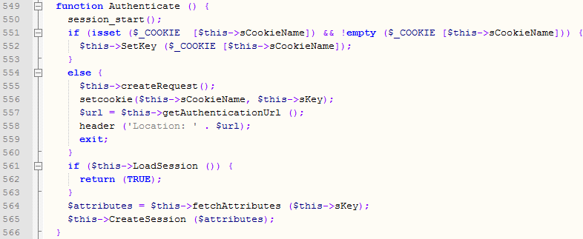

*Authenticate* is the main function. The actual authentication begins when the user is calling this function.

The application uses the native PHP session with *session_start().*

*session_start()* creates a new PHP session on the application server or uses the existing session belonging to the user. The PHP session stores the requested Tequila attributes.

If a cookie, which name is *$sCookieName*, exists, it means that the user was redirected to the Tequila server and was asked for her credentials. Otherwise, the Tequila client makes a request for service and redirects the user to the Tequila server for authentication. If the authentication is successful, the Tequila server returns an authenticated service key.

Tequila redirects the user back to the Tequila client after the user has been asked for her credentials. Now, the application tries to load the session associated to that user by calling the *LoadSession()* function. If the session has been loaded successfully, the user is redirected to the protected resource. Otherwise, the Tequila client requests the attributes by using the authenticated service key and the returned attributes are stored in a PHP session.

*LoadSession()* tests whether or not the PHP session is empty. If the session is empty, the function returns *FALSE*. Otherwise, the session’s timeout is checked and refreshed if no timeout occurred. If a timeout occurred, the session and cookie are destroyed and the user is logged out from the Tequila server.

## createRequest function



In the createRequest function the dontappendkey parameter is forced to 1. As consequence, the Tequila server redirects the user to the PHP application without the key attribute in urlaccess.

# PHP Session file

The session contains the requested Tequila attributes and a timeout variable.

Session variables are accessible by directly calling the variable $_SESSION or by calling the getValue(string) function, where string is the Tequila attribute.