Tequila – PHP client

User Guide

The purpose of this PHP client is to protect a PHP application by communicating with the Tequila server.

# API installation

API file: tequila.php

Include the API file in your PHP application with the following command:



# API invocation

## Create a Tequila client



First of all, a Tequila client must be created.

## Set up the authentication request and the request for service

This is an example how a request for service can be built.

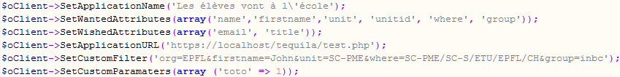

*SetWantedAttributes*, *SetWishedAttributes* and *SetCustomParameters* functions must take an array as argument.

The *request* command of Tequila is constructed by calling the *SetWantedAttributes* function.

*SetCustomFilter* constructs the *require* command of Tequila. The filter must be of the following format:  
*attribute1=value&attribute2=value.* This filter is used to put some constraints on resources that are accessed by users.

## Authentication



If the user is not yet authenticated with the Tequila server, the *Authenticate* function redirects the user to the Tequila server and is asked to enter her credentials. If the user is already authenticated, the user can access the protected resource.

## Retrieve data of the requested service

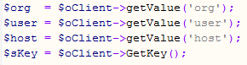

The *getValue(string)* function returns the value of *string* that is a Tequila attribute.

*GetKey()* returns the authentication key.

# Listing of all API functions

Below are functions that are necessary and useful for the PHP application.

Note that SetWantedRights, AddWantedRights, RemoveWantedRights, SetWantedRoles, AddWantedRoles, RemoveWantedRoles, SetWantedAttributes, AddWantedAttributes, RemoveWantedAttributes, SetWishedAttributes, AddWishedAttributes, RemoveWishedAttributes, SetWantedGroups, AddWantedGroups, RemoveWantedGroups, SetCustomParameters functions take an array as argument.



$iTimeout is the timeout for a Tequila session. It can also be configured, as well as $sServer, in the config file tequila_conf.inc.php.

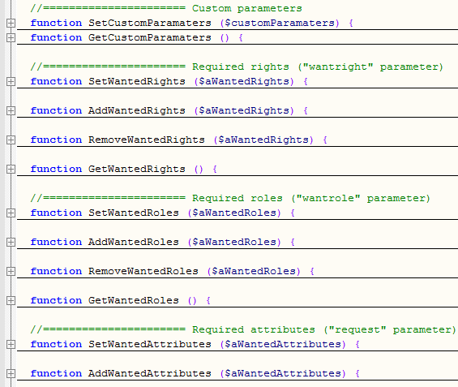

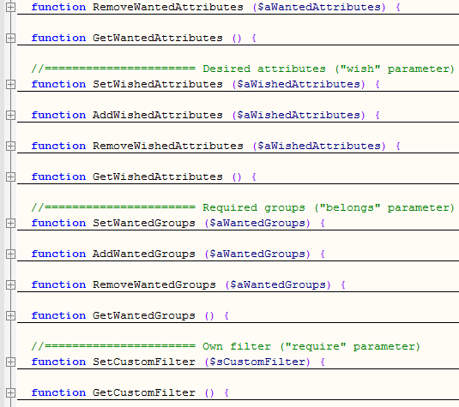

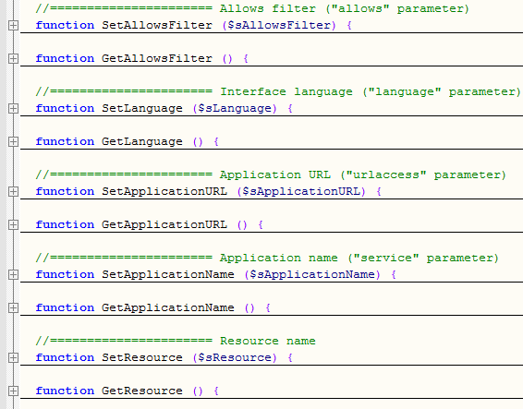

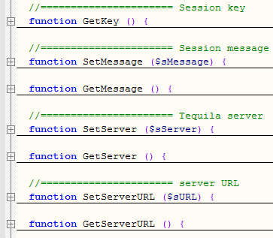



Authenticate is the main function for authentication to the Tequila server.

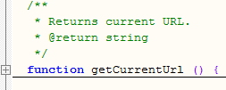

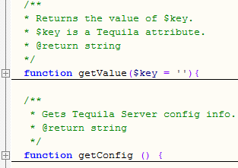



$redirectUrl is the URL where the user is redirected after being logged out from the Tequila server.