

HUDUMA KENYA
Digital Government Services Platform (DGSP)

USER REQUIREMENTS DOCUMENT
Huduma Virtual Centre (HVC) — MVP Scope
Document Reference | DGSP/PDSL/HDM/URD/2026
Prepared By | Professional Digital Systems Limited (PDSL)
Prepared For | Huduma Kenya & PDSL Joint Review
Document Type | User Requirements Document — Discussion Draft (MVP Scope)
Version | 1.1 — July 2026
Classification | Confidential
Project Sponsors
Kennedy Abuje | Huduma ICT Director
David Karanja | PDSL Chief Executive Officer
Charles Kimani | PDSL Chief Operating Officer
Project Office
Ephantus Githinji | PMO, PDSL
Steve Austin | PMO, Huduma Kenya
Faith Muthoni | PMO Team, PDSL
Development Team
Ramson Mwangi | Development Lead, PDSL
Tony Munene | Integration Engineer, PDSL
John Kibet | Infrastructure, PDSL

1. PURPOSE & SCOPE
This User Requirements Document (URD) defines the citizen- and business-facing requirements for the Huduma Virtual Centre (HVC): the digital, omnichannel equivalent of a physical Huduma Centre, delivered on the Digital Government Services Platform (DGSP). It responds directly to the scope items agreed for the initial requirements-gathering session between PDSL and Huduma Kenya, and sits alongside the existing DGSP Project Execution Plan and Technical Implementation Plan, which cover delivery governance and technical architecture respectively.
This document is scoped to the Minimum Viable Product (MVP): two to three selected government services, sufficient to prove the end-to-end model — omnichannel access, authentication, service roadmap, BPMN-driven workflow with two-way notifications, and eCitizen-based payment — before wider MDA onboarding begins.
This document was issued as Version 1.0 as a discussion draft. Version 1.1 adds the first confirmed MVP service — National ID Card Replacement — with its full process flow (Section 5.11). Further MVP service(s) will be added, and this document revised again (to Version 1.2 / 2.0), once jointly confirmed with the Huduma Kenya team.

2. REFERENCE DOCUMENTS
Document Reference | Title | Version
DGSP/PDSL/HDM/EXP/2026 | DGSP Project Execution Plan | 1.0 — June 2026
— | DGSP Technical Implementation Plan | 1.1 — February 2026
— | PDSL Infrastructure Options Proposal | March 2026
— | PDSL Resource Plan 2026 (PDSL/HR/RP/2026/001) | 2026

3. DEFINITIONS & ABBREVIATIONS
HVC | Huduma Virtual Centre — the virtual (omnichannel) equivalent of a physical Huduma Centre.
DGSP | Digital Government Services Platform — the overall platform of which the HVC citizen portal is a part.
MDA | Ministry, Department or Agency — the domicile government owner of a service.
BPMN | Business Process Model and Notation — the modelling standard used to define each service's workflow.
Camunda | The workflow/process engine embedded in DGSP to configure and execute BPMN processes.
SSO | Single Sign-On — one authentication session granting access across the platform.
Keycloak | Open-source Identity and Access Management system providing local SSO.
eCitizen | The Government of Kenya's national digital services and payment gateway.
USSD | Unstructured Supplementary Service Data — a menu-based channel accessible from any mobile phone.
PRN | Payment Registration Number — the reference used to reconcile a government payment.
Get Service | The citizen action that starts a specific service's process from the Virtual Service Centre.
Roadmap | The pre-start screen summarising a service's process, required documents, and fees.

4. USER ROLES
The requirements in Section 5 are written from the perspective of the following user roles.
Citizen / Customer | End user of the HVC; accesses services via Web, Mobile, USSD, or Kiosk.
Huduma Centre Staff (Digital Assistant) | Assists citizens at the physical kiosk; operates under Huduma mandate alongside MDA staff.
MDA Staff | Process the service on behalf of the domicile agency; own the legal outcome of the service.
Service Configurator (PDSL / Huduma) | Jointly maps services and configures the BPMN, forms, fees and channels in the DGSP backend.
System Administrator | Publishes, deactivates and manages services and platform configuration.

5. FUNCTIONAL USER REQUIREMENTS
Requirements are grouped by capability area and identified with a unique Req ID. Priority follows a simple two-level scheme for MVP planning: Must (required for MVP go-live) and Should (desirable, may follow shortly after MVP if not feasible in the initial build).

5.1 Omnichannel Access
Req ID | Requirement | Priority | Notes
UR-OMNI-01 | Citizens can access the Huduma Virtual Centre (HVC) through a Web Application. | Must | Primary MVP channel.
UR-OMNI-02 | Citizens can access the HVC through a native Mobile Application on both iOS and Android. | Must | MVP may launch with one platform first if timeline requires; both required for full MVP sign-off.
UR-OMNI-03 | Citizens can access a defined subset of services through USSD, for feature-phone and low-connectivity access. | Must | Not every service is USSD-suitable; USSD scope is set per service at configuration (UR-CFG-08).
UR-OMNI-04 | Citizens can access services through a Digital Kiosk at physical Huduma Centres, in self-service or assisted mode. | Must | Preserves the existing walk-in channel; kiosk is treated as the fourth omnichannel per Section 6 (assumption).
UR-OMNI-05 | The channels on which a given service is available (Web / Mobile / USSD / Kiosk) are configurable per service at setup. | Must | See UR-CFG-08.
UR-OMNI-06 | The citizen experience (service name, steps, roadmap, fees) is presented consistently across all channels a service is enabled on. | Should | Content should be a single source configured once, rendered per channel.

5.2 Service Origination & MDA Mandate
Req ID | Requirement | Priority | Notes
UR-SVC-01 | Every service listed on the Digital Government Services Portal (DGSP) of the HVC must be attributed to a domicile Ministry, Department or Agency (MDA) that owns the underlying government service. | Must | MDA is the legal owner of the service; Huduma delivers it.
UR-SVC-02 | Huduma Centre delivers each service under a documented level of mandate agreed with the domicile MDA, working alongside MDA staff. | Must | Mirrors the existing walk-in mandate model, extended to the virtual channel.
UR-SVC-03 | The service record captured in DGSP includes the MDA name, the mandate/agreement reference, and the scope of processing delegated to Huduma Centre. | Must | Supports audit and accountability.
UR-SVC-04 | The system distinguishes MDA staff from Huduma staff in all workflow, queue and audit views. | Must | Needed for role-based access and reporting.

5.3 Service Mapping, BPMN Configuration & Publishing
Req ID | Requirement | Priority | Notes
UR-CFG-01 | PDSL and Huduma staff jointly map the as-is process for each candidate service before it is configured on DGSP. | Must | Consistent with the Process Discovery & Mapping stage of the MDA onboarding framework.
UR-CFG-02 | A mapped service can be created as a service record in the DGSP backend, capturing its description, owning MDA, fees, and required documents. | Must
UR-CFG-03 | The BPMN workflow for each service is configured using an embedded Camunda engine. | Must | Camunda 8 per existing technical stack.
UR-CFG-04 | The backend configuration tool supports defining steps, sequencing, and task type (system task vs. human/agent task) per BPMN 2.0. | Must
UR-CFG-05 | Once configuration of a service is complete, it can be Published, which generates the citizen-facing, step-by-step process on the omnichannels directly from the configured BPMN. | Must | No separate manual build of the citizen UI per service.
UR-CFG-06 | A service in Draft (unpublished) status is not visible or accessible on any omnichannel, including the kiosk. | Must
UR-CFG-07 | A Published service can be Deactivated by an authorised administrator; deactivation immediately removes it from all omnichannels while retaining its configuration and transaction history. | Must | Reversible — reactivation restores visibility.
UR-CFG-08 | At setup/configuration, the administrator selects (ticks) which omnichannels — Web, Mobile, USSD, Digital Kiosk — a service will be available on. | Must | Directly supports UR-OMNI-05.
UR-CFG-09 | Changes to an already-Published service go through a versioned change control step before re-publishing, so citizens with an in-flight application are not disrupted. | Should | Flagged for further definition with Huduma team.

5.4 Two-Way Citizen Communication
Req ID | Requirement | Priority | Notes
UR-NOT-01 | Any step in a service's BPMN workflow can optionally be configured to trigger a citizen notification by SMS and/or email. | Must | Two-way communication per point 3 of scope.
UR-NOT-02 | Each configured notification is classified as either Actionable (requires the citizen to do something, e.g. make a payment) or Informative (status update only, no action required). | Must
UR-NOT-03 | Example: on reaching step 6 of 9 in a process, the citizen automatically receives an SMS/email alerting them to make payment (or another required action) before the process can proceed. | Must | Illustrative requirement drawn directly from process design intent.
UR-NOT-04 | Notification templates are configurable per service and per step, with placeholders for step number, total steps, service name, amount due, and any relevant deadline. | Must
UR-NOT-05 | Citizens can indicate a preferred notification channel (SMS, email, or both) on their profile; step-level configuration can override where the process requires a specific channel. | Should
UR-NOT-06 | Every notification dispatched, and its delivery status, is logged for audit purposes. | Must | Aligns with the platform's immutable audit trail principle.

5.5 Authentication & Single Sign-On
Req ID | Requirement | Priority | Notes
UR-AUTH-01 | The system implements a local Single Sign-On (SSO) using Keycloak for a 'Huduma Virtual Services' account. | Must
UR-AUTH-02 | A citizen without an existing Huduma Virtual Services account can self-register (create one) directly from the login screen. | Must
UR-AUTH-03 | The system also supports SSO via eCitizen as an alternate authentication method. | Must
UR-AUTH-04 | The login screen presents exactly two entry points: (a) Login / Create a Huduma Virtual Services account, and (b) Login with eCitizen. | Must | No other identity providers in MVP scope.
UR-AUTH-05 | Regardless of which of the two methods is used, an authenticated citizen lands in the same post-login Service Area (Virtual Service Centre). | Must | No functional difference in access after authentication.
UR-AUTH-06 | Where a citizen holds both a Huduma Virtual Services account and an eCitizen identity for the same National ID, the system should avoid creating duplicate citizen profiles. | Should | Open item — identity-matching approach to be agreed with Huduma/eCitizen team; see Section 6.
UR-AUTH-07 | Account creation and login for Huduma Virtual Services is protected by MFA/OTP. | Must | Consistent with the platform security baseline (Kenya DPA 2019, ISO 27001).

5.6 Virtual Service Centre & Service Catalogue
Req ID | Requirement | Priority | Notes
UR-CAT-01 | All activated (Published) services are listed and visible to an authenticated citizen in the Virtual Service Centre. | Must
UR-CAT-02 | The citizen starts a transaction by selecting 'Get Service' against the service they require. | Must
UR-CAT-03 | Selecting 'Get Service' routes the citizen to a dedicated workstation presenting all steps of that service's configured process in sequence. | Must
UR-CAT-04 | The Service Centre supports basic browsing/search of available services (e.g. by MDA or keyword). | Should | Low priority at MVP given only 2-3 services live; important once catalogue scales.
UR-CAT-05 | An authenticated citizen with one or more applications in progress, across any combination of services, sees these clearly on the Services Page (e.g. a 'My Applications' / 'Continue' view). | Must | Applies across services, not just within a single service.
UR-CAT-06 | The citizen can select any in-progress application from this view and continue it directly. | Must | Routes into the workstation at the correct step; see UR-CONT-04.

5.7 Service Roadmap
Req ID | Requirement | Priority | Notes
UR-RM-01 | Before entering the workstation, every service presents a Roadmap screen to the citizen. | Must
UR-RM-02 | The Roadmap gives a plain-language summary of the overall process the citizen is about to undertake. | Must
UR-RM-03 | The Roadmap lists all mandatory documents required to complete the service. | Must
UR-RM-04 | The Roadmap displays the applicable service fee(s). | Must
UR-RM-05 | The citizen must explicitly acknowledge/proceed from the Roadmap before the workstation steps begin. | Should

5.8 Checkout & Payment
Req ID | Requirement | Priority | Notes
UR-PAY-01 | Where a workflow step requires payment, checkout is processed via eCitizen. | Must
UR-PAY-02 | eCitizen collects the fee into the Government's main revenue account. | Must | DGSP does not hold or process citizen funds directly.
UR-PAY-03 | On successful payment, eCitizen returns a success token/confirmation to the originating DGSP service/workflow instance. | Must
UR-PAY-04 | The success token authorises the workflow to proceed to the next step — issuing, processing, or generating the relevant final output of that service. | Must
UR-PAY-05 | A failed or abandoned payment does not advance the workflow; the citizen is returned to the payment step with a clear status message. | Must
UR-PAY-06 | Payment confirmation (reference/receipt) is delivered to the citizen via their configured notification channel(s). | Must | Ties to UR-NOT-01 to UR-NOT-06.

5.9 Application Continuity — Pause, Draft & Resume
Req ID | Requirement | Priority | Notes
UR-CONT-01 | A citizen can pause an in-progress application at any step of the workflow. | Must
UR-CONT-02 | A paused application is automatically saved as a Draft, retaining all previously entered data, uploaded documents, and its current step position. | Must
UR-CONT-03 | Draft applications appear in the Services Page / 'My Applications' view alongside other in-progress applications, with a clear status and current step indicator (e.g. 'Step 4 of 9'). | Must | Same view as UR-CAT-05.
UR-CONT-04 | Selecting a Draft application resumes the workflow exactly at the step where it was paused, with previously entered data pre-populated. | Must
UR-CONT-05 | A Draft application persists across sessions and channels, tied to the citizen's authenticated identity — e.g. an application paused on Kiosk can be resumed on Web or Mobile. | Must | Depends on the same identity resolving across channels (UR-AUTH-01 to 05).
UR-CONT-06 | Draft applications are retained for a defined period before expiry; the citizen is notified before an unfinished Draft lapses. | Should | Retention/expiry period to be agreed with Huduma team — see Section 6.

5.10 MVP Scope
Req ID | Requirement | Priority | Notes
UR-MVP-01 | The MVP is built and validated against two to three selected services only. | Must | Service 1 (National ID Card Replacement) is confirmed as the first MVP service — see Section 5.11 for the full process flow. Remaining MVP service(s) pending joint session with the Huduma Kenya team (see Section 6).
UR-MVP-02 | All requirements in Section 5 (5.1-5.9) apply to the MVP; national/multi-MDA scale requirements are addressed separately in the DGSP Project Execution Plan and Technical Implementation Plan. | Must
UR-MVP-03 | The MVP demonstrates the omnichannel model end-to-end on Web plus at least one additional channel; full simultaneous availability across all four omnichannels for every MVP service is not mandatory at MVP stage. | Should | Subject to joint agreement on which channels the pilot services require.

5.11 MVP Service 1: National ID Card Replacement — Process Flow (Abstract to Waiting Card)
This section documents the end-to-end citizen journey for the first confirmed MVP service, the replacement of a National Identity Card, from the initial Police Abstract through to the point the citizen can download a Waiting Card. The process flow below is followed by the corresponding step-by-step description.
Figure 1: HVC National ID Card Replacement — process flow, Police Abstract to Waiting Card
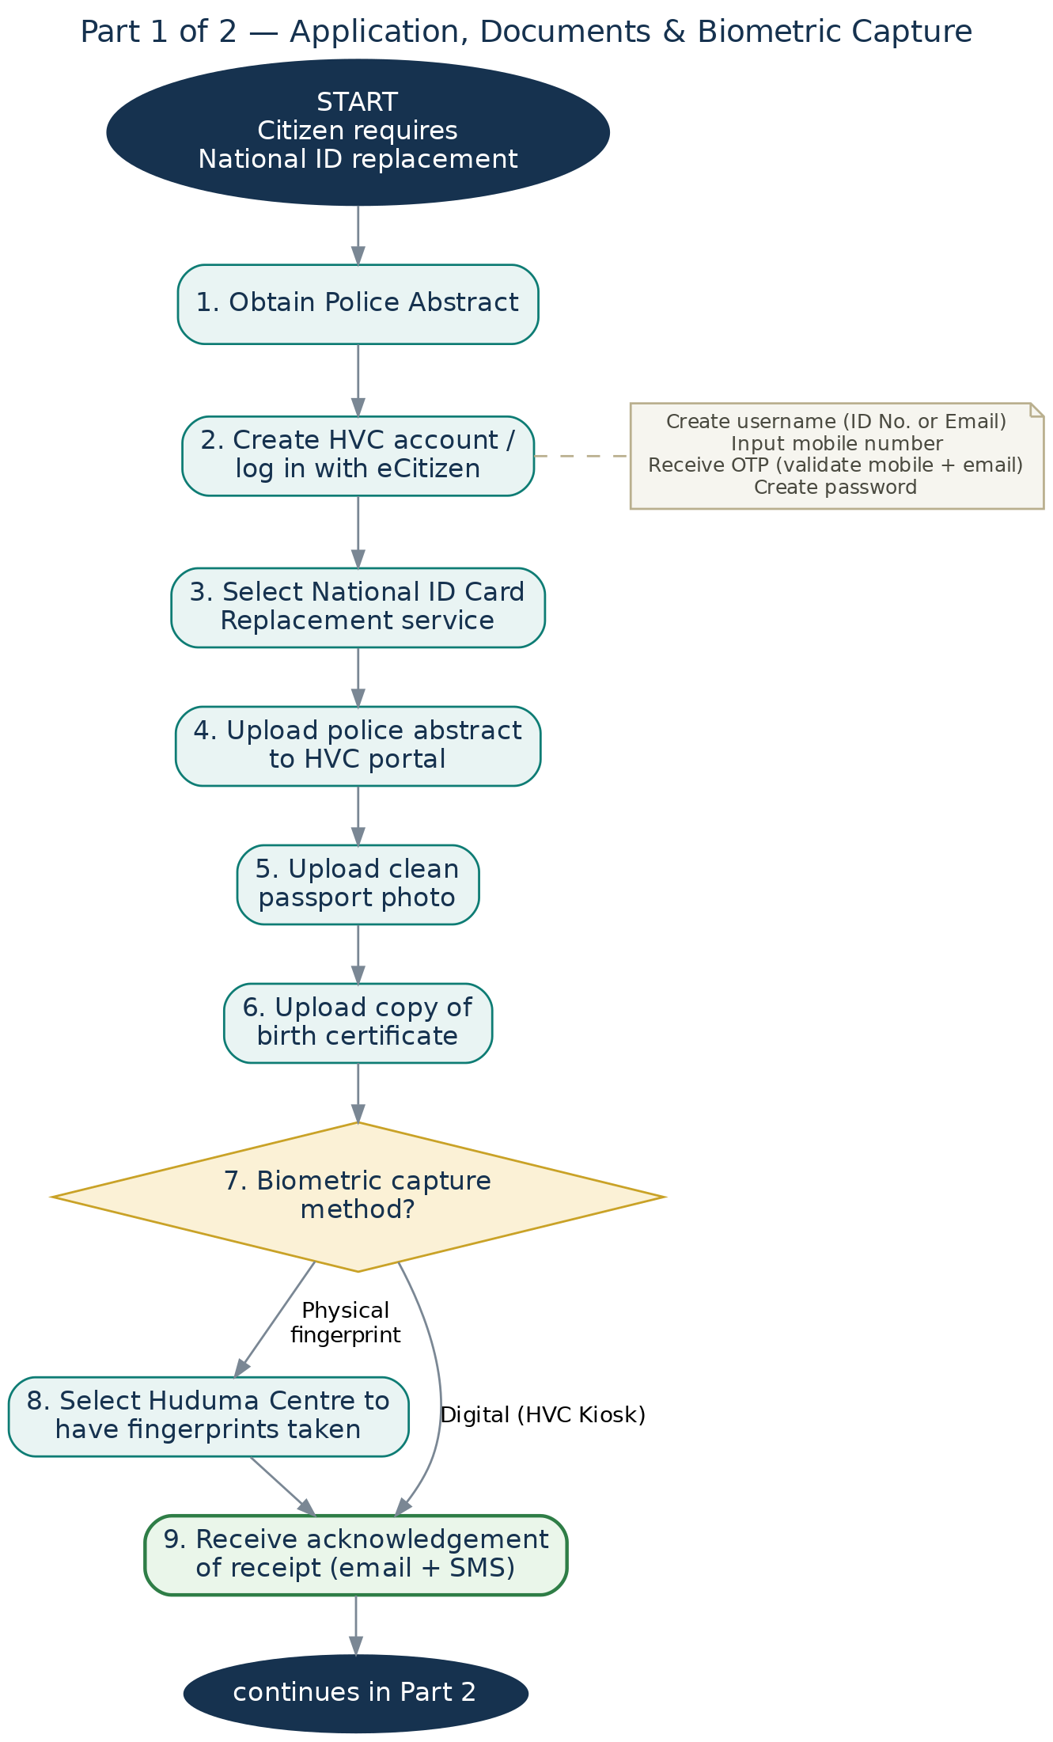 | 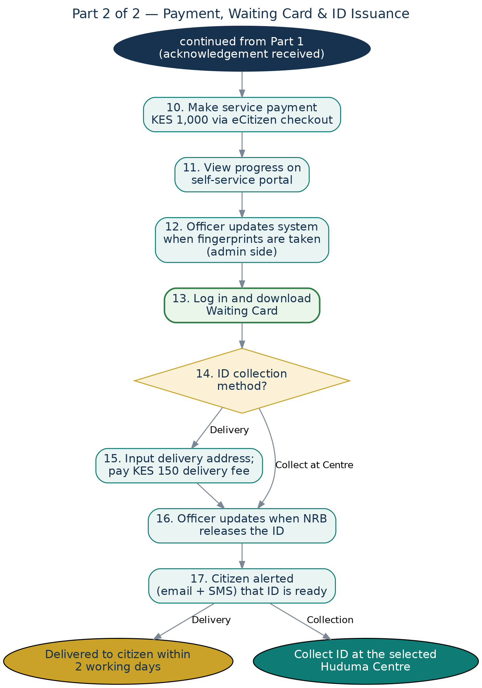

Process Steps
1. Obtain Police Abstract.
2. Create an account on the HVC portal, or log in with eCitizen:
– Create username (National ID Number or Email)
– Input mobile number
– Receive OTP to validate mobile number and email
– Create password
3. Select the National ID Card Replacement service.
4. Upload the police abstract to the HVC portal.
5. Upload a clean passport photo.
6. Upload a copy of the birth certificate.
7. Choose a biometric capture method — present two options:
– Physical fingerprint capture at a Huduma Centre
– Digital biometric capture via the HVC Kiosk
8. Select the Huduma Centre where you wish to go and have your fingerprints taken.
9. Receive acknowledgement of receipt via email and SMS.
10. Make the service payment of KES 1,000 via eCitizen checkout.
11. View process progress on the self-service portal.
12. Officer updates the system (admin side) when fingerprints are taken.
13. Log in and download a Waiting Card.
14. Select the ID collection method:
– Collect from a Huduma Centre
– Have the ID delivered
15. For delivery, input the delivery address and make an additional delivery payment of KES 150.
16. Officer updates the system when the National Registration Bureau (NRB) releases the ID.
17. Citizen receives an alert via email and SMS that the ID is ready:
– If for delivery: the ID will be delivered to {destination address} within the next 2 working days.
– If for collection: visit {selected Huduma Centre} to pick up the National ID.

6. ASSUMPTIONS & OPEN ITEMS
The following assumptions have been made in drafting this document, and the following items remain open for joint decision with the Huduma Kenya team:
- Digital Kiosk is treated as the fourth omnichannel alongside Web, Mobile and USSD. The original scope list left this item blank; Digital Kiosk is inferred from the later reference to omnichannel activation 'including the digital kiosk' and is carried through as UR-OMNI-04.
- USSD and, at MVP, other channels are not assumed to apply uniformly to every service — channel applicability is decided per service at configuration (UR-CFG-08), since USSD in particular suits simpler, lighter-weight interactions.
- Identity-matching between a Huduma Virtual Services account and an eCitizen identity for the same citizen (UR-AUTH-06) is not yet defined and requires a joint decision with Huduma Kenya and the eCitizen team.
- The list of MVP services is being confirmed in stages. Service 1 (National ID Card Replacement) is confirmed and documented in Section 5.11, including its process flow from Police Abstract to Waiting Card. The remaining one to two MVP services are pending a joint working session with the Huduma Kenya team; this document will be revised further (e.g. to Version 1.2 / 2.0) as each is confirmed, with service-specific roadmap, fees, documents and BPMN detail added.
- Definitions of 'actionable' versus 'informative' (actionless) notifications will be refined into a standard taxonomy during service configuration workshops.
- The retention/expiry period for paused Draft applications (UR-CONT-06) is not yet defined and requires a joint decision with the Huduma Kenya team.
- Consistent with prior PDSL/Huduma documentation, the physical walk-in channel at Huduma Centres remains available alongside the HVC omnichannels and is not being withdrawn.

7. OUT OF SCOPE (FOR THIS MVP)
- Onboarding of MDAs and services beyond the two to three selected for the MVP.
- Full national rollout across all 52 Huduma Centres (addressed in the DGSP Project Execution Plan, Phase 3).
- Advanced analytics, AI-powered recommendations, and API marketplace capabilities (addressed in Phase 4 of the Project Execution Plan).
- Detailed non-functional requirements (performance, availability, security architecture) — these are addressed in the DGSP Technical Implementation Plan and are referenced, not restated, here.

8. DOCUMENT CONTROL — VERSION HISTORY
Version | Date | Change Description
1.0 | July 2026 | Initial draft — user requirements for HVC MVP, for internal PDSL review and discussion with Huduma Kenya.
1.1 | 22 July 2026 | Added MVP Service 1 — National ID Card Replacement: full process flow (Police Abstract to Waiting Card) with process flow diagram (Section 5.11). Updated MVP Scope note (5.10) and Section 6 assumption on MVP service selection accordingly.
1.2 / 2.0 (planned) | Following full MVP confirmation | To be issued once the remaining MVP service(s) are jointly confirmed with the Huduma Kenya team, each documented with process flow, fees and BPMN detail equivalent to Section 5.11.

9. APPROVAL
This document is circulated for review and comment ahead of formal sign-off. Approval will be recorded once the MVP service selection is confirmed and this document is issued as Version 1.2 / 2.0.
Name | Role | Signature / Date
Steve Austin | PMO, Huduma Kenya
Charles Kimani | PDSL Chief Operating Officer
Ephantus Githinji | PMO, PDSL

