CPU Anomalies

Period: 02:05:00 ~ 02:10:00

Parameter: 05 02 7 3 * stress --cpu 32 --timeout 300s

Metric 1: CPU Utilization (millisec/second), Average CPU Load (1 minute)

The "load average" is reported by *uptime*, *top*, etc. and the PCP metric *kernel.all.load*.

The load average is an indirect measure of the demand for CPU resources. It is calculated using the previous load average (*load*) and the number of currently runnable processes (*nrun*) and an exponential dampening expression, e.g. for the "1 minute" average, the expression is:

load = exp(-5/60) * load + (1 - exp(-5/60)) * nrun

The three load averages use different exponential constants and are all re-computed every 5 seconds.

*nrun* is computed as follows:

1. Inspect every process.
2. If the process is not likely to be runnable in the near future (state not SRUN), ignore it.
3. Inspect every thread of the process.
4. If the thread is sleeping and not currently expanding its address space (state not SXBRK) and not in a long-term sleep, increment *nrun.*
5. If the thread is stopped, ignore it.
6. Otherwise if the thread is not "weightless" (being ignored by the scheduler), increment *nrun.*

Note that the "run queue length" (a variant of which is reported by the **-q** option of *sar*) counts processes using a similar, but not identical algorithm:

1. Inspect every process.
2. If the process is not likely to be runnable in the near future (state not SRUN), ignore it.
3. Inspect every thread of the process.
4. If the thread is sleeping and not currently expanding its address space (state not SXBRK), ignore it
5. If the thread is stopped, ignore it.
6. Otherwise increment the "run queue length".

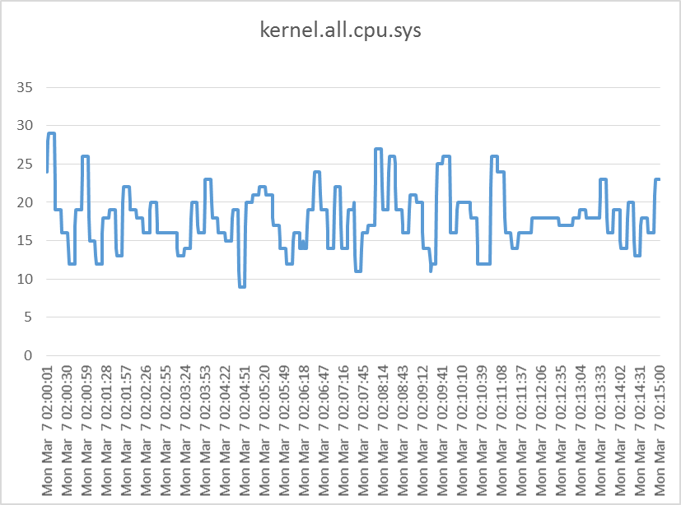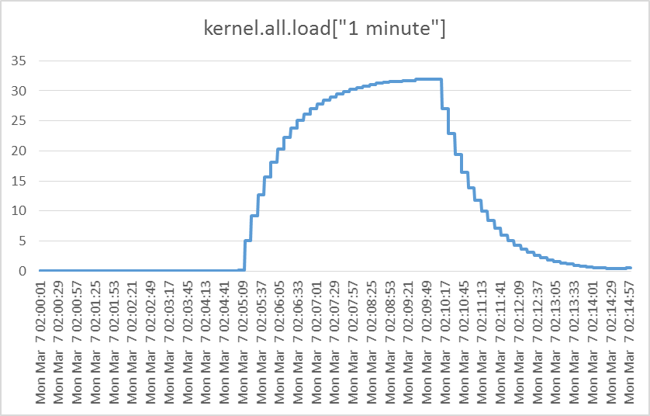

Memory Metrics:

Memory Used, Memory Free, Memory

