How VisioALS Personalizes a Response
High-level architecture: local language processing + semantic retrieval + cloud generation + patient-controlled selection
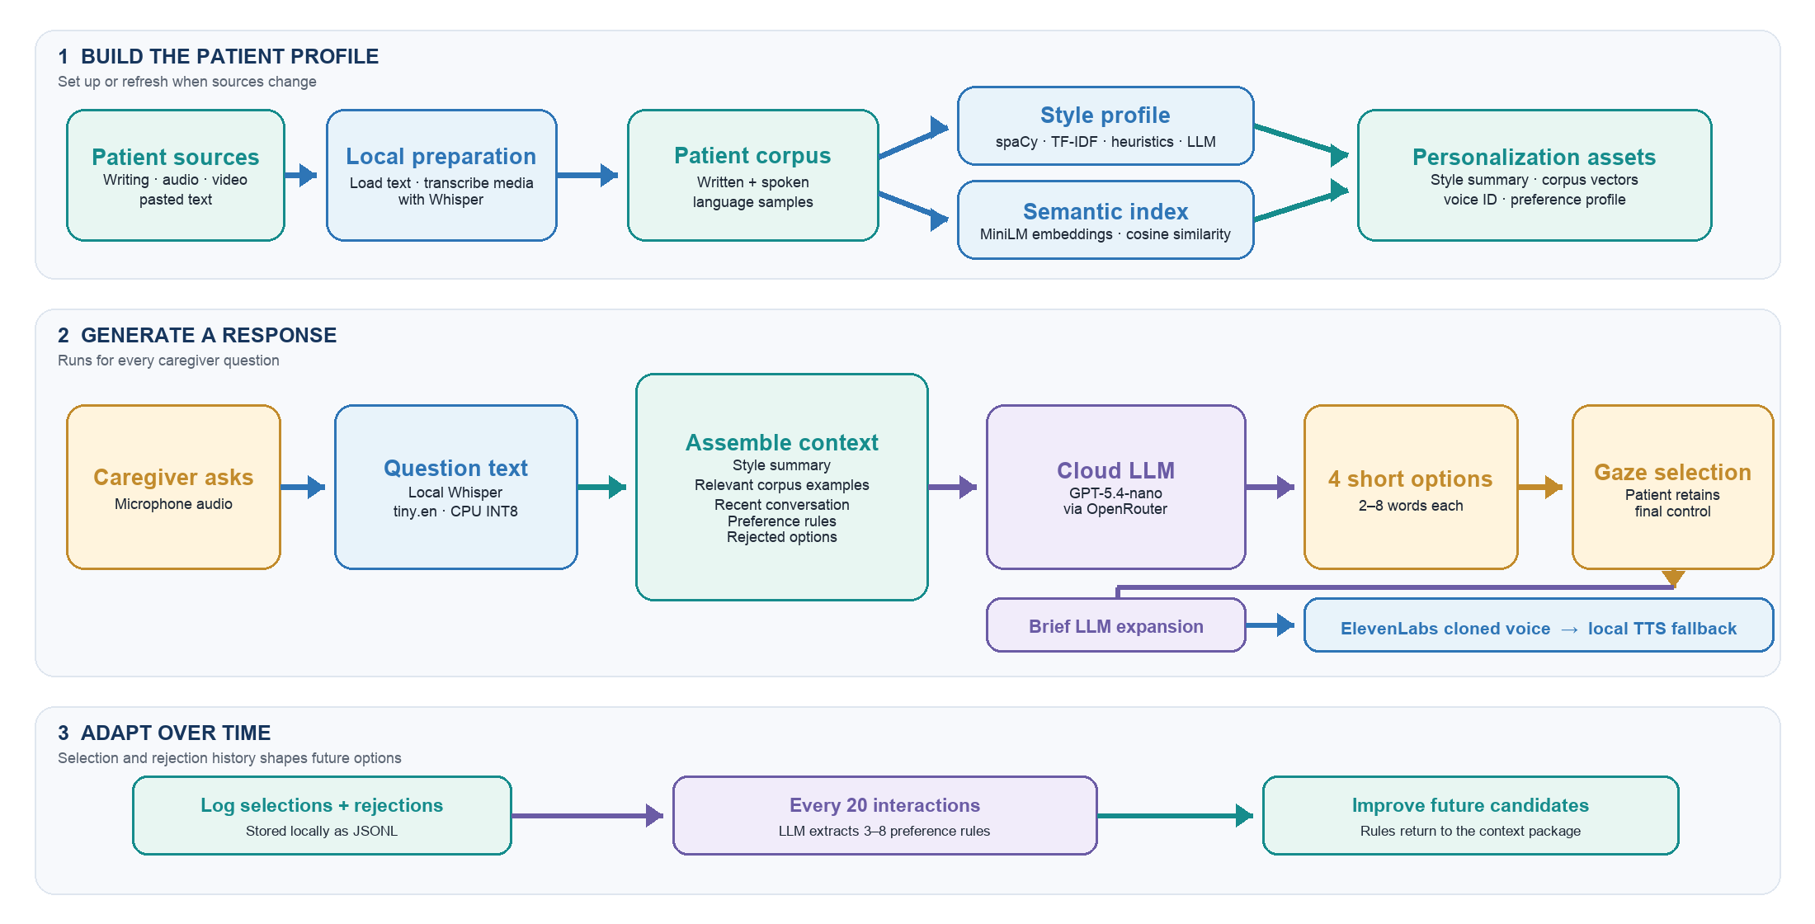
KEY IDEA The patient does not train a new language model. VisioALS conditions pretrained models with a style profile, retrieved examples, and learned preference rules.
■ LOCAL PROCESSING runs on the device ■ PATIENT DATA stored personalization assets ■ CLOUD AI LLM or cloned voice service ■ PATIENT CONTROL human question, choice, or output

