

**DEBRE BERHAN UNIVERSITY**

**INSTITUTION Of TECHNOLOGY**

**COLLAGE Of COMPUTING**

**DEPARTMENT Of SOFTWARE ENGINEERING**

**FUNDAMENTALOFBIGDATAANALYTICSANDBUSINESS INTELLIGENCY(SEng5112)**

**Prepared by: -**

**Name: Ephrem Tilahun ID No DBUR/0094/13**

**Submitted to: Mr. Derbew Felasman(MSc) February, 2025 Debre Berhan, Ethiopia**

Contents

1. Introduction 1

2. Data Source & Understanding 1

3. Data Extraction 1

4.Data Cleaning & Transformation 2

5.PostgreSQL Schema Design 2

6. Loading Data using Python 3

7. Visualization and Insights 4

# **1. Introduction**

This report documents the implementation of an End-to-End Data Pipeline for an e-commerce dataset. The pipeline processes raw transaction data, loads it into a PostgreSQL database, and visualizes key insights using Power BI.

# **2. Data Source & Understanding**

**2.1 Dataset Overview**

* File Name: **ECommerce_consumer_behaviour.csv**
* Size: 1 ,004 ,756 rows
* Columns: order_id, user_id, order_number, order_dow, order_hour_of_day, days_since_prior_order, product_id, add_to_cart_order, reordered, department_id, department, product_name
* Objective: Analyze customer purchasing behavior and sales trends.

**2.2 Identified Data Issues**

* Missing values in days_since_prior_order
* Duplicate records
* Inconsistent text formatting (department & product names)
* Data types requiring conversion (order_hour_of_day, order_dow)

# **3. Data Extraction**

Used pandas to load the CSV file into a DataFrame:

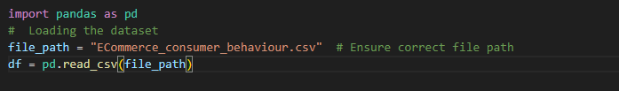

# **4.Data Cleaning & Transformation**

* Handled missing values: Filled days_since_prior_order with 0.
* Removed duplicates: Ensured unique transactions.
* Converted data types: order_hour_of_day, order_dow to integers.
* Standardized text columns: Lowercased department and product_name.

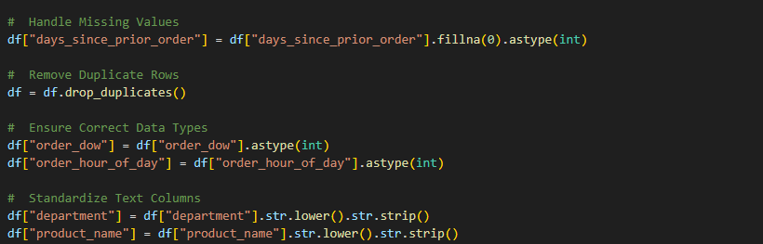

* Saved cleaned data:

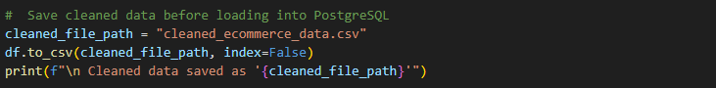

# **5.PostgreSQL Schema Design**

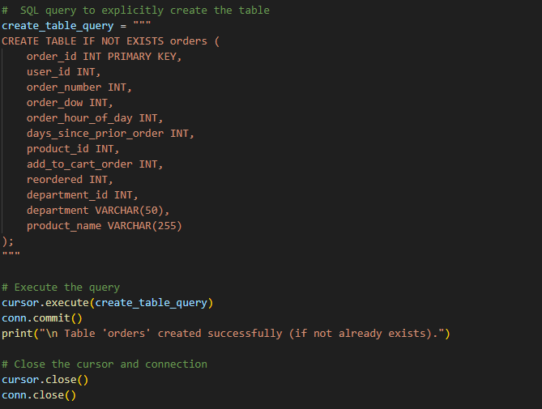

# **6. Loading Data using Python**

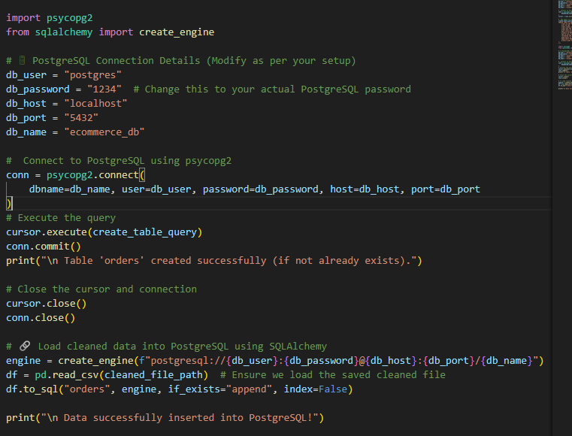

# **7. Visualization and Insights**

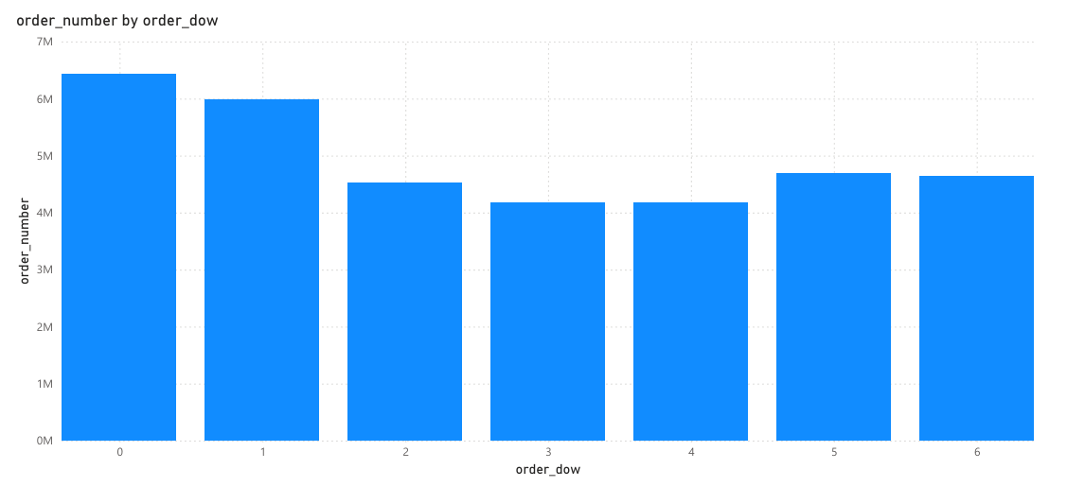

**What It Shows:**

* This bar chart represents the total number of orders placed on each day of the week.
* X-axis: order_dow (0 = Sunday, 1 = Monday, 2 = Tuesday, 3 = Wednesday ,4 = Thursday, 5 = Friday 6 = Saturday).
* Y-axis: Sum of order_number (total orders placed).

**Key Insights**

* Some days have significantly higher orders than others.

Based on the barchart Sunday is the day With the most orders.

* Identifies peak shopping days for better inventory and marketing strategies.

**Business Implications**

Schedule promotional campaigns on peak order days.  
 Optimize delivery and logistics to handle high order volumes efficiently.

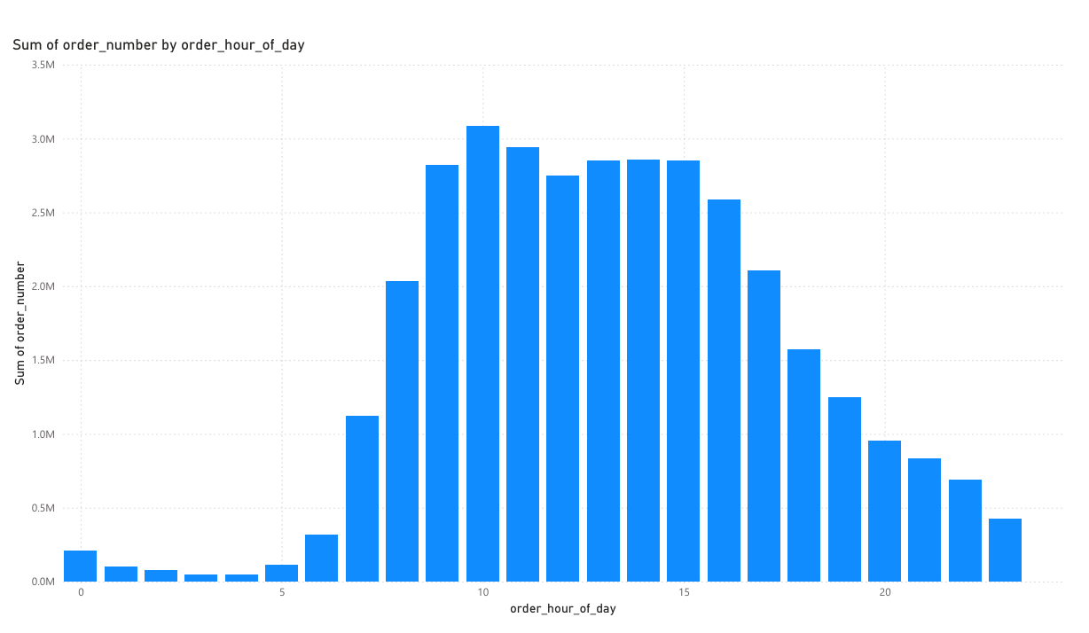

**Orders by Hour of the Day (order_hour_of_day)**

**What It Shows**

* This bar chart shows the number of orders placed at different hours of the day.
* X-axis: order_hour_of_day (0-23).
* Y-axis: Sum of order_number (total orders per hour).

**Key Insights**

* Peak order times appear between 9 AM and 3 PM.
* Orders gradually decline in the evening and night.

**Business Implications**

Optimize staffing and delivery logistics around peak hours.  
 Send targeted notifications during low-order hours to boost sales.

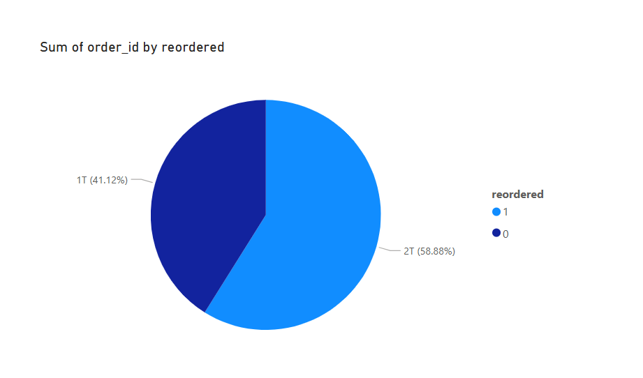

**Reordered vs. New Orders (reordered)**

**What It Shows**

* A pie chart displaying the proportion of new vs. reordered products.
* Segment 1: New orders (reordered = 0).
* Segment 2: Reordered products (reordered = 1).

**Key Insights**

* 58.88% of orders are reorders, meaning a large portion of customers purchase the same items repeatedly.

**Business Implications**

Offer loyalty rewards to frequent reordering customers.  
Use subscription models for frequently reordered products (e.g., dairy, beverages).

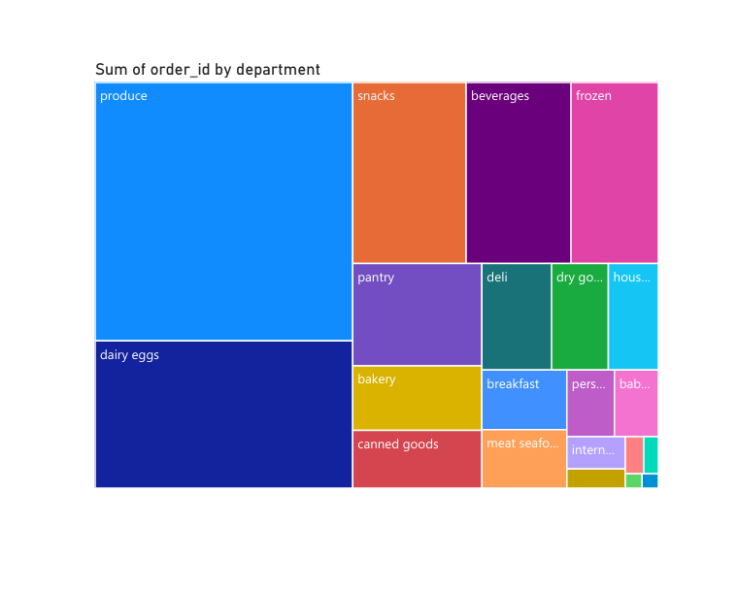

**What It Shows**

* A bar chart showing the number of orders placed per department.
* X-axis: Different product departments.
* Y-axis: Sum of order_id (total number of orders per department**).**

**Key Insights**

* The produce department has the highest orders.
* Other major departments include dairy & eggs, snacks, and beverages.

**Business Implications**

Ensure proper inventory levels for high-demand departments.  
Target discounts and promotions in lower-selling departments.