

DEBRE BERHAN UNIVERSITY
INSTITUTION Of TECHNOLOGY
COLLAGE Of COMPUTING
DEPARTMENT Of SOFTWARE ENGINEERING

FUNDAMENTALOFBIGDATAANALYTICSANDBUSINESS INTELLIGENCY(SEng5112)

-
Name: Ephrem Tilahun ID No DBUR/0094/13

Submitted to: Mr. Derbew Felasman (MSc) February, 2025 Debre Berhan, Ethiopia

Contents
1. Introduction 1
2. Data Source & Understanding 1
3. Data Extraction 1
4.Data Cleaning & Transformation 2
5.PostgreSQL Schema Design 2
6. Loading Data using Python 3
7. Visualization and Insights 4

1. Introduction
This report documents the implementation of an End-to-End Data Pipeline for an e-commerce dataset. The pipeline processes raw transaction data, loads it into a PostgreSQL database, and visualizes key insights using Power BI.

2. Data Source & Understanding
2.1 Dataset Overview
- File Name: ECommerce_consumer_behaviour.csv
- Size: 1 ,004 ,756 rows
- Columns: order_id, user_id, order_number, order_dow, order_hour_of_day, days_since_prior_order, product_id, add_to_cart_order, reordered, department_id, department, product_name
- Objective: Analyze customer purchasing behavior and sales trends.

Columns Description:
- order_id – Unique identifier for each order.
- user_id – Unique identifier for the customer who placed the order.
- order_number – The sequence number of the order for a given user (e.g., first order, second order, etc.).
- order_dow – Day of the week when the order was placed (0 = Sunday, 6 = Saturday).
- order_hour_of_day – Hour of the day when the order was placed (0–23).
- days_since_prior_order – Number of days since the customer’s previous order (helps track order frequency).
- product_id – Unique identifier for each product in the order.
- add_to_cart_order – Position of the product in the cart (1 = first item added, etc.).
- reordered – Binary value indicating whether the product has been previously ordered (1 = reordered, 0 = first-time purchase).
- department_id – Unique identifier for the department to which the product belongs.
- department – Name of the department (e.g., Dairy, Produce, Beverages).
- product_name – Name of the product purchased.

2.2 Identified Data Issues
- Missing values in days_since_prior_order
- Duplicate records
- Inconsistent text formatting (department & product names)
- Data types requiring conversion (order_hour_of_day, order_dow)

3. Data Extraction
Used pandas to load the CSV file into a DataFrame:
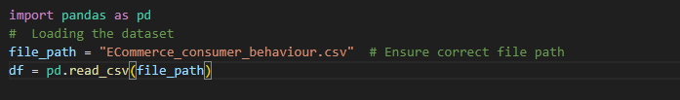

4.Data Cleaning & Transformation
- Handled missing values: Filled days_since_prior_order with 0.
- Removed duplicates: Ensured unique transactions.
- Converted data types: order_hour_of_day, order_dow to integers.
- Standardized text columns: Lowercased department and product_name.
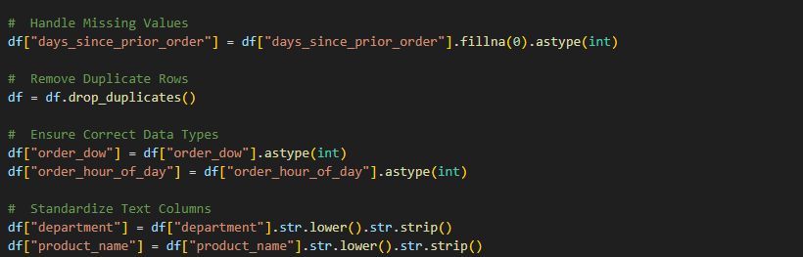

- Saved cleaned data:
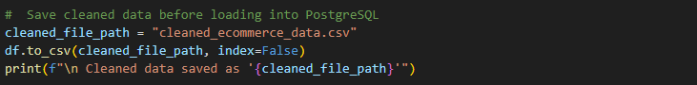

5.PostgreSQL Schema Design

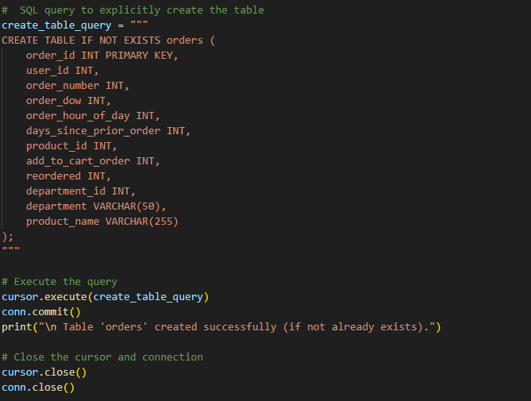

6. Loading Data using Python

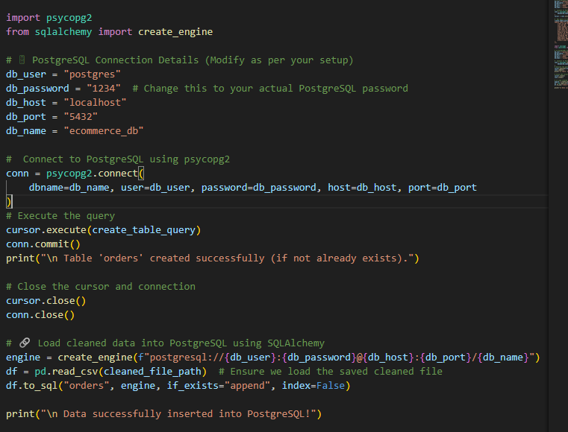

7. Visualization and Insights

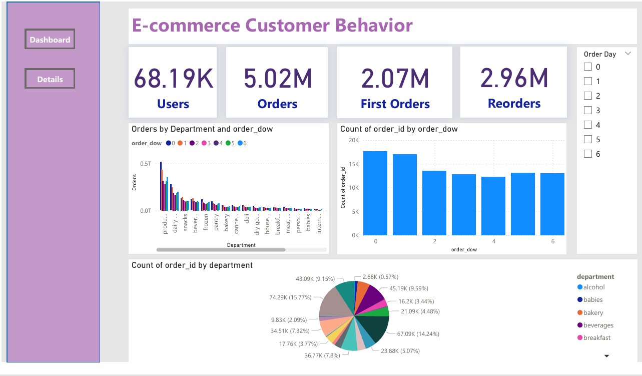
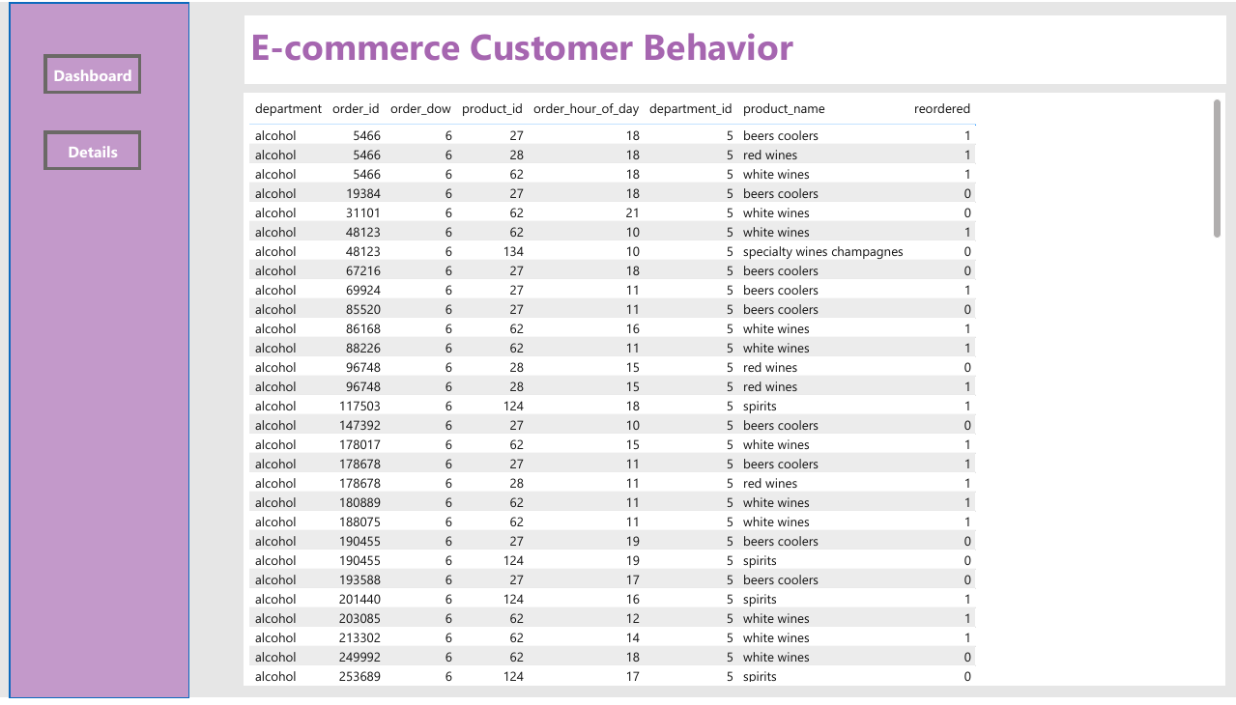

1. Order Day Filter
- A slicer that allows selecting specific days (0-6) to filter orders.
- Helps analyze customer ordering behavior by weekdays.
2. Orders by Department and Order Day (Stacked Bar Chart)
- Displays order distribution across various departments (e.g., dairy, snacks, beverages, frozen, bakery).
- X-axis: Departments.
- Y-axis: Order count.
- Each bar is segmented by the order day (0-6), showing trends across the week.
3. Key Metrics (Cards)
- 68.19K Users: Total number of users in the dataset.
- 5.02M Orders: Total number of orders placed.
- 2.07M First Orders: Orders made by new customers.
- 2.96M Reorders: Orders placed by returning customers.
4. Order Count by Order Day (Bar Chart)
- X-axis: Order Day (0-6).
- Y-axis: Number of orders.
- Displays customer order trends over the week.
5. Order Count by Department (Bar Chart)
- X-axis: Departments (Alcohol, Babies, Bakery, etc.).
- Y-axis: Order count.
- Shows the most and least ordered categories.
6. Order Details Table
- A detailed table containing:
  - Department
  - Order ID
  - Order Day
  - Product ID
  - Order Hour
  - Product Name
  - Reordered Flag (1 = Reordered, 0 = New Order)

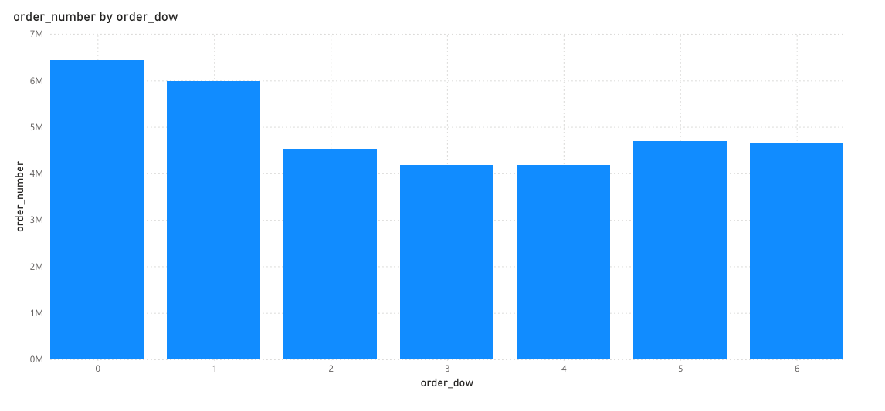
What It Shows:
- This bar chart represents the total number of orders placed on each day of the week.
- X-axis: order_dow (0 = Sunday, 1 = Monday, 2 = Tuesday, 3 = Wednesday ,4 = Thursday, 5 = Friday 6 = Saturday).
- Y-axis: Sum of order_number (total orders placed).
Key Insights
- Some days have significantly higher orders than others.
Based on the barchart Sunday is the day with the most orders.
- Identifies peak shopping days for better inventory and marketing strategies.

Technologies and Tools Utilized in the Data Pipeline

- VS Code: A code editor for writing and editing Python scripts, with built-in support for version control and extensions for various technologies.
- Python: A programming language used for data extraction, transformation, and processing in the data pipeline.
- PostgreSQL: A relational database management system for storing and managing structured data in the pipeline.
- Power BI: A business analytics tool used to visualize and analyze data, providing insights through interactive reports and dashboards.
- Git: A version control system used to track changes in code, manage collaboration, and maintain project history.

