RBAC Automation Stack
Diagram Legend and Reference

Field | Value
Version | 2.0
Created by | OpenShift Platform Team
Last updated | March 2026
Compliance | IS-20938
Diagrams covered | Reference Architecture | Implementation Detail

About These Diagrams
Two diagrams document the OpenShift RBAC automation stack. They serve different audiences and different purposes — read together, they give a complete picture of how the system is designed and how it works in practice.

Diagram | Purpose | Audience | Use when
Reference Architecture | Conceptual design — what the system is | Leadership, architects, new team members | Presenting, onboarding
Implementation Detail | Technical detail — how the system works | Platform engineers, auditors | Troubleshooting, compliance evidence

Color Legend
Both diagrams use the same color coding. Color encodes the role each component plays in the pipeline — not sequence.

Color | Role | Components
 | Blue | OIM Identity Self Service
 | Purple | Group Sync Operator, NamespaceConfig, GroupConfig
 | Teal | Namespace groups, Cluster groups
 | Amber | Namespace labels (pnc.net/mnemonic, pnc.net/app-environment)
 | Coral | RoleBindings, ClusterRoleBindings
 | Green | Users and groups on OCP

Arrow and Line Legend
Element | Meaning
Solid arrow | Automated flow — data or action moves between components with no manual intervention
Dashed vertical line | Path separator — divides the Namespace Path (left) from the Cluster Path (right)
Labeled arrow | Arrow label describes what the automation does at that step (e.g. LDAP sync, auto-generates)
Merge lines | Two paths converging — both outputs feed into a single downstream component

Diagram 1 — Reference Architecture
A conceptual view of the system with two clearly separated automation paths. No naming patterns, no policy names, no role assignments — the goal is to convey how the system is structured and how data flows through it.

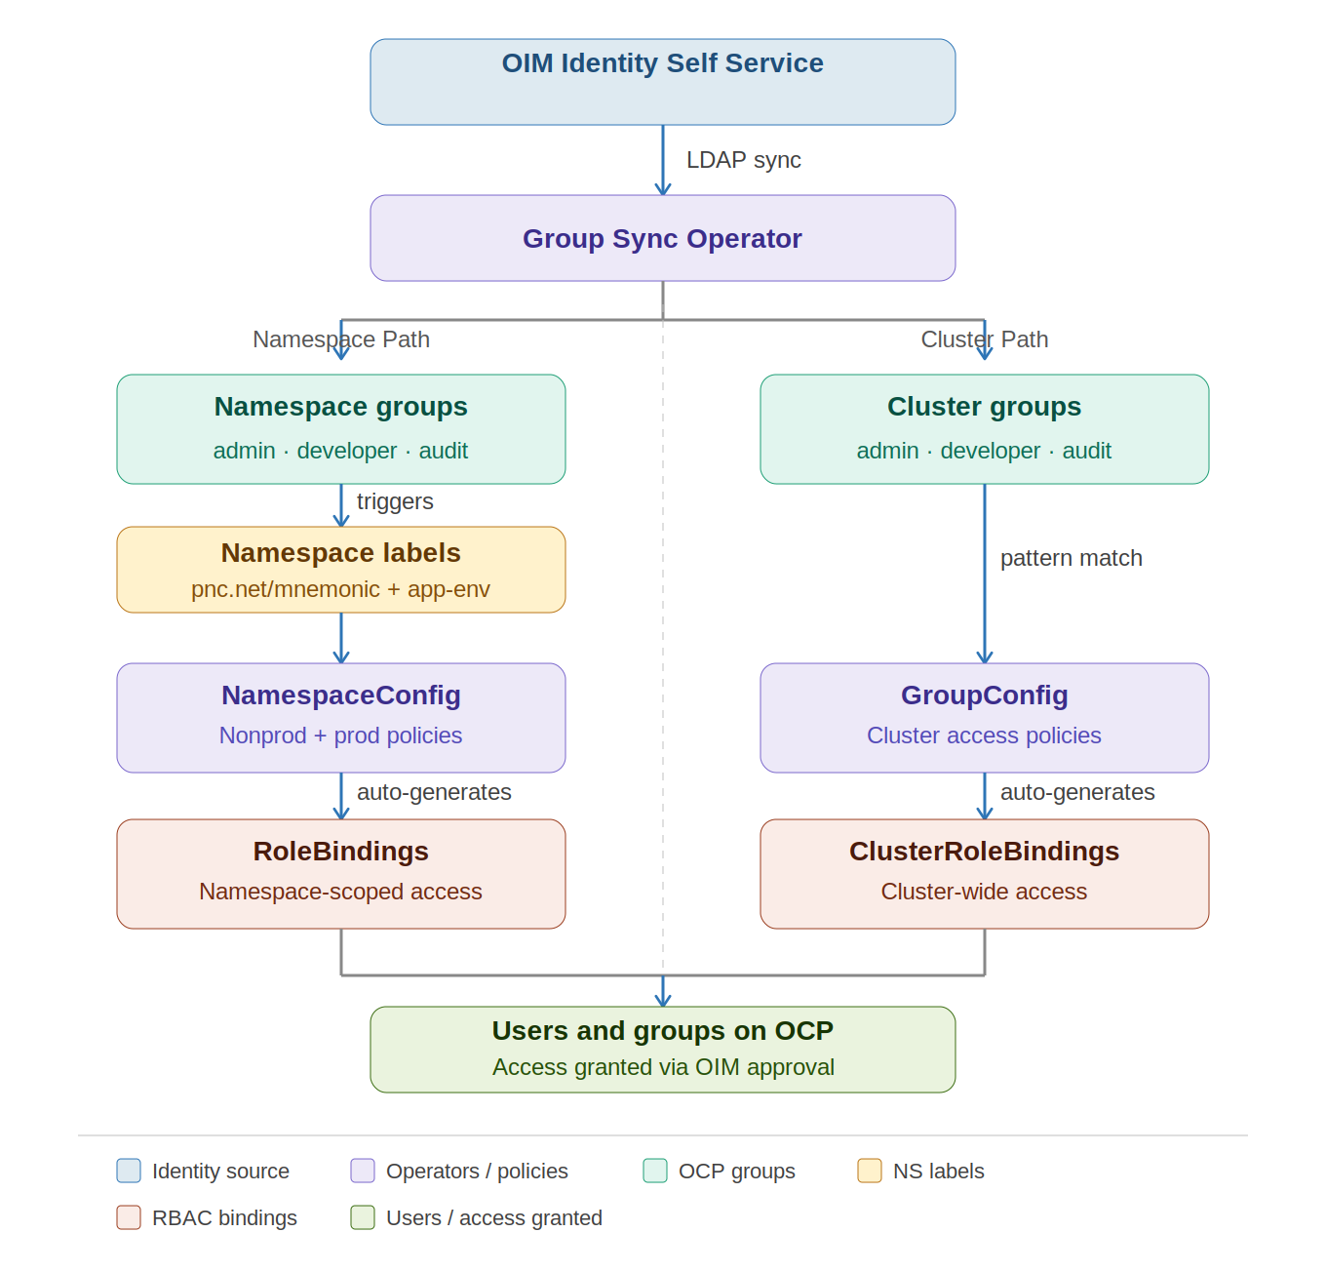

Key Design Decisions Visible in This Diagram
OIM as the single source of truth. Every component downstream of OIM is automated. The only human actions in the pipeline are submitting the OIM entitlement request and approving access requests from developers. Everything else is automatic.

The split into two paths. The Group Sync Operator produces two categories of group. These flow into two separate automation paths — one for namespace-scoped access, one for cluster-wide access. The paths are independent and use different policy types.

Namespace labels as a trigger. The namespace path requires both a group AND a namespace label to fire. The Namespace Labels component (amber) sits between the groups and the NamespaceConfig policy — it is a required co-trigger, not just metadata.

Both paths converge at the user. Users and groups on OCP is the end state of both paths. Access granted through either path becomes active after the OIM approval and the next Group Sync cycle.

Diagram 2 — Implementation Detail
The same pipeline with all technical specifics: naming conventions, policy names, role assignments, the prod restriction, and the Jenkins label automation. This is the working reference for anyone implementing, troubleshooting, or auditing the system.

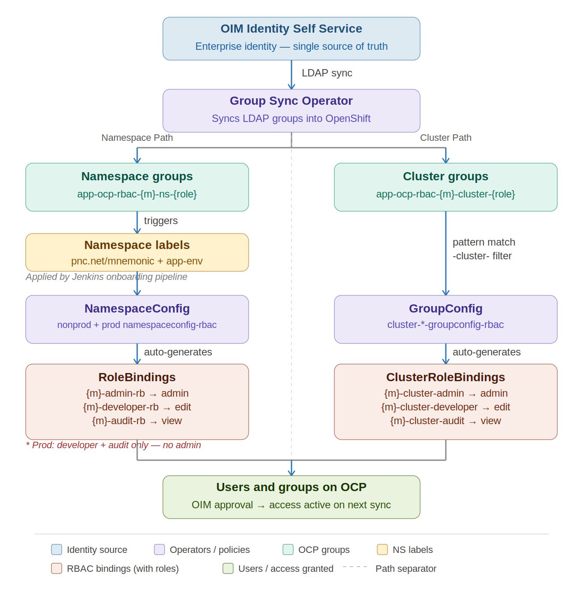

Key Technical Details Added Over Reference Architecture
Naming patterns in group boxes. The teal group boxes show the actual naming convention: app-ocp-rbac-{m}-ns-{role} (namespace path) and app-ocp-rbac-{m}-cluster-{role} (cluster path). Replace {m} with the 3-letter mnemonic and {role} with admin, developer, or audit.

Namespace label source. The amber label box carries a note: Applied by Jenkins onboarding pipeline. Labels are not set manually by mnemonic owners — they are applied automatically when a namespace is created through the standard onboarding process.

Policy names in operator boxes. The purple policy boxes show the actual resource names: nonprod + prod namespaceconfig-rbac (namespace path) and cluster-*-groupconfig-rbac (cluster path).

Pattern filtering note. The arrow from Cluster Groups to GroupConfig is labeled pattern match / -cluster- filter. The GroupConfig uses a template conditional to match only groups containing -cluster- in their name, preventing namespace-level groups from incorrectly receiving ClusterRoleBindings.

Role assignments in RBAC binding boxes. The coral binding boxes show the specific role each binding grants.

Binding | Role | Access
{m}-admin-rb | admin | Full namespace admin
{m}-developer-rb | edit | Deploy and manage workloads
{m}-audit-rb | view | Read-only
{m}-cluster-admin-crb | admin | Full cluster-wide admin
{m}-cluster-developer-crb | edit | Cluster-wide developer access
{m}-cluster-audit-crb | view | Cluster-wide read-only

Production restriction note. Below the RoleBindings box: Prod: developer + audit only — no admin. Enforced by a separate prod-namespaceconfig-rbac policy that does not generate the admin binding when pnc.net/app-environment=prod.

Users box detail. The green Users box reads: OIM approval → access active on next sync. Mnemonic owner approves in OIM → user added to LDAP group → Group Sync Operator runs → user is in the OpenShift group → existing RoleBinding grants access.

The Two Paths — Technical Reference
Property | Namespace Path | Cluster Path
Trigger | pnc.net/mnemonic + pnc.net/app-environment namespace labels | Group name pattern: app-ocp-rbac-{m}-cluster-{role}
Policy type | NamespaceConfig | GroupConfig
Policy names | nonprod-namespaceconfig-rbac, prod-namespaceconfig-rbac | cluster-admin/developer/audit-groupconfig-rbac
Output object | RoleBinding | ClusterRoleBinding
Output scope | Single namespace only | All namespaces in cluster
Roles generated | admin (nonprod only), edit, view | admin, edit, view
Prod restriction | No admin binding in prod | None
Who uses it | Application developers and auditors | Platform team (ocp mnemonic)
Label applied by | Jenkins onboarding pipeline | N/A — triggered by group name pattern

Automation Guarantee
Every RBAC object produced by this pipeline carries operator-stamped metadata. These annotations and labels are embedded at creation time and cannot be replicated by a manually created binding — they are the audit proof that the object was auto-generated.

Metadata | Value | What It Proves
app.kubernetes.io/managed-by | namespace-configuration-operator | Operator owns and reconciles this object
rbac.ocp.io/created-by | namespace-configuration-operator | Not manually created
rbac.ocp.io/mnemonic | {mnemonic} | Traceable to a specific application team
rbac.ocp.io/environment | {environment} | Correct policy branch was applied
rbac.ocp.io/source-namespaceconfig | nonprod/prod-namespaceconfig-rbac | Exact policy that drove generation
rbac.ocp.io/group-pattern | app-ocp-rbac-{m}-ns-{role} | Group name resolved from mnemonic pattern
rbac.ocp.io/environment-restriction | nonprod-only | Environment-aware policy fired correctly

Related Documents
Document | Description
Milestone 1.2 Completion Summary | Live cluster validation proving both paths work, with deep annotation analysis
OpenShift Namespace Naming Conventions and Mnemonic Req. | Mnemonic rules, namespace naming format, and label requirements
Requesting Access to OpenShift Namespaces | OIM entitlement onboarding guide for mnemonic owners
OpenShift Namespace Access — Getting Started | Confluence landing page — routing table for all personas

