

**SALALEE UNIVERSITY**

**COLLEGE OF NATURAL SCIENCE**

**DEPARTMANT COMPUTER SCIENCE**

***Internship tittle:*- NETWORK INSTALLATION AT SIINQEE BANK, TULU BOLO BRANCH**

**No. Name ID**

**1. LELISA TULU…………….……………RU0037/14-0**

**2. WAKUMA TESHOME…………………RU0036/14-0**

**Contact**

**email**

**[lalisatulu17@gmail.com](mailto:Lalisatulu17@gmail.com)**

**[wakegizaw@gmail.com](mailto:wakegizaw@gmail.com)**

**Phone number**

**+251925627801**

**+251941344994**

**Academic Advisor:- mr. Diriba .R**

**Fiche, Ethiopia.**

**Submission date:- October, 2024**

## 

## **Approval Letter**

## 

## **Acknowledgement**

First of all, we would like to praise almighty God for his grace and protection.

we would like to thank SALALE UNIVERSITY for giving us the opportunity to do an internship. We would like to thank all the employees who have given their continuous support, encouragements and guidance throughout the period (during the training).

Although quite short, for us this was a great experience we learn so many things. It helped us to explore our skills. Special thanks Mr. Biruk manager branch of Siinqee Bank Tulu Bolo branch and all the staff for being so helpful and understanding.

**Executive Summary**

This report is submitted in partial fulfillment of the requirements for the Bachelor’s degree in Computer Science at Salale University. It provides an overview of our internship experience at Siinqee Bank. As an intern, we took on various responsibilities and gained practical exposure in the field.

The report is structured into five chapters, each covering different aspects and activities encountered during our training by starting from the historical background of the Siinqee Bank. The primary purpose of the internship was to gain hands-on experience in a professional setting and apply the skills and knowledge acquired during our studies. Additionally, this report aims to document our experiences, analyze real-world organizational structures, and reflect on working in a professional and resource-rich environment.

Table of Contents

Approval Letter I

Acknowledgement I

List of figure IV

List of table V

List of acronyms V

Keywords of document 1

Chapter One 2

BACK GROUND OF THE SIINQEE BANK 2

1.1 Introduction 2

1.2 Strategic Aspiration (Vision, Mission, Objective and Core Value of the Siinqee Bank) 2

1.2.1. Organization vision 2

1.2.2. Organization Mission 2

1.3. Objectives of the Siinqee Bank 3

1.4. Core Values 3

1.5 Organizational structure and work flow of organization 4

CHAPTER TWO 5

2. OVERALL INTERNSHIP EXPERIENCE 5

2.1 Work tasks we have been executing 5

2.1.1. Overview of Tasks Completed During our Internship 6

2.1.2 How good we have been performing our tasks 6

2.1.3 Challenges Faced During our Internship 6

2.1.4 Actions Taken to Overcome the Challenges 8

2.2 Physical Devices and Tools Used During Internship Program 8

2.2.1 Network Devices 8

2.2.2 Interconnections (Cables and Connectors) 10

2.2.3 Installation Tools 13

2.2.4 Container Tools 15

2.3 Activities Done in the Organization 16

2.3.1 Task One: Crimping & Punching UTP Cable 16

2.3.2 Task Two: Preparing Network Installation Requirements 16

CHAPTER THREE 17

3. SHORT SUMMARY OF THE INTERNSHIP 17

3.1 Introduction 17

3.2 Problem Statement 17

3.3. Objective of the project 17

3.3.1. General objective 17

3.3.2. Specific Objectives 17

3.4. Methodology 18

3.5. Results & Conclusions 18

CHAPTER FOUR 20

SKILLS AND KNOWLEDGE GAINED FROM THE INTERNSHIP 20

4.1 Overall benefits we gained from an internship 20

4.1.1 What we gained in terms of improving our practical skills 20

4.1.2 What we gained in terms of improving our interpersonal communication skills 20

4.1.3 What we gained in terms of improving our team playing skills 21

4.1.4 What we gained in terms of Leadership Skills 21

CHAPTER FIVE 22

5.1 SUMMARY AND CONCLUSION 22

5.2 Recommendations 22

5.2.1 Recommendation for the Company 22

5.2.2 Recommendation for the University 23

5.2.3 Recommendation for the Students 23

5.3.References 24

## List of figure

Figure 1 :structure 4

Figure 2 NIC 8

Figure 3 Hub 9

Figure 4 : sisco switch 9

Figure 5 : Router 9

Figure 6 : Access Point 10

Figure 7 Twisted Pair Cable Arrangement 10

Figure 8 straight through cable 11

Figure 9 cross over arrangement 12

Figure 10 coaxial cable 12

Figure 11 fiber optic cable 13

Figure 12 network cable tester 14

Figure 13 punch down tool 14

Figure 14 crimping tool 14

Figure 15 multifunctional cutting & stripping tool 15

Figure 16 network rack 15

Figure 17 patch panel 16

## List of table

Table 1:Straight Through Cable Arrangement 568-B.....................................................14

Table 2:Cross Over Cable Arrangement..........................................................................14

## List of acronyms

* **NIC** - Network Interface Card
* **LAN** - Local Area Network
* **WAN** - Wide Area Network
* **TCP** - Transmission Control Protocol
* **UTP** - Unshielded Twisted Pair
* **STP** - Shielded Twisted Pair
* **RJ-45** - Registered Jack-45
* **BNC** - Bayonet Neill–Concelman
* **CAT6** - Category 6 Cable
* **NBE** - National Bank of Ethiopia
* **MFI** - Micro Finance Institution
* **WLAN** - Wireless Local Area Network
* **MAC** - Media Access Control
* **BNC** - Bayonet Neill–Concelman (Connector)
* **RJ-11** - Registered Jack-11 (Connector for telephone lines)
* **SC** - Subscriber Connector (Fiber optic connector)
* **FC** - Ferrule Connector (Fiber optic connector)
* **ST -** Straight Tip
* **LC -** Lucent Connector

## Keywords of document

UTP (Unshielded Twisted Pair),DHCP (Dynamic Host Configuration Protocol),Fiber Optic,VLAN (Virtual Local Area Network)

# 

# **Chapter One**

## **BACK GROUND OF THE SIINQEE BANK**

## **1.1 Introduction**

Siinqee Bank is a transformation of Oromia credit and saving Share Company. Which has served as Micro finance (MF) Institution since August 4/1997 to march 15/2021 after that it transformed on process was started on march 16/2021 based on the National Bank direction.On February 16/2022 SIINQEE Officially received its license from NBE to start operation with subscribed capital of above 7 billion birrs following its transformation from MFI.

Today, more than ever before, Siinqee Bank aggressively expanded its presence in all directions of the country. Despite the flourishing of private commercial banks in the country, Siinqee Bank has remained potent and is in the compiled in terms of assets, deposits, capital, and customer base. Accordingly, Siinqee bank envisions is becoming world class commercial bank by the year 2025. In its strategic document too, it is clearly stated that the bank values both its customers and employees as not only important but also essential actors in all its endeavors of fulfilling public expectations.

## **1.2 Strategic Aspiration (Vision, Mission, Objective and Core Value of the Siinqee Bank)**

1.2.1. Organization vision**”**To be the Leading Bank in Financial inclusion and Transformation”.

### 1.2.2. Organization Mission

“Siinqee Bank is dedicated to provide full-fledged banking and Microfinance service with strong commitments to reach all classes of the society through its integrated service channels, innovative financial products, engaging qualified, professionally equipped, motivated and highly disciplined employees by employing the state-of-the art technology in line with the law of the land to empower the society with provision of appropriate financial literacy, access to diversified financial services and source of area knowledge.”

## **1.3. Objectives of the Siinqee Bank**

Every organization is established for their own objectives. To achieve this objective, they have to work hard and follow up the best way effectively.Based on the vision and mission statements stated above, Siinqee bank strives to achieve the following objectives

* **Empowering society**

Siinqee Bank's objectives include empowering society through its banking and micro-finance services.

* **Economic growth**

Siinqee Bank aims to contribute to economic growth by providing financial services and mobilizing financial resources.

* **Digital banking**

Siinqee Bank uses digital banking services and technology to improve business efficiency, reduce expenses, and increase accuracy.

* **International banking**

Siinqee Bank has opened international accounts to create partnerships with international banks and provide better coverage to customers involved in import and export trade.

* **Women's rights**

Siinqee Bank's brand identity is inspired by women's rights and values in society.

* **Sharia-based banking**

Siinqee Bank offers interest-free banking services based on the principle of Sharia.

## **1.4. Core Values**

* **S: S**ocially Responsible
* **I: I**ntegrity
* **I:** **I**nnovation
* **N: N**urturing
* **Q: Q**uality service
* **E: E**fficiency
* **E:** **E**mpowering

## 1.5 Organizational structure and work flow of organization

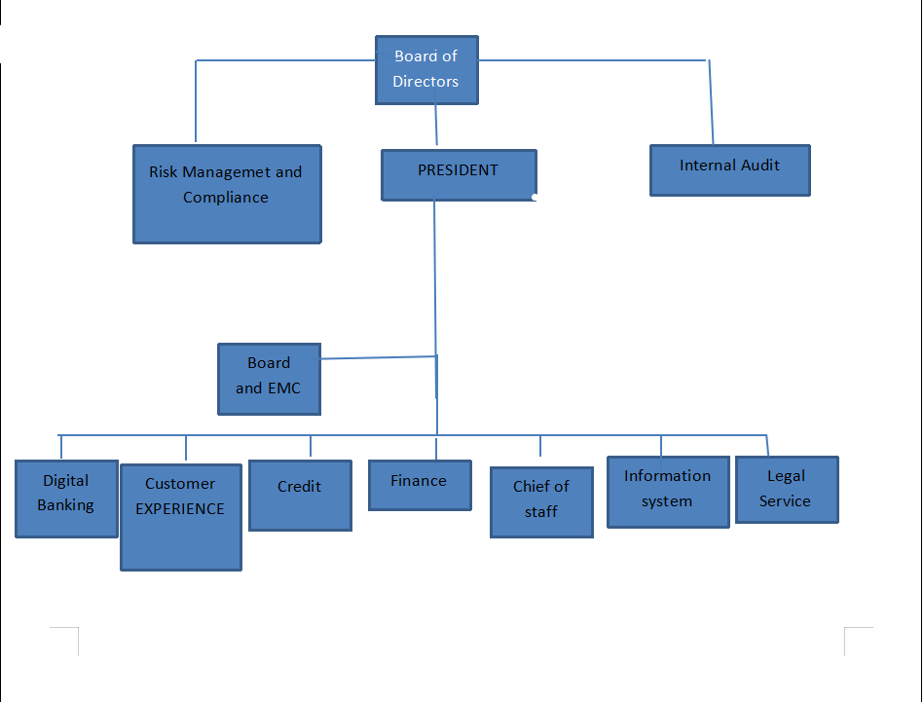

Figure 1:structure

# CHAPTER TWO

# **OVERALL INTERNSHIP EXPERIENCE**

As per the chance that opened by the institute for the students to consume a practical knowledge, we started to communicate with organization that might help us to develop our theoretical knowledge to the practical world and we submitted our request to Siinqee Bank, South West Shewa DISTRICT. They were happy to accept our request and assign us as internee to one of their branch, Tulu Bolo. they gave us an opportunity stating that we can train in their organization for the 1 months.

At our first day of internship, we visited the office and introducing staff members they explain the rule and regulation of the office and give us some orientation about work.

## **2.1 Work tasks we have been executing**

We were trained at south west Shewa district Tulu Bolo branch and since the stakeholders support us and we was doing a tasks like network installation of network devices like router, switch, Cabling & Connectivity tools and we also visited branches. As we started to practice more and more it became familiar.

This document outlines a 4-week internship program focused on Network Installation, designed to provide practical experience and skill development in a professional setting.

***Week 1: Introduction & Orientation***

* Company Introduction, Safety Procedures and Meet the Team.
* Review of Basic Networking Concepts (Local Area Network, Wide Area Network, TCP/Internet Protocol).
* Introduction to Network Devices (Hubs, Switches, Routers, Network interface Card)

***Week 2: Network Cabling, Connectivity , Network Devices & Installation***

* Introduction to Different Cable Types (Unshielded twisted pair, shielded twisted pair, Fiber Optic, Coaxial).
* Hands-on Crimping and Testing of CAT6 Cables.
* Understanding Connectors (RJ-45, RJ-11).
* The process of installing the physical components of a network, including cabling and hardware.
* The process of mounting network devices (like switches and routers) in server racks.
* Devices used to organize and connect incoming and outgoing network cables.

***Week 3: Advanced Network Concepts & Documentation***

* An assessment of the physical environment to determine the best layout for network devices and cabling.
* A comprehensive list of tasks to be completed during the network installation process.
* Methods to verify that the network installation meets performance standards (e.g., cable testing with a certifier).

***Week 4: Final Review***

* Review of Key Concepts Learned Throughout the Internship.
* Prepare Final Summarizing Projects and Learning Outcomes.
* Feedback Session.

### **Overview of Tasks Completed During our Internship**

* Identifying different categories of cables.
* Crimping several CAT6 cables.
* Testing of cable
* Identifying RJ-11 and RJ-45 connectors.

### 2.1.2 **How good we have been performing our tasks**

we really believe that we have been doing well. Also our supervisor and the staff members were giving us a good feedback and following our progress during our stay in their office. we admit that we have been trying our best to do better and better day after day. And we feel like we were improving our skills in those days.

### 2.1.3 **Challenges Faced During our Internship**

There's no suspicion that the internship environment presents unique challenges. Since it was our first time in a professional setting, adapting to work-life dynamics was not always easy. While every job has its difficulties, during our one-month internship, we encountered several common challenges. However, we saw these challenges as opportunities to learn new things and improve our problem-solving skills. The experience also allowed us to grow both personally and professionally, confronting situations we wouldn’t have been able to handle before our internship.

**Some of the main challenges we faced include:**

* Hesitation in asking questions.
* Adjusting to a new lifestyle.
* Limited support from employees who were busy with their own tasks.
* Meeting new people in an unfamiliar environment.
* Lack of proper network-related materials across branches, among other issues.

### 2.1.4 **Actions Taken to Overcome the Challenges**

Overcoming the challenges mentioned was not easy, but with the support of the staff members and our supervisor, we were able to adjust most of them. Some of the steps we took to address these issues include:

* Proactively asking senior employees if we could assist with their tasks
* Building friendly relationships with other interns and employees
* Avoiding falling into repetitive routines by trying new tasks
* Scheduling social activities and engaging in adventurous experiences to maintain balance.

## 2.2 **Physical Devices and Tools Used During Internship Program**

### **2.2.1 Network Devices**

Network devices are hardware components used to connect computers, printers, fax machines, and other electronic devices to a network. These devices ensure the fast, secure, and accurate transfer of data across the same or different networks. They serve as the key points in the transmission of data from the sender to the receiver.

**A. Network Interface Card (NIC):**

The NIC is a physical hardware component that enables a device to connect to network, typically forming a Local Area Network (LAN). The NIC serves as the computer's entry point into the network, providing a unique identity to each device.

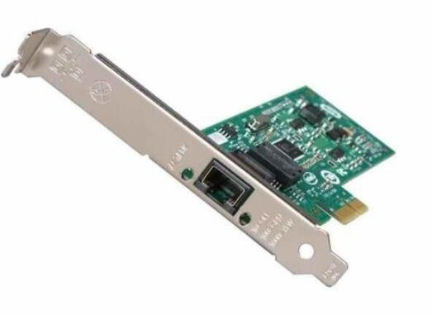

Figure 2 NIC

***B. Hub***: hub is a physical devices which connects multiple network devices together and functions as a multiport repeater. It does not filter data, so data packets are sent to all connected devices. The main drawback of hubs is the possibility of data collisions when two devices attempt to transmit frames simultaneously.

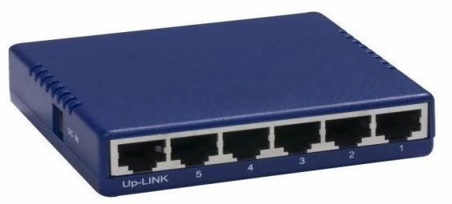

Figure 3 Hub

***C. Switch****:* A switch is network devices that connects multiple network devices together and it is a more intelligent and efficient. It connects devices on a network by using packet switching to receive, process, and forward data to the correct destination. Switches store MAC addresses of devices and use this information to filter data and direct it to the correct device, operating at the data link layer.

Figure 4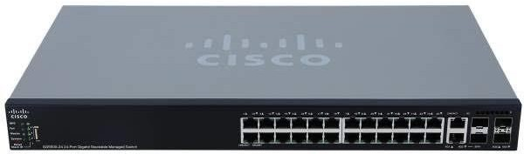: sisco switch

***D. Router*:**A router is a network device used to connects different networks together and it is responsible for routing data packets based on their IP addresses. Its primary function is to connect LANs and WANs and dynamically update routing tables to determine the best path for data transmission. Routers operate at the network layer.

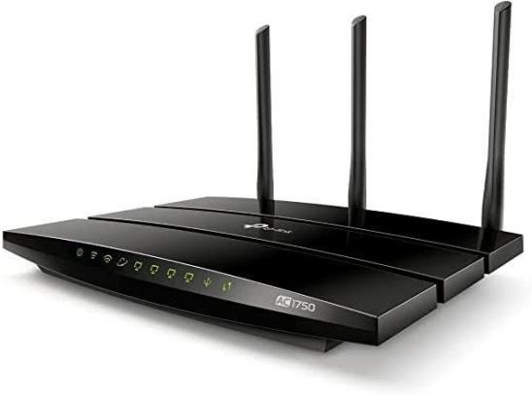

Figure 5: Router

***E. Server***:A server is a dedicated computer designed to share resources and a specialized computer on a network that provides services to other computers, known as clients. While servers use the same hardware as regular computers, their purpose differs in that they offer specific services and programs. Common types of servers include application servers, file servers, print servers, web servers, database servers, mail servers, gaming servers, and many others.

***F. Access Point***: An access point is a device that creates a wireless local area network (WLAN), typically in offices or large buildings. It connects to a wired router, switch, or hub using an Ethernet cable.

Figure 6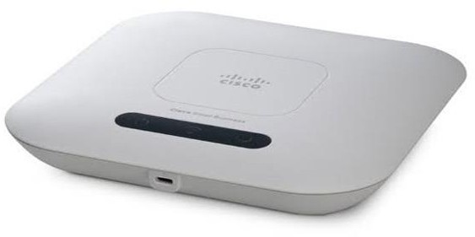: Access Point

### 2.2.2 **Interconnections (Cables and Connectors)**

These are communication channels used to interconnect nodes on a computer network. Generally, these are physical channel used for transmission in the network. Typically, these media are located below the physical layer and are controlled by the physical layer.

**Cables**

The following sections discuss the types of cables used during our internship training program and other related topics.

1. ***Twisted Pair Cable*:** It is a high-speed cable that transmits the data over 1Gbps or more. It comes in two varieties: Shielded (STP) and unshielded (UTP). The standard connector for UTP is an RJ45. STP is the least expensive cable, and it uses RJ48 as a connector.

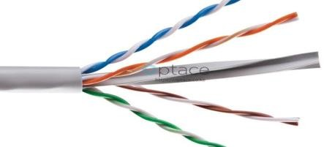

Figure 7 **Twisted Pair Cable Arrangement**

Twisted Pair cable has 2 different arrangements: straight through and cross over. The only difference between this arrangement is straight through is used to connect different devices, whereas, cross over is used to connect similar devices.

* **Straight Through-Cable Arrangement**: This cable arrangement also has 2 different category 568-A and 568-B. During our internship training we used only the most widely used standard 568-B.

|  |  |  |
| --- | --- | --- |
| Pin Id | Side A | Side B |
| 1 | White-Orange | White-Orange |
| 2 | Orange | Orange |
| 3 | White-Green | White-Green |
| 4 | Blue | Blue |
| 5 | White-Blue | White-Blue |
| 6 | Green | Green |
| 7 | White-Brown | White-Brown |
| 8 | Brown | Brown |

Table 1: Straight Through Cable Arrangement

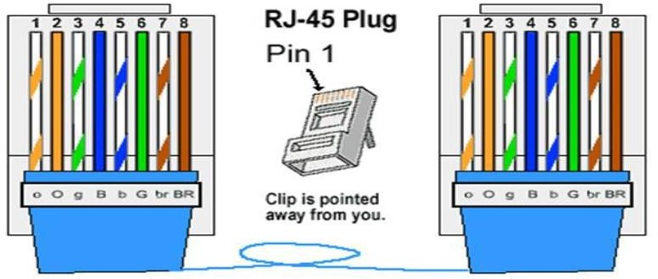

Figure 8 straight through cable

* **Cross Over Cable Arrangement:** The difference in cross over is that the 2nd side of the cable is different from the first side.

|  |  |  |
| --- | --- | --- |
| Pin Id | Side A | Side B |
| 1 | White-Orange | White-Green |
| 2 | Orange | Green |
| 3 | White-Green | White-Orange |
| 4 | Blue | White-Brown |
| 5 | White-Blue | Brown |
| 6 | Green | Orange |
| 7 | White-Brown | Blue |
| 8 | Brown | White-Blue |

Table 2 Cross Over Cable Arrangement:

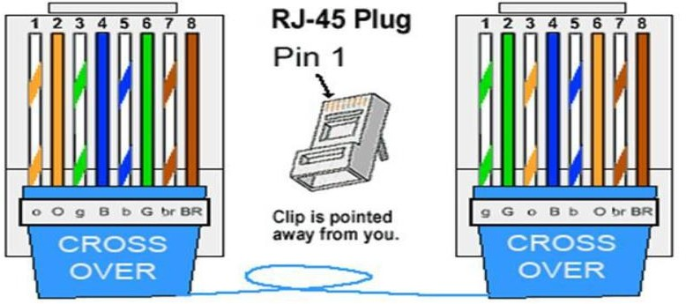

Figure 9 cross over arrangement

1. ***Coaxial Cable***: Coaxial cable resembles like a TV installation cable. Coaxial cable is more expensive than twisted pair cable, but it provides the high data transmission speed. In addition to all this it is a single copper conductor at its center. Beyond-Neil- Councilman (BNC) is most widely used connecter for coaxial cables.

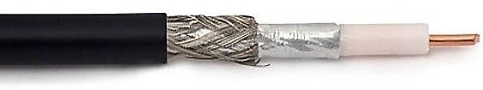

Figure 10 coaxial cable

1. ***Fiber Optic Cable***: Fiber optic cable is a high-speed cable that transmits the data using light beams. It provides high data transmission speed as compared to other cables. It is more expensive as compared to other cables, so it is installed at the government level.

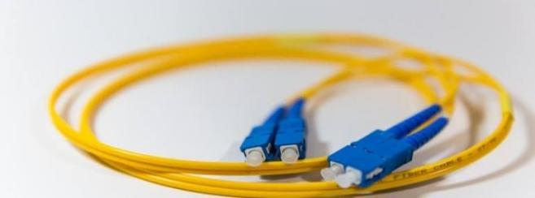

Figure 11 fiber optic cable

**Connectors**

* RJ-45 Connector: the most common connector for Ethernet cable. It is 8-pin connector, often referred to as an “ethernet jack.”
* Fiber optic connector there are various types of fiber optic connector such as ST, SC, FC and LC
* BNC Connector: is used for coaxil cables it’s bayonet style connector that provides a secure connection.

### 2.2.3 **Installation Tools**

These are hardware materials that we used to install a network in a particular area. Installation tools make the network installation easier and manageable.

* + - 1. **Tester*:*** is a device designed to measure and test existing LAN connection. It also helps to test the strength and connectivity of a particular type of cable.

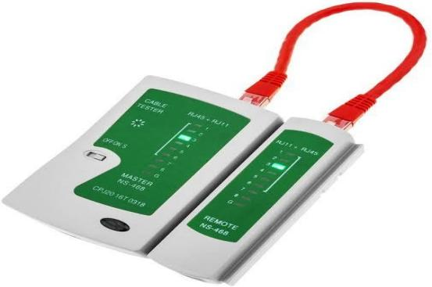

Figure 12 network cable tester

* + - 1. **Puncher**: punch down tool, also called a krone tool, is a tool that we used during our installation period. It is used for inserting wire into insulation-displacement connectors on punch down blocks, patch panels, keystone modules, and other devices.



Figure 13 punch down tool

* + - 1. **Crimper*:*** is a device used to join two pieces of metal by deforming one or both in a way that caused them to hold each other. The result of the tool’s work is called a crimp. Mostly, we used this installation tool to affix a RJ45 connector.



Figure 14 crimping tool

* + - 1. **Stripper and wire cutter**: is a cutting and stripping tool that is used to remove the upper part of network cable.

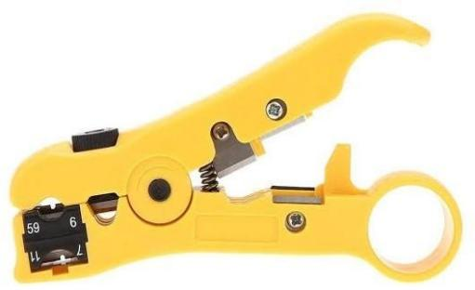

Figure 15 multifunctional cutting & stripping tool

### **2.2.4 Container Tools**

These are network tools that help to arrange and manage different network devices into one. Container tools are very useful in network environment with their grater management advantage and effective way of structuring devices. The following are container tools that we used in our internship training.

1. **Network Rack:** is a metal frame that holds, organizes, secures and protects various computer network devices and server hardware devices. Network rack can hold different types of equipment it can hold switches, routers, modems, patch panels, etc.

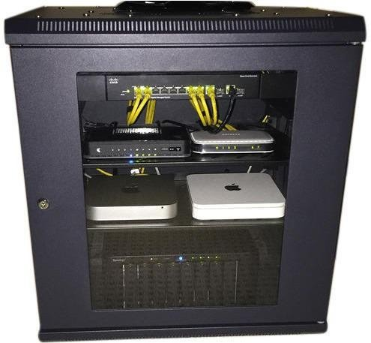

Figure 16 network rack

1. **Patch Panel:** is a collection of many ports on one panel, with each of the ports connected via a patch cable to another port elsewhere in the house. It allows for easy management of the wired network and better organization.

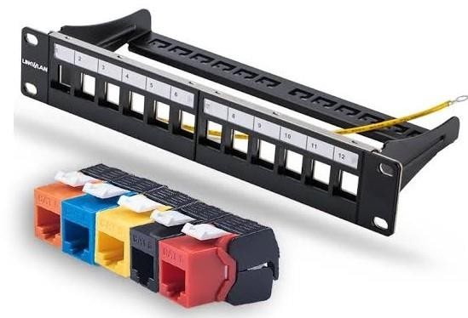

Figure 17 patch panel

## 2.3 Activities Done in the Organization

During our internship, we performed several tasks assigned by the supervisor, aimed at improving our network installation and operational skills.

### 2.3.1 Task One: Crimping & Punching UTP Cable

The first task involved crimping a CAT6 cable and punching it into a UTP patch panel. This helped us develop essential networking skills.

* **Objective**: Prepare a network cable by cutting it to length, stripping it, and attaching connectors.
* **Steps**:
  1. Prepared tools (cable, RJ45 connector, keystone jack, crimper, puncher).
  2. Stripped the cable and arranged the wires.
  3. Cut wires to 13 mm length and inserted them into the connector.
  4. Crimped the connector and tested it with a network tester.

### 2.3.2 Task Two: Preparing Network Installation Requirements

We also organized network installation requirements for a small office, based on its structure and usage needs.

* **Objective**: Learn how to efficiently prepare network installation requirements.
* **Steps**:
  1. Analyzed the office’s network topology and user needs.
  2. Planned for future scalability.
  3. Identified and listed required materials, factoring in cost and specifications

# CHAPTER THREE

# 3**.** SHORT SUMMARY OF THE INTERNSHIP

## **3.1 Introduction**

The transition from the theoretical world of network textbooks to the dynamic environment of a real-world internship was a truly interesting experience. While we had a solid grasp of the concepts, we quickly realized that the practical application of those concepts presented a whole new set of challenges. This internship at Siinqee Bank is not only deepened our understanding of network, but also sharpened essential skills like communication, teamwork, and problem-solving, proving invaluable for any successful career in the field

## **3.2 Problem Statement**

* **Resource Constraints**: Access to key resources (network materials, tools, or data) might be limited, affecting the ability to complete certain tasks effectively
* **Time Management**: Balancing multiple tasks or managing work deadlines can be overwhelming
* **Insufficient support** : Since the employees were fully engaged in different works it is a little hard to get full support.
* **Lack of Guidance**: Interns may struggle with insufficient direction or mentorship, leading to uncertainty in task execution.

## **3.3. Objective of the project**

### 3.3.1. **General objective**

The main objective of the project was to gain practical experience in network installation.

### **3.3.2. Specific Objectives**

There were Different tasks. which have been given to us during the internship and the main objective of those tasks are:

* **Install Network Hardware**: Learn to properly install and configure hardware such as routers, switches, firewalls, and access points in various locations within the bank.
* **Cable Installation and Management**: Gain expertise in laying, crimping, and organizing different types of network cables (e.g., Ethernet, fiber optic) to ensure efficient and reliable connectivity.
* **Test and Validate Connectivity**: Use tools like network testers and cable certifiers to verify that all installed network components are functioning correctly and meet performance standards.
* **Troubleshoot Installation Issues**: Develop problem-solving skills to address any issues that arise during or after installation, such as connection problems or hardware malfunctions.

## **3.4. Methodology**

**Planning**

* Assess bank needs and survey the site for installation.

· **Design**

* Create a network layout and select appropriate devices.

· **Preparation**

* · Gather all necessary tools and materials.

· **Cable Installation**

* · Lay and connect cables neatly.

· **Device Setup**

* · Install and connect routers, switches, and other devices.

· **Testing**

* · Check connectivity to ensure everything works.

· **Documentation**

* · Record configurations and network layouts for future reference.

# **3.5. Results & Conclusions**

our one-month internship at Siinqee Bank, Tulu Bolo branch was an incredible learning experience. It transformed our theoretical knowledge into practical skills, pushing us to apply our understanding of networking in a real-world setting.

our primary role was supporting network installation. We gained hands-on experience working with network devices, cables, and tools. From identifying different cable types and crimping CAT6 cables to testing network connections and ensuring proper functioning, we became more comfortable with practical applications. We also learned to analyze network issues, identify solutions, and implement them effectively.

One of the biggest challenges was adapting to a fast-paced work environment. Initially, we was hesitant to ask questions, but we realized the importance of seeking guidance to ensure we understood tasks and procedures accurately. We learned to communicate effectively with senior employees, fostering a collaborative learning environment.

This internship has significantly improved our technical skills and strengthened our ability to work effectively. It has also shown us the importance of continuous learning, problem-solving, and communication in a dynamic information technology field. We are confident that the skills and experiences we gained will be valuable as we pursue a career in the exciting world of network technology

# **CHAPTER FOUR**

# **SKILLS AND KNOWLEDGE GAINED FROM THE INTERNSHIP**

## **4.1 Overall benefits we gained from an internship**

An internship is a good introduction to the career we may want to pursue. Internships are typically arranged through an educational counselor who can help match us to a company that fits our career goals. Because companies typically have to meet educational requirements for internships. Information technology provided us with professional work experience in a safe and structured environment with help from experts. At the internship, we practiced and improved our office skills while also learning how to work. we also learnt what the roles and responsibilities of a particular career are from people working in the field. It was a real confidence builder for us. It helped us to decide if a particular career is a good match for our personality, lifestyle, passions and goals.

### **4.1.1 What we gained in terms of improving our practical skills**

Before the internship program most of our knowledge was based on theoretical basis. When it comes to the internship program it opened a great opportunity to bring the theoretical knowledge in to the real world and practice knowledge in to the real world and practice.

During the internship, we enhanced our practical skills in several areas:

**Tool Proficiency**: Gained hands-on experience using essential tools like crimpers and cable testers.

**Cable Management**: Learned effective techniques for crimping CAT6 cables and organizing network installations.

**Application of Theory**: Applied classroom knowledge to real-world scenarios, bridging the gap between theory and practice.

### **4.1.2 What we gained in terms of improving our interpersonal communication skills**

Strong interpersonal skills are important for employers because most jobs require effective interaction with other people. These skills are vital for success in the workplace. There are many different types of interpersonal communication. Some of the important skills are:

During the internship, we improved our interpersonal communication skills by:

**Clear Communication**: Learned to convey technical information clearly and concisely.

**Active Listening**: Enhanced our ability to listen to and understand colleagues’ concerns.

**Feedback Exchange**: Gained experience in giving and receiving constructive feedback.

### **4.1.3 What we gained in terms of improving our team playing skills**

During the internship, we improved our team playing skills by:

**Sharing Responsibilities**: Willingness to share tasks and support others to achieve common goals.

**Clear Exchange of Ideas**: Ensuring that information, ideas, and concerns are communicated clearly among team members.

**Reliability**: Being dependable and following through on commitments to build trust within the team.

### **4.1.4 What we gained in terms of Leadership Skills**

During the internship, we improved our leadership skills by:

* **Clear Instructions**: Ability to communicate technical concepts clearly to team members and stakeholders.
* **Building Trust**: Creating an environment where team members feel comfortable sharing ideas and concerns.
* **Decisiveness**: Making prompt decisions in high-pressure situations to keep projects on track

# **CHAPTER FIVE**

## 5.1 SUMMARY AND CONCLUSION

In general, this internship program gives usa chance to learn from the good experts. The time of our internship program was really interesting. This internship was very beneficial to us as we learned a lot, and it made us discover works in partial of real world. We believe that we have had a good working experience from the company, like how to act in office during working hours and what type of relation should we have to make with colleagues and other members of the company’s community.

After going through the whole period of internship we have observed so many professional activities and learnt as well.

* + - We learnt new concepts and new ways of working.
    - We acquired practical experience to complement the theoretical content of our study for campus, Network cable installation, network cable maintenance.
    - To conclude, we think that this internship was very beneficial to us as we learnt a lot, and it made us discover works in partial of real world.

This internship was definitely an introduction to the actual work field for me. We have learned to work in a Networking organization and apply our knowledge into practice.

## **5.2 Recommendations**

The following are the internes recommendation for improvement of internship training.

### **5.2.1 Recommendation for the Company**

As a recent intern at Siinqee Bank, we gained valuable experience and insights. To further improve the internship program and enhance its value for future participants, we recommend the following:

* **Structured Internship Program**: Develop a structured internship program with clear objectives, timelines, and project guidelines to enhance the learning experience for interns.
* **Dedicated Supervisors**: Assign dedicated supervisors to guide interns, ensuring they receive proper mentorship and support throughout their training.
* **Regular Feedback**: Implement a feedback system for interns to receive constructive criticism and recognition for their efforts, fostering a positive learning environment.

### **5.2.2 Recommendation for the University**

As an member of the information technology center in Siinqee Bank from what we observed we recommend the followings main points for university.

* **Practical Training Opportunities**: Offer more courses focused on practical applications of networking concepts to better prepare students for real-world situations.
* **Internship Coordination**: Establish a system for regular monitoring and support for students during internships to help them maximize their learning.
* **Industry Partnerships**: Foster partnerships with local companies for internship placements, ensuring students gain experience in diverse environments.

### **5.2.3 Recommendation for the Students**

* **Time Management**: Develop good time management skills to balance tasks effectively and meet deadlines.
* **Seek Feedback**: Actively seek feedback from supervisors and colleagues to improve your skills and performance during the internship
* **Documentation**: Keep detailed notes on processes and troubleshooting steps during the internship to aid in future learning and reference.

# **5.3.References**

|  |  |
| --- | --- |
|  | Siinqee, "background,"2021 . |
|  | https://siinqeebank.com/about |
|  | https://ethiopianbusinessreview.net/Siinqee. |
|  | https://banksethiopia.com/banks/siinqee |
|  | Interview with supervisor during practice. (2024. |