Screenshot 1: Include the screenshot as mentioned in the video tutorial that verifies that you have completed the entire module. Find the example submission below. Delete the following screenshot and replace it with your own screenshot. Make sure that your name is clearly visible.

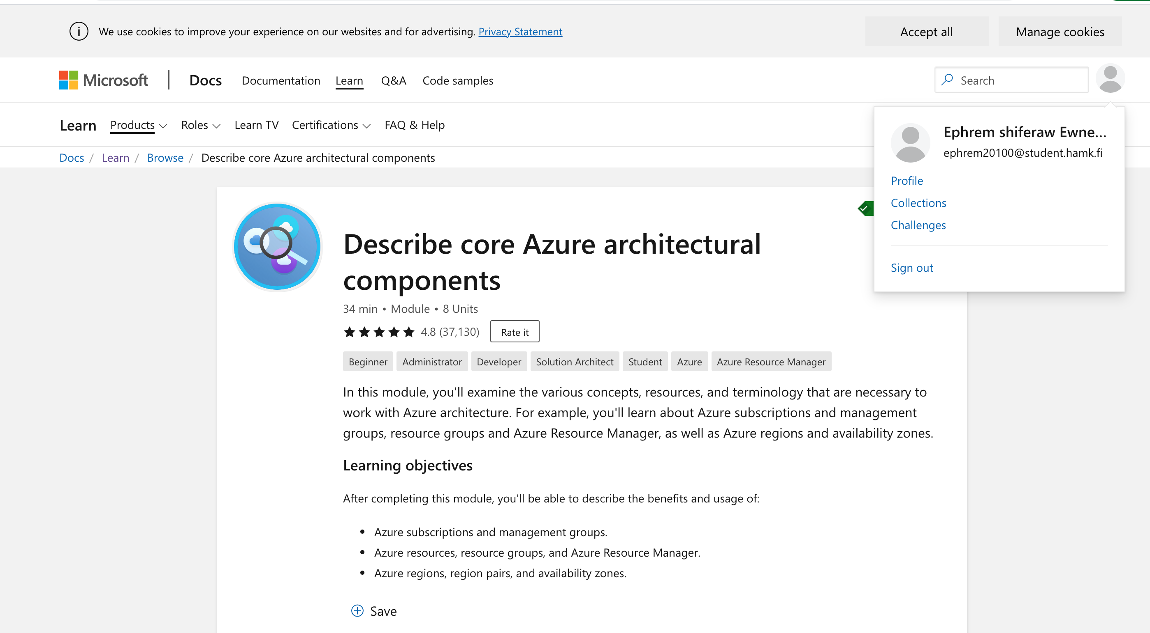

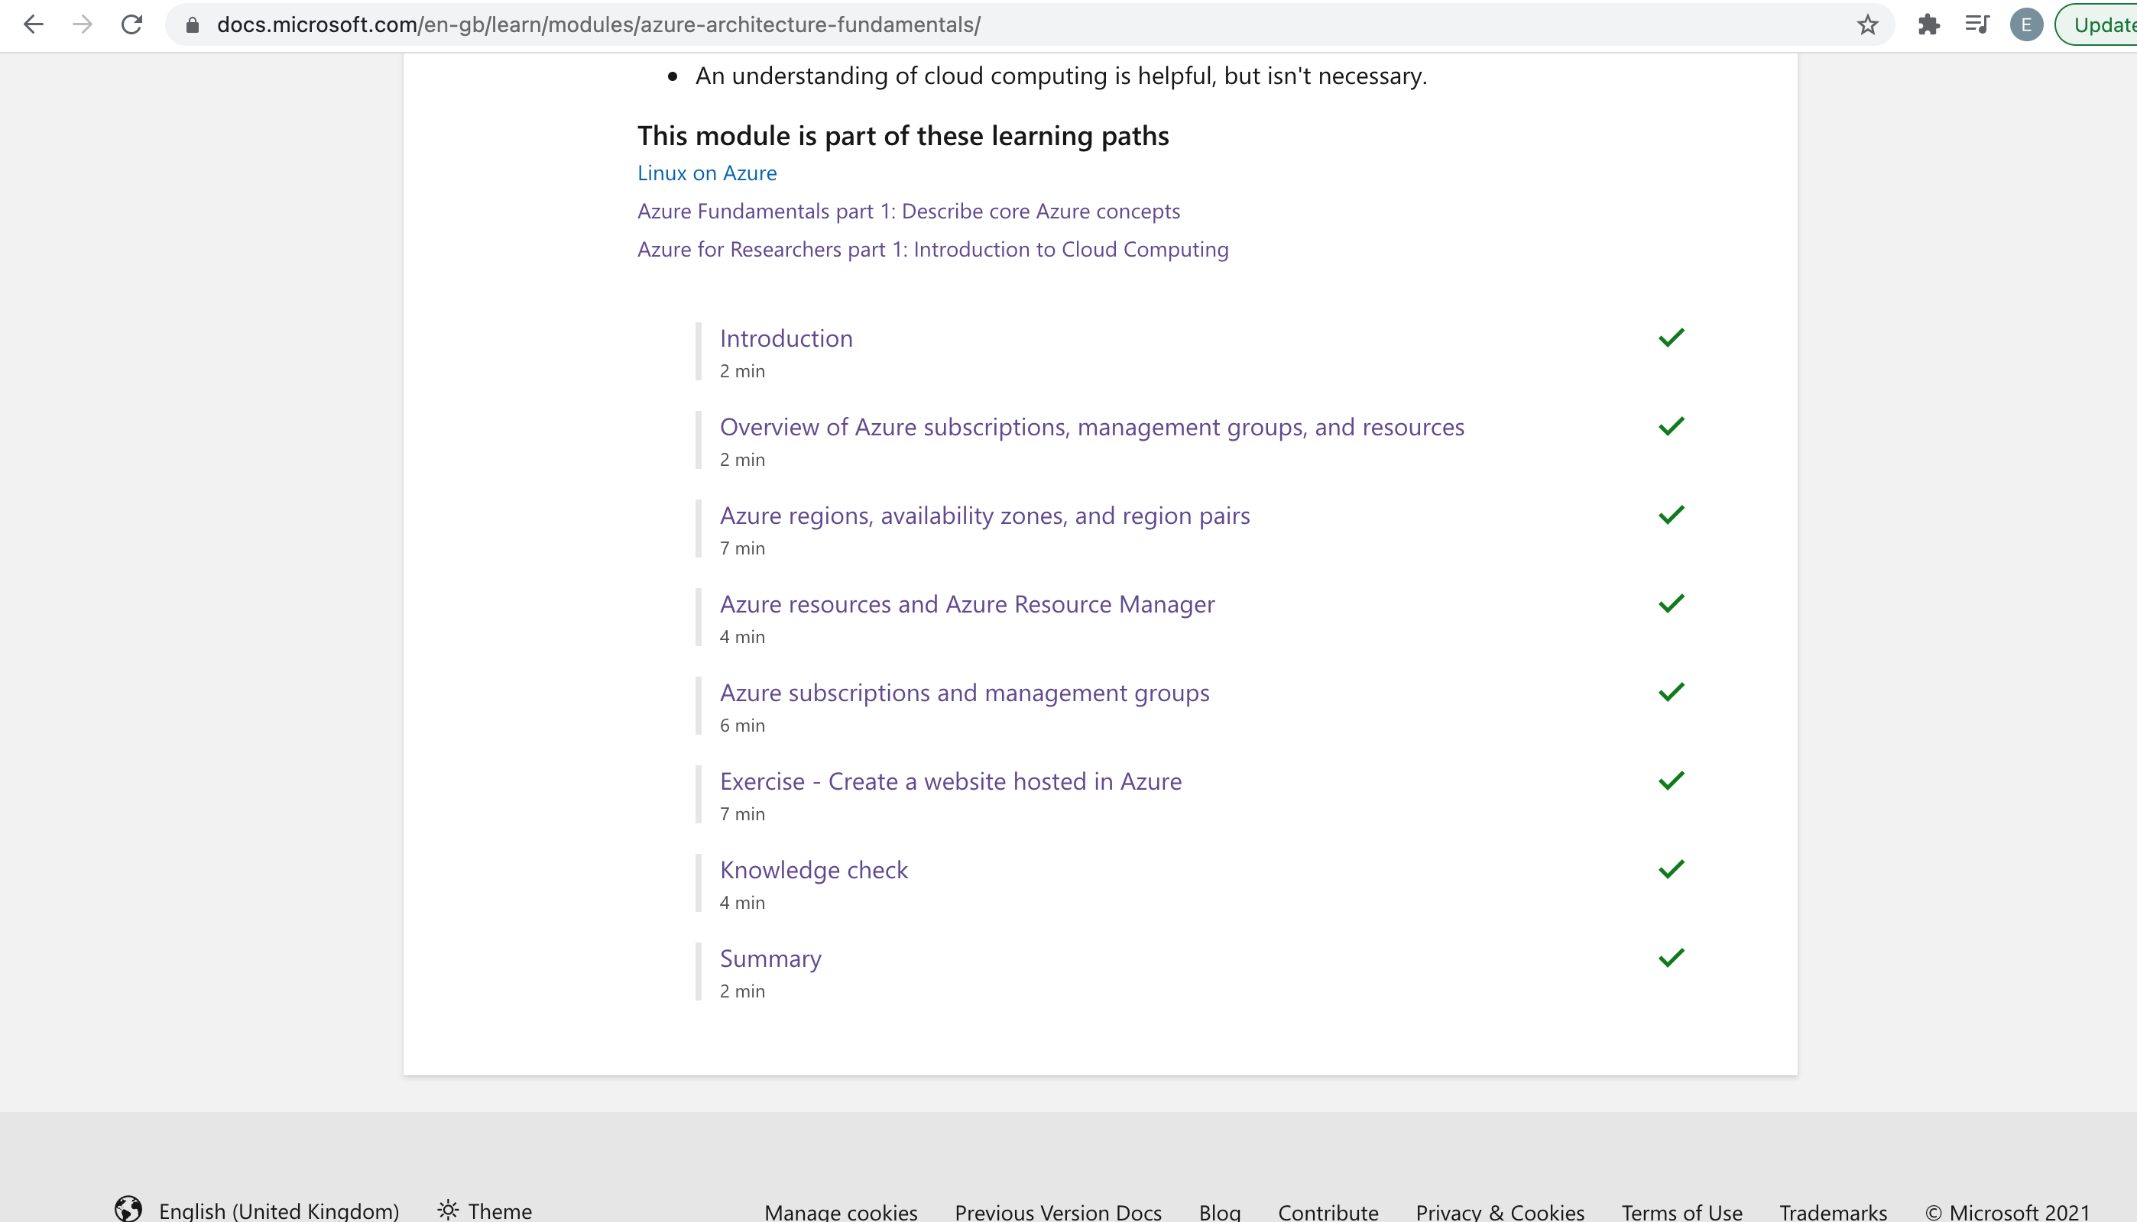

Screenshot 2: Include the screenshot that verifies that you have successfully created a word press website in Azure. You can take the screenshot after you have setup the wordpress site.

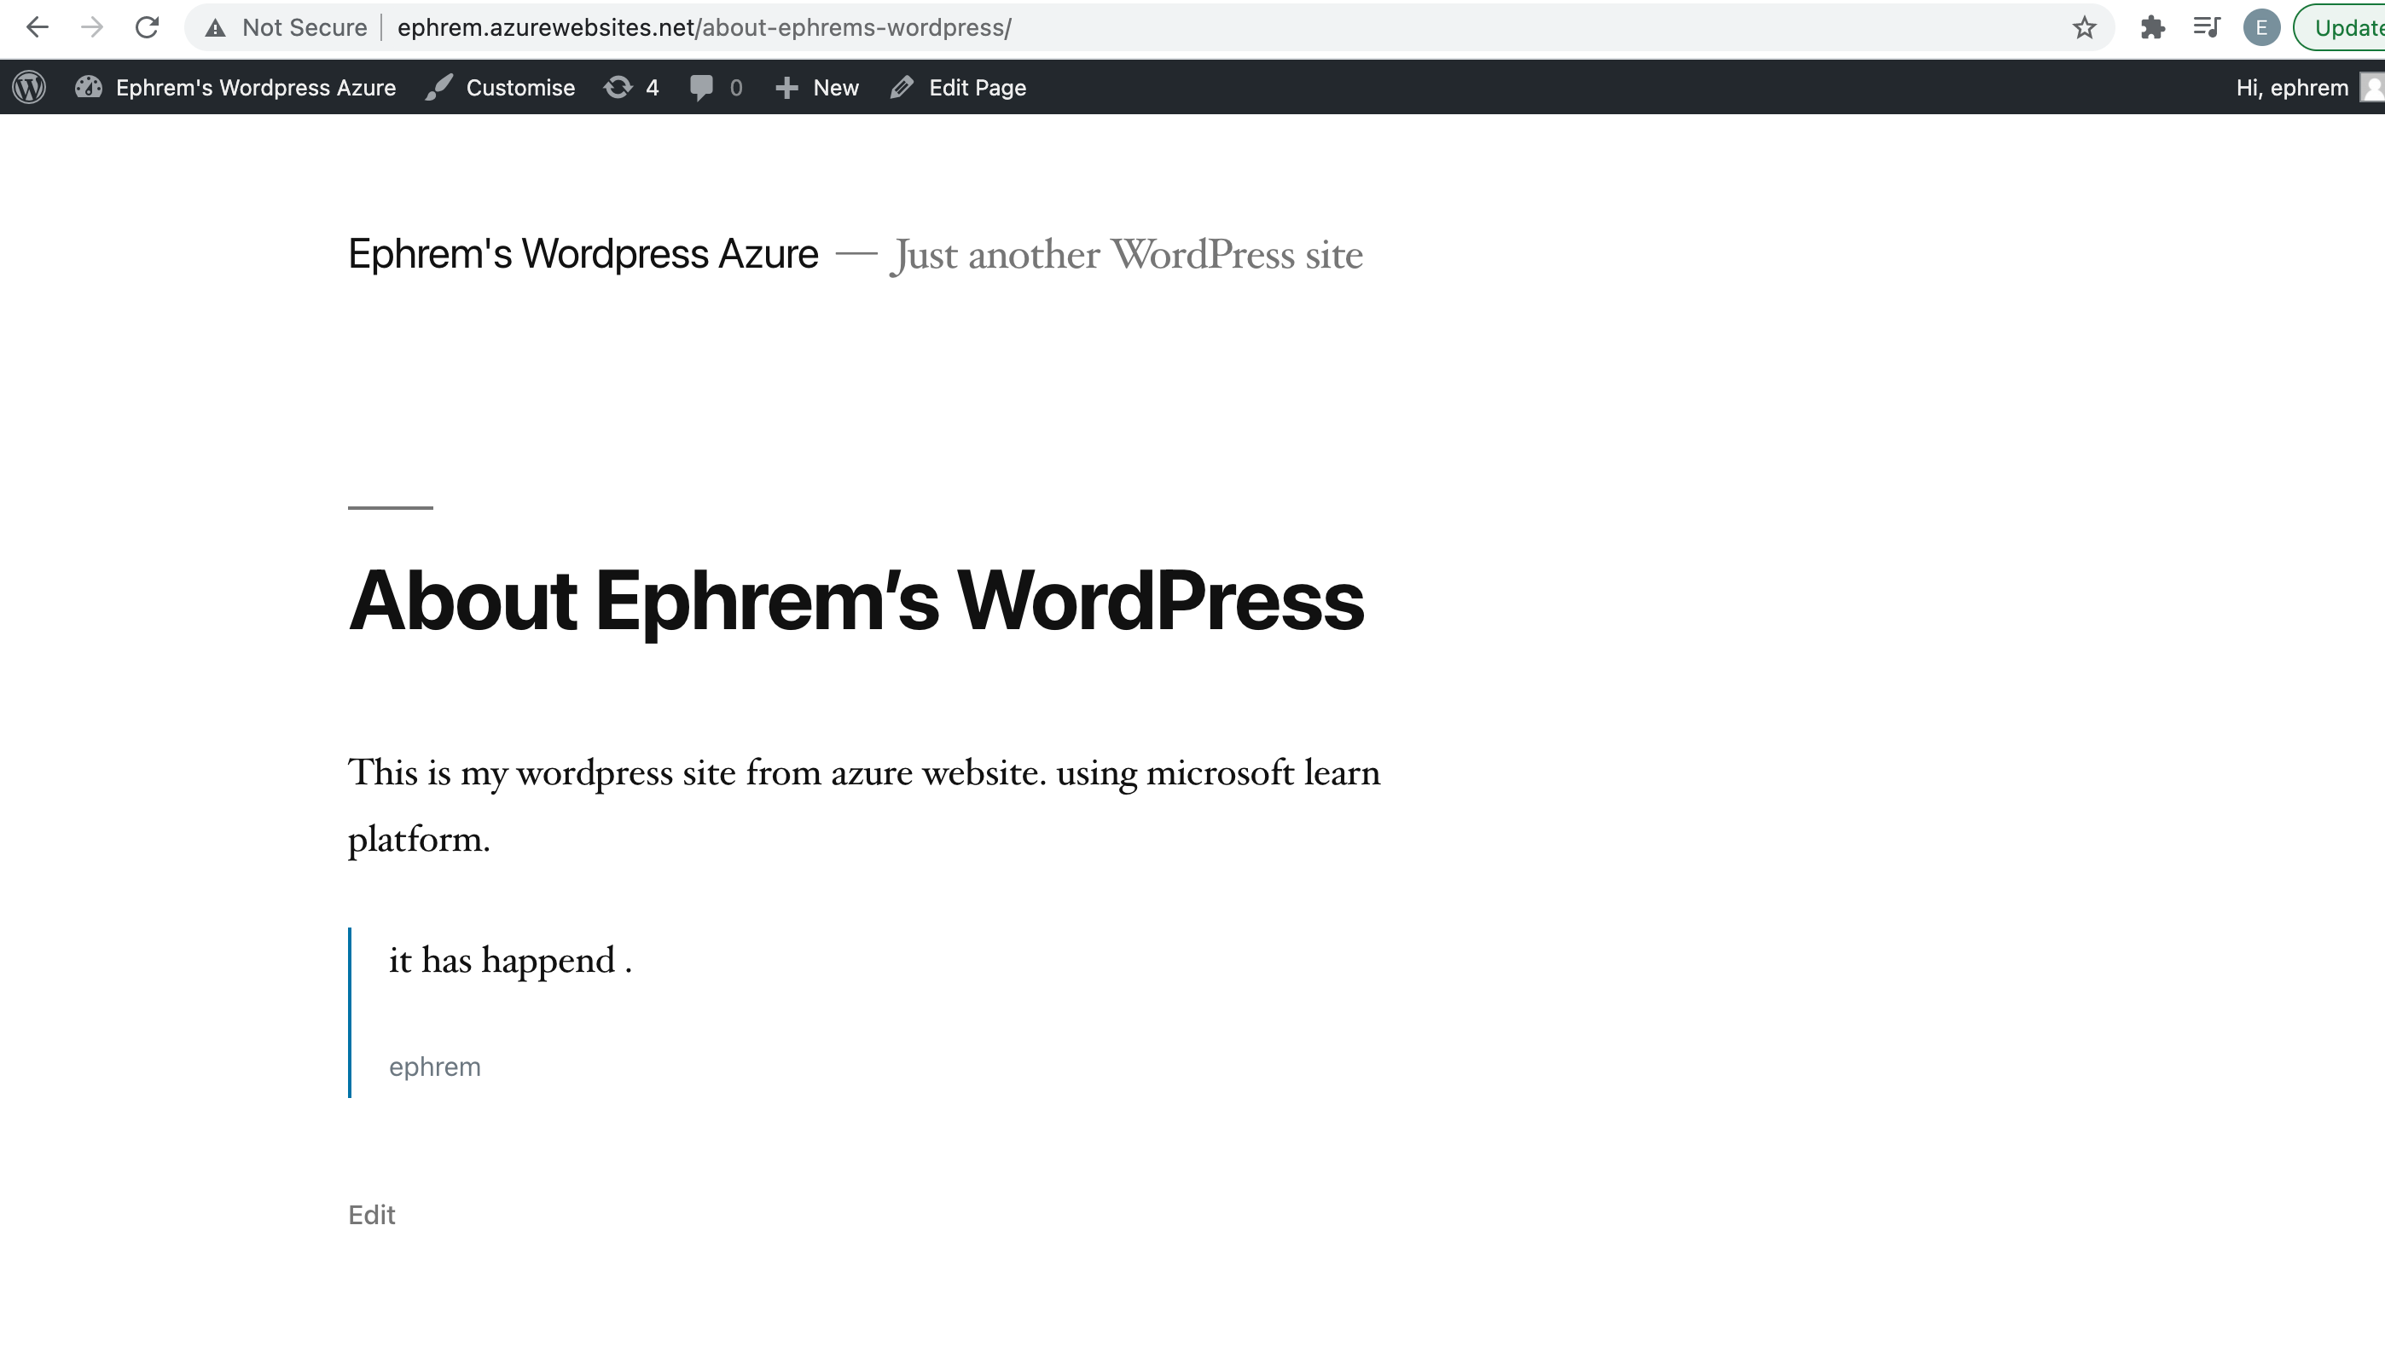

3. Write briefly about what you learnt from the lab. Please make it short and do not write more than 150 words.

What I have learned from the lab the major components that are necessary to successfully deploy resources on Azure.It has four levels: management groups, subscriptions, resource groups, and resources.Resources are instances of services that can be created, the likes virtual machines, storage, or SQL databases.Resources are combined into resource groups, acts as containers for resources for example databases can be one resource group.Subscriptions is higher in the hierarchy than resources and resource groups that limits quotas on the amount of resources that you can create and use. Management group is the policy for the subscription , it is the governing principles.

Region is a geographical area on the planet that contains at least one but potentially multiple datacenters that are nearby and networked together with a low-latency network.  Two or more regions make availability zone to ensure services and data are redundant.Each Azure region is always paired with another region within the same geography (such as US, Europe, or Asia) at least 300 miles away that provide reliable services and data redundancy.

Azure Resource Manager is the deployment and management service for Azure. It provides a management layer that enables you to create, update, and delete resources in your Azure account.

From the lab I had first hand experience with its setting up and management.

By and large, I managed to create subscription then add resource which is the Wordpress site and visualise resources as follows to explain some.