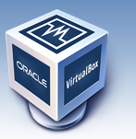

Oracle VM VirtualBox

Abstract

This exercise will give you an overview of VirtualBox Tool for creating virtual machines, cloning and taking snapshots.  
  
You have two options: Do tasks 1-7 or Do only No.8

Table of Contents

1 Lab 1: Create a Linux Server – VM 2

2 Lab 2: Taking a snapshot 3

3 Restoring a snapshot 3

4 Deleting a snapshot 3

5 Cloning a VM 3

6 Exporting Appliance in OVF 4

7 Removing Virtual Machines 4

# Lab 1: Create a Linux Server – VM

1. Make sure that you have VirtualBox installed in your machine. You may also install Extension pack for better performance.

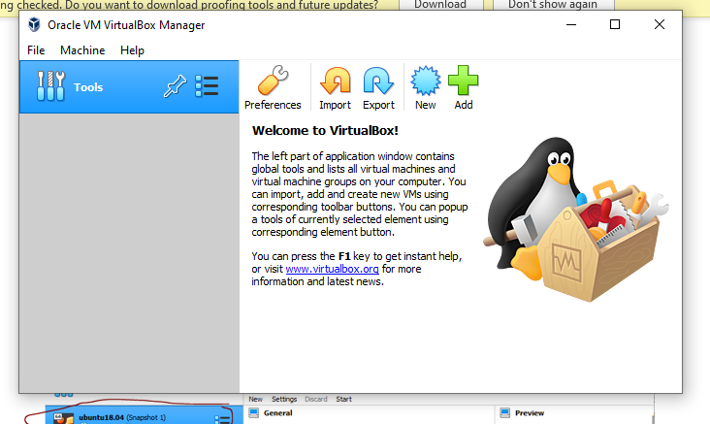

1. You first need to download the Server Install Image for Ubuntu 20.04.1 LTS (Focal Fossa). The image is available at this link: <https://releases.ubuntu.com/20.04/ubuntu-20.04.1-live-server-amd64.iso>
2. Set up a virtual machine using the image that you have recently downloaded. The configuration of the virtual machine should be as below:
   1. The name of the virtual machine must be Firstname_lastname_ubuntuSer
   2. Base Memory (RAM) : 1024 MB
   3. Storage: Type: Normal (VDI), Virtual Size: 15 GB, Dynamically allocated differencing storage

# Lab 2: Taking a snapshot

Please take a snapshot of the recently installed Virtual Machine. Replace the screenshot below with your own. Make sure your name of the virtual machine as instructed above is clearly visible.

# Restoring a snapshot

From the list of your snapshots, select the snapshot that you created and restore it. Please remember that when you restore a snapshot it will affect the virtual hard drive that is connected to your VM and the entire state of the virtual hard drive will be reverted as well. All files that were created after the snapshot will be lost. Please write the steps for restoring a snapshot.

Answer: 1. klick on the virtual machine

2.Select Snapshot

3. Klick the specific snapshot to be restored

4.Klick Restore from the upper menu.

# Deleting a snapshot

Please delete the snapshot that you created earlier and write the steps below for deleting it.

Answer: 1. klick on the virtual machine

2.Select Snapshot

3. Klick the specific snapshot to be deleted

4.Klick Delete from the upper menu.

N.B. Snapshot with child snapshots can’t be deleted .

# Cloning a VM

Create a clone of your existing VM and name it is Firsname_lastname_clone. Start the newly cloned virtual machine and submit the screenshot.

# Exporting Appliance in OVF

Export the VM you created earlier in the OVF format. Mention the steps for exporting appliance in OVF.

Answer: 1. klick on File

2. Klick Export Appliance

3.Select the virtual machine.

4. Klick Export

# Removing Virtual Machines

You may now remove (if you don’t need them) all VMs including clones and the OVF file that you created in previous tasks.

Answer: 1. Right Klick on the virtual machine

2. Select Remove

3.From the subsequent dialogue box klick Delete to remove both files and the VM.

