Title: NEPHU Population Profile Mock-Up Document

Subtitle: Section Title

# This is Header 1

## This is Header 2

### This is Header 3

#### This is Header 4

First Paragraph Text: There were 1,142,516 people who were born in Australia representing 63.7% of the NEPHU population.

Body Text: Of the remaining population that were born overseas, the top 10 countries are represented below.

* List Bullet

Normal

Normal (Footnotes):

Image caption: (For Figure Titles) Top 10 countries of NEPHU population who was born overseas

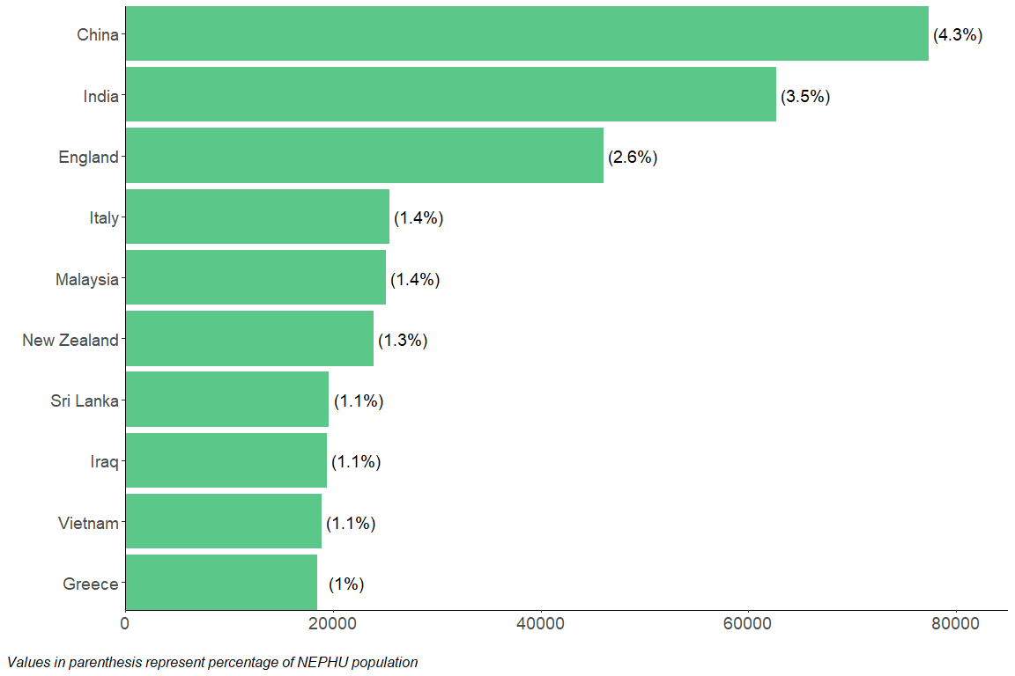

Table caption: (For Table Titles) Top 10 countries of NEPHU population who was born overseas

* Normal (Dot Points): A higher concentration of Mandarin and Cantonese speakers reside in the LGAs of Whitehorse, Manningham and Boroondara.
* A higher concentration of Arabic speakers reside in Hume LGA.
* A higher concentration of Punjabi speakers reside in Hume and Whittlesea LGAs.