9GRadio
Rig Control
User Guide
Remote frequency & mode control over the network, plus routing receive audio from your phone or tablet to a PC via Bluetooth.
Package: com.radiosport.ninegradio
Guide version 1.0 · Covers app version 1.68

Contents
- 1. What is Rig Control?
- 2. Before you start
- 3. Turning on Rig Control
- 4. Connecting a client (WSJT-X, fldigi, Gqrx, SDR++, rigctl)
- 5. Supported commands & protocol reference
- 6. Using the jog dial / rotary encoder
- 7. Hearing your phone's receive audio on the PC (Bluetooth)
- 8. Troubleshooting
- 9. Security notes

1. What is Rig Control?
Rig Control turns 9GRadio into a network-controllable receiver. It runs a small server on your phone or tablet that speaks the same wire protocol as Hamlib's rigctld — the de-facto standard that most amateur radio and SDR software already uses to talk to a "rig" (radio).
Once it's switched on, any Hamlib-compatible program on a PC on the same network — WSJT-X, JTDX, fldigi, Gqrx's remote-control panel, SDR++'s rig-control module, or the plain rigctl command-line tool — can:
- Read the frequency 9GRadio is currently tuned to.
- Set a new frequency remotely.
- Read and change the demodulation mode (AM, FM, USB, LSB, CW, CWR, WFM).
9GRadio is built around a receive-only RTL-SDR dongle, not a transceiver, so Rig Control deliberately implements only the receive-relevant subset of the protocol. Commands a real transceiver would need — PTT, split operation, TX power — are recognised so clients don't hang or error out, but are answered with Hamlib's own "not supported" result code rather than pretending to act on them.
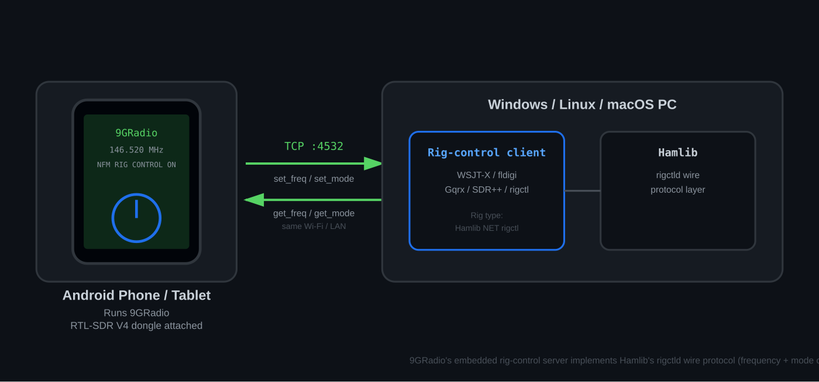
Figure 1 — How Rig Control fits together: 9GRadio runs the server, a Hamlib-compatible client on a PC connects to it over Wi-Fi/LAN.

2. Before you start
Rig Control needs:
- 9GRadio running on an Android phone or tablet, with its RTL-SDR V4 / V4L dongle attached and receiving.
- The phone/tablet and the PC on the same Wi-Fi network (or connected via USB tethering / a shared LAN). Rig Control does not work over the mobile data network or across the open internet without additional port-forwarding, which this guide does not cover.
- A Hamlib-aware client on the PC — see §4 for tested options.
NOTE: No pairing, login, or app installation is required on the PC side beyond the client program itself — Rig Control is a plain, unauthenticated TCP service, like rigctld itself.

3. Turning on Rig Control
- On the Settings tab in 9GRadio, tap Rig Control.
- Switch Server to on.
- Leave Listen port at its default, 4532, unless that port is already in use elsewhere on your network — 4532 is rigctld's own long-standing default, so most client software already assumes it.
- Optionally set the Jog dial step size (Hz) — this is the frequency step used only by an external rotary encoder / jog-dial input, separate from any protocol-aware step the on-screen dial uses. 100 Hz is the default.
- Tap Apply. The status indicator switches from ● IDLE to ● RUNNING, and a green CONNECT → row appears showing this device's IP address and port.
- Tap that address row (or its copy icon) to copy address:port to the clipboard — handy for pasting straight into a client's host field.
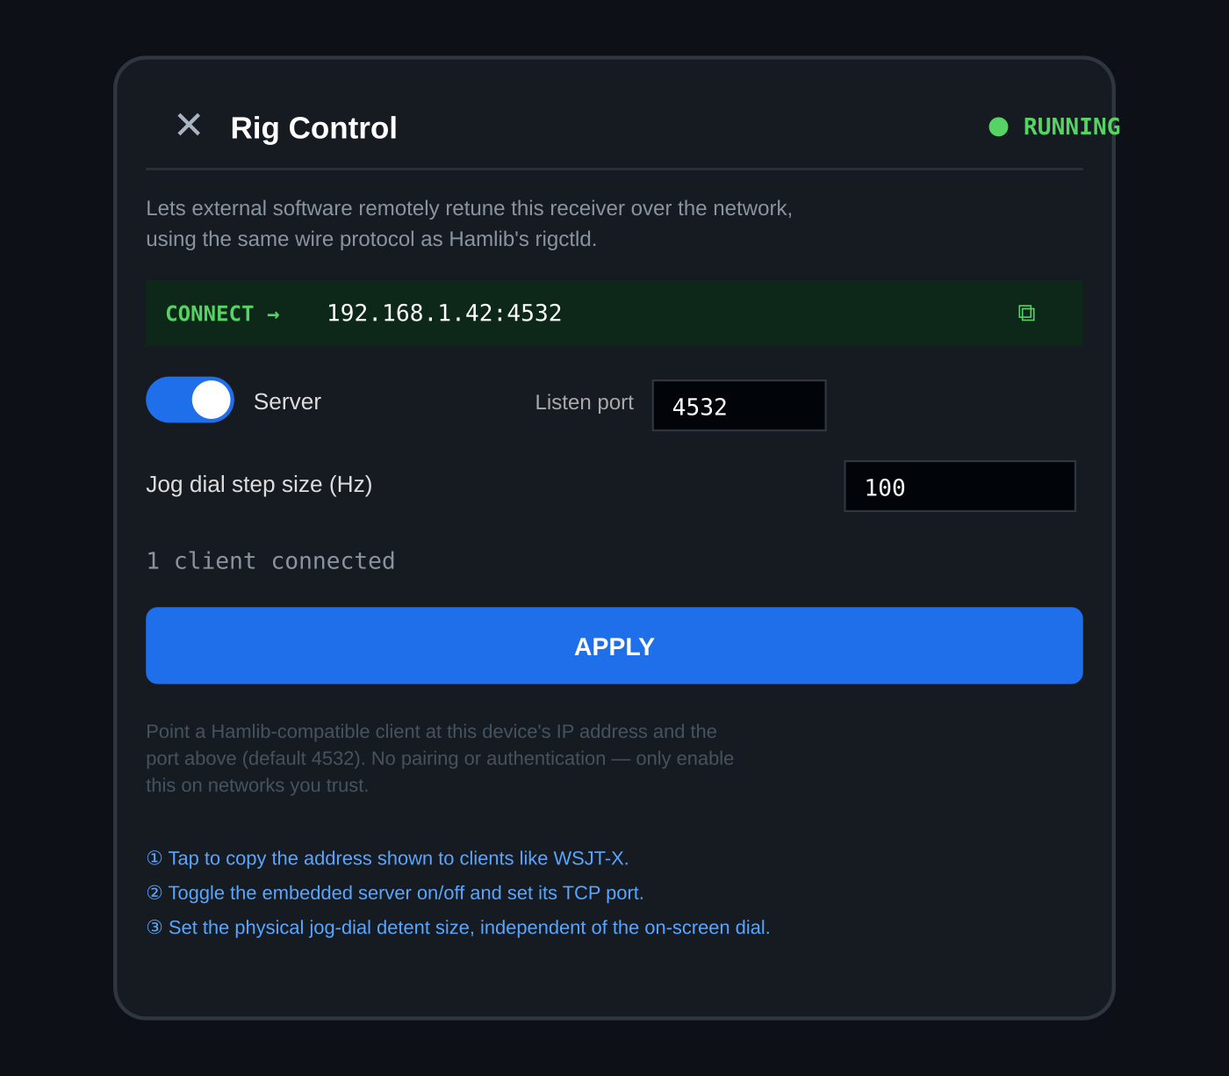
Figure 2 — The Rig Control settings card: server toggle and port (②), copy-address row, and jog-dial step size (③).
The Connected clients line under Apply shows a live count, updated once per second, so you can confirm a PC client has actually connected.

4. Connecting a client (WSJT-X, fldigi, Gqrx, SDR++, rigctl)
In every case, the settings are the same three pieces of information: the device's IP address, the port (default 4532), and a rig/backend type of “Hamlib NET rigctl” (sometimes shown as backend #2, or “NET rigctl / rigctld”).

WSJT-X / JTDX
- Settings → Radio tab.
- Rig: Hamlib NET rigctl.
- Network Server: <device IP>:4532 (e.g. 192.168.1.42:4532).
- PTT Method: None — 9GRadio can't key a transmitter, so leave PTT off and use WSJT-X purely for receive/decoding.
- Click Test CAT — it should report the frequency and mode 9GRadio is currently on.

fldigi
- Configure → Rig Control → Hamlib tab.
- Rig: NET rigctl (or Hamlib NET rigctl).
- Device: <device IP>:4532.
- Enable Hamlib rig control and Initialize.

Gqrx
- Tools → Remote Control Settings — or connect any external rigctl-compatible remote-control client to Gqrx's own remote port; 9GRadio itself is the server being connected to, so most commonly you'd point rigctl or another Hamlib client directly at 9GRadio's IP:port rather than at Gqrx.

SDR++
- Enable the Rig Control module.
- Connection type: rigctl (network).
- Host / Port: <device IP> / 4532.

Plain rigctl (command line)
rigctl -m 2 -r <device IP>:4532 f
Model 2 is Hamlib's “NET rigctl” dummy backend — the standard way any rigctl-based tool talks to a network rig server like 9GRadio's. The example above requests the current frequency; see §5 for the full command set.

5. Supported commands & protocol reference
9GRadio's Rig Control server accepts both the traditional single-letter Hamlib commands and their long-form \command aliases, exactly matching upstream rigctld's own behaviour for the subset it implements:
Command | Long form | Action | Reply
f | \get_freq | Get current frequency | <hz>\n
F <hz> | \set_freq | Tune to a new frequency | RPRT 0\n
m | \get_mode | Get current mode + passband | <MODE>\n<passband>\n
M <mode> <pb> | \set_mode | Change demodulation mode | RPRT 0\n
— | \dump_state | Capability dump for client auto-detect | capability list
— | \chk_vfo | VFO check (single-VFO rig) | CHKVFO 0\n
q / Q | — | Close the connection | (none)
T, t, v, V, s, S, p, P … | \set_ptt, \get_ptt, etc. | PTT / split / power / antenna (not applicable to a receiver) | RPRT -11\n

Mode name mapping
9GRadio's own demodulation modes are translated to the closest Hamlib mode token so client software displays a name it already understands:
9GRadio mode | Reported Hamlib token
AM | AM
FM / NFM | FM
WFM / WFM Stereo | WFM
USB | USB
LSB | LSB
CW | CW
CWR | CWR
DSB | AM
Digital-voice modes (DMR, D-STAR, YSF, dPMR, NXDN, P25, ADS-B, etc.) | FM (reports the underlying FM discriminator, since Hamlib clients have no matching token for these)

NOTE: Multiple clients can connect at the same time — for example a logging program and WSJT-X both watching the same VFO. Every connected client sees the same, single, authoritative frequency: whatever 9GRadio's own receiver is actually tuned to, kept in sync in both directions.

6. Using the jog dial / rotary encoder
If you drive 9GRadio's tuning with an external rotary controller (a physical jog dial connected via USB-serial or HID), each detent applies the Jog dial step size (Hz) set in §3 directly to the live frequency — turning one way tunes up, the other way tunes down.
This is the exact same underlying frequency-setting call that a Rig Control client's F / set_freq command uses, so external jog input and a network Rig Control client always agree on one authoritative VFO — there's no separate or conflicting notion of “current frequency” between the two input paths.

7. Hearing your phone's receive audio on the PC (Bluetooth)
Rig Control hands frequency and mode over to a PC client, but it doesn't carry audio — that's a separate network service (see 9GRadio's External Decoder feature) or, for a fully wireless setup with no cables at all, plain Bluetooth. This section covers getting 9GRadio's demodulated receive audio from your phone or tablet's speaker output into a PC program that expects a microphone/line input — for example so WSJT-X can decode audio while Rig Control handles the frequency.

The idea
Windows can receive Bluetooth audio (act as an A2DP sink), but it needs a small helper app to actually enable and manage that role — Windows itself only supplies the underlying capability. Once the phone's audio arrives at the PC as a normal playback stream, a virtual audio cable loops that playback stream back into a virtual recording device, which is what a program like WSJT-X or fldigi can select as its microphone input.
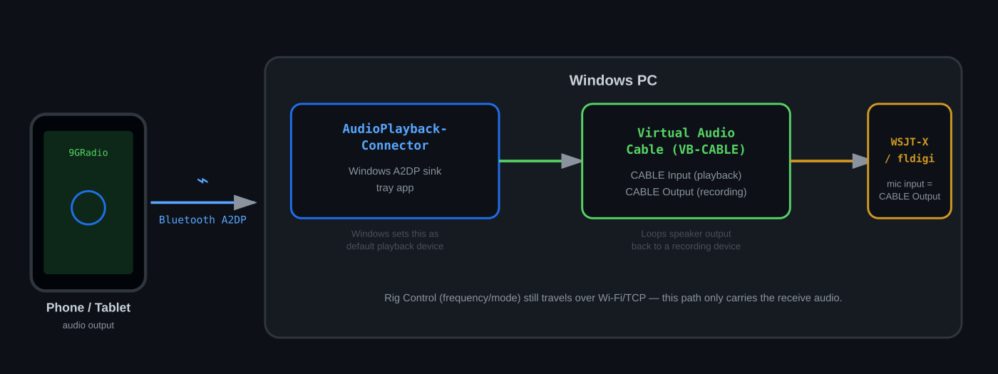
Figure 3 — Audio path: phone speaker output → Bluetooth A2DP → AudioPlaybackConnector → Virtual Audio Cable → ham radio software's mic input.

What you need
- AudioPlaybackConnector — a free, open-source Windows A2DP-sink tray app. GitHub: search “AudioPlaybackConnector”, or use the link your organisation provides.
- A virtual audio cable driver, e.g. VB-Audio Virtual Cable (VB-CABLE) — creates a virtual playback device (“CABLE Input”) and a matching virtual recording device (“CABLE Output”) that mirrors whatever is played into it.
- A Windows 10 (version 2004 or later) or Windows 11 PC with a working Bluetooth adapter.

Step-by-step setup
- Install the virtual audio cable driver on the PC and reboot if it asks you to. This creates “CABLE Input” (a playback device) and “CABLE Output” (a recording device).
- Install and run AudioPlaybackConnector on the PC. It sits in the system tray.
- On the PC, go to Settings → Bluetooth & devices → Add device → Bluetooth, and pair the PC with your phone or tablet.
- Click the AudioPlaybackConnector tray icon, select your paired phone from the list, and choose Connect.
- In Windows Sound settings, set CABLE Input as the default playback device (or set it just for the Bluetooth/AudioPlaybackConnector audio stream, if you'd rather keep other PC sounds going to your speakers).
- In your ham radio software (WSJT-X, fldigi, etc.), set the audio input / microphone device to CABLE Output.
- On the phone, start playback in 9GRadio (i.e. have it actively demodulating and outputting audio) and confirm sound appears in the receiving software's input meter on the PC.
NOTE: This path is entirely separate from Rig Control's TCP connection. You can run both at once: Rig Control (§3–§6) tells the PC software what frequency/mode 9GRadio is on, while this Bluetooth path carries the actual audio for decoding — the two don't interfere with each other.
IMPORTANT: If you route all Bluetooth/CABLE Input audio as the PC's default playback device, other Windows sounds (notifications, other apps) will also flow into CABLE Input and therefore into whatever is listening on CABLE Output. Consider routing only the specific Bluetooth stream to CABLE Input via Windows' per-app volume/output settings if that's a problem for you.

8. Troubleshooting
Symptom | What to check
Client can't connect / times out | Confirm the phone and PC are on the same network; check the phone's IP hasn't changed (re-open Rig Control settings to see the current address); confirm no firewall on the PC is blocking outbound TCP to that port.
Port already in use | Change Listen port to something else (e.g. 4534) in both 9GRadio and the client, then Apply and reconnect.
Client connects but frequency doesn't move | Confirm Server is switched on and Apply was tapped after any change; some clients cache the rig's capabilities on connect — reconnect the client after changing settings.
Frequency jumps back after a remote change | Check nothing else (another rig-control client, a memory-slot recall, or the jog dial) is also actively setting frequency at the same time.
No sound on the PC after Bluetooth setup | Confirm AudioPlaybackConnector shows the phone as Connected (not just paired); confirm CABLE Input is selected as the phone's / Bluetooth stream's playback device; confirm the receiving software's input is set to CABLE Output, not the PC's physical microphone.
Audio present but very quiet or clipped | Adjust the phone's own media volume and 9GRadio's output level, then Windows' per-device volume for CABLE Input, rather than only the receiving software's input gain.

9. Security notes
Rig Control, like upstream rigctld itself, has no pairing step, login, or encryption — any device that can reach the phone's IP address and port can issue commands. Treat it the same way you'd treat any other unauthenticated LAN service:
- Only enable it on networks you trust (home/club LAN), not on open or shared public Wi-Fi.
- Turn Server off in Rig Control settings when you're not actively using it.
- Because 9GRadio is receive-only, the practical worst case of an unwanted connection is someone else retuning your receiver — there is no transmit path for Rig Control to expose.

