# Calm Corners



Smart Local Study Room & Library Finder Team:- Code Crew



# Problem Statement

**Students often struggle to find available, quiet study spaces like libraries or cafes, especially during peak hours.**



Our Solution

A web app that shows real-time availability of nearby study spots. Includes booking feature, user reviews, and smart filters.

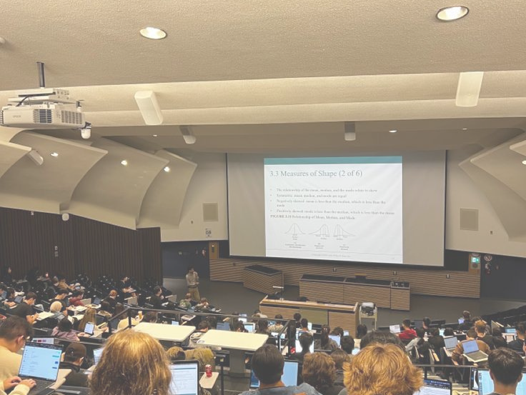

Target Audience

Students, Freelancers, Remote Workers, Book Clubs

1. Real-time Avability

**Key features**

Location-Based

1. Recommendations
2. Booking System



1. User Reviews & Rating
2. Mobile & Desktop Responsive UI

Tech stack

**Front**

**End**

HTML,CSS,

Javascript

**Back**

**End**

Node.js /

Express.js

**Database**

MongoDB /

FireBase

**Hosting**

GitHub Pages

# Workflow

 Each team member handled a specific role:

* **Frontend: UI/UX and layout**

integration

* **Backend: APIs, routing, database logic**
* **GitHub: Version control and final**

merges

# Challenges &

Learning

* + **Coordinating real-time collaboration**
  + **Merging code efficiently**
  + **Learned how to quickly debug and test under pressure**
  + **Faced time constraints while syncing team tasks efficiently**

# What’s Next?

* **Add real-time occupancy via sensors**
* **Study room check-in QR system**
* **Admin panel for library/café owners**

THANKYOU

Lẹg×s rẹxasugiani,ẹ g›ẹ say sẹ finP psacẹs ga

sguPy!

Any Quẹsgians?