4.3 Flask: Part 2 Lab

**INTRODUCTION**

Your task is to add a submission form to the cookie_tracker project you previously downloaded and worked on.

**TASK**

1. In “main.html”, add a form under the table listing the cookies. This form is only going to have 3 elements:
   1. A text input field
   2. A dropdown selector with the values 1 through 5
   3. A submit button that says “Add cookie”
2. In main.js, capture the form submission and format the data as JSON like so:  
   {“name”: <user input>, “rating”: <user input>}
3. In “cookie_tracker.py”, make an additional import: from flask import jsonify
4. Create a new endpoint in “cookie_tracker.py”. Inside this endpoint, simply log the input for now so that you see the data in the server log, and return some sort of success message in JSON format like so:   
   return jsonify({"message": "success!"}), 200
5. In main.js, issue an AJAX POST request to the new endpoint, passing the JSON data you created in step 3 as the body. In the POST request’s callback, log the data that was returned in the console.
6. When you are done, when you visit <http://localhost:5000/cookies> you should see something like this (don’t worry about matching styling):

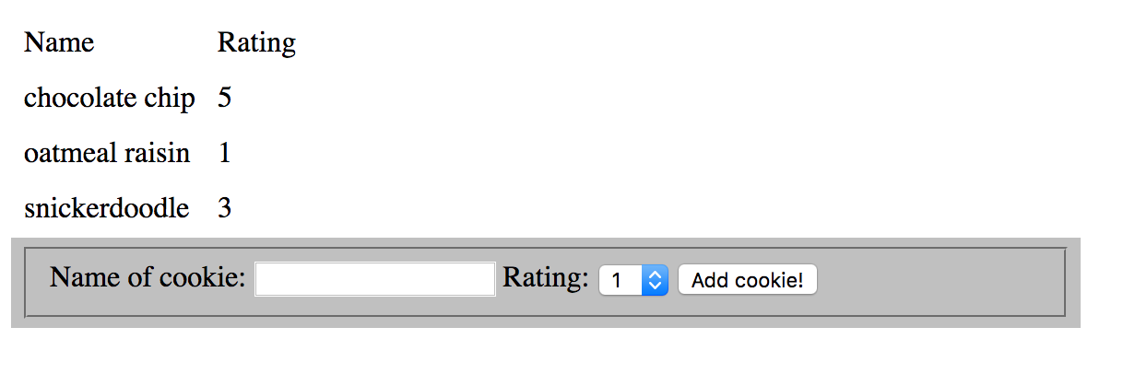

1. When you fill out a cookie name and rating and hit submit, you should see a console log with {“message”: “success!”} (or whatever message you returned from your endpoint), as well as see something like this in the server log:

ImmutableMultiDict([('rating', u'4'), ('name', u'red velvet')]) 127.0.0.1 - - [24/Mar/2017 14:05:32] "POST /cookie HTTP/1.1" 200 -