4.4 Flask: Part 3 Lab

**INTRODUCTION**

We’re going to add some backend form validation! In the last lab exercise, if you leave the cookie name field empty and click the “Add cookie!” button, you still see the success alert. This is quite misleading as we cannot (and should not) be adding cookies with no names.

**TASK**

1. In “main.html”, under your form, add a <div> with the id = “message”.
2. After you fetch the request data, check that the value for “name” is not empty. If it the value is empty, return the following:  
   jsonify({"message": "failed!"}), 400

Otherwise, if the value is a non-empty string, return the following:  
 jsonify({"message": "success!"}), 200

1. In “main.js”, add a failure callback to your AJAX POST request that writes an error message to the message <div>. Modify the success callback to write a success message to the message <div>.

Success example:

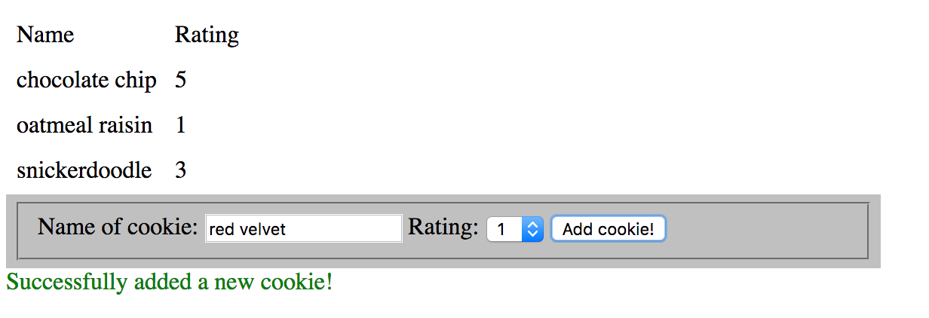

Failure example:

