Show case of outbreak-tools usage

## Introduction

Outbreak-tools is a set of tools to facilitate the creation of linelists in Excel. Among other things, these tools allow you to automate:

* Adding variables (whether drop-down lists, integer or decimal values, or even Excel formulas) and format them.
* Translating a linelist from one language to another,
* Adding analyses to the linelist in tabular form (univariate, bivariate, temporal, spatial),
* Adding graphs to the linelist,
* Import/export the entire linelist or selected variables into specific formats.
* Managing geographic data in the linelist.
* Migration of the linelist as options/variables are added or removed.

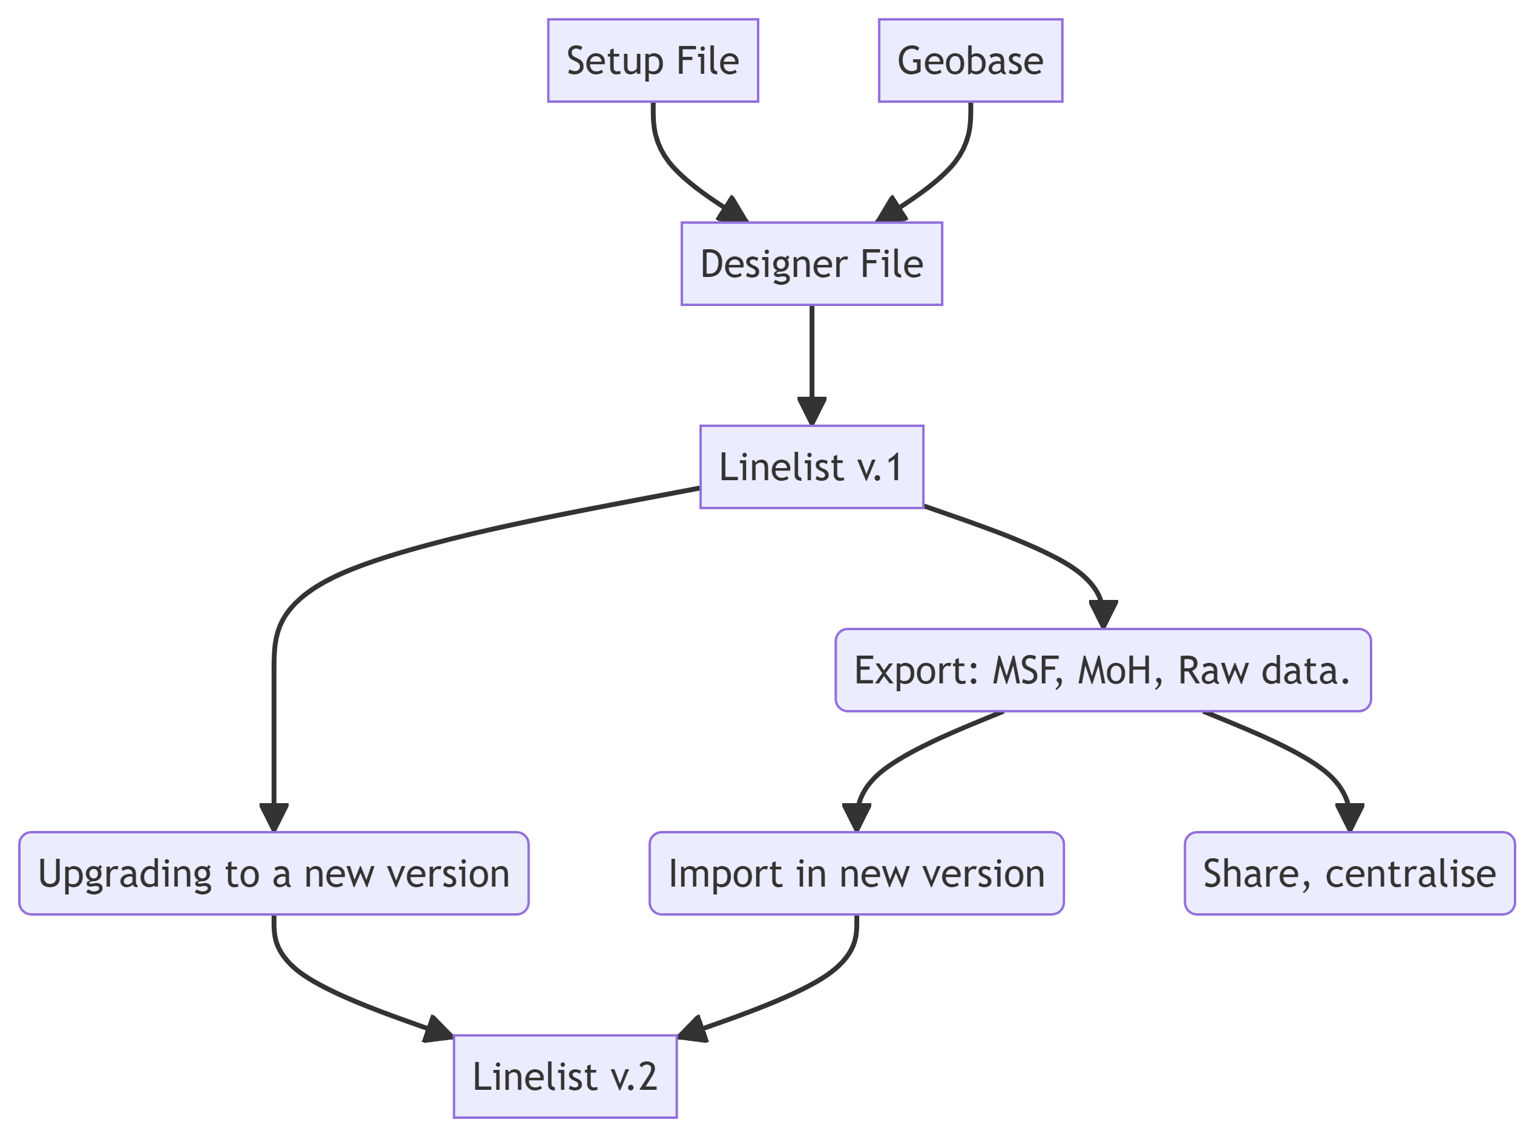

The linelist is designed in a configuration file called *setup*. This *setup* file is then loaded into another file that designs the linelist called *designer*. The designer creates the linelist, based on the configurations of the *setup*. The linelist creation procedure is a 3-step process:

1- Define your needs in the setup file: The configuration of the file is inspired from Kobo’s XLS forms. No in-depth knowledge of Excel is required. A setup file is defined by disease, and can be used to create linelists in several languages.

2- Download geographic data for the targeted area: There is [an application](https://reports.msf.net/secure/app/outbreak-tools-geoapp) available online to download geographic data for the region of interest. It is updated as new geographical information becomes available.

3- Generate the linelist by specifying the options in the designer.

# Exercises

This series of 3 exercises explores the possibilities mentioned above, using a measles setup file. The folders contain all the materials needed to perform the exercises.

|  |  |
| --- | --- |
|  | **Download and unzip the materials**  You can download the exercices in zip file for offline use [here](https://github.com/epicentre-msf/outbreak-tools-demo/raw/main/demo_materials.zip). **Extract the zip files after the download.**  **Be sure the downloaded files are not locked by windows**  On some Windows machine, you will need to unblock downloaded files to be able to use macros. In some cases, excel macro files downloaded from the web are automatically blocked for security reasons. You can unblock the files by:  0- Right click on the file  1- Select Properties  2- Check the *Unblock* box on the bottom right. |

|  |  |  |
| --- | --- | --- |
|  | **Activate macros before exercises**  If you’re going to run the designer to build a linelist, you’ll need to enable VBA macros in Excel, as well as access to the VBA object model:  0- Open Excel  1- Display the *Developer* tab in Excel.  2- In the *Developer* tab, click on *Macro security*. Check the options as shown in the following image:   |  | | --- | |  | |

## Exercise 1: Exploration.

* Open the file linelist_measles_en_ex1.xlsb located in the linelist folder. The file password is 5678.
* Browse the linelist sheets.
* Fill in geographical data using the geo-Helper. Select the data you want.
* Explore univariate, bivariate and temporal analyses. Recompute the same analyses by filtering on people under 2 years of age.
* Export the filtered data with the anonymous export for MSF. Open and browse the exported file. If you didn’t change the exports password, the password should be: **605637**.

## Exercise 2: Modifying the setup file

* Open the setup file setup_measles_base_ex2.xlsb in the setup folder. We want to add the following variables:
  + In the *Admission* section of *Linelist patients* sheet, just before the *hospitalisation* sub-section:
    - muac (MUAC) which takes three values: “Green (125+mm)”, “Yellow (115-124mm)”, “Red (< 115mm)”
  + In the *Vaccination* section of *Linelist patients* sheet, just after *Vaccination against measles*:
    - vacci_measles_doses (Number of doses received) which is a numeric variable.
    - Add a validation to this variable to make sure it’s between 0 and 4.
* Translate the added labels into French
* Check the setup for errors.

|  |  |
| --- | --- |
|  | *You should normally have a configuration file identical to* *setup_measles_exercise_two.xlsb in the* *setup folder. You can also start from this file if you like.* |

* Regenerate a new linelist named linelist_measles_en_ex2 using the designer. Save the linelist in the demo folder, making sure you’ve selected English as the language. You’ll use the file geobase-cod-2023-03-13_20230612.xlsx in the geobase folder as your geobase.
* Import the data import_linelist_en.xlsx located in the data folder into the linelist. Look at the data that has not been imported and browse the data in the linelist.

## Exercise 3: Analysis

We’ve decided to add some analyses on outcome (Type of discharge) to the linelist.

* Open the setup setup_measles_base_ex3.xlsb in the setup folder.
* In the analyses sheet, add a univariate table showing the number of patients by type of discharge. Add percentages and a graph for this table.
* In the analyses sheet, add a temporal table showing the evolution of type of discharge by notification date. Add a percentage option in row, and add a total.
* In the analysis sheet, add a graph of output types. In graph specifications, represent the number of deaths per notification date, in bars.
* Translate all labels into French.
* Check the setup for errors.

|  |  |
| --- | --- |
|  | *You should get a configuration file identical to setup_measles_exercise_three.xlsb in* *the setup folder. You can also start from this file if you like.* |

* Regenerate a new linelist named linelist_measles_en_ex3 using the designer. Save the linelist in the demo folder, making sure you’ve selected English as the language.
* Import the data import_linelist_en.xlsx located in the data folder into the linelist. Look at the data that has not been imported and browse the data in the linelist.
* Print the Linelist patients sheet.