Fahrenheit 451 Review Game

By: Ashwin Ramaswami

<http://epicfaace.github.io/F451/>

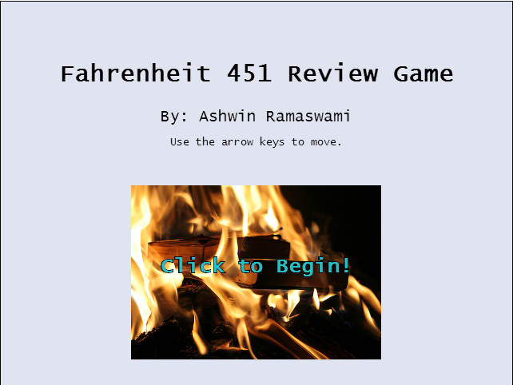

In the game, you are Montag, running away from the Hound. Use the right and left arrow keys to move around in the forest.

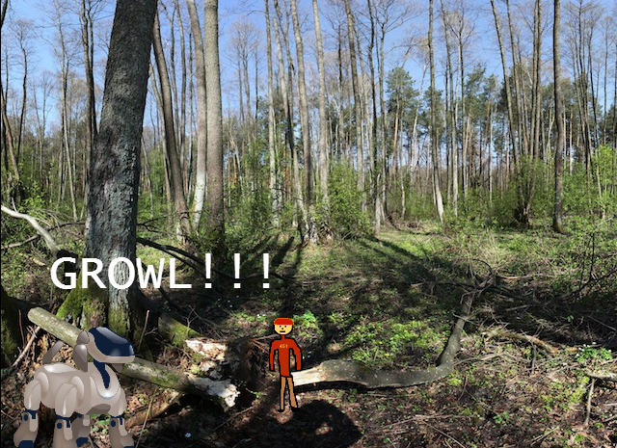

Eventually, you will reach a fork in the game, which is a question. Answer the correct question and pick the correct path with the up arrow key, and you proceed!

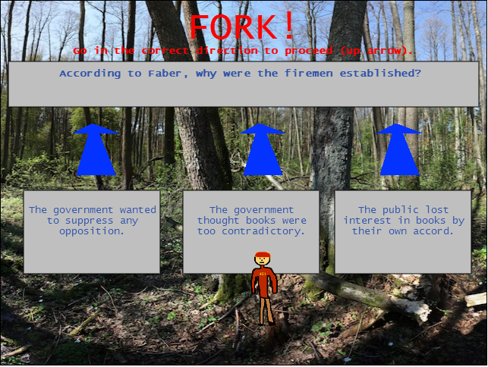

If you pick the wrong answer, the Hound gets you and you lose.

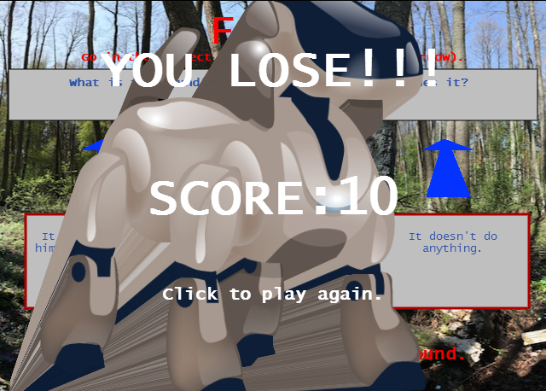

Once you finish all the questions (there are 20), you beat the game.

Sample Code

function draw() {

if (won) return;

if (!question) {

c.width=c.width;

if (-scroll.x>=scroll.min&&scroll.x-player.xvel<0) {

scroll.x-=player.xvel;

}

else {

player.xvel=0;

}

ctx.drawImage(img.terrain,scroll.x,0);

if (-scroll.x+640>img.terrain.width) {

if (-scroll.x+640<img.terrain.width+c.width) {

ctx.drawImage(img.terrain2,img.terrain.width+scroll.x,0);

ctx.textAlign="center";

ctx.font="50px Lucida Console";

ctx.fillStyle="#FF0000";

ctx.fillText("FORK!",img.terrain.width+scroll.x,50);

if (img.terrain.width+scroll.x<=c.width/2) {

question=true;

if (questions.length==0) {won=true;winGame();return;}

var ra=Math.floor(Math.random() \* questions.length);

window.curQ=questions[ra];

questions.splice(ra,1);

curQ.ans=Math.floor(Math.random() \* 3);//which index in rand .aa is the answer?

curQ.aa=[0,0,0]; //curQ.aa is randomized version of curQ.a

curQ.aa[curQ.ans]=curQ.a[0]; //first index in .a is correct answer

var r=curQ.ans;

while (r==curQ.ans) {r=Math.floor(Math.random() \* 3);}

curQ.aa[r]=curQ.a[1];

var s=3-r-curQ.ans; //0+1+2=3

curQ.aa[s]=curQ.a[2];

//console.log(curQ.ans,r,s);

renderQ();

}

else {question=false;}

}

else {

scroll.x=scroll.x+img.terrain.width;

question=false;

}

}

else {question=false;}

img.dog.y+=.5\*(Math.random()\*2-1);

img.dog.x+=.5\*(Math.random()\*2-1);

if (img.dog.y>c.height-60) img.dog.y-=20;

if (img.dog.x>c.width/2-120) img.dog.x-=20;

if (img.dog.x<0) img.dog.x+=20;

if (img.dog.y<0) img.dog.y+=20;

ctx.drawImage(img.dog.right,img.dog.x,img.dog.y,70,70);

ctx.drawImage(img.montag,c.width/2-50,c.height-150,50,100);

}

else if (!answering) {//if question is true

c.width=c.width;

if (player.xpos+player.xvel>0&&player.xpos+player.xvel<c.width-40) player.xpos+=player.xvel;

ctx.drawImage(img.terrain,scroll.x,0);

ctx.drawImage(img.terrain2,img.terrain.width+scroll.x,0);

renderQ();

ctx.drawImage(img.montag,player.xpos,c.height-150,50,100);

}

player.xvel\*=.92;

}