- Duration in Millisekunden
Move:
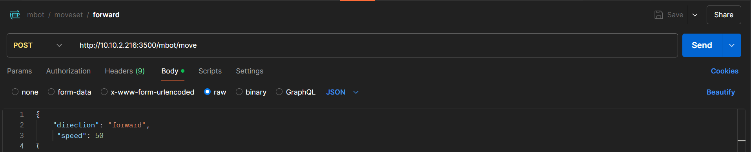
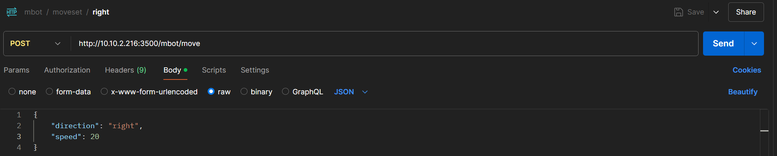
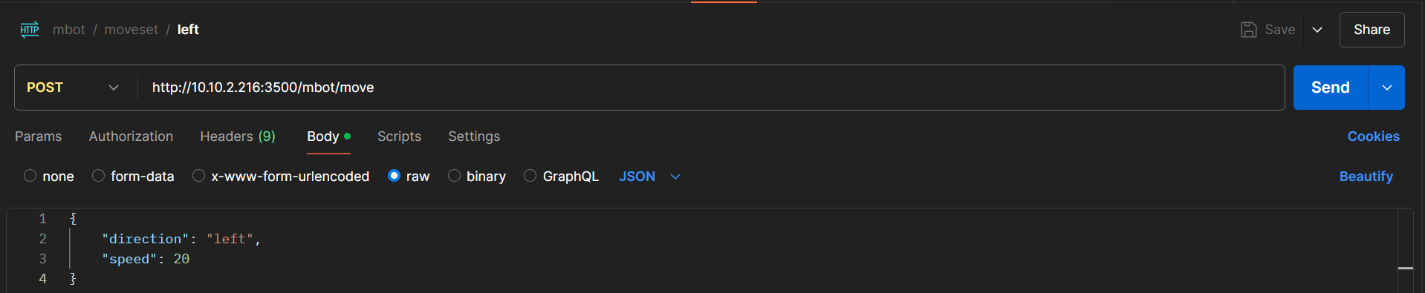
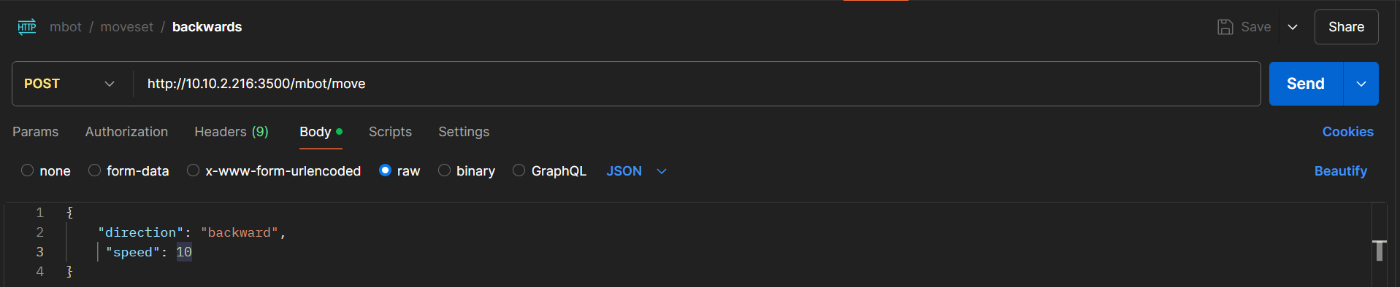

Track:
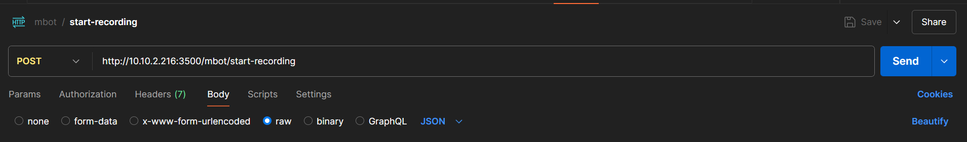

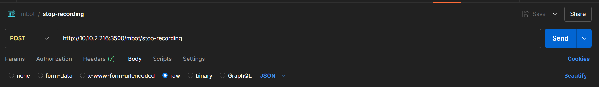

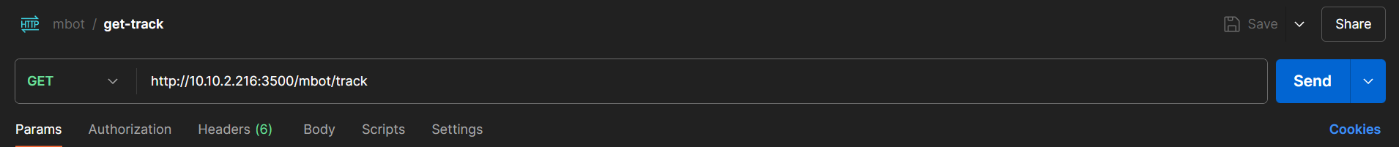

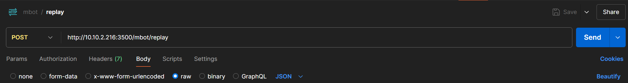

Befehlsreihe:

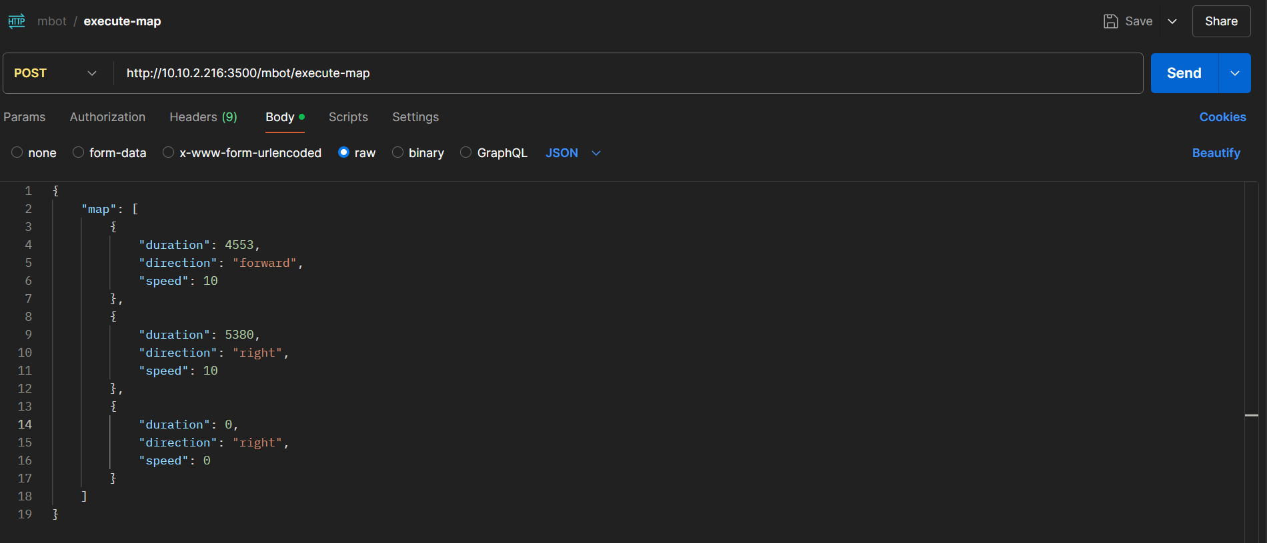
LED:

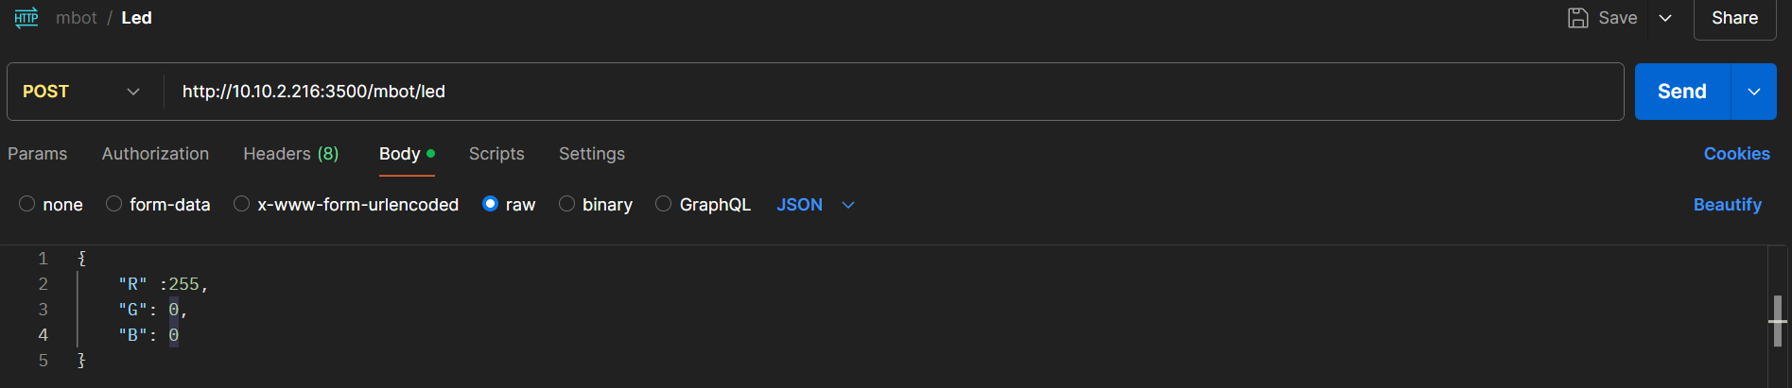
Sensors:
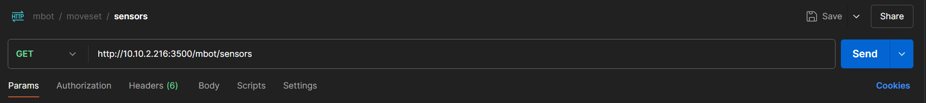

Cartography:
