**Problems and questions about LabJack modules and LJM library**

**Mark Rivers, University of Chicago**

**November 15, 2022**

**Issue 1: T8 sockets**

**Summary:** T8 cannot sometimes reopen a socket for up to 30 seconds after closing one. This includes stream mode, which uses a separate socket.

**Status:** Known firmware issue

**Issue 2: T8 cold junction temperature value**

**Summary:** T8 device temperature (cold junction) readout sometimes changes to an incorrect value, for example >400K. This seems to happen frequently when doing a stream input scan. A device reset is required to fix the problem.

**Status:** Soloman said on 11/11/2022 that they are looking into this issue.

**Issue 3: T8 stream output buffer status does not work properly.**

**Summary:** When doing a stream out operation, for example stream DAC0 and DAC1 with 100 Hz rate, the STREAM_OUT0_BUFFER_STATUS always returns 0, rather than increasing as a non-looping scan proceeds. The actual waveform out as observed on an oscilloscope is correct. The same code works fine on the T4, T7, and T7-Pro where STREAM_OUT0_BUFFER_STATUS changes correctly.

**Status:** Soloman said on 11/11/2022 that they were not aware of this issue and will investigate.

**Issue 4: T8 DAC stream output cannot start stream for some combinations of number of points and rate.**

**Summary:** If I attempt to stream out with certain combinations of number of points and rate. I get err=1302 LJME_COULD_NOT_START_STREAM. Note that it does **not** give err=2608 STREAM_SCAN_RATE_INVALID.

For example the following combinations work and fail:

|  |  |  |  |
| --- | --- | --- | --- |
| **Number of samples** | **Requested rate** | **Actual rate** | **Status** |
| 2000 | 4000.000 | 4006.410156 | Success |
| 2001 | 4002.000 | XXX | Fail, err=1302 |
| 1000 | 2000.000 | 2003.205078 | Success |
| 1001 | 2002.000 | XXX | Fail, err=1302 |
| 2000 | 1000.000 | 996.492371 | Success |
| 2001 | 1000.500 | 996.492371 | Success |
| 2002 | 1001.000 | XXX | Fail, err=1302 |

These combinations all work fine on the T4, T7, and T7-Pro. For those devices the actual rate is also much closer to the requested rate than it is on the T8

**Status:** Soloman said on 11/11/2022 that they were not aware of this issue and will investigate.

**Issue 5: T8 time to read analog inputs can vary between 1 and 8 ms. Seems to have no relationship to voltage range or resolution.**

**Summary:** The time to poll the analog input channels on the T8 implies a readout time of about 8 ms per channel after a reset. However, after doing a stream input or stream output operation the time can become much less. I have believe I have observed 1-4 ms per channel.

The following screen shot shows that the poll sleep is 10 ms and the measured poll cycle time is 25 ms. The time actually polling is thus about 15 ms .On each poll it is reading the DIO_STATE and 4 analog inputs for the channels that are enabled. (channels 0, 1, 6, 7). If the DIO_STATE read is fast then each AIN read is taking about 4 ms.

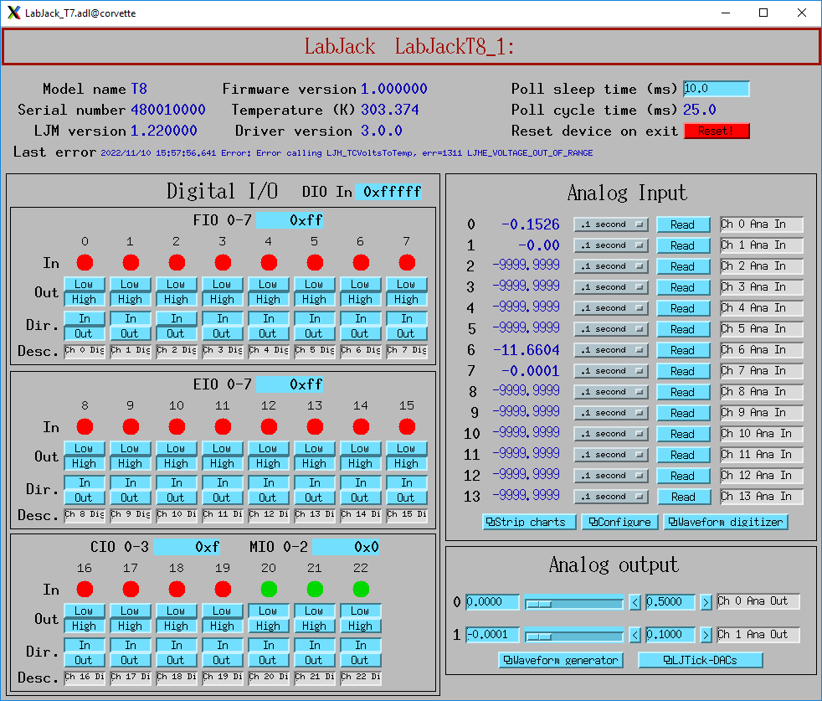

The following screen shows the configuration of the analog inputs. It shows which channels are enabled (i.e. being polled), and the mode, range, and resolution for each.

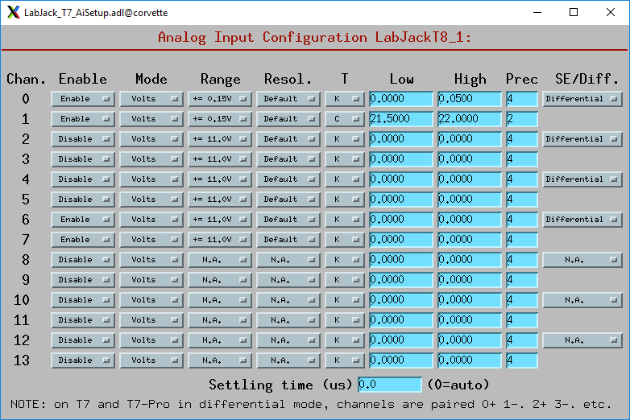

I then reset the T8 and restarted. The configuration shown above is identical. However, the poll cycle time is now 40 ms, or about 30 ms to actually read. This means the AIN reads are now taking about 8 ms, not 4 ms. Why?

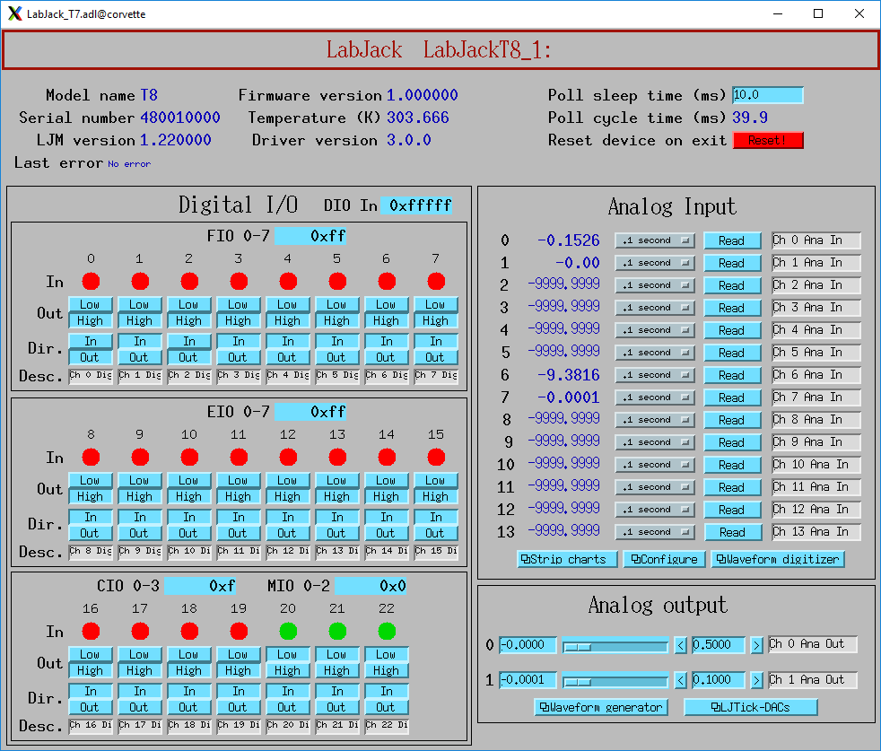

**Status:** Soloman said on 11/11/2022 that they were not aware of this issue and will investigate.

**Issue 6: Cannot set maximum number of samples that should be allowed with stream out.**

**Summary:** When setting STREAM_OUT#BUFFER_SIZE to N it works fine to write N/2-1 samples to STREAM_OUT_BUFFER_F32. However, if N/2 samples are written there is no error but the outputs do not update. For example is STREAM_OUT#BUFFER_SIZE is set to 4096 then it works fine to write 2047 samples to STREAM_OUT_BUFFER_F32. However, if 2048 samples are written then there is no error message, but nothing happens when LJM_eStreamStart() is called. This happens on all models.

**Status:** Soloman said on 11/11/2022 that they were not aware of this issue. He did some testing and was able to reproduce the problem. He said it was definitely on the firmware side.

**Issue 7: T7-Pro and T8 cannot read the analog inputs when a stream output operation is in progress.**

**Summary:** On the T4 and T7 it is possible to read the analog input channels while a stream output operation is in progress. This is very convenient because one can connect the DAC outputs to the AIN inputs and monitor the output waveform. On the T7-Pro an attempt to read the analog inputs results in an error return from LJM_eReadAddresses(). On the T8 there is no error, but the values read are all -9999. Is there a reason that the T7 can do this but the T7-Pro cannot? Can it be supported on the T8?

**Status:** LabJack support informed me on 11/14/2022 that the T7-PRO can read analog inputs, but only if the value of AIN_ALL_RESOLUTION_INDEX is <=8. I changed the driver so that when starting a stream output operation on the T7-PRO AIN_ALL_RESOLUTION_INDEX is set to 8 if it is currently 0 or >8. I was informed that the T8 cannot currently read the analog inputs while stream output is in progress. It might be added in the future, but it is not simple.

**Issue 8: There are very significant glitches in voltage readout immediately after reading TEMPERATURE_DEVICE_K.**

**Summary:** This is the issue I reported on November 4, and Soloman suggested increasing the settling time to 2000. That did not resolve the issue, but I have determined a solution described here.

In this test on the T7-Pro I have the following connections to the analog inputs:

* AIN0: Type K thermocouple, differential mode, mode=Volts, conversion to degrees C in software. +- 0.1V range, resolution=11.
* AIN2: DAC0 output.
* AIN3: DAC1 output
* AIN4-13: No connection

This is what I see when reading TEMPERATURE_DEVICE_K in one thread every 5 seconds, while polling all AIN[0-13] in another thread at 10 Hz. Note that there are temperature glitches of about -3.5 C each time that TEMPERATURE_DEVICE_K is read. The glitch is not reduced by increasing AIN_ALL_SETTLING_US to 2000, as Soloman suggested might work.

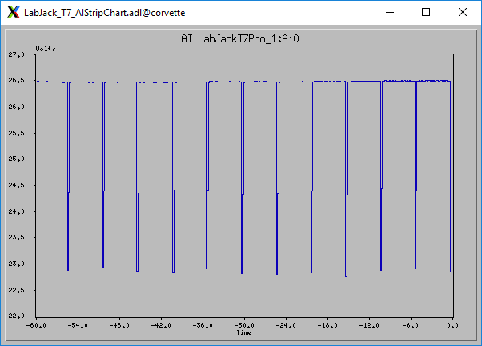

This was the configuration of the AIN channels:

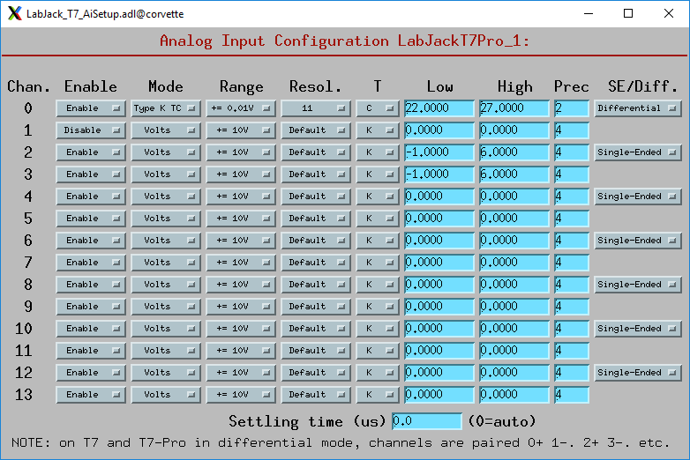

I discovered that the primary reason for the glitch was the fact that the polling thread was reading the values of the AIN4-13 channels which have nothing connected to them. By changing these channels to Disable in the above screen they are not read by the polling thread.

The input then looks like this.

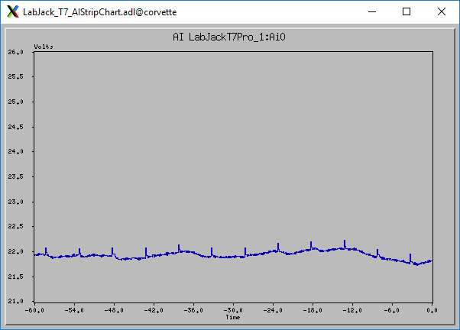

There are 2 major changes:

* The temperature value read has changed from 26.5 to 22.0. This is a huge change.
* The glitches have changed from -3.5 C to +0.1C

I was then able to eliminate even these small glitches by changing the code that reads TEMPERATURE_DEVICE_K to also do a single dummy read of each of the enabled AIN channels and discard the results. The input then looks like this:

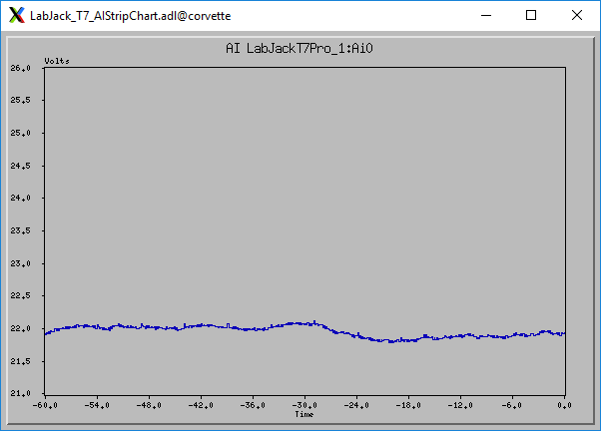

**Status:** Soloman said on 11/11/2022 that he was not able to reproduce the problem. I should provide a test program that reproduces the problem.

**Issue 9: There is significant cross-talk between analog inputs on the T7-Pro that cannot be reduced by increasing the settling time.**

**Summary:** In this test on the T7-Pro I have the following connections to the analog inputs:

* AIN0: Type K thermocouple, differential mode, mode=Volts, conversion to degrees C in software. +- 0.1V range, resolution=11.
* AIN2: DAC0 output, single-ended mode, +- 10V range, resolution=Default.
* AIN3: DAC1 output, single-ended mode. , +- 10V range, resolution=Default.

In my polling thread I am only reading these 3 AIN channels.

This is the configuration screen.

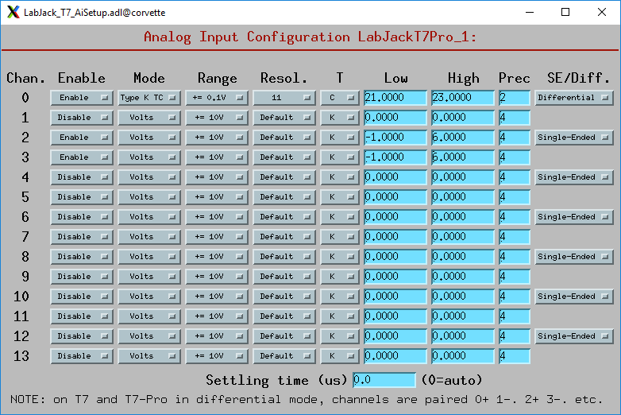

This is a strip chart of the AIN0 temperature as I change both DACs between 0V and 5V. The AIN0 temperature about 22.6 when both DACs are set to 0. When both DACs are 5V the reported temperature drops by 0.6 C to 22.0. This cross-talk is independent of the value of AIN_ALL_SETTLING_US, I have tried 0 (default), 5000, and 10000 and there is no difference.

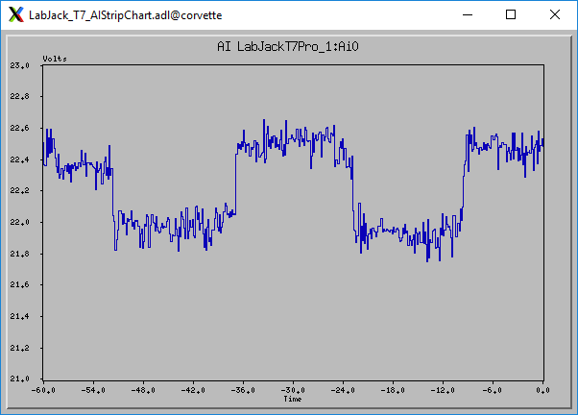

**Status:** Soloman said on 11/11/2022 that he was not able to reproduce the problem. I should provide a test program that reproduces the problem.

**Issue 10: Initial scan values have large errors on T7-Pro when running high gain.**

**Summary:** I have AIN0 connected to a type K thermocouple, differential mode with Range=+-0.01V. AIN2 is connected to DAC0 and AIN3 is connected to DAC1. Both DACs are at 0 V.

I do an input stream with just AIN0, rate=500 Hz (2 ms/point), with STREAM_RESOLUTION_INDEX=8. This shows the stream input configuration:

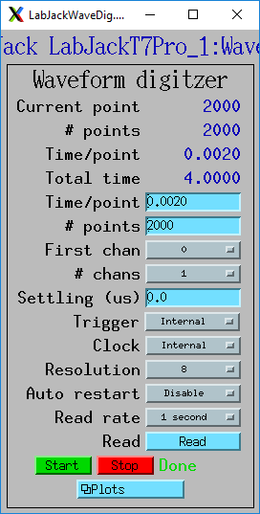

This shows the stream in data. The vertical axis is actually temperature, not Volts. Note that the temperature starts at 22.5 and drops to 21.5 in the first 0.25 seconds. This is reproducible, it happens on every scan.

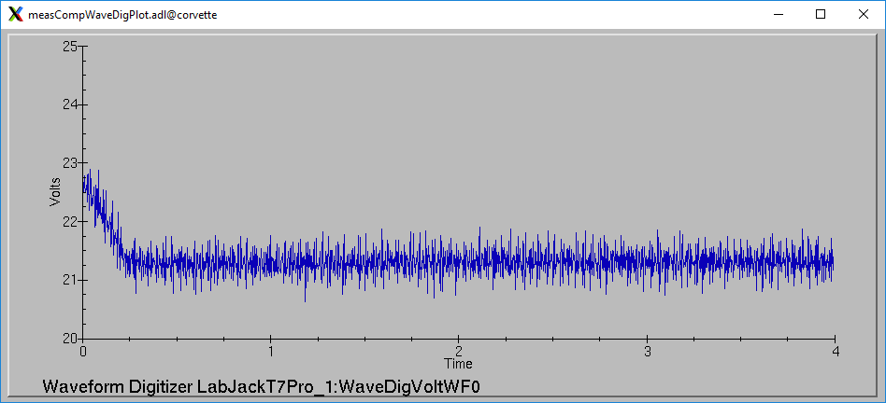

Increasing STREAM_SETTLING_US to 1000 does not change the result. This is expected since I am only scanning 1 input, STREAM_SETTLING_US should do nothing.

I then change my polling so that when stream is inactive it is only polling AIN0, and not AIN2 and AIN3. The initial glitch is then gone. I therefore believe this problem is related to the cross-talk issue (#9) above.

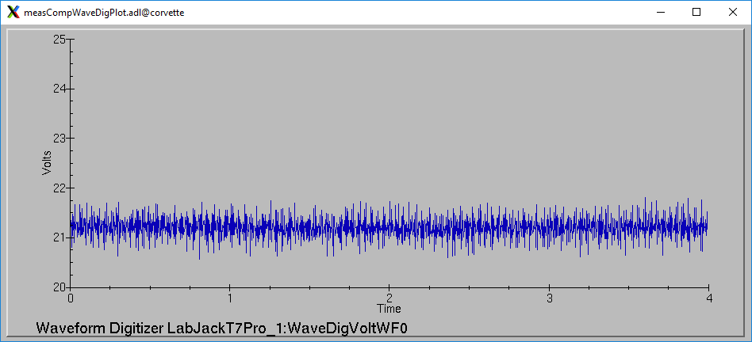

**Status:** Soloman said on 11/11/2022 that he was not able to reproduce the problem. I should provide a test program that reproduces the problem.

**Issue 11: Limitations of the current LJM_eStreamRead API.**

I think there are two important limitations/issues with the current LJM_eStreamRead API. I also think there is a straightforward and simple fix.

1) It is very important to be able to detect when the user specifies incompatible values for rate and resolution. The documentation in section 3.2 of the T-Series Datasheet says:

Sample rate is too high: When the sample rate is too high, it causes a STREAM_SCAN_OVERLAP error and stream is terminated.

Scans are triggered by hardware interrupts. If a scan begins and the previous scan has not finished, the device stops streaming and returns a STREAM_SCAN_OVERLAP error (errorcode 2942), which LJM returns immediately upon the next call to LJM_eStreamRead.

So in order to detect that a STREAM_SCAN_OVERLAP error has occurred the user needs to call LJM_eStreamRead. The problem is that this does not work if one is using callbacks with stream input. If using callbacks the call to LJM_eStreamRead() is done in the callback function. However, if there is a STREAM_SCAN_OVERLAP error LJM never calls the callback function and hence the user has no way to determine that this error has occurred.

2) It is important to be able to use external clocking for collecting each sample, and this must work for any value for the number of points N in a scan. When using external clocking it is possible that the user’s clock source will only output exactly N clock signals. For example, I use motion controllers where I can tell it to move from point A to point B and put out a clock pulse every 10 microns along the path. I know how many pulses it will output and I configure the T7 stream input scan accordingly. The value of N could even be a prime number, for example 853. In that case the only choice for scansPerRead that will work is 1 or 853. If I use 100, for example, then I will only be able to read values 0 to 799 because the clock signals for channels 853-899 will never arrive. Using 1 for scansPerRead is very inefficient, and using 853 means I cannot visualize any intermediate results.

It seems to me that the solution to both of these problems is to implement something that it appears that has been already considered for LJM. In LabJackM.h there are these lines, all commented out.

/**

* Name: LJM_STREAM_SCANS_RETURN_AVAILABLE

* Desc: A mode that will cause LJM_eStreamRead to never sleep, and always

* consume the number of scans that the LJM handle has received, up to

* a maximum of ScansPerRead. Fills the excess scan places in aData

* not read, if any, with LJM_SCAN_NOT_READ.

* Note: ScansPerRead is a parameter of LJM_eStreamStart.

* TODO: LJM_STREAM_SCANS_RETURN_AVAILABLE is not currently implemented.

**/

// LJM_STREAM_SCANS_RETURN_AVAILABLE = 3

Implementing LJM_STREAM_SCAN_RETURN_AVAILABLE is exactly what is needed. In my case it could simplify my driver a lot, because I could call LJM_eStreamRead within my poller, and not have to implement a callback function at all. I cannot currently do that because LJM_eStreamRead currently blocks, but this new mode would not block. It fixes the scansPerRead issue because I can that that to 100, but at the end of my 853 point scan it will just return the final 53 points. It fixes the problem of detecting the STREAM_SCAN_OVERLAP error because I can call LJM_eStreamRead without using callbacks.

**Status:** Hopefully a near-term enhancement.