Comparison of TetrAMM, FX4, and SRS570 + Quantum V2F100 + scaler
Mark Rivers
October 1, 2026

Motivation
Many APS beamlines measure ion chamber and photodiode currents using the following counting chain.
- Stanford Research Systems SRS570 current amplifier. This outputs a -5V to +5 V signal proportional to the input current. The range (A/V) and analog filtering can be adjusted from the front panel or from EPICS.
- Voltage to frequency converter. Commonly used models are:
  - Nova N101VTF 4-channel system. 0-10V input, switch-selectable 1,2,5, and 10 MHz/V output. These were purchased in the early days of the APS and have not been available for many years.
  - Quantum VTF100 2-channel system. Input: 1, 2.5, 5, or 10V max. Output: 10, 25, 50, or 100 MHz. This has recently been discontinued and is no longer available. This is the model that was tested in this report.
- Scaler or multi-channel scaler. Models commonly used include the Joerger VSC8, SIS3820, and Measurement Computing USB-CTR08. The USB-CTR08 was used for this report.
While these counting systems have been very useful, they are becoming obsolete, particularly because of the lack of V/F converter module suppliers. They are also much more expensive per channel than the quad electrometer devices now available. These include the following units that were tested in this report.
- TetrAMM from CAENels. This digitizes 4 currents at 100 kHz. 2 selectable current ranges are specified at the time of order. The unit used for these tests has ranges of ±120 nA and ±120 µA. The current readings can be averaged on-board the device, and additionally in the EPICS quadEM driver.
- FX4. This digitizes 4 currents at 100 kHz. 8 current ranges from ±120 nA to ±10 mA are available on all units. The current readings can be averaged on-board the device, and additionally in the EPICS quadEM driver.
The TetrAMM has been widely adopted for measuring beam position monitors in the APS storage ring and on many beamlines. However, there appears to be only anecdotal evidence on whether the TetrAMM or FX4 have similar performance compared to the traditional SR570 counting chain for experimental data acquisition with ion chambers and photodiodes. This report was done to provide a quantitative comparison under controlled and reproducible conditions.

Summary of the Results
The measurements were done with a computer-controlled current source and reading the measured currents from each system. For each device linear current ramp tests were performed for each of 6 current ranges. Each test measured 1000 points with 0.1 seconds per point. The current ranges were 0-100 nA, 0-1 µA, 0-10 µA, 0-100 µA, 0-1 mA, and 0-3 mA. The gain or current range settings of the devices were optimized for the current range being measured.
The results below are the gain or current range settings used for each device for each current range. The TetrAMM unit used has a maximum current of 120 µA, so it could not be tested in the 1 mA or 3 mA current range.
Current range | SR570 sensitivity | TetrAMM current range | FX4 current range
100 nA | 20 nA/V | ±120 nA | ±100 nA slow
1 µA | 200 nA/V | ±120 µA | ±1 µA slow
10 µA | 2 µA/V | ±120 µA | ±10 µA
100 µA | 20 µA/V | ±120 µA | ±100 µA
1 mA | 200 µA/V | N.A. | ±1 mA
3 mA | 1 mA/V | N.A. | ±10 mA

The results below are the standard deviations from the best fit straight line in nA or pA.
Current range | SR570 | TetrAMM | FX4
100 nA | 3.71 pA | 1.86 pA | 1.83 pA
1 µA | 36.1 pA | 79.8 pA | 14.4 pA
10 µA | 379 pA | 182 pA | 235 pA
100 µA | 4.81 nA | 1.44 nA | 2.99 nA
1 mA | 109 nA | N.A. | 91 nA
3 mA | 509 nA | N.A. | 209 nA

The conclusion is that all 3 devices work very well, with deviations from linearity in the range of 10-100 ppm of the maximum value. The FX4 has better performance than the SR570 in all tests. The TetrAMM has better performance than the SR570 in all tests except 1 µA range, where it is using less than 1% of its range, and the errors are 2.2X larger than the SR570.
The details of the results and the test configuration form the rest of this report.
Detailed Results

Results for linear ramp from 0 to 100 nA
The following plot shows the measured current for the linear ramp with the SR570. The plots for the TetrAMM and FX4 look identical, since the only differences are small deviations from the straight line. This is true for all current ranges, so these plots are not shown for other current ranges.
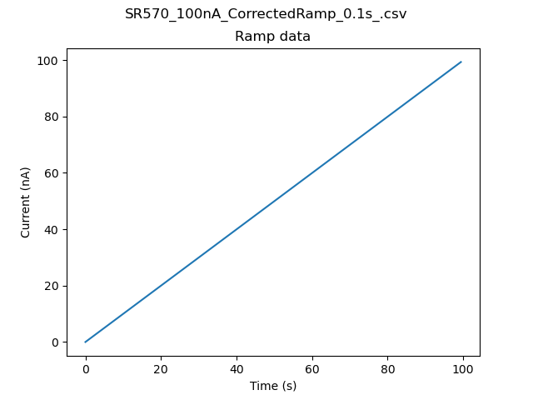

The following plots show the deviations from the best fit straight line for each device.
The error for the SR570 is 2.0 times larger than for the TetrAMM and the FX4. The difference is mainly poorer linearity for the SR570.
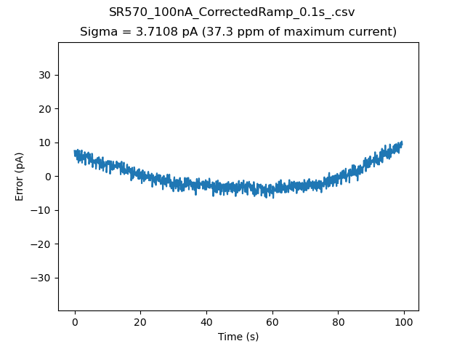
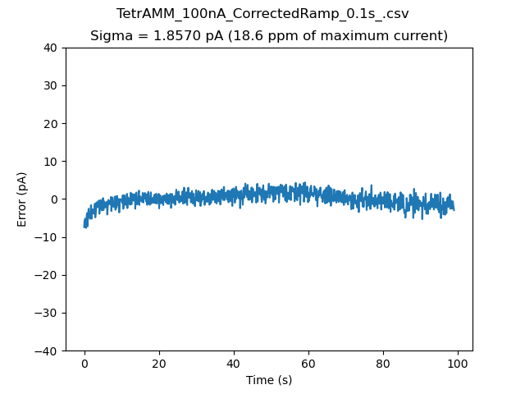
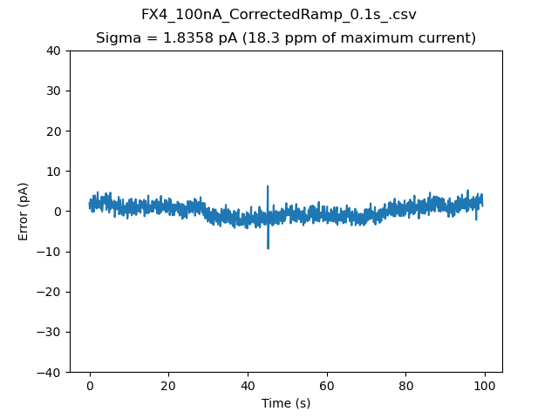
Results for 0 to 1 µA current range
The SR570 error is 2.5 times larger than the FX4, mainly due to poorer linearity. The TetrAMM error is 5.5 times larger than the FX4, because we are only using 1% of the 120 µA full scale.
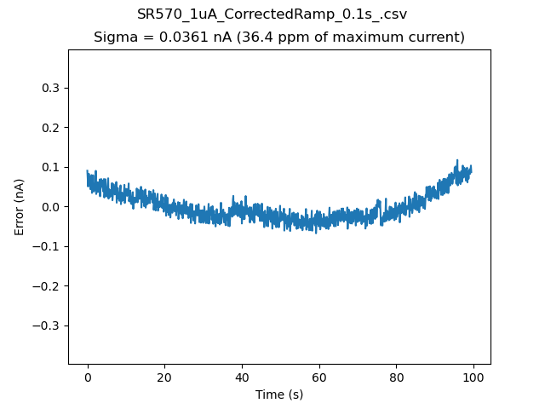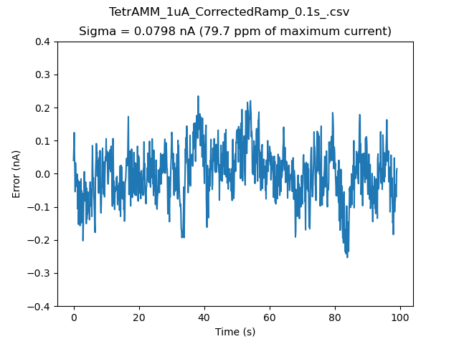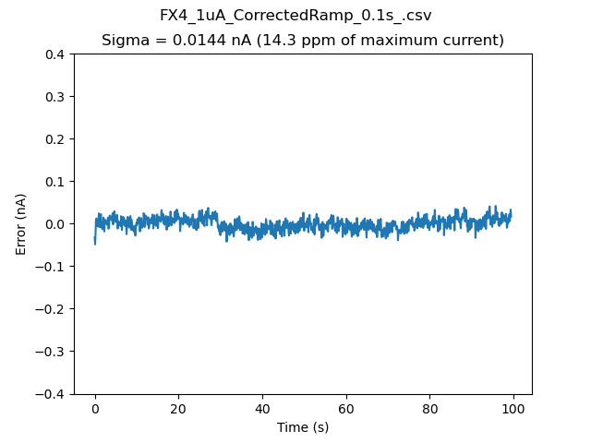
Results for 0 to 10 µA current range
The SR570 error is 2.1 times larger than the FX4, mainly due to poorer linearity. The FX4 error is 1.3 times larger than the TetrAMM.
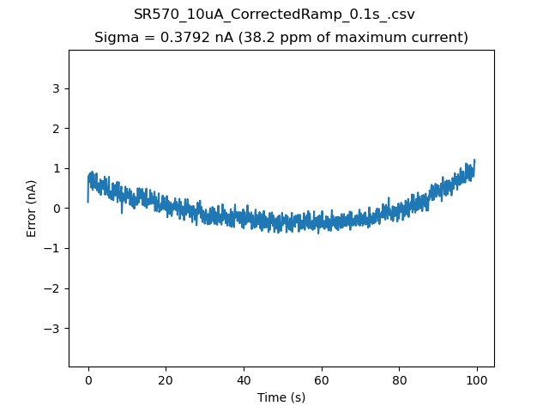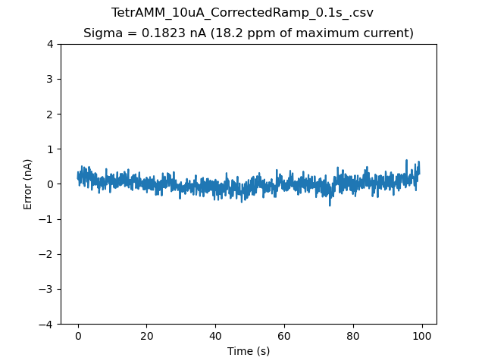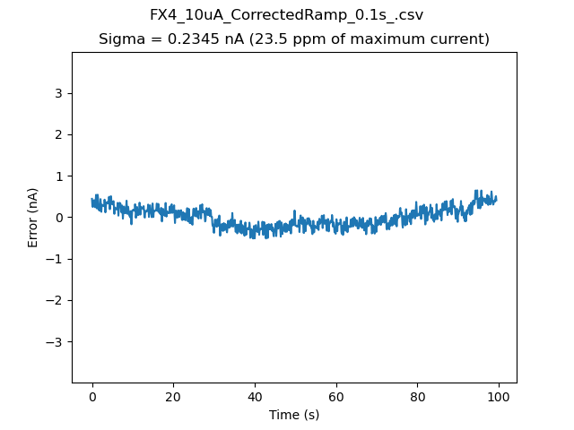
Results for 0 to 100 µA current range
The SR570 error is 3.3 times larger than the TetrAMM, mainly due to poorer linearity. The FX4 error is 2.1 times larger than the TetrAMM.
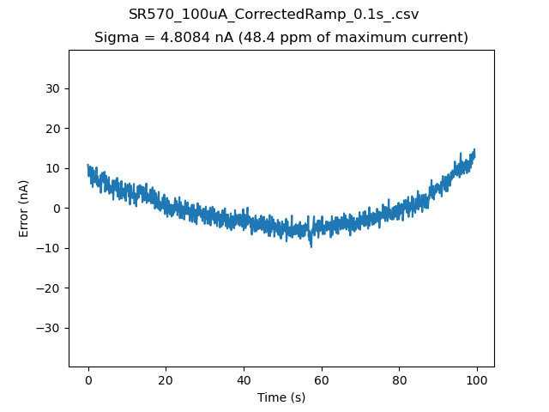
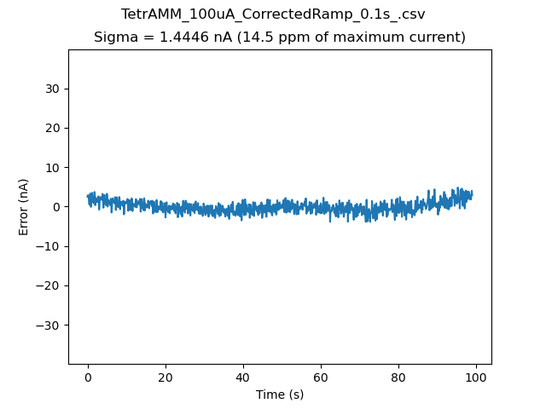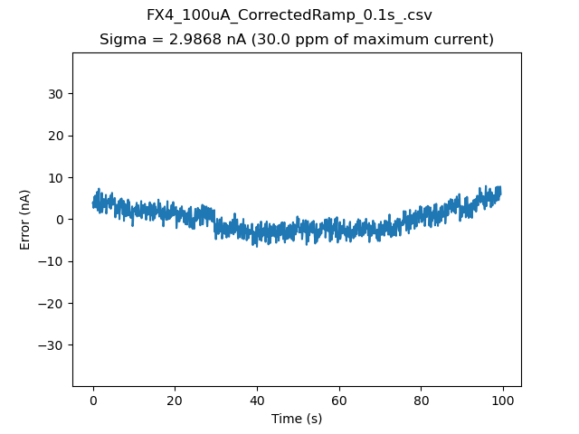

Results for 0 to 1 mA current range
The SR570 error is 1.2 times larger than the TetrAMM, mainly due to poorer linearity. Both exhibit more non-linearity in this current range than at lower currents.
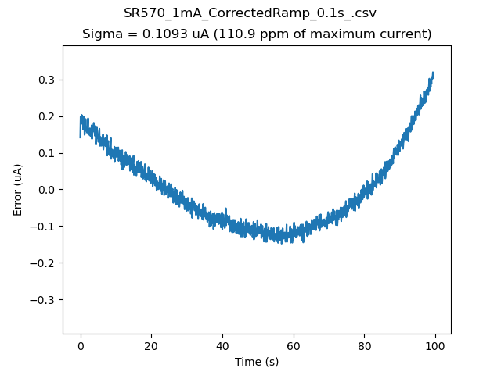
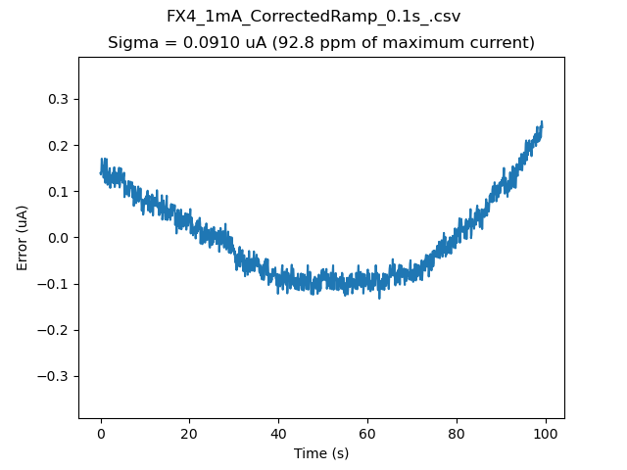

Results for 0 to 3 mA current range
The SR570 error is 2.4 times larger than the TetrAMM, mainly due to poorer linearity. Both exhibit more non-linearity in this current range than at lower currents. The systematic high frequency noise is due to the limited precision of the D/A converter. This test could only use a 0-3 V range, so the step size was 3 mV. The D/A resolution is 20/65536=0.3 mV, so there is only 10% precision in the requested output voltage step.
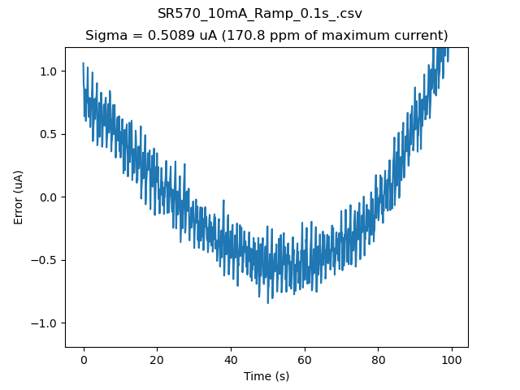
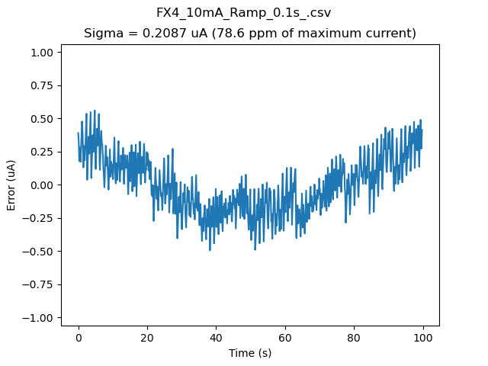

Testing Configuration

Current source
The current was generated using a 16-bit digital to analog converter (DAC) in a Measurement Computing USB-1808X. The voltage output passed through a resistor and then to the current input of the device under test. The resistor was selected with the box shown below, with values ranging from 1 kΩ to 100 MΩ. When used with a 10V input these produce currents ranging from 100 nA to 10 mA in factor of 10 steps.
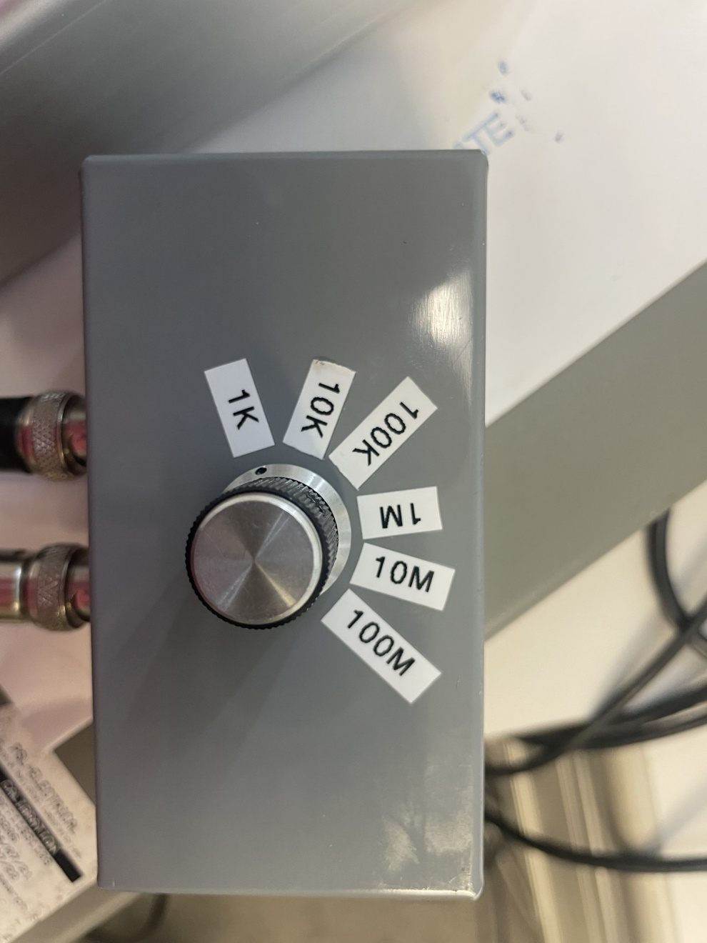
The DAC was driven in a linear ramp from 0V to 10V in the “waveform generator” mode in the USB-1808X. The 1000-point output voltage waveform is streamed from the USB-1808X at a precise 10 Hz rate, so there is no jitter in the time between output values. The DAC output was also connected to an 18-bit analog input (A/D) on the USB-1808X. This provides a readback of the actual output voltage with better resolution than the DAC. The A/D was run in the the “waveform digitizer” mode in the USB-1808X, so it is reading the voltage input at precisely 10 Hz, sampling each output from the DAC.

In the initial testing I found consistent very small upward-curved deviations from linearity for the SR570, TetrAMM, and FX4. The following is an example with the FX4 measuring 100 nA current.
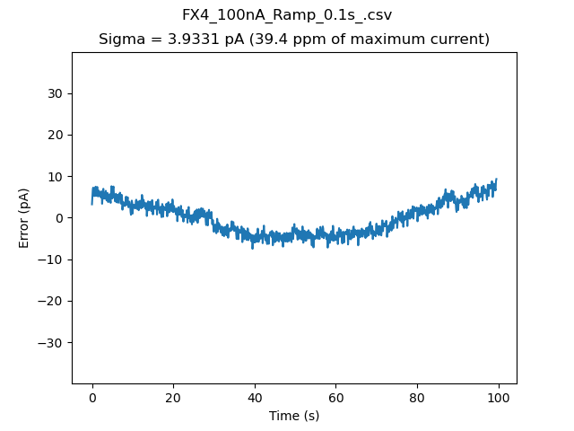
I measured the actual output voltage using the 18-bit analog input in waveform digitizer mode, and it had the same small linearity. The following is a plot of the difference between the actual and requested voltage for the 10V linear ramp. There is an offset, slope, and curvature to the difference. The noise in this plot is because the waveform digitizer does not do any averaging. The red curve is a smooth cubic spline fit to the errors.
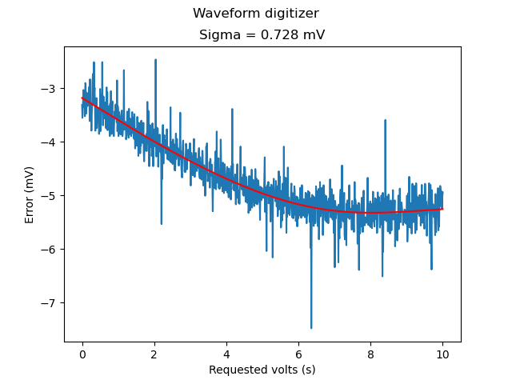
I then constructed a user-defined 0-10V ramp waveform for the USB-1808X waveform generator output that corrected the errors in the above plot using the cubic spline fit. The differences from the theoretical linear ramp were just a few bits. The currents measured with the SR570, TetrAMM, and FX4 then no longer displayed this systematic non-linearity. This is the FX4 100nA data when using the corrected voltage ramp. Most of the curvature is removed
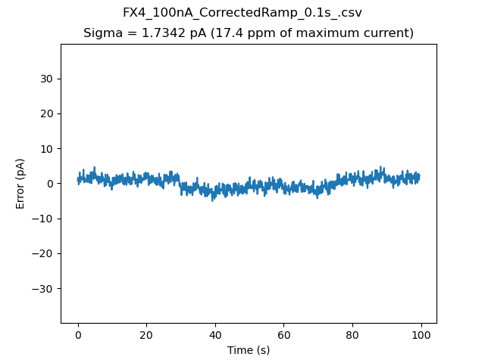
The following is a plot of the difference between the actual and requested voltage when using the corrected voltage ramp. The offset, slope, and curvature have been removed.
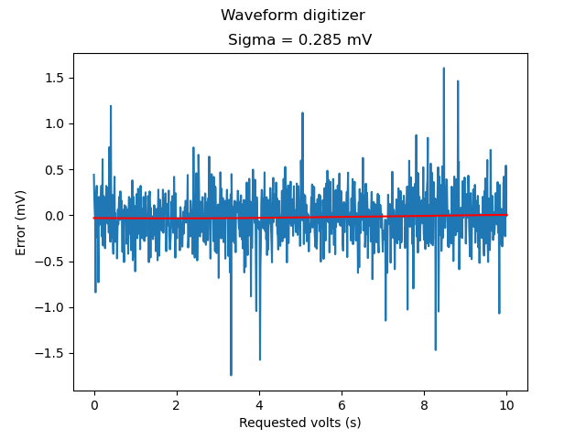
The following screenshot shows the configuration of the USB-1808X when generating the user-defined 0-10V linear ramp with the Waveform generator function. The Waveform digitizer is also measuring the actual output waveform.
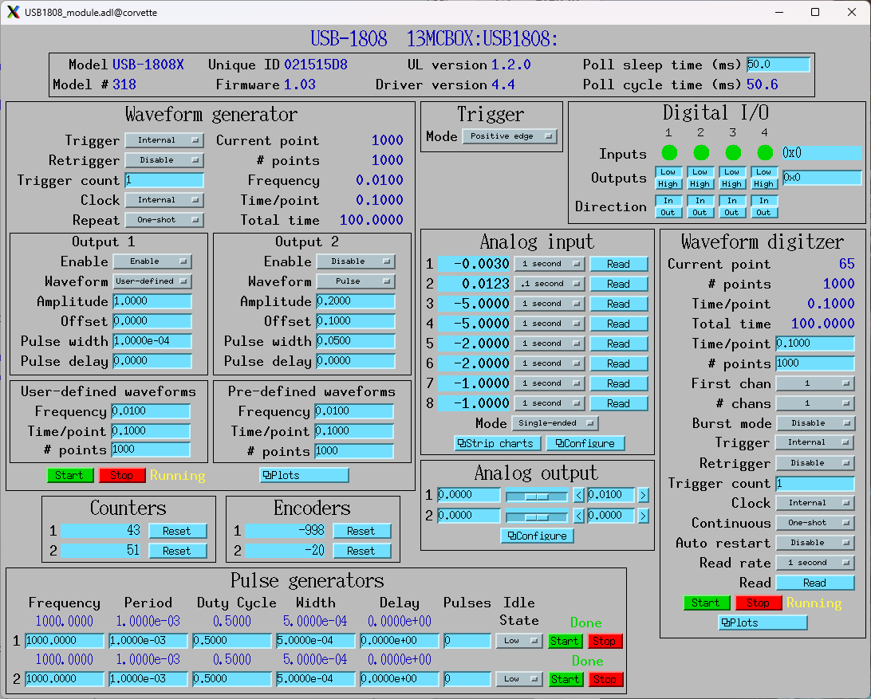

FX4 configuration
The following screenshot shows the configuration of the FX for the tests on the 0-100 nA current range.
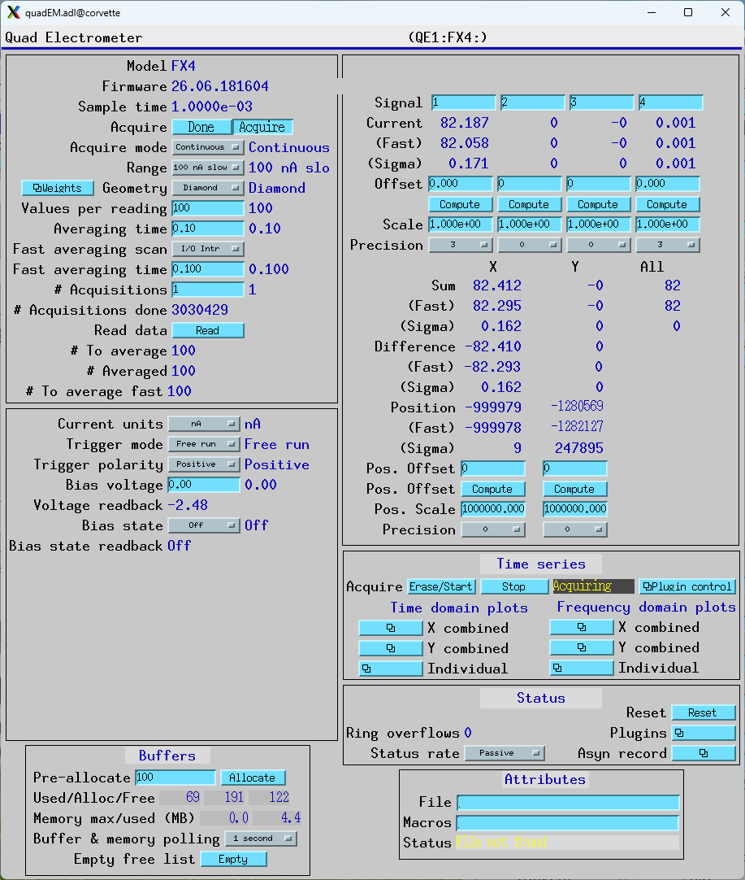

The important settings are:
- Range: 100 nA slow (1000 Hz bandpass filter)
- ValuesPerRead: 100. This means that the FX4 is doing on-board averaging for 0.001 seconds, because it digitizes at 100 kHz. This allows performing the tests in this report at up to 1000 points/s. The current report is just for 10 points/s.
- CurrentUnits: nA. This means that the values received will be in unit of nA. This is not critical, uA or pA could also be used, it just shifts the decimal point.
Note that the AveragingTime and FastAveragingTime are not important for this test. That is because we are collecting data with the TimeSeries plugin, which does its own averaging independent of AveragingTime and FastAveragingTime.
For tests with other voltage ranges the only differences are the values of the Range and CurrentUnits PVs.

This is a screenshot of the TimeSeries plugin that is used to collect the data.
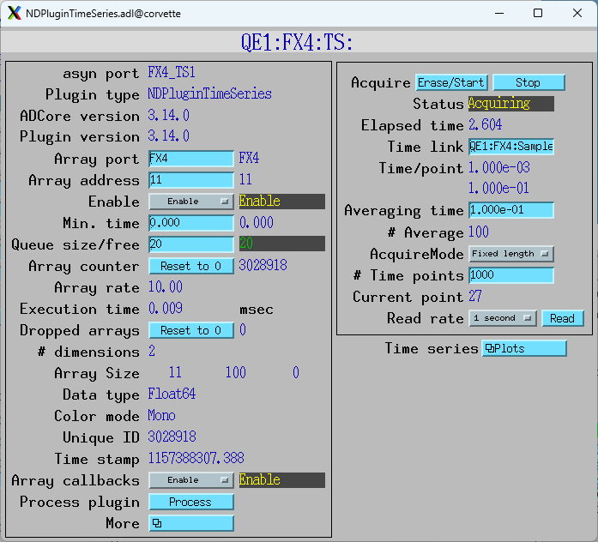
The important settings are:
- TSAveragingTime: 0.1. The averaging time is set 0.1 second, while the averaging time in the FX is 0.001 seconds. This result in TSNumAverage=100.
- TSAcquireMode: FixedLength. The plugin will collect the desired number of points and stop, rather than the continuous Circular Buffer mode.
- TSNumPoints: 1000 The plugin will collect 1000 time points at 0.1 second each, so 100 seconds total acquisition time.
- TSAcquire: This is set to 1 with the EraseStart button to begin data acquisition.

This is the plot of the time series for Current 1 after the MCS scan is complete.
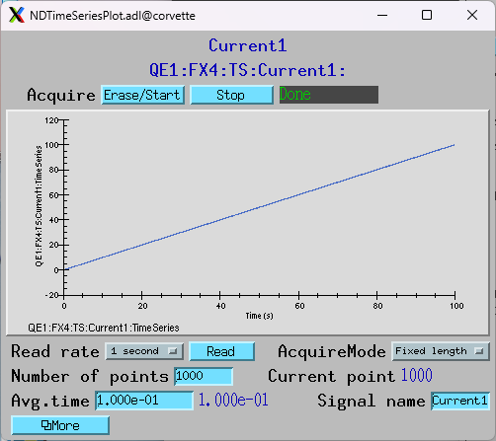

TetrAMM configuration
The following screenshot shows the configuration of the TetrAMM for the tests on the 0-100 nA current range
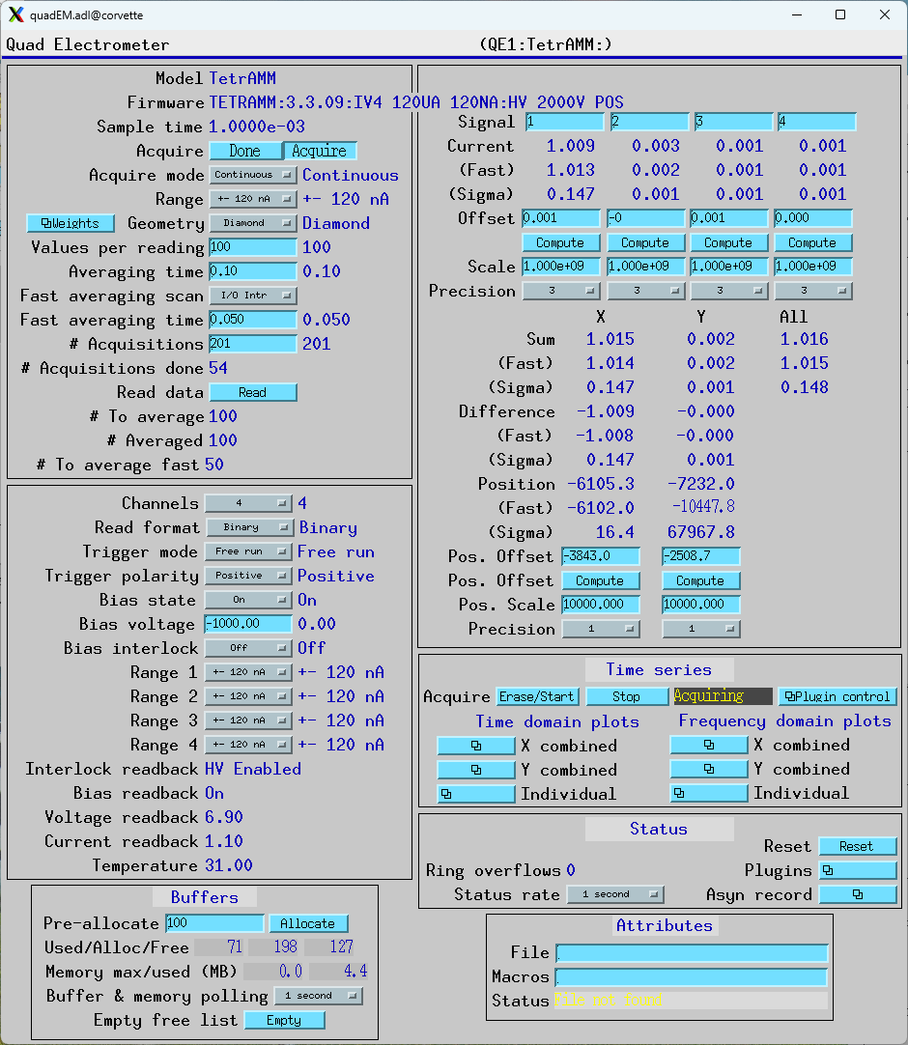
The important settings are identical to the FX4, except that Range = +- 120 nA rather than +- 100 nA. The settings on the TimeSeries plugin are identical to the FX4.
For tests with other voltage ranges the only differences are the values of Range and CurrentScale PVs.

SR570, V2F100, and USB-CTR08 configuration
The following settings were used for the SR570 for the 0-100 nA tests.
- Sensitivity: 20 nA/V, 200 nA/V, 2 µA/V, 20 µA/V, 200 µA/V, or 1 mA/V for currents ranges from 100 nA to 3 mA
- Input offset: Manually adjusted before each test to obtain 10,000 to 40,000 counts/s with 0 current.
- Input filter: 12 dB lowpass, 1 kHz frequency
This is a screenshot of the SR570 screen for the 3 mA test.
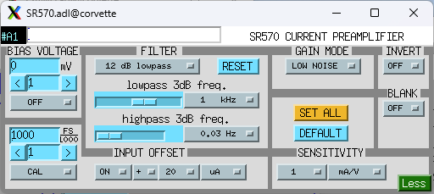
The V2F100 was configured as follows:
- Vin range: 10 V
- Vin polarity: Positive
- Fout range: 25 MHz
- Foffset: No
The output of the V2F100 was sent to the Measurement Computing USB-CTR08 operated in multi-channel scaler (MCS) mode. The MCS was run in Internal channel advance mode with a dwell time of 0.1 seconds.

This is the main configuration for the USB-CTR08 MCS:
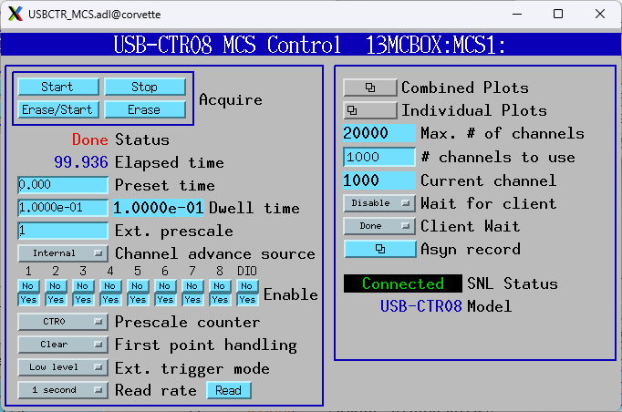
This is the plot of the MCS channel 2 which is measuring the V2F100 output.
