Comparison of TetrAMM, FX4, and SRS570 + Quantum V2F100 + scaler
Mark Rivers
September 2, 2026

Motivation
Many APS beamlines measure ion chamber and photodiode currents using the following counting chain.
- Stanford Research Systems SRS570 current amplifier. This outputs a -5V to +5 V signal proportional to the input current. The range (A/V) and analog filtering can be adjusted from the front panel or from EPICS.
- Voltage to frequency converter. Commonly used models are:
  - Nova N101VTF 4-channel system. 0-10V input, switch-selectable 1,2,5, and 10 MHz/V output. These were purchased in the early days of the APS and have not been available for many years.
  - Quantum VTF100 2-channel system. Input: 1, 2.5, 5, or 10V max. Output: 10, 25, 50, or 100 MHz. This has recently been discontinued and is no longer available. This is the model that was tested in this report.
- Scaler or multi-channel scaler. Models commonly used include the Joerger VSC8, SIS3820, and Measurement Computing USB-CTR08. The USB-CTR08 was used for this report.
While these counting systems have been very useful, they are becoming obsolete, particularly because of the lack of V/F converter module suppliers. They are also much more expensive per channel than the quad electrometer solutions now available. These include the following units that were tested in this report.
- TetrAMM from CAENels. This digitizes 4 currents at 100 kHz. 2 selectable current ranges are specified at the time of order. The unit used for these tests has ranges of ±120 nA and ±120 µA. The current readings can be averaged on-board the device, and additionally in the EPICS quadEM driver.
- FX4. This digitizes 4 currents at 100 kHz. 8 current ranges from ±120 nA to ±10 mA are available on all units. The current readings can be averaged on-board the device, and additionally in the EPICS quadEM driver.
The TetrAMM has been widely adopted for measuring beam position monitors in the APS storage ring and on many beamlines. However, there appears to be only anecdotal evidence on whether the TetrAMM or FX4 have similar performance compared to the traditional SR570 counting chain for experimental data acquisition with ion chambers and photodiodes. This report was done to provide a quantitative comparison under controlled and reproducible conditions.

Summary of the Results
The measurements were done with a computer-controlled current source and reading the measured currents from each system. For each device 3 tests were performed for each of 2 current ranges (6 tests total). Each test measured 1000 points with 0.1 seconds per point. The current ranges were 0 to 100 µA and 0 to 100 nA.
- Constant current of 1% of range maximum to measure noise over 100 seconds at 10 Hz. The results below are the standard deviations in nA or pA.
Current range | SR570 | TetrAMM | FX4
100 µA | 0.86 nA | 0.20 nA | 0.03 nA
100 nA | 0.97 pA | 1.86 pA | 1.73 nA

- Linear ramp of the current from 0 to range maximum. The results below are the standard deviations from the best fit straight line in nA or pA.
Current range | SR570 | TetrAMM | FX4
100 µA | 6.1 nA | 2.5 nA | 4.4 nA
100 nA | 13.1 pA | 11.1 pA | 11.9 pA

- Single-cycle sine wave with total range of 1% to 99% of range maximum. The results below are the standard deviations from the best site sine wave in nA or pA.
Current range | SR570 | TetrAMM | FX4
100 µA | 5.2 nA | 2.5 nA | 4.4 nA
100 nA | 12.4 pA | 12.2 pA | 10.7 pA

The details of the test configuration and the individual results form the rest of this report.

Current source
The current was generated using a 16-bit digital to analog converter (DAC) in a Measurement Computing USB-1808X. The voltage output passed through either a 100 kΩ or 10 MΩ resistor and then to the current input of the device under test. The 100 kΩ resistor produces 100 µA with a 10 volt output from the DAC, while the 10 MΩ resistor produces 100 nA with a 1 volt output. The DAC was driven in the “waveform generator” mode in the USB-1808X. The 1000-point output voltage waveform is streamed from the USB-1808X at a precise 10 Hz rate, so there is no jitter in the time between output values. The DAC output was also connected to an 18-bit analog input (A/D) on the USB-1808X. This provides a readback of the actual output voltage with better resolution than the DAC. The A/D was run in the the “waveform digitizer” mode in the USB-1808X, so it is reading the voltage input at precisely 10 Hz, sampling each output from the DAC.
The following screenshot shows the configuration of the USB-1808X when generating the sine wave with 100 µA.
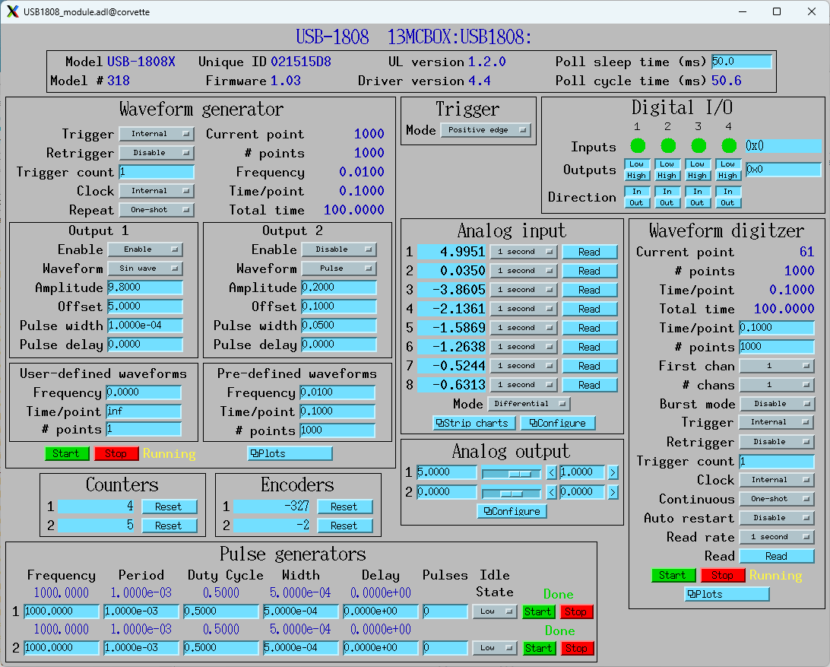
FX4 configuration
The following screenshot shows the configuration of the FX for the tests on the 0-100 nA current range.
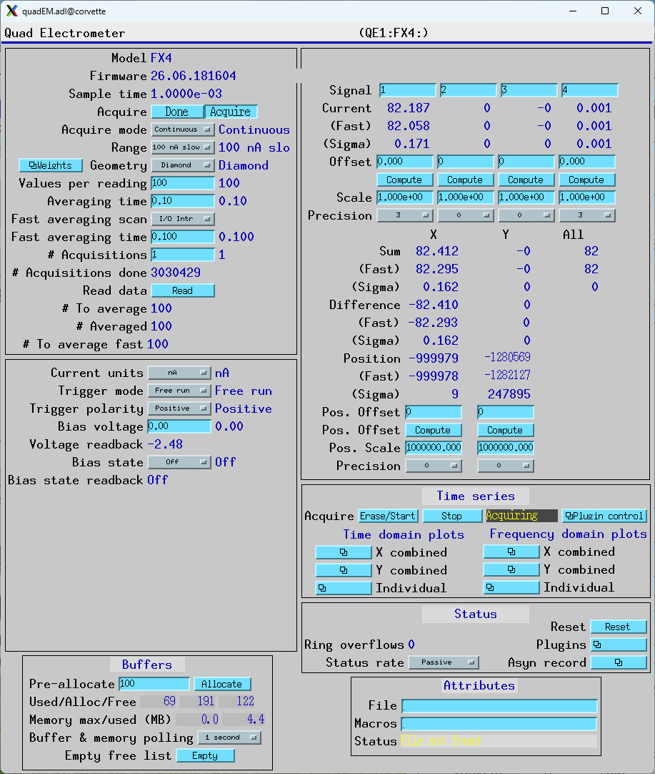

The important settings are:
- Range: 100 nA slow (1000 Hz bandpass filter)
- ValuesPerRead: 100. This means that the FX4 is doing on-board averaging for 0.001 seconds, because it digitizes at 100 kHz. This allows performing the tests in this report at up to 1000 points/s. The current report is just for 10 points/s.
- CurrentUnits: nA. This means that the values received will be in unit of nA. This is not critical, uA or pA could also be used, it just shifts the decimal point.
Note that the AveragingTime and FastAveragingTime are not important for this test. That is because we are collecting data with the TimeSeries plugin, which does its own averaging independent of AveragingTime and FastAveragingTime.
For tests on the 0-100 µA range the only differences are Range = += 100 uA and CurrentUnits = uA so the units are in µA.

This is a screenshot of the TimeSeries plugin that is used to collect the data.
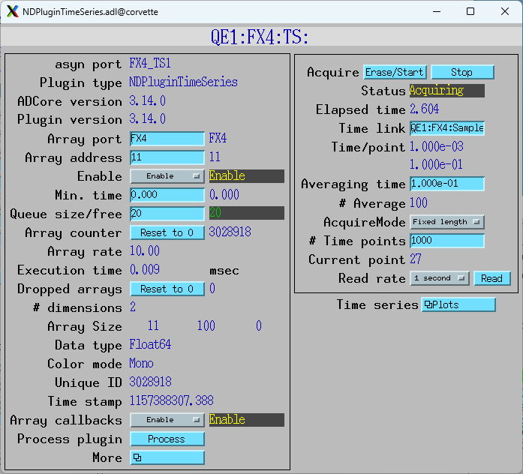
The important settings are:
- TSAveragingTime: 0.1. The averaging time is set 0.1 second, while the averaging time in the FX is 0.001 seconds. This result in TSNumAverage=100.
- TSAcquireMode: FixedLength. The plugin will collect the desired number of points and stop, rather than the continuous Circular Buffer mode.
- TSNumPoints: 1000 The plugin will collect 1000 time points at 0.1 second each, so 100 seconds total acquisition time.
- TSAcquire: This is set to 1 with the EraseStart button to begin data acquisition.

TetrAMM configuration
The following screenshot shows the configuration of the TetrAMM for the tests on the 0-100 nA current range
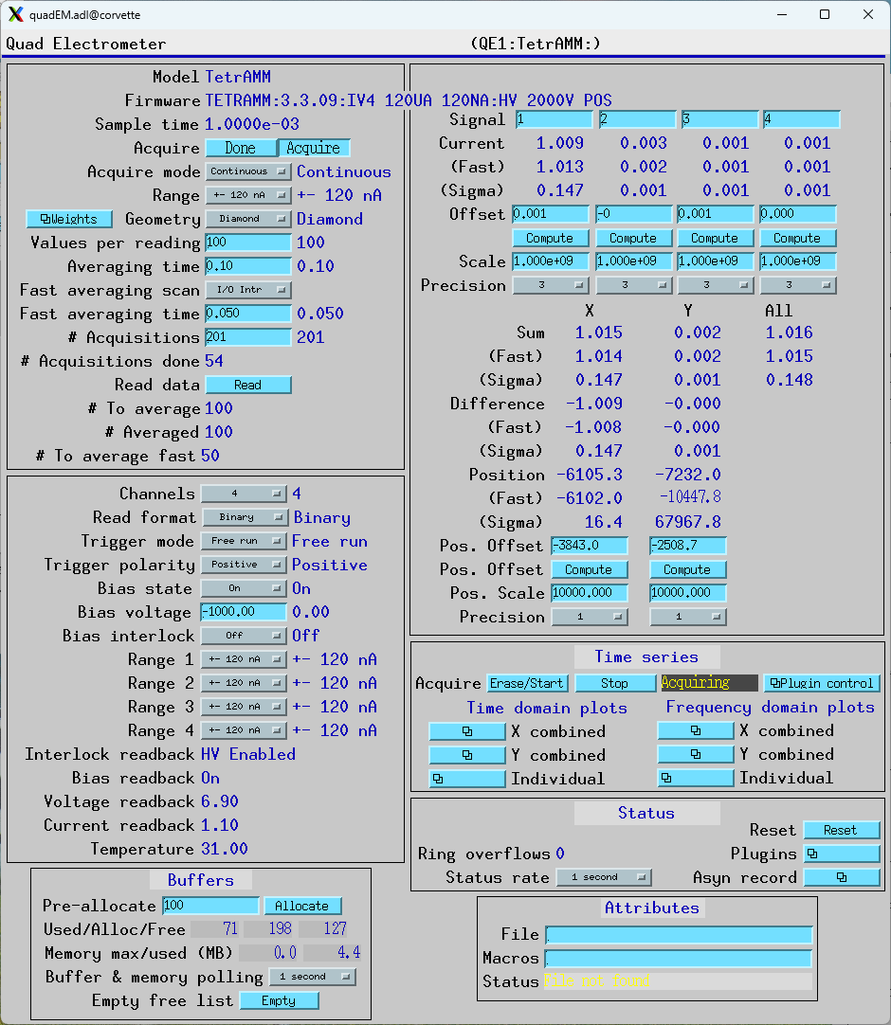
The important settings are identical to the FX4, except that Range = +- 120 nA rather than +- 100 nA. The settings on the TimeSeries plugin are identical to the FX4.
For tests on the 0-100 µA range the only differences are Range = += 120 uA and Current1Scale = 1e6 rather than 1e9 so the units are in µA.

SR570, V2F100, and USB-CTR08 configuration
The following settings were used for the SR570 for the 0-100 nA tests.
- Sensitivity: 20 nA/V
- Input offset: -2 nA, set to get V/F output counts close to zero with zero current.
- Input filter: 12 dB lowpass, 1 kHz frequency
The following settings were used for the SR570 for the 0-100 uA tests.
- Sensitivity: 20 uA/V
- Input offset: -100 nA, set to get V/F output counts close to zero with zero current.
- Input filter: 12 dB lowpass, 1 kHz frequency
- The gain of the SR570 was as expected, a nominal 100 µA produced 5.06 volt output.
The VSF100 was configured as follows:
- Vin range: 10 V
- Vin polarity: Positive
- Fout range: 10 MHz
- Foffset: No
I tested 2 different V2F100 units. On the first one (serial #335) the output was not what I expected. When configured for 10V input = 10 MHz output then for a 5 V input I would have expected 5 MHz output. I actually observed 7.5 MHz output for 5V input. I then tested a second unit (serial #445) and it had the expected gain of 1 MHz/V. I used serial #012 for the measurements in this report. This is the unit normally used in the 13-ID-E station.
On the test with the constant voltage serial #335 had a standard deviation of 0.776%, while serial #445 had a standard deviation of 0.052%, 15 times lower.

Results for constant 1 µA current and 100 µA full scale
The following plots show the measured current with the vertical range being ± 1% of the mean.
The noise on the TetrAMM is about 4 times less than the SR570. The noise on the FX4 is 26 times less than the noise on the SR570 and 6 times less than the TetrAMM.

Results for constant 1 nA current and 100 nA full scale
The following plots show the measured current with the vertical range being ± 1% of the mean.
The noise on the TetrAMM is about 1.9 times greater than the SR570, and has a high-frequency component. The noise on the FX4 is 1.8 times the noise on the SR570 and has a long term drift.

Results for linear ramp from 0 to 100 µA
The following plot shows the measured current for the linear ramp with the SR570. The plots for the TetrAMM and FX4 look identical, since the only differences are small deviations from the straight line.

The following plots show the deviations from the best fit straight line for each device.
The error for the SR570 is 2.4 times larger than for the TetrAMM and 1.4 times larger than for the FX4.

Results for linear ramp from 0 to 100 nA
The following plot shows the measured current for the linear ramp with the SR570. The plots for the TetrAMM and FX4 look identical, since the only differences are small deviations from the straight line.

The following plots show the deviations from the best fit straight line for each device.
The errors are all very similar with sigma of ~0.01 nA and a distinct periodicity. I now realize the cause for this. Ideally the 100 nA signal should be generated using a 100 Mohm resistor and a 10V DAC output. However, the largest resistor we had was only 10 M ohm. This means that 100 nA requires 1 V from the DAC. The DAC on the USB-1808X is 16-bits and has a fixed range of ± 10V. Each output bit is thus 20000 mV/65536 = 0.3 mV. The ramp is 1 V in 1000 steps, or 1 mV per step. Since the bit resolution is 0.3 mV there is up to 30% error from the desired voltage and the actual voltage. We need to fix this by either obtaining a 100 Mohm resistor, or by building a voltage divider to use with the 10 Mohm resistor.

Results for sine wave from 1 to 99 µA
The following plot shows the measured current for the sine wave input with the SR570. The plots for the TetrAMM and FX4 look identical, since the only differences are small deviations from the ideal sine wave. The analysis code does a best fit to the sine wave, which when plotted on this scale is also indistinguishable from the measured data. The fit coefficients are shown in the plot title.

The following plots show the deviations from the best sine wave for each device.
The error for the SR570 is 2.1 times larger than for the TetrAMM and 1.2 times larger than for the FX4. The sigma values for this test are nearly identical to those for the 100 µA linear ramp test discussed above.

Results for sine wave from 1 to 99 nA
The following plot shows the measured current for the sine wave input with the SR570. The plots for the TetrAMM and FX4 look identical, since the only differences are small deviations from the ideal sine wave. The analysis code does a best fit to the sine wave, which when plotted on this scale is also indistinguishable from the measured data. The fit coefficients are shown in the plot title.

The following plots show the deviations from the best fit straight line for each device.
The sigma values for this test are nearly identical to those for the 100 nA linear ramp test discussed above.
The errors are all very similar with sigma of ~0.01 nA and a distinct periodicity. The reason for this is probably the same as for the 100 nA linear ramp test discussed above, i.e. that the precision of the DAC current output is too small because only a 0-1V output is being used out of a total range of 20 V with 16-bit precision.

