Gather Service
Guobao Shen, Marty Kraimer
National Synchrotron Light Source II
Brookhaven National Laboratory, Upton, NY, 11764

Ref:
- http://epics-pvdata.hg.sourceforge.net/hgweb/epics-pvdata/pvServiceJava/file/cdc978274cba/src/org/epics/pvService/gather/package.html

Overview
PVService gather has two services: createGather and gather. Each is a state-full service, i. e. a client must connect, make one or more requests, and finally disconnect. This document describes only gather.

The gather service provides access to a set of V3 channels. Each V3 channel must be a numeric scalar or numeric array. It allows a client to get, put, and monitor the set of channels.

The client can get the following information:
value - The array of V3 values
timeStamp - The last time the V3 values were accessed
alarm - If there is a problem accessing the V3 then an alarm is raised
isBad - The client can find out if any of the V3 channels has been set bad and which ones are bad.
isConnected - The client can find out if all V3 channels are connected and if not which ones are not connected.
severityIndex - The client can find out the alarm severity of each V3 channel.

Server Side of Gather
A gather record holds the following data:
structure
structure alarm
int severity 0
string message
structure timeStamp
long secondsPastEpoch 0
int nanoSeconds 0
string options
string command processGet
double[] value []
boolean[] isBad []
boolean[] isConnected []
byte[] severityIndex []
string[] channelNames[]

A basic assumption is that every V3 channels is a numeric scalar or every channel is a numeric array.
The gather support gets and/or puts and/or monitors data in the V3 IOCs. It keeps value, connection status, severity, and pvname as array fields. The alarm is used to report problems to the client. The timesStamp is the last time the record was processed, i.e. the last time a processGet, put, or V3 monitor occurred.

The client of createGather must say if it expects each V3 channel to be an array or a scalar. If gather is told V3 channel channelsAreArrays, all scalar channels will look like an array with one element. If gather is not told that channelAreArrays then if a V3 channel is an array only the first element will be returned. Note that a V3 CA client can not know for certain if the field is an array or a scalar. Users can create a waveform record that has NELM=1 and to a CA V3 client it will look just like a scalar because ca_element_count is 1 just like for a scalar.

Why state-full service?
Gather is a state-full type service. To explain why lets consider a service that just gets the latest data value from a set of 10 IOCs.

The example will concentrate on the number of network messages that must be passed in order to implement the service. It will briefly discuss other required resources required. But before that a brief description of how a single get request is done in CA and in pvAccess is provided.

CA get request
Giving the command: caget someChannel, which is an example of a stateless CA get request. It results in the following network messages:
- search request - A UDP broadcast
- search response - A UDP message
- connect - A tcp connect request
- connected - tcp connection is made
- get request - a tcp message
- get response - a tcp message
- disconnect - terminate tcp connection
The UDP broadcast is expensive because every IOC on the controls network must process the request to see if it has the channel. The other parts of the request require the acquisition and release of resources mainly threads, tcp connections, and memory.
A state-full application would do the search, connects, and disconnect only once and allow multiple gets. If this is done then only two network messages are required. The server side of CA uses free lists so that it does not have to allocate and delete memory for each request. In the client side the client gets the data from the network buffer. Thus the client can allocate storage for the data once and reuse it for each get.

pvAccess get request
Giving the command: pvget someChannel, which is an example of a stateless pcAccess get request. It results in the following network messages:
- search request - A UDP broadcast
- search response - A UDP message
- connect - A tcp connect request
- connected - tcp connection is made
- connectGet - A tcp connectGet request
- getConnected - A tcp getConnected complete
- get request - a tcp message
- get response - a tcp message
- disconnect - terminate tcp connection
This is similar to CA except for the two extra messages: connectGet and getConnected. The reason for these is so that both client and server can allocate resources once and then reuse then for each get. Since pvAccess supports structured data it would be very difficult to use free lists to manage memory.

For both CA and pvAccess a state-full application makes much better use of the facility than a completely stateless service.

A stateless local service using CAV3 that gathers data from 10 IOCs causes the following messages:
- search - 1 UDP broadcast to server side of gather
- found - 10 UDP messages. One from each V3 IOC
- connect - 10 tcp messages. One to each V3 IOC
- connected - 10 tcp messages. One from each V3 IOC
- get - 10 tcp messages. One to each V3 IOC
- get result - 10 tcp messages. One from each V3 IOC
- disconnect - 10 tcp disconnect messages
Thus a single gather get request for 10 channels requires 60 directed messages and one broadcast message. If, however, the service does keep state then each additional get requires only 20 directed messages.

A stateless local service using pvAccess would be like the CAV3 service except that there are two additional steps:
- connectGet - 10 tcp messages
- getConnected - 10 tcp messages
Thus for a completely stateless implementation pvAccess is worse than CA. If the service keeps state than pvAccess is equivalent to CA, i. e. each additional get request takes 20 network messages.

Remote pvAccess: stateless client

If a gather server record exists then the following messages are required
- search for gather - A UDP broadcast
- gather found - A UDP message
- connectGather - A tcp connect request
- gather connected - tcp connection is made
- get request - a tcp message – This causes 10 tcp messages to V3 IOCs
- get response - a tcp message - This is after 10 tcp messages from V3 IOCs
- disconnect - terminate tcp connection
If the client is state-full then only the two get stages are required.

High Level Client API?

First at all, let’s take Bob’s comment:
For a service, we should be serving things that are generic. Servers have application knowledge.
For instance:
gatherService - collects V3 scalars and combines them into a Multi-Channel Array.
- if the scalars were marked INVALID or (forgot the name for not connected), then any general application knows that this is not a valid channel.
If you want to apply this to BPMs you can either ---
use the gatherService to get the scalar information from the IOCs and pass it along -
OR
make a more specific test for BPMs against the model
or in the INVALID when the model says that the reading is unbelievable and then
pass along a Multi-Channel Array. This one may have additional members marked as INVALID

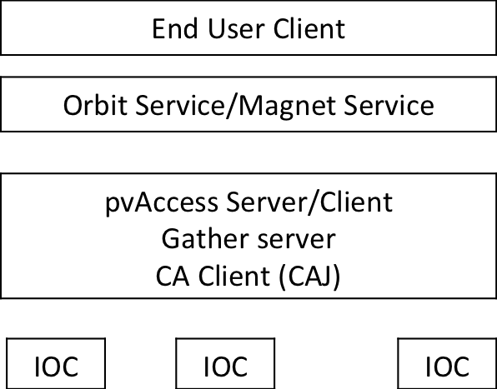
User Case 1
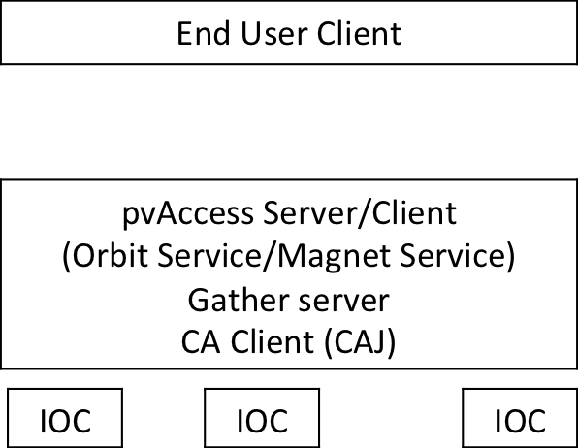
User Case 2

The high level API to use gather service by a end-user should not be aware of low level details. For example, for an end-user, he just uses a common tool-set like pvget, pvput, pvmonitor, pvinfo… which are available in both shell and script. The end-user API will hide like connection hand-shake (ChannelAccess.ClientFactory.Start(), ChannelAccess.ClientFactory.Stop()), context initialization, and so on.

