Four-circle-goniometer alignment
H. Sinn, 12-1-04

The following functions allow calculating the angles of a four circle goniometer (TTH, TH, CHI and PHI, defined as in SPEC) for a given set of H, K, L and vice versa. Since there are four angles to be defined from three lattice indices, boundary conditions have to be set. Boundary conditions described here are Ω=0 (TTH=2 TH) in the function OMG0 or PHI = constant in ARCS. Also, PHI can be set in ARCS such that | PHI | and | 90-CHI | are minimized, which is a good choice for e.g. two arc-segments with a limited range on top of the theta circle (Note: in this geometry CHI=90 is the ‘zero’ position of the arc). The coordinate system and sense of rotations are the same as in SPEC.

HKL: Calculates H, K, L indices from given angles TTH, TH, CHI, PHI

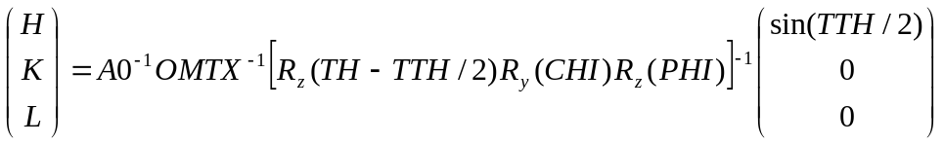

OMG0: Calculates TTH, TH, CHI, PHI from H, K, L with TH=TTH/2. Good for Euler cradle geometry.

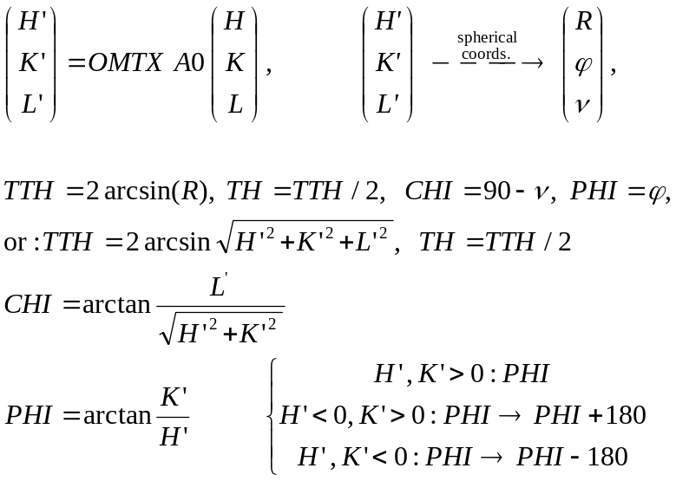

CLCA0: Calculates Matrix A0 that converts reciprocal indices into cartesian coordinates in the reciprocal space. Real space lattice parameters are: a, b, c, α, β, γ

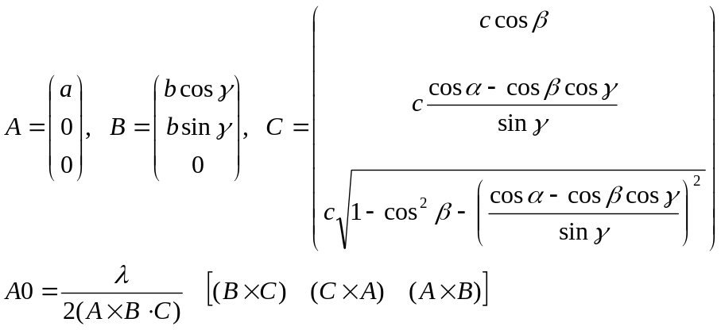

OCALC: Calculates orientation matrix OMTX from indices and angles of primary and secondary reflections V₁, V_{1A}, V₂, V_{2A}. Set OMTX = ID before using HKL.

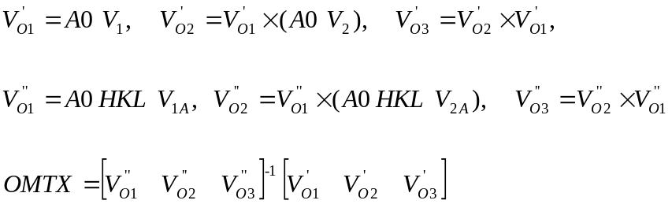

RZ: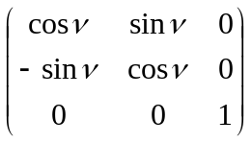

RY: 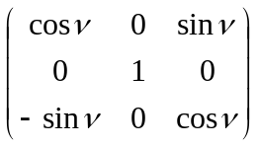
------------------------------------ Non essential functions------------------------------------

ARCS: Calculates TTH, TH, CHI, PHI from H, K, L with either PHI = constant or
| CHI| , | PHI-90 | = minimum. Good for two-arc-segment geometry.

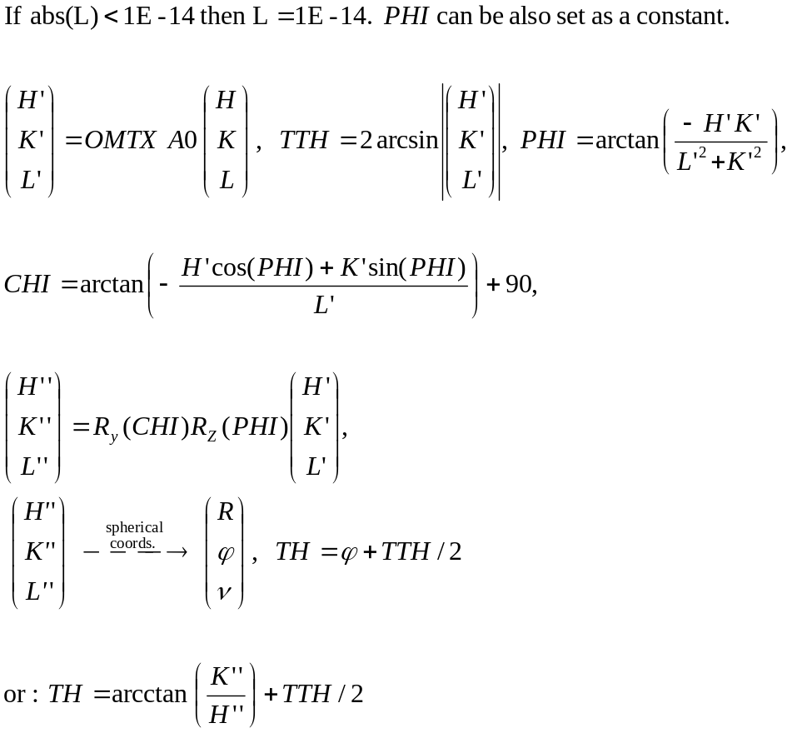

INO2P: Calculates angles V_{2A} of secondary reflection from indices V₂ under the assumption that the secondary reflection is in the scattering plane when the primary reflection is aligned.
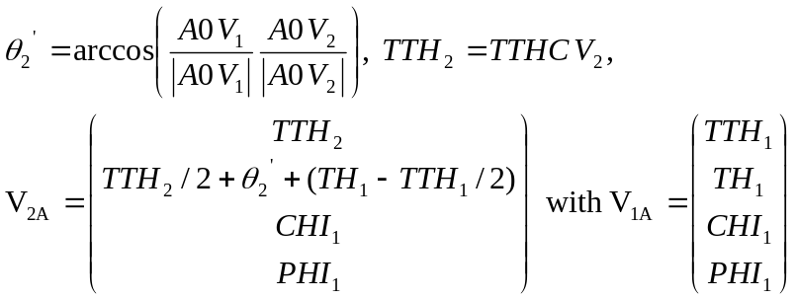

ANGL: Calculates angle between measured secondary reflection and the secondary reflection that is calculated from orientation matrix. A large value means that the indices of the secondary reflection are probably wrong.

