ADEPT Core

Software Design Description
(SDD)

Approval / Review Signatures:

_____________________________________ __________________
Approver / Reviewer date

_____________________________________ __________________
Approver / Reviewer date

_____________________________________ __________________
Approver /Reviewer date

____________________________________ __________________
Approver / Reviewer date

_____________________________________ __________________
Approver /Reviewer date

_____________________________________ __________________
Approver /Reviewer date

_____________________________________ __________________
Approver /Reviewer date

Reviewers may sign review logs instead of this document; Approvers should sign this document, and the signed copy should be placed in the Design History File.

Table of Contents
1. Document Overview 7
1.1 Scope 7
1.2 Design Conventions 10
1.3 Definitions 10
1.4 References 11
1.5 Document map 12
2. Design Overview 12
2.1 Theory of Operation 12
2.1.1 COM Interface 14
2.1.2 ADEPT Core Subsystems 14
2.1.3 Error handling 17
2.1.4 State machine 18
2.1.5 Configuration 19
2.2 Design Rationale 19
2.3 Critical Requirement Impact 20
3. Detailed Design Description 21
3.1 Callback handling 22
3.2 System subsystem 23
3.2.1 General implementation description 23
3.3 Acquisition Subsystem 26
3.3.1 General implementation description 26
3.3.2 Types of exposure 33
3.3.3 Image Information 34
3.4 Detector Subsystem 34
3.4.1 General implementation description 34
3.4.2 Detector Information File 35
3.4.3 Settling time 40
3.4.4 Detector Firmware Download 40
3.5 Display Subsystem 40
3.5.1 General implementation description 40
3.5.2 Image display using DirectX (Displaydll) 41
3.5.3 Image display during an acquisition (real time) 41
3.5.4 Image playback 41
3.5.5 Image playback in a loop 41
3.6 Processing Subsystem 42
3.6.1 General implementation description 42
3.6.2 Image processing (Processdll) 42
3.7 Peripheral Device Subsystem 44
3.7.1 General implementation description 44
3.7.2 Processing 46
3.7.3 Generator Device Controller 51
3.7.4 Light Source Device Controller 73
3.8 Sequence Manager Subsystem 83
3.8.1 General implementation description 83
3.9 Analysis subsystem 83
3.9.1 General implementation description 83
3.10 Error Management 84
3.10.1 General implementation description 84
3.10.2 Error attributes for _com_errors and AdeptErrors 84
3.10.3 Error attributes for extended errors 87
3.10.4 Error reporting 88
3.10.5 Error logging 88
3.10.6 Event logging 89
3.10.7 Clearing errors 90
3.10.8 Error log size 90
4. Appendix A – IApolloTester interface methods 90
4.1 mCancelFirmwareDownload 90
4.2 mCancelRetrieve 91
4.3 mCancelStore 91
4.4 mClearAllUserBufferInfoEthernet 91
4.5 mClearAllUserDetectorScriptInfoEtherne 91
4.6 mClearBPList 91
4.7 mConfigSysAcq 91
4.8 mConfigUserSeq 92
4.9 mDisplayImage 92
4.10 mDoTargetLevelCheck 92
4.11 mDownloadDetectorData 92
4.12 mDownloadDetectorFirmware 93
4.13 mDownloadDetectorLoaderFirmware 93
4.14 mDownloadDetectorSoftware 93
4.15 mDownloadDetectorLoaderSoftware 93
4.16 mEnableAutoscrub 94
4.17 mEnableDisplayDuringAcq 94
4.18 mEnableExpertMode 94
4.19 mEnableMappingDuringAcq 94
4.20 mEnableOffsetMapCalculation 94
4.21 mEnableSyncAutoscrubWithSysAcq 95
4.22 mEraseDisplay 95
4.23 mEraseSeqInMemory 95
4.24 mGetAcquisitionDoneStatus 96
4.25 mGetAcquisitionReadyStatus 96
4.26 mGetAdeptCoreBundleVersion 96
4.27 mGetAdeptCoreVersion 96
4.28 mGetAllImageInfoForSeqInMemory 96
4.29 mGetAutoscrubDelayInMicrosec 96
4.30 mGetAutoscrubPeriodInMicrosec 96
4.31 mGetCauseOfSettlingTime 97
4.32 mGetCurrentACState 97
4.33 mGetDetectorNIOSVersion 97
4.34 mGetDetectorParameterData 97
4.35 mGetDetectorParameterInfo 97
4.36 mGetDetectorParameterValue 98
4.37 mGetDetectorPhysicalAddress 98
4.38 mGetFrameReadoutTimeInMicrosec 98
4.39 mGetHorizFlipForDetector 98
4.40 mGetLastExtendedErrorInformation 98
4.41 mGetLastSensorDataRead 99
4.42 MGetListOfDetectedBadPixels 99
4.43 mGetNumberOfColumnsInFrame 99
4.44 mGetNumberOfDroppedBuffers 99
4.45 mGetNumberOfFramesInSequence 100
4.46 mGetNumberOfRowsInFrame 100
4.47 mGetOneImageInfoParamForSeqInMemory 100
4.48 mGetPeripheralSetVersion 100
4.49 mGetPixelValue 100
4.50 mGetProperty 100
4.51 mGetColsInCorrectedFrameBeforeROI 101
4.52 mGetRowsInCorrectedFrameBeforeROI 101
4.53 mGetResponseTimeToReadCmdInMicrosec 101
4.54 mGetSettlingTimeLeftInMillisec 101
4.55 mGetSoftwareVersion 101
4.56 mGetVertFlipForDetector 102
4.57 mIsAutoscrubOn 102
4.58 mIsDetectorKnown 102
4.59 mIsReadyForAcquisition 102
4.60 mLoadAcqFromCfgFile 102
4.61 mLoadBadPixelListFromDisk 102
4.62 mLoadLineRepairDataFromDisk 103
4.63 mLoadGainMapFromDisk 103
4.64 mLoadOffsetMapFromDisk 103
4.65 mLoadOffsetMapFromSequence 103
4.66 mLogError 104
4.67 mLookForDetector 104
4.68 mReadSensor 104
4.69 mRegisterCallbackInterface 104
4.70 mRetrieveSequence 105
4.71 mSendCommandToDetector 105
4.72 mSendCommandToDetectorRobust 105
4.73 mSetAutoscrubDelayInMicrosec 105
4.74 mSendHostScriptEvent 106
4.75 mSetCOFFFilenameForUserAcqEthernet 106
4.76 mSetCorrections 106
4.77 mSetDesiredArchiveROIOriginOverrideForSeqInMemory 106
4.78 mSetDesiredFlippingForSeqInMemory 107
4.79 mSetDesiredLineRepairForSequenceInMemory 107
4.80 mSetDesiredLineRepairFilenameForSequenceInMemory 107
4.81 mSetDesiredOriginalFrameSizeOverrideForSeqInMemory 107
4.82 mSetDesiredROIForSeqInMemory 108
4.83 mSetDetCommandTimeoutInMicrosec 108
4.84 mSetDetectorParameter 108
4.85 mSetDisplayArea 108
4.86 mSetDisplayLevel 109
4.87 mSetDisplayWindow 109
4.88 mSetExposeLongDelayInMillisec 109
4.89 mSetExposeShortDelayInMillisec 109
4.90 mSetExposeTimeDelayInMicrosec 109
4.91 mSetNextUserBufferEthernet 110
4.92 mSetNextUserDetectorScriptEthernet 110
4.93 mSetOffsetPedestal 110
4.94 mSetOneImageInfoParamForSeqInMemory 110
4.95 mSetPrepToExposeTimeInMillisec 111
4.96 mSetProperty 111
4.97 mSetRotorHoldTimeInMillisec 111
4.98 mSetSensorReadDelayInMillisec 111
4.99 mSetSwapAndReorderForExpertMode 111
4.100 mSetTargetLevelParamsForSeqInMemory 112
4.101 mSetTimeBetweenFramesInMicrosec 112
4.102 mSetUserSeqParams 112
4.103 mSetVisualBPDetection 113
4.104 mStartDefaultSettlingTime 113
4.105 mStartCineHPAcq 113
4.106 mStartCineLPAcq 113
4.107 mStartFluoroAcq 114
4.108 mStartNextAcq 114
4.109 mStartRadAcq 115
4.110 mStartTwoUserSeq 115
4.111 mStartUserSeq 115
4.112 mStopAcq 116
4.113 mStoreBinaryResponseLog 116
4.114 mStoreImage 116
4.115 mStoreSequence 116
4.116 mSysFinish 116
4.117 mSysInit 117
4.118 mUnRegisterCallbackInterface 117
4.119 mWaitForEndOfSettlingTime 117
4.120 mWaitForSystemIdle 117
4.121 mGetETDInMicroSec 118
4.122 mGetExposureDelayInMicroSec 118
4.123 mGetExposureTriggerTimeInMicroSec 118
4.124 mGetPrepToExposeTime 118
4.125 mGetRTBRecReadyLine 118
4.126 mGetRTBExpSyncLine 118
4.127 mGetRTBPrepLine 118
4.128 mGetRTBExposeLine 118
4.129 mUploadDetectorData 118
5. Appendix B – IDebugApolloTester interface methods 120
5.1 mClearDetectorCommandLog 120
5.2 mGetDisplayedPixelValue 120
5.3 mGetSensorReadDelayInMillisec 120
5.4 mProcessSingleFrame 120
5.5 mSetBinaryLogFilename 120
5.6 mSetDetectorCommandLogFilename 121
5.7 mSetDisplayTimesLogFilename 121
5.8 mSetErrorLogFilename 121
5.9 mSetSequenceTimesLogFilename 121
6. Appendix C - Script examples 122
6.1 High level script examples 122
6.2 Low level script example 123
7. Appendix D – Diagram representing types of frames with pulsed exposure and SendI (RTB signals for pulsed fluoro) 125
8. Appendix E – Acquisition diagrams for different types of exposure 126
9. Appendix F – Detector Information file 129
10. Appendix G – Error Information 131
11. Appendix H – Acquisition configuration file 136
11.1 General file format 136
11.2 Loading the file 136
11.3 Parameters that may be set 137
11.3.1 DETECTOR 137
11.3.2 ACQUISITION 137
11.3.3 POST_PROCESSING 138
11.3.4 TARGET_LEVEL_CHECK 139
11.3.5 VFP 139
11.3.6 DETECTOR_VFP 140
11.3.7 ACQUISITION_VFP 140
11.3.8 Peripherals 140
11.4 Sample 140
12. Appendix I – IEvents interface methods 145
12.1 cACState 145
12.2 cErrorReport 145
12.3 cImageComplete 145
12.4 cSeqInMemory 145
12.5 cTransitionTimeInMicrosec 146
12.6 cNewDetInfoFileLoaded 146
12.7 cAcqStartTimeInMillisec 146
12.8 cDisplayLatencyInMillisec 146
12.9 cDetectorSignature 146
13. Revision History 147

Document Overview

Scope
ADEPT is the program to develop digital x-ray detector/panel testers based on the PCDAS platform transferred to GEMS from GRC. The following diagram shows the major software elements of the ADEPT project:

ADEPT-SW
ADEPT Manufacturing application
ADEPT Engineering application
ADEPT Core
PCDAS libraries & DFN driver
Scripts

To better understand the previous diagram it is important to know the applications and users of the tester:
- Manufacturing: testers are used in different steps of the panel/detector manufacturing process. For this type of application a test is made as follows:
  - Panel/detector configuration
  - Image acquisition
  - Image store to disk
  - Analysis of images previously stored on disk
  - Test output generation
- Engineering: testers are used for various purposes:
  - Research & development
  - Detector firmware testing and debugging
  - Detector troubleshooting

In the engineering environment it is necessary to have a flexible system that allows the user to configure the detector, acquire/display/store/retrieve images and provide statistical information about the images.
- Other applications: there are other uses of the tester that are not as general. The large number of parameter-combinations and image acquisition scenarios makes it impossible to have an application to solve each of the needs of the users. For those users with very specific needs ADEPT provides scripting capabilities.

This document describes the design of ADEPT Core, which provides methods for higher-level applications, like the engineering or manufacturing application, and scripts, to perform the following functions:
- Detector configuration
- Detector firmware download.
- Image acquisition and execution of COFF files in the DFN card.
- Image display:
  - Real time during an acquisition.
  - Playback of images from sequences in memory.
- Single or multiple image store to disk (full size or ROI, raw or corrected)
- Sequence retrieve from disk.
- Analysis: statistical information calculated in a certain ROI of an image.
- Image processing: user configurable gain/offset correction for real time display. Gain, Offset, Bad-pixel and repair line corrections for non real time display, archive or analysis.
- Generator technique setting.
- Heater, conditioner and dosimeter control.

The analysis, processing, display and store operations are performed with images from sequences that are in ADEPT Core’s control, i.e. sequences that are the result of an image acquisition from a detector or sequences that have been read from disk.

The following diagram presents an overview of the software and hardware elements with which ADEPT Core interacts directly or indirectly when used with a detector that uses fiber channel for communications:

SW
HW
Device under test
DFN card
Generator
Conditioner
Heater
Dosimeter
DFN driver
DasDll
ADEPT Core
DisplayDll
ProcessDll
Dome card
High-resolution monitor
High-level application
Serial/USB
OS libraries
DirectX
RT bus
FC link
Low-resolution monitor
CAN/Arcnet

With Ethernet based detectors:

SW

DFN driver
DasDll
ADEPT Core
DisplayDll
ProcessDll
High-level application
OS libraries
DirectX

Ethernet Det

Winsock

HW
DFN card
Dome card
Serial/USB
CAN/Arcnet
Gb Ethernet
RT bus
Heater
Gb Eth.
Device under test
Generator
Conditioner
High-resolution monitor
Low-resolution monitor

Dosimeter

Design Conventions
The Rose Model that contains the detailed description of the design uses UML conventions. Methods that are specific for Ethernet based detectors include the word Ethernet in their names.

Definitions

Term or Acronym | Definition
NIC | Network interface card.
ADEPT | Apollo Defect and Engineering Panel Tester
ADEPT | Apollo Defect and Engineering Panel Tester
USB | Universal serial bus.
PC-DAS | PC based Data Acquisition System. A system developed by GRC to acquire images from Apollo digital detectors. The system uses a DFN card and the software is designed to work under Windows NT/ 2000.
DFN | Detector Framing Node.
DasDll | DLL written by the PC-DAS team to use the DFN card and handle images in memory via the DFN driver.
DOME card | High-resolution video card.
DirectX | Microsoft software package to handle graphics and audio
COFF | Common Object File Format
COFF file | This file contains the series of events to be executed by the DFN card, like the events that are necessary to acquire a sequence of images. The COFF files are generated from a Perl script.
COM | Component Object Model. Model for binary code developed by Microsoft to allow access to COM objects from COM compliant applications.
High level script | Scripts that are written in a Windows scripting language (like VBScript or JScript) using the methods provided in the COM interface.
DFN script / Low-level script | Scripts written in Perl to generate a COFF file to be executed in the DFN card. This type of scripting allows for real time control of commands to the detector and real time bus signals. Methods of ADEPT Core are necessary to run a DFN script.
Image memory | Section of RAM in the host computer reserved for storing images that are acquired from the detector or read from a file in disk.
OS memory | Section of RAM in the host computer used by the operating system. The amount of memory is specified using appropriate boot parameters and settings in ADEPT Core/PC-DAS
DMR | Mammography generator – used in the Mammo version of the ADEPT tester.
GRC | Global Research Center.
VFP | Variable Frame Parameters

References
The following table lists other specifications and documents that may be referenced in this document:

Document | Revision | Location
ADEPT Core SRS | 6 | VOB:  main.apollo.paneltester\ApolloTesters\ADEPT\Core\Documents\Software\SRSs
DasDll008a | 8.0 | VOB:  main.apollo.paneltester\ApolloTesters\ADEPT\Core\Documents\Software\ProgrammersManuals\Dasdll
Event queue user’s manual | B2.1 | VOB:  main.apollo.paneltester\ApolloTesters\ADEPT\Core\Documents\Software\ProgrammersManuals\EventQueue
DFN driver user’s manual | 3.5.3 | VOB:  main.apollo.paneltester\ApolloTesters\ADEPT\Core\Documents\Software\ProgrammersManuals\Dfndrvr
Image Information DLL SDD | 6 | VOB:  main.apollo.paneltester\ApolloTesters\ADEPT\Tools\ImageInformationDLL\Documents\Software\SDDs\ImageInformationDLLSDD.doc
Jedi CAN Communication Protocol Specification | 008 | Alembert: cancom011_protocol.pdf
Jedi CAN Communication Protocol | 011 | Alembert: canmess011_CanMsgs.pdf

Document map
The following documents will also be developed as part of the ADEPT project:
- ADEPT Manufacturing Application SDD
- ADEPT Engineering Application SDD
- ADEPT Core user’s manual
- ADEPT Manufacturing Application user’s manual
- ADEPT Engineering Application user’s manual

Design Overview

Theory of Operation
ADEPT Core has been organized in subsystems to organize the functions and allow for modularity. The interface for the user is a scriptable COM server.
The following diagram shows the internal elements of ADEPT Core:
ADEPT CORE
Acquisition
System
Sequence Manager
Detector
COM interface
Display
Archive
Processing
Analysis
Generator
Peripherals
High-level application
Windows script
or
Light source

The subsystems interact among themselves and with the COM interface. Some subsystems also use methods of the data acquisition library of PCDAS (DasDll). DasDll provides the following functionality:
- Driver/DFN initialization and closing
- Image memory management
- DFN card control: image reordering, timeout setting, internal data generator, autoscrub, real-time bus.
- COFF file execution start and stop
- Response log retrieval and processing
- Image mapping
- Send commands to detector when system is idle and during an acquisition
- Queue variable handling
- Extended error handling
The library to interact with Ethernet based detectors is also accessed by multiple subsystems. This library provides functionality for:
- Establish connection with the detector
- Send commands to the detector
- Download acquisition scripts
- Start the execution of acquisition scripts
- Temporary image buffer management
- Image reception and reordering
Following is a description of the COM interface and the subsystems.

COM Interface
The set of methods that ADEPT Core provides are implemented in interfaces that are compliant with the COM standard. There are two interfaces, one with standard functions and one with functions used for debugging (see Detailed Design Description). ADEPT Core also provides a definition of the callback interface that a high-level application should implement in order to be able to receive asynchronous messages.
When a method of the COM interface is called, the COM server calls the corresponding method of the subsystem in charge of the requested operation. For example, if the method mEraseSequenceInMemory of the COM interface is called, then the method sEraseSequenceInMemory of the Sequence Manager subsystem will be called.
Most of the methods of the COM interface are scriptable (high-level scripting). The greatest advantage of writing high-level scripts is the ability to automate system use. Some applications of this are:
- Multiple acquisitions in which the detector or acquisition parameters need to be modified in a known fashion.
- Control of ‘events’ according to ‘large scale of time’, e.g. acquire images constantly and read the temperature sensors every 20 minutes.
- Statistical analysis of image ROI. e.g. a sequence of images may be acquired and statistical information may be obtained for all the images, with the possibility of different regions of interest in the same image or between different images.

The advantage of having low-level scripts is the ability to have real time control of the commands that are sent to the detector and the state of real time bus. Applications of this are:
- Image acquisition with variable detector parameters
- Image acquisition with variable real-time bus activation.
- Execution of events that are controlled via the real-time bus.
- Sending multiple commands to the detector with known timing intervals.

Appendix C shows examples of high and low level scripts.

    - ADEPT Core Subsystems
Functionality in ADEPT Core has been grouped into subsystems to keep the system organized, to keep the different blocks of functionality independent and allow for encapsulation. Each subsystem is implemented as a single class, which may contain instances of additional member classes. Each subsystem may create additional threads to handle tasks for which it is responsible.

System subsystem
The system subsystem is responsible for:
- Subsystems initialization and termination
- Extended error checking
- Error logging
- Equilibration time control
- Keeping the state of the system

Acquisition subsystem
The acquisition subsystem is responsible for:
- Performing rad (includes cine HP and LP) and fluoro acquisitions according to parameters specified by the user (system acquisition). This applies to fiber optic and Ethernet detectors.
- For fiber optic detectors:
  - Executing a single COFF file using a buffer specified by the user. The user provides the COFF file. This allows the user to directly control commands that are sent to the detector and the state of the real time bus lines.
  - Executing two COFF files consecutively using the buffers specified by the user. The user provides the COFF files. This allows the user to acquire sequences of different image sizes.
- For Ethernet detectors:
  - Executing the specified detector scripts and (optionally) a COFF file provided by the user.
- Handling image display during an acquisition
- Handling offset map calculation during an acquisition
- Configuration file reading

Sequence manager subsystem
This subsystem is responsible for:
- Keeping configuration information for the sequences in memory
- Providing access to the images in memory
- Obtaining and loading correction maps associated with sequences in memory
- Storing response logs to disk.
- Configuration file reading.

Detector subsystem
This subsystem is responsible for:
- Detector configuration according to detector firmware
- Detector firmware download
- Enabling/disabling DFN autoscrub
- Detector identification and handling firmware related information required by other subsystems
- Sending user specified command/data to the detector
- Enabling/disabling expert mode
- Configuration file reading

Display subsystem
This subsystem is responsible for:
- Displaying images with or without corrections.
- Displaying images in a loop with or without corrections.
- Configuration file reading

Archive subsystem
This subsystem is responsible for:
- Storing sequence/image specific information and images (raw or corrected) to files in disk
- Retrieving sequence information and images from files in disk
- Configuration file reading

Image processing subsystem
This subsystem is responsible for:
- Performing gain, offset, window and level correction of images for display (8 bit per pixel images)
- Performing gain and offset correction of images for analysis and archive (16 bit per pixel images)
- Performing bad-pixel and repair line corrections for analysis, archive and non real-time display.
- Keeping two sets of correction maps to allow for fast transitions in frame size.
- Obtaining the ROI of an image.
- Visual bad pixel detection
- Configuration file reading

Analysis subsystem
This subsystem is responsible for:
- Statistical calculations on images in memory.
- Optimum window and level calculation
- Configuration file reading

Peripherals subsystem
This subsystem is responsible for:
- Determining what peripheral devices are required, then loading and initializing the appropriate device controllers.
- Setting and reading parameters in the peripheral devices controllers
- Extracting data required for the image headers from the peripheral device controllers
- Querying device controllers as to their readiness for start of acquisition
- Configuration file reading

Generator Device Control
This device controller is responsible for:
- Providing a generic API across all generator types. All information specific to the generator type will be hidden within this subsystem.
- Setting parameter values in the generator. Perform limit checks on parameters to be set. In general, limits are taken from the SDRS. They will be defined in the device configuration file.
- Reading parameter values from the generator.
- Performing the previous methods for different types of generators.
- Reading parameters from the Generator Configuration file.
- Satisfying temporal and event related communication with the generator, during boot-up and normal operation.
- Provide a mechanism for inhibiting the Generator (where possible).

Light Source Device Control
This device controller is responsible for:
- Providing a generic API across all light source types. All information specific to the light source type will be hidden within this subsystem.
- Setting parameter values in the light source. In general, limits are taken from the SDRS. They will be defined in the device configuration file.
- Reading parameter values from the light source.
- Performing the previous methods for different types of light sources.
- Reading parameters from the Light Source Configuration file.
- Provide a mechanism for inhibiting the Light Source.

Error handling
The main error handling features implemented in ADEPT Core are:
- Use of standard C++ and COM exception handling mechanisms
- Attributes for each error, including unique identifier, severity, location, and description
- Consistent, centralized error logging for all ADEPT applications
- Capability to log other system events along with errors
- Capability to clear previous errors

State machine
The concept of a state machine is used to simplify the process of determining if it is possible to perform a requested action. The system subsystem holds the state of the machine, but the control is distributed among the subsystems. A subsystem that needs to put the system in a new state first checks if the system is idle and then changes the state.

States were created for those actions whose execution cannot be performed simultaneously and for which the time to complete the requested action could be undetermined. All the states that are different from IDLE create a new thread to handle the requested action. The following diagram shows the possible states of the system:

Store
Firmware download

Acquiring

Retrieve

IDLE

Video loop

Initialize

Terminate

Configuration
ADEPT Core will use the following configuration:
- General configuration in configuration file: contains values for:
  - Path for detector information files.
  - Path for temporary storage of DFN scripts generated by ADEPT Core.
  - Filename for initial protocol to be loaded.
  - Filename for configuration parameters, including:
    - Initial correction settings.
    - Initial window and level values.
    - Initial timeout for detector commands.
    - Expose sync pulse time.
    - Receptor ready preset time.
    - Type of image display used.
  - Path for error log
  - Maximum file size of error log
- For details on the general configuration file see section 3.2.1.1
- Detector information file: contains firmware and hardware specific information like
  - Frame read time based on detector configuration
  - Commands supported by each firmware. This section of the file will contain a text identifier for the detector parameter, command associated with the parameter and bits used by the parameter (for those commands that control multiple parameters). Conversion factors will also be included for those parameters that require them.
  - Response time to read command based on detector configuration
  - Frame size based on detector configuration
  - Swap and reorder settings
  - Sensor information
  - Default settling time
  - Image flip settings
For details on the detector information file, see section 3.4.2 and appendix F.
- Protocol file(s): single or multiple files containing detector, acquisition, generator & light source parameters to be set.

Design Rationale
ADEPT Core is being designed with the objective of creating a very flexible acquisition, display and processing system. The following are some of the main design choices:

A central point of the design is the COM interface. COM was chosen for the following reasons:
- Automatic scripting capabilities when the interface is defined appropriately.
- COM is accessible from any COM enabled language like Visual C++, Visual Basic, VBA and J++.
- For a higher application ADEPT Core is just a programming object providing encapsulation and independence from the internal workings.
- If configured appropriately the COM server can be accessed from a remote computer. A user could write a script to acquire and process images and could run it from the computer at his/her desk to take advantage of processing software that is not installed in the ADEPT tester in the lab.

Another key design point for ADEPT Core is flexibility. The following are some of design decisions relating to this:
- The frame sizes are not hard-coded for acquisition, processing, analysis or display.
- All the information related to detector firmware is included in a text file. If a new command is added to the detector firmware, or a new frame size is implemented only the detector information file needs to be changed.
- When ADEPT Core is started no firmware specific setting is used. This allows the user to change detector while the system is running without restarting the application.

To simplify the synchronization between subsystems the state machine described in 2.1.4 is used. An alternative that was considered was to have a synchronization mechanism that was not state dependent. However, this method of synchronization was not chosen because of its complexity.

In terms of image processing it was decided to maintain in OS memory only the correction maps for the ‘active’ sequence. An ‘active’ sequence is one whose images are being displayed or analyzed or one that is being acquired or stored. The following are the advantages of using this method:
- Memory is not wasted on keeping maps for sequences that are not currently in use.
- Maps are kept in OS memory instead of image memory, so image memory is dedicated to detector images
- The maps associated with a sequence can be easily modified because they are not part of the sequence.

Critical Requirement Impact
One of the main features of ADEPT Core is to be a reliable tool, i.e. a tool that delivers consistent performance within the specified ranges for all the parameters that can be set. This applies to every subsystem and will be explained in the detailed design description for each one of them.

Another important requirement is to be able to acquire and display corrected images at a maximum acquisition rate that has a lower spec limit of:
- Cardiac: 30 fps
- Rad: 7.5 fps
- Mammo: 3.25 fps
Thanks to the architecture of PCDAS, images can be acquired at much faster rates than the specified. However, it is also required to correct and display images so it is the responsibility of the display and processing subsystems to perform their tasks very quickly. The display time is directly related to the video board that is used so it is the responsibility of the Processing subsystem to perform all the corrections and offset calculations in the time that is left.

Other CTQs are related to response times. ADEPT Core creates new threads to handle tasks that can take a long time so that the main thread of ADEPT Core is ready to process user requests.

Detailed Design Description
The detailed design description is located at the VOB of Apollo Testers:
VOB ApolloTesters: \Adept\Core\Documents\Software\RoseModel

The detailed design contains the definitions of the classes and the sequence diagrams for the most important operations. The information related to each subsystem is under LogicalView\ADEPT\Subsystem-name.

Callback handling
Callbacks are COM calls that are performed from ADEPT Core to any Callback enabled application that has registered using the mRegisterCallbackInterface method. Callbacks are used to inform the registered application about asynchronous events in ADEPT Core, i.e. events that happen while a method call from the application is not being processed. An example of this is a callback to inform the application that a new sequence is in memory when an acquisition is over as can be seen in the following simplified diagram:

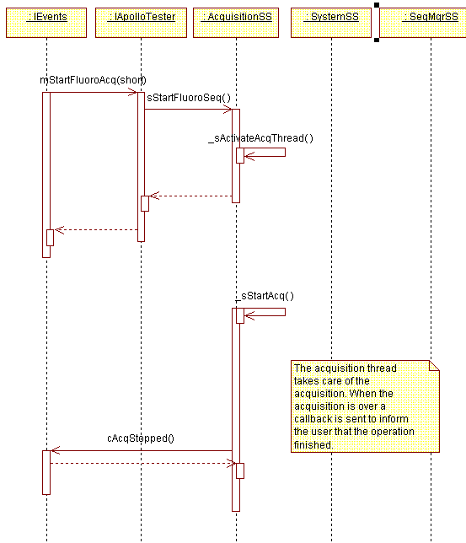

It is important to note that the callbacks are called from each subsystem using the interface pointer registered with mRegisterCallbackInterface. However, this interface pointer cannot be used from threads other than the main thread. To be able to use this pointer from other threads it is necessary to “marshal” the pointer to the new thread. This process generates a new interface pointer that can be used from the non-main thread. This process is thread specific, so for each thread that is created inside ADEPT Core a new marshaled pointer needs to be created.
The story does not end here. Threads other than the main thread can call methods in any of the subsystems. For example, the “display loop” thread requests images from SeqMgrSS and processes them using methods of the ProcessingSS. This means that a method that generates a callback can be called from any thread (like the Sequence in memory method of SeqMgrSS which can be called from the acquisition or the retrieve thread). So which interface pointer can be used to generate the callback? Inside ADEPT Core only one “marshaled” interface pointer is valid at any single time. So when a thread is activated, it sets its marshaled interface pointer in SystemSS as the currently active interface pointer. The active interface pointer is used from all the methods that can generate callbacks.

System subsystem

General implementation description
When this subsystem is initialized calls to initialize the other subsystems are made and parameters from the ADEPT Core configuration file are loaded (see next section). An independent thread to handle extended errors is created if the “use extended error thread” entry in the dfndrvr section of the registry is set to 1 (when using ADEPT core, this should always be so) and the call to DFNOpenSystem is successful. The extended error thread will report extended errors and will take action on some of them:

Extended error | Action
Host hasn’t DMAd data fast enough or at all | Abort acquisition
Unique EOF not found (wrong size specified) | Abort acquisition  Hard reset DFN when system is IDLE
Loss of sync in FC | Ask detector subsystem to look for a detector.

Another thread to handle settling time is also created. This thread is usually inactive. It is activated when a call to set the equilibration time is received (from Detector or Acquisition subsystems). The equilibration time cannot be decremented and will be incremented only when a call to set a higher equilibration time is received. The thread becomes inactive when the settling time is completed.
A call to terminate this subsystem indicates that the application is closing. The sTerminate method in each of the other subsystems is called, the extended error thread and the settling threads are killed and variables are set to NULL.
When ADEPT Core initializes the fifth line of the RT bus (RTB4) will pulse for 100ms. This signal may be used to initialize/synchronize external devices. Lines 0 through 5 of the RTB are by default configured as output and lines 6 and 7 are configured as input lines.

ADEPT Core configuration file
The ADEPT Core configuration file (ACConfig.txt) is a text file that must be present in the same directory of ADEPTCore.exe. The file has the following format and parameters:

[Miscellaneous]
MaxErrorLogSizeInKB=1024
ExposeShortDelayInMillisec=1800
ExposeLongDelayInMillisec=5000
RotorHoldTimeInMillisec=120000
PrepToExposeTimeInMillisec=200
ExposeSyncPulseTimeInMillisec=3
ReceptorReadyPulseTimeInMillisec=-5
RTBRecReadyLine=0
RTBExpSyncLine=1
RTBPrepLine=2
RTBExposeLine=3
FrameFactorInMillisec=5000
MinFrameWaitTimeInMillisec=10000
DFNPresent=1
COFFPath=C:\TEMP
DetInfoPath=C:\DetectorInfoFiles
ImageMonitor=0
DebugLogPath=C:\TEMP
ShowACConsoleWindow=1

#For Ethernet detectors:
EthernetDetector=1
HostIP=192.168.1.46
EthernetFullImageRetransmitMode=0

# Timeouts for power modes in Ethernet detectors
FullPowerModeTimeOutInMilliSec=3600000
IdlePowerModeTimeOutInMilliSec=3600000

[Peripherals]
PeripheralName1=Object1.IntefaceName1
PeripheralName1=Object1.IntefaceName1
readyForAcq_TIMEOUT_in_millisec=10000

Definitions:
- MaxErrorLogSizeInKB: maximum size for the ADEPT Core error log
- ExposeShortDelayInMillisec: short delay from expose to during section in milliseconds (see 3.3.1.2)
- ExposeLongDelayInMillisec: long delay from expose to during section in milliseconds (see 3.3.1.2)
- RotorHoldTimeInMillisec: rotor hold time in milliseconds (see 3.3.1.2)
- PrepToExposeTimeInMillisec: prep to expose time in milliseconds (see 3.3.1.2)
- ExposeSyncPulseTimeInMillisec: this parameter can be positive or negative and the behavior changes depending on the sign. If the value is positive, this is the time that expose sync is activated in milliseconds during a pulsed exposure acquisition. If the value is negative, this is the time before the end of the frame at which expose sync will become inactive.
Example: let’s suppose that the total frame time is 20ms, the time between frames is 10ms, the expose time delay is 5 ms and the ExposeSyncPulseTimeInMillisec is set to –10. The result is an expose sync pulse that is active for 15ms. (see 3.3.1.2)
Note: once the acquisition is started the pulse time is treated as fixed. Continuing with the previous example of ExposeSyncPulseTimeInMillisec set to –10, the resulting pulse has a duration of 15ms. If changes are made to the time between frames or expose time delay during the acquisition, those changes will maintain a pulse duration of 15ms.
- ReceptorReadyPulseTimeInMillisec: same behavior of ExposeSyncPulseTimeInMillisec, but with receptor ready instead of expose sync.
- RTBRecReadyLine: real time bus line to be used for receptor ready (default is 0).
- RTBExpSyncLine: real time bus line to be used for receptor ready (default is 1)
- RTBPrepLine: real time bus line to be used for Prep (default is 2)
- RTBExposeLine: real time bus line to be used for Expose (default is 3)

Note: For Advantx, the RTB lines should be set to default values or not set at all. For Jedi, Receptor ready and Expose sync should be set to the same value, corresponding to Expose Command, and Prep and Expose should be set to the same value, corresponding to Expose Demand. Also, the ExposeShortDelayInMillisec, ExposeLongDelayInMillisec, and PrepToExposeTimeInMillisec need to be set appropriately for Advantx, but don’t play an important role in Jedi as prepping is completed when the ACQ_START property is set in the controller, i.e. it is not started with the ‘Prep’ signal of the RT bus.

- FrameFactorInMillisec: frame factor to be used for calculation of settling time
- MinFrameWaitTimeInMillisec: min frame wait time in milliseconds (for settling time)
- DFNPresent: 0: DFN not present (limited functionality available); 1: DFN is present.
- COFFPath: path for the directory where COFF files generated by ADEPT Core are stored
- DetInfoPath: path for the directory that contains the detector information files
- ImageMonitor: sets monitor to display images. 0: no monitor, 1: main monitor, 2: secondary monitor
- DebugLogPath: path for the directory where debug logs will be placed (none in AC 2.1).
- ShowACConsoleWindow: 0: AC console window starts minimized, 1: AC window is displayed

For Ethernet detectors the following parameters are used:
- EthernetDetector: This is an optional parameter. If not present, ADEPT Core will assume that the detector is connected via fiber. Set to 1 if a detector is connected via Ethernet. When this parameter is set to 1 fiber channel loop back is enabled in the DFN to prevent fiber channel errors during the execution of COFF files. When, set to 0 fiber channel loop back is disabled.
- HostIP: This is an optional parameter. Set to the IP address assigned to the board that is used to talk to the detector.
- FullPowerModeTimeOutInMilliSec : Timeouts for power mode switch in Ethernet detectors
- EthernetFullImageRetransmitMode: This optional parameter determines how the software responds.to the case in which a large number (> 200) of image buffers is dropped:
  - 0: dropped buffers are ignored
  - 1: the software requests the retransmission of the whole image.

In the [Peripheral] section:
- readyForAcq_TIMEOUT_in_millisec: timeout to apply when getting the READY_FOR_ACQUISITION property from the peripherals that are configured.

Peripheral controllers are specified in the following format:
  - PeripheralID1=Object1.IntefaceName1
  - PeripheralID2=Object2.IntefaceName2'
with PeripheralID: any identifier, Object: name of the Object, InterfaceName: name of the interface (peripheral controllers must be COM objects that comply with the interface specified in the peripheral subsystem).

Acquisition Subsystem

General implementation description
When the acquisition subsystem is initialized a new thread is created (acquisition thread). This thread is not active initially, and it is usually inactive. The acquisition thread is activated when a request to start an acquisition (rad, fluoro or user sequence) is received and it has been verified that it is possible to perform the acquisition. Using the acquisition thread frees-up the main thread in ADEPT Core, allowing a user interface to interact with it during an acquisition.
When the thread is created the interface pointer to the high level application is ‘marshaled’ to allow for callbacks during an acquisition. The ‘marshaled’ interface pointer is made active when the acquisition thread is activated.

Image acquisition
For fiber detectors, images are acquired by running an appropriate COFF file in the DFN board. The DFN receives the image data, performs reordering and transfers the images to RAM in the PC. For Ethernet detectors, images are acquired by running an appropriate detector script in the detector. The Ethernet Detector library receives the images, performs reordering and keeps them in local memory buffers.

In general, there are two ways to acquire images from an Apollo digital detector using ADEPT Core:
- System generated acquisitions: using COFF files/detector scripts generated by ADEPT Core
- User acquisitions: using COFF files and/or detector scripts generated by the user and executed by ADEPT Core.
In both cases, and based on configuration parameters, ADEPT Core will verify the following conditions before activating the acquisition thread and starting the execution of the COFF file(s):
- System is IDLE
- There is enough memory to hold the requested number of frames
- COFF files and/or detector scripts exist (provided by the user or generated by ADEPT Core)
- The detector signature is recognized by the detector subsystem (if not in expert mode)
- Peripherals acknowledge correctly the setting of the EXPOSURE_MODE and NEW_SYSTEM_STATE .

Once these conditions have been verified the acquisition thread is activated and the function that the user called returns. In the case of fiber optic detectors, the acquisition thread takes care of defining all the parameters that the DFN card needs for the acquisition: For Ethernet detectors these parameters are set in the Ethernet Detector library.
- Frame size
- Buffer size
- Buffer type
- Swap and reorder
Then the COFF file and/or detector scripts are executed. Images acquired from fiber detectors are put by the DFN in upper memory as the images are acquired. For Ethernet detectors, the Ethernet Detector library receives images, reorders them, and puts them in memory buffers. Images may be displayed during the acquisition (if configured for doing that).
For Ethernet detectors, when the execution of the detector scripts finishes, the images are obtained from the Ethernet Detector library and put in upper memory as if they were coming from a sequence in disk. For fiber and Ethernet detectors when the execution of the COFF file is over:
- The Sequence manager is informed about the new sequence in memory.
- The signals in the RT bus are set to the default state.
- Callbacks are sent to inform the following:
- Acquisition is over
- Time to start the acquisition (used for CTQ measurement)
- Image display latency (used for CTQ measurement)
After this the system state is set to IDLE (a callback is issued to inform about the new system state) and the acquisition thread becomes inactive.

Information specific for Fiber optic detectors.

COFF file generation

A large part of the responsibilities of AcquisitionSS lies on the creation of the COFF files. COFF files are generated every time that a system acquisition is requested (rad or fluoro). The first version of ADEPT Core creates COFF files with exposure control for an Advantx generator. The first step to create a COFF file is to generate the DFN script (Perl script) that describes the acquisition based on the current system acquisition parameters.

- System acquisition parameters:
  - Frames before
  - Frames during
  - Frames after
  - Interval between frames
  - Frames to skip exposure (only for pulsed fluoro)
  - Time between frames
  - Expose time delay
  - Acquisition mode (first / last)
  - Acq. type (rad / fluoro)
  - Fluoro type (continuous / pulsed)
- Other parameters:
  - Frame readout time
  - Response time to read command.
  - Rotor hold time
  - Expose short & long delay
  - Prep to Expose time
  - EXPOSE_SYNC pulse time: time during which the expose sync signal in the RT bus remains active within a frame (continuous/pulsed fluoro acquisition).

Different types of DFN scripts are created depending on the previous variables:
- Type of DFN script:
  - Rad (Rad/Cine High Power, Cine Low Power)
  - Fluoro (continuous / pulsed)

- Number of DFN scripts:
  - 1 script if acquisition mode is first or acquisition mode is last and the number of frames ‘before’ is zero, or the number of frames ‘during’ and ‘after’ is zero.
  - 2 scripts if acquisition mode is last and both ‘before’ and ‘after’ frames are larger than zero.

To construct the DFN scripts ADEPT Core uses several types of frames. Each frame needs to be carefully designed and implemented so that timing is precise and consistent for all the different combinations of acquisition parameters. The following types of frames are used:
- Frame readout:
  - Pulsed exposure with SendI (See Appendix D – Diagram representing types of frames with pulsed exposure and SendI)
    - Before read: the EXPOSE_SYNC pulse starts and ends before the read-out command is sent.
    - Before-after read: the EXPOSE_SYNC pulse starts before the read-out command is sent and ends after it.
    - After read: the EXPOSE_SYNC pulse starts and ends after the read-out command is sent.
  - No exposure with SendI
  - No exposure
- Scrub
  - Pulsed exposure
  - No exposure

In addition, the first ‘during’ frame, the first ‘after’ frame, and the frame(s) at which Prep and Expose become active are handled as special cases.
The DFN script includes the activation and deactivation of the following signals to control the exposure:
- Prep
- Expose
- Receptor ready
- Expose sync
These signals are activated only when the number of frames ‘during’ is larger than zero. Prep and Expose are activated before the start of the ‘during‘ section based on the Rotor hold time, Expose short delay, Expose long delay and Time between Prep and Expose as the following table shows:

Time since last exposure | Prep preset time (only RAD) | Expose preset time
> Rotor hold time | Prep to Expose Time +  Expose Preset Time | Expose Long Delay +  Expose Time Delay
< Rotor hold time | Prep to Expose Time +  Expose Preset Time | Expose Short Delay +  Expose Time Delay
Prep preset time: time between the activation of Prep and the activation of Receptor Ready/Expose Sync
Expose preset time: time between the activation of Expose and the activation of Receptor Ready/Expose Sync.

If the time needed for Prep and Expose to be active before the ‘during’ section is larger than the time to complete the ‘before’ section then scrubs are inserted to allow for the activation of the signals at the right time.
The process of creating scripts is quite complex. Many variables need to be considered. In addition, the following important details regarding DFN scripts need to be taken into consideration for version 3.5.1 of PC-DAS:
- Only one SendI instruction can be present in a DFN script. For ADEPT Core it was decided that only the “during” section will contain a SendI instruction, i.e. only in the “during” section will it be possible to send commands to the detector when the SendI instruction is processed.
- Nested loops are not supported. To generate each of the requested number of “before”, “during” and “after” frames a loop may be used. The loop usually acquires one frame per iteration. However, the loop can be much larger if the user sets “interval between frames” (IBF) or “frames to skip expose” (FSE) to values larger than zero because additional instructions are inserted in the loop. For instance, if IBF is set to 2, then the loop will contain a frame read and two scrubs, plus the other instructions that are necessary to generate correct timing.
Setting IBF or FSE to large numbers may generate scripts that are too large to handle by the DFN card.
- “Interval between frames” and “frames to skip expose” cannot be both larger than zero at the same time. This is because the combination of values for these two parameters can generate scripts that are too large to fit on the available space in the DFN card. For example, if the user sets IBF to 7 and FSE to 8 the resulting “period” will be 56 frames long (about 360 instructions).
- To synchronize with DFN autoscrub correctly a script needs to start sending a read or scrub command. This is because the DFN card will start executing a DFN script at the moment were the next scrub command would be issued. Unfortunately this also means that the first frame in a script cannot be an “exposed” frame, so during a sequence transition two scrubs will be issued (one by the DFN card due to auto-scrub and one by the second script to synchronize with auto-scrub and achieve correct timing).
- This is VERY important. The instructions used to create DFN scripts take a fixed amount of time to execute. This time needs to be considered and corrections need to be introduced to get correct timing. The following is a list of instructions and how they are adjusted:
  - Send: takes 2 us.
  - SendI: if there is no command to send it takes 2us. Otherwise it will take as long as the command takes to be acknowledged (cannot be compensated when commands are sent).
  - Delay: takes 2us. In addition the argument starts at zero (a delay(0) takes 4us).
  - LoopKN, LoopKF: takes 2us.
  - Flag: takes 2us.

- The LoopN instruction will loop at least twice. The event compiler provides additional functions to control loops:
  - LoopN_begin(N), LoopN_end()
  - LoopF_begin(Flag), LoopF_end()
The LoopN_begin/ LoopN_end function will be converted into a LoopKN function by the event compiler only when the number of repetitions is larger than 2. This means that a Loop_begin(N) with N<2 will not use a LoopKN instruction and consequently the time that takes to complete is different.

Once the script, or scripts are ready, they are compiled and COFF files are generated. They will be executed later from the acquisition thread.

Queue variables used by acquisition subsystem
Queue variables are used to allow the user to change the time between frames or the expose time delay. Depending on the type of frame (pulsed exposure, no exposure, etc) different queue variables are used. There are specific functions to calculate the values of the queue variables for each type of frame. These functions are used to get the initial values as well as when new values are needed due to new parameters specified by the user.
Changes in “expose time delay” and “time between frames” are allowed in the ‘during’ section of the acquisition as long as the order of events in the script remains unchanged (pulsed acquisitions).
Since there is no method to synchronize the activation of multiple queue variable changes, it is not possible to guarantee that changes in “time between frames” or “expose time delay” will be completed within a single frame.
Queue variables used in the ‘during’ section for continuous exposure acquisitions may also be used in user provided COFF files. The following are the queue variables used:
- ‘del_qv10’ : to control time between frames
- ‘si_cmd’: queue variable that holds the command sent to the detector using the SendI instruction
- ‘si_data’: queue variable that holds the data sent to the detector using the SendI instruction

COFF execution
As mentioned before, a system acquisition may require one or two COFF files. ADEPT Core also provides methods to execute one or two user provided COFF files. In both cases the acquisition subsystem will perform the same tasks. However, in the case of a system acquisition that requires two COFF files ADEPT Core will treat the two sequences as one and will perform appropriate mappings to translate public sequence and frame numbers to internal (DFN/dasdll) sequence and frame numbers.
During the execution of a single COFF file the DFN card takes care of the real-time execution of the events of the COFF file. This is possible due to its independence from the operating system of the PC in which it resides. Unfortunately, the DFN card can only keep one COFF file in memory, so when two COFF files are needed, it is necessary to download the second COFF file as soon as the first one is executed. This takes some time and requires software intervention; so complete real time control is not possible.
To keep control during the transition between sequences the software has been optimized so that the transition time is usually less than one frame (not 100% of time because the OS may not give time to the acquisition thread when the transition is happening). As you may already be thinking, the transition time is not constant. To deal with this, DFN-Autoscrub should be enabled.
When DFN-Autoscrub is enabled, the DFN card sends scrubs periodically with a period equal to the sum of the FC timeout and the autoscrub delay. In this mode, a COFF file will be executed after it is in DFN memory and just at the point in time at which the next scrub command would be sent. The COFF file is then executed normally and as soon as the COFF file is over, the DFN card will send a scrub command and will continue sending periodic scrubs after that until a new COFF file is downloaded and executed.
So by using DFN-autoscrub it is possible to make the transition time discrete, in multiples of the DFN-autoscrub period. Since the transition time is very short most of the time, the transition time between sequences will most of the times be equal to one frame (assuming that the autoscrub period is set to one frame). However, remember that the second COFF file should start with a scrub or a readout command to ensure that the detector is read at a constant rate, which implies that the first frame of the second COFF file is a dark frame. So, in last mode when two COFF files are needed there will be two scrubs between the ‘before’ and the ‘during’ sections.

Information specific for Ethernet detectors

Detector script and COFF file generation.
For Ethernet detectors, scripts are generated to control image acquisition, while a COFF file may be created to control real time lines for exposure (if Frames during is set to a number greater than zero). The scripts and COFF file are created based on the acquisition configuration parameters listed in section 3.3.1.2.1.

The real-time control of the events is control by the detector and the DFN board. Successful synchronization of x-ray and image readout depends on accurate timing on the detector and the DFN.

Detector script and COFF file execution.
Detector scripts and COFF files are created with the assumption that they will start running at the same time and that the timing of events in the detector and DFN can be controlled with the same precision. However, both the COFF file and the detector script cannot be started at the same time and timing of events may not be exactly the same.

Because of this there are two opportunities for miss-synchronization:
- Lack of synchronization at the start of the detector script and DFN COFF file: to minimize this, the COFF file is started and a Flag is used to indicate to the software when the COFF file is running. Then the detector script start command is issued. The detector replies with the amount of time that elapsed (due to autoscrub) before the detector script actually starts. This time is used to adjust the DFN COFF file in real-time using queue variables. Be aware that, because of this extra delay, the Prep preset time specified in ACConfig.tzt will not be delivered. Instead, the Prep preset time will be the specified in ACConfig.txt plus a random value between 0 and the frame period at the time of the acquisition.
- Synchronization mismatch over long acquisitions due to differences in the clocks and settings of the detector scripts and COFF file: this can be calibrated by adjusting the frame readout time in the detector information file.

Settling time for changes in time between frames
Due to the characteristics of the detector there is a transition period when the frame at which the detector is read changes. During this transition period it is not recommended to acquire images. To deal with the transition period, the acquisition subsystem will set the generic settling time in the system subsystem when the time between frames changes. The settling time will be set according to the following formula:
Settling time = FTFactor * max(F1/F2) or FTMinWait
FTFactor and FTMinWait are configuration constants
F1: present frame time
F2: new frame time

Types of exposure
Several types of exposure signals (in the real time bus) can be generated by ADEPT Core. The timing of these signals is affected by the settings in the ADEPT Core configuration file (ACConfig.txt) and by the type of detector being used. In the case of fiber channel detectors, the timing of the image readouts and the signals in the real time bus is precisely controlled by the DFN board (via the COFF file created by ADEPT Core). In the case of Ethernet detectors, the timing of image readout and RT bus signals is controlled independently by the detector and the DFN board, respectively (see section ‘Detector script and COFF file execution).

Using an appropriate hardware interface board the exposure signals can be used to have synchronized control over exposures for any generator type.

Rad
In this type of exposure, Prep and Expose are activated as indicated in 3.3.1.2. Receptor ready is activated at the beginning of the ‘during’ section. The activation occurs ‘expose time delay’ milliseconds after the end of the previous frame or scrub. See Appendix E – Acquisition diagrams for different types of exposure

Cine High Power
The signals in the real time bus are the same as for Rad.

Cine Low Power
The signals in the real time bus are the same as for Rad.

Pulsed fluoro
In this type of exposure, Expose is activated as indicated in 3.3.1.2. RCPTR_RDY is activated at the beginning of the ‘during’ section, ‘expose time delay’ milliseconds after the end of the previous frame or scrub.
EXPOSE_SYNC is activated each ‘during’ frame for the amount of time specified by the ‘expose sync pulse time’ and the activation occurs ‘expose time delay’ milliseconds after the end of the previous frame.
See Appendix E – Acquisition diagrams for different types of exposure

Continuous fluoro
In this type of exposure, Expose is activated as indicated in 3.3.1.2. RCPTR_RDY is activated at the same time at which EXPOSE_SYNC is first activated (first frame of the ‘during’ section). Expose sync and receptor ready remain active for the duration of the ‘during’ section. See Appendix E – Acquisition diagrams for different types of exposure

Image Information
Image information is the name given to all detector parameters, acquisition parameters, peripheral parameters and image attributes valid at the beginning of an acquisition. This information is collected at the beginning of each acquisition and it is kept inside ADEPT Core until the sequence is deleted from memory. This information is saved as the header of the file when a sequence is stored to disk. For more information on the contents of the header please refer to the Image Information DLL SDD.

Detector Subsystem

General implementation description
The tasks performed by the detector subsystem fall into two broad categories: detector configuration and detector firmware download.
At initialization the detector subsystem first creates a thread for firmware download. This thread is active when firmware is being downloaded to the detector and inactive at all other times. The rest of detector subsystem initialization and operation depends upon which of two modes of operation is selected: normal mode or expert mode.

Normal Mode
Normal mode, the system default, will be appropriate in most circumstances. In this mode the detector subsystem maintains state information including the signature of the current detector (if any), firmware-specific information for the current detector, and current detector parameter values.
In normal mode, the next step in initialization (after creating the firmware download thread) is to look for a detector by sending a signature request. If no response is received, it is assumed that no detector is present, and no further initialization is needed. The system will then make periodic attempts to find a detector provided that the extended error thread in the System subsystem is active.
If a response to the signature request is received, the system next attempts to find a detector information file for that signature. If no file is found, the user is notified (except when using a script), and initialization is complete. If a file is found, it is read in, and upon reading it successfully, default parameter values are sent to the detector. If an error occurs when reading in the file, the user is notified and no information is stored.
Parameter information, including parameter name, current value, default, and conversion factor, is stored in the detector information table. This gives users capabilities such as setting parameters by specifying the parameter name and a new value, and performing acquisitions with scripts generated by a high-level application. This, of course, is in addition to the ability to send raw detector commands and perform acquisitions with a user-provided COFF file.
If the detector is disconnected, ADEPT Core generates an error, the detector information is erased from memory, and the system will check periodically to see if a detector has been connected. Upon finding a detector, the system will clear the previous error (see section 3.8.7), look for a detector information file, load it, and send default parameter values.

Expert Mode
Expert mode should be used when the user wishes to have complete control over communications between ADEPT Core and the detector. In expert mode, no attempt is made to communicate with the detector unless the user actually sends a command. This may be useful, for example, to an engineer trying to determine the problem with a broken detector.
If expert mode is desired, the user must set it before system initialization (i.e. before calling mSysInit). Attempting to set expert mode when the system is already running will result in indeterminate behavior.
In expert mode, no further initialization is performed after starting the firmware download thread. Since no detector information is stored, a user wishing to set a detector parameter can only do so by sending raw commands. Similarly, an acquisition can only be performed if the user provides a COFF file.

Detector Information File

Introduction
The detector information file is a comma-separated values (csv) file containing firmware and hardware specific detector information; each known firmware should have its own detector information file with filename 0xNNNNNNNN.csv, where NNNNNNNN is its signature in hex. Keeping firmware-specific information in the detector information file allows for the introduction of new firmware without modifying the code – all that is needed is a new detector information file. The file may be created and edited using a plain text editor or Microsoft Excel. Excel will sometimes place extraneous commas at the end of a line; however, this is not a problem when reading in the file.
All contents of the detector information file are stored in tables in memory when the file is first read in (i.e. at initialization, when new firmware is downloaded, or when a detector is newly connected). In addition to the contents of the file, the subsystem also maintains current values of all detector parameters.
Currently the detector information file contains eight sections. All eight sections must be present, and they may appear in any order. The section identifiers are:
$Commands
$SwapAndReorder
$ReadoutTime
$FrameSize
$ResponseToRead
$Sensors
$DefaultSettling
$ImageFlip
The file may also contain comments starting with the # character. A comment may appear either on its own line or at the end of a line.

$Commands
The $Commands section contains information about all the commands recognized by the detector. An example of a few lines from this section is:

$Commands,command,mask,offset,gain,type,min,max,default,waitType,waitParams,comment
Scrub,0x0000,0x00000000,0,0,0,0,0,0,0,0,# no data needed
RampSelection,0x4020,0xF0000000,0,1,0,0,15,0,0,0,
SetVCommon1,0x6001,0xFF,0.9714,-0.068117,1,-16.398435,0.9714,-9.314267,1,60 24,
Note: all parameters specified in the $Commands section must exist in the header of the images (See Image Information DLL – DefaultImageInfoConfig.csv).
The first line identifies this as being the section for commands. It must start with $Commands followed by a comma. The rest of the line is ignored when reading in the file, but is helpful in order for the user to keep track of the order of items in the following lines.
Each of the other lines in the section consists of eleven items separated by commas. They are:
- Name: Character string that will be used to refer to the command. These names must be unique.
- Command: The command number that will be sent to the detector. This need not be unique.
- Mask: Mask identifying which bits of data are used for this command. In the example above, only the upper four bits are used for RampSelection. The 1’s in the mask must be consecutive. Under most circumstances a command number that appears more than once in the file will not have overlapping masks; however, overlapping masks for the same command number are allowed.
- Offset: Offset that will be used when converting a number from machine representation to actual value.
- Gain: Gain that will be used when converting a number from machine representation to actual value. In the example above, for SetVCommon1, a machine representation of 200 would result in an actual value of 0.9714 – 0.068117*200 = 12.652. For commands that do not have a value associated with them, such as Scrub, gain and offset should both be zero.
- Type: This is the type of value used in this line. 0 indicates an unsigned integral number, as for RampSelection, or no value, as for Scrub; 1 indicates a floating-point number, as for SetVCommon1.
- Min: The minimum value that this parameter may have, in actual (non-machine) representation.
- Max: The maximum value that this parameter may have, in actual (non-machine) representation.
- Default: The default value that this parameter will have at initialization, or whenever the user chooses to restore default configuration. This (obviously) must be within the limits specified by Min and Max.
- Wait type: Indicates the formula that should be used to calculate settling time. A value of 0 indicates no settling time is needed.
- Wait parameters: Parameters that should be used when calculating settling time. This is a whitespace-delimited string.
- Comment: An optional comment, preceded by #.

$Sensors
The $Sensors section contains information about detector sensors. An example of a few lines from this section is:
$Sensors,number,offset,gain
Humidity,0x00,25.7480315,0.078740158
VoltageLevel_P5V_REF,0x10,0,0.012316895
VoltageLevel_VON,0x11,0,0.012316895
Again, the first line is used to identify the beginning of the section. It must start with $Sensors followed by a comma; the rest of the line is ignored by the application but may be useful to the user.
Each line consists of four items:
- Name: Character string that will be used to refer to the sensor. These names must be unique.
- Number: Number of the sensor. These must also be unique.
- Offset: Offset that will be used when converting reply from detector to scaled value. The units of this scaled value depend on the type of sensor being read; for the humidity sensor it is percent humidity, for voltage sensors it is volts, and for temperature sensors it is degrees C.
- Gain: Gain that will be used when converting reply from detector to scaled value.
Comments, preceded by #, may also be included at the end of the line.

$DefaultSettling
The $DefaultSettling section contains just one number: the default settling time in milliseconds. This settling time will normally be used to allow detector parameters to settle at system initialization and any other time a new detector is connected. The value specified may be any value greater than or equal to zero. An example is:
$DefaultSettling
60000

$ReadoutTime and $ResponseToRead
These two sections specify one parameter that may depend on the values of other parameters. The information they contain is:
- $ReadoutTime – Frame readout time, in microseconds
- $ResponseToRead – Length of time that the detector takes to respond to a read command, in microseconds
An example is:
$ReadoutTime,TimingMode,time,
entry1,0,21140,
entry2,1,23150,
entry3,2,36796,
entry4,3,31224,
entry5,4,21138,
entry6,5,21140,
entry7,6,63196,
entry8,7,63196,
This example specifies values for frame readout time based on timing mode. The line beginning with $ReadoutTime identifies the beginning of the section and also is used to identify the parameter(s) upon which readout time depends. So in this example, readout time is dependent on TimingMode. TimingMode must appear as the name of an entry in the $Commands section; an error is thrown if it does not. The final token in the first line, “time”, is ignored.
Each of the following lines contains an entry identifier, which is ignored by the software (but must be included), followed by a value of TimingMode and the resulting readout time. This information is stored in a table when the file is read in. Then, when the user or another subsystem requests the frame readout time, the detector subsystem looks up the current timing mode, and upon finding it returns the corresponding readout time. If the current timing mode is not found, an error is thrown.
There may be more than one condition, that is, readout time may depend on more than one condition. There is no upper limit on the number of conditions. An example of a few lines in this format, where readout time depends on both TimingMode and FOVSelect, is:
$ReadoutTime,TimingMode,FOVSelect,time,
entry1,0,0,21136,
entry2,1,0,23146,
entry3,2,0,36792,
entry4,3,0,31222,
Finally, there may also be cases where readout time depends on no other parameters (i.e. is constant). This could be written as:
$ReadoutTime,time,
entry1,21136,

$FrameSize, $SwapAndReorder, $ImageFlip
These three sections each specify two parameters that may depend on the values of other parameters. The information they contain is:

- $FrameSize – Frame X and Y size, in pixels
- $SwapAndReorder – Swap and reorder settings. Values for swap are zero if not needed, one if needed. For reorder:
  - 0 = no reorder
  - 1 = cardiac, rad, angio, and combo reordering
  - 2 = LFOV mammo
  - 3 = TRAD (virtual split).
- $ImageFlip – Horizontal and vertical image flip settings to put detector images in standard orientation. Values are zero if not needed, one if needed.
The format of these sections is similar to that of $ReadoutTime and $ResponseToRead, the only difference being that two parameters are specified, not just one. In the $FrameSize section, x and y must appear in that order at the end of the line. In the $SwapAndReorder section, swap and reorder must appear in that order at the end of the line. In the $ImageFlip section, horizontal image flip and vertical image flip must appear in that order at the end of the line.
An example of these three sections:

$SwapAndReorder,swap,reorder,,,,,,
entry1,0,1,,,,,,

$ReadoutTime,TimingMode,StoreLowTempSetpoint,time,,,,,
#Binned,,,,,,,,
entry1,0,0,21136,
entry2,1,0,23146,
entry3,2,0,36792,
entry4,3,0,31222,
entry5,4,0,21136,
entry6,5,0,21136,
entry7,6,0,63192,
entry8,7,0,63192,
#ROI,,,,
entry9,0,1,21116,
entry10,1,1,23126,
entry11,2,1,36758,
entry12,3,1,31192,
entry13,4,1,21114,
entry14,5,1,21108,
entry15,6,1,63130,
entry16,7,1,63116,
#2k,,,,
entry17,0,2,126002,#not valid
entry18,1,2,126002,#not valid
entry19,2,2,126002,#not valid
entry20,3,2,126002,#not valid
entry21,4,2,126002,#not valid
entry22,5,2,125910,#not valid
entry23,6,2,125910,
entry24,7,2,125910,

$FrameSize,StoreLowTempSetpoint,rows,cols,
entry1,0,1024,1024,
entry2,1,1024,1024,
entry3,2,2048,2048,

$ImageFlip,horizontal,vertical,
entry1,0,0,,,,

$ModeGain, $RampInformation, $ElectronsPerCount
These sections were added in ADEPT Core 2.1 to facilitate the work of analysis programs.
The $ModeGain section is similar to $Readout section in that it has a single parameter that may depend on other detector parameters like FOVSelect.
The $RampInformation section depends on one detector parameter (RampSelection) but four parameters are associated with each setting: Load zero, max LUT out, Min LUT out & max linear.
Finally, the $Electrons per count section is similar to the $FrameSize section in that there are two data parameters for each entry and an entry is selected depending on the settings of two detector parameters.

An example of these three sections:

$ModeGain,ModeGain,,,,,
entry1,1,,,,,

$RampInformation,RampSelection,LoadZero,MaxLUTOut,MinLUTOut,MaxLinear
entry1,0,1820,8713,1054,1737
entry2,1,1820,16100,1343,1820
entry3,2,1820,16100,1343,1820
entry4,3,1820,14321,1488,1820
entry5,4,1820,11634,1582,1820
entry6,5,1820,14076,1700,1820
entry7,6,1820,16100,935,1820
entry8,7,1820,10620,1156,1820
entry9,8,1820,11634,1253,1820

$ElectronsPerCount,ARCPostIntegrator,ARCIntegrator,ElecPerCount
entry1,0,0,1100
entry2,0,1,2200
entry3,0,2,3300
entry4,0,3,4400
entry5,1,0,550
entry6,1,1,1100
entry7,1,2,1650
entry8,1,3,2200
entry9,2,0,367
entry10,2,1,733
entry11,2,2,1100
entry12,2,3,1467
entry13,3,0,275
entry14,3,1,550
entry15,3,2,825
entry16,3,3,1100
For an example of a complete detector information file, see Appendix F.

Settling time
The detector subsystem makes use of the generic settling time functionality provided by the system subsystem. A settling time formula number and parameter string are specified with each parameter in the detector information file, and the formula is applied each time the parameter is set. Currently a formula number of zero indicates no settling time, in which case the parameter string is simply 0. For example, changing the ramp requires no settling time:
RampSelection,0x4020,0xF0000000,0,1,0,0,15,0,0,0,
A formula number of one indicates that settling time is needed and should be the greater of
MIN and FACTOR*abs(oldValue – newValue)
where MIN is the first value in the parameter string and FACTOR is the second. For example, if changing common voltage 1 requires a settling time of 24 times the difference in voltages, or 60 seconds, whichever is greater, the following line would appear in the detector information file:
SetVCommon1,0x6001,0xFF,0.9714,-0.068117,1,-16.398435,0.9714,-9.314267,1,60 24,
Note that the parameter string is simply a series of numbers delimited by whitespace.
If additional formulas are needed in the future, they may be added by assigning a new formula number and adding a case to DetectorSS::_sUpdateSettlingTimeForDetectorParameter(). This method applies the formula to calculate required settling time and then passes this result to the system subsystem, which can update the settling thread accordingly.

Detector Firmware Download
When the user chooses to download new application firmware from the PC to the detector, the detector subsystem first checks to see if the file with the firmware exists and the system state is IDLE, and if so, changes the state to FIRMWARE_DOWNLOAD. It then activates the firmware download thread to perform the actual download.
The first action taken in the firmware download thread is to boot the detector into boot firmware, as new application firmware may only be downloaded when the detector is in boot firmware. Next, flash memory (i.e. the old application firmware) is erased. The new firmware is then downloaded to the detector. For this, all the data in the firmware file is sent to the detector. At the end of firmware download command 0x4011 is sent to the detector (this is to support firmware download in DCB2) and then the detector is booted back into application firmware. Finally, if not in expert mode, the new detector information file is read in and default configuration sent to the detector. The system state is returned to IDLE, and the firmware download thread again becomes inactive.
The user may cancel firmware download at any point during this process. If this is done, the firmware download is simply stopped; no attempt is made to revert to the previous firmware.

Display Subsystem

General implementation description
As indicated by its name, the Display subsystem takes care of displaying images. To accomplish this task the Display subsystem relies on the services provided by Displaydll.dll and of the Processing subsystem (which relies on Processdll.dll).

In ADEPT Core, the images to be displayed come from ‘upper’ memory of the PC. They are put there when they are acquired from the detector or when images are read from disk. Images in memory have 16 bits per pixel. In order to display them it is necessary to map them to Windows memory and ‘convert’ them into 8 bits per pixel images using the window and level values, as well as the correction settings defined by the user.

So, to display an image it is first mapped, then it is processed by the Processing subsystem and then it is displayed by the Display subsystem.

When the Display subsystem is initialized, calls are made to initialize Displaydll and to set the default frame size, default window value and default level value. In addition, a thread is created to handle image display in a loop (displayLoop thread).

Image display using DirectX (Displaydll)
To display images, Displaydll uses DirectX, which is a suite of multimedia application programming interfaces (APIs) that comes with Microsoft Windows® operating system.

When Displaydll is initialized, two surfaces are created (primary and off-screen). A surface can be described as a memory location in which data to be displayed is put. The primary surface is special because it contains the data that is displayed.

To display an image, data is copied to the off-screen surface and then a blit operation is performed to transfer the data to the primary surface (data should not be written directly to the primary surface). Since in ADEPT Core the data to be displayed is generated by the Processing subsystem, it is necessary to pass to the Processing subsystem a pointer to the off-screen surface to be used as output buffer.

An independent thread is created by the Displaydll to perform the blit operation. This allows for faster return time of the call to display an image, which is beneficial for acquisitions with real time display.

Image display during an acquisition (real time)
To display images during an acquisition, the Acquisition subsystem sets the appropriate display size before the start of the acquisition. Then, once the acquisition starts, images are mapped as they are acquired and they are passed to the Display subsystem to be displayed. For each image, the Display subsystem requests from the Processing subsystem that the image be processed and then the image is displayed using a blit operation.

Image playback
Image playback is very similar to image display during an acquisition. The difference is that this operation is driven by the Display subsystem instead of by the Acquisition subsystem. Requests to display images are processed by the Display subsystem. Once a request is received, the Display subsystem asks the Sequence Manager subsystem for the frame to be displayed (the image is mapped from upper memory). Then, the image is processed and displayed.

Image playback in a loop
The set of images to be displayed in a loop is specified by the user before the start of the loop operation. When the request to start the loop operation is received, ADEPT Core moves to the VIDEO_LOOP state and the Display subsystem activates the displayLoop thread. From this thread, the Display subsystem requests the first frame to be displayed, then makes the calls to perform the processing and then displays it. Then, the system waits the amount of time that is necessary to achieve the frame rate specified by the user, and the processed is repeated with the next frame. After the last frame in the sequence is displayed, the whole process starts again with the first image.

After image playback in a loop is started it will continue indefinitely until a request to stop the image loop is received. This will cause the displayLoop thread to become inactive again and the system will return to the IDLE state.

Processing Subsystem

General implementation description
The processing subsystem takes care of:
- Window and level adjustments for display
- Offset, gain and pseudo-bad pixel correction
- Image flipping
- Line repair
- Visual bad pixel detection
To perform these operations, the Processing subsystem uses the services of the Processdll. Looking at ADEPT Core as a complete system, the processing of images also uses services from the Sequence Manager and Acquisition subsystem. This is due to the fact that correction maps are not loaded by the processing subsystem. In general, the Sequence Manager will load correction maps. However, the calculation and loading of the offset map during an acquisition will be driven by the Acquisition subsystem.

Image processing (Processdll)
The Processdll is a highly optimized library capable of correcting images in real time (CTQ is 1kx1k images @ 30fps). To accomplish this, the Processdll uses two independent threads, created at initialization, to process the images (each thread takes care of a half of an image). However, this approach is practical only when dual processor computers are used.
In addition to multiple threads, Processdll uses MMX instructions, which allow processing of four pixels per instruction. Since MMX instructions are low level, it is necessary to understand some of the details of the processors to take full advantage of them.
To optimize memory access the processing algorithms in Processdll will process 16 pixels per iteration. This limits the size of the images to process and of the processing size to multiples of 16 bits.
Processdll will allow the setting of the following parameters:
- Gain map (two entries, set by the Acquisition or Seq. Manager Subsystem)
- Offset map (two entries, set by the Acquisition or Seq. Manager Subsystem)
- Window: 2-16383.
- Level: 0-16383.
- Size of input buffer (two entries): number of rows, number of columns
- Size of output buffer (two entries): number of rows, number of columns
- Size of region to process (two entries): number of rows, number of columns
- Processing offset (two entries): row, column
- Output offset: row, column
- Corrections: gain, offset, horizontal flip, vertical flip, ROI and line repair.
Window and level are used to set the contrast and brightness of a displayed image. Values that are lower than the specified level – window/2 are displayed black, values that are larger than level+window/2 are displayed white, values that are between level – window/2 and level+window/2 are displayed in gray levels (from black to white) using a linear transformation.
These settings allow the use of different sets of correction maps according to the acquired image size, so that when consecutive acquisitions with different sizes are performed the images are always displayed appropriately corrected.
Processdll will generate output images that are 16 bits/pixel (for archive or analysis) or 8 bits/pixel (for display).
Another important feature of the Processing DLL is the detection of pixels that are away from the spatial mean of the image. The detection is performed on the images after gain/offset/window/level corrections, i.e. the data processed is 8 bits per pixel. When ‘normal’ images are used, it is possible to perform the corrections in real time during an acquisition. See mSetVisualBPDetection for more details on this feature.

Peripheral Device Subsystem

General implementation description
The peripheral device subsystem provides Adept Core with an interface to the peripheral devices. This subsystem will determine what peripheral devices are required (via a system configuration file) for system operation and will load the appropriate device controllers. It will pass data to the peripheral device controllers and query the device controllers for information. Peripheral device controllers include (but are not limited to):
- Generator
- Light Source
- Dosimeter
- Heater
- Collimator
- Conditioner/Chiller
- Interlocks and x-ray enable status monitor
- Power supply

Peripheral device controllers are independent objects. A device controller is tasked with interfacing with and controlling the actual device (using hardware drivers as necessary). Any needed knowledge of the device behavior is contained within device controllers and their drivers. A device controller may have its own configuration file that provides information specific to that device (e.g. parameter limits or baud rates).

The peripheral device subsystem interfaces to the peripheral device controllers through a common generic interface. Each device controller must support the following set of methods:
- Initialize method. The device controller must perform whatever is required to make the device operational. The device controller throws an exception if an error occurs.
Prototype: long sInitialize();
- Terminate method. The device controller must perform whatever is necessary to terminate activity of the device. The device throws an exception if an error occurs.
Prototype: long sTerminate();
- Get Property method. The device controller receives a string that contains a parameter name. The device controller returns a string that contains the current value of the parameter. The device controller throws an exception if an error occurs.
Prototype: long sGetProperty(BSTR paramName,
BSTR *paramValue);
- Set Property method. The device controller receives a string that contains a parameter name and a string that contains the new value of the parameter. A NULL string is returned if the set is successful. A string containing the parameter name and value if the parameter is not settable. The device controller throws an exception if an error occurs.
Prototype: long sSetProperty(BSTR paramName,
BSTR paramValue,
BSTR *returnStatusPtr);

The peripheral device subsystem extracts information from the system configuration file. The system configuration file provides information on what peripheral devices are required for system operation.
[Peripheral Devices]
xrayGenerator = “program ID”
Collimator = “program ID”
InterlocksMonitor = “program ID”
…..
ReadyForAcq_TIME_OUT=10000 #time in milliseconds
[end Peripheral Devices]

The peripheral device subsystem provides a similar interface to ADEPT core.
- Initialize method. The peripheral subsystem initializes all configured device controllers.
- Terminate method. The peripheral subsystem terminates activities of configure device controllers.
- Get Property method. The peripheral subsystem receives a string that contains a device name and a string that contains the parameter name. The device name must match the name used in the system configuration file for the device. The peripheral subsystem returns a string that contains the current value of the parameter. This method is only valid after the peripheral subsystem has been initialized. It is not valid after the peripheral subsystem has been issued a terminate request.
- Set Property method. The peripheral subsystem receives a string that contains a device name, a string that contains the parameter name, and a string that contains the new value for the parameter. The device name must match the name used in the system configuration file for the device. The peripheral subsystem returns a NULL string if the set was successful. The peripheral subsystem returns a string containing parameter name and value if the parameter is not settable. This method is only valid after the peripheral subsystem has been initialized. It is not valid after the peripheral subsystem has been issued a terminate request.
- Set Property for All method. The peripheral subsystem receives a parameter name and a parameter value and attempts to set it in all configured peripheral controllers. Errors thrown by the peripherals are ignored.

In addition, the peripheral subsystem also supports several special get methods.
- Ready For Acquisition. Returns the ready for acquisition status for configured device controllers. This method is only valid after the peripheral subsystem has been initialized. It is not valid after the peripheral subsystem has been issued a terminate request.
- Get Image Data. Returns selected parameters and their values for inclusion in the image data headers for configured device controllers. This method is only valid after the peripheral subsystem has been initialized. It is not valid after the peripheral subsystem has been issued a terminate request.

- Get Acquisition Done Status. Returns whether any error occurred in the last acquisition. A zero value indicates no error. A non-zero value indicates an error occurred. This method is only valid after the peripheral subsystem has been initialized. It is not valid after the peripheral subsystem has been issued a terminate request.

All configured peripherals MUST support the following properties:
- "ACQ_START": set
- "ACQ_END": set
- "READY_FOR_ACQUISITION": get. Must return empty string if there are no problems to start an acquisition.
- "ACQUISITION_DONE_STATUS": get. Must return empty string if there are no errors between ACQ_START and ACQ_END.
- "IMAGE_DATA": get. Must return all parameters from the peripheral that go in the header.
- "NEW_SYSTEM_STATE": set.
- "EXPOSURE_MODE": set.
- "RECONFIGURE": set.

Note: all parameters returned by GetProperty for IMAGE_DATA must exist in the header of the images (See Image Information DLL – DefaultImageInfoConfig.csv).

    - Processing

Initialize

The Peripheral Subsystem provides an Initialize() method. This method must be called prior to any other peripheral subsystem method being called. When this method is invoked, the peripheral subsystem will initialize its local variables. It will use the system configuration file to determine the peripheral devices needed for operation of the system. The peripheral subsystem will then load the device controller DLL associated with the device. Once the device controller has been successfully loaded, the peripheral subsystem will invoke the Initialize() method for that device controller. If the initialization is completed successfully a good status (E_OK) will be returned by this method.

Prototype:

long sInitialize();

Possible errors from this method include:

- IDS_DEVICE_NOT_FOUND. A device controller DLL was not found or not loaded.

- IDS_DEVICE_NOT_REGISTERED. A device controller DLL was not registered.

- IDS_DEVICE_NOT_INITIALIZED. The device controller did not properly initialize.

This method satisfies Adept Core SRS requirement AC-Devices-03, AC-Devices-04 and AC-Devices-05.

Terminate

The Peripheral Subsystem provides a Terminate() method. This method must be called to terminate activity for configured device controllers. The peripheral subsystem will then call the individual terminate() methods for each configured device controller. If all devices are terminated successfully, a good status (E_OK) will be returned by this method.

Prototype:

long sTerminate();

Possible errors thrown from this method include:
- IDS_SUBSYSTEM_NOT_INITIALIZED. Peripheral subsystem was not initialized.

- IDS_DEVICE_NOT_TERMINATED. Device controller DLL did not properly terminate.

This method satisfies Adept Core SRS requirement AC-Devices-08.

GetProperty
The peripheral subsystem provides a GetProperty() method. The input to this method is a string that specifies the device name and a string that specifies the parameter name. The output from this method is a string that specifies the current value of the parameter. The device name must match the name used in the system configuration file.

The peripheral subsystem will invoke the Get Property method on the appropriate device controller to retrieve the information

Prototype:

long sGetProperty(BSTR deviceName,
BSTR paramName,
BSTR *paramValue);

Possible errors from this method include:
- IDS_SUBSYSTEM_NOT_INITIALIZED. Peripheral subsystem was not initialized.

- IDS_DEVICE_NOT_INITIALIZED. Device controller was not initialized or device controller was not configured.

- IDS_DEVICE_UNKNOWN. Unknown device controller.

This method satisfies Adept Core SRS requirement AC-Devices-07, AC-Devices-10, and AC-Devices-11

Set Property
The peripheral subsystem provides a SetProperty() method to ADEPT Core. The input to this method is a string that specifies the device name, parameter name, and the requested value. The output from this method is a NULL string if the set was successful. It the parameter is not settable a string is returned that contains the parameter name and the value of the parameter.

Prototype:

long sSetProperty (BSTR deviceName,
BSTR paramName,
BSTR paramValue,
BSTR *statusPtr);

Possible errors from this method include:
- IDS_SUBSYSTEM_NOT_INITIALIZED. Peripheral subsystem was not initialized.

- IDS_DEVICE_NOT_INITIALIZED. Device controller not initialized. Device controller not configured.

- IDS_DEVICE_UNKNOWN. Unknown device controller.

This method satisfies Adept Core SRS requirement AC-Devices-06.

Set Property for All
The peripheral subsystem provides a SetPropertyForAll() method to ADEPT Core. The input to this method is a string that specifies the parameter name, and the requested value. The Peripheral Subsystem will try to set the specified property in all configured peripheral controllers. Errors thrown by the peripheral controllers are ignored. This method returns 0.

Prototype:

long sSetPropertyForAll (BSTR paramName,
BSTR paramValue);

Possible errors from this method include:
- IDS_SUBSYSTEM_NOT_INITIALIZED. Peripheral subsystem was not initialized.

This method is used by the System Subsystem to set the current state of ADEPT Core (Idle, Acquisition, etc.) with the “SetCurrentState” property. It is also used by the Acquisition Subsystem at the start and end of an acquisition to set the “AcqStart” and “AcqEnd” properties with the value corresponding to the AcqType (see AcqType enum in AcquisitionSS.h).

Ready For Acquisition
The peripheral subsystem provides a special get method isReadyForAcqisition(). This method is only valid after the peripheral subsystem has been initialized. It is not valid after the peripheral subsystem has been issued a terminate request. The input to this method is a string that specifies the device name and a boolean flag (Wait For Ready). If Wait For Ready is true, the peripheral subsystem will wait for some predetermined time for the device to be ready (if not ready). The wait time shall be configurable and defined in the system configuration file. If Wait For Ready is false, the status of the device will be returned immediately. The output from this method is a boolean that specifies the ready for acquisition status.

If the device name corresponds to ALL_DEVICES, the peripheral subsystem will return the logical AND of the ready for acquisition status of all configured devices. The output will be a Boolean indicating the ready for acquisition status. A true indicates all devices are ready for acquisition. A False indicates that at least one device is not ready.

The peripheral subsystem will retrieve the information from the device controllers. The peripheral subsystem will perform a GetProperty with parameter name READY_FOR_ACQUISITION.

Prototype:

long sIsReadyForAcquisition(BSTR deviceName,
long waitForReady);

Possible errors from this method include:
- IDS_SUBSYSTEM_NOT_INITIALIZED. Peripheral subsystem was not initialized.

- IDS_DEVICE_NOT_INITIALIZED. Device controller not initialized. Device controller not configured.

- IDS_DEVICE_UNKNOWN. Unknown device controller.

- IDS_WAIT_FOR_ACQUISITION_READY_TIMEOUT. Time out waiting for a device to reprot ready for acquisition.

This method satisfies Adept Core SRS requirement AC-Devices-09.

Get Image Data
The peripheral subsystem provides a special get method GetImageData(). The input to this method is a string that specifies the device name. The output from this method is a string that specifies the parameter name and parameter value pairs.

If the device name corresponds to ALL_DEVICES, the peripheral subsystem will return a string containing the above information for all configured devices.

The peripheral subsystem will retrieve the information from the device controllers. The parameters required for the image data shall be contained in a configuration file (device configuration?).
The peripheral subsystem will retrieve the information from the device controllers. The peripheral subsystem will perform a GetProperty with parameter name IMAGE_DATA.

Prototype:

long sGetImageData(BSTR deviceName,
BSTR *paramList);

Possible errors from this method include:
- IDS_SUBSYSTEM_NOT_INITIALIZED. Peripheral subsystem was not initialized.

- IDS_DEVICE_NOT_INITIALIZED. Device controller not initialized. Device controller not configured.

- IDS_DEVICE_UNKNOWN. Unknown device controller.

This method satisfies Adept Core SRS requirement AC-Devices-13.

Get Acquisition Done Status
The peripheral subsystem provides a special get method GetAcquisitionDoneStatus(). The input to this method is a string that specifies the device name. The output from this method is a long int that specifies the device status from the last acquisition. A value of 0 indicates no error occurred during the acquisition. A non-zero value indicates that an error occurred in the peripheral device during the acquisition.

If the device name corresponds to ALL_DEVICES, the peripheral subsystem will get the acqusition done status for all configured devices. A value of zero indicates no errors. A non-zero value indicates that at least one device reported an error.

The peripheral subsystem will retrieve the information from the device controllers. The peripheral subsystem will perform a GetProperty with parameter name ACQUISITION_DONE_STATUS.

Prototype:

long sGetAcquisitionDoneStatus(BSTR deviceName);

Possible errors from this method include:
- IDS_SUBSYSTEM_NOT_INITIALIZED. Peripheral subsystem was not initialized.

- IDS_DEVICE_NOT_INITIALIZED. Device controller not initialized. Device controller not configured.

- IDS_DEVICE_UNKNOWN. Unknown device controller.

This method satisfies Adept Core SRS requirement AC-Devices-15.

Generator Device Controller

General implementation description
The Generator Device Controller provides two primary services with regard to the generator. First, it will interact with the generator to initialize it in preparation for taking exposures. Second, it will interact with the generator during the acquisition (if necessary) to satisfy the generator’s requirements. Since the ADEPT program is geared towards consolidating multiple flavors of Apollo testers into one platform, the Generator Device Controller must support numerous types of generators. In doing so, the Generator Device Controller is designed to hide the details of the generator from the rest of the system. This means that changing the generator within a given test station will have little or no effect on any other devices or subsystems within ADEPT Core (except for scripts and configuration files). This is important because it makes the tester more flexible, and it simplifies the process of upgrading the hardware components within the tester.
To accomplish this, the Generator Device Controller software will be partitioned into a common component, and generator specific components. The common component will be implemented as a class or collection of classes, and will provide a consistent (COM) interface to the rest of the ADEPT Core. The generator specific components (i.e. generator interface) will be needed conditionally, based on the current generator selection. Thus, only one generator interface needs to be supported at any given time, and the other generator interfaces need not be present.
To support this flexibility in the software, the common component and generator specific components will be linked together in the form of Windows DLLs, one per generator type. These DLLs will encapsulate all generator specific functionality, and will provide a consistent COM interface to the Peripheral Subsystem. The desired DLL will be loaded when the Peripheral Subsystem is initialized, based on a configuration parameter that indicates the type of generator present in the system. Refer to below.
Similarly, the generators use different physical communication links (e.g. Arcnet, CAN, RS-422, etc.). Here too, encapsulation of the physical link interface is desirable. To accomplish this, off-the-shelf Windows communication drivers will be used. Again, based on the generator configuration, the appropriate communication driver will be used. (Note that the DLL and communication driver are separate software entities, but the DLL and communication driver will be coupled together as a pair, to support the specific generator types).
This implementation provides flexibility with dynamically configurable software that can support the desired generator types by merely changing a configuration file. It also supports a future growth path, supporting future generator types with a new DLL/communication driver pair and a configuration file.

ADEPT Core

MKE SW
User Modifiable
Vendor SW
Generator
DLL’s

Windows
Drivers

Advantx
Jedi
DMR
?
Peripheral Subsystem
Arcnet
CAN
?
Advantx
?
DMR
Gen-erator
Jedi
Gen-erator
Config
File
RT-Bus
COM Interface
COM Interface

Figure 1 - Generator Device Controller Software Architecture.

Software Architecture
As discussed in the previous section, the Generator Device Controller is built with two main components – a common portion and a generator type specific portion.

Refer to Figure 2 while reading this section of the document.

Common Components.

COM Interface
This interfaces consists of a collection of methods that are accessible to ADEPT Core, and also provide a scriptable interface. This is the only public API for the Generator Device Controller.

Command Parser
This entity parses incoming commands, and converts incoming parameters from a string format into usable data.

Read/Parse Configuration File
This entity reads in the data from the configuration file for the Generator Device Control. The values read in from the file are applied to internal Generator Device Controller properties (member variables) by using the setProperty() interface. This process emulates the same behavior as when ADEPT Core invokes the sSetProperty() method.

State Machine
This entity manages state variables and generator properties that are treated generically across all generator types. Set and get commands that pertain to such generic properties are handled at this level. If the State Machine entity receives a command that it does not know how to respond to, it will forward the command to the Command Processor in the generator specific portion of the Generator Device Controller.

Generator Type Specific Components

Command Processor
This entity manages most of the properties within the Generator Device Controller. Commands like set and get that pertain to these properties are handled here. The Command Processor also manages the communication interface(s) to the generator, where applicable.

Communication Interface
Figure 2 shows the Arcnet interface for the Advantx/LFX generator, but this would analogously apply to other communication interfaces (e.g. the CAN interface to the Jedi). This entity provides a mechanism for sending messages to the generator. It also contains a thread(s) to monitor for received messages.

Communications Driver Interface Layer
This entity provides a wrapper around the communications driver (e.g. Arcnet driver in the case of Advantx/LFX). The purpose for this is to minimize the impact to the Generator Device Controller software resulting from a change in the communications hardware and/or driver.

Pulse Width Control Interface
This entity is exclusively used for the Advantx/LFX generator. It is analogous to the Communication Interface discussed in a previous section, and provides a send/receive interface to the Pulse Width Controller.

Serial Communications Interface
This entity is exclusively used for the Advantx/LFX generator. It is analogous to the Communication Driver Interface Layer, and interfaces to the Win32 Serial Port API.

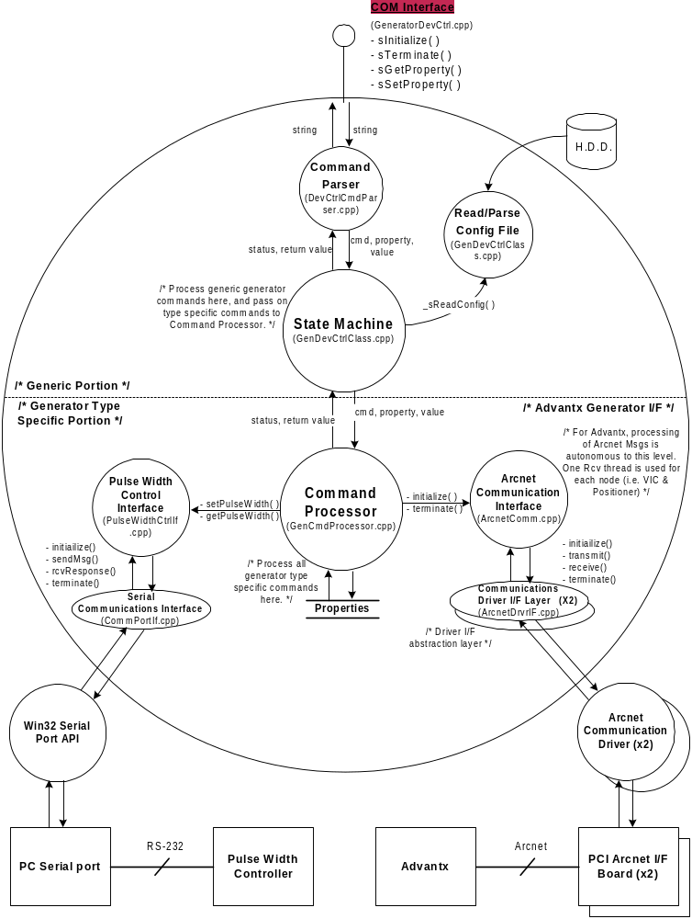
Figure 2 - ADEPT Generator Device Controller Software Architecture.

Processing

Initialization
At installation, the Generator Device Controller DLL that corresponds to the generator that is physically in the system will be registered. At initialization time, the Peripheral Subsystem will invoke the sInitialize() method on the Generator Device Controller DLL. The Generator Device Controller will then load its configuration and complete its initialization. Finally, where possible, default values for the techniques will be loaded on the generator.

Acquisition Configuration File
This configuration file will provide generator techniques that are specific to an acquisition. This includes the following:
- kVp.
- mA.
- Expose Time.
- Frame Rate.
- Focal Spot.
The parameters will be read external to the Generator Device Control, and the values will be set in the Generator Device Controller via its public interface methods.
Note that the term Expose Time is used synonymously with Pulse Width. Also note that mAs is a calculated value, based on mA and Expose Time. This file is not directly accessed by the Generator Device Control.

Generator Configuration File

Generator Techniques
This section of the configuration file will provide generator technique limits and default values. This includes the following:
- kVp default value.
- mA default value.
- mAs default value.
- Expose Time default value.
- Frame Rate default value.
- Focal Spot default value.
- kVp Min/Max.
- mA Min/Max.
- mAs Min/Max.
- Expose Time Min/Max.
- Frame Rate Min/Max.
- Focal Spot Min/Max.
- Tube Number.
These limits will be used to limit check the generator techniques before the start of an acquisition. The default values are used to initialize the generator.

Generator Communication Interface
The generator configuration file will also contain configuration parameters for any generator communication interface.

Jedi
For Jedi, this includes the following:
- CAN Communication board channel number.
- CAN Communication node ID.

Advantx/LFX
For the Advantx/LFX generator, this includes the following:
- Arcnet Communication board number(s).
- Arcnet Communication node IDs (0x0A for VIC, 0x0B for Positioner).

For Advnatx/LFX, the generator configuration file will also contain configuration parameters for a serial port used to communicate with the Pulse Width Controller (Advantx/LFX option only). This includes the following:
- Pulse Width Control type – manual, or automatic (ADEPT controlled).
- Serial port comm. port.
- Serial port baud rate.
- Serial port byte size.
- Serial port parity.
- Serial port stop bit(s).
Note that these parameters do not apply to other generator types.

Generator Initialization
When the Generator Device Controller is initialized, communications can be established with the generator, and the generator itself can be initialized. This processing is outlined in Section 3.7.3.3.2 below.

Generator-Specific Processing
Each generator is unique with respect to how it is controlled. However, they may be loosely classified into two categories – manual control and automated control. For the manual control generators, the test station does NOT have the ability to set the techniques. Therefore, the operator must be instructed to set the desired techniques manually on the generator from an operator’s console. Conversely, for the automated control generators, the test station has the ability to set the techniques on the generator via its communication link. Therefore, tests may be fully automated and require no operator intervention. In addition, each generator has unique requirements for processing, details of which are discussed below.

DMR Generator
The DMR Generator falls squarely into the manual control category. The test station has no means of controlling, or even interacting with the DMR generator. Therefore, there is no special processing associated with this generator.

Advantx / LFX Generator
The Advantx / LFX generator is also a manually controlled generator. There is no direct interaction between the Generator Device Controller and the LFX generator. However, since a partial Advantx system is used to support the LFX generator, the Generator Device Controller is required to emulate the missing components of the Advantx system – in this case, this means the VIC and Positioner modules.

All messages sent to / from the VIC and Positioner modules (nodes on Arcnet) must be handled. Refer to Figure 3 and Figure 4 below for details on the message sequencing for these modules. Note that many of the messages sent from the ASC to the VIC and Positioner modules are not depicted in theses figures. For all messages not explicitly depicted, the VIC and Positioner will examine the messages, and reply with an acknowledge if requested. Otherwise, the messages will be discarded with no response.

In addition to the Arcnet communications, the Generator Device Controller may also have to communicate via a serial port with the Pulse Width Controller. This is a configurable feature within the Advantx/LFX specific software. If the generator configuration file indicates that the Pulse Width Controller is present, then all sets/gets of the Exposure Time (Pulse Width) property are formatted and forwarded to the Pulse Width Controller. If this Pulse Width Controller is not present, then this property is treated as “un-settable”.

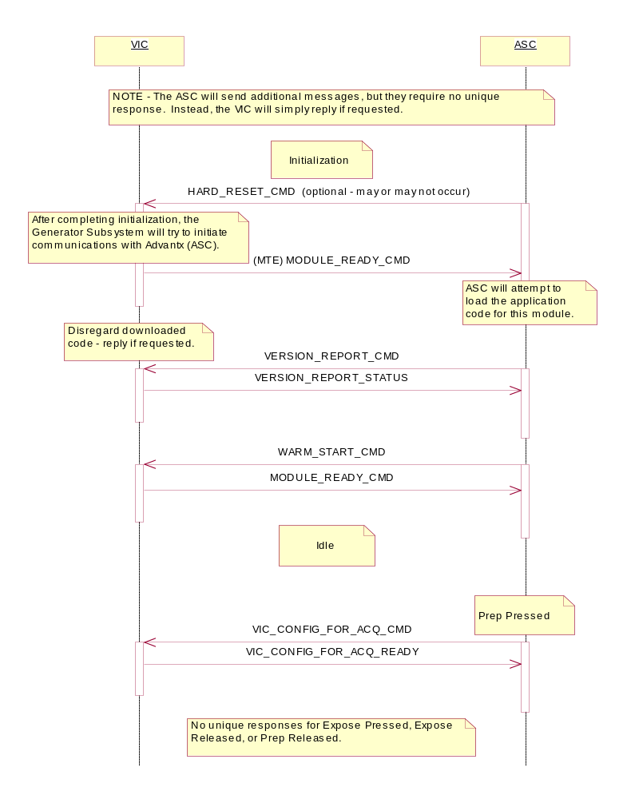
Figure 3 - VIC Module Communications

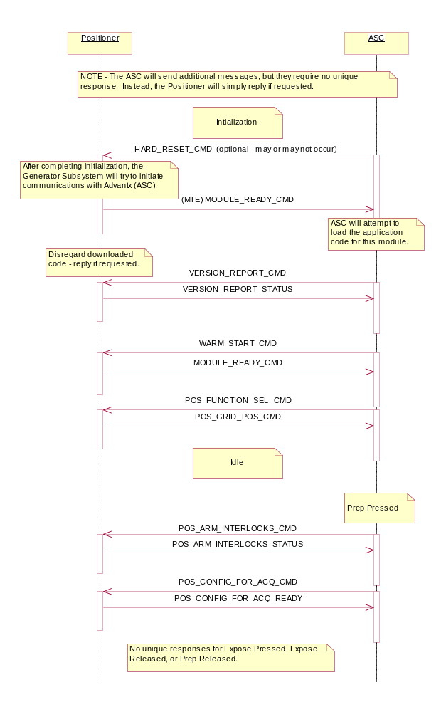
Figure 4 - Positioner Module Communications

Jedi Generator
The Jedi generator is clearly an automated control generator. The physical interface to the Jedi generator is a CAN link. Through this link, the Generator Device Controller must handshake with the Jedi to initialize it, and to perform acquisitions. With out this interaction, the Jedi will be inoperative. Refer to the “JEDI CAN Communication Protocol Specification” for specific information on the Jedi interface, and message sequencing with the Jedi generator. Note that since a Vascular version of Jedi is being used for ADEPT, please refer to the sections of this document that apply to the “Liberty” program.

Initialization
There are two scenarios for initialization that need to be supported. First, there is the case when ADEPT initiates communications. This may occur when only ADEPT is rebooted. It may also occur when both ADEPT and Jedi are rebooted, and ADEPT initializes sooner.

The second scenario is the case when Jedi initiates communications. This may occur when only Jedi is rebooted. It may also occur when both ADEPT and Jedi are rebooted, and Jedi initializes sooner.

Refer to below for the details of this communication.

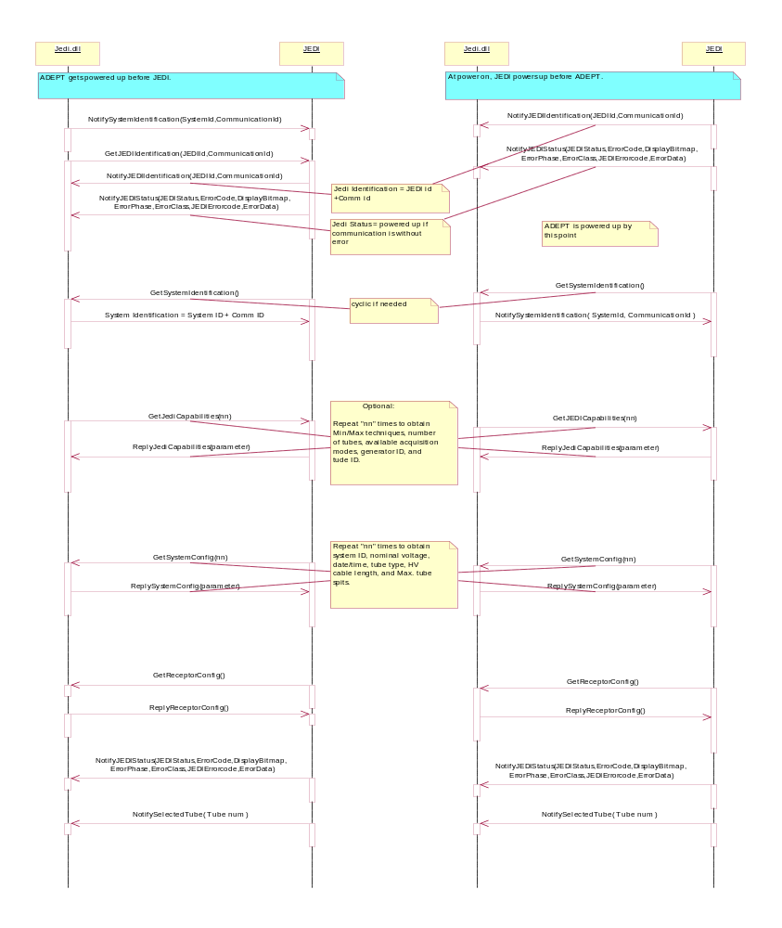
Figure 5: ADEPT/Jedi Communication at Initialization.

Fluoro
The communication with the Jedi depicted in Figure 6 is required Fluoro.
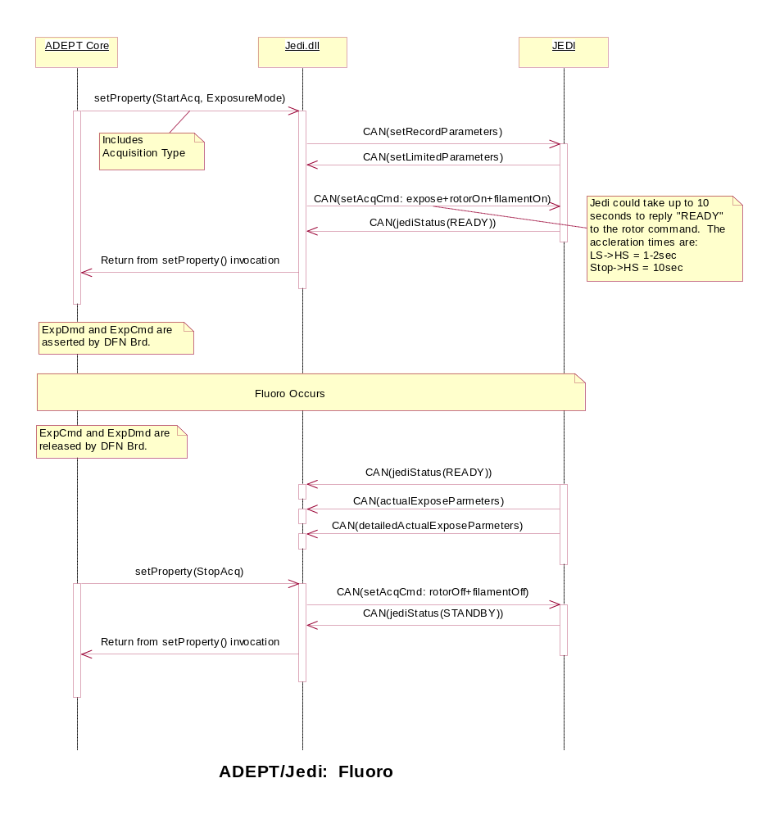
Figure 6: ADEPT/Jedi Communication for Fluoro.

Rad / Digital Record
The communication with the Jedi depicted in Figure 7 is required for RAD and Digital Record modes.
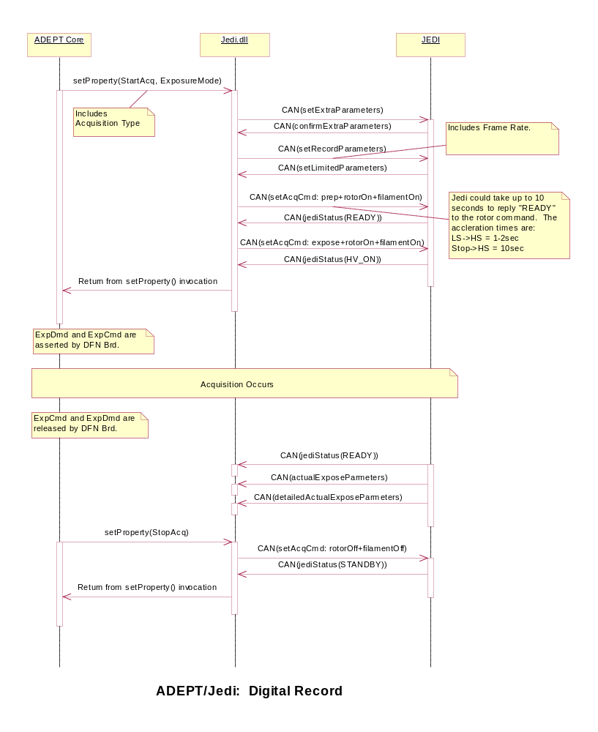
Figure 7: ADEPT/Jedi Communication for RAD / Digital Record.

Tube Warm-Up
No support is currently planned for Tube Warm-Up. If it should be deemed necessary to support Tube Warm-Up, this will most likely be accomplished by writing a script to cycle through a series of 18 RAD exposures. This approach will require no special functionality in either ADEPT Core or the Jedi DLL.

Enable/Disable Generator (Inhibit)
Though not an absolute requirement, it may be beneficial to the customer for ADEPT to be able to support multiple exposure sources (i.e. generators, light source) within a given test station. Depending on the configuration of the test station and the nature of the test that is being run, it is possible that one source will have to be disabled while another is exposing the detector. An example of this would be a test station configured with both a light source and a generator.
Based on the ADEPT architecture, the Generator Device Controller has no absolute means of inhibiting acquisitions (preventing the RT signals from reaching the generator). Therefore, acquisition inhibit will be handled by another subsystem. However, a redundant mechanism may be implemented in the Generator Device Control. This mechanism will place the generator, where possible, in a mode in which it will not take exposures. This will be accomplished for each generator as outlined below.

DMR Generator
The Generator Device Controller has no control over the DMR Generator, so no functionality can be provided here.

Advantx / LFX Generator
The Generator Device Controller has no direct control over the LFX Generator. However, the Positioner module can inhibit acquisitions via Arcnet message sequencing with the ASC. At the start of an acquisition, the ASC will send a POS_ARM_INTERLOCKS_CMD to the Positioner. When the Positioner replies with the POS_ARM_INTERLOCKS_STATUS message, it can successfully inhibit the acquisition by sending a non-zero data byte in that message. This will cause the ASC to abort the acquisition.

Jedi – UNIMPLEMENTED FEATURE
The Generator Device Controller does have control over the Jedi Generator. While an explicit inhibit mechanism does not exist, the Jedi generator can effectively be inhibited by forcing it to cycle through a power-up sequence, and then not completing the power-up dialogue with the Jedi. The resetting of the Jedi can be accomplished by sending a "System Identification" message to the Jedi while Jedi is in the "idle" state. After the Jedi reboots, it will try to re-establish communications with the Generator Device Controller by sending a “Notify Jedi Identification” message. If the Generator Device Controller does not reply to this message, the Jedi will remain in the “Power-up” state. While in this state, the Jedi will not take exposures. To re-enable the Jedi, the Generator Device Controller just needs to complete the power-up dialogue with the Jedi.

Termination
When the Generator Device Controller is instructed to terminate, it will perform the following:

- Terminate communications with the generator.
- Release any other resources currently in use by the device controller.

      - Public Interface
The public interface for the Generator Device Controller will adhere to the COM interface standard. Four methods will be supported, as listed below:

Initialization
The method used to initialize the Generator Device Controller will have the following prototype:
HRESULT sInitialize(void)

Setting Parameters
One set method will be used for all parameters within the Generator Device Control. This method will have the following prototype:
HRESULT sSetProperty([in] BSTR propertyName,
[in] BSTR propertyValue,
[out, retval] BSTR * returnUnsetParamPtr)
The table below lists the parameters that may be set on the Generator Device Controller via this set method.

Table 1 – Generator Device Controller “Settable” Parameters.
Parameter ID | Comment | Range (min/max) | Values
kVp | Generator technique. | Read from config. file. | Any numerical value within range.
mA | “ “ | “ | “
mAs | “ “ | “ | “
ExposureTimeInMillisecs | “ “ | “ | “
FrameRateInFps | “ “ | “ | “
FocalSpotInMM | “ “ | “ | “
kVpMin/kVpMax | Generator technique limits. | Read from config. file. | “
mAMin/mAMax | “ “ | “ | “
mAsMin/ mAsMax | “ “ | “ | “
ExposureTimeMinInMillisecs/ExposureTimeMaxInMillisecs | “ “ | “ | “
FrameRateMinInFps/FrameRateMaxInFps | “ “ | “ | “
FocalSpotMinInMM/FocalSpotMaxInMM | “ “ | “ | “
ExposureMode | Indicates the type of acquisition to be performed. | n/a | Values are dependant on the generator type – see documentation for each generator.
GeneratorType | Indicates the type of generator currently in use. | n/a | DMR, JEDI, ADVANTX / LFX
TubeSelection | Indicates tube selection (connection) on the generator. | n/a | TUBE_1, TUBE_2
TubeType | Indicates the type of x-ray tube currently installed. | n/a | Refer to “canmess011_CanMsgs.pdf” for the appropriate values.
PulseWidthControlType | Indicates whether the pulse width is set manually, or via software in ADEPT (Advantx/LFX only). | n/a | MANUAL_PW_CTRL, AUTO_PW_CTRL
Reconfigure | Requests that the current techniques be loaded on the generator (Jedi only). | n/a | ADEPT Core AcqType - see Acquisition Subsytem.
AcqStart | Requests that the generator be prepped for acquisition (Jedi only). | n/a | ADEPT Core AcqType - see Acquisition Subsytem.
AcqEnd | Requests that the generator be set to standby (Jedi only). | n/a | n/a
SendModuleReady | Causes the Generator DLL to send a ModuleReady command from both the VIC and Positioner to the ASC (Advantx/LX only). | n/a | n/a
DebugMode | Indicates whether debug messages are logged. | n/a | TRUE, FALSE
CommBrd1Num | Generator communication I/F board number. | Dependant on comm. type. | Any numerical value within range.
CommBrd2Num | Generator communication I/F board number. | “ | “
CommNode1Id | Generator communication I/F node ID. | “ | “
CommNode2Id | Generator communication I/F node ID. | “ | “
SerialPortCommPort | Pulse width controller I/F serial port comm. port. | Win32 specific. | “
SerialPortBaudRate | Pulse width controller I/F serial port baud rate. | “ | “
SerialPortByteSize | Pulse width controller I/F serial port byte size. | “ | “
SerialPortParity | Pulse width controller I/F serial port parity. | “ | “
SerialPortStopBits | Pulse width controller I/F serial port stop bits. | “ | “
SerialPortAbortOnErr | Pulse width controller I/F serial port abort on error flag. | “ | “
SerialPortReadIntervalTO | Pulse width controller I/F serial port read interval timeout. | “ | “
SerialPortReadTotConsTO | Pulse width controller I/F serial port read total constant timeout. | “ | “
SerialPortReadTotMultTO | Pulse width controller I/F serial port read total multiplier timeout. | “ | “
SerialPortWriteTotConsTO | Pulse width controller I/F serial port write total constant timeout. | “ | “
SerialPortWriteTotMultTO | Pulse width controller I/F serial port write total multiplier timeout. | “ | “

Getting Parameters
One get method will be used for all parameters within the Generator Device Control. This method will have the following prototype:
HRESULT sGetProperty([in] BSTR propertyName,
[out, retval] BSTR * returnValuePtr)
In addition to ALL of the parameters listed above in the “Settable” parameter list, the table below lists the “read-only” parameters on the Generator Device Controller.

Table 2 – Generator Device Controller “Read-only” Parameters.

Parameter ID | Comment | Range (min/max) | Values
GenDevCtrlState | Indicates the status of the Generator Device Controller. | n/a | ERROR_STATE,  INITIALIZING_STATE,  IDLE_STATE,  PREP_STATE,  EXPOSE_STATE
VERSION_ID | Indicates the version number of the Generator DLL. | n/a | number
Inhibit_Status | Indicates whether acquisitions are inhibited. | n/a | TRUE, FALSE
ready_for_ acquisition | Indicates whether the generator is ready for acquisitions. | n/a | Null string if ready, else an error string.
acquisition_done_ Status | Indicates whether an error occurred during the last acquisition. | n/a | Null string if no errors, else error string.
IMAGE_DATA | A collection of all generator techniques and settings – intended for image header information gathering. | n/a | See individual parameters.

Termination
The method used to terminate the Generator Device Controller will have the following prototype:
HRESULT sTerminate(void)

    - Light Source Device Controller

General implementation description
The Light Source Device Controller provides one primary service with regard to the Light Source - it will interact with the Light Source to initialize it in preparation for taking exposures. Following the model for the Generator Device Controller and other peripheral devices, the Light Source Device Controller software will exist in the form of a Windows DLL. This DLL will encapsulate all Light Source Device specific functionality, and will provide a consistent COM interface to the Peripheral Subsystem. This DLL will be loaded when the system is installede. Since there are similarities here with the Generator Device Controller, attempts will be made to share common code wherever possible.

Processing

Initialization
At initialization, the Peripheral Subsystem will invoke the sInitialize() method on the Light Source Device Controller DLL. The Light Source Device Controller will then load its configuration and complete its initialization. Finally, the default parameter values will be loaded into the Light Source.

Acquisition Configuration File
This configuration file will provide light source parameters that are specific to an acquisition. This includes the following:
- Strobe Intensity.
- Strobe Pulse Width.
The parameters will be read external to the Light Source Device Controller, and the values will be set in the Light Source Device Controller via its public interface methods.

Light Source Configuration File
There will be one of these files for each type of light source supported. This configuration file will provide light source parameter limits and default values specific to the type of light source. This includes the following:
- Debug mode.
- Light source type.
- Strobe Intensity Min/Max
- Strobe Pulse Width Min/Max
- Strobe Intensity default value.
- Strobe Pulse default value.
- Strobe light flash period.
- Strobe intensity offset.
- Strobe intensity scalar.
- Serial Port:
  - COM port number.
  - Baud rate.
  - Byte size/
  - Parity.
  - Stop bits.
The min./max. limit parameters will be used to limit check the light source parameters before the start of an acquisition. The default values are used to initialize the light source.

Light Source Initialization
Once the Light Source DLL has been initialized, communications can be established with the light source, and the light source itself can be initialized with default parameter values.

Runtime Processing
Each type of light source (GRC, as well as potential future light sources) is unique with respect to its physical interface. However, the interface to the Light Source Device Controller contains a fixed set of parameters – StrobeIntensity and StrobePulseWidth. The Light Source Device Controller will use the LightSourceType configuration parameter to determine how to convert the two input parameters into the necessary parameters used by that light source.

GRC Light Source
The follow information is specific to the GRC Light Source. If in the future, another light source is to be supported, then this section will need to be replicated for that light source.

Parameter Conversion
The GRC expects eight parameters as inputs. These parameters are listed and defined in Table 3 below.

Table 3 - GRC Light Parameters
Parameter | Explanation | Range | Units | Value Used
entry_num | Position in the light source exposure table. | 0-9 | N/A | This parameter will not be used, ALWAYS = 0
trig_mode | Trigger mode. | 0 = RAD,  1 = fluoro, 0xFF to indicate end of list. | N/A | Determined from exposure mode.
lat | Latency between trigger and first strobe. | 0-65535 | MSec | ALWAYS = 0
strb_per | Amount of time that the light pulse is off per cycle. | 0-65535 | Multiples of  0.8 uSec | The optimal value has been pre-determined, so ALWAYS = 1225
strb_del | Amount of time that the light pulse is on per cycle. | 0-65535 | mSec | ALWAYS = 1
strb_cnt | Number of pulses. | 0-65535 | N/A | Calculate – see below.
dac_cnt | Input to DAC value. | 0-255 | N/A | Calculate – see below.
rep_cnt | Number of times that this exposure table entry should be repeated before loading the next. | 0 = forever, 1-65535 indicates that number of repetitions | N/A | This parameter will not be used, ALWAYS = 0

strb_cnt - Given the values listed above for strb_per and strb_del, the period for one flash of the strobe light will be 2.5 ms. Given that, the strb_cnt is calculated as follows:

strb_cnt = StrobePulseWidth(ms) / 2.5ms eq. 1

The acceptable range for strb_cnt is 0-65535, and a value of zero means there will be no flash.

dac_cnt – By plotting empirical data of StrobeIntensity vs. dac_cnt, it was found that this relationship was approximately linear. After analyzing this data, the following relationship was found:

dac_cnt = (StrobeIntensity - 0.811) / -0.0024 * eq. 2

The acceptable range for dac_cnt is 0-255.

* Note this calculation pertains to the light intensity at the center of the FOV, and assumes a calibrated light source using a 71% neutral density filter.

Communication Interface
The physical link to the GRC Light Source is an RS-232 serial link. The specific port to be used is defined in the configuration file. The dialogue between the Light Source Device Controller and the GRC Light Source is very simplistic. The GRC Light Source does not require any special initialization; the only interaction that is necessary is when new parameters need to be passed along. The dialogue to set new parameters on this light source is depicted in Figure 6Figure 6 below.

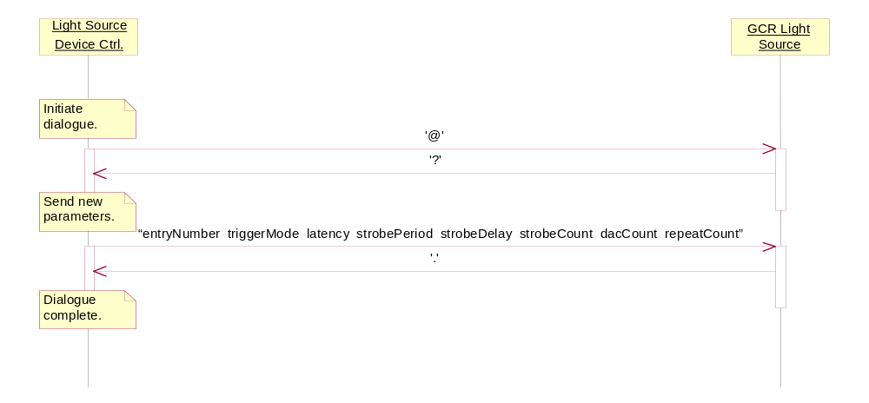
Figure 6: GRC Light Source Communication

Enable/Disable Light Source (Inhibit)
Though not an absolute requirement, it may be beneficial to the customer for ADEPT to be able to support multiple exposure sources (i.e. generators, light source) within a given test station. Depending on the configuration of the test station and the nature of the test that is being run, it is possible that one source will have to be disabled while another is exposing the detector. An example of this would be a test station configured with both a light source and a generator.
Based on the ADEPT architecture, the Light Source Device Controller has no absolute means of inhibiting acquisitions (preventing the RT signals from reaching the generator). Therefore, acquisition inhibit will be handled by another subsystem. However, a redundant mechanism may be implemented in the Light Source Device Controller. This mechanism will place the light source in a mode in which it will not take exposures. This will be accomplished by setting the Light Source parameters, Strobe Intensity and Strobe Pulse Width, to their minimum values (a value of zero in the case of Strobe Pulse Width). Doing so will prevent the strobe from flashing.

Termination
When the Light Source Device Controller is instructed to terminate, it will perform the following:
- Terminate communications with the light source.
- Release any other resources currently in use by the Device Controller.

      - Public Interface
The public interface for the Light Source Device Controller will adhere to the COM interface standard. Four methods will be supported, as listed below:

Initialization
The method used to initialize the Light Source Device Controller will have the following prototype:
HRESULT = sInitialize(void)

Setting Parameters
One set method will be used for all parameters within the Light Source Device Controller. This method will have the following prototype:
HRESULT = sSetProperty([in] BSTR propertyName,
[in] BSTR propertyValue,
[out, retval] BSTR * returnUnsetParamPtr)
The table below lists the parameters that may be set on the Light Source Device Controller via this set method.

Table 4 – Light Source Device Controller “Settable” Parameters.
Parameter ID | Comment | Range (min/max) | Values
StrobeIntensityInFtL | Light source parameter. | Read from config. file – values to be extrapolated from Table 3 and eq. 1 & 2. | Any numerical value within range, units are in Ft-Lamberts.
ExposureTimeInMillisecs | “ “ | “ | “
StrobeIntensityMinInFtL/StrobeIntensityMaxInFtL | Light source parameter limits. | “ | Any numerical value within light source’s range, units are in Ft-Lamberts.
ExposureTimeMinInMillisecs/ExposureTimeMaxInMillisecs | “ “ | “ | “
LightSourceIsConnected | Indicates whether a Light Source is actually connect to ADEPT. | n/a | TRUE, FALSE
LightSourceType | Indicates the type of light source currently in use. | n/a | GRC
InhibitStatus | Indicates whether acquisitions are inhibited. | n/a | TRUE, FALSE
ExposureMode | Indicates the type of acquisition to be performed. | n/a | Values are dependant on the generator type – see documentation for each generator.
Reconfigure | n/a – supported as a general property. | n/a | n/a
AcqStart | n/a – supported as a general property. | n/a | ADEPT Core AcqType - see Acquisition Subsytem.
ACQ_STOP | n/a – supported as a general property. | n/a | n/a
DebugMode | Indicates whether debug messages are logged (to console window). | n/a | TRUE, FALSE
SerialPortCommPort | Pulse width controller I/F serial port comm. port. | Win32 specific. | “
SerialPortBaudRate | Pulse width controller I/F serial port baud rate. | “ | “
SerialPortByteSize | Pulse width controller I/F serial port byte size. | “ | “
SerialPortParity | Pulse width controller I/F serial port parity. | “ | “
SerialPortStopBits | Pulse width controller I/F serial port stop bits. | “ | “
RECONFIGURE | n/a – supported as a general property. | n/a | n/a
NEW_SYSTEM_STATE | n/a – supported as a general property. | n/a | n/a

Getting Parameters
One get method will be used for all parameters within the Light Source Device Controller. This method will have the following prototype:
HRESULT = sGetProperty([in] BSTR propertyName,
[out, retval] BSTR * returnValuePtr)
In addition to ALL of the parameters listed above in the “Settable” parameter list, the table below lists the “read-only” parameters on the Light SourceDevice Controller.

Table 5 – Light Source Device Controller “read-only” Parameters.
Parameter ID | Comment | Range (min/max) |  | Values
GenDevCtrlState | Indicates the status of the Light Source Device Controller. | n/a |  | ERROR_STATE,  INITIALIZING_STATE,  IDLE_STATE,  PREP_STATE,  EXPOSE_STATE
VERSION_ID | Indicates the version number of the Generator DLL. |  | n/a |  | number
Inhibit_Status | Indicates whether acquisitions are inhibited. | n/a |  | TRUE, FALSE
ready_for_ acquisition | Indicates whether the Light Source is ready for acquisitions. | n/a |  | Null if ready, else an error string.
acquisition_done_ Status | Indicates whether an error occurred during the last acquisition. | n/a |  | Null if no errors, else an error string.
IMAGE_DATA | A collection of all Light Source techniques and settings – intended for image header information gathering. | n/a |  | See individual parameters.

Termination
The method used to terminate the Light Source Device Controller will have the following prototype:
HRESULT = sTerminate(void)

Sequence Manager Subsystem

General implementation description
The sequence manager subsystem is in charge of handling sequences in memory and their associated parameters (like header information).
.
If an acquisition config file is used, the following data members may be set by the acq config file:
- in ArchiveSS: archive ROI for the next acq, window/level for next acq
- in AnalysisSS: target level checking params for next acq

These will only be applied if the acq is started using mStartNextAcq.

When any call to start an acq is made (ie, mStartNextAcq, mStartRadSeq, mStartFluoroSeq, mStartUserSeq, mStartTwoUserSeq), two data structures are dynamically allocated and filled in (this is done before the actual acquisition): a "process info" and an "image info". The process info object contains desired archive ROI and flipping, and desired target level parameters. It is filled in from the static members in ArchiveSS and AnalysisSS. The image info is the actual header that will be archived with the sequence, if it is archived. In addition, if desired window/level were set, these are applied in DisplaySS in addition to setting them in the image info.

Once the seq has been acquired, the call to sSeqInMemory places pointers to the process info and image info objects into the _sProcessInfo and _sImageInfo maps in SeqMgrSS (the "key" for these maps is the seq #, and the "value" is a ptr to the image or process info object). At any time while the sequence is in memory, changes may be made to the process info or image info by calling the appropriate methods in Core:
- mSetOneImageInfoParamForSeqInMemory
- mSetDesiredROIForSeqInMemory
- mSetDesiredTargetLevelParamsForSeqInMemory, etc

If mDoTargetLevelCheck is called, the target level params are copied into the image info, and the results are also written into image information. They may then be accessed using mGetOneImageInfoParamForSeqInMemory. If/when the sequence is archived, the correct archival ROI is written into a copy of the II, which is then written to disk. The actual seq in memory and its entries in _sProcessInfo and _sImageInfo are not changed. Anytime a seq is erased from memory, the corresponding entries in _sProcessInfo and _sImageInfo must also be removed and the memory freed.

Analysis subsystem

General implementation description
The analysis subsystem is in charge of performing statistical calculations to be used in target level checking.
The following parameters are used to perform target level checking:
- TargetLevelROIUpperRow: number of the upper row of the ROI in which target level is calculated
- TargetLevelROILeftCol: number of the left column of the ROI in which target level is calculated
- TargetLevelROILowerRow: number of the lower row of the ROI in which target level is calculated
- TargetLevelROIRightCol: number of the right column of the ROI in which target level is calculated
- FrameNumber: number of the frame (in seqNum) in which to do target level check.
- PercentRange: percentage of allowable variation around targetValue (converted internally to USHORT)
- TargetValue: desired target value
- SeqNum: number of the sequence in memory

Target level checking is performed in the following steps:
- Get frame from sequence in memory
- Get median of the target level ROI (including horizontal and vertical flipping settings)
- Set target level parameters in header of the image
- Evaluate median against target value and percent range.

Error Management

General implementation description
ADEPT Core handles three distinct types of errors: AdeptErrors, _com_errors, and extended errors.
AdeptError is the class of errors generated within ADEPT Core. These are handled using standard C++ exception handling (i.e. ‘throwing’ and ‘catching’ errors). If an AdeptError occurs while executing a method called through its COM interface, the error is also thrown (returned) through the COM interface to the calling application or script. Once an AdeptError is thrown through the COM interface, it becomes a _com_error, so the calling application or script does not see AdeptErrors.
_com_errors come from lower-level ADEPT components, such as dasdll. These errors are also handled using standard C++ exception handling: they are caught in ADEPT Core, and may be rethrown in ADEPT Core. As with AdeptErrors, _com_errors may be thrown through ADEPT Core’s COM interface to a calling application or script.
Extended errors come from the extended error thread of the DFN driver. While the behavior of AdeptErrors and _com_errors is very similar, extended errors are handled quite differently. Instead of throwing and catching extended errors, they are processed by the error thread in the System subsystem, which takes action on some of them. See section 3.2.1 for further information on how ADEPT Core handles extended errors. For detailed information on extended errors, see the DFN driver user’s manual.
All types of errors are logged in the error log for troubleshooting and debugging purposes. In addition, ADEPT Core provides the capability to log system events here as well. Any occurrence in ADEPT Core or another ADEPT component can be considered a system event.

Error attributes for _com_errors and AdeptErrors
Each _com_error and AdeptError has three basic components: a number, a description, and a location. Each of these are further divided into fields that describe the error.

Error numbers
Every error has a unique identifier. Error values are 32 bits long and are organized as follows:

31 | 30 | 29 | 28 | 27 | 26 | 25 | 24 | 23 | 22 | 21 | 20 | 19 | 18 | 17 | 16 | 15 | 14 | 13 | 12 | 11 | 10 | 9 | 8 | 7 | 6 | 5 | 4 | 3 | 2 | 1 | 0
R |  | C | R |  |  |  |  | Facility |  |  |  |  |  |  |  | Code
 |  |  |  |  |  |  |  |  |  |  |  |  |  |  |  | E |  |  |  | Subsystem |  |  |  | Number

R = Reserved bits
C = Clear bit
0 – Error is being cleared.
1 – Error occurred.
See section 3.8.7 for an explanation of clearing errors.
Facility = facility code
RPC_RUNTIME 0x2
RPC_STUBS 0x3
IO_ERROR_CODE 0x4
DFNDRVR_ERROR_CODE 0x7
DLL_ERROR_CODE 0x13
ADEPT_CORE_ERROR_CODE 0x53
PROCESS_DLL_ERROR_CODE 0x58
IMGINFO_DLL_ERROR_CODE 0x60
AMA_ERROR_CODE 0x70
ACL_ERROR_CODE 0x80
Code = Error code. For ADEPT Core errors, this is further subdivided as follows:
E = Error/event bit (bit 15). See section 3.8.6 for information on events.
0 – Error
1 – Event
Bits 14-12 are unused in ADEPT Core errors and should be set to zero.
Subsystem = Subsystem that generated the error (bits 11-8). The values used for subsystem identification will be as follows:
General 0x0
System 0x1
Detector 0x2
Acquisition 0x3
Sequence Manager 0x4
Archive 0x5
Display 0x6
Processing 0x7
Analysis 0x8
Peripherals 0xE
Number = Number identifying the error (bits 7-0)
For a complete listing of all ADEPT Core errors, please see Appendix G of this document.

Error description
Each error has a text field that contains a short description of the error. For AdeptErrors, this field also may include an error severity and display/no display option.
ADEPT Core stores the descriptions of all AdeptErrors in a string table resource. A few lines of the string table may look like:

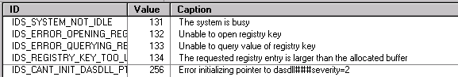

The first column, ID, is the constant identifier used in the code to refer to the error. The second column, Value, is the number corresponding to the ID, and is also the lowest sixteen bits of the error number. The third column, Caption, is the error description.
Also, the end of the caption may specify other attributes of the error. This can be done by using the delimiter ### and a tag indicating what is being specified. For example, to specify that IDS_SYSTEM_NOT_IDLE has severity 1 and should be displayed, the caption would read:
The system is busy###severity=1###display=1
The following are the possible values for severity and display/no display, along with their default values for both events and errors (for information on events, see section 3.8.6):
 |  | Error default | Event default
Severity | 0 – event |  | X
Severity | 1 – error | X
Severity | 2 – fatal error
Display/No display | 0 – no display |  | X
Display/No display | 1 – display | X
In addition to the description specified in the caption, ADEPT Core may add more specific information to the description each time an error occurs. This is useful, for example, to indicate the exact line where an error was found while reading in a config file. The additional information is added by simply appending to the description before throwing the error. Note that this may also be done for _com_errors from the lower-level components, if needed; however, since Adept CORE cannot modify a _com_error object, it must convert the _com_error to an AdeptError and then append the extra text.

Location
For software development and debugging purposes, it is useful to know the exact location where an error originated. The location is specified in a text field that includes the method, filename, and line number of the error, in the following format:
Method=DetectorSS::sLookForDetector(), File=D:\ADEPT\Core\DetectorSS.cpp, Line=4302
The one exception to this is _com_errors coming from dasdll, where location is specified by a string such as “Dasdll.DFNCard.1”.

Error attributes for extended errors
Extended errors as received in the error thread of the System subsystem do not contain exactly the same attributes as AdeptErrors and _com_errors. Instead, it contains three 32-bit words, one each for event queue errors, fiber channel errors, and image/DMA errors, along with a text field describing the error. For purposes of error logging, ADEPT Core converts the information it receives in extended errors to a similar format as is used for AdeptErrors and _com_errors.
The error number used by ADEPT Core for all extended errors is the same, regardless of the type(s) of extended error that occurred. It uses the same 32-bit format as above, with the facility code set to 0x53 (ADEPT Core, since that’s where this number is being created), error/event bit set to 0 (error), subsystem set to 0 (general), and error number set to 0x80. This results in the number 0xE05300080.
The error description is unchanged from what the extended error thread receives.
The error location is listed as method SystemSS::_sErrorThread(), with the appropriate filename and line number.
For a complete description of extended errors, see the DFN driver user’s manual.

Error reporting

_com_errors and AdeptErrors
_com_errors and AdeptErrors will be reported to higher-level applications using two methods:
- During execution of methods called by the high-level application the standard error mechanism of COM will be used. This is done by using one of the overloaded Error() methods provided by ATL.
- Asynchronous errors will be reported using the callback interface provided by the high-level application.
High-level scripts will also use the first error reporting mechanism just described. However, since a script is not able to register a callback interface, it will not be possible to use the second method for asynchronous errors. Instead, the following functionality is provided:
- For asynchronous errors that occur while the system is not IDLE, the script may call mWaitForSystemIdle, which throws the _com_error or AdeptError that occurred while the system was not IDLE.
- It is not possible for a script to receive a report of an asynchronous error that occurs while the system is IDLE. This design decision was made because it is unlikely for an asynchronous error to occur while the system is IDLE when executing a script; thus it should not cause problems.

Extended errors
Extended errors are reported via a callback to high-level applications with a registered callback interface. All extended errors will be reported in this manner with the exception of the repeated extended errors that occur when a detector is not connected and/or responding; in this case, only the first one or two extended errors will be reported.
For high-level scripts, ADEPT Core will provide a method to request information for the last extended error. ADEPT Core keeps track of the most recent extended error and erases it each time the system state is changed from IDLE to another state, so if no extended errors have occurred since that time, none is returned.

Error logging
The error log is a text type file where all errors that are caught or generated by ADEPT Core are logged. The filename is fixed as AdeptCoreError.log.
Each occurrence of an error is logged exactly once. Errors that come from lower-level components are logged the first time they are caught by Core; errors that are generated in Core are logged just before they are first thrown. Extended errors are logged from the extended error thread in the System subsystem. However, with extended errors, there is one exception to the rule that each occurrence of an error is logged exactly once: since loss-of-sync extended errors occur constantly while the detector is disconnected, only the first one or two of these will be logged, and subsequent ones will be ignored. ADEPT Core also allows higher-level applications to specify their own errors to be logged.
Each entry in the error log includes the complete number, location, and description information specified in sections 3.8.2 and 3.8.3, plus a date and time stamp indicating when the error occurred or was received by Core. AdeptErrors, _com_errors, and extended errors are all logged in the same format.
A few entries from the error log might look like:

ERROR E0532021
18-Aug-2002 16:48:01
Method=DetectorSS::sLookForDetector(), File=D:\ADEPT\Core\DetectorSS.cpp, Line=4302
Sev=1, Disp=1
Description:
The detector is not responding
//

ERROR E0530003
18-Aug-2002 16:48:01
Method=SystemSS::_sErrorThread(), File=D:\ADEPT\Core\SystemSS.cpp, Line=744
Sev=1, Disp=1
Description:
EQ Err:0x00000040
FC problem on TX event
FC Err:0x00000071
FC receive CRC error
FC loss of sync on FC link
FC bad data from FC receiver
FC timeout occurred before ack
//

ERROR E007010A
18-Aug-2002 19:03:41
DasdllLocation=Dasdll.DFNCard.1
Sev=1, Disp=1
Description:
IDFNCard:: Sending detector command failed Driver: DFN card received command but executed it with an error.

DFNSendDetectorCommand Failed. Command=1002, Data=0
//

The first of these sample entries is an AdeptError, the second, an extended error, and the third, a _com_error. Line-by-line, they are all similar:
Line 1: Start of error/event (“ERROR” or “EVENT”) followed by error/event number
Line 2: Timestamp on one line in the format “dd-Mmm-yyyy hh:mm:ss”
Line 3: Location information on one line handled as a generic string. Note that for AdeptErrors and extended errors, method, file, and line are all specified. For _com_errors from dasdll only, the location information provided by dasdll is specified.
Line 4: Severity and display on one line in the format “Sev=x, Disp=x”
Lines 5 - ?: Description. May span multiple lines.
Last line: “//” to indicate the end of the entry.

Event logging
To aid in debugging, ADEPT Core also allows for the logging of system “events” in the error log. Core may log events itself, or it may log events that have been specified by another application. Events are very similar to errors, with the number being in the same format and having bit 15 set to 1. Event entries in the log begin with “EVENT” instead of “ERROR”; otherwise, the information in event entries is identical to that of error entries. All events default to severity 0 (event) and display 0 (no display); see section 3.8.2.2.

Clearing errors
ADEPT Core provides for errors to be “cleared” once appropriate operator action has been taken to correct them. When an error is cleared, ADEPT Core will write an entry in the error log indicating that the error has been corrected, and it will also notify higher-level applications via their registered callback interface. This would be useful, for example, to an application that has an error-display window that it would need to update.
Error clearing is intended to be used for errors that can be corrected by some physical action by the operator, such as connecting a detector or closing the interlocks. However, it can be used for any error.
ADEPT Core may keep track of some errors itself, and higher-level applications may keep track of other errors and ask Core to clear them. In this case, all that the application needs to do is call mLogError with the clear bit set to 0 in its error number. Core then simply logs the error and sends a callback to the application to confirm that the error has been cleared.

Error log size
In order to prevent problems that would result if the error log fills up the disk, ADEPT Core provides a configuration setting to limit the size of the log file. The user may either specify a maximum size in kilobytes or allow the system’s default limit to be used. If the user is not concerned about disk space, he should specify 0 as the maximum size, which will indicate that the file should be allowed to grow indefinitely.
The size is limited by “rolling” the error log and discarding the oldest errors when the limit is reached. This is accomplished in the following manner. The log file is called AdeptCoreError.log. As new errors are logged, the size of this file grows and eventually reaches the size limit. When this occurs, AdeptCoreError.log is renamed to AdeptCoreError2.log, and new errors are logged starting with a blank AdeptCoreError.log. When AdeptCoreError.log fills up again, the existing AdeptCoreError2.log is deleted, AdeptCoreError.log is renamed to AdeptCoreError2.log, and logging once again starts with a blank AdeptCoreError.log. This system of maintaining two files is convenient because it is easy to implement, and at the same time allows recent error history to be maintained even when the error log fills up.
The file size is checked against the limit each time a new error is logged, so there is no danger of letting the file grow too big as a result of a large number of errors occurring in a very short time.

Appendix A – IApolloTester interface methods
The following is a listing of all methods available to the user via the COM interface at the time of this revision. Included in the descriptions are some possible reasons for failure. Note that the reasons listed are not the only way the method may fail; rather, they are the most common problems.

mCancelFirmwareDownload
Cancels firmware download to detector. The download is simply stopped; no attempt is made to recover the previous firmware.

long mCancelFirmwareDownload()

mCancelRetrieve
Cancels retrieval of an image sequence from disk. When this method is called, any portion of the sequence that has already been retrieved is removed from image memory.

long mCancelRetrieve()

mCancelStore
Cancels sequence or image store to disk. Any partially written file will be left in disk. The user needs to perform any clean-up if necessary.

long mCancelStore()

mClearAllUserBufferInfoEthernet
Erases all user buffer information set previously with mSetNextUserBufferEthernet.

long mClearAllUserBufferInfoEthernet();

mClearAllUserDetectorScriptInfoEtherne
Erases all user script information set previously with mSetNextUserDetectorScriptEthernet.

Long mClearAllUserDetectorScriptInfoEthernet();

mClearBPList
Erases the specified bad pixel list in memory.

Long mClearBPList(short BPListType)

BPListType: 1 = suspect bad pixel list
0 = permanent bad pixel list

mConfigSysAcq
This method sets some of the parameters that are needed to perform a system-generated acquisition (rad or fluoro). The remaining system acquisition parameters are set by mSetTimeBetweenFramesInMicrosec and mSetExposeTimeDelayInMicrosec.

long mConfigSysAcq
(long framesBefore,
long framesDuring,
long framesAfter,
long intervalBetweenFrames,
long framesToSkipExpose,
short acquisitionMode,
short fluoroType)

Note: a new method (mSetUserSeqParams) was added to comply with the standard row, column format for frame sizes and ROIs (SPR XRYge44701). This method was left unchanged to keep backwards compatibility.

mConfigUserSeq
Configures the parameters to run a COFF file provided by the user. Two sets of parameters (userSeqId =1 or 2) can be programmed. The first set is used when mStartUserSeq is called. Both sets of parameters are used when mStartTwoUserSeq is called.

long mConfigUserSeq
(long bufferSize,
short frameXSize,
short frameYSize,
BSTR coffFilename,
Short wrapMode,
Short userSeqId)

mDisplayImage
Displays the specified image of the specified sequence. This method works only with sequences in memory.

long mDisplayImage
(long sequenceNumber,
double frameNumber)

Failure may be caused by: system busy.

mDoTargetLevelCheck
Performs target level check on the specified sequence. Target level check parameters are set with mSetTargetLevelParamsForSeqInMemory. When this function is called the median of the ROI (of the specified frame and sequence) is calculated and compared against the target level value and the percent range.

long mDoTargetLevelCheck
(long sequenceNumber)

This method returns 0 (false) if the test failed and 1 (true) if the test passed.

mDownloadDetectorData
Downloads data to the detector. The type of data that is downloaded is specified using the dataType input paramenter.

Long mDownloadDetectorData
(BSTR filename,
short dataType)

As of rev. 30 of this document, the detector supports the following data types:
0: Application firmware
1: Loader firmware
2: Application software
3: Loader software
4: Micro-controller firmware

Errors will be thrown if the specified file does no exist, or if there are errors during download.

This function runs in an independent thread. When running from a script appropriate functions (mWaitForSystemIdle, mGetCurrentACState) must be called to determine when download is over.

mDownloadDetectorFirmware
Downloads application firmware from the specified file to the detector. This function is valid for fiber optic and Ethernet based detectors.

long mDownloadDetectorFirmware
(BSTR filename)

Failure may be caused by: system busy; problem opening firmware file; problem activating firmware download thread; problem sending commands to detector; problem communicating with detector after firmware downloaded.

This function runs in an independent thread. When running from a script appropriate functions (mWaitForSystemIdle, mGetCurrentACState) must be called to determine when application firmware download is over.

mDownloadDetectorLoaderFirmware
Downloads loader firmware from the specified file to an Ethernet detector.

long mDownloadDetectorLoaderFirmware
(BSTR filename)

Failure may be caused by: system busy; problem opening firmware file; problem activating firmware download thread; problem sending commands to detector; problem communicating with detector after firmware downloaded.

This function runs in an independent thread. When running from a script appropriate functions (mWaitForSystemIdle, mGetCurrentACState) must be called to determine when loader firmware download is over.

mDownloadDetectorSoftware
Downloads application software from the specified file to an Ethernet detector.

long mDownloadDetectorSoftware
(BSTR filename)

Failure may be caused by: system busy; problem opening file; problem activating firmware/software download thread; problem sending commands to detector; problem communicating with detector after firmware/software download.

This function runs in an independent thread. When running from a script appropriate functions (mWaitForSystemIdle, mGetCurrentACState) must be called to determine when software download is over.

mDownloadDetectorLoaderSoftware
Downloads loader software from the specified file to an Ethernet detector.

long mDownloadDetectorLoaderSoftware
(BSTR filename)

Failure may be caused by: system busy; problem opening file; problem activating firmware/software download thread; problem sending commands to detector; problem communicating with detector after firmware/software download.

This function runs in an independent thread. When running from a script appropriate functions (mWaitForSystemIdle, mGetCurrentACState) must be called to determine when software download is over.

mDownloadUserDetectorScriptEthernet
This method applies to Ethernet detector and allows for immediate download of scripts to the detector. This method is intended to be used while the detector is already running an acquisition script and tests the ability of the detector to execute scripts continually.

mDownloadUserDetectorScriptEthernet(BSTR scriptFilename,
short bufferId)

The specified buffer must already exist.

mEnableAutoscrub
Enables/Disables DFN autoscrub:

long mEnableAutoscrub
(short enableAutoscrub)

enableAutoscrub = 1: autoscrub is enabled
enableAutoscrub = 0: autoscrub is disabled

Failure may be caused by: syncAutoscrubWithSysAcq is enabled but would result in an invalid autoscrub delay; DFNEnableAutoscrub or DFNDisableAutoscrub fails.

mEnableDisplayDuringAcq
Enables image display during an acquisition.

long mEnableDisplayDuringAcq
(short enableDisp)

enableDisp = 1: display is enabled
enableDisp = 0: display is disabled

mEnableExpertMode
Turns expert mode on or off. Should only be called prior to mSysInit(); calling it later will result in indeterminate behavior.

long mEnableExpertMode
(short enableExpertMode)

enableExpertMode = 1: expert mode is enabled
enableExpertMode = 0: expert mode is disabled

mEnableMappingDuringAcq
Enables image mapping during an acquisition. If image mapping is disabled no images are displayed.

long mEnableMappingDuringAcq
(short enableMapping )

enableMapping = 1: mapping is enabled
enableMapping = 0: mapping is disabled

mEnableOffsetMapCalculation
Enables calculation of offset map using the before images of sequences.

long mEnableOffsetMapCalculation
(short enableOffsetMapCalculation,
short mapID)

enableOffsetMapCalculation = 1: offset map calculation is enabled
enableOffsetMapCalculation = 0: offset map calculation is disabled
mapID = 0, 1 (currently only mapID 0 is supported).

mEnableSyncAutoscrubWithSysAcq
For fiber optic detectors:
Enables or disables synchronization of DFN autoscrub delay with the following parameters: frame readout time, time between frames, fiber channel timeout, and response time to read command.

For Ethernet detectors:
Enables or disables synchronization of detector autoscrub with the acquisition frame rate, which is controlled by frame readout time, time between frames, and response time to read command.

If sync is enabled: A new autoscrub delay is calculated anytime one of these parameters or any other detector parameter changes. If this calculated value is greater than or equal to zero, the autoscrub delay is set to this value. If this calculated value is less than zero and autoscrub is enabled, an error is thrown. If the value is less than zero and autoscrub is not enabled, no error is thrown, but an error will be thrown if the user subsequently attempts to enable autoscrub.
If sync is disabled: Autoscrub delay is not affected when the above parameters are changed. If the user attempts to enable sync and the calculated value is valid, sync will be enabled and the new autoscrub delay will be set. If the user attempts to enable sync and the calculated value is not valid, sync will not be enabled and an error will be thrown.

long mEnableSyncAutoscrubWithSysAcq
(short sync)

sync = 1: sync is enabled
sync = 0: sync is disabled

Failure may be caused by: (when enabling sync) calculated autoscrub delay is negative. The method should not fail if disabling sync.

mEraseDisplay
Clears the display.

long mEraseDisplay()

mEraseSeqInMemory
At this moment this method erases all sequences in memory regardless of the parameter that is used.

long mEraseSeqInMemory
(long sequenceNumber)

Failure may be caused by: DFNDeleteAllSequences fails.

mGetAcquisitionDoneStatus
This method gets the ACQUISITION_DONE_STATUS property from all the peripherals that are configured.

BSTR mGetAcquisitionDoneStatus
(BSTR deviceName)

If there are no errors the returning string must be empty.

mGetAcquisitionReadyStatus
This method gets the READY_FOR_ACQUISITION property from all the peripherals that are configured.

BSTR mGetAcquisitionReadyStatus
(BSTR deviceName)

If there are no errors the returning string must be empty.

mGetAdeptCoreBundleVersion
This method returns the current version of ADEPT Core Bundle, as found in the VS_VERSION_INFO resource of the AdeptCore Visual C++ project.

BSTR mGetAdeptCoreBundleVersion ()

mGetAdeptCoreVersion
This method returns the current version of ADEPT Core, as found in the VS_VERSION_INFO resource of the AdeptCore Visual C++ project.

BSTR mGetAdeptCoreVersion()

mGetAllImageInfoForSeqInMemory
Returns a string with all the header parameters for the specified sequence number. The format of the data is:

“ParamName1=Value1|ParamName2=Value2….”

BSTR mGetAllImageInfoForSeqInMemory
(long seqNum)

An error is thrown if the specified sequence does not exist.

mGetAutoscrubDelayInMicrosec
This method returns the current autoscrub delay in microseconds.

long mGetAutoscrubDelayInMicrosec()

mGetAutoscrubPeriodInMicrosec
This method returns the current autoscrub period in microseconds.

long mGetAutoscrubPeriodInMicrosec()

mGetCauseOfSettlingTime
This function returns an identifier of the reason for the settling time (e.g. detector configuration change, frame time change, etc.). This function is mainly for debugging purposes. At his moment the following identifiers are used:
- 0x0: frame time change
- 0x1: detector parameter change
- 0x2: default settling time

long mGetCauseOfSettlingTime()

mGetCurrentACState
Returns the current state of the system (i.e., IDLE, FIRMWARE_DOWNLOAD, etc.). This function can be called instead of mWaitForSystemIdle to know when ADEPT Core has finished a task.

long mGetCurrentACState()

mGetDetectorEventTimeout
Applies to Ethernet detectors. Waits for an event from the detector with the specified timeout and returns the event that is received. If no event is received within the specified timeout an error will be thrown.

long mGetDetectorEventTimeout(long timeoutInMillisec)

mGetDetectorNIOSVersion
Returns the version of the NIOS processor in the Ethernet detector currently connected.

unsigned long mGetDetectorNIOSVersion()

An error will be thrown when ADEPT Core is not configured to handle Ethernet detectors or when an Ethernet detector is not connected.

mGetDetectorParameterData
Returns the data associated with the specified detector parameter (name must match an entry in the detector information table). “Data” refers to the actual binary word that was sent to the detector when setting the parameter; for example, an input word to a DAC.

double mGetDetectorParameterData
(BSTR paramName)

Failure may be caused by: parameter name unknown.

mGetDetectorParameterInfo
Returns a BSTR with all the detector parameters that are valid for the detector that is currently connected. For each parameter the name, type,min value, and max value are included. The format of the BSTR is: "ParamName1,Type,MinValue,MaxValue|ParamName2,…". For example:

"SetVCommon1,1,-16.398435,0.9714|SetVCommon2,1,-16.398435,0.9714|TimingMode,0,0,7.."

This information comes from the Detector information file.

BSTR mGetDetectorParameterInfo()

This method throws an error if Expert mode is on. If no detector is connected, or no detector information file exists, the method will return a blank string.

mGetDetectorParameterValue
Returns the value of the specified detector parameter (name must match an entry in the detector information table). “Value” refers to the value of the parameter in real units, such as volts or degrees C.

double mGetDetectorParameterValue
(BSTR paramName)

Failure may be caused by: parameter name unknown.

mGetDetectorPhysicalAddress
Returns the MAC address of the Ethernet currently connected.

unsigned long mGetDetectorPhysicalAddress()

An error will be thrown when ADEPT Core is not configured to handle Ethernet detectors or when an Ethernet detector is not connected.

mGetFrameReadoutTimeInMicrosec
Returns the current frame read time in microseconds.

long mGetFrameReadoutTimeInMicrosec()

Failure may be caused by: unknown detector; readout time for current detector configuration not specified in detector information file.

mGetHorizFlipForDetector
This method returns 1 if horizontal flip is needed to put images from the current detector in standard orientation, 0 if not.
long mGetHorizFlipForDetector()

mGetLastExtendedErrorInformation
This method returns a BSTR with information for the last extended error that occurred. When returning this information, the string begins with the three 32-bit words for event queue, fiber channel, and image/DMA errors, followed by description of the error(s). An example is:
EQ: 0x00000040 FC: 0x00000071 IMG: 0x00000000
EQ Err:0x00000040
FC problem on TX event
FC Err:0x00000071
FC receive CRC error
FC loss of sync on FC link
FC bad data from FC receiver
FC timeout occurred before ack
The “last extended error” is erased each time the system changes state from IDLE to some other state, so if no extended errors have occurred since then, an empty BSTR is returned.

BSTR mGetLastExtendedErrorInformation()

mGetLastSensorDataRead
Gets last data read for the specified sensor. The sensor may be specified by name or number as in mReadSensor. The value returned by mGetLastSensorDataRead is the actual reply from the detector, not the scaled value. If the sensor has not yet been read, the value returned is zero.

double mGetLastSensorDataRead
(BSTR sensorNumOrName)

Failure may be caused by: unknown sensor name or number.

MGetListOfDetectedBadPixels
Returns a string that contains all the detected bad pixels. Suspect bad pixels will be returned when suspectedBP is set to 1, while permanent bad pixels are returned when suspectedBP is set to 0.

BSTR mGetListOfDetectedBadPixels
(short suspectedBP)

The format of the returned string (BSTR) for permanent bad pixels is:
row1, col1
row2, col2
row3, col3
i.e. pixels are returned in row, column format with line feed (‘/n’)characters between pixels.

The format of the returned string (BSTR) for suspect bad pixels is:
row1, col1, count1
row2, col2, count2
row3, col3, count3
i.e. pixels are returned in row, column, count format with line feed (‘/n’)characters between pixels. Count is an integer that represents the number of times that a pixels has crossed the threshold specified in mSetVisualBPDetection

mGetNumberOfColumnsInFrame
Returns the number of columns in a frame for the current detector configuration.

long mGetNumberOfColumnsInFrame ()

Failure may be caused by: no frame size specified in detector information file for current detector configuration.
Note: This method was called mGetFrameXSize in all ADEPT Core releases prior to 2.1

mGetNumberOfDroppedBuffers
This function returns the number of dropped buffers (Ethernet detectors only) during an image acquisition.

long mGetNumberOfDroppedBuffers()

mGetNumberOfFramesInSequence
This function returns the number of frames in a sequence in memory.

long mGetNumberOfFramesInSequence
(long sequenceNumber)

mGetNumberOfRowsInFrame
Returns the number of rows in a frame for the current detector configuration.

long mGetNumberOfRowsInFrame ()

Failure may be caused by: no frame size specified in detector information file for current detector configuration.
Note: This method was called mGetFrameYSize in all ADEPT Core releases prior to 2.1

mGetOneImageInfoParamForSeqInMemory
Gets the value of one parameter from the image information for the specified sequence. The value is returned as a BSTR; if the value is actually numeric, the calling program must convert it after it has been returned.

BSTR mGetOneImageInfoParamForSeqInMemory
(BSTR paramName,
long seqNum)

Failure may be caused by: sequence does not exist in memory; requested parameter is not part of image information.

mGetPeripheralSetVersion
Returns the version of the peripheral set used by NIOS in Ethernet detector currently connected.

unsigned long mGetPeripheralSetVersion()

An error will be thrown when ADEPT Core is not configured to handle Ethernet detectors or when an Ethernet detector is not connected.

mGetPixelValue
This function returns the pixel value (16 bit) of the specified pixel from an image of a sequence in memory.

long mGetPixelValue
(long sequenceNumber,
double imageNumber,
long rowCoordinate,
long colCoordinate);

This function will throw an error if the coordinates of the pixel are larger than the size of image specified.
Note: Due to SPR XRYge44701the parameters for this method were modified with respect to the previous version. Any scripts using this function will have to be modified to match the new parameter format.

mGetProperty
This method performs a get property on the selected peripheral device. If successful, the current value of the property is returned.

long mGetProperty(
BSTR deviceName,
BSTR propertyName,
BSTR* returnPropertyValuePtr)

mGetColsInCorrectedFrameBeforeROI
Returns the number of columns in a frame for the specified sequence before ROI is extracted. Currently it is only useful for line repair.

long mGetColsInCorrectedFrameBeforeROI
(short seqNumber)

mGetRowsInCorrectedFrameBeforeROI
Returns the number of rows in a frame for the specified sequence before ROI is extracted. Not very useful at this moment.

long mGetRowsInCorrectedFrameBeforeROI
(short seqNumber)

mGetResponseTimeToReadCmdInMicrosec
Returns response time to read command in microseconds.

long mGetResponseTimeToReadCmdInMicrosec()

Failure may be caused by: unknown detector; response time to read command for current detector configuration not specified in detector information file.

mGetSettlingTimeLeftInMillisec
This function returns the reaming settling time. This function can be used instead of mWaitForEndOfSettlingTime to determine when the settling time has been completed.

long mGetSettlingTimeLeftInMillisec()

mGetSoftwareVersion
Returns the version of the software running in the Ethernet currently connected.

unsigned long mGetSoftwareVersion()

An error will be thrown when ADEPT Core is not configured to handle Ethernet detectors or when an Ethernet detector is not connected.

mGetVertFlipForDetector
This method returns 1 if vertical flip is needed to put images from the current detector in standard orientation, 0 if not.
long mGetVertFlipForDetector()

mIsAutoscrubOn
Returns 1 if DFN autoscrub is enabled, 0 otherwise.

long mIsAutoscrubOn()

mIsDetectorKnown
Returns true if a detector is present and if a detector information table has been loaded. Note that it will always return false when in expert mode.

long mIsDetectorKnown()

mIsReadyForAcquisition
This method requests the acquisition status from the peripheral device. Returns true if the device is ready for acquisition else returns false. If waitForAcquisitionReady is true, there will be a wait (defined in the system config file) for the device to be ready. A device name of ALL_DEVICES returns the acquisition status of all configured devices ANDed together.

long mIsReadyForAcquisition(
BSTR deviceName,
boolean waitForAcqReady
boolean *returnAcqStatusPtr)

mLoadAcqFromCfgFile
Loads an acquisition section from an acquisition configuration file. For a sample acquisition configuration file and an explanation of what happens when it is loaded, please see Appendix H.
Warning: If the device controller for a peripheral device specified in this file has not been loaded no error is reported. Please take caution and ensure that any peripheral device you wish to use is specified in the ADEPT Core system configuration file.

long mLoadAcqFromCfgFile
(BSTR acqCfgFilename,
BSTR acqName)

Failure may be caused by: file does not exist; acquisition name not found in file; invalid detector or acquisition parameter specified; invalid value for detector or acquisition parameter specified.

mLoadBadPixelListFromDisk
Clears the ‘suspect’ and ‘permanent’ bad pixel lists, and loads the bad pixels in the specified file into the ‘permanent’ bad pixel list.

long mLoadBadPixelListFromDisk
(BSTR BPListFilename,
short mapID)

Note: mapID should be set to zero.

mLoadLineRepairDataFromDisk
This method loads the specified line repair data file. This method is similar to mSetDesiredLineRepairFilenameForSequenceInMemory,with the difference that the repair file specified with the latter is loaded when the file is archived. The actual line repair will only take place if it is enabled with the mSetCorrections or mSetDesiredLineRepairForSequenceInMemory.

mLoadLineRepairDataFromDisk
(BSTR lineRepairDataFilename,
short mapID,
long *returnValuePtr)

Errors may be thrown if the file does not exist, cannot be opened or the format of the data is not what is expected. The following formats are supported:

GRC format:
bad row[tab]bad column[tab]repair column
bad row[tab]bad column[tab]repair column
bad row[tab]bad column[tab]repair column

Buc format:
DETECTOR_ID
bad column[tab]repair column[tab]bad row
bad column[tab]repair column[tab]bad row
bad column[tab]repair column[tab]bad row

mLoadGainMapFromDisk
Loads a gain map from a file in disk. The gain map must have a standard ADEPT header with an image depth of 32. The data will be loaded as float into memory. Only the first frame in the file is read.

long mLoadGainMapFromDisk()

mLoadOffsetMapFromDisk
Loads a gain map from a file in disk. The gain map must have a standard ADEPT header with an image depth of 16. The data will be loaded as uint into memory. Only the first frame in the file is read.

long mLoadOffsetMapFromDisk()

mLoadOffsetMapFromSequence
Generates and loads an offset map from the specified sequence in memory. The offset map is calculated from the before images by taking the average of the nearest power of 2 images. (e.g. if there are 12 before images, 8 will be used to calculate the offset map). If the number of before images in the sequence is zero (0), no action is taken.

long mLoadOffsetMapFromSequence(long sequenceNumber)

mLogError
This method allows applications to specify errors and events that should be logged to the ADEPT error log. The application passes in the required information as parameters, and ADEPT Core formats the information and writes it to the file. This method is also used to clear previous errors; the application just needs to change the clear bit of the error number to 0 before calling this method.

long mLogError
(double errorNum,
BSTR errorDescription,
BSTR methodName,
BSTR filename,
long lineNumber)

mLookForDetector
In normal mode, sends a signature request to the detector, and if a response is received, attempts to find and load a detector information file. In expert mode, does nothing.

long mLookForDetector()

Failure may be caused by: no response to signature request; problem opening or loading detector information file.

mReadSensor
Reads specified sensor. The sensor may be specified by name or by number (if a number, must be a hex string starting with “0x” or “0X”).

If the sensor read delay is zero, a call to mReadSensor causes the sensor to be read immediately. If the delay is greater than zero, the following sequence occurs:
- A scan setup command is sent with the sensor number in bits 2-7 of the data. All other bits retain their previous value.
- Sleep is called for the specified delay.
- The sensor is read.
- A scan setup command is sent to restore the previous value to bits 2-7.

In either case, the reply from the detector is scaled using gain and offset information from the detector information file, and that scaled value is returned.

mReadSensor requires that the command to read sensors be named “ReadSensor” in the detector information file and that bits 2-7 of the scan setup command be named “AnalogTestSource”.

double mReadSensor
(BSTR sensorNumOrName)

Failure may be caused by: unknown sensor name or number; “ReadSensor” or “AnalogTestSource” not specified as indicated in detector information file; insufficient FC timeout.

mRegisterCallbackInterface
Registers a callback interface. Callback interfaces cannot be used from scripting languages.

long mRegisterCallbackInterface
(IEvents *pCallback)

pCallback: pointer to the callback interface that the high-level application implemented.

mRetrieveSequence
Retrieves an image sequence from a file on disk. The file must have an ADEPT image header, followed by some number of frames. This method returns the sequence number (assigned by dasdll) of the newly-retrieved sequence.

long mRetrieveSequence(BSTR filename)

Failure may be caused by: insufficient memory; system busy; problem activating retrieve thread; problem reading from disk; problem opening archive sequence in DFN memory or getting next frame from DFN; file integrity check fails.

mSendCommandToDetector
Sends a command to the detector. The return value for this method is the reply of the detector to the command.

long mSendCommandToDetector
(long command,
long data)

Failure may be caused by: detector disconnected; insufficient FC timeout; invalid command or data.

mSendCommandToDetectorRobust
Sends a command to the detector with “extra” timeout (beyond the regular fiber channel timeout) and the option of multiple retries. The return value for this method is the reply of the detector to the command.

double mSendCommandToDetectorRobust
(long command,
long data,
long timeoutAfterFailInMillisec,
long retries)

This method will send a command to the detector using the normal mechanism. The command may fail due to insufficient timeout (max timeout handled by DFN is 932ms). for fiber optic detectors , if the command fails, this method will check the registers of the DFN card that hold the reply from the detector every 50 ms to check if a reply, matching the command that was sent, has been received. If no reply is received after the specified timeoutAfterFailInMillisec the command will be sent again (as specified in the retries parameter). For Ethernet based detectors the command will be repeated the specified number of retries after the specified timeout expires.

Failure may be caused by: detector disconnected; no valid reply from the detector.

mSendHostScriptEvent
Sends the specified event to the Ethernet detector currently connected.

mSendHostScriptEvent(unsigned long EventID)

An error will be thrown when ADEPT Core is not configured to handle Ethernet detectors, when an Ethernet detector is not connected or when the command fails.

mSetAutoscrubDelayInMicrosec
Sets the autoscrub delay in microseconds. The autoscrub period is the sum of the autoscrub delay and the detector command timeout.

Note that this method may be called by the user even when sync autoscrub with system acquisition is enabled (see mEnableSyncAutoscrubWithSysAcq). If this happens, sync will still be enabled but the autoscrub period will be different from the calculated value. If the user then sets fiber channel timeout, time between frames, or any detector parameter, a new autoscrub delay will be calculated and set.

long mSetAutoscrubDelayInMicrosec
(long autoscrubDelay)

Failure may be caused by: DFNSetAutoscrubDelay fails.

mSendEventToDetector

Send event to detector

HRESULT mSendEventToDetector(long eventId)

mSetCOFFFilenameForUserAcqEthernet
Sets the COFF file to be used (for real time bus control) when running a user acquisition with an Ethernet detector.

long mSetCOFFFilenameForUserAcqEthernet
(BSTR COFFFilename)

COFFFilename: name and path for the COFF file to be used when starting a user acquisition with an Ethernet based detector.

mSetCorrections
Sets corrections to be performed on the images.

long mSetCorrections
(short corrections,
short mapID)

corrections: this is bit-mapped variable, with the following bit assignment:
- bit 0: gain correction (only for image display)
- bit 1: offset correction (only for image display)
- bit 2: horizontal flipping (only for sequence store to disk and target level check)
- bit 3: vertical flipping (only for sequence store to disk and target level check)
- bit 4: line repair (only for image display)
- bit 5: pseudo bad pixel correction (only for image display). Bad pixels are set to the mean (spatial) pixel value in the image
mapID: id of the set of maps to use for the corrections (currently only map 0 is supported)

Note: the flipping settings with this method will be overridden by flipping settings for sequences in memory set with mSetDesiredFlippingForSeqInMemory and vice-versa. Likewise for line repair.

mSetDesiredArchiveROIOriginOverrideForSeqInMemory
Sets the desired override values for the origin of the archive ROI in the header of the image. The settings specified here will be applied if and when the sequence specified by seqNum is archived using mStoreSequence.

long mSetDesiredArchiveROIOriginOverrideForSeqInMemory
(short upperRowOverride,
short leftColOverride,
long seqNum)

Failure may be caused by incompatible override values for the current frame size or original frame size.

mSetDesiredFlippingForSeqInMemory
Sets the desired horizontal and vertical flipping for a sequence in memory. The settings specified here will be applied if and when the sequence specified by seqNum is archived using mStoreSequence and when target level check is performed. When both flipping and ROI are specified (see mSetDesiredROIForSeqInMemory), the flipping will be done before the ROI is extracted. If this method is not called before archiving the sequence, it defaults to no flipping.

long mSetDesiredFlippingForSeqInMemory
(long hFlip,
long vFlip,
long seqNum)
Failure may be caused by: attempt to set horizontal or vertical flipping to a value other than 0 or 1; sequence does not exist in memory.

mSetDesiredLineRepairForSequenceInMemory
Sets the desired line repair action for a sequence in memory. The line repair setting specified here will be used if and when the specified sequence number is stored to disk. The header of the sequence stored to disk will show as original image size (rows and columns) the size of the repaired image.

long mSetDesiredLineRepairForSequenceInMemory
(short lineRepair,
long seqNum)

mSetDesiredLineRepairFilenameForSequenceInMemory
Sets the desired line repair data filename for a sequence in memory. The line repair file specified here will be used if and when the specified sequence number is stored to disk and line repair is enabled.

long mSetDesiredLineRepairFilenameForSequenceInMemory
(BSTR repairFilename,
long seqNum)

mSetDesiredOriginalFrameSizeOverrideForSeqInMemory
Sets the desired override values for the original image size in the header of the image. The settings specified here will be applied if and when the sequence specified by seqNum is archived using mStoreSequence.

long mSetDesiredOriginalFrameSizeOverrideForSeqInMemory
(short numberOfRowsOverride,
short numberOfColsOverride,
long seqNum)

Failure may be caused by invalid override values for the current image size.

mSetDesiredROIForSeqInMemory
Sets the desired archival ROI for a sequence in memory. The ROI specified here is what will be saved to disk if and when the sequence specified by seqNum is archived. upperRow and leftCol represent the upper left point of the desired ROI; lowerRow and rightCol define the lower right point of the ROI. If upperRow, leftCol, lowerRow, and rightCol are all zero, the sequence will be archived with each image in its entirety. If this method is not called before archiving the sequence, it defaults to storing the full image.

Warning: The number of columns in the ROI must be a nonzero even number, and the number of rows must be a nonzero multiple of 4. The DFN driver does not allow frame sizes that do not conform to these specifications, so if such a sequence is archived, it will not be possible to read the sequence back into upper memory at a later time.

long mSetDesiredROIForSeqInMemory
(long upperRow,
long leftCol,
long lowerRow,
long RightCol,
long seqNum)
Failure may be caused by: sequence does not exist in memory.
Note: Due to SPR XRYge44701the parameters for this method were modified with respect to the previous version. Any scripts using this function will have to be modified to match the new ROI definition format.

mSetDetCommandTimeoutInMicrosec
Sets the detector command acknowledge timeout (also known as Fiber channel timeout) in microseconds.

long mSetDetCommandTimeoutInMicrosec
(long fcTimeout)

Failure may be caused by: syncAutoscrubWithSysAcq is enabled and new FC timeout would result in invalid autoscrub period; DFNSetDetectorCommandAckTimeout fails. Maximum timeout is 932 milliseconds. See mSendCommandRobust for an alternative to send commands with longer timeouts.

mSetDetectorParameter
Sets the specified detector parameter (name must match an entry in the detector information table) to the specified value.

long mSetDetectorParameter
(BSTR paramName,
double newValue)

In the case of fiber detectors this method uses a timeout of 932ms when autoscrub is off. When autoscrub is on the timeout timeout will remain the same.

In the case of Ethernet detectors a fixed timeout of 2 seconds will be used.

Failure may be caused by: parameter name unknown; new value invalid; new value results in invalid autoscrub delay (if syncAutoscrubWithSysAcq is enabled)

mSetDisplayArea
Sets the area of the acquired image to be displayed in the high-resolution monitor.
long mSetDisplayArea
(short startRow,
short startCol,
short numberRows,
short numberCols,
short mapID)

Failure may be caused by setting the display area to be larger or outside of the boundaries of the acquired image. Each of startRow & startCol must be a multiple of 8. NumberRows, numberCols must be a multiple of 16.

Note: mapID should be set to 0.

mSetDisplayLevel
Sets the ‘level’ value to be used when displaying images. If the system is IDLE a call to this method will cause the re-display of the currently displayed image. This function returns the Level value that the system will use.

long mSetDisplayLevel
(short levelValue)

mSetDisplayWindow
Sets the ‘window’ value to be used when displaying images. If the system is IDLE a call to this method will cause the re-display of the currently displayed image. This function returns the Window value that the system will use.

long mSetDisplayWindow
(short windowValue)

mSetExposeLongDelayInMillisec
Sets the "long" time between Expose signal and the beginning of the first during frame in an acquisition with exposure.

long mSetExposeLongDelayInMillisec(long newExposeLongDelayInMillisec)

ADEPT Core keeps track of the last exposure and the Rotor hold time. If the time since the last exposure is longer than the Rotor hold time, the expose "long" delay will be used. Otherwise, the expose "short" delay will be used.

mSetExposeShortDelayInMillisec
Sets the "short" time between the Expose signal and the beginning of the first during frame in an acquisition with exposure.

long mSetExposeLongDelayInMillisec(long newExposeLongDelayInMillisec)

See mSetExposeLongDelayInMillisec for a description of "long" and "short".

mSetExposeTimeDelayInMicrosec
Sets the exposure time delay. If an acquisition is running, this method will update the appropriate queue variables in the DFN script to generate the desired expose time delay. Applies to pulsed fluoro acquisitions only.

long mSetExposeTimeDelayInMicrosec
(long exposeTimeDelay)

Failure may be caused by: invalid value specified; problem updating queue variables.
returned.

mSetNextUserBufferEthernet
Sets the next buffer to be used when acquiring images from a Ethernet based detector. Memory is not allocated at this time. The allocation happens when a call to start an acquisition is made.

long mSetNextUserBufferEthernet
(long numberOfFrames,
short rows,
short columns,
short wrapMode)

numberOfFrames: number of frames in the buffer
rows: number of rows per frame
columns: number of columns per frame
wrapMode: 0 for linear buffer, 1 for circular buffer

Note: All buffers need to be allocated for the same number of rows and columns. To change the frame size, call mClearAllUserBufferInfoEthernet, and create buffers with the new frame size.

mSetNextUserDetectorScriptEthernet
Sets Ethernet detector script information in ADEPT Core and associates the script with a buffer in memory. The script is not downloaded with this call. The script is downloaded when a call to start an acquisition is made.

Scripts should be set sequentially.

long mSetNextUserDetectorScriptEthernet
(BSTR scriptFilename,
short bufferId,
short repeatCount,
long repeatBreakEventId)

scriptFilename: name and path of the file containing the script
bufferId: number of the buffer where images coming from this script will be put. Buffers start at 0.
repeatCount: number of times that the script will be repeated
repeatBreakId: event used to break a loop (specified when repeatCount = 0)

Scripts are executed by calling mStartUserSeq.

mSetOffsetPedestal
Sets the offset pedestal, which is a value added to all the pixels of a frame before offset and gain correction are applied. Gain and offset correction are only performed on images to be displayed.

long mSetOffsetPedestal(short offsetPedestal)

OffsetPedestal: value to be used as offset pedestal. Please take care when setting this value as it is converted to a USHORT internally. Do not try to set offsetPedestal to negative values.

mSetOneImageInfoParamForSeqInMemory
Sets the value of one parameter in the image information for the specified sequence. The value must be passed in as a string representation.

long mSetOneImageInfoParamForSeqInMemory
(BSTR paramName,
BSTR paramValue,
long seqNum)

Failure may be caused by: sequence does not exist in memory; requested parameter is not part of image information.

mSetPrepToExposeTimeInMillisec
Sets the time between Prep and Expose signals for Rad acquisitions.

long mSetPrepToExposeTimeInMillisec
(long newPrepToExposeTimeInMillisec)

mSetProperty
This method performs a set property on the selected peripheral device. If successful, a NULL is returned. If the property can not be set, a string containing property name and value is returned.

long mSetProperty(
BSTR deviceName,
BSTR propertyName,
BSTR propertyValue,
BSTR *returnStatusPtr)

mSetRotorHoldTimeInMillisec
This method sets the rotor hold time. If the time since the last exposure is less than the Rotor Hold Time, then Prep is activated RotorToSpeedShortDelay before Expose, otherwise Prep is activated RotorToSpeedLongDelay before Expose.

long mSetRotorHoldTimeInMillisec(long newRotorHoldTimeInMillisec)

mSetSensorReadDelayInMillisec
Sets sensor read delay, i.e., the amount of wait time before reading a sensor. The same delay will be used regardless of which sensor is being read. For details on how sensor read delay affects sensor reading, see the information under mReadSensor().

long mSetSensorReadDelayInMillisec
(double newDelayInMillisec)

Failure may be caused by: attempt to set a delay less than zero.

mSetSwapAndReorderForExpertMode
Sets swap and reorder values to be used in expert mode. (Swap and reorder in normal mode are set from the detector information file.)

long mSetSwapAndReorderForExpertMode
(short newSwap,
short newReorder)

mSetTargetLevelParamsForSeqInMemory
Sets the parameters to be used for target level check.

long mSetTargetLevelParamsForSeqInMemory
(long upperRow,
long leftCol,
long lowerRow,
long rightCol,
long frameNumber,
long percentRange,
long targetValue,
long seqNum)

upperRow: number of the upper row of the ROI in which target level is calculated
leftCol: number of the left column of the ROI in which target level is calculated
lowerRow: number of the lower row of the ROI in which target level is calculated
rightCol: number of the right column of the ROI in which target level is calculated
frameNumber: number of the frame (in seqNum) in which to do target level check.
percentRange: percentage of allowable variation around targetValue (converted internally to USHORT)
targetValue: desired target value
seqNum: number of the sequence in memory

mSetTimeBetweenFramesInMicrosec

Sets the time between frames. If an acquisition is running, this method will update the appropriate queue variables in the DFN script to generate the desired time between frames.

long mSetTimeBetweenFramesInMicrosec
(long timeBetweenFrames)

Failure may be caused by: invalid value specified; problem updating queue variables.

mSetUserSeqParams
Sets the parameters to execute a user provided COFF file.

long mSetUserSeqParams
(double bufferSize,
short frameRows,
short frameCols,
BSTR coffFilename,
short wrapMode,
short userSeqId,

bufferSize: size of the buffer (in frames)
frameRows: number of rows per frame
frameCols:: number of columns per frame
coffFilename: path and name of the COFF file
wrapMode: 0 = wrap mode off, 1 = wrap mode on
userSeqId:: id of the user sequence (1 or 2)

Note: this method provides the same functionality of mConfigUserSeq but using the standard notation (row, col) for frame size and ROI. XRYge44701

mSetVisualBPDetection
Enables or disables visual bad pixel detection. For visual bad pixel detection to work correctly, pseudo bad pixel correction should be enabled. Visual bad pixel detection works by analyzing all pixels in the displayed image. The mean (μ) and standard deviation (σ) of the image are calculated, and those pixels that are more than maxNumberOfStdDeviations*σ away from the mean are flagged as “suspect” bad pixels and are added to the “suspect” bad pixel list. If a “suspect” pixel is already in the list, the number of times that it has been found (countValue) is increased. When the countValue of a pixel reaches minCountValue it is added to the permanent bad pixel list.

mSetVisualBPDetection
(short enableBPDetect,
double maxNumberOfStdDeviations,
long minCountValue,
short mapID)

mStartDefaultSettlingTime
This method sets the settling time to a default value specified in the detector information file. It will typically be used to allow detector parameters to settle at initialization (either when ADEPT Core is started or when a new detector is connected and configured).
long mStartDefaultSettlingTime()

mStartCineHPAcq
Starts an acquisition in which the signals in the real time bus are activated for a RAD exposure (see Appendix E) and the EXPOSURE_MODE property set in the peripherals is CINE_HP. The other acquisition parameters are obtained from the system acquisition parameters set with mConfigSysAcq.

During a Cine High Power acquisition it is possible to send commands to the detector, but only in the ‘during’ section of the acquisition. The command is sent after the pervious frame read out time is completed. Time between frames may be changed during the acquisition, Expose time delay may be changed in the ‘during’ section.

long mStartCineHPAcq
(short exposureType)

Return value: the function will return the sequence number of the acquisition that just started. If the acquisition requires the execution of two COFF files, i.e. in last mode with frames before and frames during both larger than zero, the number of the first sequence will be returned.

exposureType: currently ignored.

Failure may be caused by: system busy; insufficient memory; unknown detector.

mStartCineLPAcq
Starts an acquisition in which the signals in the real time bus are activated for a RAD exposure (see Appendix E) and the EXPOSURE_MODE property set in the peripherals is CINE_LP. The other acquisition parameters are obtained from the system acquisition parameters set with mConfigSysAcq.

During a Cine Low Power acquisition it is possible to send commands to the detector, but only in the ‘during’ section of the acquisition. The command is sent after the pervious frame read out time is completed. Time between frames may be changed during the acquisition, Expose time delay may be changed in the ‘during’ section.

long mStartCineLPAcq
(short exposureType)

Return value: the function will return the sequence number of the acquisition that just started. If the acquisition requires the execution of two COFF files, i.e. in last mode with frames before and frames during both larger than zero, the number of the first sequence will be returned.

exposureType: currently ignored.

Failure may be caused by: system busy; insufficient memory; unknown detector.

mStartFluoroAcq
Starts an acquisition in which the signals in the real time bus are activated for a Pulsed or Continuous Fluoro exposure (see Appendix E) and the EXPOSURE_MODE property set in the peripherals is PULSED_FLUORO or CONT_FLUORO. The other acquisition parameters are obtained from the system acquisition parameters set with mConfigSysAcq.

During a fluoro acquisition it is possible to send commands to the detector, but only in the ‘during’ section of the acquisition. The command is sent after the pervious frame read out time is completed. Time between frames may be changed during the acquisition, Expose time delay may be changed in the ‘during’ section.

long mStartFluoroAcq(short exposureType)

Return value: the function will return the sequence number of the acquisition that just started. If the acquisition requires the execution of two COFF files, i.e. in last mode with frames before and frames during both larger than zero, the number of the first sequence will be returned.

exposureType: currently ignored.

Failure may be caused by: system busy; insufficient memory; unknown detector.

mStartNextAcq
Starts an acquisition based upon the values of AcquisitionType and ExposureMode* that have been read in from an acquisition configuration file. As specified by AcquisitionType, the acquisition may be RAD, pulsed fluoro, continuous fluoro, user single, user double, cineHP or cineLP.

long mStartNextAcq()

Failure may be caused by: system busy; insufficient memory; unknown detector; AcquisitionType or ExposureMode unspecified.

* Only for user acquisitions.

mStartRadAcq
Starts an acquisition in which the signals in the real time bus are activated for a RAD exposure (see Appendix E) and the EXPOSURE_MODE property set in the peripherals is RAD. The other acquisition parameters are obtained from the system acquisition parameters set with mConfigSysAcq.

During a rad acquisition it is possible to send commands to the detector in the ‘during’ section of the acquisition. The command is sent after the previous frame read out time is completed. Time between frames may be changed during the acquisition

double mStartPseudoRadAcq(short exposureType)

Return value: the function will return the sequence number of the acquisition that just started. If the acquisition requires the execution of two COFF files, i.e. in last mode with frames before and frames during both larger than zero, the number of the first sequence will be returned.

exposureType: currently ignored.

Failure may be caused by: system busy; insufficient memory; unknown detector.

mStartTwoUserSeq
Starts the execution of the specified COFF files in the set of parameters for user-acquisition 1 and 2. The exposureType specified will be set in the peripherals that are configure as ExposureMode. This allows the users to run COFF files that control X-ray or light exposures.

long mStartTwoUserSeq(short exposureType)

Return value: the function will return the sequence number of the first acquisition that just started.

Failure may be caused by: system busy; insufficient memory; unknown detector.
Note: the exposureType is set as the EXPOSURE_MODE property to all the peripherals that are configured. To get the desired exposure make sure that the peripherals support it and the signals in the Real Time bus (in the COFF file) are correct. The following exposure modes are supported by the Jedi peripheral controller:

NONE=0, RAD=1, CINE_LP=2, CINE_HP=3, PULSED_FLUORO=4, or CONT_FLUORO=5.

mStartUserSeq
Starts the execution of a user sequence. For the case of detectors with fiber optic communications this function starts the specified COFF file in the set of parameters for user-acquisition 1. For Ethernet detectors, this function starts the execution of the detector scripts and the COFF file (if one was specified – see note2 for information on how to synchronize the COFF file with the detector scripts).

The exposure Type specified will be set in the peripherals that are configured as the ExposureMode parameter. This allows the users to run COFF files that control X-ray or light exposures.

long mStartUserSeq(short exposureType)

Return value: the function will return the sequence number of the acquisition that just started.

Failure may be caused by: system busy; insufficient memory; unknown detector.

Note 1: the exposureType is set as the EXPOSURE_MODE property to all the peripherals that are configured. To get the desired exposure make sure that the peripherals support it and the signals in the Real Time bus (in the COFF file) are correct. The following exposure modes are supported by the Jedi peripheral controller:

NONE=0, RAD=1, CINE_LP=2, CINE_HP=3, PULSED_FLUORO=4, or CONT_FLUORO=5.

Note 2: In the case of Ethernet detectors, ADEPT Core will start the detector script(s) first and will wait for the reception of a detector event. Once the event is received, the COFF file will be launched (if one was provided). If no event comes from the detector, the COFF file will be launched after a time equal to two detector autoscrub periods. Events from the detector are sent using the SendHostEvent primitive.

mStopAcq
Used to stop an acquisition. The behavior of this method depends on the parameter used.

long mStopAcq
(short stopType)

stopType = 0 : abort the acquisition
= 1 : send flag 01 (used in last mode)

mStoreBinaryResponseLog
Stores response log to the specified file on disk.

mStoreBinaryResponseLog
(long sequenceNumber,
BSTR filename)

Failure may be caused by: problem getting response log from RL buffer; problem writing RL to file on disk.

mStoreImage
Stores a single image to disk. Not yet implemented.

mStoreSequence
Stores a sequence in memory to disk. This method will apply flipping and ROI set by mSetDesiredFlippingForSeqInMemory and mSetDesiredROIForSeqInMemory. It will apply line repair set by mSetDesiredLineRepairForSequenceInMemory and mSetDesiredLineRepairFilenameForSequenceInMemory. It writes the image header to the file, followed by each flipped, ROI’ed frame.

long mStoreSequence
(long sequenceNumber,
BSTR filename)

Failure may be caused by: sequence does not exist in memory; insufficient disk space.
Note: the original image size will be set to the size of the repaired image is line repair is on.

mStoreUserBufferEthernet
This method applies to Ethernet detectors and allows for storing to disk the data present in the image buffers created in the Ethernet Detector Generic Library. The data will be stored to disk with a bare-bones ADEPT image header (with only number of rows, columns, original number of rows and columns and number of frames). This method is intended to be used for user acquisitions in which images of multiple sizes are acquired during a single acquisition.

mStoreUserBufferEthernet(BSTR bufferNumber,
BSTR filename)

Errors will be thrown if there is not enough disk space to store the images, or the specified buffer number does not exist.

mSysFinish
This method terminates the internal subsystems of ADEPT Core. Do not call this method from a script that is executed while the engineering user interface is running.

long mSysFinish()

mSysInit
This method initializes the internal subsystems of ADEPT Core. Do not call this method from a script that is executed while the engineering user interface is running.

long mSysInit()

Failure may be caused by: error getting COM interface pointer, error starting other threads (e.g. acquisition, firmware download).

mUnRegisterCallbackInterface
Un-registers the currently registered callback interface.

long mUnRegisterCallbackInterface()

mWaitForEndOfSettlingTime
This function blocks until the settling time has completed. When certain detector parameters or the frame time change, ADEPT Core will keep track of a settling time. The settling time is a period of time that during which acquisitions are not recommended because the detector is not in a stable state.
Warning: this function may block the COM interface. No other calls to ADEPT Core or callbacks may be issued. Using this function may cause system lock-up if ADEPT Core needs to send a callback to a registered high level application (like when running a Windows script that uses ADEPT Core while the engineering user interface is running).

long mWaitForEndOfSettlingTime()

mWaitForSystemIdle
Blocks until the ADEPT Core returns to the IDLE state. The system can be in one of the following states:
- IDLE
- ACQ
- VIDEO LOOP
- FIRMWARE DOWNLOAD
- STORE
- RETRIEVE
If the state of ADEPT Core is not IDLE, then an operation requested by the user is being performed. When that operation finishes the system returns to IDLE.

If there is an error while ADEPT Core is not IDLE, that error will be reported via callback. However, scripts will not be able to get the callback. To deal with this, if there are errors while the system is not IDLE, ADEPT Core will keep a copy of the last error and will throw it in mWaitForSystemIdle as soon as ADEPT Core goes back to idle.

Warning: this function may block the COM interface. No other calls to ADEPT Core or callbacks may be issued. Using this function may cause system lock-up if ADEPT Core needs to send a callback to a registered high level application (like when running a Windows script that uses ADEPT Core while the engineering user interface is running).

long mWaitForSystemIdle()

mGetETDInMicroSec

Gets the exposure time delay.

unsigned long mGetETDInMicroSec();

mGetExposureDelayInMicroSec
Gets the exposure time delay.

unsigned long mGetExposureDelayInMicroSec(short Flag);

if flag is 1, it returns the exposure long delay, otherwise, return the exposure short delay.

mGetExposureTriggerTimeInMicroSec
Gets the exposure trigger time.
unsigned long mGetExposureTriggerTimeInMicroSec();

If flag is 1 it returns the receptor ready pulse time, otherwise, it returns the expose sychronized pulse time.

mGetPrepToExposeTime
Gets the time btween PREPON and EXPOSEON signals.
unsigned short mGetPrepToExposeTimeInMicroSec ();

mGetRTBRecReadyLine
Gets the line number of RecReady real-time line

mGetRTBExpSyncLine
Gets the line number of ExpSync real-time line

mGetRTBPrepLine
Gets the line number of Prep real-time line

mGetRTBExposeLine
Gets the line number of Expose real-time line

mUploadDetectorData
Upload the data to detector, and it will be stored in a file named dataFileName. It works for Ethernet Detectors
Long mUploadDetectorData(BSTR dataFileName, short dataType);

Appendix B – IDebugApolloTester interface methods

mClearDetectorCommandLog
This method erases all entries from the file that was specified by mSetDetectorCommandLogFilename().
long mClearDetectorCommandLog

mGetDisplayedPixelValue
This function returns the displayed value (8 bits) that corresponds to the specified location. This function and mGetPixelValue (in IApolloTester) are used to verify that the Window / Level algorithm is working correctly.

long mGetPixelValue
(long rowCoordinate,
long colCoordinate);

This function will throw an error if the coordinates of the pixel are larger than the size of image specified.
Note: Due to SPR XRYge44701the parameters for this method were modified with respect to the previous version. Any scripts using this function will have to be modified to match the new parameter format.

mGetSensorReadDelayInMillisec
Gets current sensor read delay.

long mGetSensorReadDelayInMillisec()

mProcessSingleFrame
Processes a single frame in a sequence based upon the current desired ROI and flipping settings (set by mSetDesiredROIForSeqInMemory and mSetDesiredFlippingForSeqInMemory) and writes the processed frame into DFN memory as a sequence consisting of just that one processed frame. Useful for debugging ROI and flipping.

long mProcessSingleFrame
(long sequenceNumber,
double frameNumber)

Failure may be caused by: sequence does not exist in memory; frame number does not exist in sequence.

mSetBinaryLogFilename
Sets the filename (including path) of the file where the binary response logs are written. Used for debugging purposes. The response logs are written by default in LogPath\binaryXX.log, where XX is the sequence number (LogPath is specified through the Windows registry).

Note: This file is currently not being generated automatically. However, the user can call mStoreBinaryResponseLog to store a binary log to disk.

long mSetBinaryLogFilename
(BSTR binaryLogFilename)

mSetDetectorCommandLogFilename
This method sets the filename to be used for the detector command log. If the filename is not set, commands will not be logged.
Each line of the log contains four 4-byte words in the following order, delimited by commas: the command sent to the detector, the data sent to the detector, detector response 1, and detector response 2. All numbers are in hex (but NOT preceded by 0x). For example, an entry in the log showing a signature request to firmware with signature 0x52300000 would look like:
00001002,00000000,00001002,52300000
long mSetDetectorCommandLogFilename
(BSTR newFilename)

mSetDisplayTimesLogFilename
Sets the filename (including path) of the file where the displayed times are logged. Used for debugging purposes. The display times log is written by default to LogPath\FrameDisplayTime.log (LogPath is specified through the Windows registry).

long mSetDisplayTimesLogFilename
(BSTR displayTimesLogFilename)

mSetErrorLogFilename
Sets the filename (including path) of the file where errors are logged. Used for debugging purposes. The error log is written by default to LogPath\ADEPTCoreError.log (LogPath is specified through the Windows registry)

long mSetErrorLogFilename
(BSTR errorLogFilename)

mSetSequenceTimesLogFilename
Sets the filename (including path) of the file where the end and beginning times for a sequence are logged. Used for debugging purposes. The sequence-times log is written by default to LogPath\StartEndTimes.log (LogPath is specified through the Windows registry).

Note: This file is currently not being generated.

long mSetSequenceTimesLogFilename
(BSTR sequenceTimesLogFilename)

Appendix C - Script examples
It is important to note that scripting capabilities are included in the Windows 2000 operating system and are available (http://msdn.microsoft.com/library/default.asp?url=/nhp/Default.asp?contentid=28001169) to be installed in other Microsoft operating systems like NT4 and Windows 98.

High level script examples
The following is a high level script written in JScript. This script will execute a COFF file provided by the user and will save the resulting sequence in disk.

var FrameXSize = 1024;
var FrameYSize = 1024;
var BufferSize = 10;
var WrapMode = 0;
var seqId = 1;
var Mapping = 0;
var Display = 0;
var WshShell = new ActiveXObject("WScript.Shell");
var ADEPTCore = new ActiveXObject("AdeptCore.ApolloTester")
var sequenceNumber = 0;
var Filename = “C:\\tmp\\TestSequence”;
var CoffFilename = “C:\\tmp\\CoffFile1.bin”;

ADEPTCore.mSysInit();
WScript.Sleep(2000);
ADEPTCore.mConfigUserSeq
(BufferSize,
FrameXSize,
FrameYSize,
CoffFilename,
WrapMode,
seqId);
sequenceNumber = ADEPTCore.mStartUserSeq(0);
ADEPTCore.mWaitForSystemIdle();
ADEPTCore.mSetDesiredROIForSeqInMemory(0,0,1024,1024);
ADEPTCore.mStoreSequence(sequenceNumber, Filename);
ADEPTCore.mWaitForSystemIdle();
ADEPTCore.mSysFinish();

The following is an Excel Macro that sends commands to the detector, in this case reading a sensor, and puts the response of the detector in a worksheet:

Declare Sub Sleep Lib "kernel32" (ByVal dwMilliseconds As Long)
Sub AC_Test()
Dim ADEPTCore As Object
Dim WshShell As Object
Dim Repetitions
Dim Command
Dim DetectorResponse
Dim Row

Sheets("Sheet1").Select
Range("A1").Select
ActiveCell.FormulaR1C1 = "Signature"

Set ADEPTCore = New ApolloTester ‘ApolloTester is the name of the
‘COM interface

Row = 2
ADEPTCore.mSysInit
DetectorResponse = ADEPTCore.mSendCommandToDetector(0, 0, 50)
Sleep 100
For Repetitions = 1 To 100
DetectorResponse = ADEPTCore. mSendCommandToDetector (&H7900, &H70, 1)
Range("A" & Row).Select
ActiveCell.FormulaR1C1 = DetectorResponse
Row = Row + 1
Next
ADEPTCore.mSysFinish
End Sub

A more complex macro could be created to analyze the data also. An application of this could be to read sensors in the detector during an extended period of time, generate graphics with the variations over time and calculate the statistics associated with the changes.

Low level script example
The following is a DFN script written in Perl. When the COFF file generated using this script is executed in the DFN card the following events will occur:
- Send a scrub command
- Wait 600ms
- Send a scrub command
- Wait 600ms
- Send scan set-up command (4020) with data 0x00328200 to enable a test pattern.
- Start a loop that will be repeated 10 times. The following events take place in the loop:
  - Send an image readout command
  - Wait 33ms
In summary, the DFN card will acquire 10 images at a rate of 30 fps (assuming that the detector has cardiac firmware).

use event;

sub test_frame
{

$frame_name = 'test_frame';
%qv = ();
%qp = ();

compile_init(@_, \%qp, \%qv, $frame_name);
Send(0,0); #Scrub command
Delay(600*500); #Wait for 600ms
Send(0,0);
Delay(600*500);
Send(0x00004020, 0x00328200); #Test pattern
LoopN_begin(10);
Send(0x00008000,0); #Image read out command
Delay(16496); #Wait 32.992ms
LoopN_end();
compile_finit();
}

sequence_begin();
test_frame (NULL, NULL, 1);
sequence_end();

The images that are acquired by the DFN card are transferred to host memory. However, the images that are in memory at the end of the execution of the script depend on how the buffer was defined. e.g. if the buffer is defined as ‘wrapped’ of length 5, then the last 5 images will be kept in memory.

For a more detailed description of the methods commands that can be used in a DFN script please see the Event Queue user’s manual.

Appendix D – Diagram representing types of frames with pulsed exposure and SendI (RTB signals for pulsed fluoro)
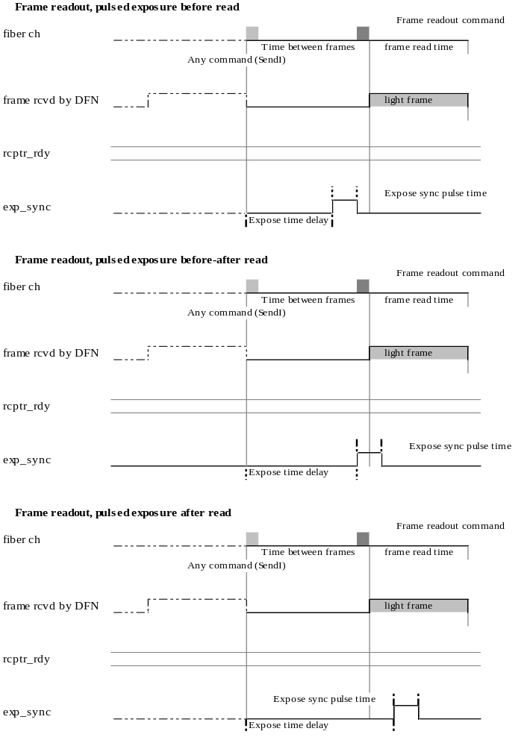

Appendix E – Acquisition diagrams for different types of exposure
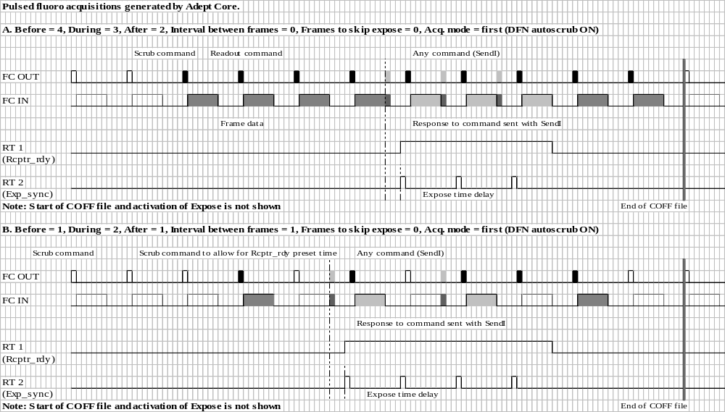

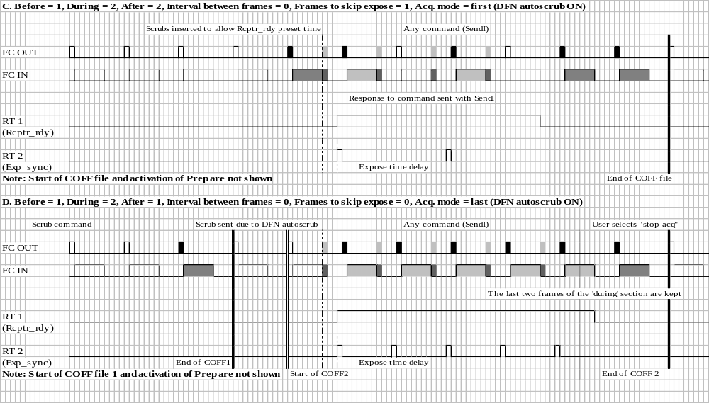

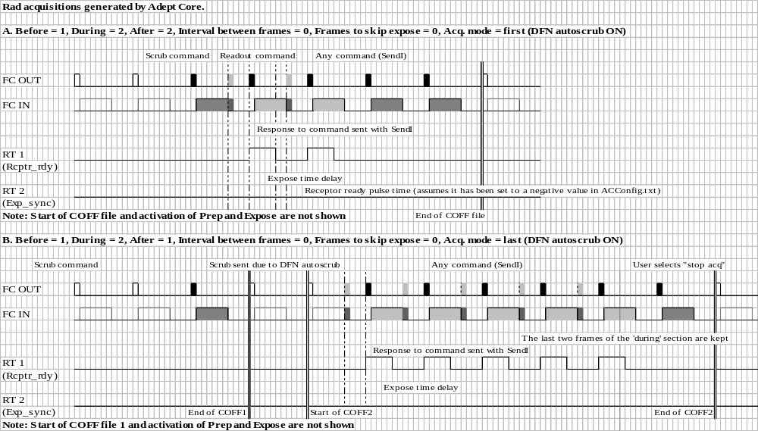
Note: For Continuous fluoro acquisitions Expose Sync will behave like Receptor Ready does for a pulsed fluoro acquisition.

Appendix F – Detector Information file
The following is an example of the detector information file 0x30310000.csv, for cardiac firmware.

$Commands,command,mask,offset,gain,type,min,max,default,waitType,waitParams,comment

Scrub,0x0000,0x00000000,0,0,0,0,0,0,0,0,# no data needed
ImageReadout,0x800000,0x00000000,0,0,0,0,0,0,0,0,# no data needed
SignatureRequest,0x1002,0x00000000,0,0,0,0,0,0,0,0,# no data needed
ResetBoot,0x4008,0x00000000,0,0,0,0,0,0,0,0,# no data needed

SetVCommon1,0x6001,0x000000FF,0.9714,-0.068117,1,-16.398435,0.9714,-9.314267,1,60 24
SetVCommon2,0x6002,0x000000FF,0.9714,-0.068117,1,-16.398435,0.9714,-5.908,1,60 24
SetAREF,0x6004,0x000000FF,3.117,-0.014317647,1,-0.534,3.117,1.342,0,0
SetAREFTrim,0x6005,0x000000FF,0,1,0,0,255,127,0,0
SetSpareVoltageSource,0x6006,0x000000FF,0,0.01953125,1,0,4.98046875,2.48046875,0,0
SetCompensationVoltage,0x6008,0x000000FF,0,-0.011816,1,-3.01308,0,-1,0,0
SetRowOffVoltage,0x6010,0x000000FF,-5,-0.048586,1,-17.38943,-5,-10.976,0,0
SetRowOnVoltage,0x6020,0x000000FF,5,0.035547,1,5,14.064485,11.043,0,0

ReadADConverter,0x7800,0x000000FF,0,0,0,0,0,0,0,0
ReadSensor,0x7900,0x000000FF,0,0,0,0,255,0,0,0

RampSelection,0x4020,0xF0000000,0,1,0,0,15,0,0,0
TimingMode,0x4020,0x0E000000,0,1,0,0,7,0,1,15 0
Bandwidth,0x4020,0x01000000,0,1,0,0,1,0,0,0
ARCIntegrator,0x4020,0x00C00000,0,1,0,0,3,0,0,0
ARCPostIntegrator,0x4020,0x00300000,0,1,0,0,3,0,0,0,
NumberOfRows,0x4020,0x000C0000,0,1,0,0,0,0,0,0,# not supported
RowEnable,0x4020,0x00020000,0,1,0,0,1,1,1,30 0,
EnableStretch,0x4020,0x00010000,0,1,0,0,1,0,0,0,
CompEnable,0x4020,0x00008000,0,1,0,0,1,1,1,15 0,
CompStretch,0x4020,0x00004000,0,1,0,0,1,0,0,0,
LeftEvenTristate,0x4020,0x00002000,0,1,0,0,1,0,0,0,
RightOddTristate,0x4020,0x00001000,0,1,0,0,1,0,0,0,
TestModeSelect,0x4020,0x00000E00,0,1,0,0,7,0,0,0,
AnalogTestSource,0x4020,0x000001FC,0,1,0,0,127,0,0,0,
VCommonSelect,0x4020,0x00000002,0,1,0,0,1,0,0,0,
DRCColumnSum,0x4020,0x00000001,0,1,0,0,1,0,0,0,

TestPatternFrameDelta,0x4030,0xF0000000,0,1,0,0,15,1,0,0,
TestPatternRowDelta,0x4030,0x0F000000,0,1,0,0,15,1,0,0,
TestPatternColumnDelta,0x4030,0x00F00000,0,1,0,0,15,1,0,0,
TestPatternSaturationValue,0x4030,0x000F0000,0,1,0,0,15,10,0,0
TestPatternSeed,0x4030,0x0000FFFF,0,1,0,0,65535,0,0,0

$SwapAndReorder,swap,reorder,,,,,,,,
entry1,0,1,,,,,,,,

$ReadoutTime,TimingMode,time,,,,,,,,
entry1,0,21140,,,,,,,,
entry2,1,23150,,,,,,,,
entry3,2,36796,,,,,,,,
entry4,3,31224,,,,,,,,
entry5,4,21138,,,,,,,,
entry6,5,21140,,,,,,,,
entry7,6,63196,,,,,,,,
entry8,7,63196

$FrameSize,rows,cols
entry1,1024,1024

$ResponseToRead,TimingMode,time
entry1,0,90
entry2,1,90
entry3,2,90
entry4,3,90
entry5,4,90
entry6,5,90
entry7,6,90
entry8,7,90

$Sensors,number,offset,gain
Humidity1,0x00,-25.7480315,0.078740158
VoltageLevel_P5V_REF,0x10,0,0.012316895
VoltageLevel_VON,0x11,0,0.012316895
VoltageLevel_VOFF,0x12,0,0.012316895
VoltageLevel_VCOMMON,0x13,0,0.012316895
VoltageLevel_VCOMP,0x14,0,0.012316895
VoltageLevel_PVCOL,0x15,0,0.012316895
VoltageLevel_NVCOL,0x16,0,0.012316895
VoltageLevel_COL_VCC,0x17,0,0.012316895
VoltageLevel_TP138,0x18,0,0.012316895
VoltageLevel_P5VA_SW,0x19,0,0.012316895
VoltageLevel_N5VA_SW,0x1A,0,0.012316895
VoltageLevel_P17V_SW,0x1B,0,0.012316895
VoltageLevel_N22V_SW,0x1C,0,0.012316895
VoltageLevel_VCC,0x1D,0,0.012316895
VoltageLevel_LGND,0x1E,0,0.012316895
VoltageLevel_AGND,0x1F,0,0.012316895
VoltageLevel_FGATE_COL_VCC,0x20,0,0.012316895
VoltageLevel_FGATE_NVC_L,0x21,0,0.012316895
VoltageLevel_FGATE_NVC_U,0x22,0,0.012316895
VoltageLevel_FGATE_PVC_L,0x23,0,0.012316895
VoltageLevel_FGATE_PVC_U,0x24,0,0.012316895
VoltageLevel_VCC_UNREG,0x25,0,0.012316895
VoltageLevel_PCOLPREG,0x26,0,0.012316895
VoltageLevel_NCOLPREG,0x27,0,0.012316895
VoltageLevel_P19V_UNREG,0x2D,0,0.012316895
VoltageLevel_N24V_UNREG,0x2E,0,0.012316895
RowModulePlaneTest1,0x30,0,1
RowModulePlaneTest2,0x31,0,1
RowModulePlaneTest3,0x32,0,1
RowModulePlaneTest4,0x33,0,1
RowFlexPlaneTest1,0x34,0,1
RowFlexPlaneTest2,0x35,0,1
RowFlexPlaneTest3,0x36,0,1
RowFlexPlaneTest4,0x37,0,1
VoltageNoise_P5V_REF,0x40,0,0.012316895
VoltageNoise_VON,0x41,0,0.012316895
VoltageNoise_VOFF,0x42,0,0.012316895
VoltageNoise_VCOMMON,0x43,0,0.012316895
VoltageNoise_VCOMP,0x44,0,0.012316895
VoltageNoise_PVCOL,0x45,0,0.012316895
VoltageNoise_NVCOL,0x46,0,0.012316895
VoltageNoise_COL_VCC,0x47,0,0.012316895
VoltageNoise_TP138,0x48,0,0.012316895
VoltageNoise_P5VA_SW,0x49,0,0.012316895
VoltageNoise_N5VA_SW,0x4A,0,0.012316895
VoltageNoise_P17V_SW,0x4B,0,0.012316895
VoltageNoise_N22V_SW,0x4C,0,0.012316895
VoltageNoise_VCC,0x4D,0,0.012316895
VoltageNoise_LGND,0x4E,0,0.012316895
VoltageNoise_AGND,0x4F,0,0.012316895
RefRegTemp1,0x50,0,0.122070313
RefRegTemp2,0x60,0,0.122070313
DetectorControlTemp,0x70,0,0.122070313
10KResistor,0x78,0,0.019608

$DefaultSettling,,,
60000,,,

$ImageFlip,horizontal,vertical,,,
entry1,0,0,,,

$ModeGain,modeGain,,,,
entry1,1,,,,

$RampInformation,RampSelection,LoadZero,MaxLUTOut,MinLUTOut,MaxLinear
entry1,0,1710,8751,1054,1740
entry2,1,1803,16150,1343,1823
entry3,2,1763,16141,1343,1825
entry4,3,1803,14371,1488,1824
entry5,4,1792,11663,1582,1825
entry6,5,1806,14103,1700,1824
entry7,6,1729,16125,935,1829
entry8,7,1752,10647,1156,1825
entry9,8,1735,11657,1253,1826
entry10,9,1777,14095,1480,1827
entry11,10,1799,16117,1678,1828
entry12,11,1814,16116,1765,1828
entry13,12,1797,16124,1599,1826
entry14,13,1820,16383,1317,2148
entry15,14,0,0,0,0
entry16,15,65535,65535,65535,65535

$ElectronsPerCount,ARCPostIntegrator,ARCIntegrator,ElecPerCount,,
entry1,0,0,1100,,
entry2,0,1,2200,,
entry3,0,2,4400,,
entry4,0,3,8800,,
entry5,1,0,550,,
entry6,1,1,1100,,
entry7,1,2,2200
entry8,1,3,4400
entry9,2,0,367
entry10,2,1,733
entry11,2,2,1466
entry12,2,3,2932
entry13,3,0,275
entry14,3,1,550
entry15,3,2,1100
entry16,3,3,2200

Appendix G – Error Information
The following is a listing of all Adept Core error codes and a brief description of each.

Number (hex) | Sev | Disp | Description
E0530080 | 1 | 1 | Extended Error
E0530081 | 1 | 1 | An error occurred
E0530082 | 1 | 1 | An error occurred in the input stream
E0530083 | 1 | 1 | The system is busy
E0530084 | 1 | 1 | Unable to open registry key
E0530085 | 1 | 1 | Unable to query value of registry key
E0530086 | 1 | 1 | The requested registry entry is larger than the allocated buffer
E0530100 | 2 | 1 | Error initializing pointer to dasdll
E0530101 | 1 | 1 | Could not activate the settling thread. Cannot control settling time.
E0530102 | 1 | 1 | An error occurred while querying for product version string
E0530103 | 1 | 1 | The ADEPT Core config file could not be opened
E0530104 | 1 | 1 | The requested configuration parameter could not be found
E0530105 | 1 | 1 | An invalid value was specified in the ADEPT Core config file
E0530106 | 1 | 1 | Unable to open acquisition configuration file
E0530107 | 1 | 1 | A section is duplicated in the acquisition configuration file
E0530108 | 1 | 1 | The requested acquisition cannot be found in the acquisition configuration file
E0530109 | 1 | 1 | Error initializing pointer to image information dll
E053010A | 1 | 1 | An unknown section was found in the acquisition configuration file
E053010B | 1 | 1 | The level of subsection in the acquisition configuration file is unknown
E053010C | 1 | 1 | The parameter name or parameter value is missing for the current line in the acquisition configuration file
E053010D | 1 | 1 | The requested value in the acquisition configuration file is invalid
E053010E | 1 | 1 | The subsection in the acquisition configuration file has not been specified
E053010F | 2 | 1 | Could not initialize COM. ADEPT Core will close. Please contact the developer.
E0530110 | 1 | 1 | An error occurred while getting the ADEPT Core Bundle version
E0530111 | 1 | 1 | Unable to determine ADEPT Core installation path
E0530112 | 1 | 1 | Unable to convert string to ULONG
E0530113 | 1 | 1 | Unable to convert string to long
E0530200 | 1 | 1 | Unable to open detector information file
E0530201 | 1 | 1 | Error reading from detector information file
E0530202 | 1 | 1 | The requested parameter is unknown
E0530203 | 1 | 1 | Attempted to set invalid mask
E0530204 | 1 | 1 | Attempted to set invalid type of value
E0530205 | 1 | 1 | Attempted to set invalid maximum value
E0530206 | 1 | 1 | Attempted to set invalid default value
E0530207 | 1 | 1 | Attempted to set invalid parameter value
E0530208 | 1 | 1 | Missing comma in detector information entry
E0530209 | 1 | 1 | The requested parameter name has already been specified
E053020A | 1 | 1 | Bad line in detector information file
E053020B | 1 | 1 | Image flip could not be determined
E053020C | 1 | 1 | The requested method cannot be used in expert mode
E053020D | 1 | 1 | The response time to read command could not be determined
E053020F | 1 | 1 | A timing mode specified in the detector info file is invalid
E0530210 | 1 | 1 | An unknown section was found in the detector information file
E0530211 | 1 | 1 | A section is missing from the detector information file
E0530212 | 1 | 1 | A section is duplicated in the detector information file
E0530213 | 1 | 1 | The frame read time could not be determined
E0530214 | 1 | 1 | The frame size could not be determined
E0530215 | 1 | 1 | Swap and reorder could not be determined
E0530216 | 1 | 1 | An item is missing from the detector information file
E0530217 | 1 | 1 | No information is available for the current detector. A detector is not connected or there is no detector information file for it.
E0530218 | 1 | 1 | No detector is currently connected
E0530219 | 1 | 1 | The specified detector firmware or software file does not exist
E053021A | 1 | 1 | Command to detector failed
E053021B | 1 | 1 | Failed to activate firmware download thread
E053021C | 1 | 1 | The detector is not in boot firmware
E053021D | 1 | 1 | Error reading detector firmware file
E053021E | 1 | 1 | An unexpected character was found in the detector information file
E053021F | 1 | 1 | User cancelled firmware download
E0530220 | 1 | 1 | Invalid autoscrub delay was requested. Check for FC timeout too long.
E0530221 | 1 | 1 | The detector is not responding
E0530222 | 1 | 1 | The detector is STILL disconnected
E0530223 | 1 | 1 | An invalid sensor was specified
E0530224 | 1 | 1 | Could not find read sensor command in detector information
E0530225 | 1 | 1 | An error occurred while parsing settling time parameters
E0530226 | 1 | 1 | An invalid settling parameter type was specified
E0530227 | 1 | 1 | An invalid settling time was specified
E0530228 | 1 | 1 | Error occurred while determining data to send to detector
E0530229 | 1 | 1 | Mode gain could not be determined
E053022A | 1 | 1 | Ramp information could not be determined
E053022B | 1 | 1 | Electrons per count could not be determined
E053022C | 1 | 1 | Autoscrub delay cannot be sent when Sync. autoscrub with system acquisition is ON.
E0530300 | 1 | 1 | The expose time delay is too long
E0530301 | 1 | 1 | The number of frames to acquire is zero
E0530302 | 1 | 1 | Interval between frames & frames to skip expose cannot be greater than 0 at the same time
E0530303 | 1 | 1 | DFNGetNextFrameTimeout() timed out
E0530304 | 1 | 1 | Unable to activate acquisition thread
E0530305 | 1 | 1 | The expose time delay is invalid
E0530306 | 1 | 1 | The time between frames is invalid
E0530308 | 1 | 1 | The buffer size specified for the first sequence is invalid
E0530309 | 1 | 1 | The specified buffer size is invalid. Buffer size must be greater than zero or -1 (reserves all memory)
E053030A | 1 | 1 | The specified COFF files does not exist or is not accessible
E053030B | 1 | 1 | Unable to determine value for setting acquisition parameter
E053030C | 1 | 1 | An invalid value was requested for acquisition parameter
E053030D | 1 | 1 | An unknown acquisition parameter was requested
E053030E | 1 | 1 | No valid acquisition type has been specified for the next acq
E053030F | 1 | 1 | An invalid argument was passed to AcquisitionSS::_sCollectImageInfo
E0530310 | 1 | 1 | The requested pulse with for a signal in the real time bus is invalid because it is longer than the maximum allowable time. Please decrease Expose Time Delay, increase the Time Between Frames or reduce the pulse time.
E0530311 | 1 | 1 | Invalid frame size specified. All buffers need to be defined for the same number of rows and columns.
E0530312 | 1 | 1 | An unknown variable frame parameter was requested
E0530313 | 1 | 1 | A duplicate detector variable frame parameter ID was found
E0530314 | 1 | 1 | A duplicate acquisition variable frame parameter ID was found
E0530315 | 1 | 1 | An acquisition variable frame parameter ID was not found
E0530316 | 1 | 1 | A detector variable frame parameter ID was not found
E0530317 | 1 | 1 | Variable Frame acquistion enabled with invalid VFP configuration sections
E0530318 | 1 | 1 | Variable frame parameter not allowed in acquisition VFP section
E0530319 | 1 | 1 | A required parameter was not specified
E053031A | 1 | 1 | No valid exposure mode has been specified for the next acq
E0530400 | 1 | 1 | There is not enough memory
E0530401 | 1 | 1 | Error writing response log to disk
E0530402 | 1 | 1 | Response log length is zero
E0530403 | 1 | 1 | Error opening file for binary log
E0530404 | 1 | 1 | The requested sequence was not found
E0530500 | 1 | 1 | Failed to activate store thread
E0530501 | 1 | 1 | Failed to activate retrieve thread
E0530502 | 1 | 1 | Image integrity check failed
E0530503 | 1 | 1 | Cannot open image file
E0530504 | 1 | 1 | The requested sequence number does not exist in memory
E0530505 | 1 | 1 | Failed to check disk free space
E0530506 | 1 | 1 | Not enough disk free space for archiving sequence
E0530507 | 1 | 1 | Found an error while reading file from disk. The image size does not match the specified size in the header.
E0530508 | 1 | 1 | An invalid archival ROI was specified.
E0530509 | 1 | 1 | It is not possible to do repair corrections on images that are not full size
E053050A | 1 | 1 | The specified override value for the original number of rows and columns is smaller than the image size.
E053050B | 1 | 1 | The specified override value for the origin of the archive ROI or the original frame size is invalid.
E0530600 | 1 | 1 | The specified pixel is not part of the requested frame
E0530601 | 1 | 1 | An error occurred while initializing the display
E0530602 | 1 | 1 | An error occurred while closing the display
E0530700 | 1 | 1 | Attempted to set an invalid desired flipping value
E0530701 | 1 | 1 | The image depth of the file in disk does not match the expected image depth.
E0530702 | 1 | 1 | Attempted to set an invalid desired line repair
E0530703 | 1 | 1 | Cannot enable/disable calculation of offset map during an acquisition.
E0530704 | 1 | 1 | Cannot change line repair during an acquisition when calculate offset map is enabled.
E053076C | 1 | 1 | An invalid ROI for statistics was specified.
E0530E00 | 1 | 1 | The peripheral subsystem has not been initialized.
E0530E01 | 1 | 1 | The peripheral subsystem detected device controller was not found or not loaded.
E0530E02 | 1 | 1 | The peripheral subsystem detected a device controller was not registered.
E0530E03 | 1 | 1 | The peripheral subsystem detected a device controller did not properly initialize.
E0530E04 | 1 | 1 | The peripheral subsystem received a request for an unknown device controller
E0530E05 | 1 | 1 | The peripheral subsystem detected a device controller did not properly terminate
E0530E06 | 1 | 1 | The peripheral subsystem timed out waiting for acquisition ready from a device controller
E0530E20 | 1 | 1 | Device Controller Exception
E0580001 | 1 | 1 | The 16-bit output buffer is too small for the requested operation
E0580002 | 1 | 1 | The specified ROI is invalid
E0580003 | 1 | 1 | Number of columns in image is illegal for repair line correction
E0580004 | 1 | 1 | Could not open the file specified
E0580005 | 1 | 1 | The format of the repair file is not as expected
E0580006 | 1 | 1 | Could not allocate memory
E0580007 | 1 | 1 | The repair list contains columns that do no exist in the image

Appendix H – Acquisition configuration file
An acquisition configuration file can be used to set detector, acquisition, and peripheral device parameters in ADEPT Core.

General file format
The general format of this file is as follows:
- Section headers are enclosed in brackets. The number that appears here is the "level" of the section. For example, a 1 indicates top level, a 2 indicates a subsection of the top level, a 3 would indicate a subsection of the preceding level 2 section, and so forth. For acquisition config files, only 1 and 2 are used, but deeper levels may be used for other config files.
- Each section may contain any number or parameter/value pairs in the format ParameterName=ParameterValue. Leading and trailing whitespace is ignored, as is whitespace on either side of the equals sign.
- Comments begin with the pound sign, and must appear on their own line.
- Blank lines are ignored.
The following information is specific to acquisition configuration files:
- Top level names (ie level 1) should correspond to the "acquisition name". Usually this will be the name of a test.
- Second level names may be one of the following: DETECTOR, ACQUISITION, POST_PROCESSING, TARGET_LEVEL_CHECK, VFP, or the name of a peripheral. If this file is being read in and a second level name is not DETECTOR, ACQUISITION, POST_PROCESSING, TARGET_LEVEL_CHECK or VFP it will be assumed that it is a peripheral.
- For the DETECTOR section, parameter names must be EXACTLY the same as a parameter name in the detector information file. These parameters will be set by the DetectorSS::sSetParameter() method. If a parameter does not exist, the method reading in the file will throw an error. These names are also the same as the names used in image information.
- For the ACQUISITION, POST_PROCESSING and TARGET_LEVEL_CHECK sections, parameter names must match a name in the file AcqParamNames.h. This file is part of Adept Core. If a parameter does not exist, the method reading in the file will throw an error. For those parameters that are also included in the image information, these names should match as well.
- For the VFP sections, see the VFP section below.
- Third level names may be one of the following: ACQUISITION_VFP or DETECTOR_VFP. Currently, on VFP sections use third level names.
- Peripherals information will be passed to the peripherals subsystem and handled using methods defined there. Unsettable parameters will be returned from the peripherals subsystem in a string containing the parameter name and desired value. Core adds the device name to the string and returns a string indicating all unsettable parameters when it finishes loading the section.

Loading the file
In order to load the configuration in a section of this file, the calling application or script should call the following method in the ApolloTester interface:
ApolloTester::mLoadAcqFromCfgFile(BSTR acqCfgFilename, BSTR acqName)
For example, if we assume that AdeptCore is a CApolloTester instance, and we want to load the BAD_FET acquisition from the file D:\Ash\AcqConfig.txt, we would call
AdeptCore.mLoadAcqFromCfgFile("D:\\Ash\\AcqConfig.txt", "BAD_FET");
The return from this method is a string indicating the unsettable parameters from the peripherals and the value to which the user should set them. For example:
The following parameters could not be set by the system.
Please set them to the values indicated below:
Device: Parameter: Value:
GENERATOR kVp 5
GENERATOR mA 8
Warning: If the device controller for a peripheral device specified in this file has not been loaded no error is reported. Please take caution and ensure that any peripheral device you wish to use is specified in the ADEPT Core system configuration file.

Parameters that may be set
This section describes parameters that may be set using an acquisition configuration file.

DETECTOR
The DETECTOR section of the acquisition configuration file may contain any parameters that are known to the current detector (i.e., those parameters that are specified in the detector information file for the current firmware). Any attempt to set a detector parameter that is not listed in the detector information file, or any attempt to set a listed parameter to an invalid value, will result in an error.

ACQUISITION
The following is a listing of parameters that may be included in the ACQUISITION section of the acquisition configuration file. Any attempt to set an acquisition parameter that does not appear on this list will result in an error.
- DisplayDuringAcquisition: 0 = disable, 1 = enable
- MappingDuringAcquisition: 0 = disable, 1 = enable
- DFNAutoScrubOnOff: 0 = disable, 1 = enable
- FiberChannelTimeOutInMicrosecs
- DFNAutoScrubDelayInMicrosecs: set this parameter only when SyncAutoscrubWithSysAcq is off
- SyncAutoscrubWithSysAcq: 0 = disable, 1 = enable
- FramesBeforeExpose
- FramesDuringExpose
- FramesAfterExpose
- IntervalBetweenFrames
- TimeBetweenFramesInMicrosecs
- FluoroType: 0 = continuous, 1 = pulsed (not needed after release 2.2.1)
- AcquisitionMode: 0 = first mode, 1 = last mode
- ExposeTimeDelayInMicrosecs
- FramesToSkipExpose
- BufferSize1
- NumberOfColumnsForUserSeq1
- NumberOfRowsForUserSeq1
- WrapMode1
- BufferSize2
- NumberOfColumnsForUserSeq2
- NumberOfRowsForUserSeq2

- WrapMode2
- AcquisitionType: possible values are
  - 1 = rad,
  - 2 = pulsed fluoro,
  - 3 = cont. fluoro,
  - 4 = user single,
  - 5 = user double,
  - 7 = cine HP,
  - 8 = cine LP,
  - 9 = VFP
- ExposureMode: It is only necessary to specify ExposureMode when the AcquisitionType is user (4 or 5). If specified with other acquisition types this parameter is ignored. Possible values are:
  - 0 = None,
  - 1 = Rad,
  - 2 = cine LP,
  - 3 = cine HP,
  - 4 = pulsed fluoro,
  - 5 = continuous fluoro.

POST_PROCESSING
The following is a listing of parameters that may be included in the POST_PROCESSING section of the acquisition configuration file. Any attempt to set an acquisition parameter that does not appear on this list will result in an error.

- ArchiveROIRow0
- ArchiveROICol0
- ArchiveROIRow1
- ArchiveROICol1
- WindowValueDesired
- LevelValueDesired
- LineRepairFileName
- LineRepair
- DisplayLineRepairedDuringAcquisition
- HorizontalFlip
- VerticalFlip
- OriginalNumberOfRowsHeaderOverride: this value will be put as the OriginalNumberOfRows in the header of the acquired images.
- OriginalNumberOfColumnsHeaderOverride: this value will be put as the OriginalNumberOfColumns in the header of the acquired images.
- RowNumberUpperLeftPointArchiveROIHeaderOverride: this value will be put as the RowNumberUpperLeftPointArchiveROI in the header of the acquired images.
- ColNumberUpperLeftPointArchiveROIHeaderOverride: this value will be put as the ColNumberUpperLeftPointArchiveROI in the header of the acquired images.

TARGET_LEVEL_CHECK
The following is a listing of parameters that may be included in the TARGET_LEVEL_CHECK section of the acquisition configuration file. Any attempt to set an acquisition parameter that does not appear on this list will result in an error.

- TargetLevelROIRow0
- TargetLevelROICol0
- TargetLevelROIRow1
- TargetLevelROICol1
- FrameNumberForTargetLevelROI
- PercentRangeForTargetLevel
- TargetValue

VFP
The following is a listing of parameters that may be included in the VFP section of the acquisition configuration file. Any attempt to set an acquisition parameter that does not appear on this list will result in an error. WARNING: There is a limitation on the number of VFP sections that can processed at once, which is determined by the number of scripts the detector can process. Each VFP section will generate 1 script. Each time a new detector section is used, determined by the DetectorVFPId, a script would be generated. The first VFP section will always generate 3 scripts: one for the first scrub, one for any preparation time, and one for the VFP section.

- AcquisitionVFPId (optional: Matches the ID specified in the ACQUISITION_VFP section. Default is the original ACQUISITION section if not specified)
- DetectorVFPId (optional: Matches the ID specified in the DETECTOR_VFP section. Default is the original DETECTOR section if not specified)
- NumberOfFrames (required: Number of frames. Note: The Before, During and After frame specified in the ACQUISITION section are ignored)
- Read (required: 1 – Read frames, 0 – Do not read frames [scrub])
- Exposure (required: 1 – Exposure on, 0 – Exposure off)

DETECTOR_VFP
The DETECTOR_VFP section of the acquisition configuration file may contain any parameters that are known to the current detector (i.e., those parameters that are specified in the detector information file for the current firmware). Any attempt to set a detector parameter that is not listed in the detector information file, or any attempt to set a listed parameter to an invalid value, will result in an error.
- DetectorVFPId (required: A unique unsigned integer > 1. This value will identify those detector settings for a particular VFP section.

ACQUISITION_VFP
The ACQUISITION_VFP section may contain a listing of parameters that may be included in the ACQUISITION section of the acquisition configuration file. Any attempt to set an acquisition parameter that does not appear on this list will result in an error. Note: this section only affects a select few ACQUISITION parameters.

- AcquisitionVFPId (required: A unique unsigned integer > 1. This value will identify those acquisition settings for a particular VFP section.
- IntervalBetweenFrames
- TimeBetweenFramesInMicrosecs
- ExposeTimeDelayInMicrosecs
- ExposureMode

Peripherals
Any parameter for any peripheral device may appear in a peripherals section of the acquisition configuration file. Please see the return value information and warning in the above section, “Loading the file”.

Sample
The following is a sample acquisition configuration file containing information for two acquisitions (i.e., tests): BAD_FET and BAD_ITO. This is only a sample; some of the values may be nonsense, but the format is correct.

# Sample acquisition configuration file
[1,BAD_FET]

[2, DETECTOR]
#FOVSelect=0
SetVCommon1=-9
SetVCommon2=-6
SetAREF=1.3
SetAREFTrim=127
SetSpareVoltageSource=2.5
SetCompensationVoltage=-1
SetRowOffVoltage=-11
SetRowOnVoltage=11
RampSelection=0
TimingMode =0
Bandwidth=0
ARCIntegrator=0
ARCPostIntegrator=0
NumberOfRows=0
RowEnable=0
EnableStretch=0
CompEnable=0
CompStretch=0
LeftEvenTristate=0
RightOddTristate=0
TestModeSelect=0
AnalogTestSource=0
VCommonSelect=0
DRCColumnSum=0

[2,ACQUISITION]
DisplayDuringAcquisition=1
MappingDuringAcquisition=1
DFNAutoScrubOnOff=0
SyncAutoscrubWithSysAcq=1
FramesBeforeExpose=0
FramesDuringExpose=2
FramesAfterExpose=0
IntervalBetweenFrames=0
TimeBetweenFramesInMicrosecs=10000
AcquisitionMode=0
ExposeTimeDelayInMicrosecs=100
FramesToSkipExpose=0
AcquisitionType=2
ExposureMode=0

[2,GENERATOR]
Kvp=100
mA=200

[2,POST_PROCESSING]
ArchiveROIRow0=127
ArchiveROICol0=127
ArchiveROIRow1=511
ArchiveROICol1=511
WindowValueDesired=100
LevelValueDesired=1700

[2,TARGET_LEVEL_CHECK]
TargetLevelROIRow0=500
TargetLevelROICol0=500
TargetLevelROIRow1=525
TargetLevelROICol1=525
FrameNumberForTargetLevelROI=2
PercentRangeForTargetLevel=5
TargetValue=3000

[2,LIGHT_SOURCE]
Intensity=20
PulseWidth=100

[2,CONDITIONER]
Temperature=30
Gradient=10

[2,GOOD_DUMMY]
#POWER_IN_WATTS=100
CURRENT_IN_AMPS=5
VOLTAGE_IN_VOLTS=8
MAX_POWER_IN_WATTS=300

[1,BAD_ITO]

[2,DETECTOR]
FOVSelect=0
SetVCommon1=-9
SetVCommon2=-6
SetAREF=1.3
SetAREFTrim=127
SetSpareVoltageSource=2.5
SetCompensationVoltage=-1
SetRowOffVoltage=-11
SetRowOnVoltage=11
RampSelection=0
TimingMode=0
Bandwidth=0
ARCIntegrator=0
ARCPostIntegrator=0
NumberOfRows=0
RowEnable=0
EnableStretch=0
CompEnable=0
CompStretch=0
LeftEvenTristate=0
RightOddTristate=0
TestModeSelect=0
AnalogTestSource=0
VCommonSelect=0
DRCColumnSum=0

[2,ACQUISITION]
DisplayDuringAcquisition=1
MappingDuringAcquisition=1
DFNAutoScrubOnOff=0
SyncAutoscrubWithSysAcq=1
FramesBeforeExpose=5
FramesDuringExpose=10
FramesAfterExpose=5
IntervalBetweenFrames=0
TimeBetweenFramesInMicrosecs=10000
AcquisitionType=1
AcquisitionMode=0
ExposeTimeDelayInMicrosecs=500
FramesToSkipExpose=0
ExposureMode=0

[2,POST_PROCESSING]
ArchiveROIRow0=127
ArchiveROICol0=127
ArchiveROIRow1=511
ArchiveROICol1=511
WindowValueDesired=100
LevelValueDesired=1700

[2,TARGET_LEVEL_CHECK]
TargetLevelROIRow0=500
TargetLevelROICol0=500
TargetLevelROIRow1=525
TargetLevelROICol1=525
FrameNumberForTargetLevelROI=2
PercentRangeForTargetLevel=5
TargetValue=3000

[2,GENERATOR]
Kvp=100
mA=200

[2,LIGHT_SOURCE]
Intensity=20
PulseWidth=100

[2,CONDITIONER]
Temperature=30
Gradient=10

# VFP Additions

[3, DETECTOR_VFP]
DetectorVFPId=1
RampSelection=1
TimingMode=1

[3, DETECTOR_VFP]
DetectorVFPId=2
RampSelection=0
TimingMode=0
SetVCommon1=-9.4
SetVCommon2=-6.2

[3, ACQUISITION_VFP]
AcquisitionVFPId=1
ExposeTimeDelayInMicrosecs=500
TimeBetweenFramesInMicrosecs=20000

[3, ACQUISITION_VFP]
AcquisitionVFPId=2
ExposeTimeDelayInMicrosecs=5000
TimeBetweenFramesInMicrosecs=4500

[3, ACQUISITION_VFP]
AcquisitionVFPId=30
TimeBetweenFramesInMicrosecs=30

# VFP sections are taken in order. The following is an example of a before,
# during, and after acquisition

[2, VFP]
AcquisitionVFPId=1
DetectorVFPId=0
NumberOfFrames=2
Read=1
Exposure=0

# Uses the default ACQUISITION section
[2, VFP]
DetectorVFPId=1
NumberOfFrames=2
Read=1
Exposure=1

# Uses the default DETECTOR section
[2, VFP]
AcquisitionVFPId=30
NumberOfFrames=10
Read=1
Exposure=0

Appendix I – IEvents interface methods
The following methods are called by ADEPT Core is the application registers a callback interface. The application is responsible for the implementation of all these methods.

cACState
Called by ADEPT Core one the internal state changes (see state machine)

long cACState(short ACState)

cErrorReport
Called by ADEPT Core when an error is detected asynchronously, i.e. while not processing a call from an application.

long cErrorReport(ErrorStruct *errorPtr)

typedef struct
{
BSTR description;
BSTR location;
long number;
} ErrorStruct

cImageComplete
Called every time that an image from a sequence has been stored to disk. This is in general used to update progress bars while storing.

long cImageComplete()

cSeqInMemory
Called when a new sequence of images has been loaded into memory from the detector or from disk.

long cSeqInMemory(long status,
long sequenceNumber,
long signature,
long upperRow,
long leftColumn,
long lowerRow,
long rightColumn
double firstFrameNumber,
double lastFrameNumber,
BSTR filename,
short offsetCorrected,
short gainCorrected,
short archived)

cTransitionTimeInMicrosec
Called when a double user acquisition is performed or an acquisition in last mode is perfomed requiring two sequences to be acquired. This method is called at the end of the second acquisition.

long cTransitionTimeInMicrosec (float transitionTimeInMicrosec)

cNewDetInfoFileLoaded
Called every time that a detector information file is loaded

long cNewDetInforFileLoaded(double signature)

cAcqStartTimeInMillisec
Called at the end of an acquisition. Reports the time between the start of the processing of the call to start an acquisition and the start of the function that begins COFF file execution in the DFN.

long cAcqStartTimeInMillisec(float acqStartTimeInMillisec)

cDisplayLatencyInMillisec
Called at the end of the acquisition. Reports the time between the call to begin the execution of the COFF file and the display of the first image.

long cDisplayLatencyInMillisec(float displayLatencyInMillisec)

cDetectorSignature
Called when a new detector signature is identified.

long cDetectorSignature(double signature)

Revision History
The following table previous changes and associated version numbers for this SDD.

Rev. | Author | Change | SPR#
1 | German Vera  Ashlesha Joshi | First draft
2 | Ashlesha Joshi  German Vera | Changes resulting from HII review of first draft
3 | Ashlesha Joshi  German Vera | Additions for display, processing, error handling | N/A
4 | Ashlesha Joshi  German Vera | Changes resulting from HII review of rev. 3 | N/A
 |  | Note: Versions 5 & 6 in ClearCase are invalid. Therefore, those version numbers have been skipped in this document. | N/A
7 | Dan Spors | Added sections for Generator and Light Source subsystems. | N/A
8 | Dan Spors | Modifications based on feedback from HII review. | N/A
9 | H. Haralson | Added peripheral device subsystem (sec 3.7). Made Generator and Light source subsections of peripheral subsystem. | N/A
10 | H. Haralson | Updated peripheral device subsystem based on HII review. | N/A
11 | H. Haralson | Updated peripheral device subsystem (3.7).  Added peripheral subsystem scriptable methods(4.73-4.75).  Added peripheral subsystem errors (appendix G) | N/A
12 | Dan Spors | Modified for pulse width controller interface. | N/A
 |  | Note: Version 13 in ClearCase is not valid. | N/A
14 | Dan Spors | Modifications based on feedback from HII review. | N/A
15 | Dan Spors | Updated Light Source content. | N/A
16 | Dan Spors  Ashlesha Joshi  German Vera | Changes resulting from HII review of Rev. 15 and SPR resolution (section 3.3.1.2 and appendix E) | XRYge27870
17 | Germán Vera | Updates to Appendixes A, B & C. Added Appendix I.  Updated section 1.4. Added section 3.3.3 | XRYge44701
18 | Germán Vera | Added target level check, ACconfig.txt, updated methods in COM interface, new sections in detector info file, new sections in acquisition config file | XRYge44841, XRYge44848, XRYge44977,  XRYge44775
19 | Dan Spors | Modified sections pertaining to the Generator Subsystem to reflect the Jedi design. | N/A
20 | Dan Spors | Modified per Jedi design HII review inputs. | N/A
21 |  | Not valid
22 |  | Not valid
23 | Dan Spors/ Germán Vera | Updated MSCs for Jedi. Added line repair  Added new methods of the Peripheral Subsystem  Note: version 22 in clear case had the new MSCs. However, changes for release 2.2 were missing and it was easier to create version 23 based on those changes and add the new Jedi MSCs | N/A  XRYge47380
24 | Dan Spors | Updated Generator and Light Source property lists. | N/A
25 | Germán Vera | Updated information for loading repair line file  Added information on original image size when repair is on  Added parameters to override the original image size and origin of archive ROI  Updated example of detector information file  Added errors from process DLL | XRYge49119  XRYge49135  XRYge48815
26 | shaht | Updated the get/set properties of LightSource. | XRYge49173
27 | Germán Vera | Updated description of Queue variables and exposure pulse time in ACConfig.txt | XRYge50062
28 | Germán Vera | Updated string for common peripheral properties | N/A
29 | Germán Vera | Updated for Ethernet based detector functionality | N/A
30 | Germán Vera | Updates for new functionality for Ethernet detectors | XRYge53745
31 | Germán Vera | Added method to get number of dropped buffers | N/A
32 | Germán Vera | Added description of methods to detect blinking pixels & track pixels | N/A
33 | Darrick White | Added VFP | XRYge46490
33 | Germán Vera | Added new methods and modified timeout for mSetDetectorParameter | XRYge60530

