Detector Installation Instructions

Abstract:

Unpacking, installation, and repacking instructions for the GE Detector acquisition system.

Author: Ken Kump

Key Words: Detector Installation Instructions Manual

Revision | Date | Author | Remarks
A | 22-Aug-05 | KK | Initial Release

Table of Contents
1. Objective 4
2. List of Equipment 4
3. Unpacking the Equipment 4
3.1 Unpack the Detector 4
3.2 Unpack other equipment. 5
4. Connecting the Equipment 5
4.1 Setup Adept Acquisition Workstation 5
4.2 Mount Detector 6
4.3 Connect Chiller 6
4.4 Connect Detector Power Supply 6
4.5 Confirm Connections & Power Up 6
4.6 Connect Fiber optic Communication Cable 7
5. Functional Test 7
5.1 Start Adept Acquisition Application 7
5.2 Configure Detector 7
5.3 Acquire Images 7
5.4 Archive Images 7
6. Repacking Instructions 7
7. Help 7
8. Appendix 8

Objective
The objective of this document is to describe the procedures for the hardware installation. It does not cover the software configuration.

List of Equipment
The following parts should be included:

Digital Detector

Chiller
Hoses
Coolant
AC power cable
Syringe Kit

Detector Power Supply
Detector Power Cable
Power supply AC cable

Fiber Optic Cable

Adept Acquisition Workstation PC
Monitor
Keyboard
Mouse
AC power cable

Unpacking the Equipment
The following instructions are provided to unpack the equipment.

Unpack the Detector
Unpack detector from crate. Be careful, detector weighs nearly 90 lbs. A hoist is supplied to aid in getting the detector out of the box.
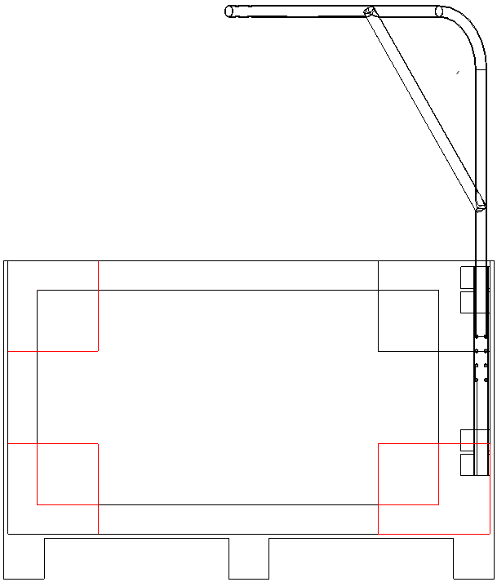
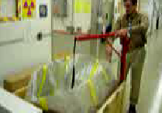
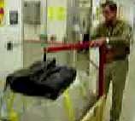
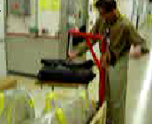
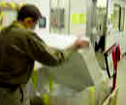
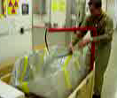
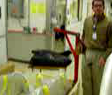

Remove handles (cross) from the detector using Allen wrench.

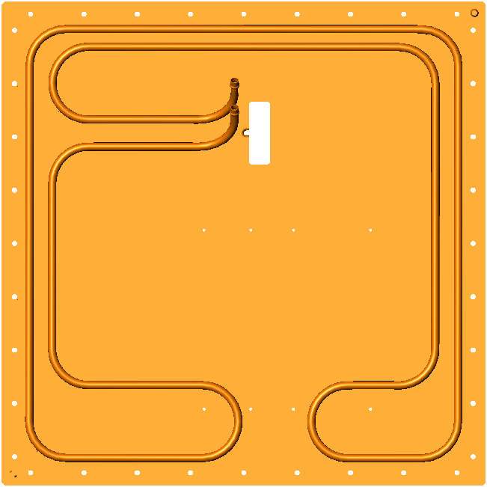

Unpack other equipment.

Unpack the other equipment. Verify that all materials are included and arrived undamaged. Call GEHC if you suspect damage.

Retain all packing materials and shipping containers for return to GEHC.

Connecting the Equipment

Setup Adept Acquisition Workstation
Place Adept workstation on bench or cart. Attach monitor to PC using monitor cable. Plug monitor’s AC power input into AC source. Plug in keyboard and mouse. Plug in AC power cable into PC and into AC source. Turn on power to Adept computer and monitor. Verify boots properly to Windows.

Administrator account
Username: administrator
Password: adept2
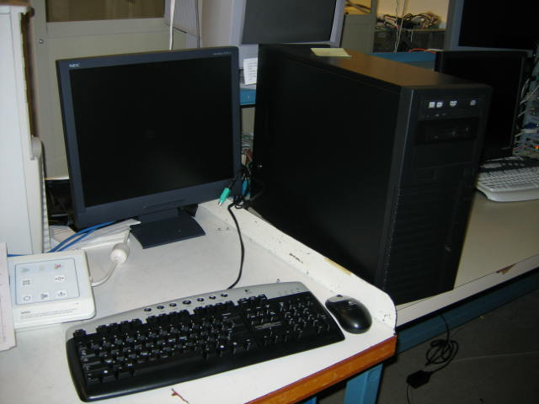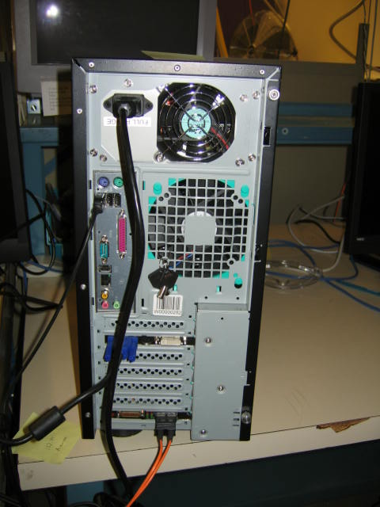

Mount Detector
Place detector in desired location. Secure using M5? screws into the back cover of the detector. Mount to allow access to power, fiber optic communication, and coolant hoses.
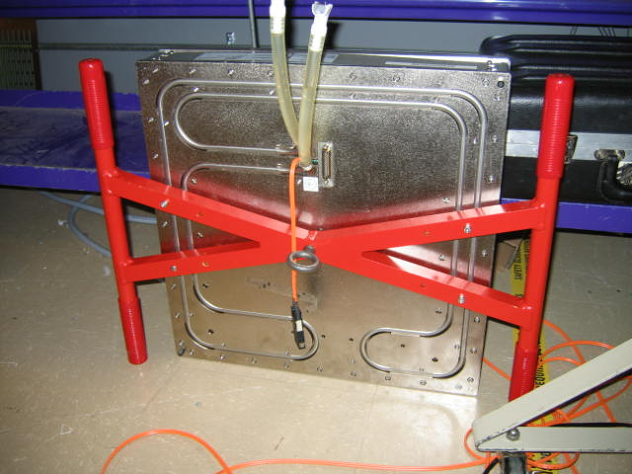

Connect Chiller
Position chiller in a convenient, accessible (able to turn on/off) location that has AC input power and is within the coolant hoses’ reach to the detector. Ensure that the chiller is in a location that would not create a safety hazard in the unlikely event of a leak. Fill reservoir with coolant. Connect coolant lines to the chiller and detector. The direction of flow through the detector does not matter, ie, connect hoses to each of the 2 detector quick-disconnect fittings. Connect AC power to the chiller. Turn on the chiller. As the system (hoses, detector) fills with coolant, refill the reservoir. Verify there are no leaks in the system. The default setpoint of the chiller is 26 degrees C.
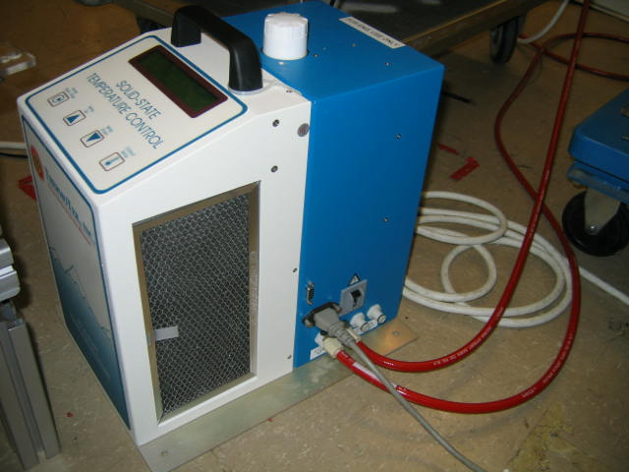

Connect Detector Power Supply
Position power supply in a convenient, accessible (able to turn on/off) location that has AC input power and is within the power supply cable’s reach to the detector. Connect power supply DC cable (25-pin sub-D) to detector and to power supply. Connect power supply AC input cable between power supply and AC input source.

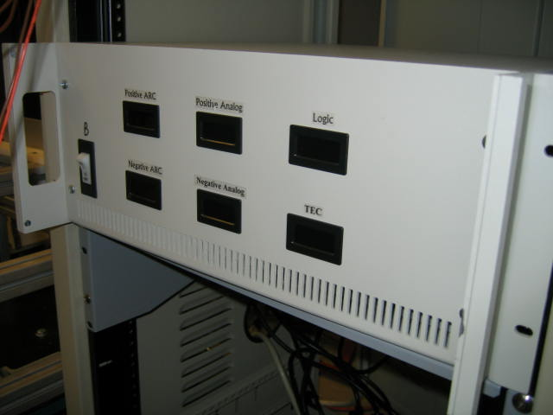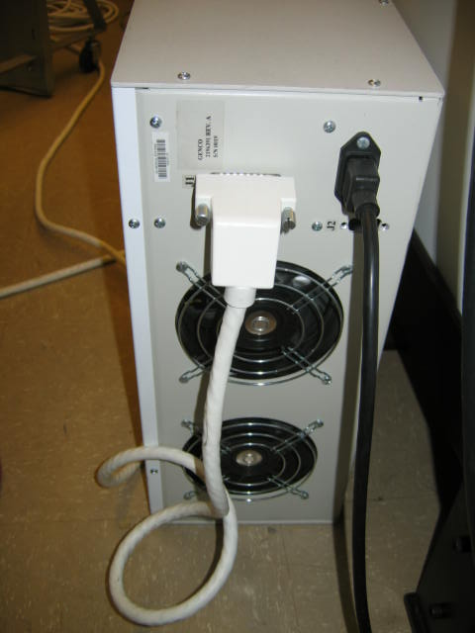

Confirm Connections & Power Up
Confirm all connections are secure. Confirm that detector power supply and chiller are powered and running.

Connect Fiber optic Communication Cable
Route fiber optic cable from detector to Adept workstation. Fiber optic cable is delicate and should not be crushed or stretched. Note the minimum bend radius is 1.2 inches (3cm). Connect fiber optic connector to detector (LC). Repeat at Adept workstation end (SC). Contact GE if additional cable length is desired or use adapter and extension cable.
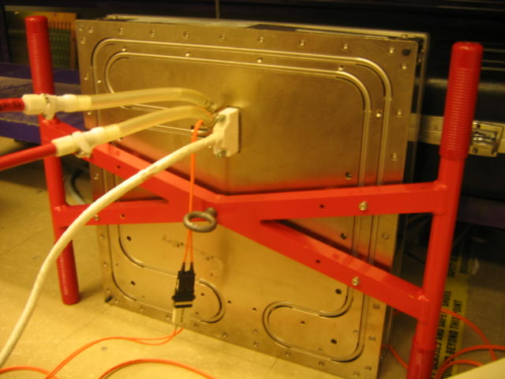

Functional Test

Start Adept Acquisition Application
Double-click on the Adept Engineering GUI icon. Interface should appear within 10 seconds. Verify no error pop-up windows appear.

Configure Detector
Open the configuration screen by clicking on the Configuration 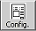 icon. The screen shown in the Appendix should appear.

Acquire Images
Click on Start Acquisition 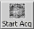 Icon to start the image acquisition.

Archive Images
Click on the Store 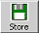 icon to save the 2-image sequence to archive the state of the detector upon delivery.

Repacking Instructions
Reverse the installation instructions. Before shipment, detector coolant needs to be removed from detector, hoses, and chiller. Use syringe and cup to collect coolant. Coolant can be flushed down toilet or returned to GEHC. MSDS for the coolant is available from GE.
Place equipment into the original shipping containers. If the original shipping containers are not available, please contact GE for instructions.

Help
Please contact GE for assistance or questions:

Ken Kump
Email: Kenneth.Kump@med.ge.com
Phone: (262) 548-4549
Cell: (262) 424-3240

German Vera
eMail: German.Vera@med.ge.com
Phone: (262) 548-2454

Jim Gent
EMail: James.Gent@med.ge.com
Phone: (262) 548-5177

Carey Shawn Rogers
Email: Carey.Rogers@med.ge.com
Phone: (414) 647-4475

Appendix
Sample config page for Adept.

