ADEPT Engineering Application

Software Design Description
(SDD)
revision 3

Approval / Review Signatures:

_____________________________________ __________________
Approver / Reviewer date

_____________________________________ __________________
Approver / Reviewer date

_____________________________________ __________________
Approver /Reviewer date

Reviewers may sign review logs instead of this document; Approvers should sign this document, and the signed copy should be placed in the Design History File.
Table of Contents
1. Document Overview 4
1.1 Scope 4
1.2 Design Conventions 5
1.3 Definitions 5
1.4 References 6
2. Design Overview 6
2.1 Theory of Operation 6
2.2 Design Rationale 6
2.3 Critical Requirement Impact 6
3. Detailed Design Description 7
3.1 Initialization 7
3.2 Main form 8
3.2.1 Menus 9
3.2.2 Image acquisition 9
3.2.3 Sequences in memory 10
3.2.4 Window/Level 10
3.2.5 Displayed image and sequence number 10
3.3 Detector, acquisition and corrections for display configuration 11
3.3.1 Menus 12
3.3.2 Detector Configuration 13
3.3.3 Peripherals 13
3.3.4 Acquisition Configuration 14
3.3.5 DFN Auto-scrub 14
3.3.6 Corrections for display 14
3.3.7 Archive ROI 15
3.3.8 Detector signature 15
3.3.9 Reconfigure button 15
3.3.10 Open configuration file 15
3.3.11 Select configuration section 15
3.3.12 Save configuration file 16
3.4 Send commands to detector 16
3.5 Read detector sensor 17
3.6 Detector firmware download 17
3.7 Callback Errors 17
3.8 Peripherals control 18
3.9 Image display control 18
3.10 Statistics 19
3.11 Header 19
3.12 Store Binary log 20
3.13 Archival ROI 20
3.14 About form 21
4. Requirements to Design Traceability 21
5. Error Summary 21
6. Appendix A – Acquisition configuration file format 23
7. Appendix B – AEA Peripherals configuration file format 25
8. Revision History 25

Document Overview

Scope
ADEPT is the program to develop digital x-ray detector/panel testers based on the PCDAS platform transferred to GEMS from GRC. The following diagram shows the major software elements of the ADEPT project:

ADEPT-SW
ADEPT Manufacturing application
ADEPT Engineering application
ADEPT Core
PCDAS libraries & DFN driver
Scripts
To better understand the previous diagram it is important to know the applications and users of the tester:
- Manufacturing: testers are used in different steps of the panel/detector manufacturing process. For this type of application a test is made as follows:
  - Panel/detector configuration
  - Image acquisition
  - Image store to disk
  - Analysis of images previously stored on disk
  - Test output generation
- Engineering: testers are used for various purposes:
  - Research & development
  - Detector firmware testing and debugging
  - Detector troubleshooting

In the engineering environment it is necessary to have a flexible system that allows the user to configure the detector, acquire/display/store/retrieve images and provide statistical information about the images.

This document has two purposes:
- Describes the design of the ADEPT Engineering application
- Serves as a users manual for the application

Design Conventions
None

Definitions
The following table defines acronyms and terms used in this SDD that are specific to the ADEPT Engineering Application and this specification.

Term or Acronym | Definition
AEA | ADEPT Engineering Application
ADEPT | Apollo Defect and Engineering Panel Tester
PC-DAS | PC based Data Acquisition System. A system developed by GRC to acquire images from Apollo digital detectors. The system uses a DFN card and the software is designed to work under Windows NT/ 2000.
DFN | Detector Framing Node.
DasDll | DLL written by the PC-DAS team to use the DFN card and handle images in memory via the DFN driver.
DOME card | High-resolution video card.
DirectX | Microsoft software package to handle graphics and audio
COFF | Common Object File Format
COFF file | This file contains the series of events to be executed by the DFN card, like the events that are necessary to acquire a sequence of images. The COFF files are generated from a Perl script.
COM | Component Object Model. Model for binary code developed by Microsoft to allow access to COM objects from COM compliant applications.
High level script | Scripts that are written in a Windows scripting language (like VBScript or JScript) using the methods provided in the COM interface.
DFN script / Low-level script | Scripts written in Perl to generate a COFF file to be executed in the DFN card. This type of scripting allows for real time control of commands to the detector and real time bus signals. Methods of ADEPT Core are necessary to run a DFN script.
Image memory | Section of RAM in the host computer reserved for storing images that are acquired from the detector or read from a file in disk.

References
The following table lists other specifications and documents that may be referenced in this document:

Document | Revision | Location
ADEPT Core SRS | 14 | VOB:  main.apollo.paneltester\ApolloTesters\ADEPT\Core\Documents\Software\SRSs
ADEPT Core SDD | 28 | VOB:  main.apollo.paneltester\ApolloTesters\ADEPT\Core\Documents\Software\SDDs
DasDll008a | 8.0 | VOB:  main.apollo.paneltester\ApolloTesters\ADEPT\Core\Documents\Software\ProgrammersManuals\Dasdll
Event queue user’s manual | B2.1 | VOB:  main.apollo.paneltester\ApolloTesters\ADEPT\Core\Documents\Software\ProgrammersManuals\EventQueue
DFN driver user’s manual | 3.5.3 | VOB:  main.apollo.paneltester\ApolloTesters\ADEPT\Core\Documents\Software\ProgrammersManuals\Dfndrvr
Image Information DLL SDD | 6 | VOB:  main.apollo.paneltester\ApolloTesters\ADEPT\Tools\ImageInformationDLL\Documents\Software\SDDs\ImageInformationDLLSDD.doc

Design Overview

Theory of Operation
The ADEPT Engineering Application is a user interface application that allows easy access to the functionality provided by ADEPT Core, i.e. simple Apollo Digital X-ray detector configuration, image acquisition, image display, image sequence store and retrieve, firmware download, etc.

Design Rationale
The ADEPT Engineering Application was designed based on the IDC tester Eng. UI. Additional features available in the ADEPT platform were added and obsolete features were removed. The application was developed using Visual Basic 6, Service Pack 5, on Windows 2000.

Critical Requirement Impact
There are not CTQs associated with the ADEPT Engineering Application at this moment.

Detailed Design Description
The Engineering application is organized in forms, as follows:

Main

Config
About

Send command
Archive properties

Read Sensor
Store binary log

FW download
Header

Statistics
Callback errors

Image display
Peripheral control

As shown in the previous diagram, the Main form provides access to all others using the menus and buttons in the toolbar. In addition to the forms, there are three internal modules that are used to perform initialization or other specialized functionality:
- Module: contains definitions for external functions and constants used, as well as functions used during initialization.
- ErrorHandling: provides methods for error generation, logging and display.
- AcqConfigFile: provides methods to handle acquisition configuration files.
The entry point of the application is the main function in Module.

Initialization
When the application starts the following events take place:
- ADEPT Core is initialized
- Registers callback interface with ADEPT Core
- Loads default configuration: the default acquisition configuration file (DetAcqStruct.cfg) is loaded from the same directory where AEA is. If a detector is connected, a section matching the detector’s signature will be loaded. If such a section does not exist, a default section will be loaded ([1, Default]). If this section does not exist, the configuration shown in Appendix A is loaded.

Main form
The main form provides access to the following functionality:
- Access to other forms through the menu and toolbar
- Display of sequences in memory
- Start and stop of acquisition
- Window and level control for currently displayed image
- Current ADEPT Core state
- Error callback information
- Detector test mode display
- Auto window/level

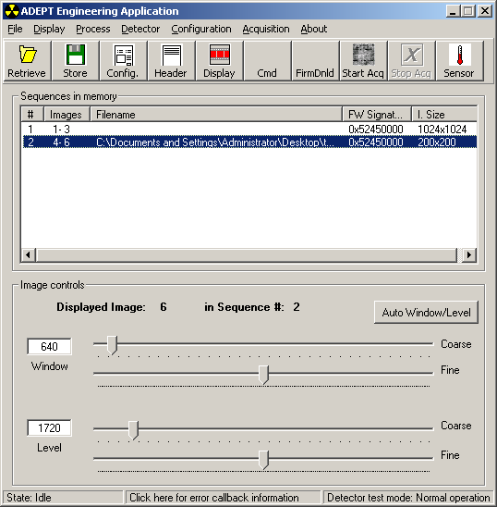
2
1
4
3
8
5
6
7

Menus
The following menus are accessible from the main form:
- File
  - Retrieve: shows a std form to select the file to retrieve.
  - Store: shows a std form to select the name of the file in which the currently selected sequence should be stored (full image size will be stored).
  - Store ROI: Shows the Store ROI form and then a form to select the name of the file in which the currently selected sequence should be stored.
  - Exit: quits the application (state must be IDLE)
- Display
  - Controls: shows the image display form
  - Erase display: erases the display
- Process
  - Reset memory: erases all sequences in memory (no undo possible)
  - Statistics: displays the form to calculate statistics
  - Header: displays the header of the currently selected sequence
  - Store response log: shows the form that allows to store binary response logs for sequences in memory
- Configuration
  - Det. Acq. Configuration: shows the configuration form
  - Peripherals: shows the peripheral control form
- Acquisition
  - Start Acquisition
  - Stop Acquisition
- About
  - About ADEPT: shows the about form

Image acquisition
Image acquisition starts when the ‘Start Acq’ button is clicked or the Acquisition > Start Acq menu is selected. The settings for the acquisition are the ones shown in the configuration form (see 3.3)
When the acquisition starts the Stop acquisition button becomes enabled. Clicking this button causes different behavior depending on the acquisition mode selected in the configuration screen:
  - First mode: causes a call to abort the acquisition
  - Last mode: causes a call to stop the acquisition.
- The buttons in the toolbar can be modified by double clicking on the toolbar

Sequences in memory
The “sequences in memory” box displays a line for each sequence in memory with the following information:
- Sequence number for AEA. Sequence numbers in AEA will, most likely, not match the ones in ADEPT Core
- First and last image number for AEA. Image numbers in AEA will, most likely, not match the ones in AEA.
- Filename: name of the file in disk from which the sequence was read or to which the sequence was saved.
- Signature of the detector firmware from which the images were acquired
- Size of the image (Rows x Columns)
Note: acquisitions in last mode will generate two sequences in memory: one with the ‘before’ images and another with the ‘during’ and ‘after’
A sequence entry in the box has to be clicked for the following buttons/menus to become enabled:
- Store
- Store ROI
- Header
- Image display
- Auto window/level
When a sequence is selected (clicked):
- The first image in the sequence is displayed. If offset calculation is enabled, the offset map is calculated using the ‘before’ images, and loaded to be used. To display images with offset correction for the second of the two sequences acquired in last mode, select the first sequence (to calculate and load the offset map) and then select the second sequence (since there are no ‘before’ images the offset map is not calculated and the last offset map loaded is used)
- If the Header form is displayed the information is updated to show the parameter for the selected sequence

Window/Level
Window and level values can be set by typing values in the text boxes or by adjusting the sliders.
Automatic window and level values can be obtained by clicking the auto window/level button. The automatic values are calculated using the median and std. deviation of the center 1/3 of the displayed image. Level is set to the median, and window is set to 6*std. dev.

Displayed image and sequence number
Displayed image and sequence number are available in the main screen. The values are updated when a new sequence is in memory and when an image is displayed using the image display control.

Detector, acquisition and corrections for display configuration
This form is perhaps the most important form of the application. It provides the following tow major features:
- Access to all acquisition configuration settings, except for firmware download.
- Ability to read and write acquisition configuration files in the format that ADEPT Core handles.

The following is the functionality of each area of the form:
- Displays the name of the currently loaded acquisition configuration file (if any), and allows for the selection of any section within the file. See Appendix A for a description of the format of the acquisition configuration file generated by AEA.
- Fiber channel timeout
- Detector configuration
- Peripherals configuration.
- Display of settling time left
- Display of current detector signature and button to manually try to identify detector (in case ADEPT Core fails to do it automatically)
- System acquisition configuration
- User acquisition configuration
- DFN Autoscrub configuration
- Corrections for display
- Archive ROI (in configuration file)
- Reconfiguration of all parameters (this is only needed when a new detector is connected).

(see figure in next page)
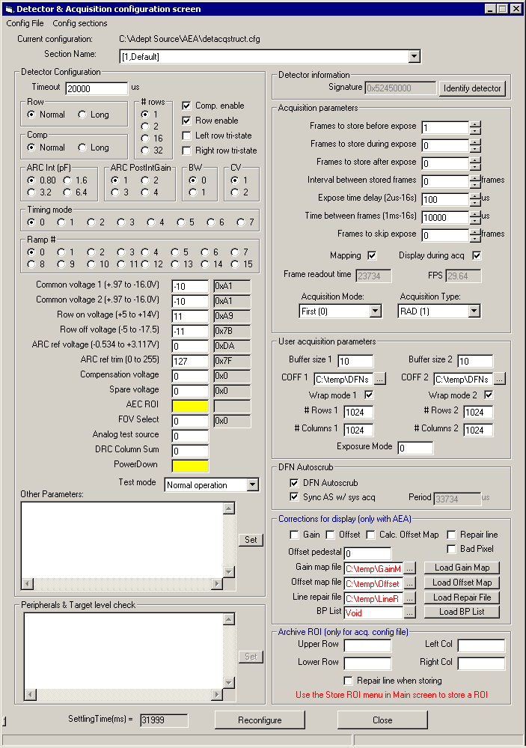
1
2
3
4
6
7
8
9
10
11
5
(*)
12

Menus
The following menus are available:
- Config File
  - Open: shows std dialog to select acquisition configuration file to load
  - Save: saves the current configuration
  - Save as: shows std dialog box to select file to which current configuration will be saved
  - Close: closes the form.
- Config Sections
  - Create New Section: shows a dialog to enter a name for the new section and creates the new section in memory. Note that the file in disk is not modified until you select the Save or Save as option.
  - Delete Current Section: shows a dialog to confirm the deletion of the section, then deletes the section from memory. Note that the file in disk is not modified until you select the Save or Save as option.

Detector Configuration
Detector parameters are set as follows:
- Checkbox or radio button controls: as soon as the new value is selected
- Text boxes: when the ‘Return’ key is pressed or when the focus moves away from the text box. One exception to this rule is the ‘Other parameters’ text box. This text box allows setting any detector parameter by typing the name of the parameter followed by an equal sign and the value of the parameter. For example:
128NumberOfColumns = 12
128NumberOfRows = 12
Once the parameter are in the text box the ‘Set’ button should be pressed for the parameters to be set.

Entries shown in red are for values that have not been set in ADEPT Core because of:
- Parameter not supported by the current firmware (background color will be yellow)
- Error trying to set the parameter (out of range, FC timeout, etc).

For the parameters set via text boxes, the box to their right, pointed to by “*” in the figure, shows the actual values sent to the detector when the parameter was set. By double-clicking on top of the values the display will change to the corresponding quantized ‘real-life’ value.
Most detector parameters can be set while in the ‘during’ section of acquisitions in ‘last’ mode.
Note: when DFN auto-scrub is enabled only one command per scrub can be sent to the detector. If the auto-scrub period is long, it is possible that the application become unresponsive while the command is waiting to being sent.
Warning: Detector configuration is set using the mSetDetectorParameter method of ADEPT Core. Detector settings applied using the ‘Send Command’ window will be transparent to ADEPT Core and to AEA. Therefore, if the Send Command window is used to set detector configuration it may be possible to get incorrect timing during image acquisition and the information in the header of the images will be incorrect.

Peripherals
Configuration of peripherals can be accomplished in two ways:
- Using the text box provided in this form
- Using the Peripherals control form accessible from the main menu.
The intent of the control from the detector and acquisition configuration form is to facilitate the development and modification of acquisition configuration files. When a section of an acquisition configuration file that has peripheral subsections is loaded, those subsections will be displayed in the peripherals box. The contents of the box can be edited and then set using the ‘Set’ button.

Acquisition Configuration
Acquisition parameters are set as follows:
- Text boxes: when the ‘Return’ key is pressed or when the focus moves away from the text box.
- Checkbox and combo box controls: as soon as the new value is selected
The values for Time between frames and Expose time delay can be changed while in the ‘during’ section of an acquisition in ‘last’ mode with some restrictions.

DFN Auto-scrub
The DFN controls the auto-scrub rate as follows:
Auto-scrub period = FC timeout + auto-scrub delay
The auto-scrub rate can be set manually by setting the FC timeout and the auto-scrub delay or by setting the FC timeout and letting ADEPT Core calculate the auto-scrub delay to match the frame period of the system acquisition & detector settings. The latter is turned on by checking: Sync AS w/ sys. acq
Note that when Sync auto-scrub with system acquisition is enabled, if the FC timeout is increased to an amount larger than the auto-scrub period an error (generated by ADEPT Core) will be displayed.

Corrections for display
Corrections for display parameters are set as follows:
- Offset pedestal: when the ‘Return’ key is pressed or when the focus moves away from the text box.
- Offset, gain and repair files: type the name (with path) of the file or select it from the dialog box that is displayed by clicking the button with the three dots. Then click the corresponding ‘Load **’ button
  - The format of the line repair data file supported is documented in the ADEPT Core SDD, Appendix A, method mLoadLineRepairDataFromDisk.
  - The format of the offset and gain maps supported is documented in the ADEPT Core SDD, Appendix A, methods mLoadGainMapFromDisk and mLoadOffsetMapFromDisk
- Checkbox controls: as soon as the new value is selected

Archive ROI
This section displays the archive ROI settings of the section selected from the currently loaded acquisition configuration file. If there are no archive ROI settings, the fields will be empty. The entries in this section do no affect how images are acquired. Archive ROI information will be used only when using the Store ROI menu of the main screen.
There is no error checking on the values entered in this section.
Note: the archive ROI settings will only be saved to disk if all fields are non-empty. Likewise, the Store Properties window displayed when the Store ROI menu is selected in the Main screen will use the archive ROI settings of the detector and acquisition configuration only if all fields are non-empty.

Detector signature
The signature of the firmware of the detector currently connected is displayed in the upper right corner. If the detector is not connected 0x0 will be displayed. If the detector is not connected or there is no detector information file for it’s signature, the label next to the signature will become red and the text will change to show more information.

Reconfigure button
By clicking the reconfigure button all parameters in the screen (except for archive ROI) are set in the detector and in ADEPT Core. Since all parameters are set automatically as they are entered, it is not necessary to use this button under normal operation. To allow for fast detector configuration, DFN auto-scrub will be disabled (if it is enabled) at the start of the operation, and will be re-enabled once reconfiguration is completed.

Open configuration file
When a configuration file is opened, its contents are read and kept in memory. The combo-box control labeled section name will be updated to show all the sections in the configuration file.

Select configuration section
When a section is selected the following events take place:
- Previously selected section is updated. For example, if section [1,DsaLag] is currently selected it will be updated when a section is selected. Any changes to the configuration will be kept in memory until the configuration is saved to disk
- The following default values are set:
  - Peripherals = ""
  - Offset pedestal = 0
  - Archive ROI fields = ""
  - Line Repair = unchecked.
- All the parameters defined in the file are set. Any parameters that are not defined in the acquisition configuration file will remain with their original values, and will be added to the section when it is updated. After all the parameters are set a reconfiguration operation (equivalent to clicking the reconfigure button) is performed.

Save configuration file
When the Save or Save as options are selected the current configuration (all sections) is saved to disk. The following details are important:
- Any detector parameters that are not black will not be saved. Furthermore, any existing entry for such parameter is erased. This allows for storing only the parameters that are supported by the firmware of the detector that is connected.
- Parameters that are missing from a section are added at the end of the section.
- Auto-scrub delay is only saved when ‘sync’ AS w/ sys. acq.’ is not enabled.
- Comments will not be modified
- Existing parameters are left in their original positions.
- Peripheral’s subsections that were removed are erased. Peripheral’s subsections that are new are added.

Send commands to detector
This form is used to send commands to the detector. The timeout displayed here is the same timeout displayed in the Configuration form.
Warning: detector parameters set using this window will not be ‘seen’ by ADEPT Core. Therefore, timing for image acquisition may be incorrect and header information will be incorrect.

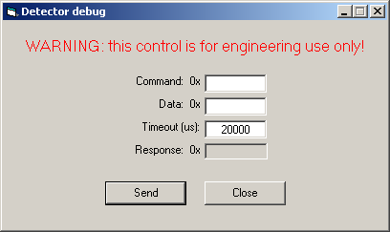

Read detector sensor
This form is used to read detector sensors. Sensors are specified by their name or their number (as defined in the Detector Information File for the firmware being used). The number must be in the form ‘0x*”

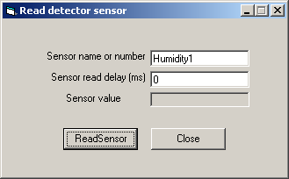

Detector firmware download
This form is used to download firmware to the detector. The name and path of the file to download can be typed or selected using the ‘Browse’ button. The firmware download operation is started when the ‘Start’ button is pressed. This form will automatically disappear when the firmware download operation is completed successfully. If errors are encountered during the download, this form will remain open.

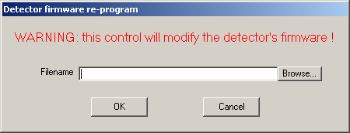

Callback Errors
This form displays errors received from ADEPT Core via callbacks. These are errors that happen asynchronously, like when the system is idle and the FC cable is disconnected.
This form is displayed by clicking on top of area #6 of the main form.
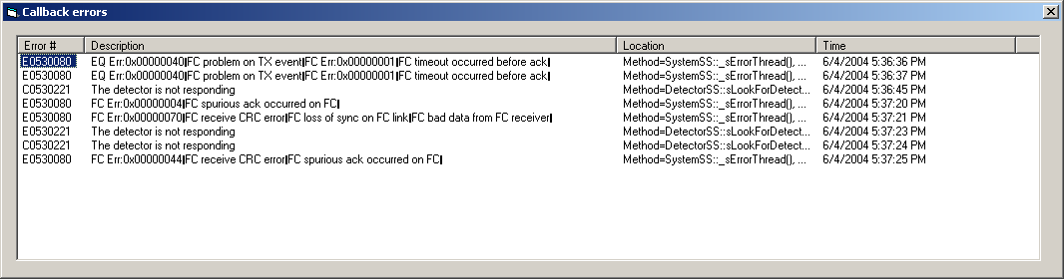

Peripherals control
This form allows for setting and getting peripheral’s parameters. The name of both the peripheral and the parameter are selected from the combo box controls. The parameter value is required when setting it.
The contents of the combo box controls are read-in from the AEAPeripheral.cfg. For a format of this file please see Appendix B.

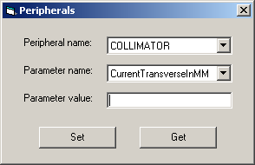

Image display control
This form allows controlling the image that is displayed (from the currently selected sequence in the main form). A rudimentary display loop can be performed by doing a left click on the up/down control and holding the mouse button down.

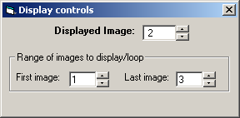

Statistics
This form allows getting statistics on the specified region of interest for the currently displayed image.
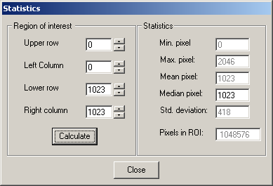

Header
This form displays header information for the currently selected sequence.
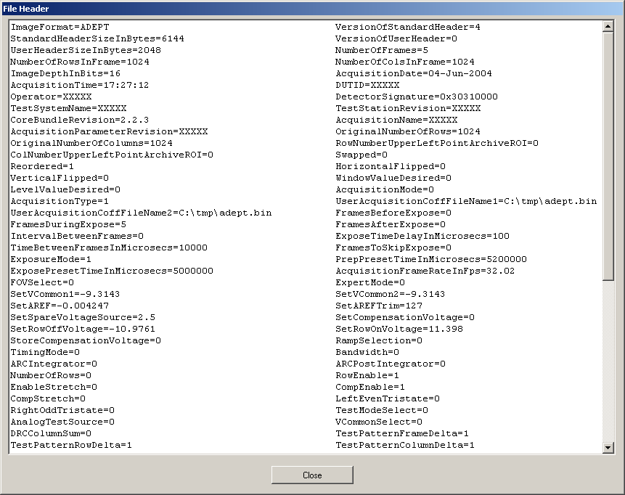

Store Binary log
This form allows the user to store the binary response log generated by the DFN when a sequence is acquired. To store the response log a filename and sequence number (in AEA) need to be provided.

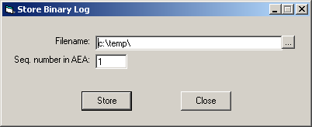

Archival ROI
This form is displayed when the Store ROI menu is selected, and allows users to:
- Set the ROI to be stored
- Set image flipping
- Enable line repair and specify line repair file (see section Corrections for display for information on the format of the repair file).

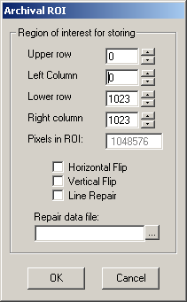

The ROI rows and columns are pre-filled with the entries of the detector and acquisition form, if they are non-empty, or with the maximum image size if any field is empty. The check box control for line repair will be taken from the detector and acquisition form.
When the ‘Ok’ button is pressed a std. Form is shown to select the name and location of the file in which the currently selected sequence will be saved using the settings in the Archival ROI form.

About form
This form displays revision information for:
- ADEPT Core
- AEA
- Displaydll (C:\ADEPT\Core\Displaydll.dll)
- ProcessDll (C:\ADEPT\Core\Processdll.dll)
- Dasdll (C:\ADEPT\Core\Dasdll.dll)

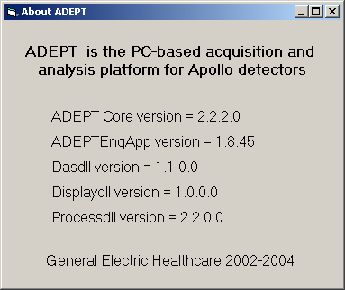

Requirements to Design Traceability
There are no specific requirements associated with this application.

Error Summary
The ADEPT Engineering Application generates the following errors:

Error Number | Error Description | Reason
0xE0900000 | Invalid window value | Invalid window value entered in text box
0xE0900001 | Invalid level value | Invalid level value entered in text box
0xE0900002 | No acquisition configuration file has been loaded | Attempt to save a configuration file (instead of Save as)
0xE0900003 | The specified section of the acquisition configuration file could not be found | If you see this error, then you found a bug in AEA. Please write an SPR.
0xE0900004 | The specified sequence is invalid. | If you see this error, then you found a bug in AEA. Please write an SPR.
0xE0900005 | The specified image is invalid. | Invalid image number has been specified in the image display control
0xE0900006 | The Engineering Application is already running | Attempt to start the application while it is already running
0xE0900007 | The acquisition configuration file specified is empty | Acquisition configuration file has not data in it.
0xE0900008 | Invalid configuration entry | An invalid value was entered for a configuration parameter
0xE0900009 | The specified parameter was not found | If you see this error, then you found a bug in AEA. Please write an SPR.

In addition to the errors generated by AEA, errors produced by ADEPT Core or errors produced by calls to system libraries can be displayed.

Appendix A – Acquisition configuration file format
In an acquisition configuration file there are sections, subsections and parameters. Sections start with ‘[1,’, subsections start with ‘[2,’, parameters have no starting identifier, but there is an equal sign between the parameter name and the parameter value.
The following is an example showing the default values used be AEA at start-up if the default configuration file does not exist or not appropriate section is found within the file:

#********************************************************************************
[1,AEADefault]
[2,DETECTOR]
FOVSelect = 0
SetVCommon1 = -10
SetVCommon2 = -10
SetAREF = 0
SetAREFTrim = 127
SetSpareVoltageSource = 0
SetCompensationVoltage = 0
SetRowOffVoltage = -11
SetRowOnVoltage = 11
RampSelection = 0
TimingMode = 0
Bandwidth = 0
ARCIntegrator = 0
ARCPostIntegrator = 0
NumberOfRows = 0
RowEnable = 1
EnableStretch = 0
CompEnable = 1
CompStretch = 0
LeftEvenTristate = 0
RightOddTristate = 0
TestModeSelect = 0
AnalogTestSource = 0
DRCColumnSum = 0
VCommonSelect = 0

[2,ACQUISITION]
FramesBeforeExpose = 1
FramesDuringExpose = 0
FramesAfterExpose = 0
IntervalBetweenFrames = 0
TimeBetweenFramesInMicrosecs = 10000
AcquisitionMode = 0
AcquisitionType = 1
ExposeTimeDelayInMicrosecs = 100
FramesToSkipExpose = 0
FiberChannelTimeOutInMicrosecs = 20000
DFNAutoScrubOnOff = 0
SyncAutoscrubWithSysAcq = 0
DFNAutoScrubDelayInMicrosecs = 50000
DisplayDuringAcquisition = 1
MappingDuringAcquisition = 1
BufferSize1 = 10
NumberOfColumnsForUserSeq1 = 1024
NumberOfRowsForUserSeq1 = 1024
UserAcquisitionCoffFileName1 = C:\temp\DFNscript1.bin
WrapMode1 = 1
BufferSize2 = 10
NumberOfColumnsForUserSeq2 = 1024
NumberOfRowsForUserSeq2 = 1024
UserAcquisitionCoffFileName2 = C:\temp\DFNscript2.bin
WrapMode2 = 1
ExposureMode = 0

[2,POST_PROCESSING]
WindowValueDesired = 50
LevelValueDesired = 1610
LineRepair = 0

[2,AEA]
LineRepairCorrectionEnable = 0
LineRepairDataFilename =
OffsetPedestalValue = 0
GainCorrectionEnable = 0
OffsetCorrectionEnable = 0
CalculateOffsetMap = 0
OffsetMapFilename =
GainMapFilename =

#********************************************************************************

Any other sub-sections found within a section will be considered peripherals.

Appendix B – AEA Peripherals configuration file format
When the peripherals control menu is selected, the application will read in the AEAPeripherals.cfg file from the same directory where the application is located. Each line of this file will be interpreted as follows:
peripheralName1,param11,param12,param13 ….
peripheralName2,param21,param22,param23,param24….
peripheralName3,param31,param32….
:
:
Lines starting with a ‘#’ are ignored. The following is an example of the contents of a real AEA peripherals configuration file:

#Peripherals configuration
COLLIMATOR,CurrentTransverseInMM,CurrentLongitudinalInMM,CurrentSIDInMM
GENERATOR,kVp,ma,ExposureTimeInMillisecs,FocalSpotInMM
INTERLOCKS,DOOR_INTERLOCKS_STATUS,XRAY_ENABLE_STATUS

Revision History
The following table lists the previous versions and their associated version numbers, and changes made to the current version of this SDD.

Rev. | Date | Author | Change | SPR#
1.0 | 16-June-04 | Germán Vera | First version | N/A
2.0 | 17-June-04 | Germán Vera | Changes after HII review | N/A
3.0 | 10-Aug-05 | Germán Vera | Changes in detector configuration screen | XRYge61555

