Event Queue User’s Manual

AUTHOR | Robert Wodnicki

RECORD OF CHANGES

Document Location: /projects/cardiact/documents/crd/queue_manual.doc

Rev | Date | Author | Comments | SPR#
B1.1 | 25-March-1999 | Robert Wodnicki | Initial Version
B1.2 | 21-June-1999 | Robert Wodnicki | Updated
B1.3 | 3-July-2000 | Robert Wodnicki | Reflects major changes for Beta release
B2.0 | 16-November-2000 | Robert Wodnicki | Reflects major changes for Rev3 release
B2.1 | 7-December-2000 | Robert Wodnicki | Reviewed

Introduction

Purpose
This document describes a framework for real-time control of the Apollo detector system during X-ray image acquisition. The intention is to allow for high level and versatile control of a number of low level, real-time events. A low level processor is used for control of the Apollo detector and X-ray generator. This device is controlled using a micro-sequencing language whose constructs are also defined. Examples of EAB Event code for typical acquisition scenarios are provided and discussed.

Scope
The document covers the standard event instructions supported by the current (R3) release of DFN firmware. Some examples of representative event code are provided and explained.

The following table defines terms and definitions used in this document:

Term | Definition
DFN | Detector Framing Node
EP | Event Processor
DAP | Data and Address Processor
FC | Fibre Channel
FPGA | Field Programmable Gate Array
IDC | Image Detector Control
PCI Bus | Peripheral Component Interconnect Bus
F/W | Firmware

IMPORTANT NOTE: In this document hexadecimal numbers are denoted by "0x..."
For example, 146 decimal = 0x92 in hexadecimal notation. In all other cases,
numbers are decimal.

References

The following table lists all documents that supply inputs to this specification:

Document | Revision | Location
DFN Programming Specification | B1.3 | /projects/cardiact/documents/crd/dfn spec programming b1.3.doc
System Design Requirement Specification PC Based Data-Acquisition and Control for Digital X-ray Test | 4 | /projects/cardiact/documents/crd /drs-ver6.doc
Apollo Data Acquisition Platform SRS | 1.0 | /projects/cardiact/documents/crd /tester_srs_rev_1_0
Preliminary Definition of Communication between IDC and Apollo Detector by Scott Petrick | 2/27/98

System Overview
An inexpensive and easily upgraded digital X-ray system should take advantage of widely available PC technology for a host platform. The system should be simple enough to be run under a standard PC operating system such as Windows NT. At the same time it should be versatile, providing an experienced user with complete control of the low level events occurring during image acquisition.

To create a system satisfying these requirements it is necessary to partition high level and low level functions for best utilization of resources. In particular, all functions which must occur in real-time should be pushed down into hardware to relieve the burden of real-time operation on the PC operating system. These functions are often better suited to hardware implementation since they do not require any complex data processing operations to be performed. In contrast, image processing functions such as gain and offset correction are often relatively costly to implement in special purpose hardware. These functions can take advantage of increasingly high performance PC CPU's for efficient implementation.

Therefore, a system which uses simple and special purpose hardware for real-time control, and processes image data on the host PC should make efficient use of available resources. Figure 2.1 shows a block diagram of the proposed system architecture. The system is divided into two sections: The host PC implements high level functions and data processing. A custom PCI card called the Detector Framing Node (DFN) sits in the PC and provides the bridge between the detector, the X-ray generator and the PC host. As illustrated, the PC part of the system requests image acquisition, processes the retrieved data and archives it to disk. The DFN orchestrates image acquisition in real-time as discussed in the next section.

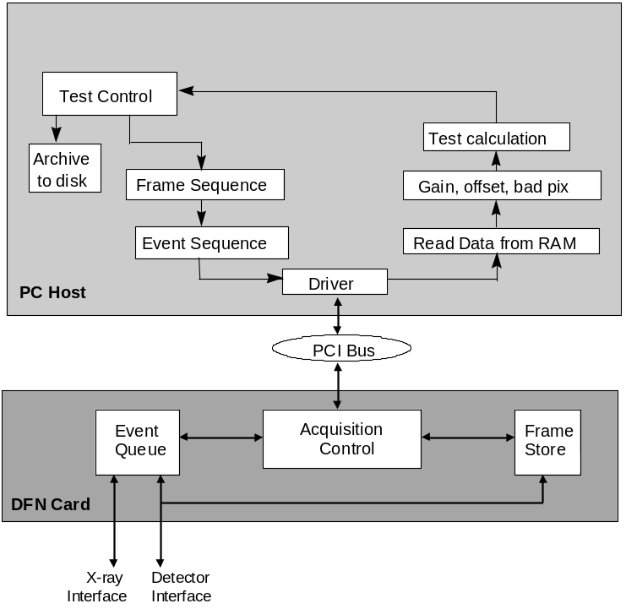

Figure 2.1 - System Data Flow Diagram

The Event Sequence
Image acquisition consists of a sequence of events which occur at precisely-timed intervals and involve control of the X-ray generator and the Apollo detector. In most cases, the user knows the exact order in which these events need to occur well in advance of the image acquisition. This sequence will vary from acquisition to acquisition depending on the type of experiment being performed and the type of information the user is seeking to learn through the image acquisition. Therefore, it should be possible to construct a list or description of the required sequence of events which must be performed. This list need not be constructed in real-time and is therefore easily done on the host PC. Once this Event Sequence is known, the details can be transmitted to special purpose hardware for execution in real-time.

The system shown in Figure 2.1 operates as just described. A high level description of the required image acquisition is generated by the acquisition control software. This description consists of a sequence of frames to be acquired and may include details such as required frame time or the amplifier gain to be used during acquisition. This Frame Sequence is then translated to an Event Sequence using a compiler which knows the details of the target control hardware. This event sequence is then sent over the PCI bus to the DFN card where it is stored in preparation for execution. Execution of the sequence is initiated by sending a Begin Sequence command over the PCI bus. It is important to note that the extent of real-time control allotted to the PC is limited to the act of initiating the sequence. Once the Event Sequence is complete, the PC can retrieve the acquired data in addition to various diagnostics and responses which were recorded during execution of the event sequence. Therefore the PC is only involved in pre- and post-processing roles and is entirely relieved of the burden of real-time operation.

The Event Graph
A typical sequence for image capture will consist of a series of isolated events each of which is planned to take place at a predetermined point in time. These events can be represented schematically using an Event Graph as shown in Figure 2.2. Here a typical acquisition is illustrated. Beginning on the left hand side, a series of scrub frames (panel scan with no data returned) are shown. These represent the scrub frames which are taken while the detector is sitting idle prior to the event sequence. This idle state is referred to as DFN Normal mode and is the default state of operation. The event sequence is triggered and begins as the system leaves Normal mode and enters Run mode (event sequence execution). The first event in the sequence, E0, sets up the detector for the frame. E1 is the delay time from the start of the first frame until the beginning of readout of the first frame. This is followed immediately by E2 which is an image request and E3 which is a delay accounting for the image readout time. Once E3 is complete, E4 sets up the next frame and E5 - the delay for the second frame - begins. The frame is readout on E6-E7, and the EndQ event E8 corresponds to the end of the event sequence. When this point is reached, the execution is completed, and the system leaves Run mode to return to Normal mode.

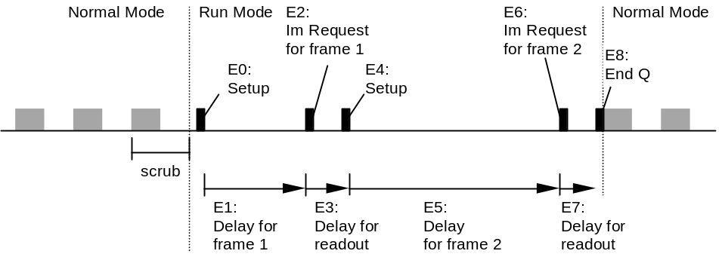

Figure 2.2 - The Event Graph for a single Event Sequence

During execution of the sequence shown in Figure 2.2, two frames of data were acquired. These frames were transferred directly to PC memory. In addition, commands sent to the detector to initiate the readout each resulted in acknowledgment being returned from the detector. This acknowledgment was recorded for each event and stored in host memory in the Response Log Buffer. All of this information along with pointers to the frame data in PC memory are passed to the top level host application immediately following completion of the event sequence. The sequence can be repeated again by sending another begin sequence command to the DFN card over the PCI bus.

Standard Event Set

Introduction
The Standard Event Set for the Rev 3 firmware release of the DFN card contains a minimal number of events intended to support all of the proposed features of the PC based tester. These events are presented in this section and are grouped roughly by functionality. Each event consists of a single Op-Code byte specifying the event, followed by the argument bytes to be used when applicable. All op-code words are one byte long and their arguments are multiple bytes long as indicated. Op-code and argument bytes are packed for optimum utilization of the DFN EAB memory. The descriptions in this section contain diagrams illustrating the format of control and data words for each event. The diagrams show the exact byte order of data in EAB memory beginning with the op-code. Multi-byte words show the byte ordering with "(0)" being the least significant byte. A summary of the Standard Event set is shown in Table 3.1. All events take one cycle of the 2 us event clock to be read form EAB memory and processed.

Event Mnemonic | Event  (showing size of arguments) | Event Op Code (hex) | Event Data  (bytes) | Total  (bytes)
EndQ | EndQ | 14 | 0 | 1
Delay (T) | Delay (0xff ff ff ff) | 10 | 4 | 5
Send (command, value) | Send (0xff ff ff ff, 0xff ff ff ff) | 04 | 8 | 9
LoopKN (K, N) | LoopKN (0xff ff, 0xff) | 0C | 3 | 4
LoopKF (K, F) | LoopKF (0xff ff, 0xff ff ff) | 0D | 5 | 6
Wait (F) | Wait (0xff ff ff) | 09 | 3 | 4
Flag (F) | Flag (0xff ff ff) | 08 | 3 | 4

Table 3.1: Standard Event Set. The size of the arguments for the Rev 3 release are indicated in Hex.

The Event Compiler and Perl Script
The PC-DAS system uses the Perl scripting language to describe Event Sequences using the Standard Event Set. The Perl code is compiled to generate a binary file (called the "COFF" file) which is sent to the DFN card for sequence execution. For the purposes of illustration, some lines of Perl code are provided in the examples which follow for each event in this section. For a complete description of the use of Perl with PC-DAS, please see the PC-DAS Quick Start Manual.

Send

Binary Format:

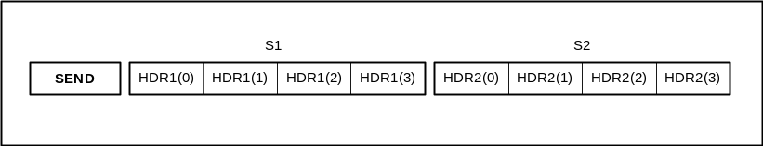

Description:
This event sends the command words S1 and S2 to the detector. The response from the detector is recorded in the Response Log on the host PC.

Perl Script Example:

Send(0x1002, 0x0);

In this example, the detector Signature Request command is sent to the detector. The reply from the detector which will be recorded in the Response Log will be of the form:

ACK1 = 0x1002
ACK2 = 0x30200000

Here, the detector responds with a signature indicating that it is running Cardiac H20 firmware.

Applications:
- Store Scan Setup
The send event can be used to send a Store Scan Setup Parameters command to the detector. In this case S1 will have the format of the command, "0x00004020" and S2 will be the 32 bit parameter word to be stored.

- Read Temperature
The send event can be used for the Read Temperature command. In this case, S1 is "0x00004100" and S2 has no effect. After processing this command, the detector will reply with an acknowledgement consisting of two 32 bit words which are recorded in the Response Log. The first of these should be a copy of the original S1 word unless the command was not recognized in which case it would be "0x0000FFFF". The second word will be the requested temperature.

Execution time:
Send is executed in a single 2 usec tick of the Event Sequence clock. A Fibre Channel timeout is set with a user programmed register on the card. If this timeout is exceeded without a reply from the device, an error is generated. The timeout for return of Fibre Channel acknowledgement ("ACK's") is set in 28 ns increments with a maximum timeout of 1024*28 ns = 28.672 ms. The timeout is currently set to a nominal value (e.g. 256 counts) by the DFN driver, and will be accessible to the user as an NT registry entry in a future release.

Error Conditions:
Fibre Channel error conditions are detected by the DFN card and passed on to the host using a PCI interrupt. They are also recorded in the Response Log. The Send event has a time-out on its execution (see DLL document for more information). The return information is monitored by the DFN card to determine whether the information has been received and processed correctly. Table 3.2 provides a list of the reported Fibre Channel errors.

Error Mnemonic | Description of Error
FC_TIMEOUT | Timeout expired with no ACK detected
FC_BAD_ACK | ACK did not match transmitted command
FC_EXTRA_ACK | Unexpected ACK received
FC_EXTRA_CMD | New Send event while waiting for ACK from previous Send
SIG_DETN | No input signal power on Fibre Channel (cable disconnected?)
RXERROR | Fibre Channel receiver detected bad data (defective chipset?)
WRDSYNCN | Fibre Channel Data link unsynchronized
CRXS(1) | Bad Received CRC detected (Fiber-optic cable problem?)
CRXS(3) and CRXS(2) | Bad order in link state machine (defective chipset?)

Table 3.2 Errors Reported for Fibre Channel Send Event

Delay(T)

Binary Format:
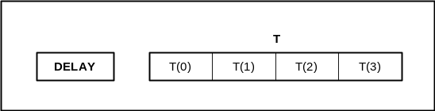
Description:
This event provides a delay in execution given by T, where T is a 32 bit binary word representing the number of ticks of the 2 usec event sequence clock. It is important to note that timing of frame readout is not regulated implicitly by an interrupt system which counts off 30 Hz increments in the background. In DFN Run mode, precise timing of frame readout must be maintained entirely by events in the Event Queue.

Perl Script Example:

Delay(16500);

In the Perl script, the decimal argument to this event is provided in ticks of the 2 us event clock. Therefore the above example measures out a delay of 33 ms, which is the frame time for a cardiac image.

Applications:
- Frame Time Generation
The Delay event is useful for generating the delay between successive readouts of the detector which would then constitute part of the entire frame time with the remainder of the time being taken up by the readout operation (approx. 125 ms for Rad, 20 ms for Cardiac). Please see Section 4 for examples of these.

- X-ray Setup Delay
The Delay event can be used to insert a delay between the beginning of a light frame and the point at which the X-ray generator is turned on.

LoopKN(K,N)

Binary Format:
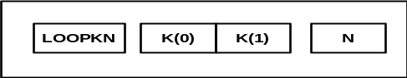

Description:
This event decrements the Event Queue pointer to allow looping on sections of the Event Queue. Looping is performed on instructions which occur before the loop event. The distance the pointer is moved is given by K, and the number of times the loop is performed is given by N+2. Note that the loop pointer is zero-based and the loop instruction is not reached until the first time through the loop. These two conventions account for the additional two counts which must be added to the counter. Currently loops cannot be nested. Note that looping is performed on the events prior to the Loop event, therefore all loops are executed at least once (N=0). Currently, N is one byte long and therefore a maximum of 257 loops (255+2) are allowed.

Perl Script Example:

Send(0x800000, 0x0);
Delay(16500);
LoopKN(2, 20);

In this example, the detector is read 22 times at a frame rate of 33 ms per frame. This is accomplished by sending the image request command ("0x800000, 0x0"), followed by a delay of 16500 2 us counts, and a LoopKN statement. It is important to note that in the Perl file, the jump distance "K" is provided in terms of number of events, whereas in the binary event compiler output COFF file, it is specified in terms of actual bytes. The compiler takes care of performing the mapping between these two ways of specifying the event.

Applications:
- Repeated Frames
The LoopKN event is useful for taking a prescribed number of data frames from the detector. It can encompass a section of the event sequence which includes both dark and light frames. In this way it is possible to capture a long series of images using a relatively short sequence of events.

Flag(F)

Binary Format:
It is important to note that the diagram below shows the order of bytes in EAB memory. This order is reversed in the Perl script ("TYPE, MASK, STATE" in EAB memory becomes "STATE, MASK, TYPE" in the Perl script) due to the differences in Endian ordering.
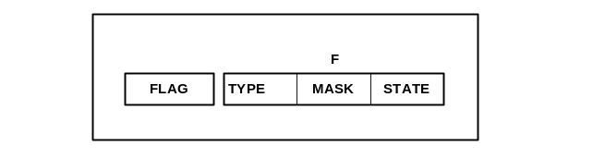

Description:
This event generates the flag F. The exact nature of the flag is determined as indicated. TYPE is used to indicate whether the flag will be applied to the RT bus (TYPE=”00”) or will generate an interrupt to the host PC (TYPE=”01”). Note that currently only two types of flags are defined. MASK is used to select which bits are to be controlled, and STATE holds the corresponding levels for each bit. Setting a particular bit position in the MASK to '1' selects this bit position in the flag value to be changed. The flag value bit is changed to either a '1' or a '0' depending on the respective bit in the same position in the STATE byte. Separating the MASK and the STATE is important since the state of the RT bus does not need to be read in order to change a given bit; the previous state can be left unchanged as necessary. Flags on the RT bus remain until they are cleared by a subsequent event. Flags sent to the host PC cause a single interrupt to be generated and cause the flag value (STATE x MASK) to be transmitted to the host application. Flags sent to the RT Bus are used to set the RT Bus to the flag value (STATE x MASK). See the PC-DAS Quick Start Manual for more detail on use of the RT Bus.

Perl Script Example:

Flag(0xB1F100);

In this example, an RT bus flag (TYPE="00") is generated. Since the MASK is "F1" the upper four bits of the RT bus are all changed to the state specified "B", while of the lower four bits, only the least significant bit is changed.

Applications:
- X-Ray On
The Flag F event can be used to generate the X-Ray on signal for turning on the X-ray generator. This is done by selecting the appropriate bit on the RT bus with the MASK and then setting it to the desired level with the STATE. This bit can later be cleared using another Flag F event.

- Host-Synchronized Image Acquisition
The Flag F event can be used to generate a flag to the host PC indicating that the Graphe button has been detected by a previous Wait event. The host PC can use this information to signal to the high level user the status of the image acquisition.

Wait(F)

Binary Format:
It is important to note that the diagram below shows the order of bytes in EAB memory. This order is reversed in the Perl script ("TYPE, MASK, STATE" in EAB memory becomes "STATE, MASK, TYPE" in the Perl script) due to the differences in Endian ordering.
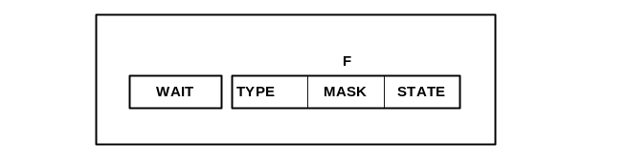

Description:
This event pauses execution of the queue until the flag F is received. The exact nature of the flag is determined as indicated above using the TYPE, MASK and STATE fields. Type is used to indicate the origin of the flag (TYPE “00” = RT Bus, TYPE “01” = Host Flag). At present there are only these two types. Mask is used to select which bits are to be tested, and STATE holds the corresponding expected states for the test to pass. For example, in order to wait for bit 0 on the RT bus, the following TYPE, MASK, STATE construction is used: (“00,01,01”). Note that it is possible to wait on any bit independently of any others. This feature is important since it allows individual bits to be assigned different functions where the state of other bits does not need to be checked against when a particular bit is of interest. The RT bus can also be read by the host if required using the DFNReadRTBState() function call.

Perl Script Example:

Wait(0x0A0F01);

In this example, execution is paused at the Wait statement until the pattern "0A" is received from the Host application. Note that in this case, since the MASK is "0F" only the lower nibble of bits of the incoming Host Flag will be tested.

Applications:
- Graphe Button
Mammography provides a good example of the need for separate MASK and STATE definitions. The operator must hold down both the “Prepa” and “Graphe” buttons to initiate an X-ray exposure, with Graphe actually applying voltage to the X-ray tube. A Wait event in the X queue could be made to look for a signal indicating that the Graphe button on the operator console has been pressed. The Graphe button can be interfaced using the RT bus and will be represented by a single bit which can be tested against for state effectively corresponding to a flag. The bit is selected for testing using the MASK part of the flag definition. Once this flag is received, execution would move on to the next event which would be a Flag F command to the X-ray generator calling for the X-ray generator to be turned on.

- Host-Synchronized Acquisition
The Wait event can be used to synchronize the Event Queue operation to the host PC. A Wait event can be used to stop execution until the host signals that it is ready to proceed. For example, using a Wait in an image loop, an operator could step through a series of precisely timed image acquisitions with a keyboard press on the PC used to tell the host to proceed to the next frame in the sequence. After each keyboard key press, the host would signal to the Event Queue with the required flag F with an application program.

LoopKF(K,F)

Binary Format:
It is important to note that the diagram below shows the order of bytes in EAB memory. This order is reversed in the Perl script ("TYPE, MASK, STATE" in EAB memory becomes "STATE, MASK, TYPE" in the Perl script) due to differences in Endian ordering.
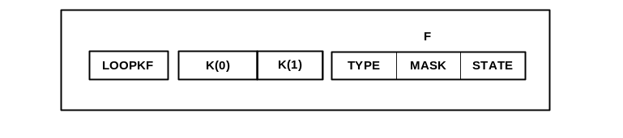
Description:
This event decrements the Event Queue pointer to allow looping on sections of the Event Queue. The distance the pointer is moved is given by K. Looping continues until the F flag is received. F is described by the Type (RT bus = “00”, Host Flag = “01”), the Mask and the State. Note that nested looping is not currently supported. See Flag or Wait for a description of Flags.

Perl Script Example:

Send(0x800000, 0x0);
Delay(16500);
LoopKF(2, 0xAAFF01);

In this example, the detector is read indefinitely at a frame rate of 33 ms per frame until a Host Flag is received from the user application (see Wait or Flag for Flag definition). This is accomplished by sending the image request command ("0x800000, 0x0"), followed by a delay of 16500 2 us counts, and a LoopKF statement. It is important to note that in the Perl file, the jump distance "K" is provided in terms of number of events, whereas in the binary event compiler output COFF file, it is specified in terms of actual bytes. The compiler takes care of performing the mapping between these two ways of specifying the event.

Applications:
- Synchronized Light Frame
The LoopKF event can be used to synchronize the Event Queue to an external input for acquisition of a light frame. A sequence of events incorporating a scrub frame can be placed in the LoopKF loop with the event waiting for the flag F from the RT bus. Once the X-ray generator is ready, the RT bus changes state to F which causes the Event Queue to leave the LoopKF loop and proceed on to the next event which is a data frame. Together, the X-ray On and data frame realize a light frame which is in lock step with the previous detector scrub operations.

- Infinite Loop
The LoopKF event can be used to generate an infinite loop for debugging of detector operation. The loop can be made sensitive to a flag from the host PC indicating that execution should be completed.

EndQ
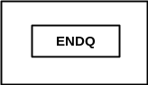
Description:
This event constitutes the end of the event sequence. When this event is reached, DFN passes from Run mode to Normal mode, and notifies the host that execution is complete.

Perl Script Example:

Note that the EndQ is inserted automatically by the event compiler and is not present in the Perl script.

Sample Event Sequences
The following pages show examples of typical event sequences which may be implemented. They are intended to demonstrate the flexibility of the architecture proposed herein. Each example consists of an event graph illustrating the sequence execution in time. The graph is accompanied by a representation of the Event Queue in EAB memory on the DFN card for the sequence.

Mammo Sequence
Image acquisition for mammography provides a good example of an event sequence controlled by external events. Here we present an example of a typical Mammo acquisition based on currently existing X-ray generator hardware (i.e. the DMR). It is assumed that the tester system has access to the Graphe push button as a signal on the real-time bus indicating that voltage should be applied to the X-ray tube. It is further understood that X-ray On time in this simple example is set manually by the user as part of the technique set at the console (i.e. mAs). The tester has control over the beginning of the X-ray exposure through the real-time bus but does not control the on-time directly. It is up to the application code to set up the Event Queue correctly to allow for the expected delay due to the given mAs setting. This procedure could be automated further if a better interface to the DMR were available.

Figure 4.1 a) shows the event graph for the acquisition while Figure 4.1 b) provides the equivalent Event Queue descriptions. The start of the sequence is initiated by the host using the Begin Sequence command on the PCI bus once the queues have been properly setup. At this point DFN leaves Normal mode, and begins sequence execution.

The Event Queue begins by looping on scrub frames and waits for the Graphe button to be pressed (RT1). As illustrated in the graphs, this is accomplished using events E0-E2, where E1 is a Send event for a Scrub, and E2 is a LoopKF event. The control event E2 takes as defining arguments the flag RT1 which will end the loop as well as the distance K to jump back to the event which begins the loop. In this case K=2 since the loop contains two events. RT1 is a flag from Real-Time bus defined by specifying which signal to monitor (for the Graphe press) and the state to look for (high or low). Once Graphe is pressed, the Event Queue detects this change and leaves the scrub loop since image acquisition is about to begin.

The next group of events in the sequence initiate the offset or dark frame acquisition and then provide the synchronization between the start of the light frame and the start of the X-ray exposure. These events correspond to E3-E10. E4 is a Send event which sends an Image Request to the detector. Note that the readout delay for the image request must be accounted for using the Delay event E5. Once E5 completes execution, data has been stored locally on the DFN in a frame buffer. The completed acquisition triggers DMA of this frame buffer to the host over the PCI bus. X-ray exposure is phased relative to the start of the light frame; E6 provides this time delay. Following the delay, E7 sends the X-ray On signal by changing the value of the flag RT2 corresponding to the X-ray On signal on the real-time bus to the DMR. As mentioned previously, the current mammography test system does not have the facility for setting the duration of the X-ray on time. Therefore, this X-ray on signal only tells the DMR when to begin exposure, and X-ray off is not required. The sequence ends when E11 terminates the queue. The EndQ event moves DFN from Run mode back to Normal mode to idle and scrub the panel.
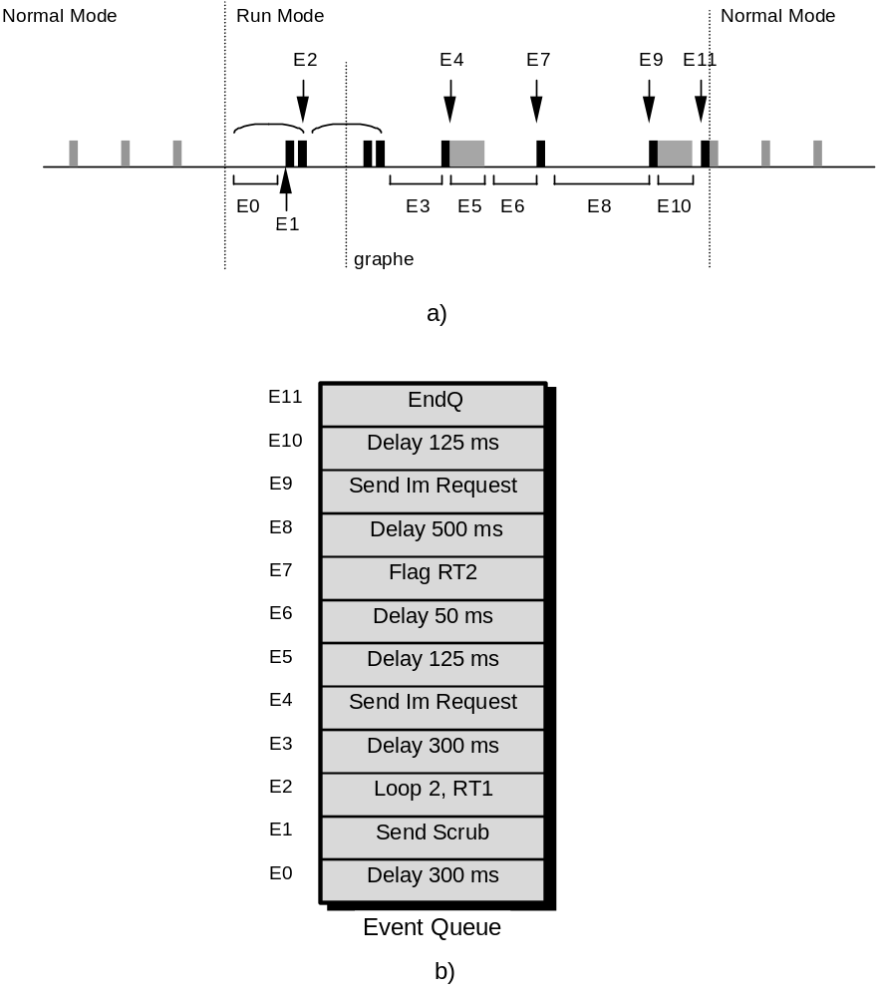
Figure 4.1 - Mammo Event Sequence

Gated Cardiac Sequence
Image acquisition of a gated cardiac sequence provides a slightly different example of an externally controlled event sequence. It is assumed that a trigger signal on the real-time bus provides the gate to control when images are acquired during a frame sequence. Such a gating signal might be provided by a heart monitor to synchronize light image acquisition with certain phases of heart activity. Figure 4.2 a) shows the event graph for the acquisition while Figure 4.2 b) provides the equivalent Event Queue description. As in the Mammo case, the start of the sequence is initiated by the host using the Begin Sequence command on the PCI bus.

At the start of the sequence, the Wait event E0 pauses sequence execution until a heart beat is detected on the RT Bus inputs (RT1). When the beat arrives, the detector is scrubbed once (E1-E2) to begin the panel integration time. The X-ray is then turned on at E3. Assuming that the generator turns off automatically after 10 ms, E4 waits for this period to complete. E5-E6 complete the integration period and readout the detector. The entire construct of E0-E6 is looped using E7 which waits for the Host Flag HF1 from the PC application telling the sequence to exit with the EndQ, E8.

The sequence will run continuously an synchronize with the heart beat until the PC application tells it to exit. Alternately with two layers of nested looping it would be possible to scrub the panel at a set rate until the heart beat was detected. One loop would scrub the panel, and the second loop would repeat the entire construct (scrubbing + single image acquire) until the host application signaled done.

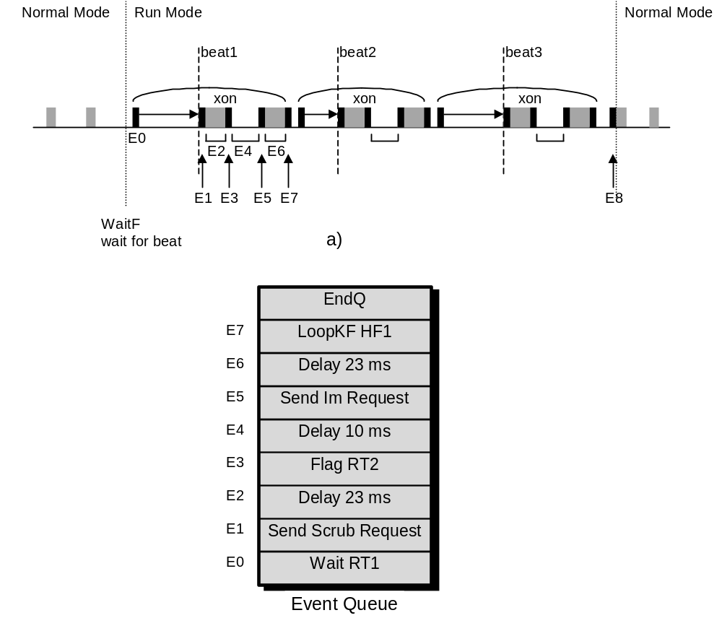

Figure 4.2 - Gated Cardiac Sequence

For examples of Perl scripts, please see the PCDAS Quick Start Manual
Note that since the gain will change in hardware, the host application must take care of using the proper tables for gain correction.
For a list of all detector send commands for a particular detector modality and firmware revision, please see the respective firmware release document.
For examples of Perl scripts please see the PC-DAS Quick Start Manual.
For examples which show Perl scripts, please see the PCDAS Quick Start Manual.

