BCSE498J Project-II / CBS1904 - Capstone Project

BEHAVIORAL BIOMETRICS BASED INTEGRITY ANALYSIS FOR ONLINE CODING ASSESSMENTS

22BCE3054 | YASH KAUSHIK
22BBS0203 | HARDIK SINGLA

Under the Supervision of
Dr. BOOMINATHAN P
Professor Grade 1
School of Computer Science and Engineering (SCOPE)

B.Tech.
in
Computer Science and Engineering


School of Computer Science and Engineering (SCOPE)

February 2026

ABSTRACT

Online coding evaluations have become a norm in technical education and recruitment, but they are accompanied by a serious integrity issue. Simultaneous device cheating, where a candidate looks at a solution on a secondary display and manually enters it into the evaluation system, is hard to detect by conventional means. Plagiarism detection software is not effective because the code is typed manually. Webcam-based proctoring raises serious privacy issues and can be bypassed easily by placing devices out of sight. This project aims to provide a behavioral biometrics solution that identifies suspicious typing patterns by observing how the candidate interacts with the coding environment, without recording any code or using surveillance.
The proposed system consists of four phases. A Chrome extension logs interaction data during coding activities on LeetCode, recording keyboard, mouse, timing, and workflow activity such as running or submitting code. A feature extraction module extracts 58 behavioral attributes from the raw interaction data into seven categories: navigation patterns, editing patterns, typing patterns, mouse activity, code development, sequence patterns, and workflow activity. These are then passed through a machine learning pipeline that trains a Logistic Regression and Linear SVM classifier using 5-fold stratified cross-validation with regularization to avoid overfitting. The trained classifier then assigns a suspicion score between 0.0 and 1.0 with corresponding behavioral markers to explain the classification decision.
The proposed solution is intended to be useful and non-intrusive. It is implemented as a full-stack system comprising a Chrome extension for behavioral data collection, a Python Flask backend that performs the analysis, and a React-based web interface through which instructors can upload session files and review detailed suspicion reports. Accuracy, precision, recall, F1-score, and ROC-AUC analysis can be used to show that behavioral attributes are effective in identifying actual problem-solving activity from linear typing patterns indicative of copying. This work has implications for both academic integrity research and the development of privacy-respecting alternatives to traditional webcam-based proctoring.

TABLE OF CONTENTS
Chapter No. | Contents | Page No.
 | Abstract | 2
1. | INTRODUCTION | 5
 | 1.1 BACKGROUND | 5
 | 1.2 MOTIVATIONS | 5
 | 1.3 SCOPE OF THE PROJECT | 6
2. | PROJECT DESCRIPTION AND GOALS | 8
 | 2.1 LITERATURE REVIEW | 8
 | 2.1.1 Behavioral Biometrics Based | 8
 | 2.1.2 Machine Learning Based | 9
 | 2.2 GAPS IDENTIFIED | 10
 | 2.3 OBJECTIVES | 11
 | 2.4 PROBLEM STATEMENT | 12
 | 2.5 PROJECT PLAN | 12
3. | TECHNICAL SPECIFICATION | 14
 | 3.1 REQUIREMENTS | 14
 | 3.1.1 Functional | 14
 | 3.1.2 Non-Functional | 15
 | 3.2 FEASIBILITY STUDY | 17
 | 3.2.1 Technical Feasibility | 17
 | 3.2.2 Economic Feasibility | 17
 | 3.2.3 Social Feasibility | 18
 | 3.3 SYSTEM SPECIFICATION | 18
 | 3.3.1 Hardware Specification | 18
 | 3.3.2 Software Specification | 19
4. | DESIGN APPROACH AND DETAILS | 20
 | 4.1 SYSTEM ARCHITECTURE | 20
 | 4.2 DESIGN | 21
 | 4.2.1 Sequence Diagram | 21
 | 4.2.2 ER Diagram | 22
 | 4.2.3 Use Case Diagram | 23
 | 4.2.4 Activity Diagram | 24
 | 4.2.5 Data Flow Diagram | 25
 | REFERENCES | 26

CHAPTER 1

INTRODUCTION

1.1 BACKGROUND
Coding assessment tools have become an integral part of technical learning and recruitment. LeetCode, HackerRank, and CodeChef have become popular tools for assessing programming skills on a large scale. The use of online assessment tools saw a sudden surge during the pandemic era. However, this sudden increase in usage has also revealed some major flaws in securing these online assessment tools.
The most challenging type of cheating is multi-device cheating. Here, the candidate sees the entire solution on a second device such as a smartphone, tablet, or another computer, and then manually enters the solution into the online assessment tool. Since the code is manually entered and not copy-and-pasted, it cannot be detected by any plagiarism software. The final code submitted is no different from code written by a candidate.
However, the current security systems are inadequate in three respects. Firstly, code similarity detectors compare the final solution with existing solutions, but they cannot determine whether the code was written independently or merely copied from another source if there are only a few valid solutions for a particular problem. Secondly, webcam proctoring is highly privacy-invasive, requires high bandwidth, and can be easily circumvented by simply moving the devices out of the webcam’s range. Thirdly, lockdown browsers prevent copying within the assessment device but do not prevent the candidate from reading off solutions on a completely separate screen.
Behavioral biometrics provide a fresh perspective on this issue. Rather than analyzing what the candidate writes or what they look at, this method analyzes how they use the coding environment. The hallmark of actual problem-solving is that the programmer moves back and forth between the code, fixes errors, pauses to think, and tests repeatedly. On the other hand, copying code creates a completely different profile, which is a steady, top-to-bottom typing pattern with very few edits, few pauses to think, and little need for testing because the code has already been tested on another device.

1.2 MOTIVATIONS
Academic Integrity Crisis
The integrity of online assessments has a very high impact on the validity of academic qualifications and the hiring process. If the assessments fail to accurately reflect real ability then students who genuinely put in great effort will fall behind and employers may hire candidates whose skills do not qualify their requirements. This issue is particularly faced in computer science, where solutions to common problems are widely available online and can be easily generated by Artificial Intelligence.
This project addresses this challenge by shifting detection away from the final submitted code and toward the process used to create it. The behavioral patterns seen during authentic problem solving differ fundamentally from those produced when a solution is copied, even when the end result appears nearly identical. As a result, the approach remains effective even when the submitted code cannot be distinguished from a legitimately developed solution.
Technical Innovation and Practical Deployment
From a research standpoint, this work explores a relatively underexamined area. While keystroke dynamics have been extensively studied for identity verification, their application to detecting cheating in coding assessments remains largely unexplored. The challenge here differs from traditional authentication: instead of matching behavior to a known user profile, the system must distinguish between two distinct cognitive processes which are active problem solving and transcribing a known solution, both of which involve typing.
The project also focuses on real world practicality. Rather than assuming ideal conditions, the system is designed for deployment in everyday settings. It operates as a browser extension without requiring server infrastructure, involves minimal setup, produces results quickly and generates reports that are easy for non technical reviewers to understand. This makes it better than conventional proctoring solutions, especially for smaller institutions or organizations that cannot support the cost and complexity of full surveillance based systems.

1.3 SCOPE OF THE PROJECT
Technical Implementation
The project is structured around five core technical components. The Chrome extension records behavioral data when a person solves a problem on LeetCode, capturing keyboard events, mouse movements, timing information, and workflow actions. All the data is locally stored on the candidate’s device until they choose to export it. A Python-based feature extraction module then processes these logs and extracts 58 behavioral features which are grouped into seven categories: navigation patterns, editing patterns, typing rhythm, mouse interactions, code development, sequence patterns, and workflow actions. The machine learning module trains Logistic Regression and Linear SVM models using 5-fold stratified cross-validation with strong regularization to make the most of the training dataset. A Python Flask REST API serves as the backend, receiving uploaded session files and returning structured analysis results. Finally, a React-based web interface allows instructors to upload session files, view suspicion scores, risk levels, and detailed behavioral indicators without any command-line interaction.
Functional Capabilities and Methodology
The system performs binary classification, distinguishing authentic problem-solving behavior from linear typing patterns that are indicative of copying. Each session is assigned a suspicion score between 0.0 and 1.0, which can be divided into four risk levels: LOW, MEDIUM, HIGH and CRITICAL. Results include plain-language behavioral explanations so that reviewers without technical expertise can easily understand why a session was flagged. The training dataset consists of 32 real coding sessions augmented with synthetically generated variants, providing sufficient behavioral variation to validate the methodology. Model performance is evaluated using 5-fold stratified cross-validation with accuracy, precision, recall, F1-score, and ROC-AUC. Logistic Regression achieved an F1-score of 0.971 and ROC-AUC of 1.0, while the Linear SVM achieved perfect scores of 1.0 across all metrics, confirming the strong discriminative power of the extracted behavioral features.
Defined Limitations
The current implementation is specific to LeetCode, and extending it to other platforms would require additional, platform-specific event capture logic. Analysis is performed in batch mode after a coding session is completed rather than in real time. The system does not attempt to defend against candidates who intentionally alter their typing behavior to appear genuine. Individual behavioral baselines are not used, as collecting such detailed per-candidate data is impractical in most assessment environments. To preserve privacy, code content is never captured or analyzed.
Deliverables and Success Criteria
The project delivers a Chrome extension for behavioral data collection, Python scripts for feature extraction and model training, trained machine learning models, a Python Flask REST API backend, a React-based web dashboard for instructors to upload sessions and review results, a command-line prediction tool, and both technical and user-focused documentation. The system achieved an F1-score of 0.971 with Logistic Regression and a perfect 1.0 with Linear SVM under 5-fold cross-validation, well exceeding the target of 0.80. Additional success criteria include zero capture of code content or surveillance data, producing outputs that non-technical reviewers can act upon, and demonstrating reliable operation in production-like conditions. All methods are thoroughly documented to enable reproducibility and future research extensions.
This scope balances ambition with practicality, delivering a complete system that demonstrates the viability of behavioral biometrics for coding assessment integrity while acknowledging areas for future improvement.

CHAPTER 2
PROJECT DESCRIPTION AND GOALS

2.1 Literature Review
Online coding assessments have become a common way to evaluate students and job candidates, but they also come with a growing cheating problem. Tools like ChatGPT can now generate correct solutions to standard algorithmic problems in seconds, and students can view these solutions on a second device while typing them into the assessment platform. Traditional plagiarism detectors are not built to catch this — they look at what was written, not how it was written. For coding problems in particular, correct solutions tend to look similar regardless of who wrote them, so content-based tools struggle to flag anything suspicious. AI detection tools have made things worse in some ways. Studies have shown that they produce results that are not reliable and have a high number of false positives, to the point where some universities have stopped using them altogether. This shows us that there is no reliable way to verify whether a student actually solved a coding problem on their own only on the basis of the submission alone. Behavioral biometrics offers a different approach entirely ,i.e., instead of analysing the code itself, it looks at the patterns in how the student typed, moved the mouse, and edited their work. These patterns carry information about the cognitive process behind the submission, and that is what makes them useful for detecting whether someone was genuinely problem-solving or simply copying from an external source.
2.1.1 Behavioural Biometrics Based
Behavioral biometrics identifies people based on how they behave rather than physical features like fingerprints. In the context of online assessments, this means capturing patterns from keyboard and mouse activity during the session. Revett laid out the foundational framework for using behavioral data as a remote verification method, and more recent work by Sharma and Elmiligi tells us how the field has developed since then, from early authentication systems to modern fraud detection applications.
Keystroke dynamics is the most widely studied form of behavioral biometrics. The basic idea is straightforward: when someone types, the timing between key presses, the duration each key is held down and the rhythm of the typing all create a pattern that is unique to that person. Teh surveyed the field comprehensively, covering how these features are extracted and how they have been used for identification and verification. Shadman built on that with a more recent review, and the practical side of how these systems actually work in deployed products is covered by Plurilock. What matters most for this project is that keystroke patterns also tell us something about the cognitive process behind the typing. Someone who is genuinely solving a problem will pause to think, go back and delete things, try different approaches. Someone who is copying a solution from another screen will type more steadily and in a more linear fashion.
Chukharev-Hudilainen showed through a keystroke logging study that pauses in written communication are closely tied to the writer's thought process, which supports the idea that pause patterns can distinguish authentic writing from copied text. Jiang took this further by using keystroke behavior to detect inauthentic submissions in writing assessments and importantly, they also evaluated whether their model treated different groups of students fairly which is something that any real integrity system has to account for. Crossley demonstrated directly that keystroke logs contain enough information to detect plagiarism in writing tasks.
Mouse behavior adds another layer to the picture. Subash looked at mouse-based biometrics specifically for catching fraud in online education platforms. Portugal reviewed continuous user identification in distance learning, covering both keyboard and mouse signals together. Combining these two types of data gives a better picture of how someone is actually interacting with the assessment, which makes it harder for a copying scenario to go unnoticed. Several groups have already built systems that put this into practice. Amigud developed one of the earlier frameworks that combined behavioral biometrics with machine learning for e-assessment integrity. Subash and Song built a real-time version of this, monitoring behavior continuously throughout the assessment. More recently, Roh applied keystroke analysis to detect LLM-assisted cheating, and Niu used similar techniques to identify copy-typing and even cheating rings in digital tests.
2.1.2 Machine Learning Based
Once behavioral features have been extracted from a session, the next step is classifying them which is deciding whether the pattern looks like genuine problem-solving or like someone copying. This is where machine learning comes in. Two approaches have been particularly effective for this kind of task: logistic regression and support vector machines. Both are well-understood, relatively simple to interpret, and work well even when the training dataset is not very large.
Logistic regression works by estimating the probability that a session belongs to one category or another based on the input features. It is one of the most commonly used methods in educational research for exactly this reason. Peng provide a clear introduction to how logistic regression is applied and reported in educational contexts. Chung covers the mathematical side of how the model is actually fitted, and Maalouf situates it within the broader toolkit of data analysis methods, discussing when it works well and when other approaches might be better suited.
Support vector machines take a different approach, they find the boundary between two classes that gives the widest possible margin of separation. Hearst give a solid overview of how SVMs work and why they became so popular in the late 1990s. Evgeniou and Pontil go deeper into the theory, particularly around how regularization in SVMs helps prevent overfitting, which is relevant here given that behavioral datasets from assessments tend to be small. A linear SVM is a good fit for this project because it performs well on the kind of feature space we are working with, and its decisions are easier to explain to an instructor than those of a black-box model.
Deep learning has also been applied to keystroke biometrics. Acien introduced TypeNet, a neural network architecture designed specifically for this purpose, and it performs well on large-scale datasets. The trade-off, though, is that deep learning models generally need a lot more data to train properly, and they are much harder to interpret. For a system where an instructor needs to understand why a session was flagged, that is a real limitation. Lamba and Sharma reviewed deep learning approaches to cheating detection more broadly, and their work highlights both the power and the practical constraints of these methods in educational settings.
The existing literature makes a strong case for behavioral biometrics as a way to assess integrity in online coding assessments. Content-based detection has clear limitations, especially when AI can generate correct code and when correct solutions naturally look alike. Behavioral signals like typing rhythm, pause patterns, editing behavior which capture something that code analysis simply cannot, the process behind the submission. The combination of keystroke and mouse data, classified using interpretable machine learning models like logistic regression or linear SVMs, provides a practical and privacy preserving way to flag sessions that warrant closer review. This project builds directly on that foundation, applying it to the specific scenario of dual-device cheating in coding assessments.

2.2 GAPS IDENTIFIED
A comprehensive analysis of existing cheating detection and online proctoring systems reveals several critical gaps:
- Excessive Dependence on Similarity Detection Mechanisms
Current online assessments substantially depend on similarity identification tools, which can be readily circumvented through manual transcription or slight code alterations, making them ineffective against modern cheating methods.
- Multi-Device Cheating Goes Undetected
Current proctoring systems are not designed to identify cases where a candidate views solutions on a separate device and types them in by hand. This approach evades both similarity checks and camera-based monitoring simultaneously.
- Lack of Behavioral Analysis Capabilities
Present solutions neglect to examine behavioral characteristics including typing rhythm, navigation frequency or editing patterns, which constitute crucial markers of authentic problem-solving compared to typing by copying from an external source.
- Manual Retyping Remains Undetected
When a candidate types a solution from memory or from a visible source, the final code appears perfectly normal within the platform. No current system is equipped to detect this form of dishonesty based on how the code was produced.
- Scalability Challenges in Large-Scale Assessments
Camera-oriented and real-time supervision solutions demand substantial infrastructure and personnel resources, making them expensive and difficult to scale.
- No Measurement of Cognitive Effort
Current approaches do not account for the pauses, corrections, and iterative refinements that characterize active thinking. These signals are important indicators of whether a candidate is genuinely working through a problem or simply entering a known answer.

2.3 OBJECTIVES
The objectives of this project are defined as follows:
- Analyze Behavioral Typing Patterns
To study typing rhythm, navigation behavior, and editing patterns to identify characteristics of genuine problem-solving and suspicious linear typing.
- Detect Manual Retyping and Linear Typing Behavior
To identify behavior patterns that indicate manual retyping of solutions from external sources during assessments.
- Develop a Machine Learning-Based Classification Model
To build and train a machine learning model capable of classifying coding sessions as genuine or suspicious based on extracted behavioral features.
- Generate Explainable Suspicion Scores
To provide interpretable outputs, including suspicion scores and key behavioral indicators, to support manual review and decision-making.
- Ensure Scalability and Practical Deployment
To design the system in a way that can be easily integrated with online coding platforms and scaled for large-scale assessments.
- Evaluate Model Performance Using Standard Metrics
To assess the effectiveness of the proposed system using accuracy, precision, recall, F1-score, and cross-validation techniques.

2.4 PROBLEM STATEMENT
In online coding assessments, accurately evaluating whether a candidate is genuinely engaged in problem-solving based on their coding behavior is a significant challenge. Genuine problem-solving typically involves non-linear coding behavior, including frequent edits, navigation across different parts of the code, pauses for reasoning and iterative testing. In contrast, some coding sessions exhibit highly linear typing patterns with minimal corrections and limited navigation.
Current online assessment applications primarily evaluate the final code output and do not analyze the behavioral patterns demonstrated during code development. As a result, candidates who exhibit suspicious linear typing behavior cannot be effectively distinguished from those who demonstrate natural problem-solving behavior.
Therefore, the problem addressed in this project is the absence of a behavioral analysis system that examines typing rhythm, editing frequency, navigation patterns and workflow actions to identify suspicious coding behavior during online coding assessments.

2.5 PROJECT PLAN
- Literature Review and Requirement Analysis
A detailed study of existing research and systems related to online coding assessments is conducted to understand current limitations. Based on this analysis, functional and non-functional requirements are identified to guide system development.
- System Design
The overall architecture of the system is designed by defining the flow of behavioral data from collection to classification. This phase ensures a modular and structured design that supports efficient processing and future scalability.
- Data Collection
A Chrome extension is developed to capture candidate interaction behavior during coding sessions. Interaction events such as keystroke timings, navigation actions, editing operations and workflow commands are recorded for analysis. To address the limited availability of real labeled sessions, a synthetic data generation pipeline is also developed. This pipeline processes publicly available coding session recordings to produce additional behavioral event logs with distinct genuine and copying profiles, increasing the effective training dataset size through controlled augmentation.
- Feature Engineering
Raw interaction logs are processed to derive behavioral features that represent typing rhythm, correction behavior, navigation patterns and code evolution dynamics. These features serve as inputs for machine learning models.
- Model Development and Training
Machine learning models are developed to classify coding behavior based on extracted features. Training and evaluation are performed using cross-validation techniques to ensure accuracy and generalization.
- Performance Evaluation
The performance of the proposed system is evaluated using standard metrics such as accuracy, precision, recall and F1-score. The results provide insight into the effectiveness of behavioral analysis for detection.
- Documentation and Reporting
Comprehensive documentation is prepared covering system architecture, implementation details, experimental setup and results. This ensures clarity, reproducibility and proper presentation of the project outcomes.

Phase | Activity | Duration | Milestone | Deliverable
Phase 1 | Literature Review &  Requirement Analysis | Week 1 | Requirements finalized | Requirement Specification Document
Phase 2 | System Design | Week 2 | Architecture approved | System Architecture Diagram
Phase 3 | Data Collection | Week 3 | Extension functional | Chrome Extension + Sample Logs
Phase 4 | Feature Engineering | Week 4 | Feature set finalized | Feature Dataset (CSV)
Phase 5 | Model Development & Training | Week 5 | Trained model | ML Model & Evaluation Results
Phase 6 | Performance Evaluation | Week 6 | Metrics validated | Performance Analysis Report
Phase 7 | Documentation & Reporting | Week 7 | Final submission | Project Report & PPT
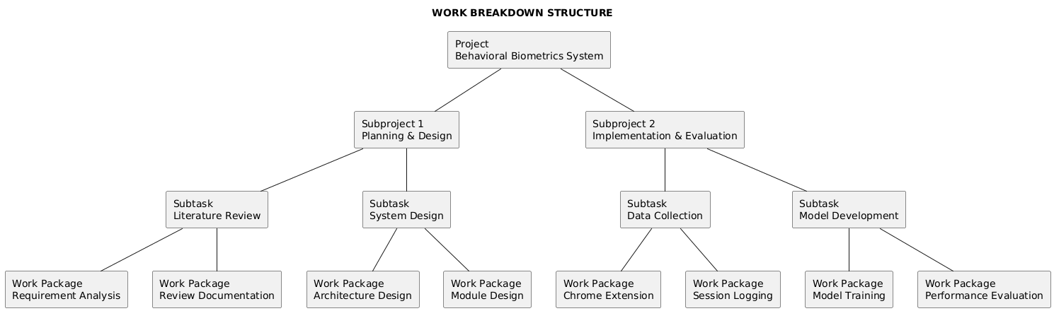

CHAPTER 3

TECHNICAL SPECIFICATION

3.1 REQUIREMENTS
This section describes the functional and non-functional requirements of the proposed behavioral analysis system used to evaluate candidate coding behavior during online assessments.

3.1.1 Functional Requirements

3.1.1.1 Administrator Functional Requirements
Session Review and Monitoring Instructors can upload completed session JSON files through the React-based web dashboard and immediately view a full behavioral analysis. The dashboard displays the session ID, verdict (GENUINE SOLVING or LINEAR TYPING DETECTED), suspicion score on a visual gauge, risk level (LOW, MEDIUM, HIGH, or CRITICAL), a grid of eight behavioral statistics including arrow key usage, backspace count, deletion ratio, editor clicks, run count, submit count, edit switches, and modifier key usage, and a list of key behavioral indicators each marked with a color-coded severity tag.
Result Interpretation and Decision Support The dashboard presents a plain-language recommendation alongside each analysis: sessions scoring below 0.3 are cleared as legitimate, scores between 0.3 and 0.6 suggest manual review, scores between 0.6 and 0.8 recommend follow-up proctoring, and scores above 0.8 flag the session for immediate review and possible disqualification. Each key indicator specifies the exact behavioral feature, its measured value, a plain-language message, and a detailed explanation, enabling instructors without a technical background to understand precisely why a session was flagged without relying solely on the automated verdict.
Report Generation The Flask API returns a structured JSON response for every session analysis containing the session ID, prediction label, suspicion score, confidence percentage, risk level, a behavioral statistics object, and a list of key indicator objects. The React dashboard renders this into a visual report that instructors can review directly in the browser. Additionally, the command-line prediction tool can output the same structured result as formatted text or JSON for integration with existing academic record systems or batch audit workflows.
3.1.1.2 General System Functional Requirements
Behavioral Event Capture During programming sessions, the Chrome extension continuously records eleven distinct event types: keydown (with key identity, modifier state, and timestamp), keyup, click (with x/y coordinates), mousemove, scroll, codeSnapshot (periodic code length snapshots), copy, paste (with character length and line count), blur (window focus lost), focus (window focus regained), and sessionStart. All events are stored locally on the candidate’s device as a JSON file and are never transmitted externally during the session, ensuring candidate privacy throughout the assessment.
Session-Based Logging All recorded events are aggregated into a single session JSON file containing the session ID, start timestamp, total duration in milliseconds, problem URL and title, label (if known), suspicion type, total event count, and the complete ordered event array. Each event carries a millisecond-precision timestamp enabling time-series behavioral analysis. Upon session completion the instructor exports this JSON file and uploads it through the React dashboard or submits it to the Flask API for analysis.
Workflow Action Detection The solution identifies and quantifies twenty-one workflow-level behavioral signals: selection operations, copy events, paste events (including character length and line count per paste), undo and redo operations, save operations, run-code shortcuts, submit shortcuts, tab switches away from the editor (blur events), time spent outside the editor between blur and focus events, paste density per minute, tab-switch density per minute, average and maximum paste length, average and maximum paste lines, large paste count (pastes exceeding 500 characters or 10 lines), pastes occurring without a prior copy event, and paste-to-copy ratio.These operations provide insight into participants' problem-solving techniques and development methodologies.
Behavioral Feature Extraction The solution will process raw interaction datasets to generate 58 behavioral indicators spanning seven categories: typing rhythm variations, deletion and correction patterns, navigational activity, mouse interaction density, code growth trajectories, sequential editing patterns, and workflow actions such as copy-paste, tab switching, and code submission behavior. These indicators form the foundation for behavioral classification.
3.1.1.3 Machine Learning Functional Requirements
Behavior Classification Two machine learning models are trained and evaluated: Logistic Regression with L2 regularization (C=0.5, balanced class weights) and Linear SVM (C=1.0, balanced class weights, probability estimation enabled). Both models are trained on 58 scaled behavioral features extracted from 32 labeled sessions using 5-fold stratified cross-validation. The best-performing model (Linear SVM, F1=1.0) is serialized and loaded by the Flask API at startup for sub-millisecond inference on new sessions. The scaler fitted during training is also saved and applied identically during prediction to prevent data leakage.
Suspicion Score Computation The suspicion score is derived from the trained model's probability output for the suspicious class using scikit-learn's predict_proba() method, producing a continuous value between 0.0 and 1.0. A score of 0.0 indicates fully genuine behaviour and 1.0 indicates maximally suspicious behaviour. The score is mapped to four risk levels: LOW (below 0.3), MEDIUM (0.3 to 0.6), HIGH (0.6 to 0.8), and CRITICAL (0.8 and above). These thresholds are applied consistently across the Flask API backend, the predictor module, and the React dashboard. In the dashboard, the score is rendered as a colour-coded arc gauge showing 0 to 100 percent, with the arc colour transitioning from green for LOW to yellow for MEDIUM, orange for HIGH, and red for CRITICAL.
Explainable Prediction Output The predictor module's _analyze_indicators method evaluates each session against reference distributions and flags features that deviate significantly from expected genuine behaviour. Each indicator returned in the Flask API response contains a feature name, the observed value, a plain-language message describing what the value means, an optional detail field providing context, and a severity type (critical, warning, or info). The React dashboard renders these indicators as a colour-coded list with red tags for critical findings, yellow for warnings, and green for normal observations. This design allows reviewers without a machine learning background to understand which specific behaviours triggered the alert, such as an unusually low backspace ratio, consistently uniform inter-key timing, or absence of navigation key usage, and to make an informed decision about whether to escalate the case for further review.
3.1.2 Non-Functional Requirements
3.1.2.1 Performance Requirements
Efficient Event Processing The system has two distinct event processing layers. The Chrome extension captures keyboard, mouse, scroll, focus, and workflow events using lightweight asynchronous JavaScript listeners that push events into an in-memory array without blocking the browser's main thread, ensuring that LeetCode's editor remains fully responsive throughout the session. The Flask API backend processes the uploaded session JSON synchronously using NumPy and scikit-learn, completing feature extraction and model inference in well under one second for typical session files. The React dashboard renders results immediately upon receiving the API response with no perceptible delay.
Low Resource Overhead The Chrome extension maintains a single event array in memory and performs no computation during the session, keeping its resource footprint negligible on the candidate's machine. The Flask API loads the serialised model and scaler once at startup, avoiding repeated disk reads during inference. The React dashboard is a static single-page application built with Vite and requires only a modern browser with no additional installation on the instructor's machine. The Python-based feature extractor and model trainer are intended for offline use on the instructor's or researcher's machine and require standard hardware meeting the minimum specification outlined in Section 3.3.1.
3.1.2.2 Availability Requirements
Continuous System Operation The system comprises two independent subsystems with separate availability requirements. The Chrome extension must remain active for the full duration of the candidate's coding session; because it stores events locally in browser memory and writes to a JSON file only on export, no network connectivity is required during data collection, and no server outage can disrupt event capture. The Flask API and React dashboard are used only after the session is complete for post-session analysis, so brief downtime during data collection has no impact. In a future production deployment, the analysis server should target high uptime to support timely review of submitted sessions.
Fault Tolerance The Chrome extension writes all captured events to a local JSON file on the candidate's device at the point of export, meaning that even if the browser crashes mid-session, any events buffered in memory up to that point are preserved in the extension's storage. The feature extractor handles missing or null values by filling them with zero before model inference, preventing crashes due to incomplete sessions. The Flask API cleans up temporary files after each request using a try-finally block, ensuring no disk accumulation even if an error occurs during processing.
3.1.2.3 Scalability Requirements
Concurrent Session Support The current prototype processes sessions individually in batch mode after a coding session is completed. In a production deployment, the system should be extended to accommodate multiple simultaneous session analysis requests without performance deterioration. This is a planned future enhancement for institutional environments where numerous participants may submit sessions concurrently.
Scalable Architecture The system's decoupled architecture supports independent scaling of each component. The Chrome extension scales horizontally by design since each candidate runs a separate instance with no shared state. The Flask REST API is stateless between requests, loading the model once at startup and processing each uploaded session file independently, making it straightforward to deploy behind a load balancer or to containerise using Docker for cloud deployment. The React frontend is a fully static build that can be served from any CDN or web server without modification. This separation of concerns means that the data collection, analysis, and presentation layers can each be scaled or replaced independently as institutional demand grows.
3.1.2.4 Usability Requirements
Non-Intrusive Operation The system is non-intrusive at two levels. For candidates, the Chrome extension operates entirely in the background as a standard browser extension, adding no visible UI elements to the LeetCode editor and producing no audible or visual interruptions. Candidates are aware the extension is installed but are not required to interact with it at any point during their coding session. For instructors, the React dashboard provides a clean single-page interface that requires no installation, no command-line knowledge, and no technical expertise; instructors interact only through a drag-and-drop file upload and receive a fully formatted visual report within seconds.
Minimal User Interaction Candidates are not required to perform any configuration or activation steps during a coding session. The Chrome extension begins capturing events automatically once the candidate opens a LeetCode problem page, and stops when the page is closed. The only deliberate action required is clicking the extension's export button at the end of the session to save the JSON file. For instructors, the entire analysis workflow consists of opening the React dashboard in a browser, dragging the session JSON file onto the upload area, and clicking the Analyze Session button. No installation, login, or command-line interaction is needed at any stage of the instructor workflow.
3.1.2.5 Maintainability and Extensibility Requirements
Modular System Design The system is organised into five independent modules with clearly defined interfaces. The Chrome extension handles data collection and export with no dependency on the analysis backend. The feature extractor (feature_extractor_v4.py) encapsulates all 58 feature computations in a single class and can be updated or extended without modifying the model trainer or predictor. The model trainer (model_trainer_final.py) handles the full training pipeline independently and outputs serialised artefacts consumed by the predictor. The predictor (predictor_final.py) loads these artefacts and performs inference, serving as the backend for the Flask API. The Flask API (backend/app.py) and the React frontend are fully decoupled through a JSON REST interface, allowing either to be replaced or upgraded independently.
Support for Future Enhancements The architecture is designed to accommodate future enhancements without restructuring the system. New behavioral features can be added by extending the ImprovedBehaviorExtractor class and retraining the model with the updated feature set. Alternative models such as gradient boosting or neural networks can be substituted in the training pipeline by modifying only the model_trainer_final.py file. Planned future enhancements include support for additional coding platforms beyond LeetCode, real-time streaming analysis rather than post-session batch processing, a multi-user authentication layer for the instructor dashboard, and an expanded dataset incorporating a greater diversity of coding styles and problem types to improve generalisation across populations.
3.1.2.6 Security Requirements
Secure Data Handling The solution must ensure protected storage and processing of accumulated interaction information to prevent unauthorized access. In the current prototype, session files are processed locally and never transmitted to external servers. In a production deployment, all data transfers between the browser extension, backend API, and instructor interface should be secured using HTTPS, with access control mechanisms to ensure only authorized personnel can view assessment results.
Controlled Administrative Access In the current prototype, the Flask API and React dashboard operate without an authentication layer, as the system is intended for controlled research use on a local network. Session files are processed ephemerally and are not stored on the server after analysis, reducing the risk of unauthorised access to candidate data. In a production deployment, the dashboard should be protected by institutional single sign-on or role-based access control to ensure that only authorised instructors and administrators can upload session files and view analysis results. The Flask API should additionally be placed behind HTTPS and configured to reject requests from unauthorised origins using appropriate CORS policies.

3.2 FEASIBILITY STUDY
A feasibility study is conducted to evaluate the practicality of implementing the proposed behavioral analysis system for online coding assessments. The study examines the system from technical, economic, and social perspectives to ensure that it is realistic, sustainable, and acceptable in real-world environments.
3.2.1 Technical Feasibility
The proposed system is technically feasible as it is developed using widely available and mature technologies. The behavioral data collection is implemented using a Chrome extension, which can reliably capture user interaction events such as keystrokes, navigation actions, and editing behavior during coding sessions. Feature extraction and machine learning components are implemented using Python-based libraries that support efficient data processing and model development.
The system does not require specialized hardware or complex infrastructure, and it can operate on standard computing environments. Additionally, the modular architecture allows easy integration with existing online coding platforms, making the system adaptable and scalable for different assessment environments.
3.2.2 Economic Feasibility
The project is economically feasible as it primarily relies on open-source tools and freely available software technologies. Development tools such as Python, JavaScript, and machine learning libraries incur no licensing costs. Data storage requirements are minimal, as the system stores only behavioral metadata rather than large multimedia files.
Since the system does not require continuous human supervision or expensive proctoring resources, it significantly reduces operational costs compared to traditional monitoring methods. This makes the solution cost-effective and suitable for deployment in educational institutions and recruitment platforms.
3.2.3 Social Feasibility
The proposed system is socially feasible as it focuses on analyzing coding behavior rather than monitoring personal activities. By evaluating interaction patterns during code development, the system avoids intrusive surveillance methods that may cause discomfort or resistance among users.
The system supports fairness by distinguishing different coding behavior patterns and providing explainable results that can be reviewed by evaluators. This approach promotes transparency and acceptance among students and educators, making it suitable for use in academic and professional assessment settings.

3.3 SYSTEM SPECIFICATION
This section outlines the hardware and software requirements of the proposed system. The specifications are selected to ensure reliable data collection, efficient feature processing, and effective machine learning model execution without requiring specialized infrastructure.
3.3.1 Hardware Specification
The system has two hardware roles: the candidate machine running Chrome with the extension installed, and the analysis machine running the Flask API, React dashboard, and Python tools. Both roles can be fulfilled by standard consumer hardware. The specifications below apply to the analysis machine unless otherwise noted; the candidate machine requires only a modern computer capable of running Google Chrome.
Component | Specification | Rationale
Processor | Intel Core i3 or equivalent | Sufficient for running browser extensions and machine learning tasks
RAM | 8 GB minimum | Required for handling behavioral data processing and model training
Storage | 50 GB free disk space | Used for storing session logs, datasets, and model files
System Architecture | 64-bit | Supports modern operating systems and ML libraries
Input Devices | Keyboard and Mouse | Necessary for capturing user interaction behavior
Network | Stable Internet Connection | Required on the candidate machine to access LeetCode; the analysis machine requires local network access to serve the Flask API and React dashboard
Python Runtime | Python 3.8 or later (analysis machine only) | Required to run the Flask REST API, feature extractor, and model trainer
3.3.2 Software Specification
The software tools and technologies are selected to support data collection, feature extraction, and machine learning analysis. All technologies used are open-source or freely available, ensuring ease of development and maintenance.
Component | Technology | Purpose
Operating System | Windows / Linux / macOS | Provides the execution environment for the system
Programming Language | Python | Feature extraction and machine learning model development
Programming Language | JavaScript | Development of Chrome extension for behavioural data capture
Browser | Google Chrome | Executes the Chrome extension during assessments
ML Library | Scikit-learn | Training and evaluating machine learning models
Data Processing Library | NumPy, Pandas | Efficient processing of behavioural data
Data Format | JSON | Storage and interchange of interaction logs
Development Tool | Visual Studio Code | Code development and debugging
Backend Framework | Flask (Python) | REST API for session analysis and prediction
Frontend Framework | React 19 + Vite 6 | Web-based instructor dashboard for session upload and result review

CHAPTER 4
DESIGN APPROACH AND DETAILS

4.1 SYSTEM ARCHITECTURE
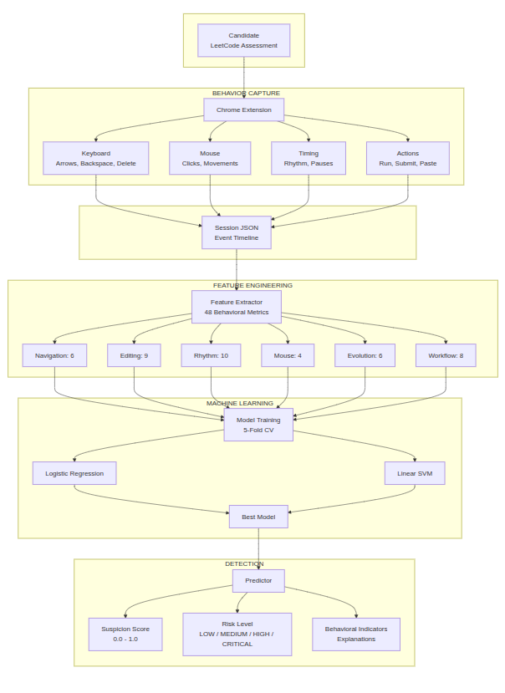

4.2 DESIGN
4.2.1 Sequence Diagram
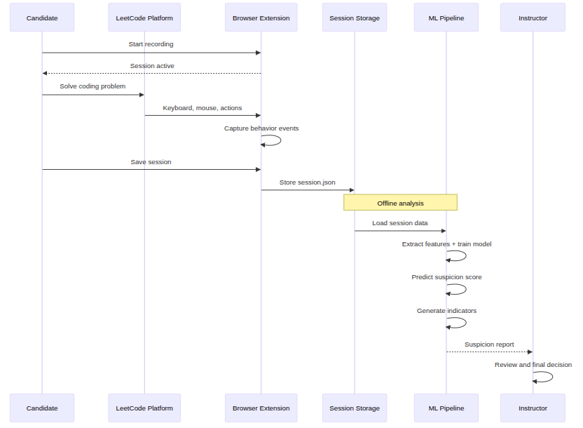

4.2.2 ER Diagram
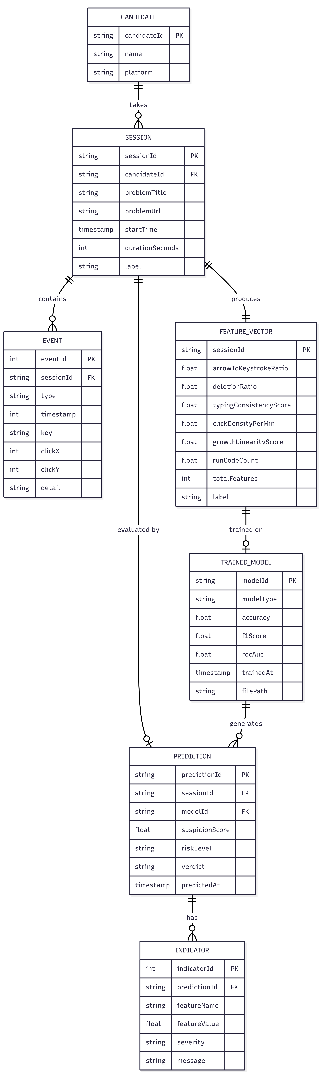

4.2.3 Use Case Diagram
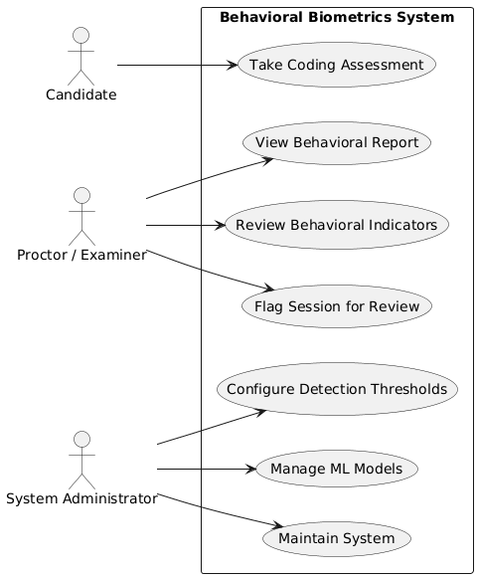

4.2.4 Activity Diagram
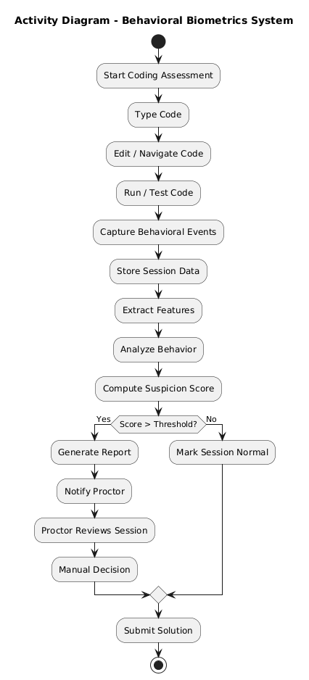
4.2.5 Data Flow Diagram
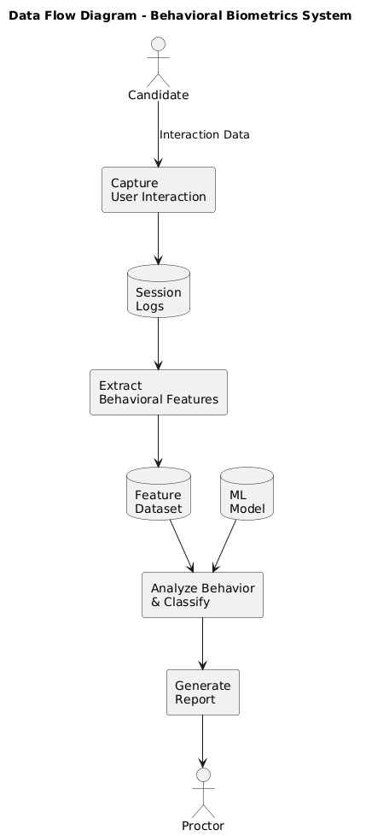

REFERENCES
Journals
- Chukharev-Hudilainen, E. (2014). Pauses in spontaneous written communication: A keystroke logging study. Journal of Writing Research, 6(1), 61–89.
- Clark, E., August, T., Serrano, S., Haduong, N., Gururangan, S., & Smith, N. A. (2021). All that’s human is not gold: Evaluating human evaluation of generated text. arXiv preprint, arXiv:2107.00061.
- Duanli, Y., Fauss, M., Hao, J., & Cui, W. (2023). Detection of AI-generated essays in writing assessments. Psychological Test and Assessment Modeling.
- Foltýnek, T., Meuschke, N., & Gipp, B. (2019). Academic plagiarism detection: A systematic literature review. ACM Computing Surveys (CSUR).
- Frohling, L., & Zubiaga, A. (2021). Feature-based detection of automated language models: Tackling GPT-2, GPT-3 and Grover. PeerJ Computer Science.
- Jiang, Y., Zhang, M., Hao, J., Deane, P., & Li, C. (2024). Using keystroke behavior patterns to detect nonauthentic texts in writing assessments: Evaluating the fairness of predictive models. Journal of Educational Measurement.
- Shadman, R., Wahab, A. A., Manno, M., Lukaszewski, M. S., Hou, D., & Hussain, F. (2023). Keystroke dynamics: Concepts, techniques, and applications. arXiv preprint.
- Lamba, S., & Sharma, N. (2024). Deep learning-based multimodal cheating detection in online proctored exams. Journal of Educational Technology Systems, 20(3).
- Weiss, M. (2019). Deepfake bot submissions to federal public comment websites cannot be distinguished from human submissions. Technology Science. Published December 17, 2019.
- Acien, A., Morales, A., Monaco, J. V., Vera-Rodriguez, R., & Fierrez, J. (2022). TypeNet: Deep learning keystroke biometrics. IEEE Transactions on Biometrics, Behavior, and Identity Science (TBIOM).
- Hearst, M. A., Dumais, S. T., Osuna, E., Platt, J., & Schölkopf, B. (1998). Support vector machines. IEEE Intelligent Systems and Their Applications, 13(4), 18–28.
- Kamra, A., Khurana, S., & Goel, A. (2025). Keystroke dynamics based user authentication focusing on fixed text approaches. In Proceedings of the 3rd International Conference on Device Intelligence, Computing and Communication Technologies (DICCT 2025) (pp. 427–432). IEEE.
- Peng, J., Lee, K., & Ingersoll, G. (2002). An introduction to logistic regression analysis and reporting. Journal of Educational Research, 96(1), 3–14.
- Chung, M. K. (2020). Introduction to logistic regression. arXiv preprint, arXiv:2008.13567.
- Maalouf, M. (2011). Logistic regression in data analysis: An overview. International Journal of Data Analysis Techniques and Strategies, 3(4), 281–299.
- Giray, L. (2024). The problem with false positives: AI detection unfairly accuses scholars of AI plagiarism. The Serials Librarian, 85(1), 1–9.
- González, N. (2023). KSDSLD — A tool for keystroke dynamics synthesis and liveness detection. Software Impacts, 15, 100454.
- Teh, P. S., Teoh, A. B., & Yue, S. (2013). A survey of keystroke dynamics biometrics. The Scientific World Journal, 2013, 408280.
- Portugal, D., Faria, J., Belk, M., Martins, P., Constantinides, A., Pietron, A., Pitsillides, A., Avouris, N., & Fidas, C. (2023). Continuous user identification in distance learning: A recent technology perspective. Smart Learning Environments, 10, Article 55.
- Tiong, L. C. O., Lee, Y., Lim, K. L., & Lee, H. J. (2024). Advancing online assessment integrity: Integrated misconduct detection via Internet Protocol analysis and behavioral classification. IEEE Access, 12, 106056–106069.
- Subash, A., Song, I., Lee, I., & Lee, K. (2025). Integrating user demographic parameters for mouse behavioral biometric-based assessment fraud detection in online education platforms. EURASIP Journal on Information Security, 2025(1), Article 21.
- Traore, I., Woungang, I., Obaidat, M. S., Nakkabi, Y., & Lai, I. (2014). Online risk-based authentication using behavioral biometrics. Multimedia Tools and Applications, 71(2), 575–605.
- Garg, M., & Goel, A. (2025). A comprehensive approach for mitigating impersonation in online assessment: Integrity policy and random authentication. International Journal of Information Security, 24(1).
Conferences
- Dugan, L., Ippolito, D., Kirubarajan, A., Shi, S., & Callison-Burch, C. (2023). Real or fake text? Investigating human ability to detect boundaries between human-written and machine-generated text. In Proceedings of the AAAI Conference on Artificial Intelligence.
- Ippolito, D., Duckworth, D., Callison-Burch, C., & Eck, D. (2019). Automatic detection of generated text is easiest when humans are fooled. arXiv preprint, arXiv:1911.00650.
- Roh, D., Kumar, R., & Ngo, A. (2025). LLM-assisted cheating detection in Korean language via keystrokes. In Proceedings of the IEEE International Joint Conference on Biometrics (IJCB).
- Uchendu, A., Le, T., Shu, K., & Lee, D. (2020). Authorship attribution for neural text generation. In Proceedings of the Conference on Empirical Methods in Natural Language Processing (EMNLP).
- Rebira, J., & Kumar, R. (2025). How well do LLMs imitate human writing style? In Proceedings of the IEEE UEMCON. New York, NY, United States.
- Niu, C., Shih, Y.-S., Liao, M., Liu, R., & Ortmann Lee, A. (2025). Keystroke analysis in digital test security: AI approaches for copy-typing detection and cheating ring identification. In Proceedings of an international conference on natural language processing and assessment security. Duolingo, Inc.
- Crossley, S., Tian, Y., Choi, J. S., Holmes, L., & Morris, W. (2024). Plagiarism detection using keystroke logs. In Proceedings of an international conference on educational data mining and writing analytics (Version v1). July 12, 2024.
- Amigud, A., Arnedo-Moreno, J., Daradoumis, T., & Guerrero-Roldan, A.-E. (2016). A behavioral biometrics based and machine learning aided framework for academic integrity in e-assessment. In Proceedings of the 2016 International Conference on Intelligent Networking and Collaborative Systems (INCoS) (pp. 255–262). IEEE.
- Subash, A., & Song, I. (2021). Real-time behavioral biometric information security system for assessment fraud detection. In Proceedings of the 2021 IEEE International Conference on Computing (ICOCO) (pp. 186–191). IEEE.
- Amigud, A., Arnedo-Moreno, J., Daradoumis, T., & Guerrero-Roldan, A.-E. (2016). A behavioral biometrics based and machine learning aided framework for academic integrity in e-assessment. In Proceedings of the 2016 International Conference on Intelligent Networking and Collaborative Systems (INCoS) (pp. 255–262). IEEE.
- Haytom, A., Rosenberger, C., Charrier, C., Zhu, C., & Régnier, C. (2019). Biometric application for authentication and management of online exams. In Proceedings of the Summer School on Biometrics and Forensics. Alghero, France.

Book Chapters / Reports
- Chadaga, N. V. (2025). How candidates use technology to cheat in online technical assessments.
- Revett, K. (2008). Behavioral Biometrics: A Remote Access Approach. Germany: John Wiley & Sons.
- Evgeniou, T., & Pontil, M. (2001). Support vector machines: Theory and applications. In Lecture Notes in Computer Science (Vol. 2049, pp. 249–257). Springer.
- Holloway, L. (2025). How to cheat in exams using AI (and how to prevent it).
- Kochegurova, E. A., & Zateev, R. P. (2022). Hidden monitoring based on keystroke dynamics in online examination systems.
- Soparkar, S. (2025). Proctoring in the age of AI: Tackling modern cheating techniques.
- Sharma, M., & Elmiligi, H. (2022). Behavioral biometrics: Past, present and future. In M. Sarfraz (Ed.), Recent advances in biometrics (Chap. 4). IntechOpen.
Other Academic Works
- Dempere, J., Modugu, K., Hesham, A., & Ramasamy, L. K. (2023). The impact of ChatGPT on higher education. Frontiers in Education.
- The failure of plagiarism detection in competitive programming.
- Mining online homework clickstream: Detecting students’ cooperative behavior.
- Behavioral biometrics for continuous authentication in the Internet-of-Things era: An artificial intelligence perspective.
- User authentication method based on keystroke dynamics and mouse dynamics with scene-irrelevant features in hybrid scenes.
- Keystroke dynamics analysis and prediction with XGBoost.
Web links:
- Coley, M. (2023, August 16). Guidance on AI detection and why we’re disabling Turnitin’s AI detector. Vanderbilt University. (https://www.vanderbilt.edu/brightspace/2023/08/16/guidance-on-ai-detection-and-why-were-disabling-turnitins-ai-detector/)
- Plurilock. (n.d.). Keystroke dynamics.(https://plurilock.com/deep-dive/keystroke-dynamics)
- ASEE Cybersecurity Blog. (n.d.). What is behavioral biometrics authentication? (https://cybersecurity.asee.io/blog/what-is-behavioral-biometrics-authentication/)
- CrossClassify. (n.d.). Behavioral biometrics for fraud prevention. (https://www.crossclassify.com/resources/articles/behavioral-biometrics-fraud-prevention/)

