Data Flow Diagram

0-level DFD:

System

Output

Users/Admin

2-level DFD:

2.1

Administrator/users

CheckingProcess

Login Process

Login Failed

Company

Data Stored

After login

Data Entry

Data Stored

Data Entry

Data Entry

Data Entry

After login

After login

After login

Data Stored

Data Stored

Category

Configuration

Product

Administrator/Users

Config

Entry

Product Entry

CompanyEntry

Category Entry

2-level DFD:

2.2

Administrator/users

CheckingProcess

Login Process

Login Failed

Stock

Add  
products

Stock Record

Select customer

Customer Record

Update  
Stock

Stock

Data Stored

After login

Data Entry

Data Stored

Data Entry

Data Entry

After login

After login

After login

Data Stored

Data Stored

Customer

Product Sold

Sales

Administrator/Users

Billing (Sales)

Stock Entry

CustomerEntry

Database Tables

Category:Table  
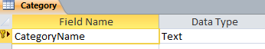  
Company:Table  
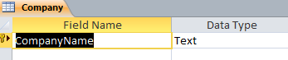  
Product:Table  
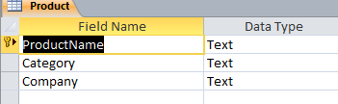  
Config:Table  
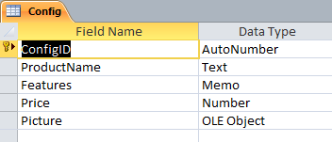  
Stock:Table  
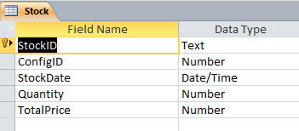  
Users:Table  
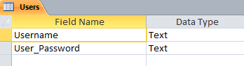  
Customer :Table  
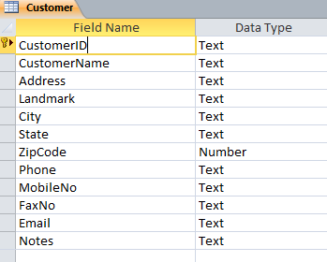  
Sales:Table  
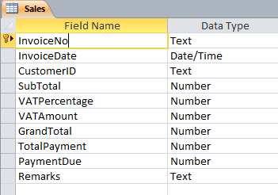  
ProductSold:Table  
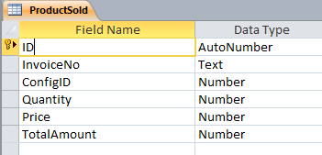

Registration:Table  
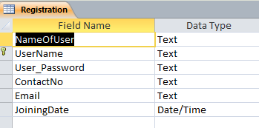  
  
  
 Database Diagram  
  
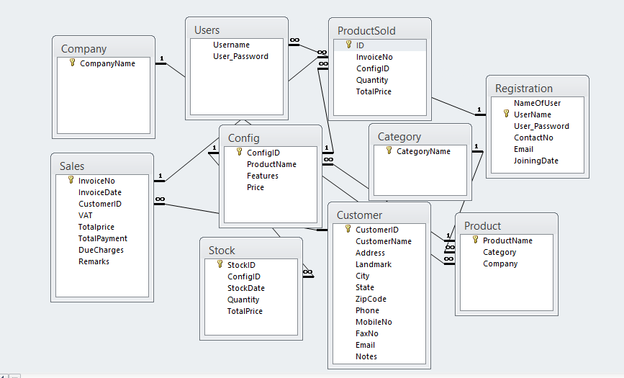

Dependency Graph

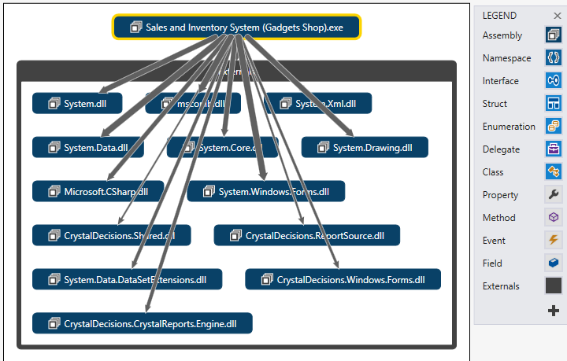  
  
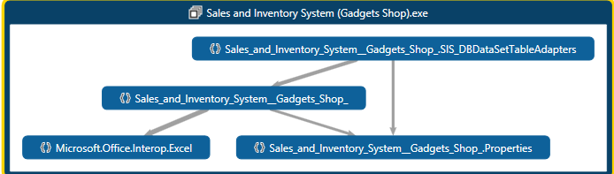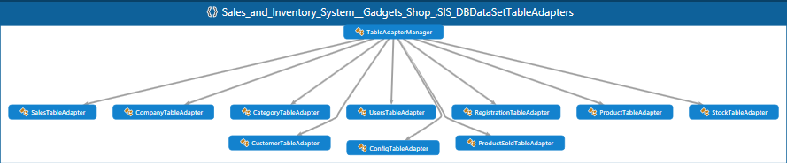  
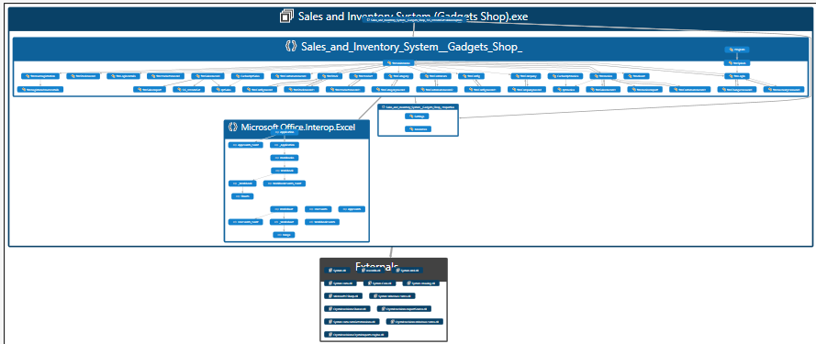 Windows Forms  
  
Splash Form  
  
  
Category Form  
  
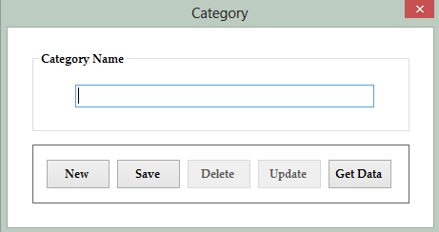

Login Form  
  
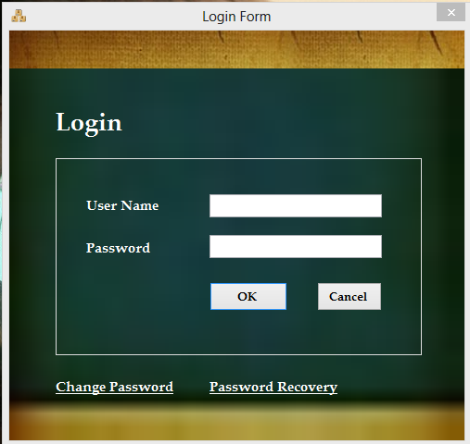  
  
Company Form  
  
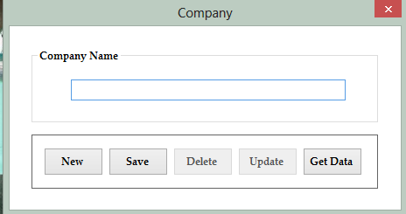

Product Form  
  
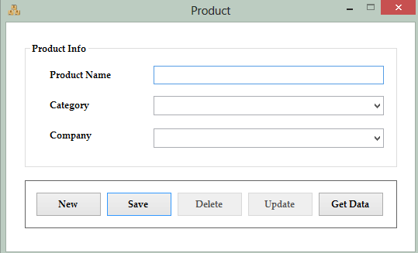  
  
Config Form  
  
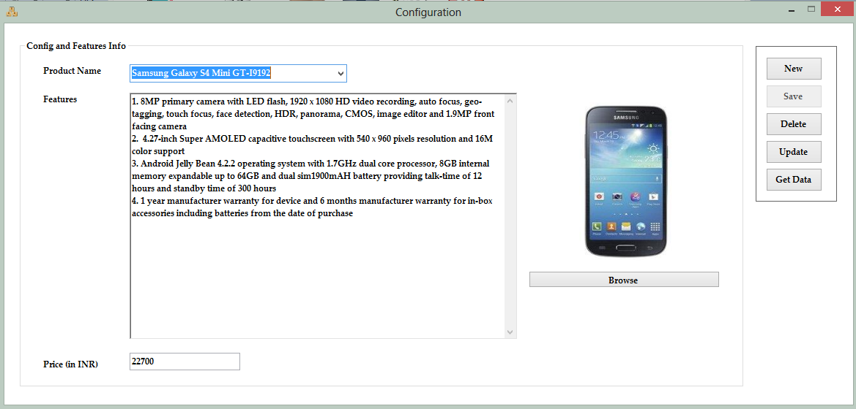  
Customer Form  
  
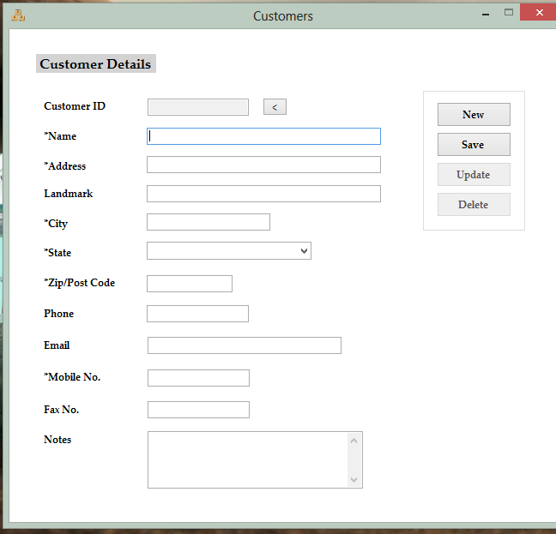

Registration Form  
  
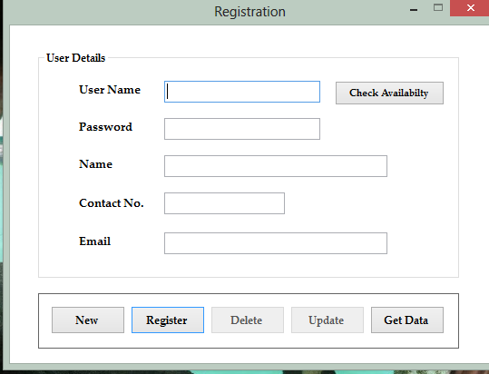  
  
Stock Form  
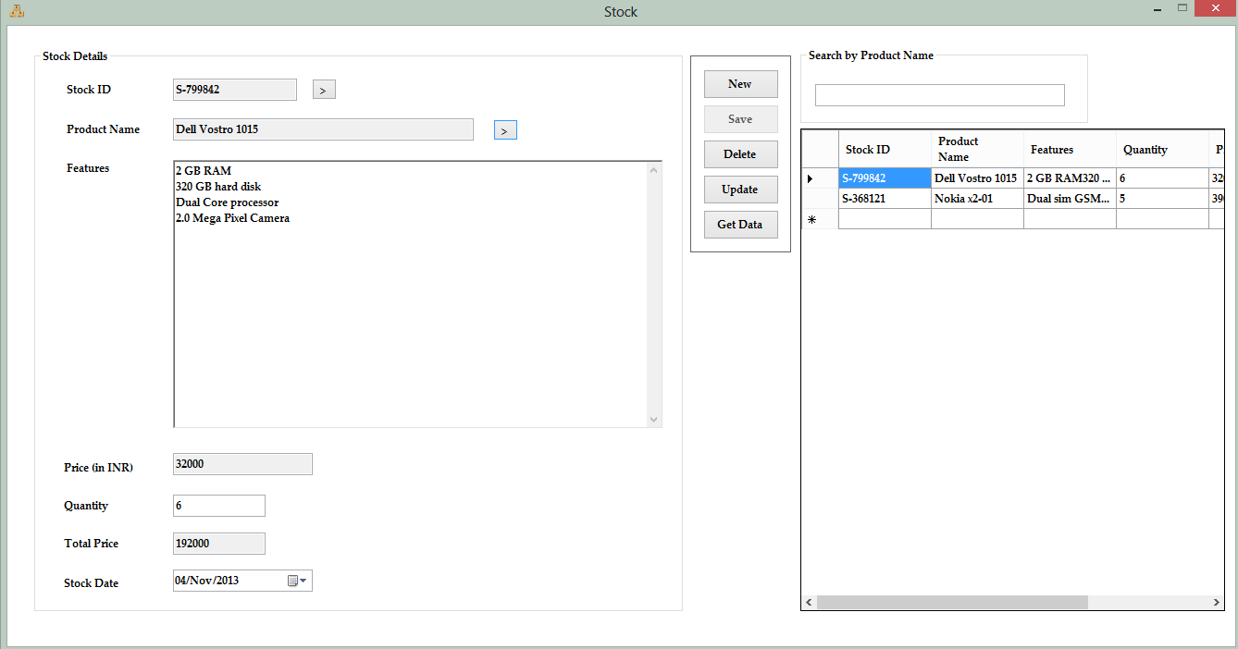Sales (Billing) Form  
  
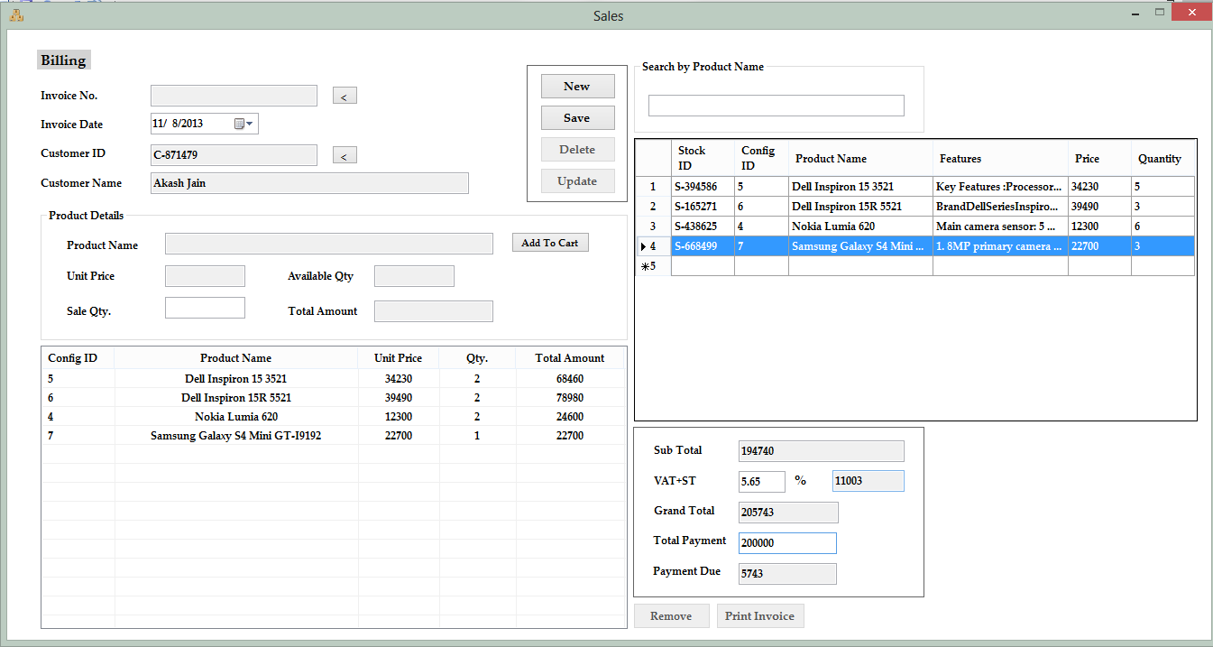

Invoice  
  
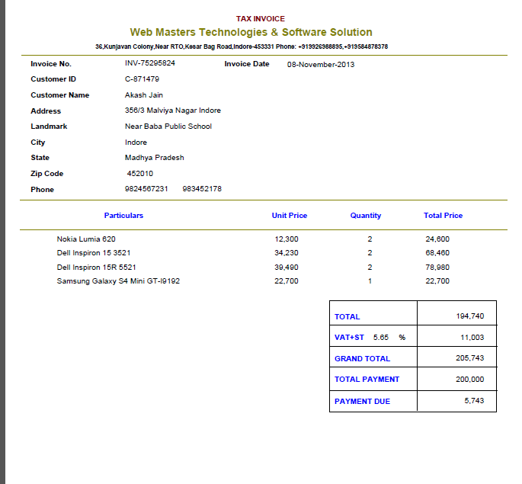

Main & About Form  
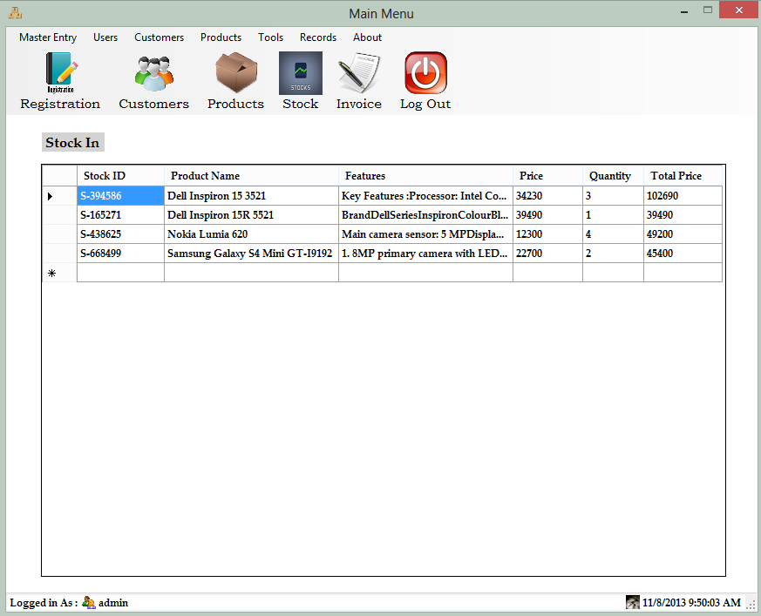  
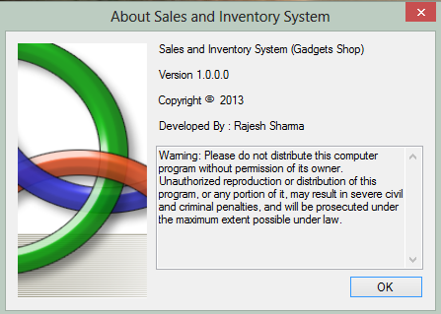

Dependency Graph

  
  
  
 Windows Forms  
  
Splash Form  
  
  
Category Form  
  


Login Form  
  
  
  
Company Form  
  


Product Form  
  
  
  
Config Form  
  
  
Customer Form  
  


Registration Form  
  
  
  
Stock Form  
Sales (Billing) Form  
  


Data Flow Diagram

0-level DFD:  
  
 1-level DFD:

System

Output

Users/Admin

Registration Process

Report Generation

Login Process

Config Entry

Product Entry

Company Entry

Category Entry

Master Entry

Customer Entry

Stock Entry

Invoice Generation

Data Flow Diagram

0-level DFD:

System

Output

Users/Admin

2-level DFD:

2.1

Administrator/users

CheckingProcess

Login Process

Login Failed

Company

Data Stored

After login

Data Entry

Data Stored

Data Entry

Data Entry

Data Entry

After login

After login

After login

Data Stored

Data Stored

Category

Configuration

Product

Administrator/Users

Config

Entry

Product Entry

CompanyEntry

Category Entry

2-level DFD:

2.2

Administrator/users

CheckingProcess

Login Process

Login Failed

Stock

Add  
products

Stock Record

Select customer

Customer Record

Update  
Stock

Stock

Data Stored

After login

Data Entry

Data Stored

Data Entry

Data Entry

After login

After login

After login

Data Stored

Data Stored

Customer

Product Sold

Sales

Administrator/Users

Billing (Sales)

Stock Entry

CustomerEntry

Database Tables

Category:Table  
  
Company:Table  
  
Product:Table  
  
Config:Table  
  
Stock:Table  
  
Users:Table  
  
Customer :Table  
  
Sales:Table  
  
ProductSold:Table  


Registration:Table  
  
  
  
 Database Diagram  
  


Dependency Graph

  
  
  
 Windows Forms  
  
Splash Form  
  
  
Category Form  
  


Login Form  
  
  
  
Company Form  
  


Product Form  
  
  
  
Config Form  
  
  
Customer Form  
  


Registration Form  
  
  
  
Stock Form  
Sales (Billing) Form  
  


Invoice  
  


Main & About Form  
  


Dependency Graph

  
  
  
 Windows Forms  
  
Splash Form  
  
  
Category Form  
  


Login Form  
  
  
  
Company Form  
  


Product Form  
  
  
  
Config Form  
  
  
Customer Form  
  


Registration Form  
  
  
  
Stock Form  
Sales (Billing) Form  
  


Data Flow Diagram

0-level DFD:  
  
 1-level DFD:

System

Output

Users/Admin

Registration Process

Report Generation

Login Process

Config Entry

Product Entry

Company Entry

Category Entry

Master Entry

Customer Entry

Stock Entry

Invoice Generation

2-level DFD:

2.1

Administrator/users

CheckingProcess

Login Process

Login Failed

Company

Data Stored

After login

Data Entry

Data Stored

Data Entry

Data Entry

Data Entry

After login

After login

After login

Data Stored

Data Stored

Category

Configuration

Product

Administrator/Users

Config

Entry

Product Entry

CompanyEntry

Category Entry

2-level DFD:

2.2

Administrator/users

CheckingProcess

Login Process

Login Failed

Stock

Add  
products

Stock Record

Select customer

Customer Record

Update  
Stock

Stock

Data Stored

After login

Data Entry

Data Stored

Data Entry

Data Entry

After login

After login

After login

Data Stored

Data Stored

Customer

Product Sold

Sales

Administrator/Users

Billing (Sales)

Stock Entry

CustomerEntry

Database Tables

Category:Table  
  
Company:Table  
  
Product:Table  
  
Config:Table  
  
Stock:Table  
  
Users:Table  
  
Customer :Table  
  
Sales:Table  
  
ProductSold:Table  


Registration:Table  
  
  
  
 Database Diagram  
  


Dependency Graph

  
  
  
 Windows Forms  
  
Splash Form  
  
  
Category Form  
  


Login Form  
  
  
  
Company Form  
  


Product Form  
  
  
  
Config Form  
  
  
Customer Form  
  


Registration Form  
  
  
  
Stock Form  
Sales (Billing) Form  
  


Invoice  
  


Main & About Form  
  


Dependency Graph

  
  
  
 Windows Forms  
  
Splash Form  
  
  
Category Form  
  


Login Form  
  
  
  
Company Form  
  


Product Form  
  
  
  
Config Form  
  
  
Customer Form  
  


Registration Form  
  
  
  
Stock Form  
Sales (Billing) Form  
  


Data Flow Diagram

0-level DFD:  
  
 1-level DFD:

System

Output

Users/Admin

Registration Process

Report Generation

Login Process

Config Entry

Product Entry

Company Entry

Category Entry

Master Entry

Customer Entry

Stock Entry

Invoice Generation