Supplemental Materials

William Norfolk

11/27/2019

The script contains the supplementary figures files generated by research project “Analysis of citizen science water quality monitoring in Key Largo, Florida.” All figure paths are relative to their locations within the project directory. For in depth details of figure creation, evaluation, or additional supporting/testing/evaluation figures please see the embedded coding commentary within script of orgin indicated by the subtitile of the figure section.

library(knitr)

## Exploratory Analysis Seasonal

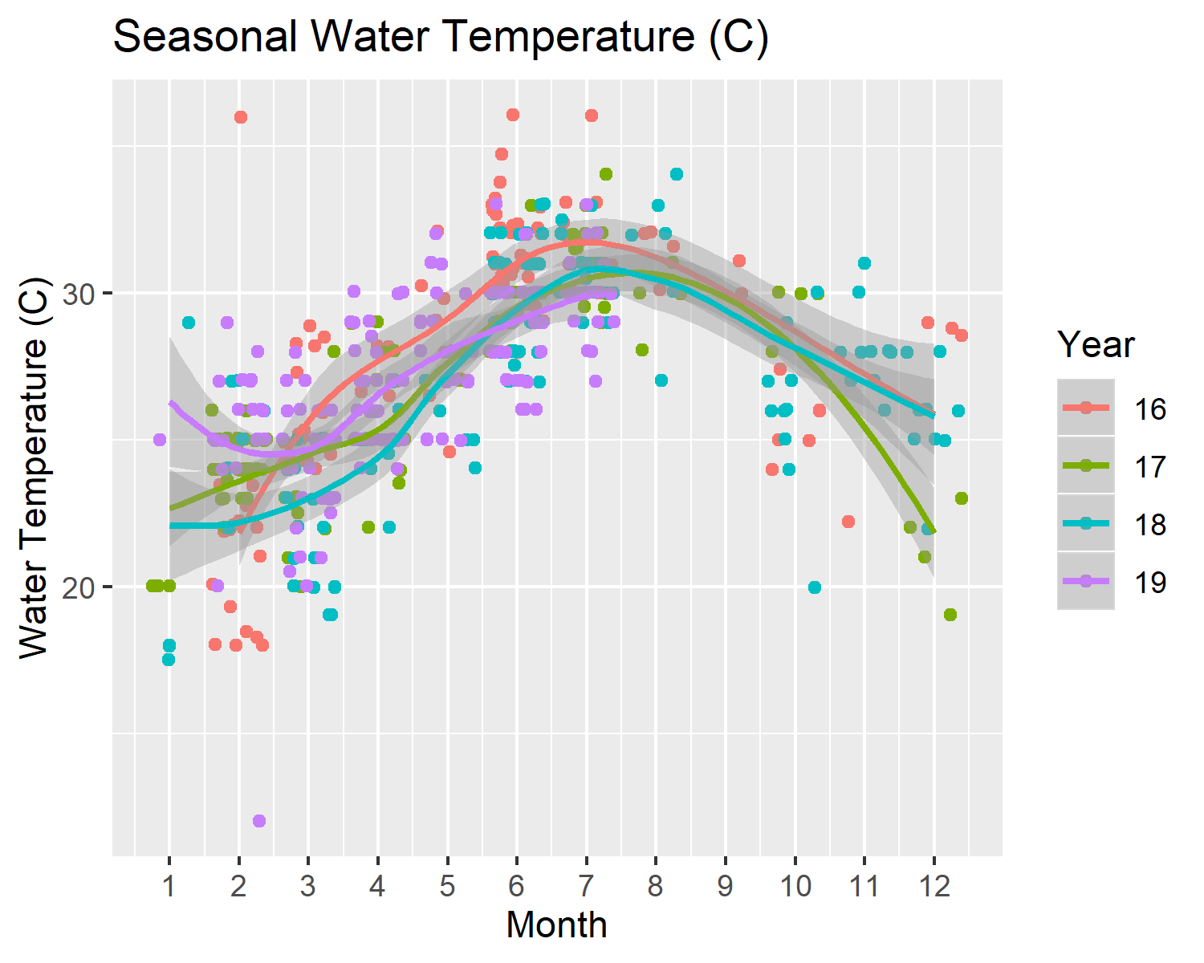

Seasonal water temperature (C) levels in Key Largo, Florida from 2016-2019.

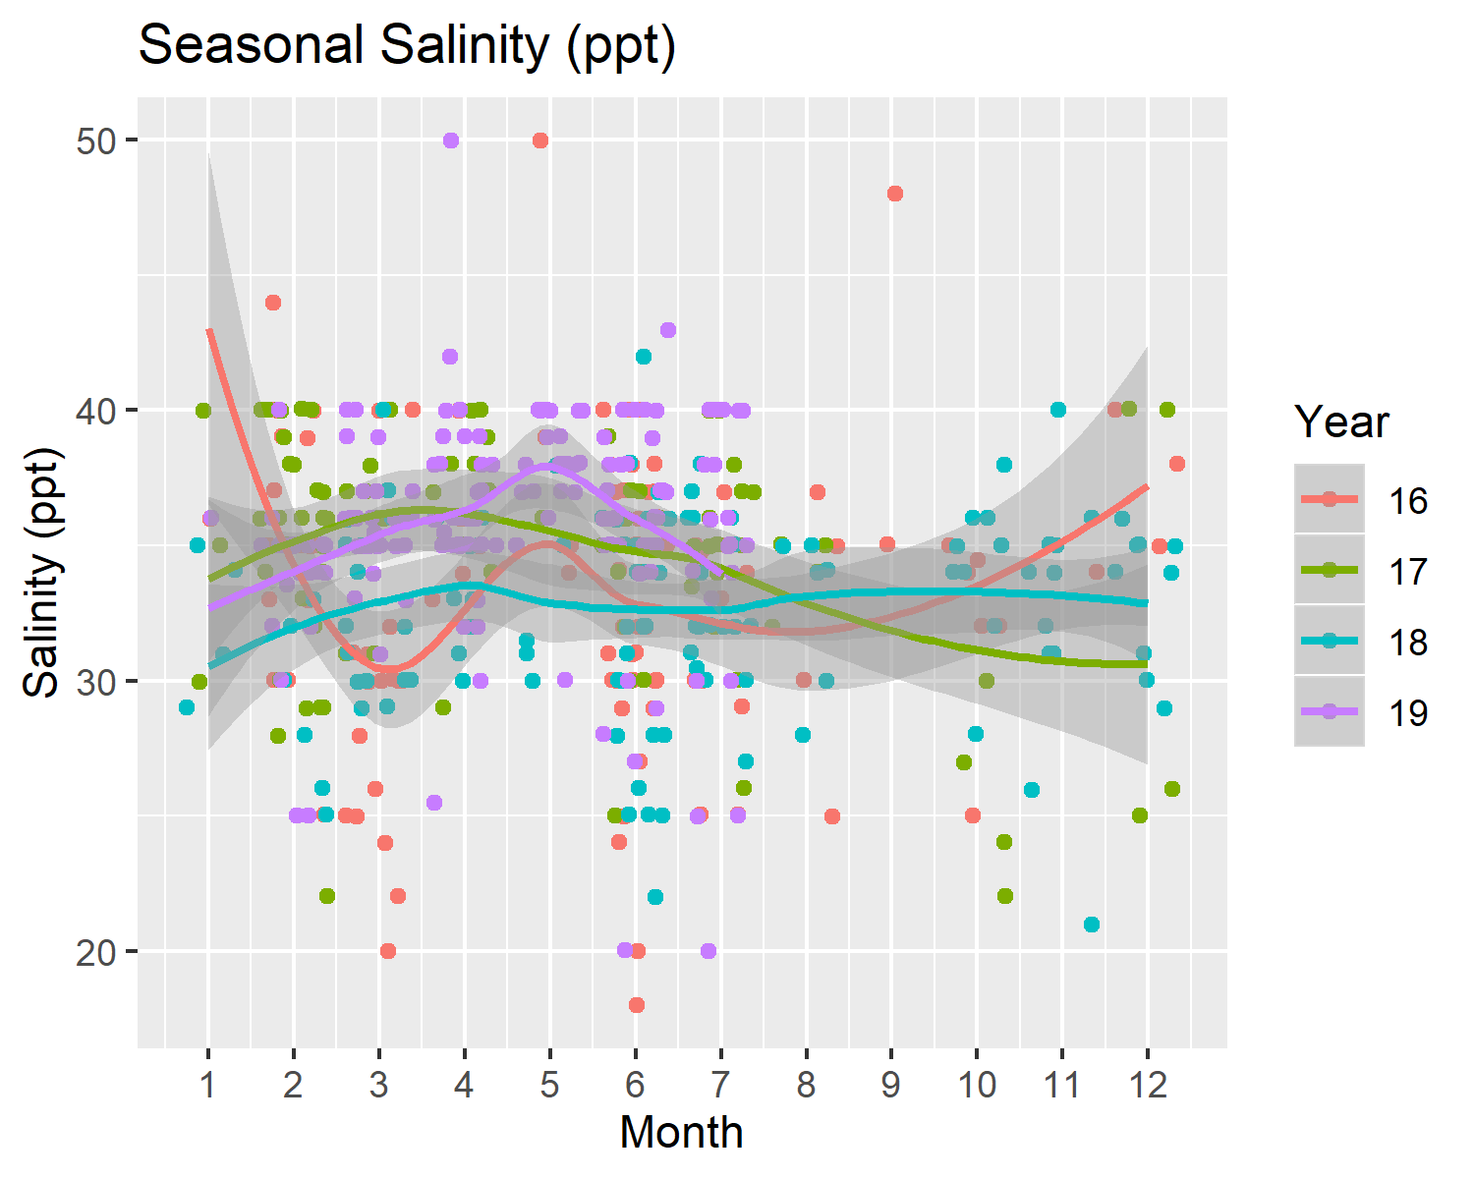

Seasonal salinity (ppt) levels in Key Largo, Florida from 2016-2019.

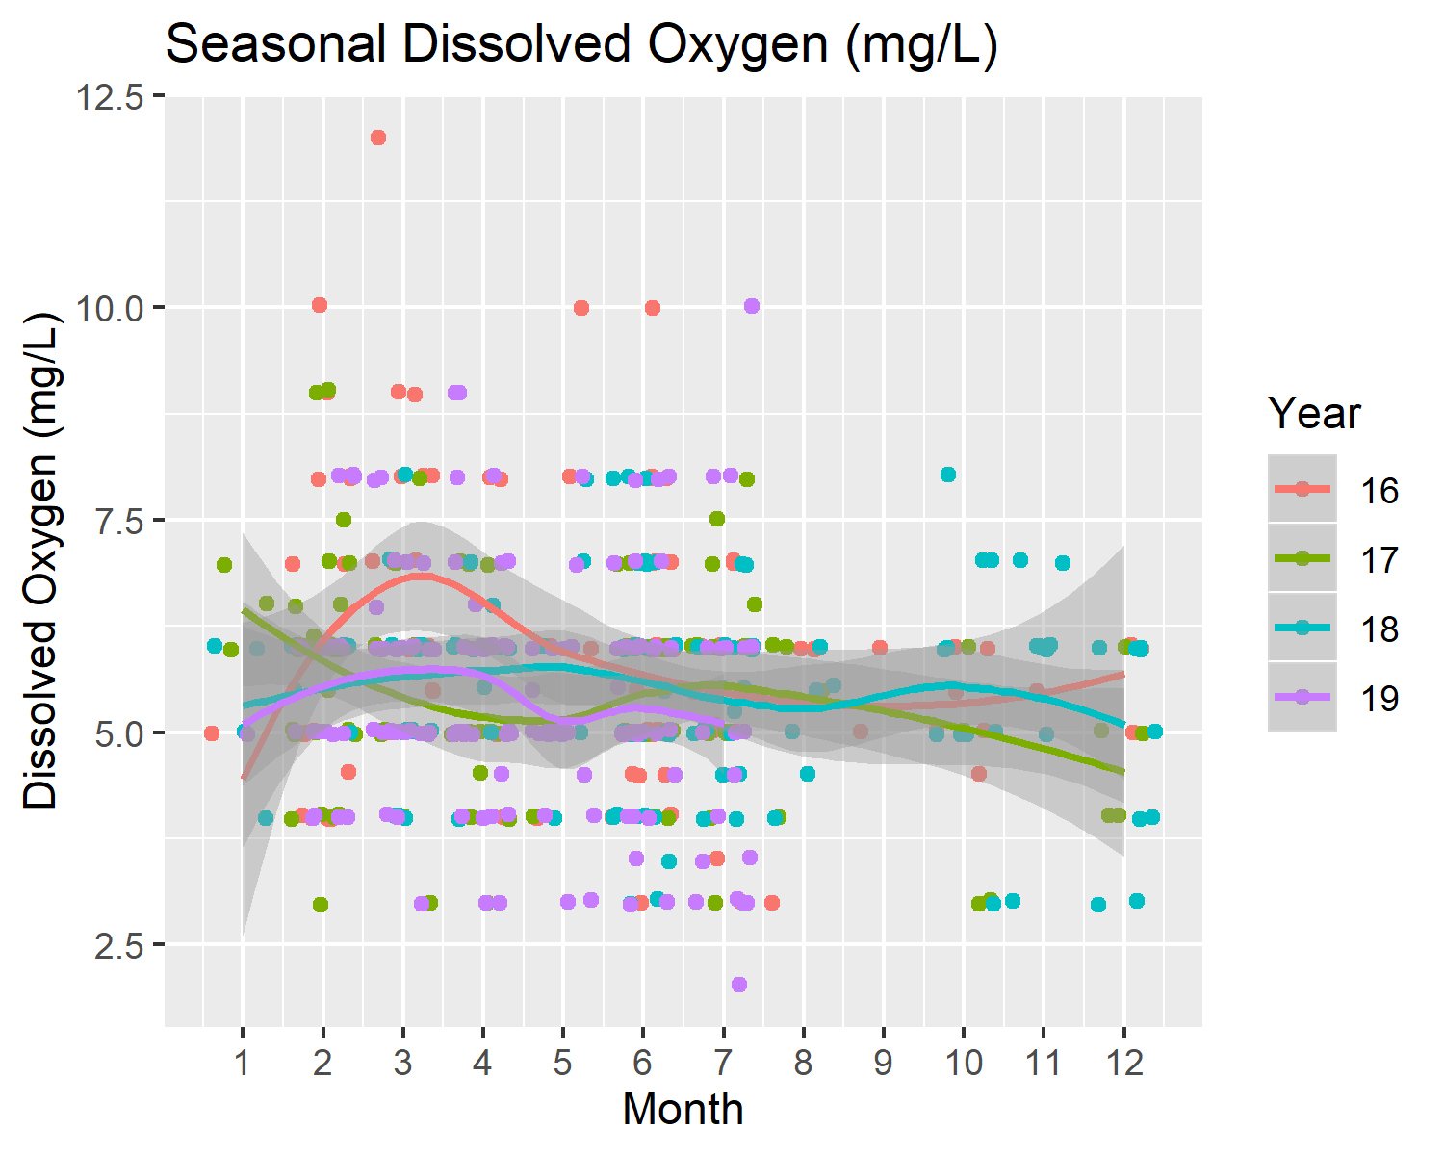

Seasonal dissolved oxygen (mg/L) levels in Key Largo, Florida from 2016-2019.

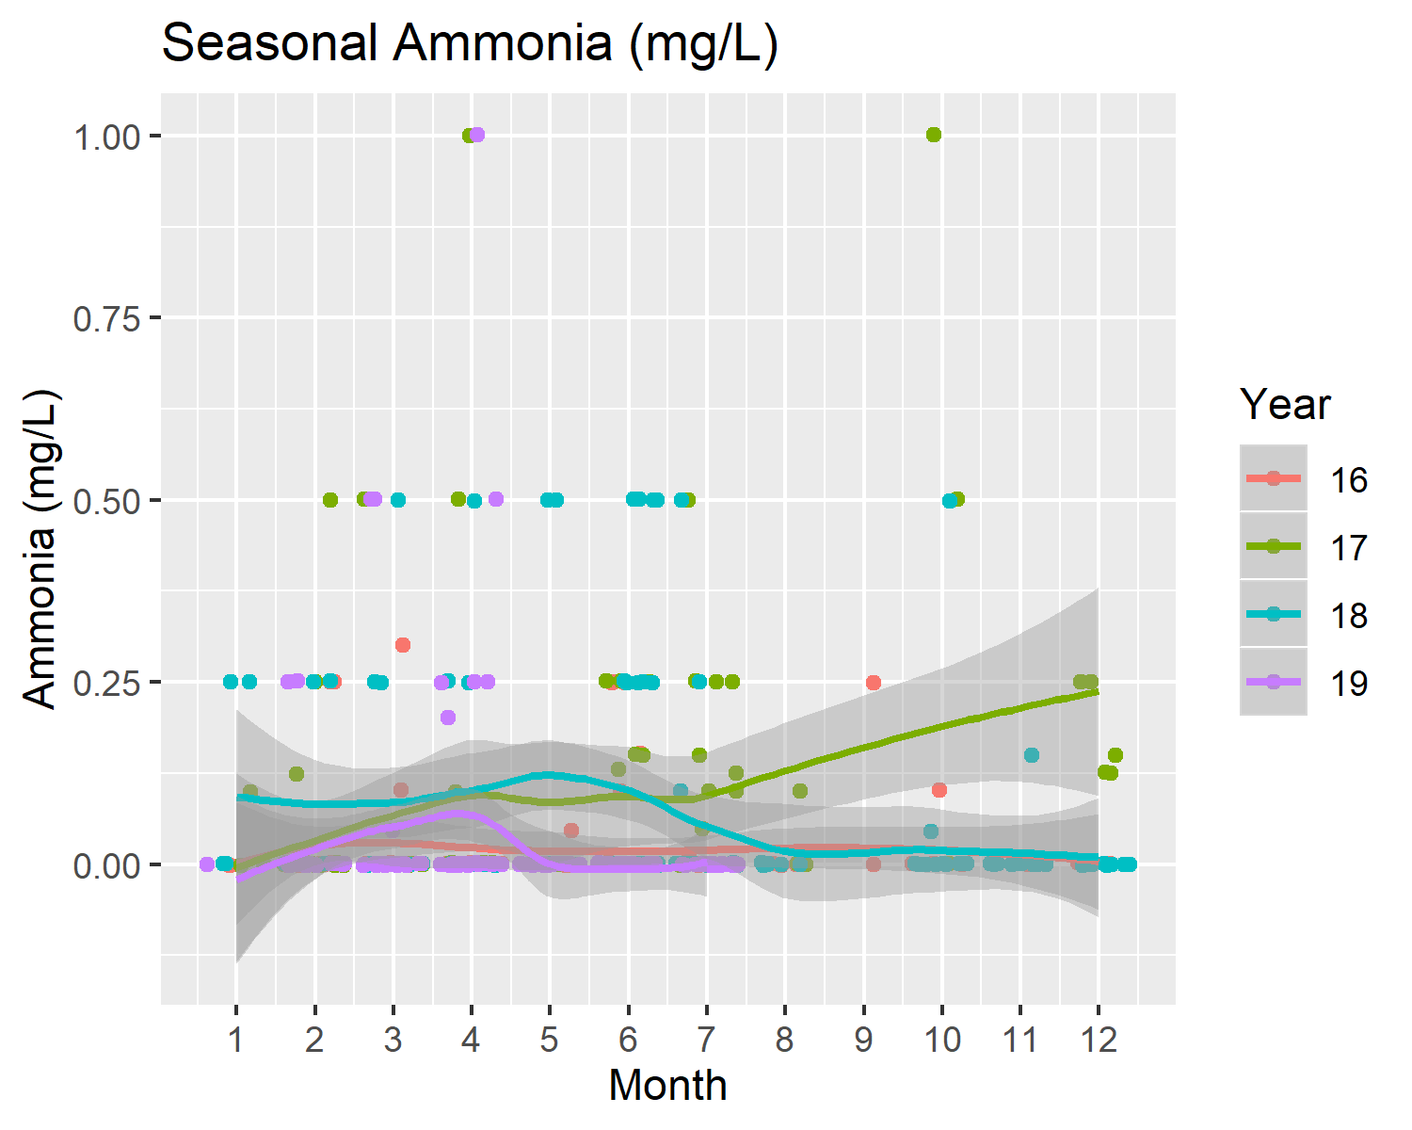

Seasonal ammonia (mg/L) levels in Key Largo, Florida from 2016-2019.

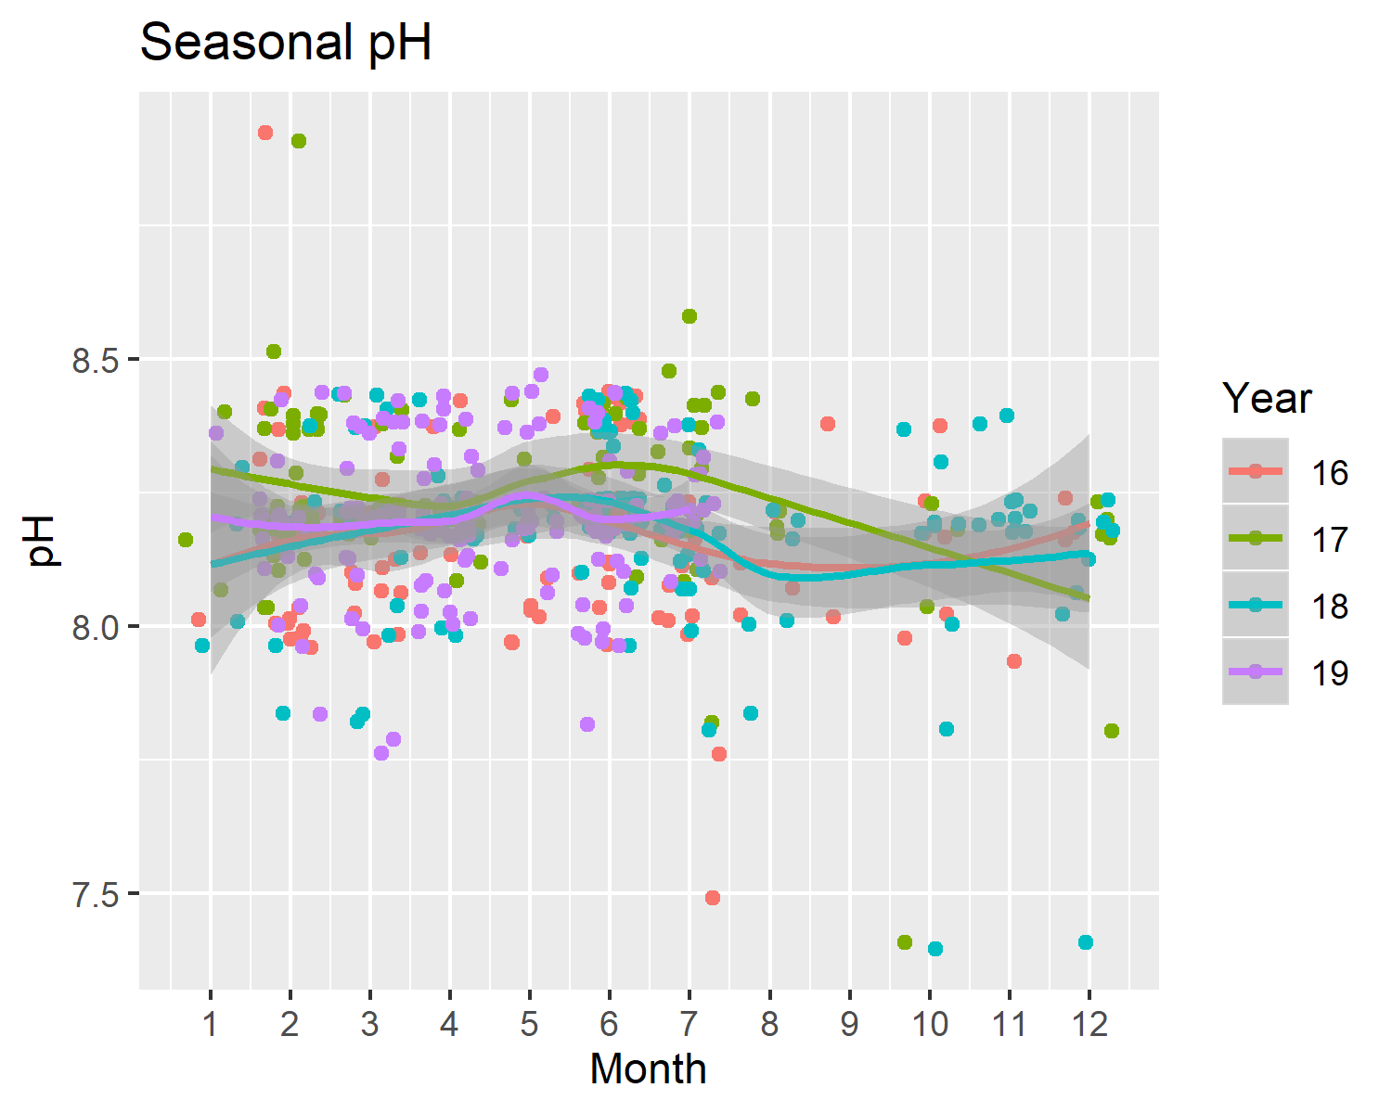

Seasonal pH levels in Key Largo, Florida from 2016-2019.

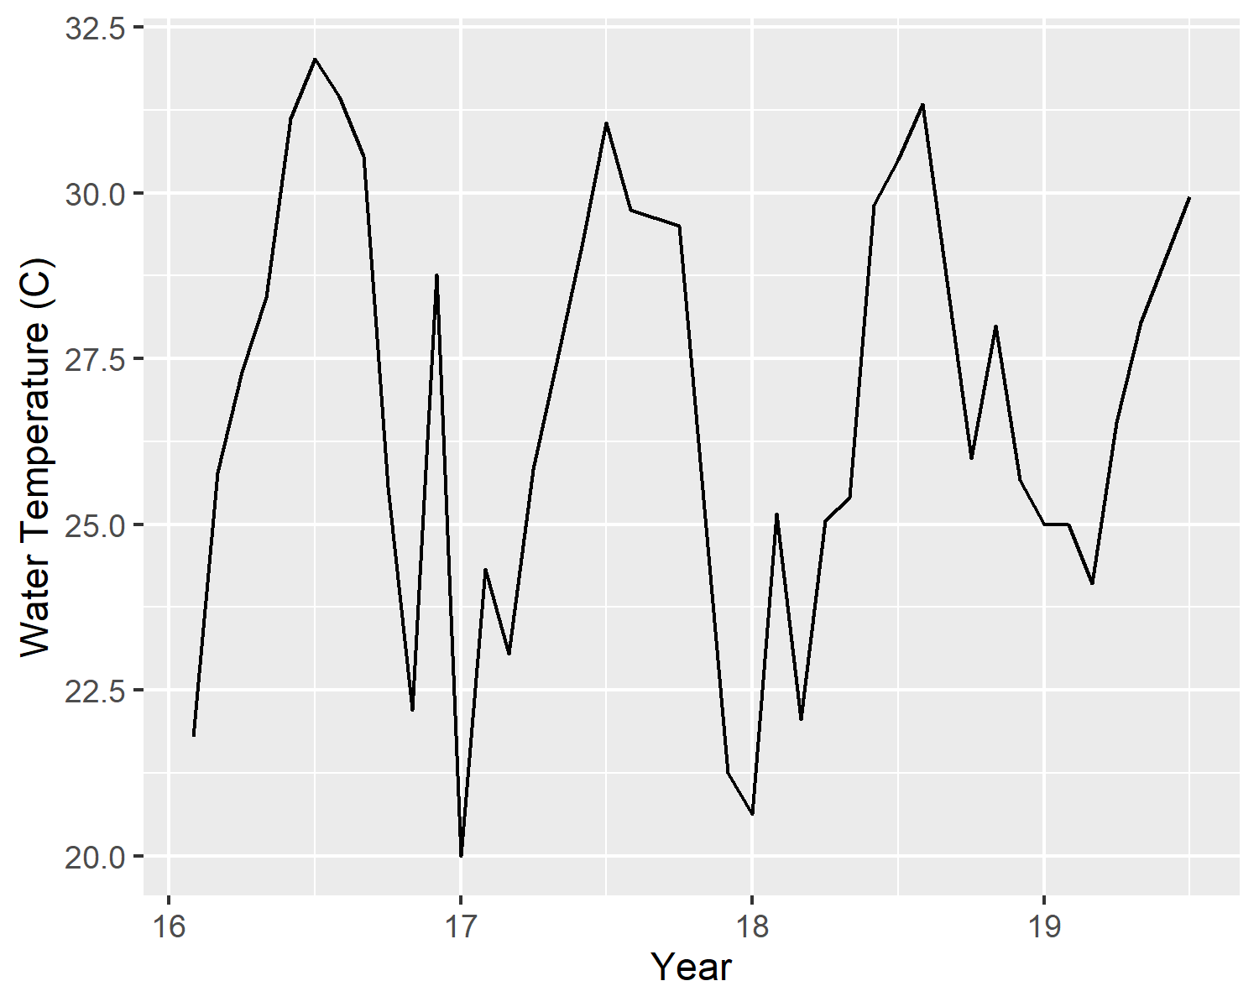

Mean monthly water temperature (C) in Key Largo, Florida from 2016-2019.

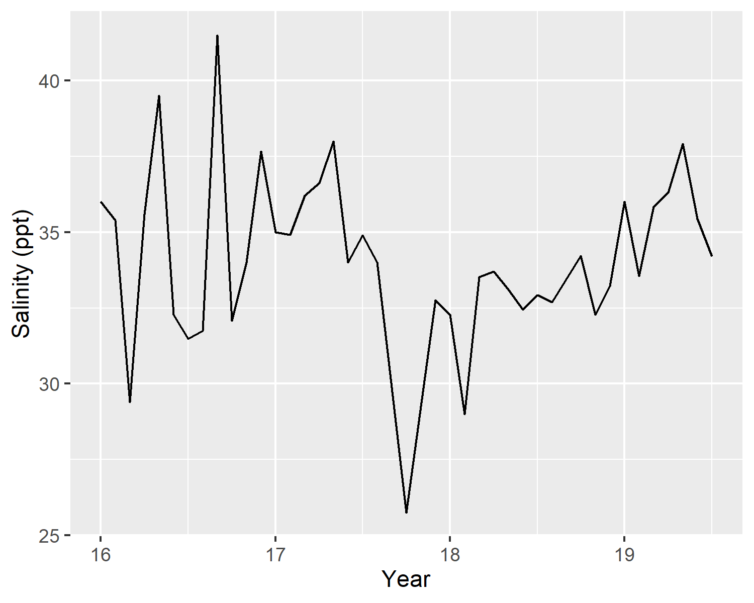

Mean monthly salinity (ppt) in Key Largo, Florida from 2016-2019.

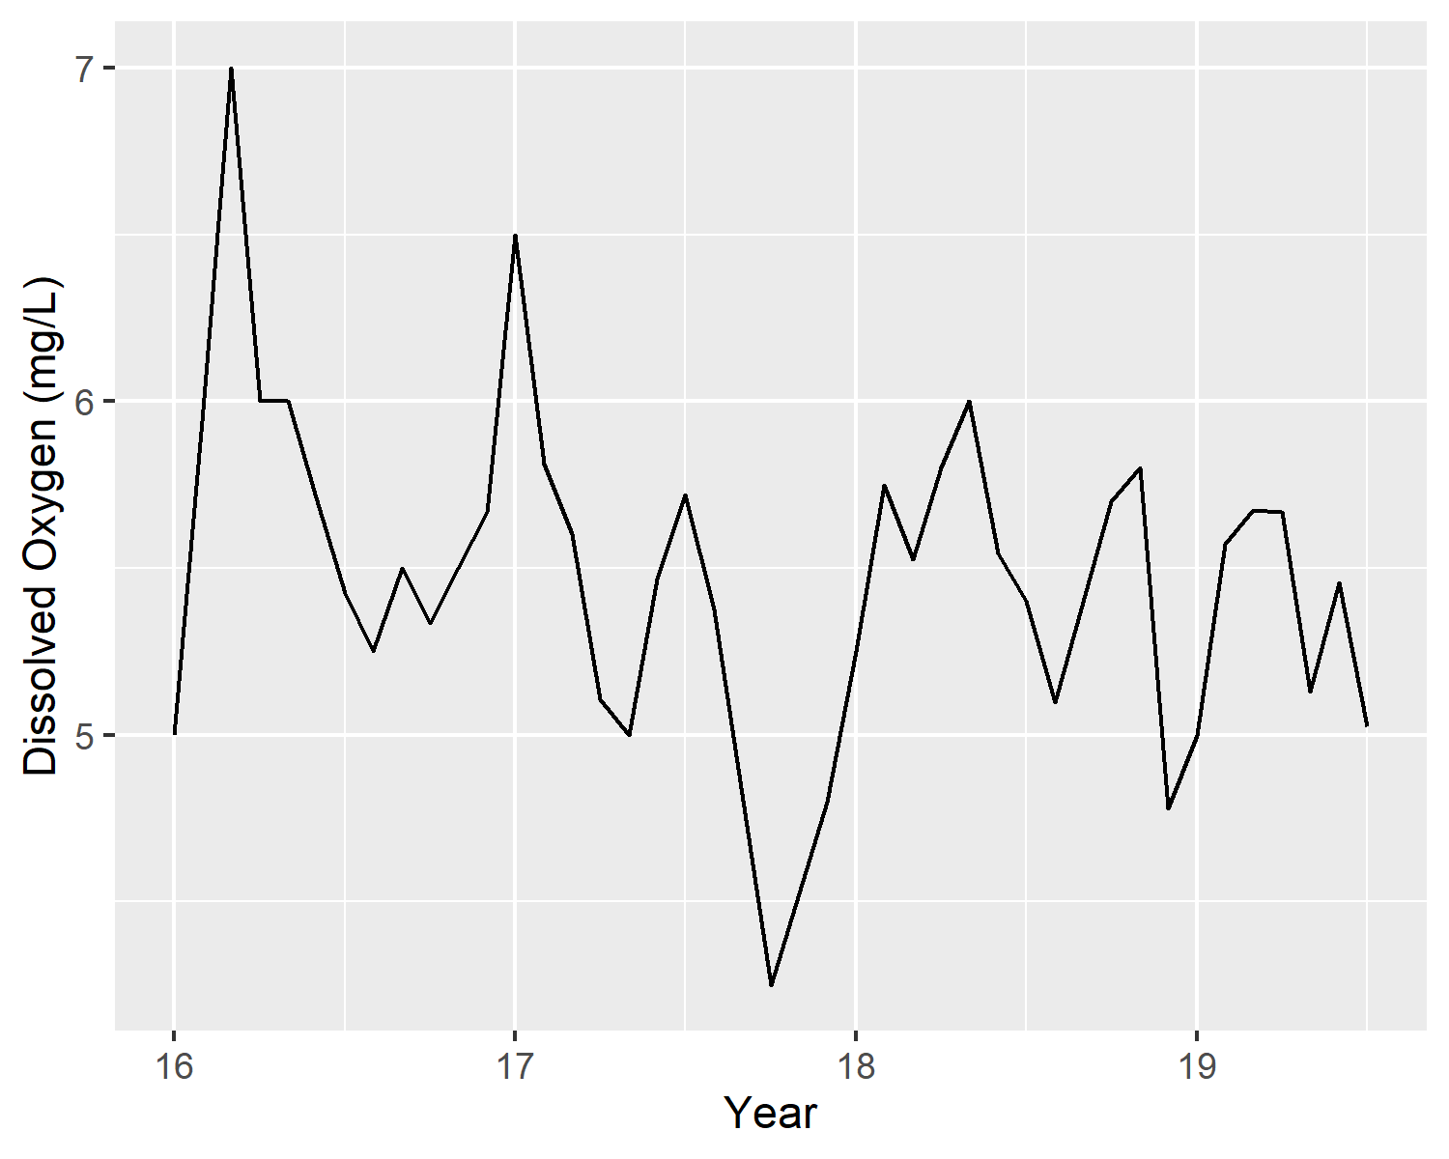

Mean monthly dissolved oxygen (mg/L) in Key Largo, Florida from 2016-2019.

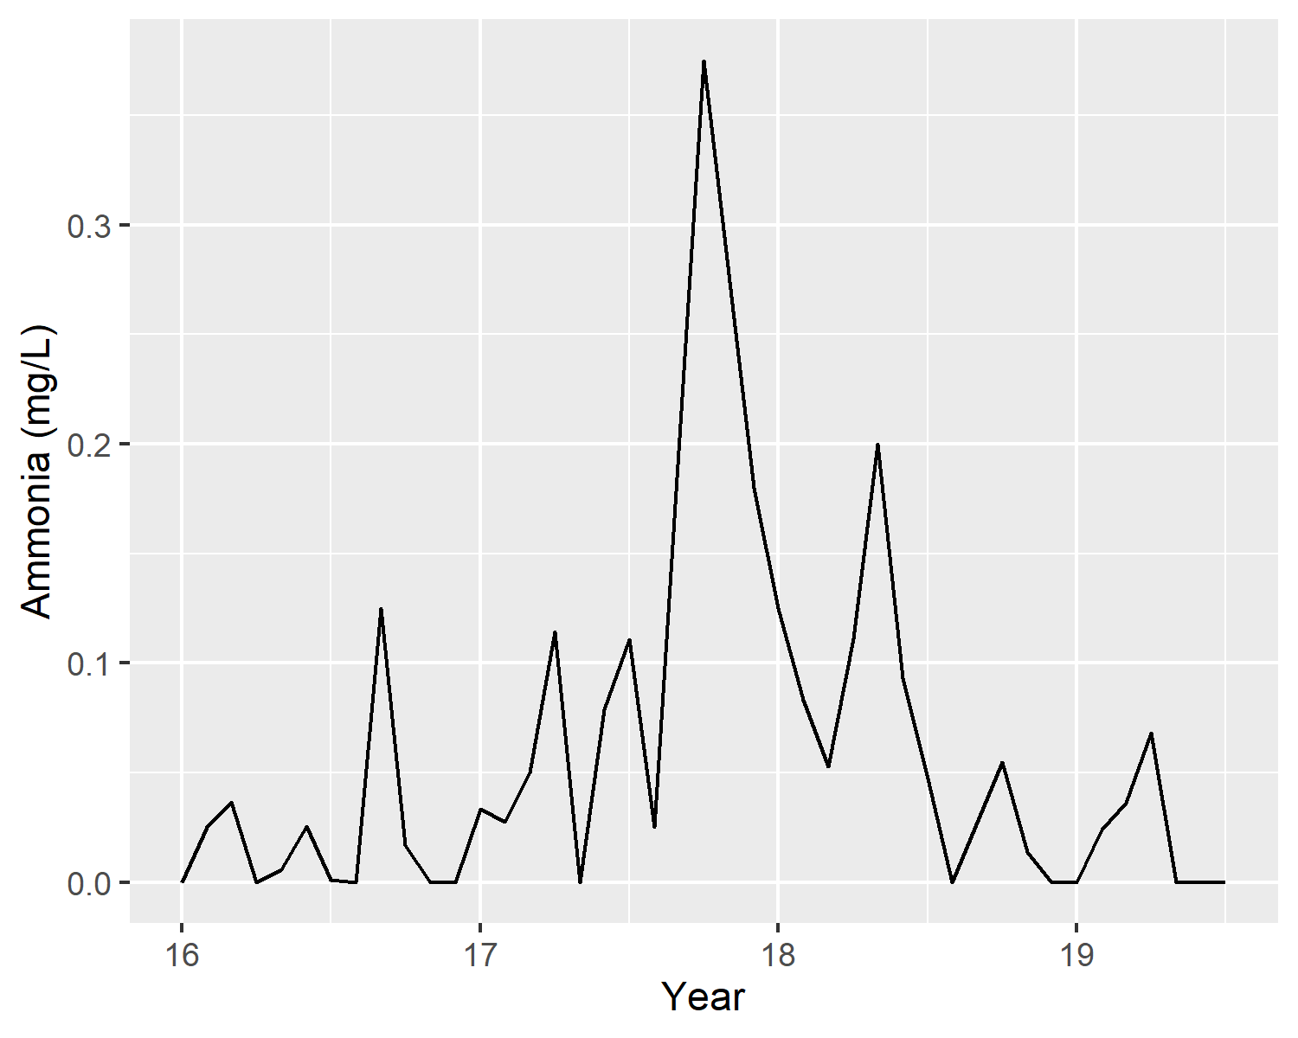

Mean monthly ammonia (mg/L) in Key Largo, Florida from 2016-2019.

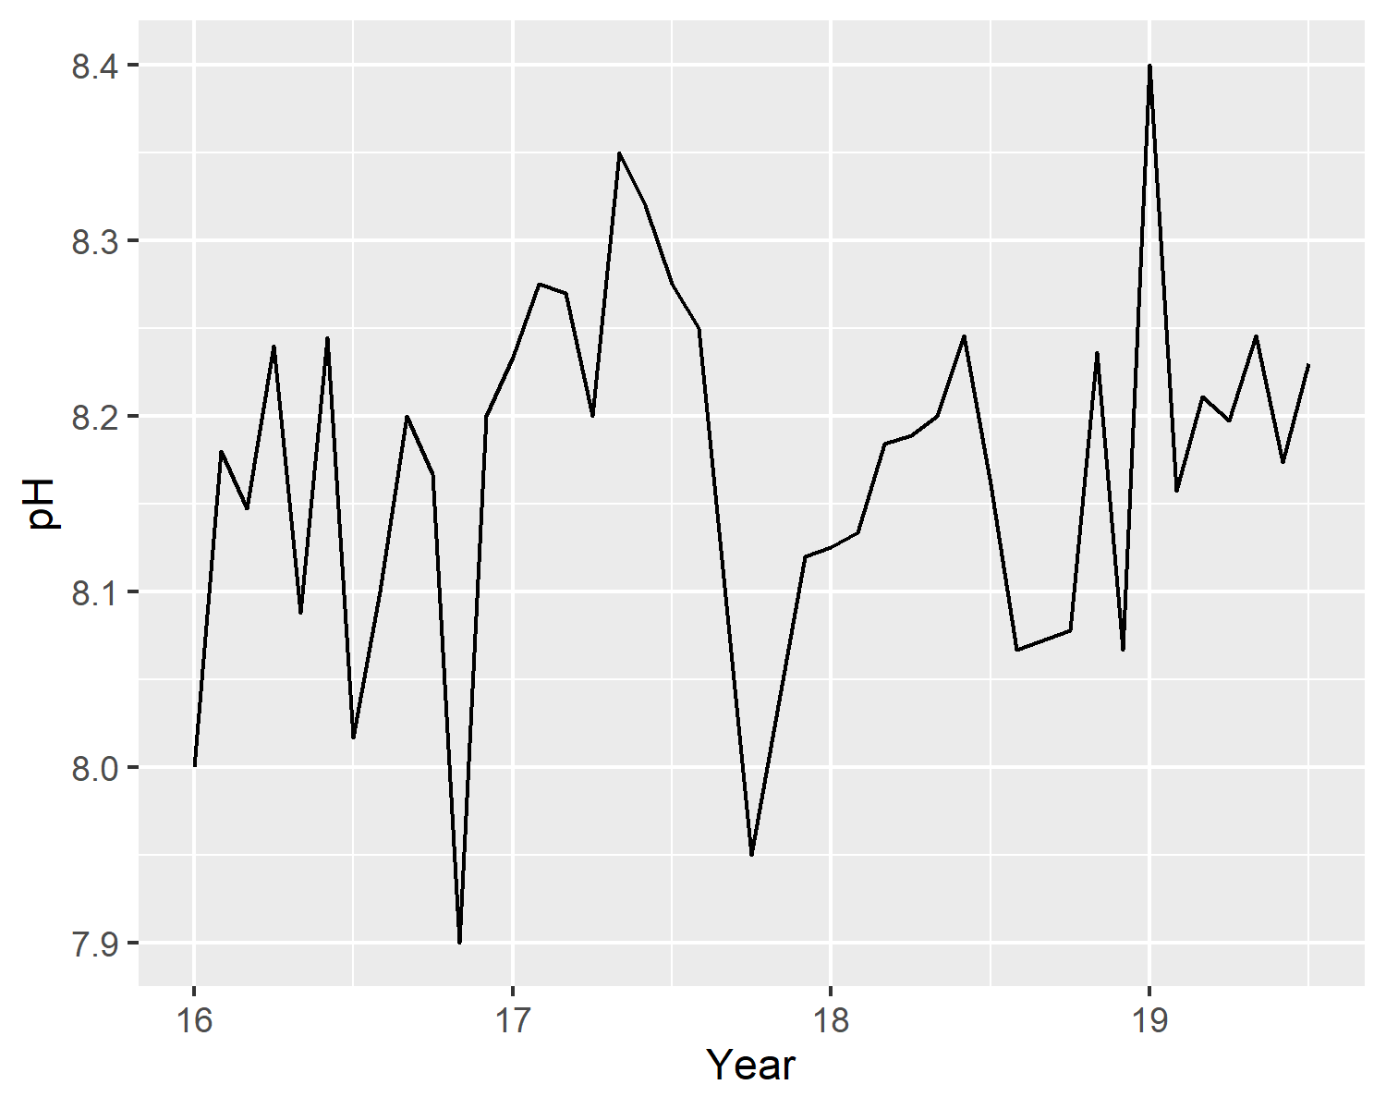

Mean pH in Key Largo, Florida from 2016-2019.

## Bivariate Analysis

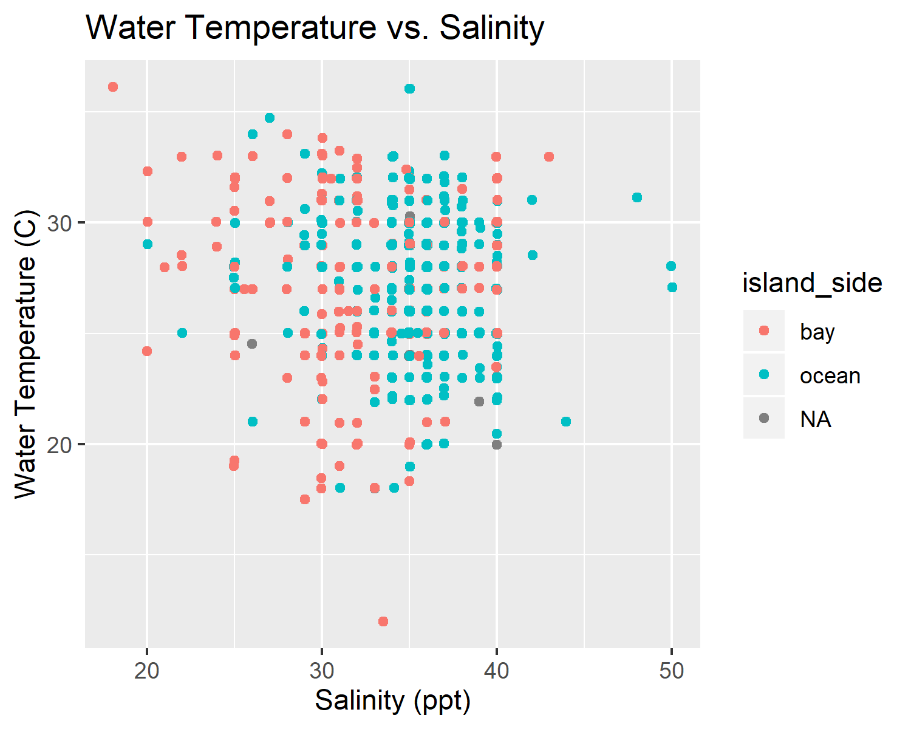

Water temperature verses salinity.

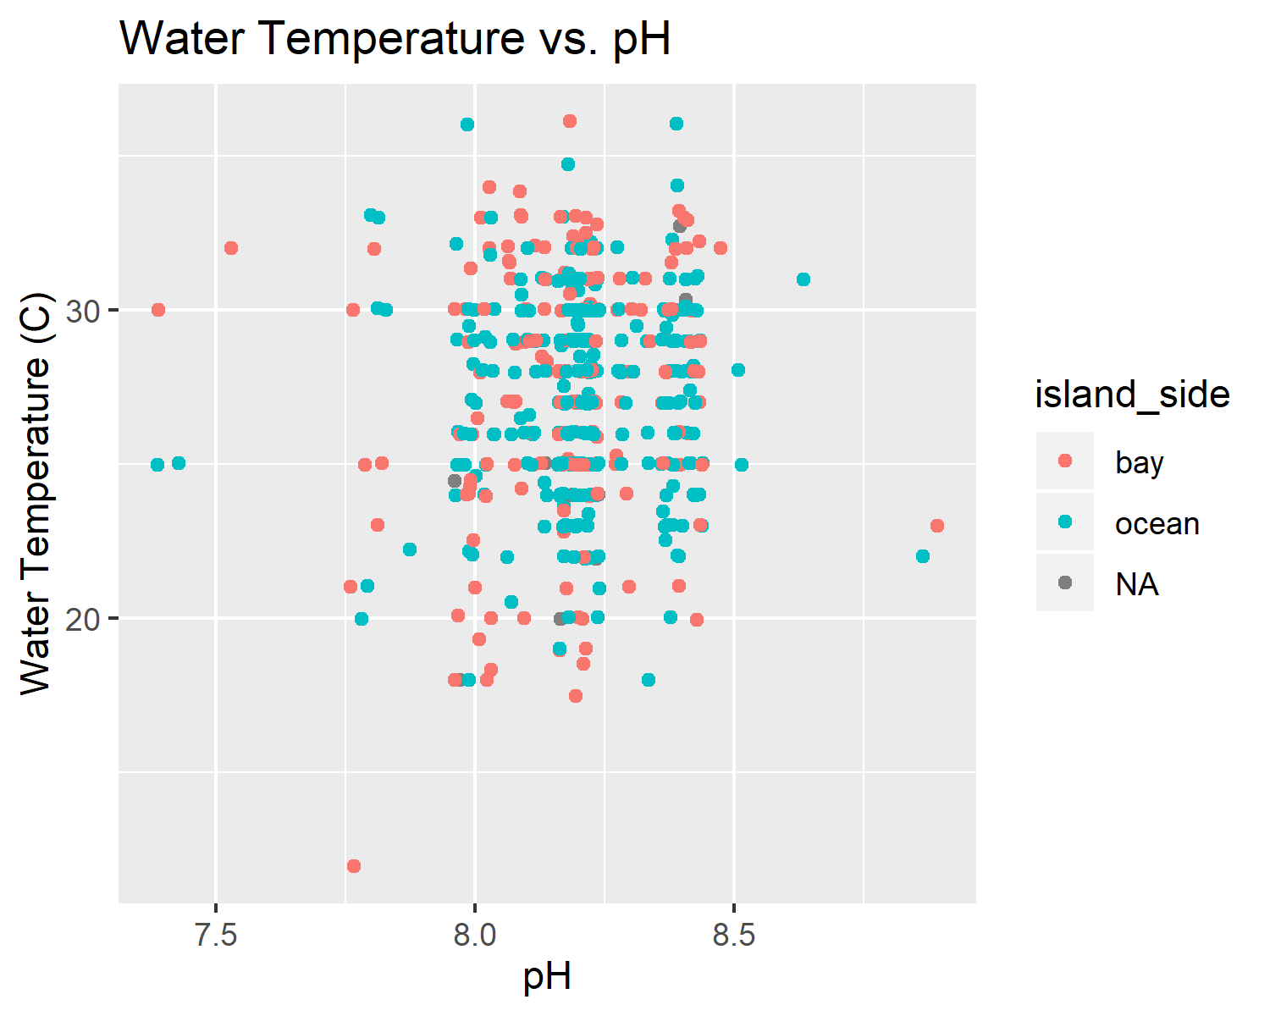

Water temperature verses pH

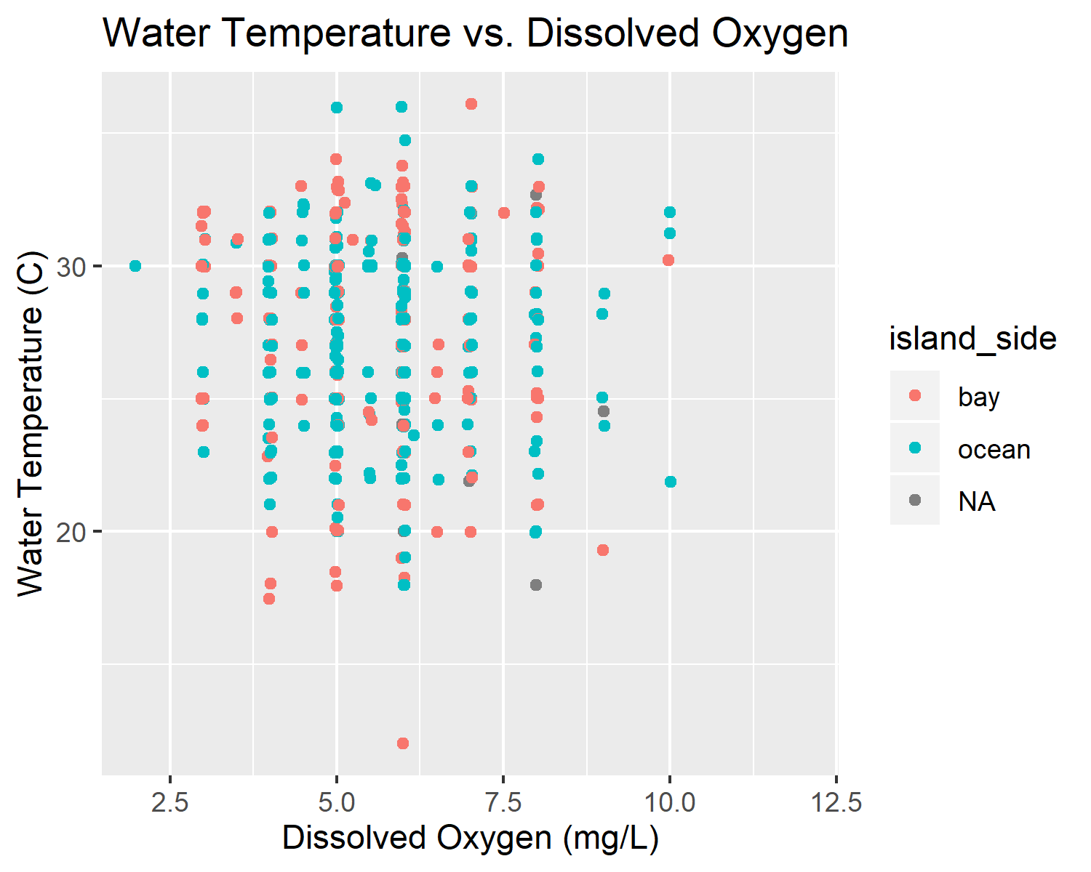

Water temperature verses dissolved oxygen

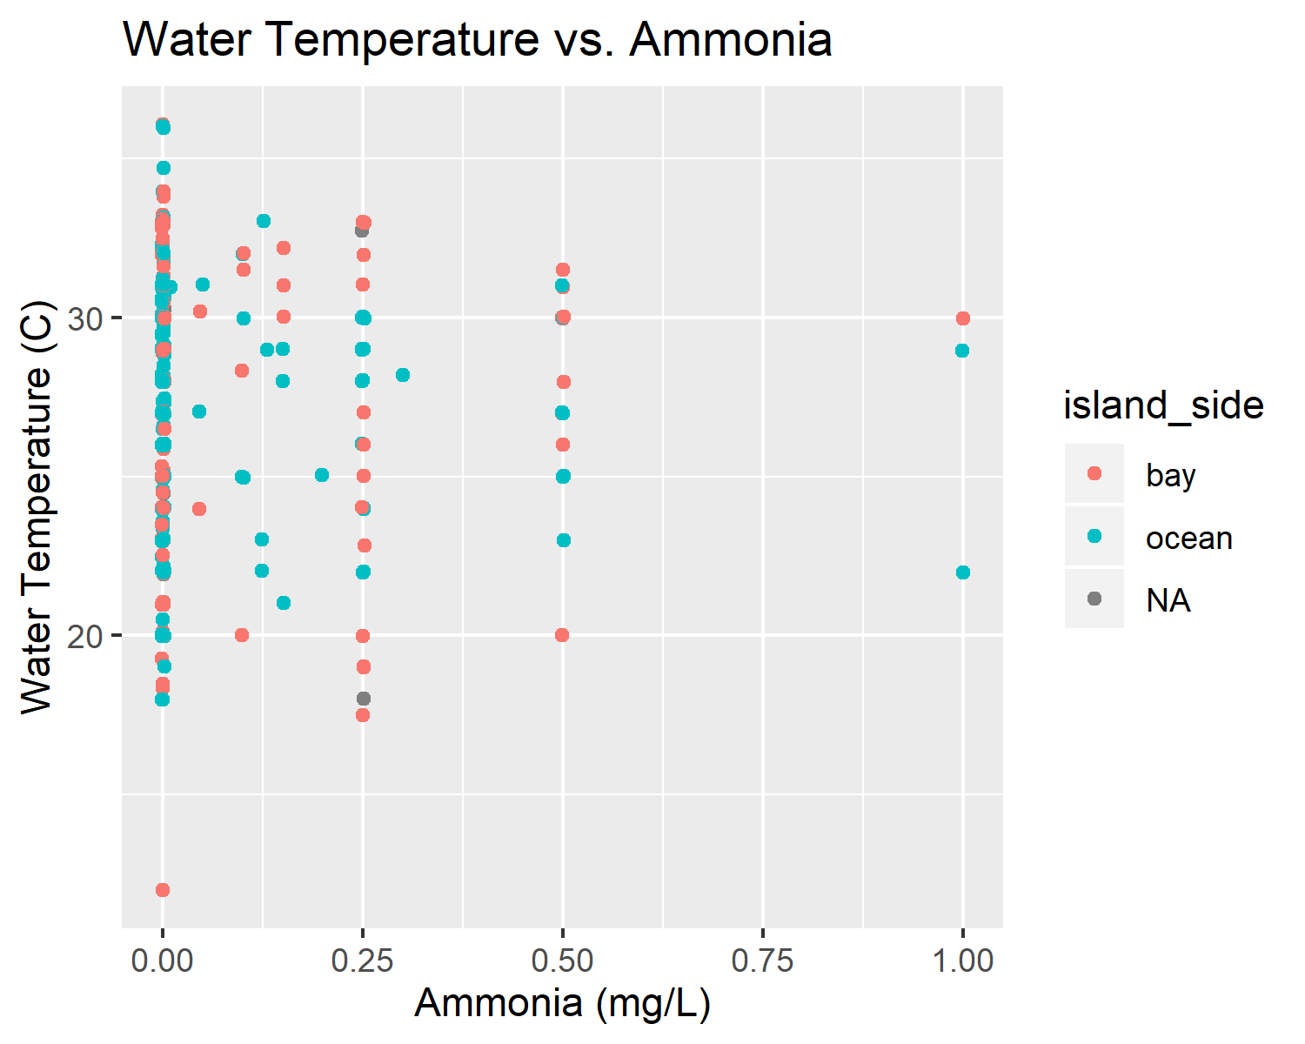

Water temperature verses ammonia

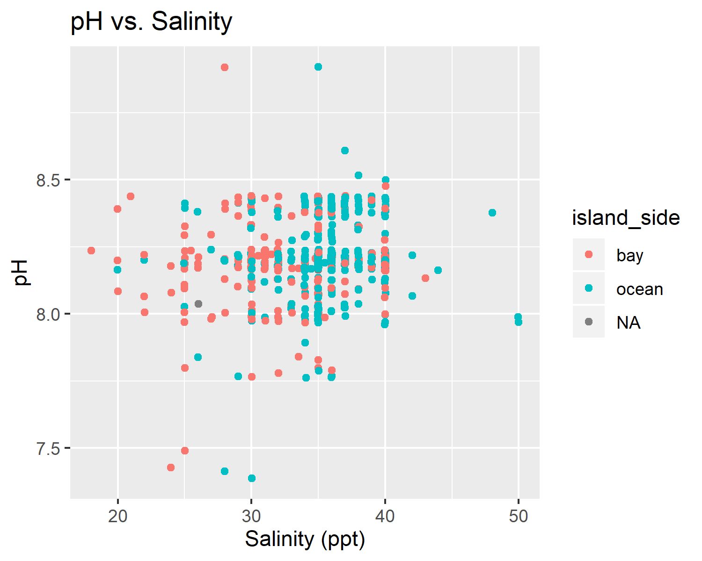

pH verses salinity.

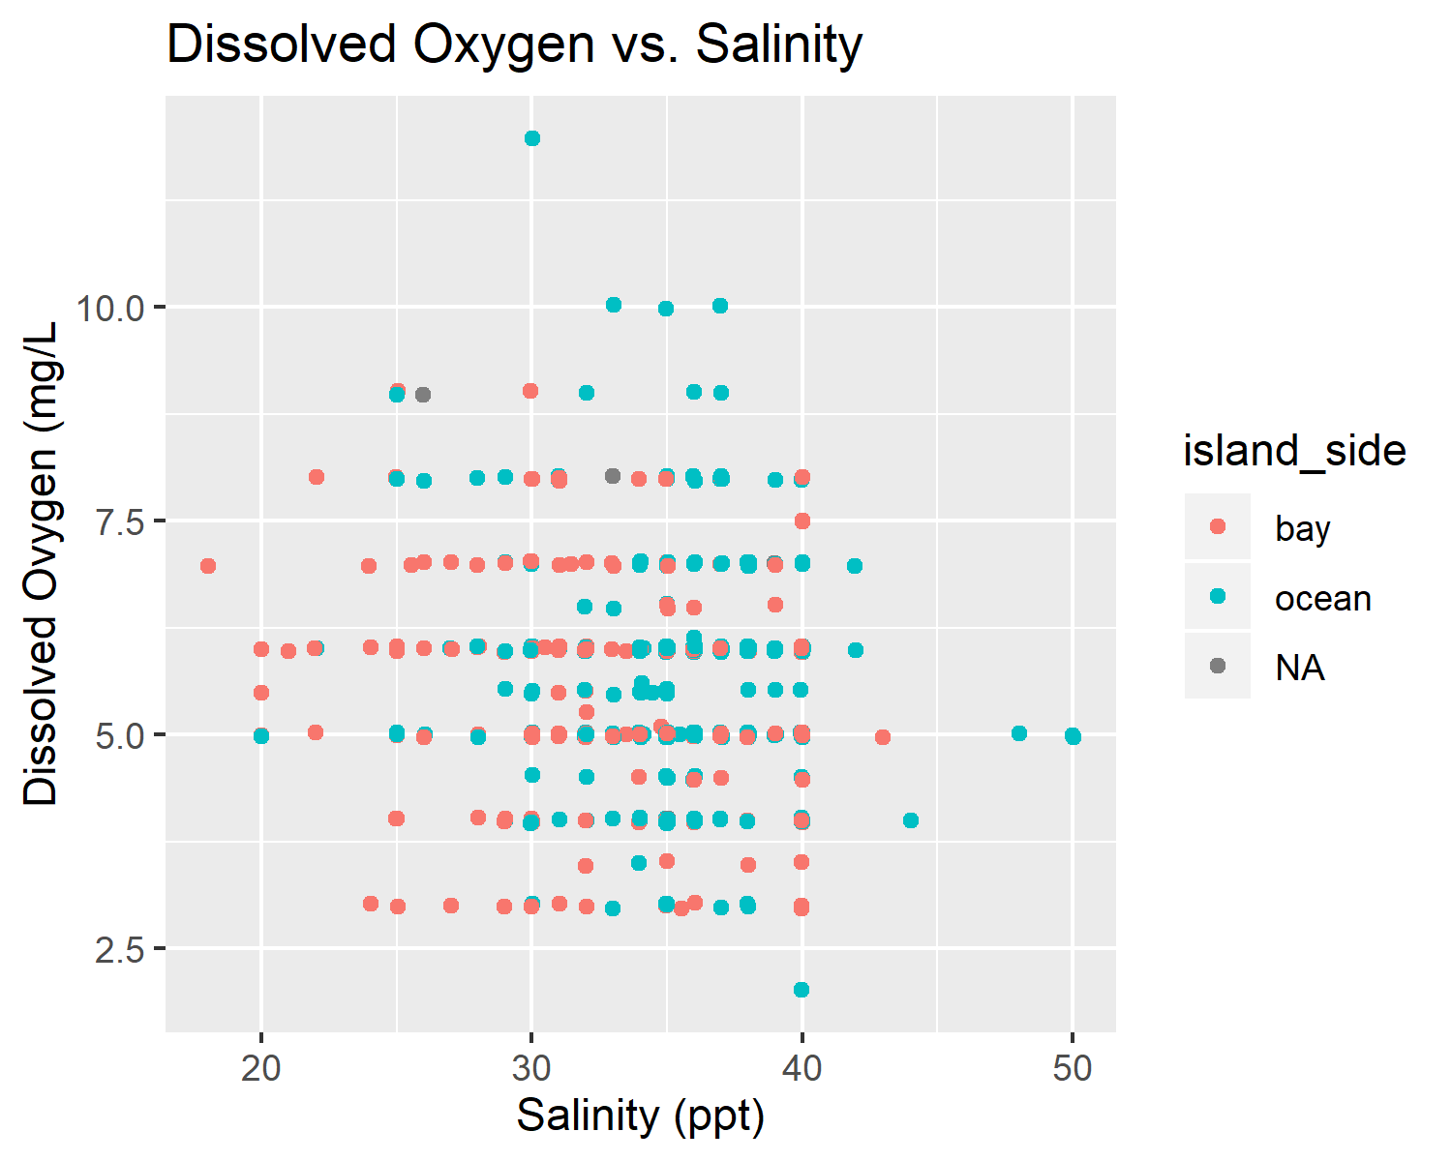

Dissolved oxygen verses salinity.

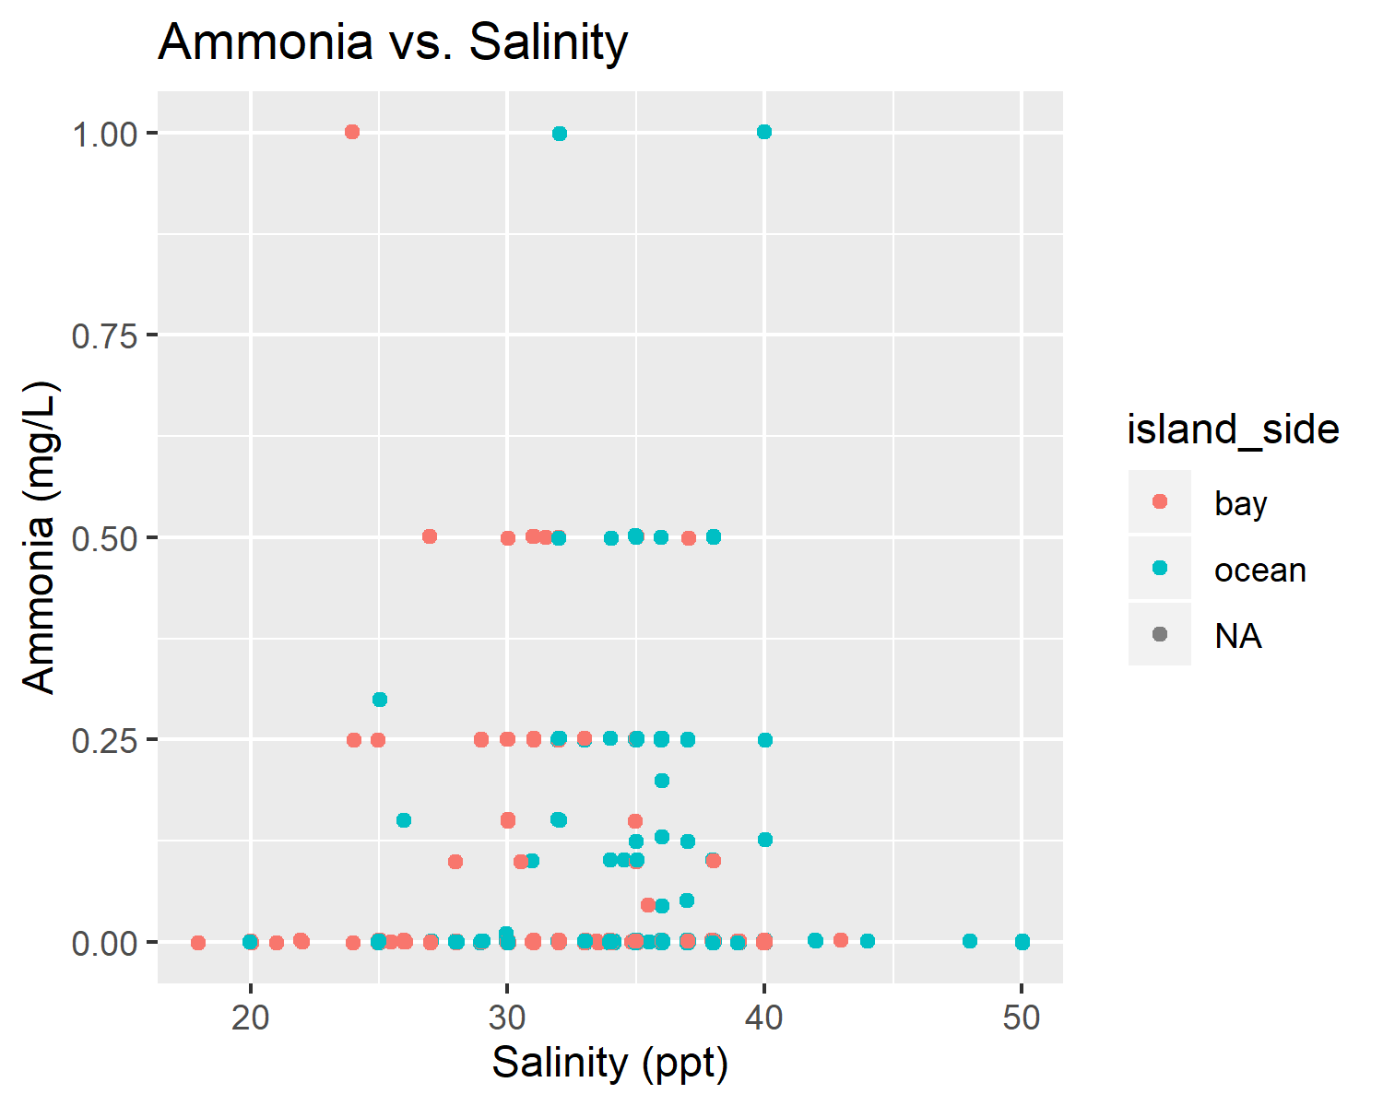

Ammonia verses salinity.

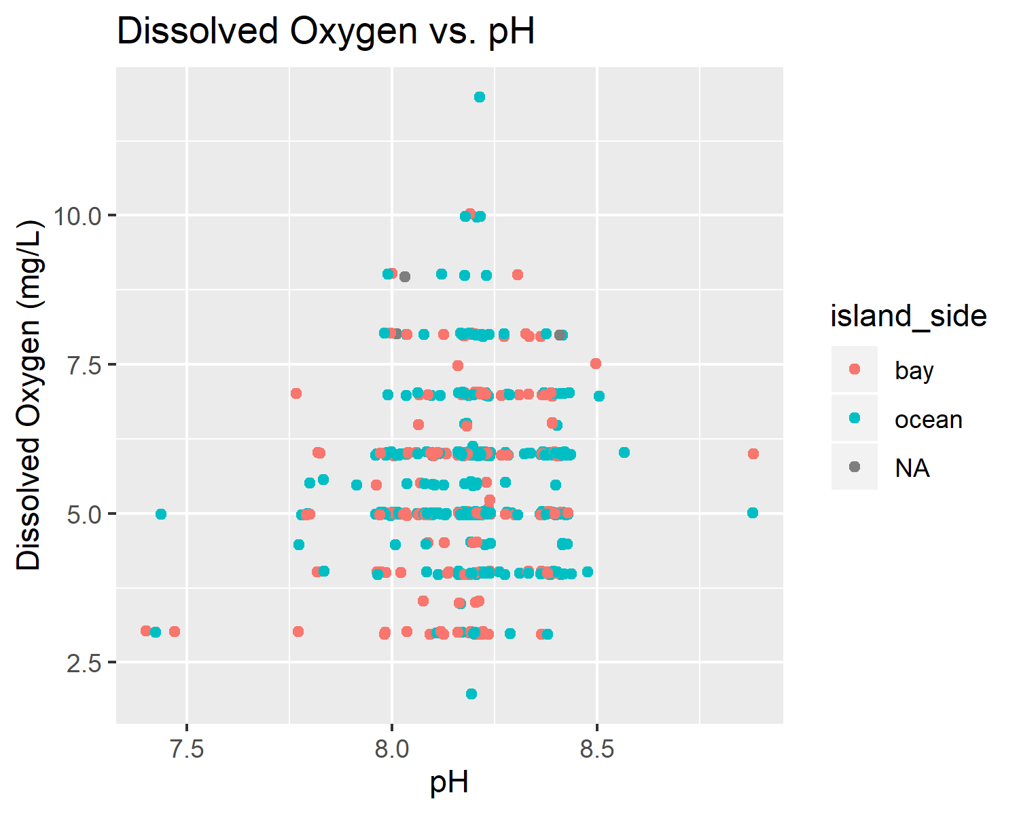

Dissolved oxygen verses pH

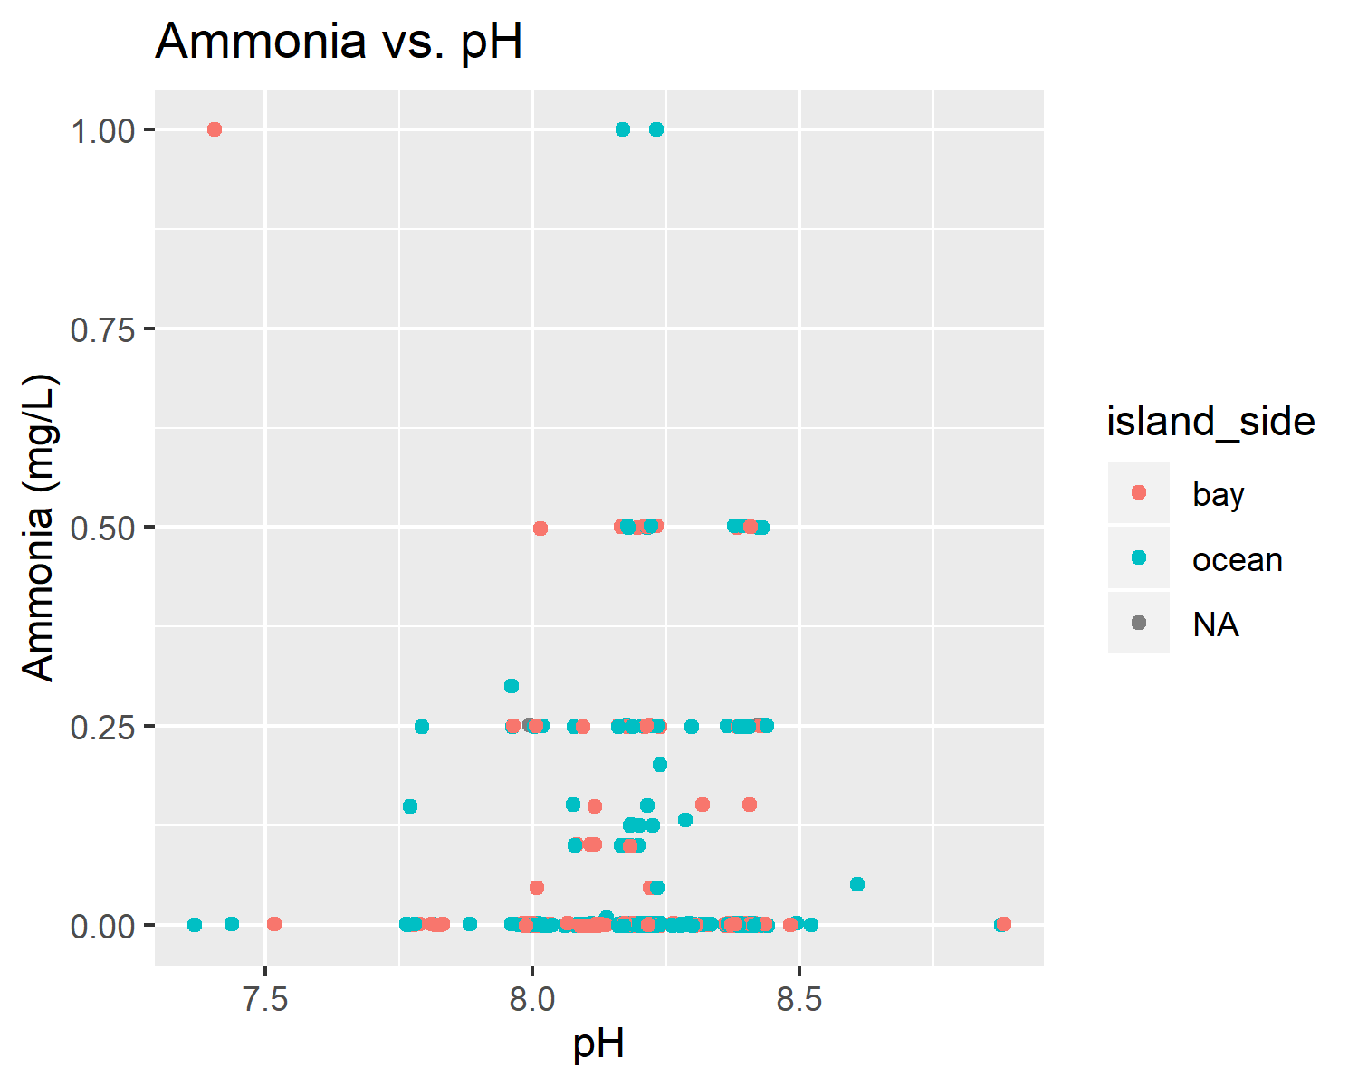

Ammonia verses pH.

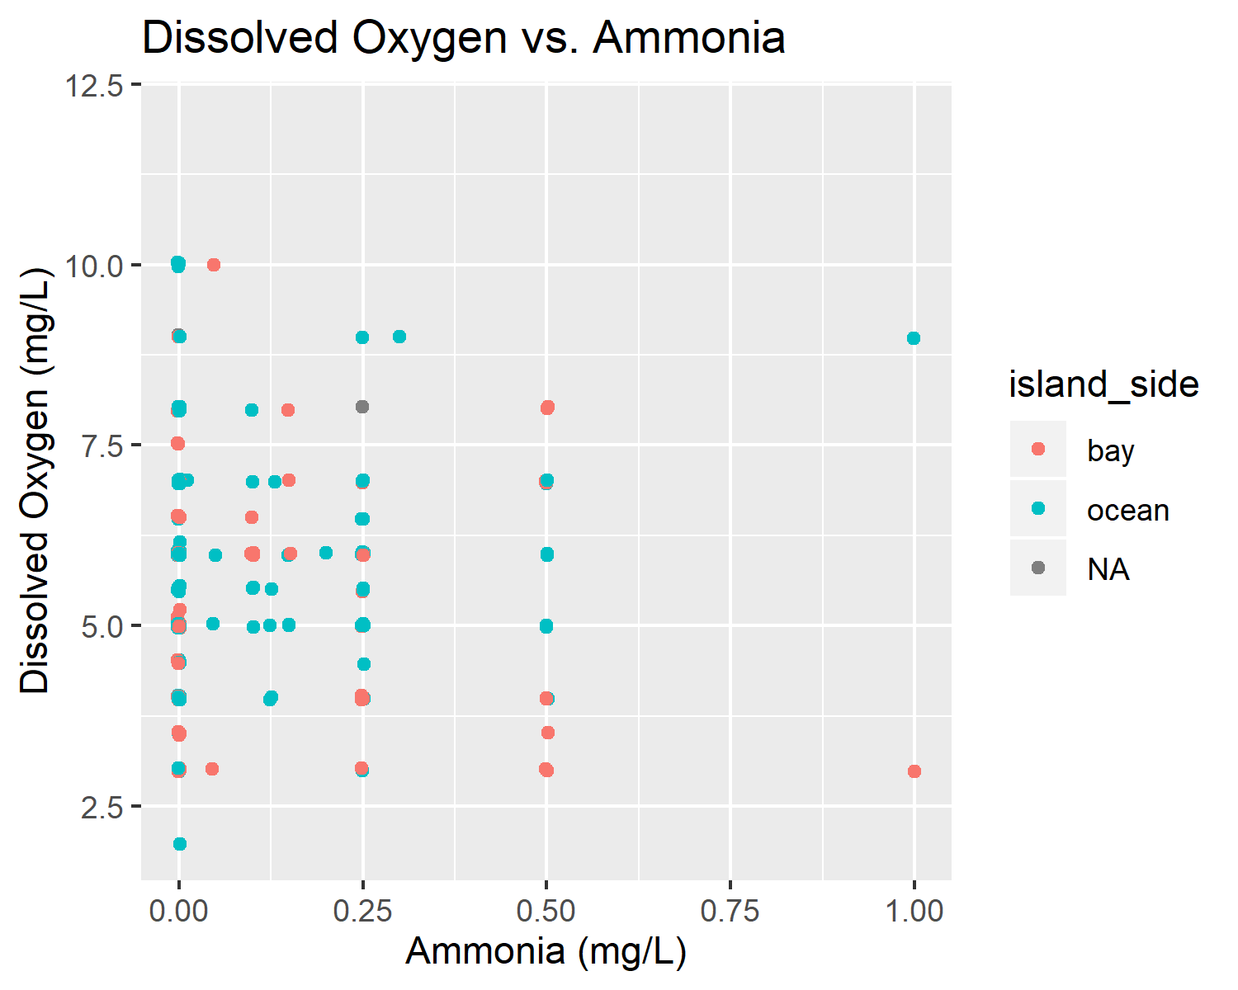

Dissolved oxygen verses ammonia.

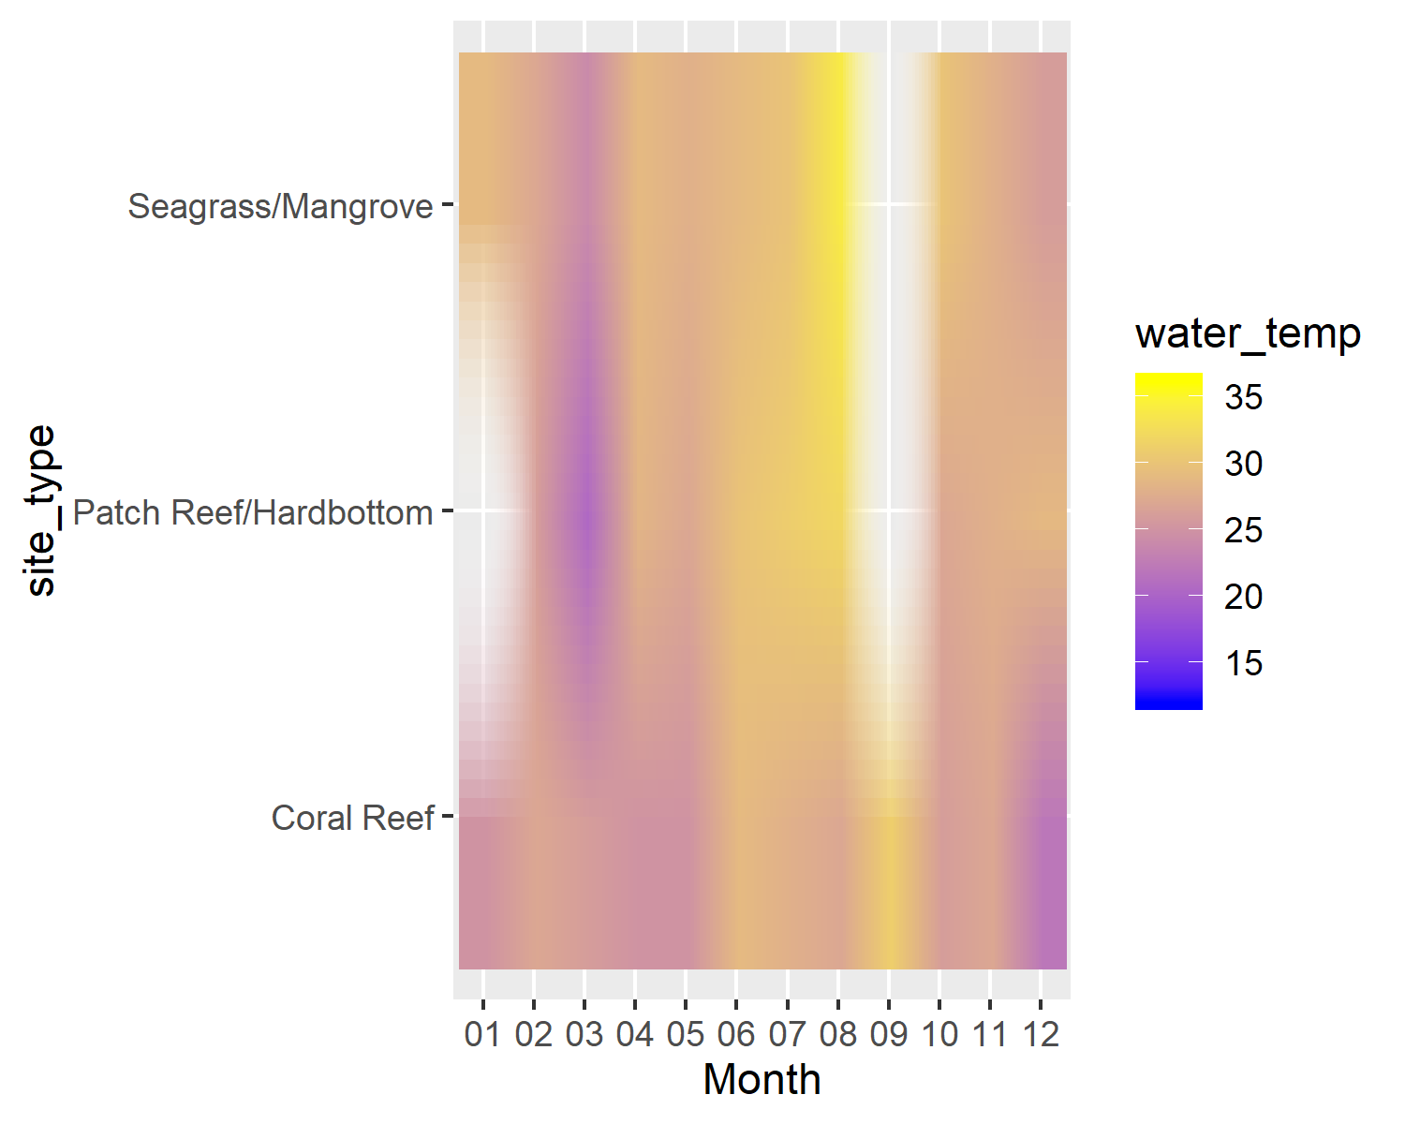

Monthly raster plot of site type and water temperature (C).

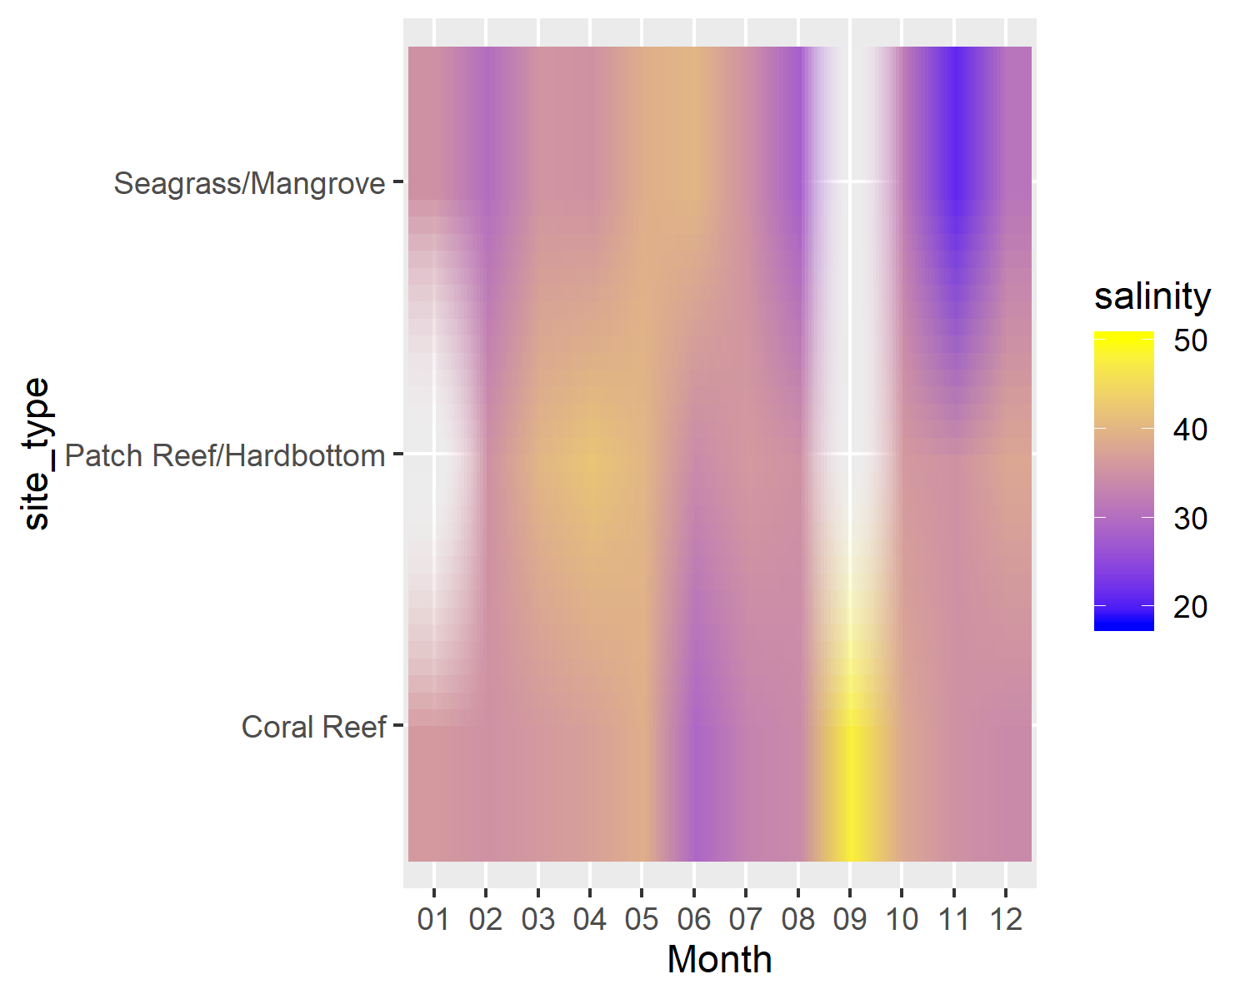

Monthly raster plot of site type and salinity (ppt).

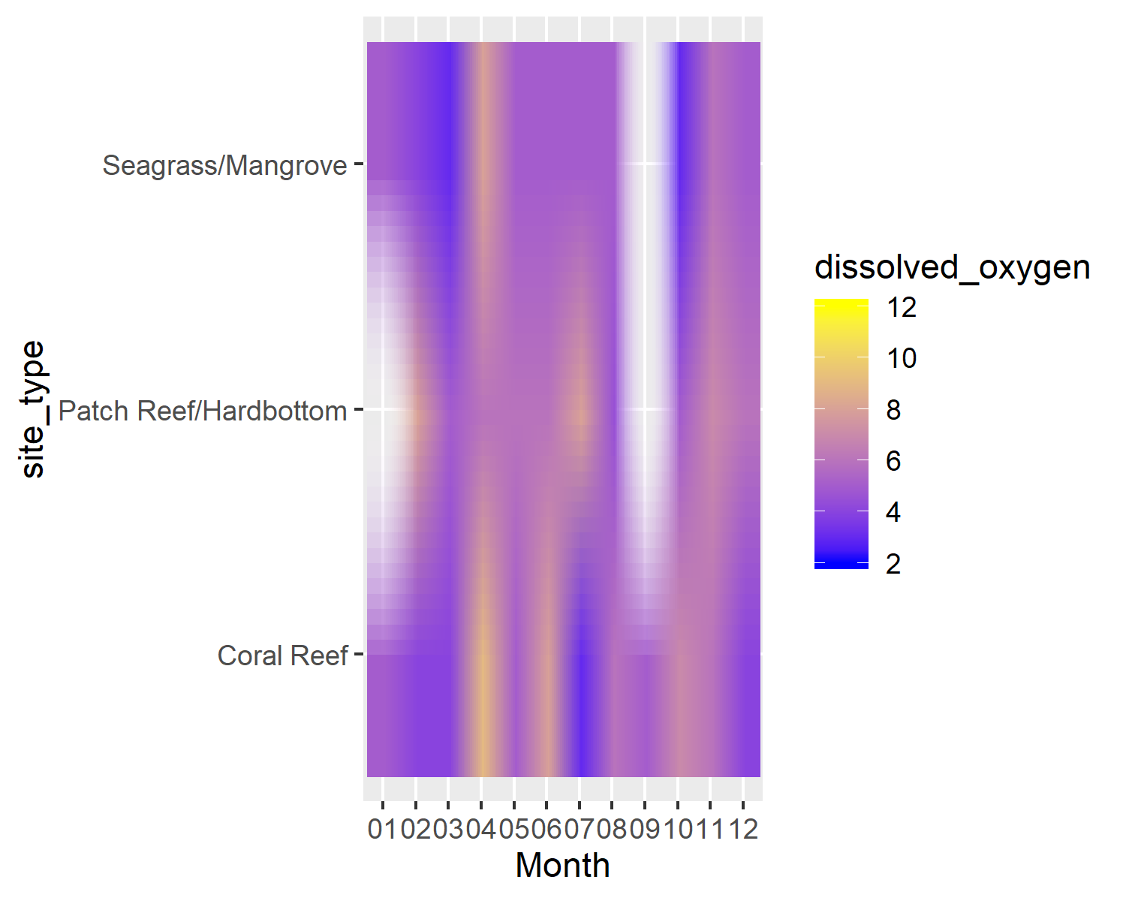

Monthly raster plot of site type and dissolved oxygen (mg/L).

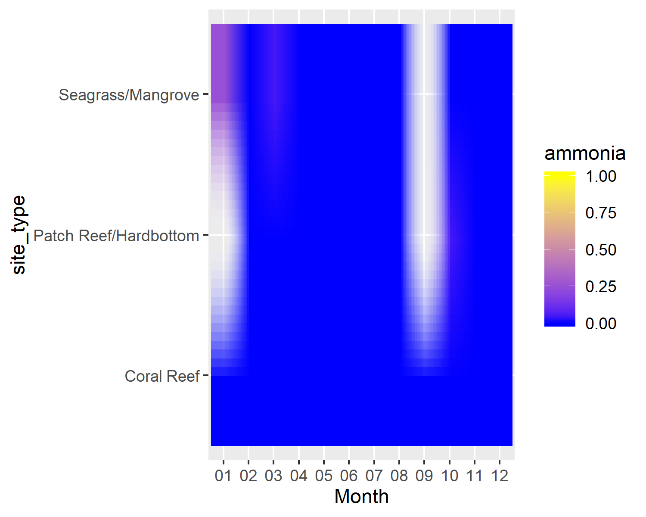

Monthly raster plot of site type and ammonia (mg/L).

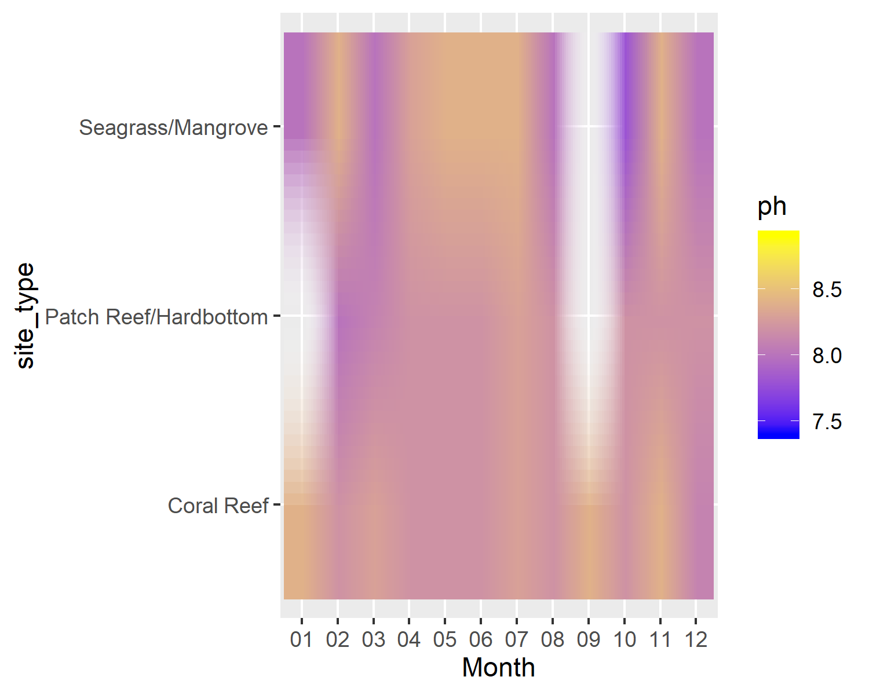

Monthly raster plot of site type and pH.

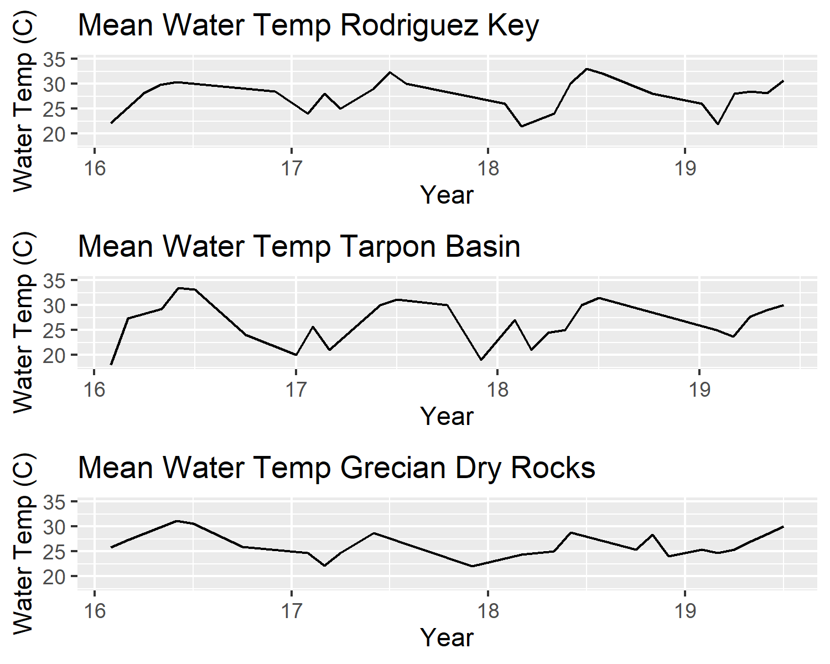

Mean water temperature over time for the three representative (most frequently visited) sampling sites.

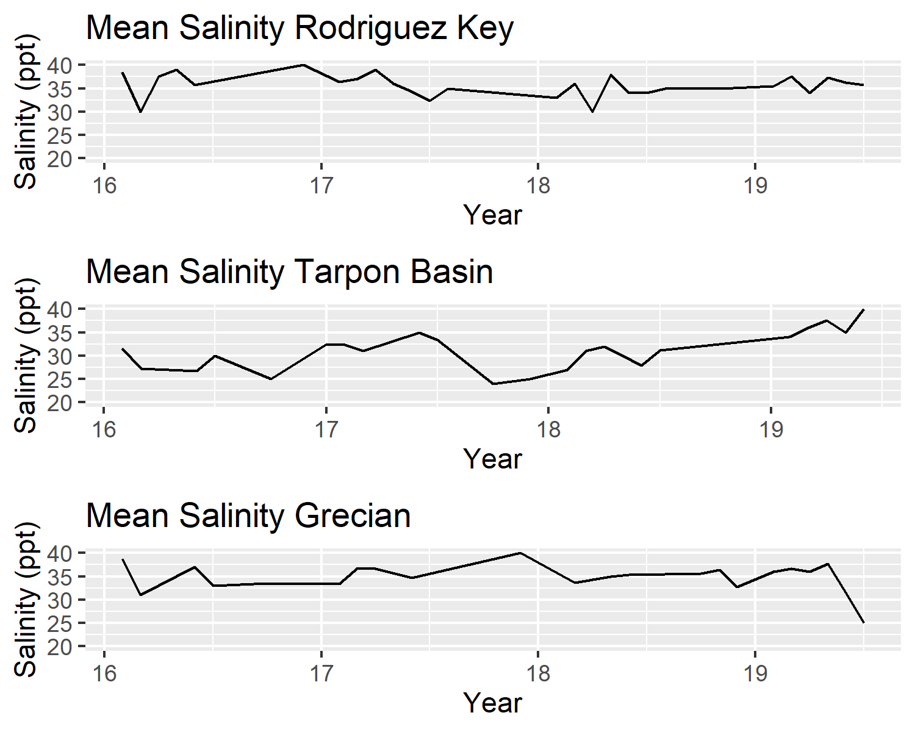

Mean salinity over time for the three representative (most frequently visited) sampling sites.

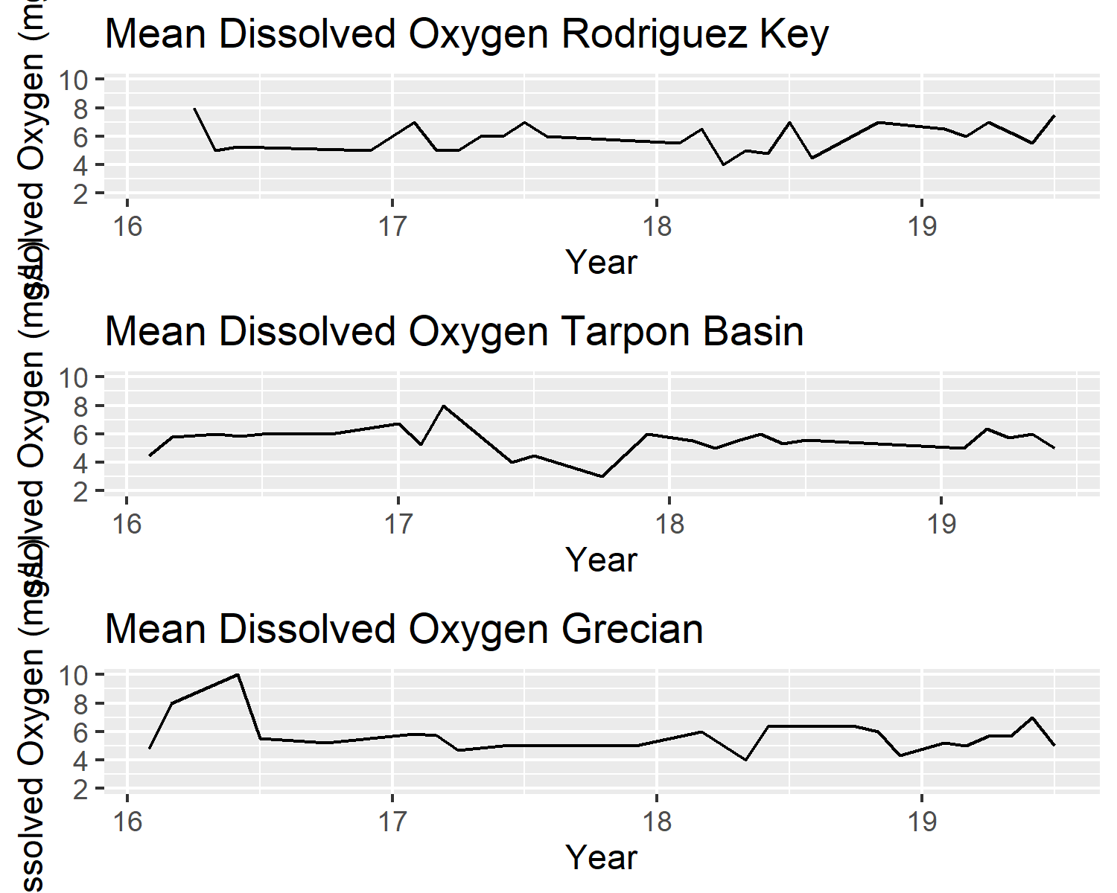

Mean dissolved oxygen over time for the three representative (most frequently visited) sampling sites.

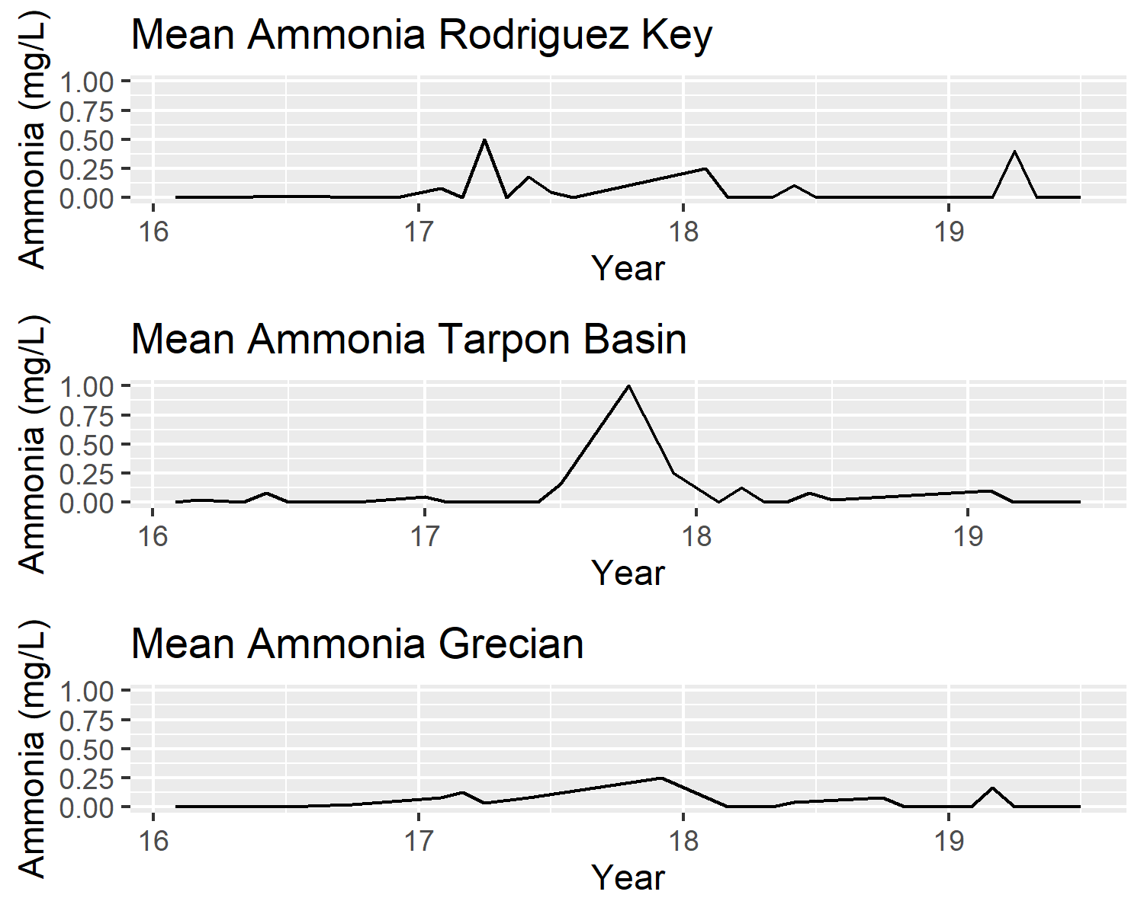

Mean ammonia over time for the three representative (most frequently visited) sampling sites.

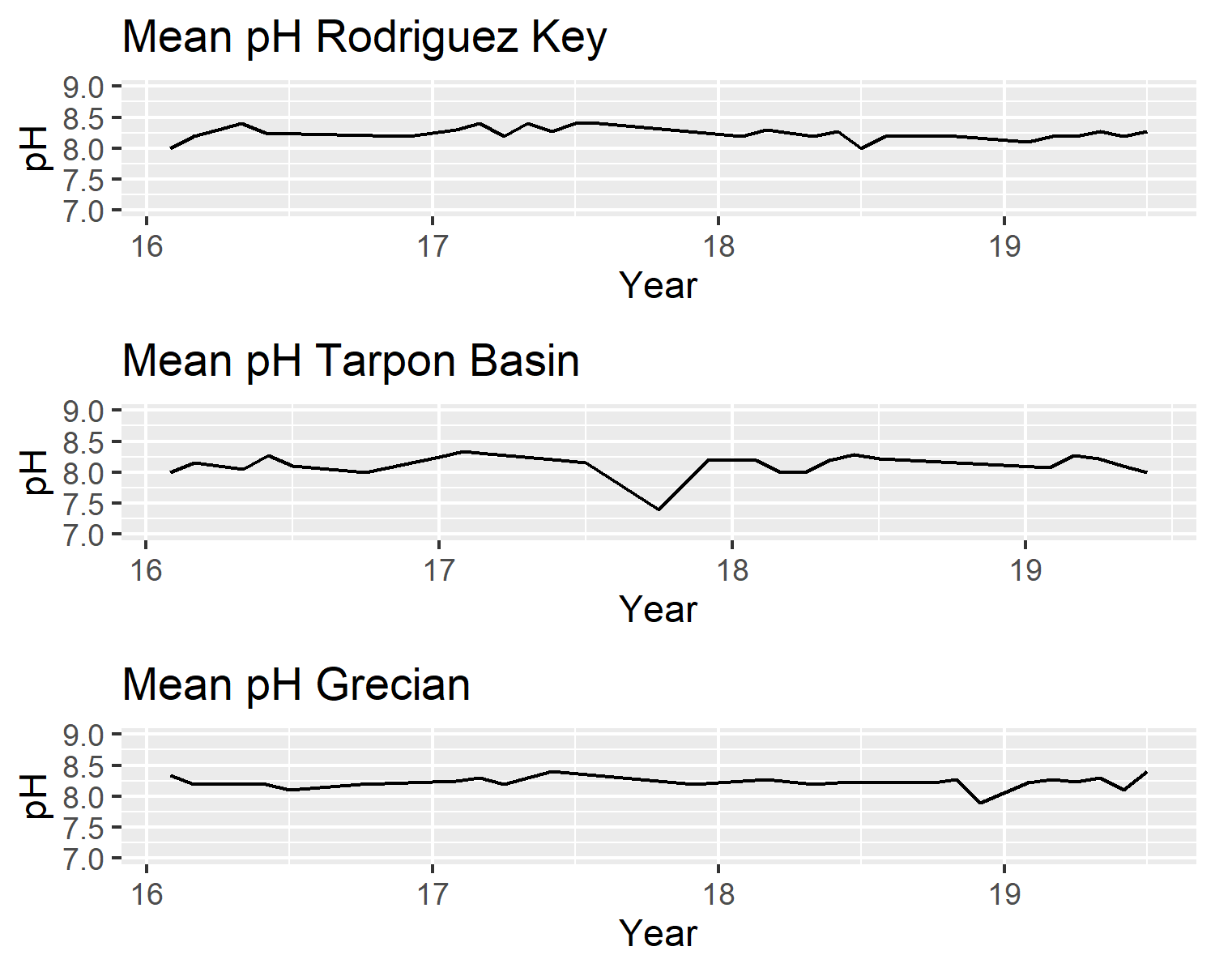

Mean pH over time for the three representative (most frequently visited) sampling sites.

## Unsupervised Learning Analysis

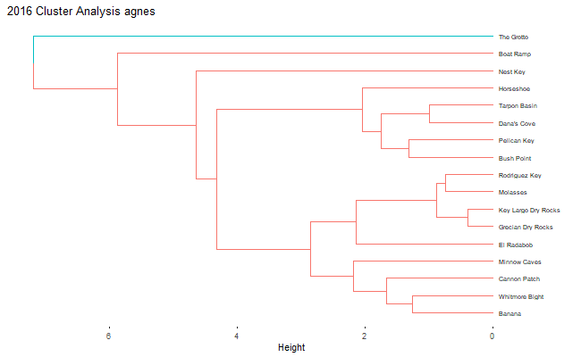

Agglomerative cluster analysis of 2016 sampling sites.

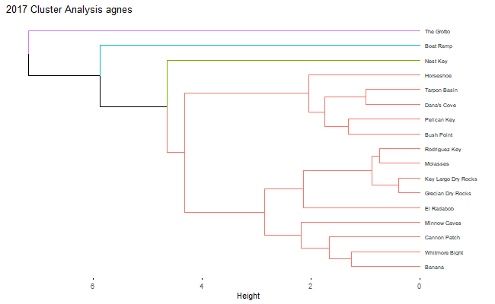

Agglomerative cluster analysis of 2017 sampling sites.

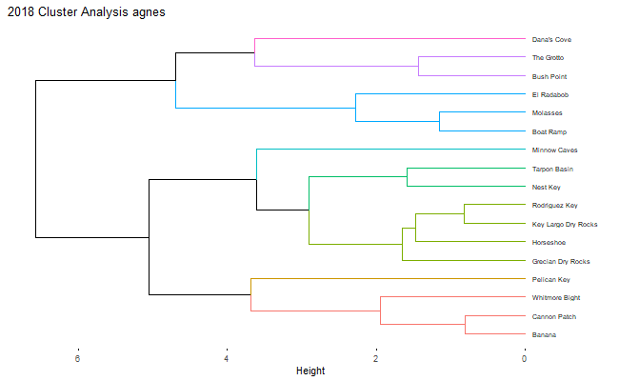

Agglomerative cluster analysis of 2018 sampling sites.

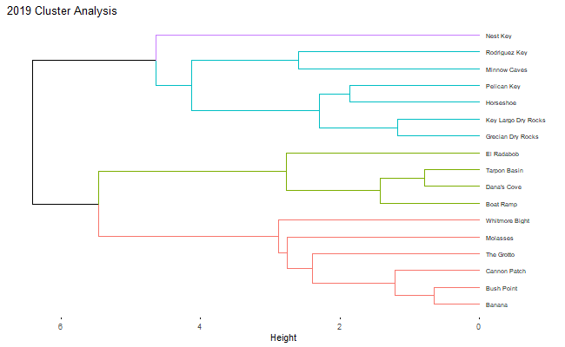

Agglomerative cluster analysis of 2019 sampling sites.

#### Year-to-Year Cluster Analysis

In addition to seasonal clustering, a year-to-year comparison of replicate sampling sites was analyzed with cluster analysis to compare the reproducibility of previous grouping patterns to each other. The results of this analysis were inconclusive due to limitations of the data collection and modeling techniques used. A standardized sampling system and timescale would be needed to properly control confounding variables to utlize this type of analysis. A detailed description of these methods and exploratory figures can be found in the written commentary for the Unsepervised_Learning_Analysis script in the code folder and analysis_code subfolder.

## Citizen Science Processing Script

For detailed instructions to install, input data, and run the citizen science water quality processing script please see the complete instructions found within the ReadMe file in the code subfolder of the project repository. For a detailed description of coding decisions and output formats please see the embedded commentary within the script titled citizen_science_processing_script found in the processing_code subfolder in the project repository.