Supplemental Materials

Megan Lott

2019-12-11

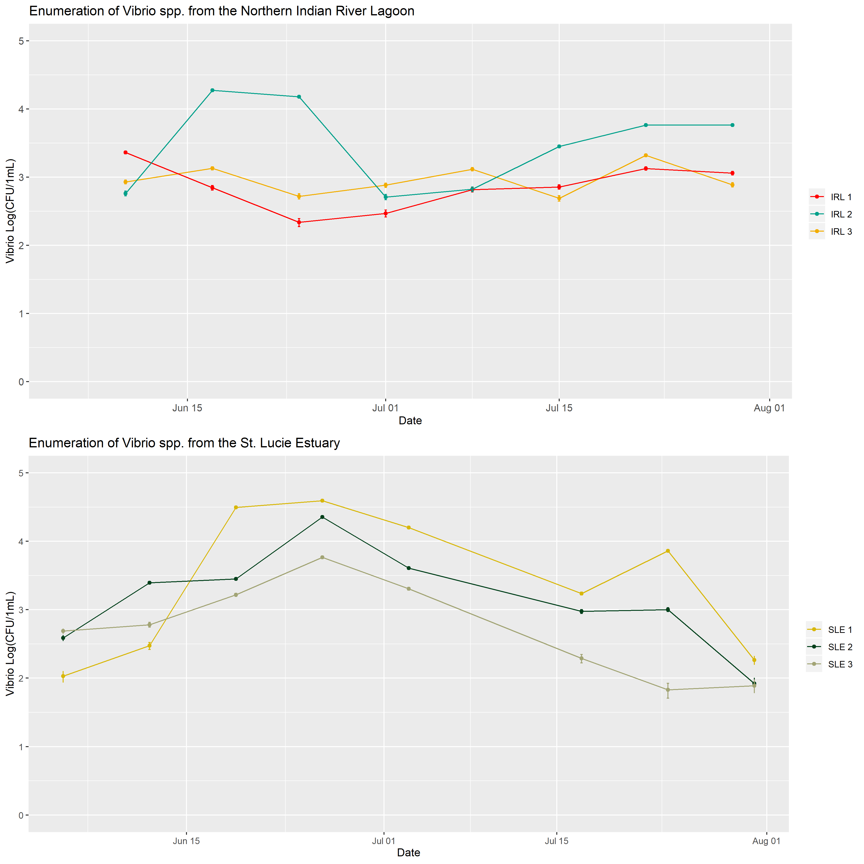

Figure 1: Enumeration of *Vibrio* spp. from the Indian River Lagoon and St. Lucie Estuary. Samples were collected between June 5, 2019 and July 30, 2019. *Vibrio* was enumerated on TCBS plates.

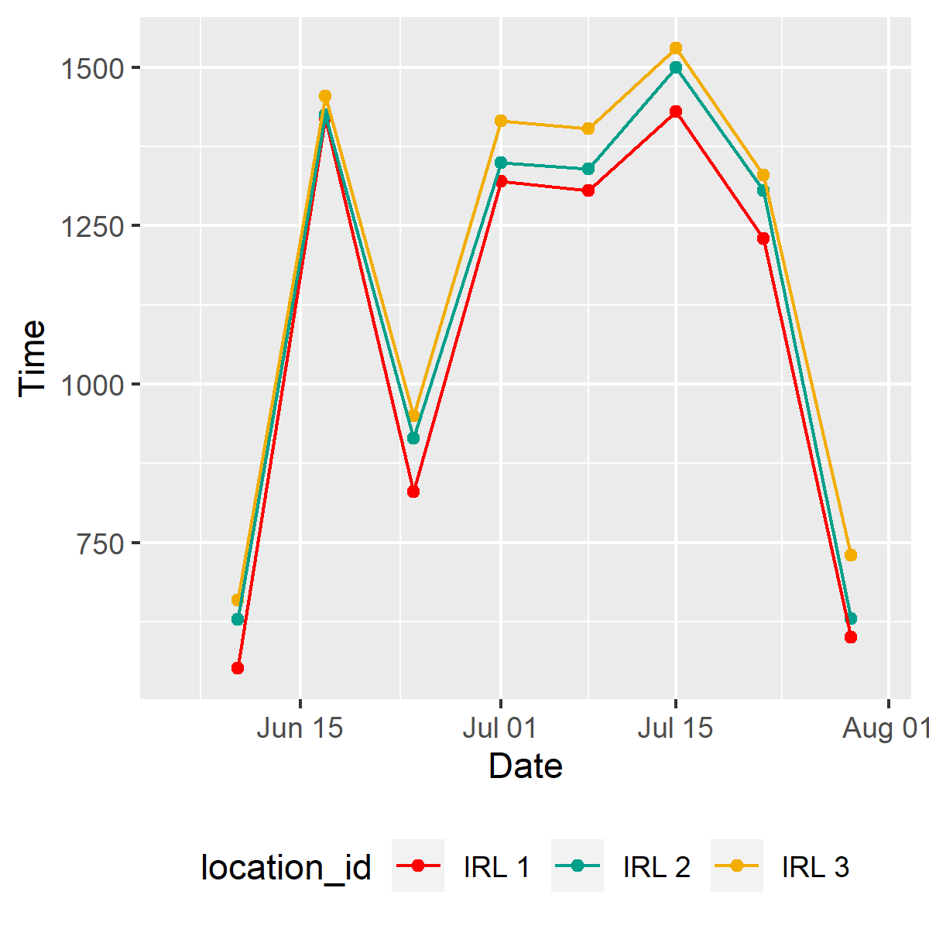

Figure 2: Time of sample collection from IRL 1, IRL 2, and IRL 3 between June 10 and July 29, 2019.

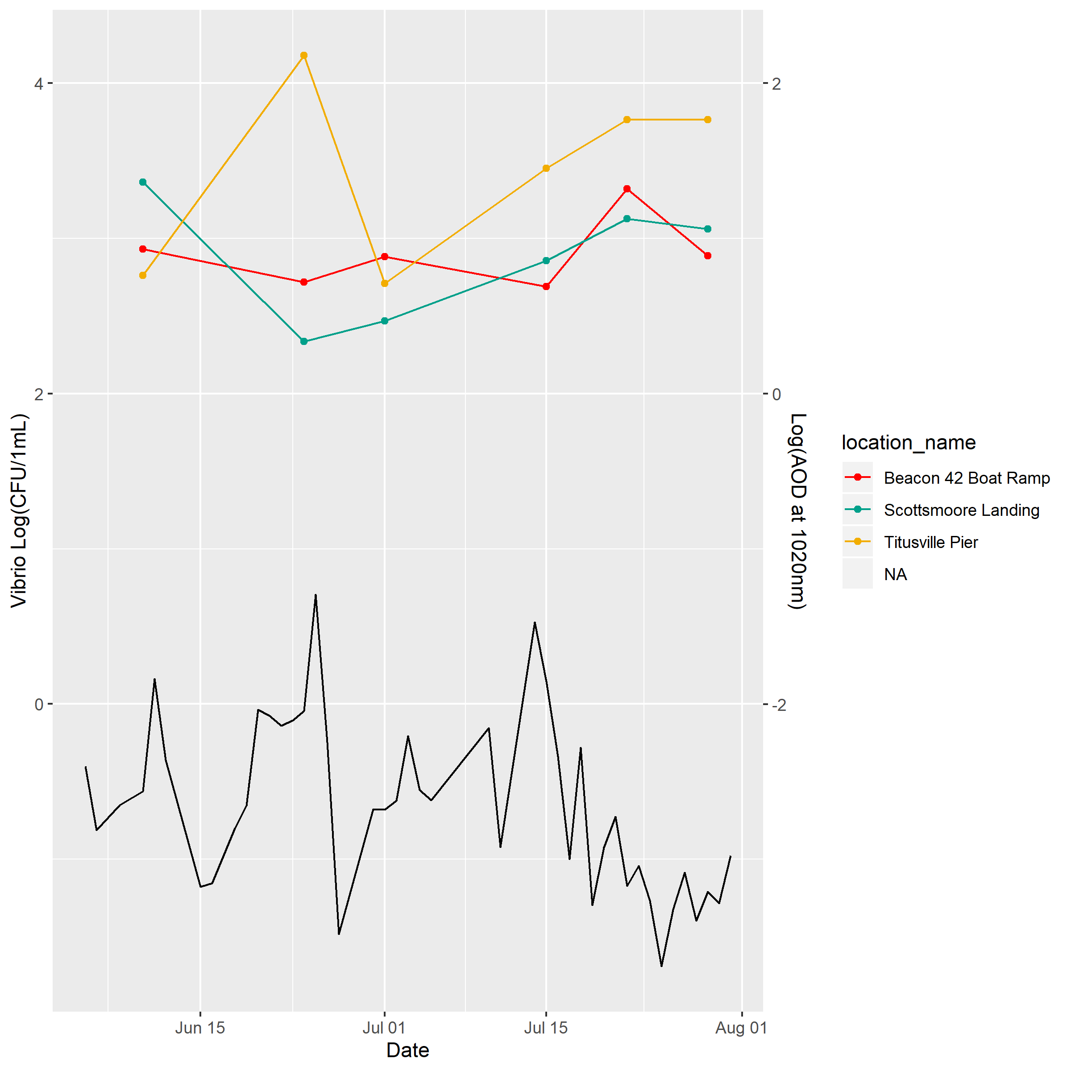

Figure 3: Abundance of Vibrio spp. and Aeorosol Optical Density in the IRL

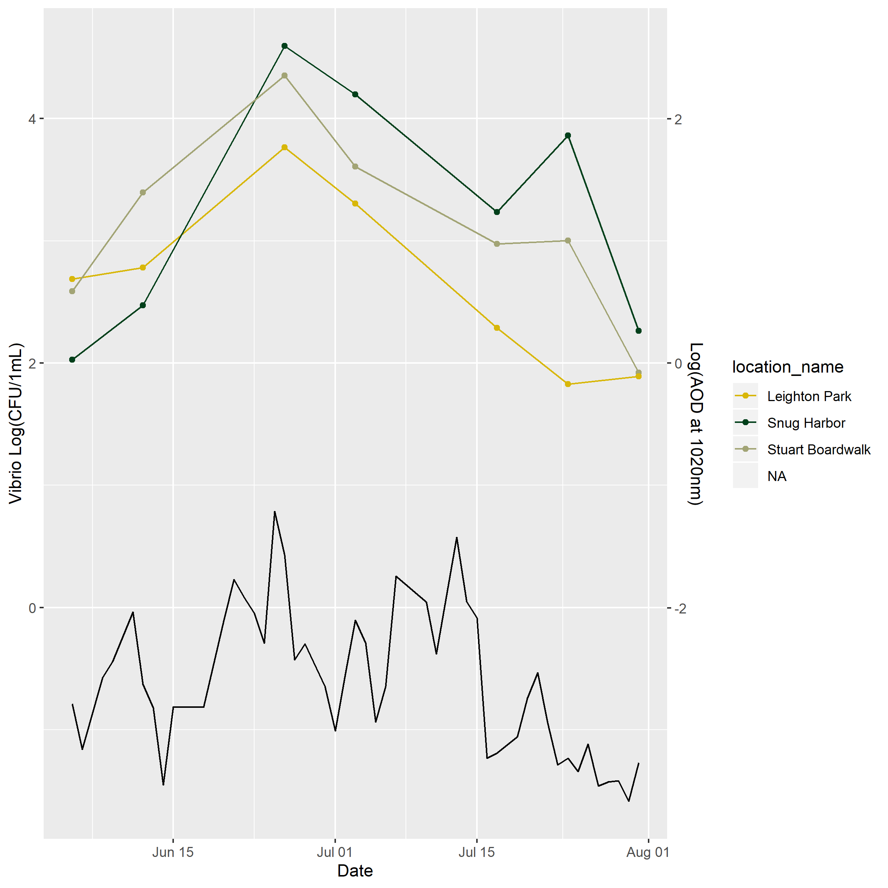

Figure 4: Abundance of Vibrio spp. and aeorosol optical density in the SLE

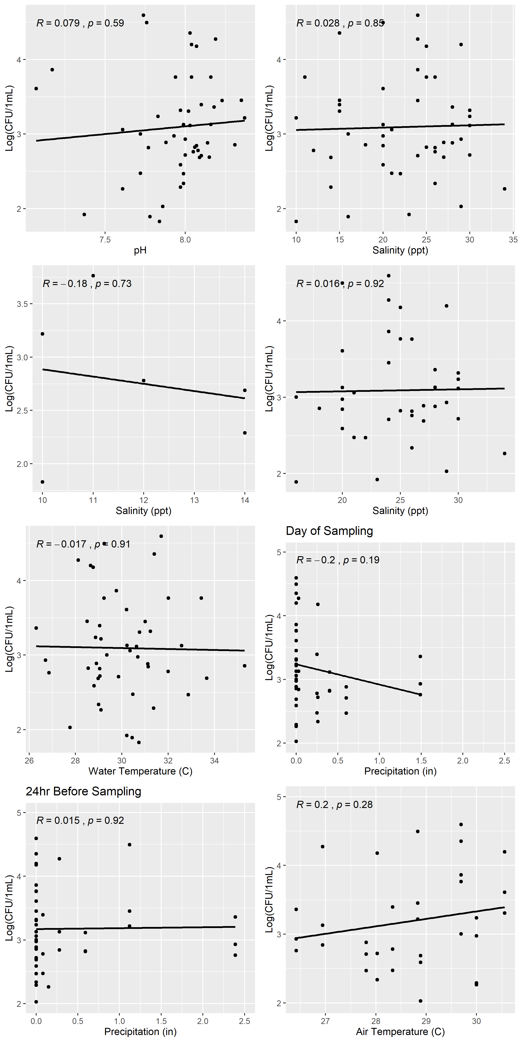

Figure 5: Enumeration of *Vibrio* spp. from the Indian River Lagoon and St. Lucy Estuary in relation to water quality parameters. Pearson’s correlation coefficient (R) and p-value (p) presented for each relationship.