Emily Piersiak

ECO 602

25 September 2020

Individual Assignment: Deterministic Functions

**Question 1: Histogram of elevation**

Examine the histogram for sampling site elevation.

*Q1 (1 pt). Upload an image file of your histogram.*

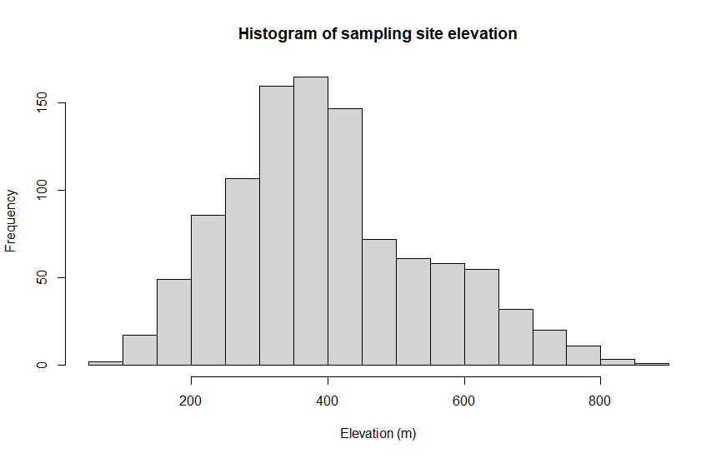

*Q2 (3 pts). Interpret the histogram in non-technical terms. Be sure to describe how are the sampling sites distributed with respect to elevation. Are they mostly low elevation? Are they evenly distributed with respect to elevation?*

Most of the sites are in the elevation range of 300 to 450 meters. There are fewer sites at extreme low and high elevations than there are at middle elevations. There are more plots at higher elevations than there are at lower elevations.

**Question 2: Histogram of slope**

Examine the histogram for sampling site slope.

*Q1 (1 pt). Upload an image file of your histogram.*

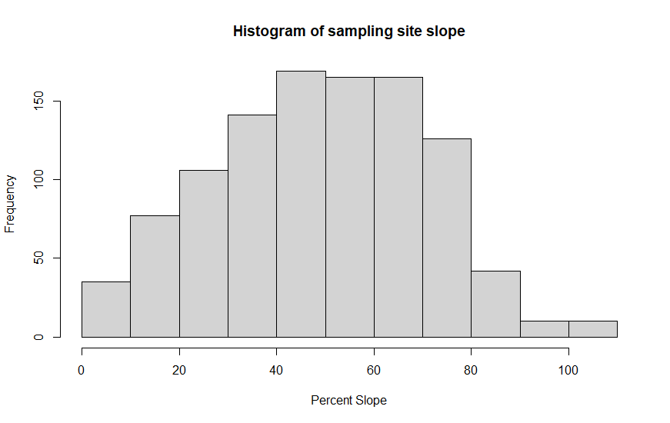

*Q2 (3 pts). Interpret the histogram in non-technical terms. Be sure to describe how are the sampling sites distributed with respect to elevation. Are they mostly low elevation? Are they evenly distributed with respect to elevation?*

Most of the sites have a percent slope between 40 and 70%. There are more sites with slopes below 40% than above 70%

**Question 3: Histogram of aspect**

Examine the histogram for sampling site aspect.

*Q1 (1 pt). Upload an image file of your histogram.*

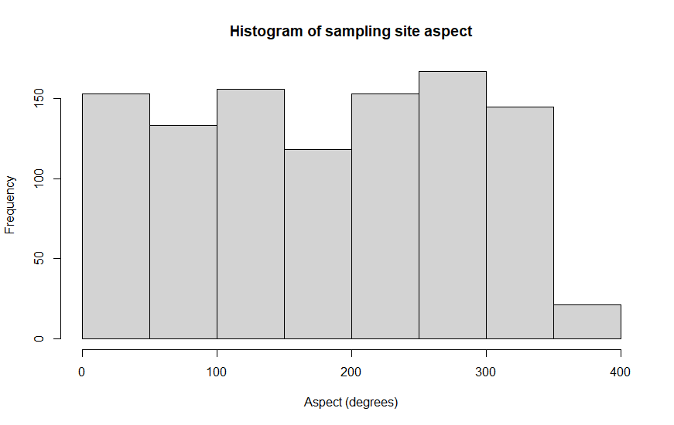

*Q2 (2 pt). What is aspect, and how is it measured?*

Aspect is a numerical representation of the cardinal direction that the plot is facing. It is measured using a compass. North is at 0 and 360 degrees, South is at 180 degrees, East is at 90 degrees, and West is at 270 degrees.

*Q2 (3 pts). Interpret the histogram in non-technical terms. Be sure to describe how are the sampling sites distributed with respect to aspect. Do the sampling sites tend to be on north-facing slopes? South-facing? Evenly distributed?*

The relationship of aspect and slope is relatively evenly distributed. There is a roughly equal amount of sites facing East and West, and slightly more North facing sites than South facing.

**Question 4: Interpret terrain histograms**

Consider the terrain in the state of Oregon. Consult a topographic map if needed (Dr. Google is your friend).

*Q1 (3 pts). Discuss the distribution of the terrain characteristics of the sampling sites in reference to the terrain of the state of Oregon.*

Oregon seems to be about half rugged, mountainous terrain, and half flatter, more gentle terrain. The elevation of Oregon seems to be poorly represented in the site samples as it ranges from 0 to 800 meters, whereas many parts of the mountains in the stat lie above the 800 meter elevation mark.

The slope is normally distributed, which does seem quite representative of Oregon’s natural features because there is a lot of variability in the slope of the terrain.

The aspect is also well represented because it is roughly evenly distributed across all 4 cardinal directions, as are the aspects of the terrain of Oregon.

*Q2 (2 pts). Speculate on how the histograms might differ if the research were conducted in a less rugged state such as Ohio.*

If this research was conducted in Ohio, not much would change in terms of the shape of the distribution for aspect. However, there may be an increase in the amount of sampling sites with no aspect (they are on totally flat land).

The slope distribution would look similar but with lower values on average. The same is generally true of elevation, but the histogram for elevation would probably be skewed left instead of right as it is in Oregon.

**Question 5: Terrain and basal area scatterplots**

*Q1 (3 pts). Upload image files of the three scatterplots you created of the terrain variables and basal area.*

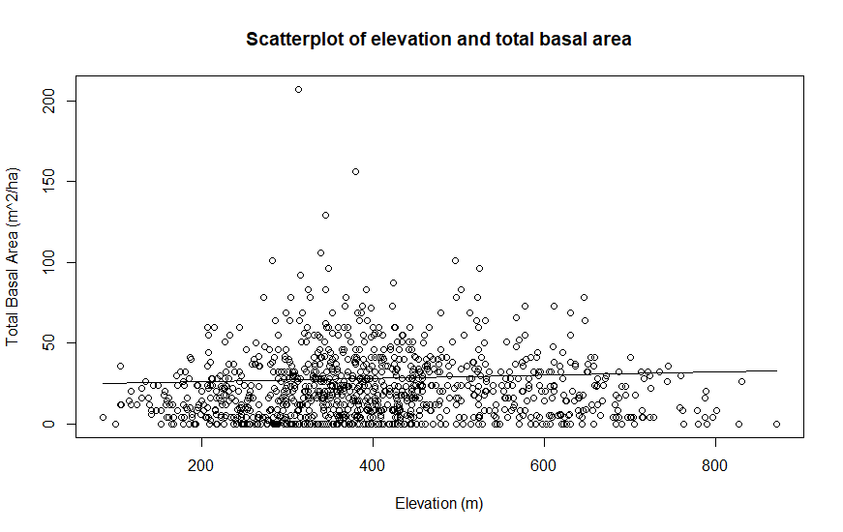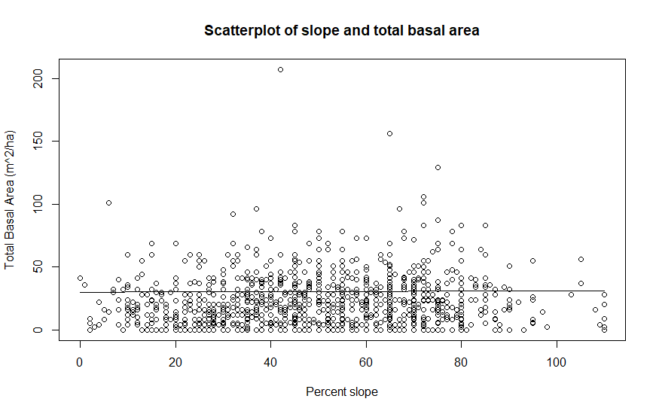

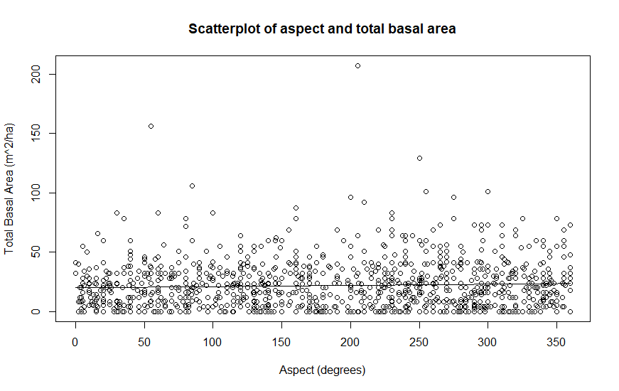

**Question 6: Terrain and basal area scatterplots: interpretation**

Consider the three terrain/basal area scatterplots.

*Q1 (1 pts). Describe the relationship you observe between elevation and basal area.*

Basal area is highest at moderate elevations. Above 700 meters and below 200 meters, basal area does not exceed 50 m^2/ha.

*Q2 (1 pts). Describe the relationship you observe between slope and basal area.*

Basal area seems relatively consistent across all slopes. There are a few high basal area outliers between 40 and 80% slope, but excluding those, basal area doesn’t seem to change with slope.

*Q3 (1 pts). Describe the relationship you observe between aspect and basal area.*

There is no relationship between aspect and basal area. There are a few outliers in the Northeast and Southwest, but no relationships.

Q4 (3 pts). Describe how basal area varies with terrain in the sample sites in Oregon. Make sure your answer is in non-technical language that an audience of non scientists would understand.

Basal area doesn’t really vary with terrain in these sample sites in Oregon. I believe that this is due to a non-representative sample selection for the state of Oregon. There are many high elevation locations where basal area would decrease with elevation that are not represented within this dataset. Basal area generally does not change with slope or aspect, but tree species may. However, tree species is not relevant in this analysis.