**Methods**

We identified waves in Rt estimates by finding local minima and maxima of median Rt estimates for each data source over a rolling window of 7 days. The centre of each wave was taken as the mean of the Rt estimates at the peak and the preceding trough, the amplitude as the estimate at the peak minus that at the centre, and the period as the time in days between peaks. To avoid the first epidemic wave dominating plots and obscuring differences, all plots were limited to the earliest date that any Rt estimate for England crossed below 1 after the peak.

We hypothesised that localised outbreaks and resulting increases in testing and case detection rates might increase the variability of Rt estimates from test-positive cases. We also investigated whether age and vulnerability were related to Rt estimate variation, because of the increased severity of disease (thus, representation in hospital or death data) with age and co-morbidities (#ref), although this was limited by lack of available public data. We explored the national distribution of age among test-positive cases and hospital admissions over time (#ref), and we also hypothesised that regional outbreaks of Covid-19 among care home residents could be linked to variation in Rt estimates by data source.

We sourced weekly data on regional and national test positivity (percentage positive tests of all tests conducted), from Public Health England ([#ref](https://www.gov.uk/government/publications/national-covid-19-surveillance-reports)), and used a binary threshold of 5% test positivity (#ref-WHO) to plot over time. We interpreted results in light of known outbreaks and policy changes ([#ref](https://www.health.org.uk/news-and-comment/charts-and-infographics/covid-19-policy-tracker)). We sourced weekly data on the number of outbreaks reported in care homes by region (#[ref](https://www.gov.uk/government/statistical-data-sets/covid-19-number-of-outbreaks-in-care-homes-management-information)). Care homes were defined as supported living facilities (residential homes, nursing homes, rehabilitation units and assisted living units). An outbreak was defined as two or more suspected or confirmed cases. Any individual care home was included in the dataset only once, at the first outbreak. Therefore, new outbreaks were those reported in care homes that had not previously reported an outbreak. No subsequent data were available on the size or duration of outbreaks and data were not published beyond 13 July. We took the percentage of care homes reporting new outbreaks in one week against total care homes by region and plotted over time.

**Results**

Across England, positive Covid-19 tests peaked at 4,793 test-positive cases (22 April), 3,099 admissions (1 April), and 974 deaths (8 April) per day. From this level, counts among admissions and deaths declined more gradually than from test-positive cases through April and May (time to a -50% decline from peak of 28, 20, 22 days respectively: figure 1A). This mean that counts among test-positive cases matched counts of admissions on 20 May, at 900 cases. Admissions and test-positive cases then gave approximately the same counts through June (+- 10%), with all three counts declining by 10% from 20th May to Jun 27th. This trend continued for counts of admissions and deaths from Covid-19 until August 20th. However, from late June, case counts from all reported test-positive cases increased rapidly (+10% over 7 days) and then gradually (+10% until 30 days until August 20th).

Rt estimates from all sources of cases moved in sine waves throughout the time series (figure 1B), but the frequency, amplitude, and trend of waves varied both by data source and within each Rt estimate over time. The net effect of the differences in wave frequency and amplitude is seen in the ratios between each Rt estimate (Figure 1C-E). Over April through to mid-June, Rt estimates from cases, admissions, and deaths in England had minor waves with no clear linear trend, with waves on average centred around 0.85 (95%CI for mean 0.75-0.93), 0.88 (95%CI 0.86-0.9), and 0.84 (95%CI 0.81-0.88) respectively. Rt estimates from admissions saw lower amplitude and higher frequency waves than that from deaths (respective mean wave amplitude from centre 0.05 (95%CI 0.01-0.08), with average period 25 days (95%CI 16-35); amplitude 0.09 (95%CI 0.07-0.1), with mean period 42 days (95%CI 21-63)). Among all estimates, Rt from deaths saw the lowest trough at 0.74 (90% credible interval (CrI) of estimate 0.61-0.87) in late May, before rising to match the Rt from admissions at 0.8 (90%CrI 0.65-0.94) on 26 June.

Through July and August, Rt from deaths and admissions in England then remained in synchrony (on average, admissions 3% higher, 95%CI 2-5%). Over this period, Rt from both deaths and admissions increased linearly, to reach 0.9 (95%CI 0.68-1.09) and 0.95 (95%CI 0.89-1.01) respectively by 3 August. In contrast, Rt from test-positive cases peaked on the 29th June at 1.36 in a high amplitude wave (amplitude 0.26, centre 1.1), followed by a lower second wave (amplitude 0.1, centre 1.05, peak at 1.15 on 30 July). Therefore, by 10 August the median Rt from admissions was only 3% lower than the median Rt from test-positive cases.

We hypothesised that variations in Rt estimates based on data reflecting more severe outcomes (hospital admissions and deaths) were related to changes in the age distribution of cases over time. The age distribution among all test-positive cases in England decreased towards a younger population over time, with the combined 0-49 years age group representing 57% cases by 14 June (N=6,472 over following week). Similar ages (0-44 years) never accounted for more than 13% among admissions (N=690 in the week of 23 August). This might be seen if Rt estimates from either of the latter two sources diverges from Rt estimated from all test-positive cases. For example, the ratio of Rt estimates from cases to that from admissions saw smaller peaks in early and late May before a high-amplitude wave with peak in late June, similar to local peaks in the percentage of younger age groups among test-positive cases, while hospital admissions by age remained largely stable.

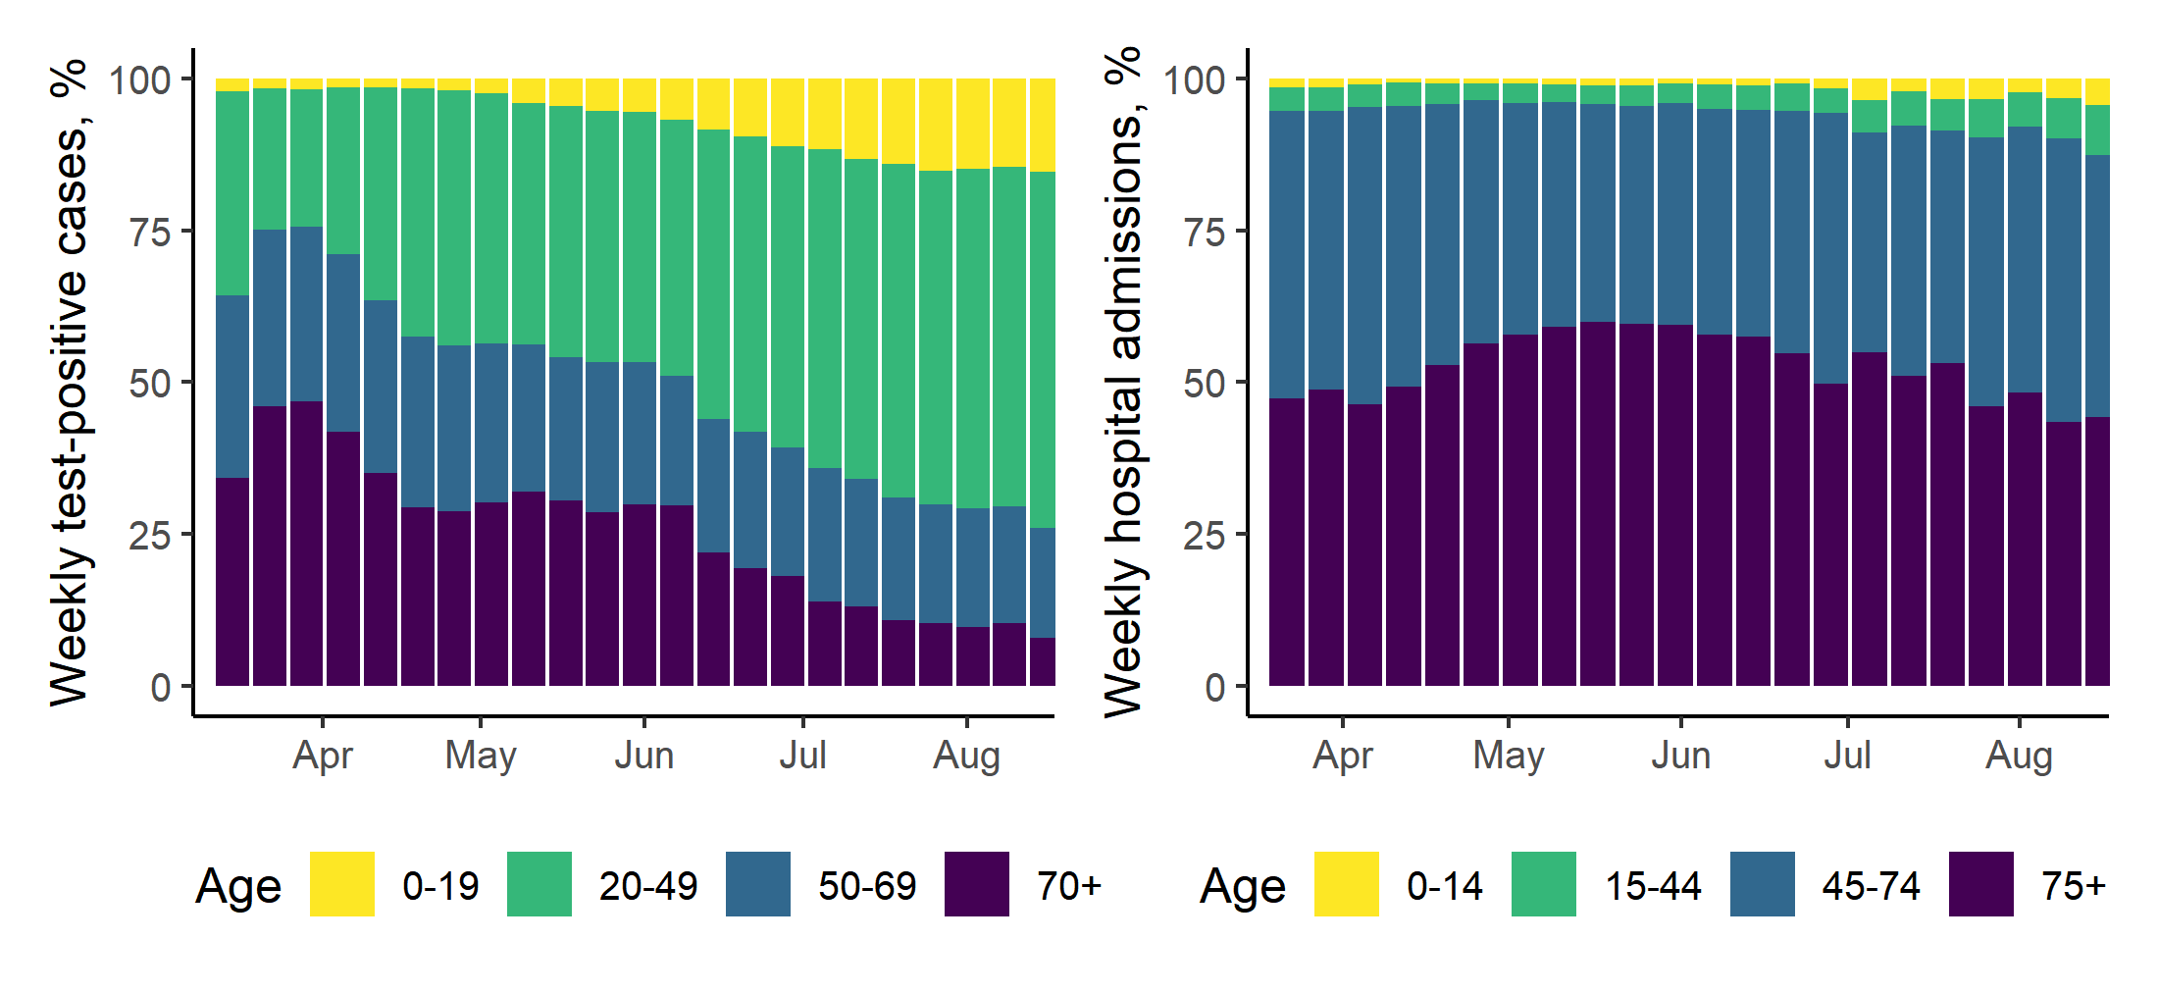

*Figure #. Percentage of cases in England by age among test-positive cases (left) and newly diagnosed hospital admissions (right).*

At a regional scale, Rt estimates by data source also varied in the timing, level, and amplitude of the first and subsequent waves of transmission. For example, the date after the initial peak when Rt crossed below 1, indicating a declining epidemic, was spatially variable when estimated from cases (earliest median estimate below 1 on 28 March in London, latest 23 April in South West), but more consistent when estimated from admissions or deaths (range among regions 4 days and 8 days respectively, with an identical average of 1 April). On average across all regions, cases saw a higher Rt estimate than admissions or deaths (mean of respective median estimates 1.1 (95%CI of mean 1.09-1.13), 0.89 (95%CI 0.89-0.9), 0.94 (0.92-0.96). Meanwhile, Rt estimates from cases had a lower frequency (mean periodicity among all regions of 39 days (95%CI 32-46)), and lower amplitude (0.11, 95%CI 0.06-0.15), compared to admissions (periodicity 29 days (95%CI 24-34), amplitude 0.06 (95%CI 0.04-0.07)). These characteristics of Rt estimated from cases were in fact more similar to Rt estimated from deaths (periodicity 36 (95%CI 30-43)), amplitude 0.12 (95%CI 0.07-0.17)).

However, this disguises strong regional variation in Rt over time. For example, among Rt estimates from cases, London saw a very long periodicity (mean 67 days, 95%CI 0-239) with a near-linear increase in trend between a trough on 8 May and the following peak on 8 July. In contrast, Rt from cases in both the North East and Yorkshire, and the Midlands, had just under monthly periodicity (both mean 28 days; respective 95%CIs 22-34 and 24-33). A potential driver could be uneven changes in case detection in the community, with targeted testing around regionally localised outbreaks. For example, both the North East and Yorkshire, and the Midlands, saw high test positivity rates among community (Pillar 2) tests (figure #2A; respectively: mean 6%, 95%CI 4.5-7.4; mean 5.8, 95%CI 4.6-7, both from 10 May when testing data became available to 30 August). This might suggest targeted testing among known outbreaks, such as in Leicester and a Luton factory, in the Midlands (local restrictions in place from 4 July and 25July, [#ref](https://www.legislation.gov.uk/uksi/2020/685/memorandum/contents)), or Bradford, Calderdale, and Kirklees, in Yorkshire (with local restrictions from 1 August, [#ref](https://www.legislation.gov.uk/uksi/2020/828/contents/made)). This would mean that within the region, the population receiving tests changed over time (with selective testing of those more likely to be positive), contributing to the oscillation in Rt estimates after mass testing became widespread from 10 May.

Rt estimates from admissions and deaths were typically more similar in level compared to Rt from cases (figure #). Notably, after the first epidemic peak, Rt estimated from either admissions or deaths experienced near-synchronous local peaks over April or May (figure #), and this was out of phase compared to peaks in Rt estimated from cases in all regions except in London and the South West. In the East, South East, and North East and Yorkshire, Rt estimates from admissions or deaths were at a peak while estimates from cases were declining or in a trough. For example, in the North East and Yorkshire on 22 April, Rt estimated from admissions and deaths peaked (0.91, 90%CrI 0.85-0.97, and 0.9, 90% CrI 0.82-0.99) while Rt from cases maintained a linear decline (a fall of 16% since the previous peak on 14 April, to 0.94, 90%CrI 0.98-0.99). This also meant that all estimates were relatively similar at that point in time (average ratio across regions of Rt from cases to: Rt from deaths, 1.04, 95%CI 0.95-1.13; and Rt from admissions, 1.01, 95%CI 0.9-1.13).

We explored a comparison with care home outbreaks by region. In most regions, our rolling window estimate of the local peak of Rt transmission from both admissions and deaths matched or preceded possible inflection points in care home outbreaks. For example, in the East of England, a peak in Rt from admissions and deaths on the 17 and 18 April (median estimates 0.93 (90%CrI 0.86-0.98), 0.89 (90%CrI 0.79-1) was followed by a peak in outbreaks in care homes on 20 April (108 new care homes reported outbreaks of 1726 total care homes). Alternatively, the difference between Rt estimates from admissions and estimates from deaths might indicate outbreaks in particularly vulnerable populations (without means of registering as a hospital admission). However, this was difficult to determine: available data gave no indication of the size, duration, or outcomes of care home outbreaks, so we can offer little clear evidence of the regional case and mortality burden and transmission dynamics of Covid-19 in care homes.

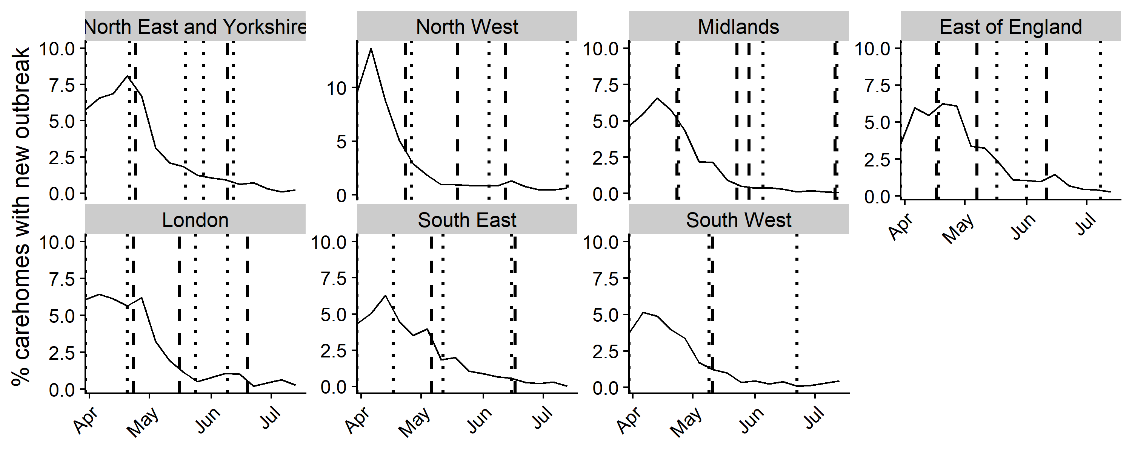

*Figure #. Number of care homes reporting new outbreaks over time as % of all care homes by region, 4 April to 13 July 2020.* *Care homes include residential homes, nursing homes, rehabilitation units and assisted living units. An outbreak was defined as two or more suspected or confirmed cases. Any individual care home was included in the dataset only once, when reporting its first outbreak. Vertical intercepts are regional local peaks (rolling 7-day maxima) in Rt estimates from admissions (dotted) and deaths (dashed).*