Recommendation report

2015004248
Jo Hyung Jung

1. Overview

In this project, I predict ratings of movies in test data by using training data containing movie ratings of users. There are typically two ways to recommend, content-based method and collaborative filtering method respectively.
I used collaborative filtering method. Since there are several methods in collaborative filtering, I had to implement those methods and compare each of them. I found that using ‘user-based collaborative filtering’ is the best way based on RMSE value.

2. Run-time environment

- OS: Ubuntu 18.04
- Language: Python 3.6
- Libraries:
Python argparse module: for getting command-line arguments.

3. Summary of algorithm

I tested several methods in collaborative filtering to find out best result. Following is the each of them respectively.

1. Rating matrix

i) User-based collaborative filtering
Use relationship of users to build rating matrix.

ii) Item-based collaborative filtering
User relationship of items to build item matrix. In this project, the information of relationship of items is much less than of users. So I used ‘User-based collaborative filtering’.

2. Similarity measure

i) Cosine similarity
w(a,i) = sum[ {v(a,j) / sqrt{sum(v(a,k)**2}} * {v(i,j) / sqrt{sum(v(i,k)**2}} ]

ii) Pearson coefficient correlation similarity
w(a,i) = sum[{v(a,j)-mean of v(a)} * {v(i,j)-mean of v(i)}] /
sqrt[sum{(v(a,j)-mean of v(a))**2} * sum{(v(i,j)-mean of v(i))**2}]
3. Aggregation of ratings

i) Simple average
r(c,s) = sum{r(c`,s)} / N

ii) Weighted average
r(c,s) = sum{sim(c,c`) * r(c`,s)} * k

iii) Weighted average (normalized version)
r(c,s) = mean of r(c) + sum[sim(c,c`) * {r(c`,s) -mean of r(c`)}] * k

4. Implementation details
In testing above methods, I found out using ‘User-based’ & ‘Cosine similarity’ & ‘Weighted average (normalized version)’ is the best solution. Below is the flow chart.

Extract required data
Calculate cosine similarity of users
For making rating matrix
Predict ratings in test data
[Flow chart]

5. Analysis of code

i) Data structures
I used one class named ‘Recommender’
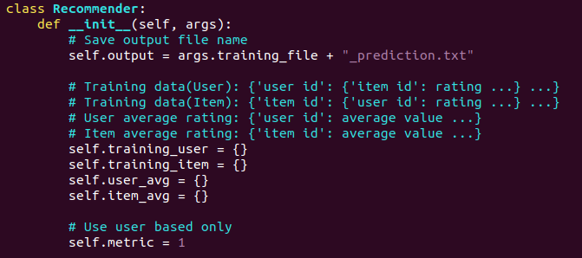
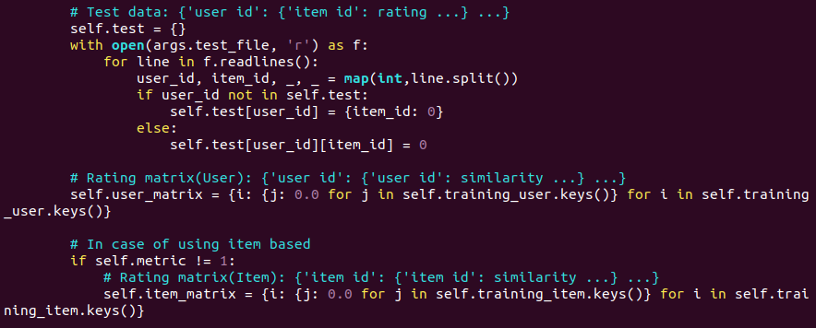
There are 9 attributes in ‘Recommender’ class.
1. output: represents output file name
2. training_user: represents training data in user-based model
3. training_item: represents training data in item-based model
4. user_avg: represents rating average of each user in user-based model
5. item_avg: represents rating average of each item in item-based model
6. metric: represents whether using user-based model or item-based model. Fixed to use user-based model.
7. test: represents test data ( Target user/item to predict rating)
8. user_matrix: represents rating matrix in user-based model
9. item_matrix: represents rating matrix in item-based model
ii) Functions
I use 9 functions in ‘Recommender’ class.
- __init__
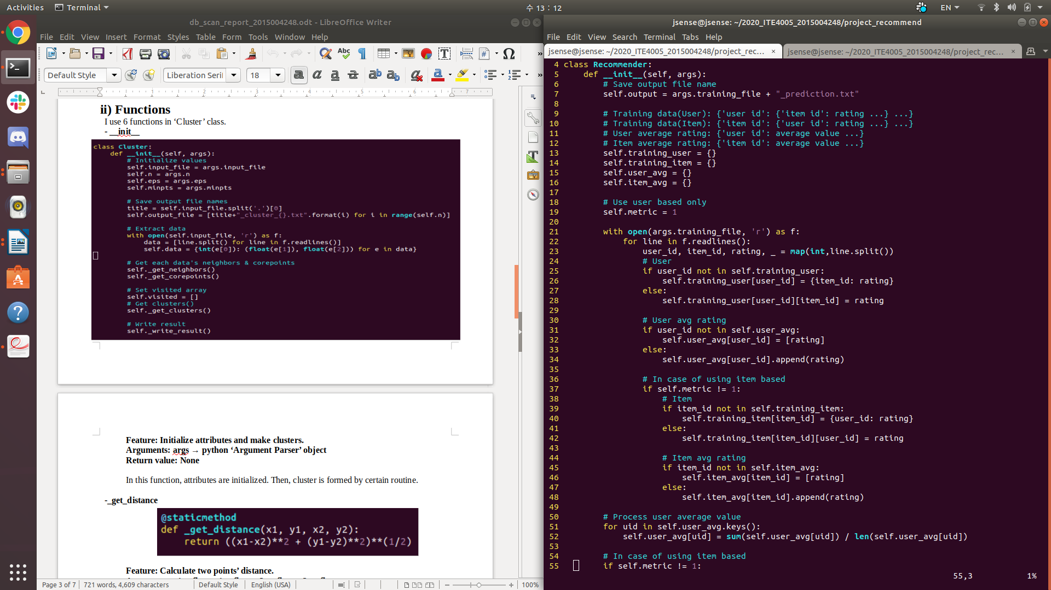
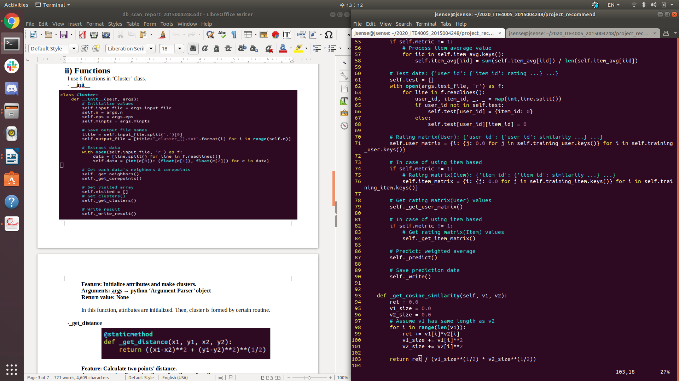
Feature: Initialize attributes and predict ratings.
Arguments: args → python ‘Argument Parser’ object
Return value: None

In this function, attributes are initialized and total process is proceeded.

First, initialize variables and set metric value. Metric value is set to 1 denoting ‘User based model’ which is the best solution.

Second, read training file and extract data. I don’t use timeline data in this project. Training data is saved as dictionary format: {‘user id’: {‘item id’: rating …} …}.
After processing training data, calculate average rating values of each user. It is also saved as dictionary format: {‘user id’: average value …}.

Third, read test file and extract data. Target user and item id is saved as dictionary
format: {‘user id’: {‘item id’: rating …} …}. Then make initial rating matrix.

Fourth, make rating matrix using function ‘_get_user_matrix’. More specific information of this function is below.

Fifth, make prediction using rating matrix above. Then write result in appropriate file format.

-_get_cosine_similarity
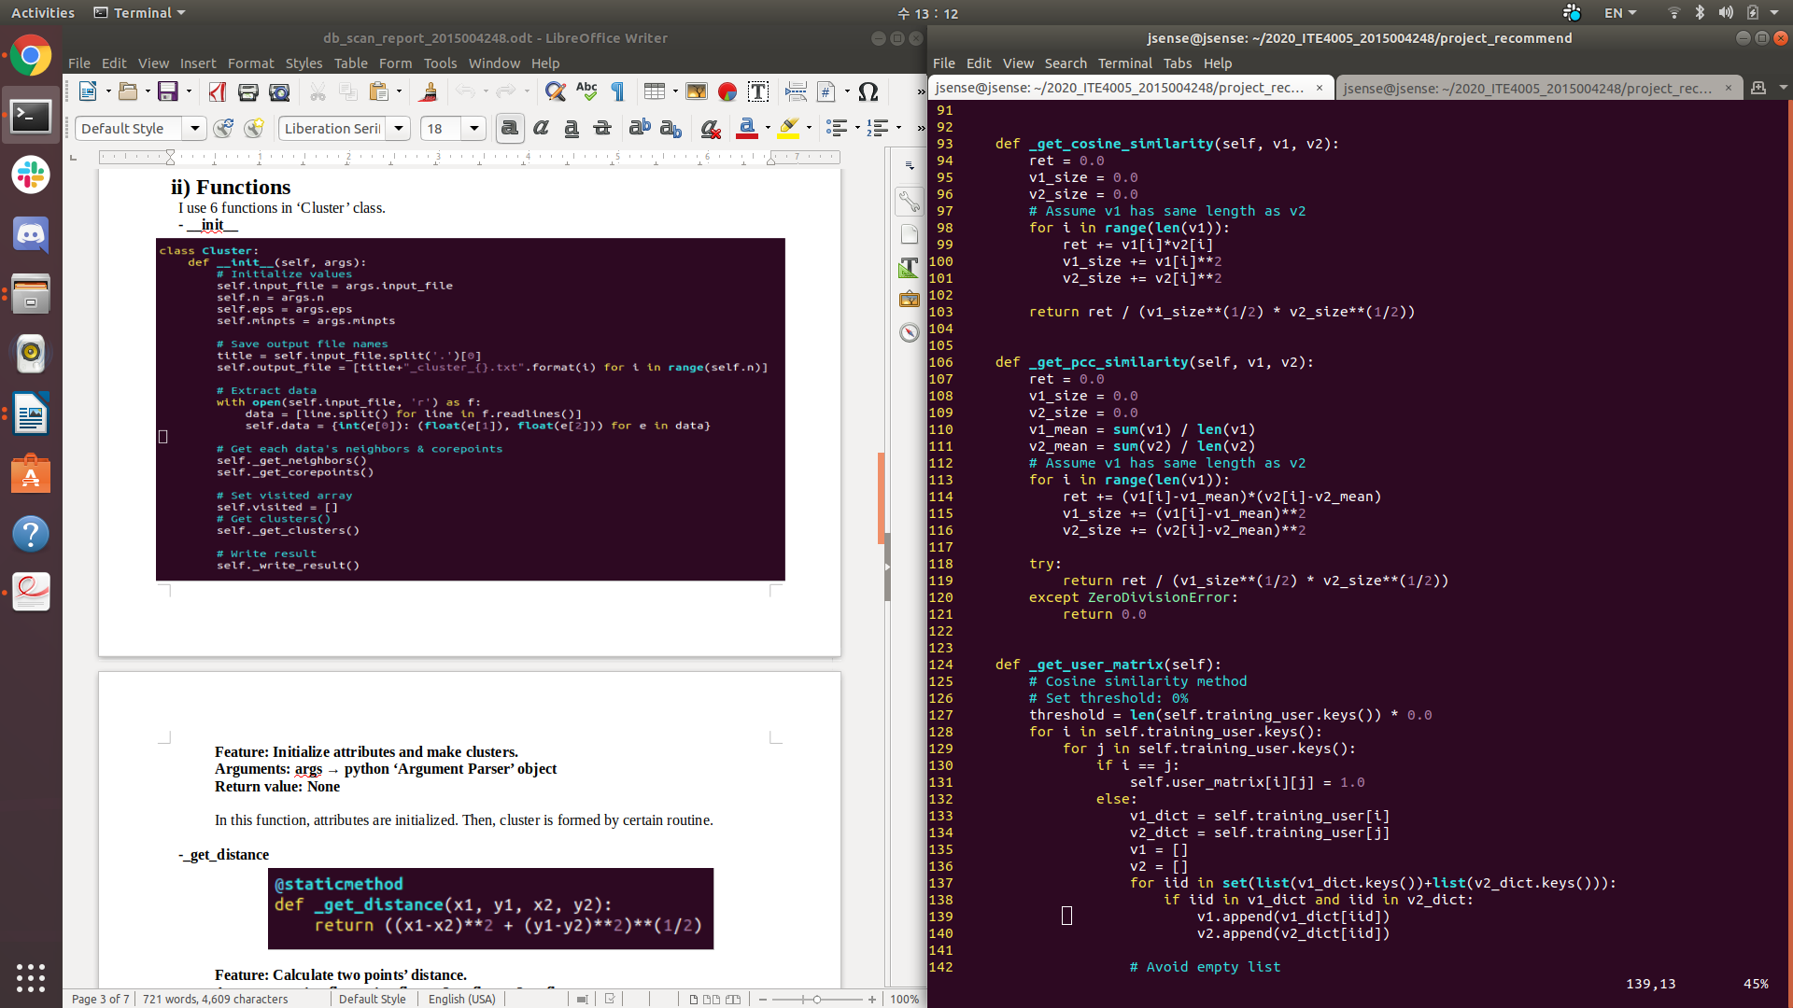
Feature: Calculate cosine similarity
Arguments: v1→ list, v2 → list
Return value: ret / (v1_size**(1/2) * v2_size**(1/2))

In this function, calculate cosine similarity of two given vectors. Same size of two vectors is guaranteed. To avoid divide zero error, caller of _get_cosine_similarity checks whether v1 and v2 are empty or not.

-_get_pcc_similarity

Feature: Calculate pearson correlation coefficient similarity
Arguments: v1→ list, v2 → list
Return value: ret / (v1_size**(1/2) * v2_size**(1/2)) or 0.0

In this function, calculate pearson correlation coefficient similarity of two given vectors. Same size of two vectors is guaranteed. If numerator is zero, return 0.0 to avoid ‘ZeroDivisionError’. This function isn’t used for better result.

-_get_user_matrix
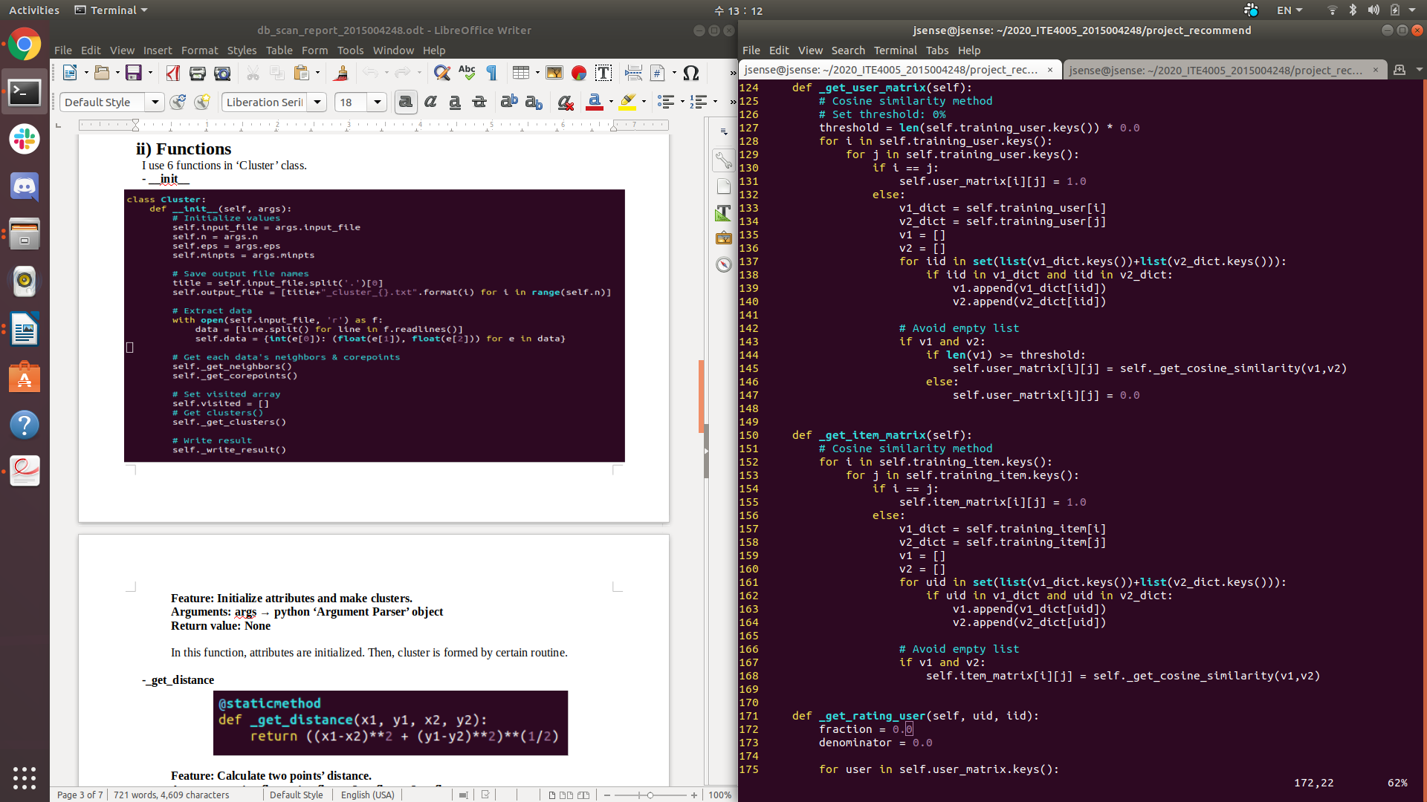

Feature: Create rating matrix in user-based method.
Arguments: None
Return value: None

In this function, create rating matrix in user-based method. By iterating every user, calculate similarity of two given users. Cosine similarity is used to calculate similarity. If there are no common rated items, set similarity to zero. This function isn’t used for better result.

-_get_item_matrix
Feature: Create rating matrix in item-based method.
Arguments: None
Return value: None

In this function, create rating matrix in item-based method. By iterating every user, calculate similarity of two given users. Cosine similarity is used to calculate similarity. If there are no common values, set similarity to zero.

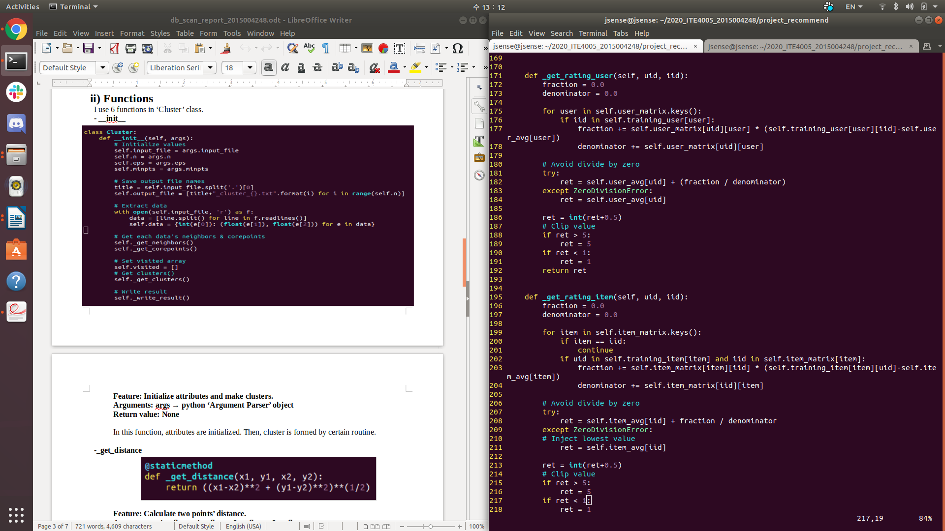
-_get_rating_user

Feature: predict rating in user-based method
Arguments: uid→ int, iid→ int
Return value: ret→ int

In this function, rating is predicted by using rating matrix and given user id & item id.
I used weighted average aggregation with normalization. Normalization is done by subtracting mean values. If ‘ZeroDivisionError’ occurs, mean value of given user is returned. Return value is clipped when it’s over 5 (Maximum rating value) or below 1 (Minimum rating value).

-_get_rating_item

Feature: predict rating in item-based method
Arguments: uid→ int, iid→ int
Return value: ret→ int

In this function, rating is predicted by using rating matrix and given user id & item id.
I used weighted average aggregation with normalization. Normalization is done by subtracting mean values. If ‘ZeroDivisionError’ occurs, mean value of given item is returned. Return value is clipped when it’s over 5 (Maximum rating value) or below 1 (Minimum rating value).

-_predict
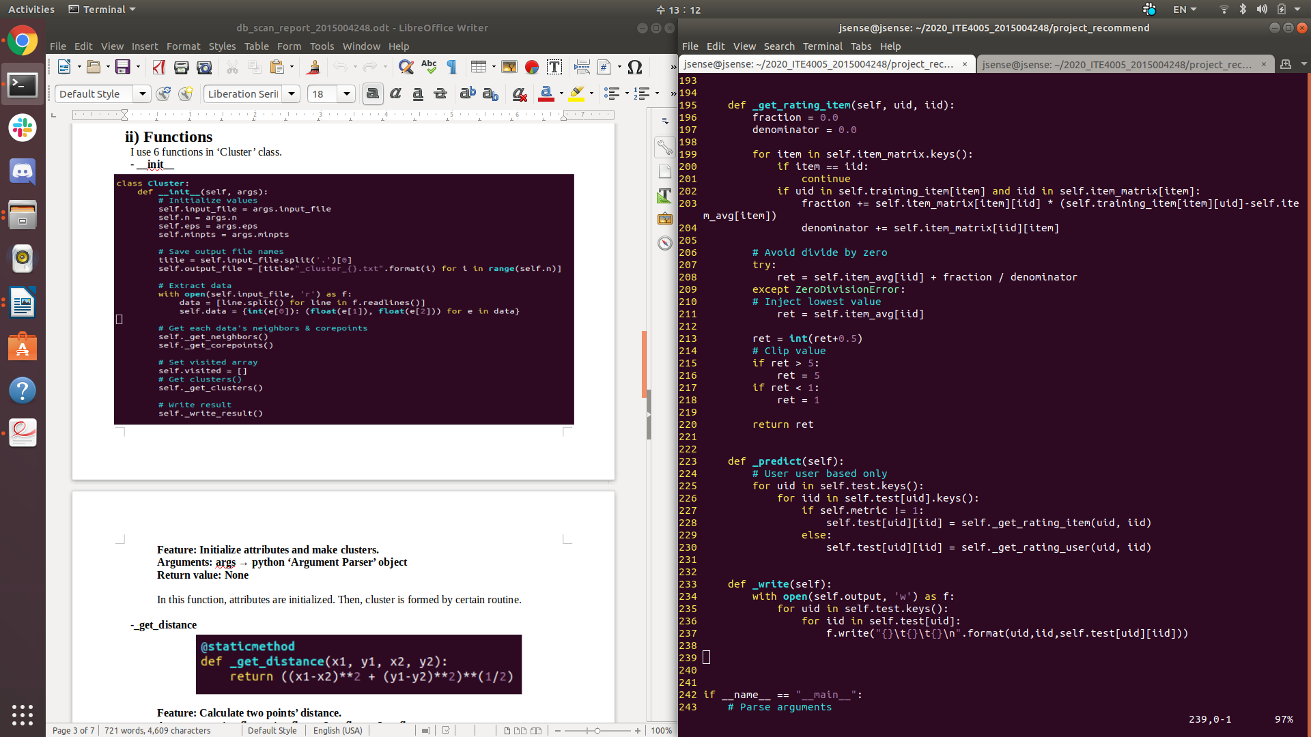

Feature: Predict target ratings
Arguments: None
Return value: None

In this function, ratings in test file is predicted. Using ‘_get_rating_user’ function, each of rating in user & item is predicted.

-_write
Feature: Write result values in to output file
Arguments: None
Return value: None

In this function, result values are written in to output file. Each line has given format.

iii) Code flow

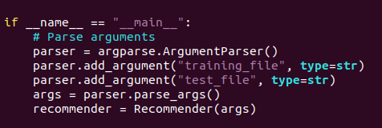
[In main routine]

1. Parse command-line arguments.
2. Construct ‘Recommender’ class
[In __init__ function]

1. Save arguments
2. Extract data from training & test file
3. Create rating matrix
4. Predict target ratings
5. Write result values in to output file

6. Instructions for execution
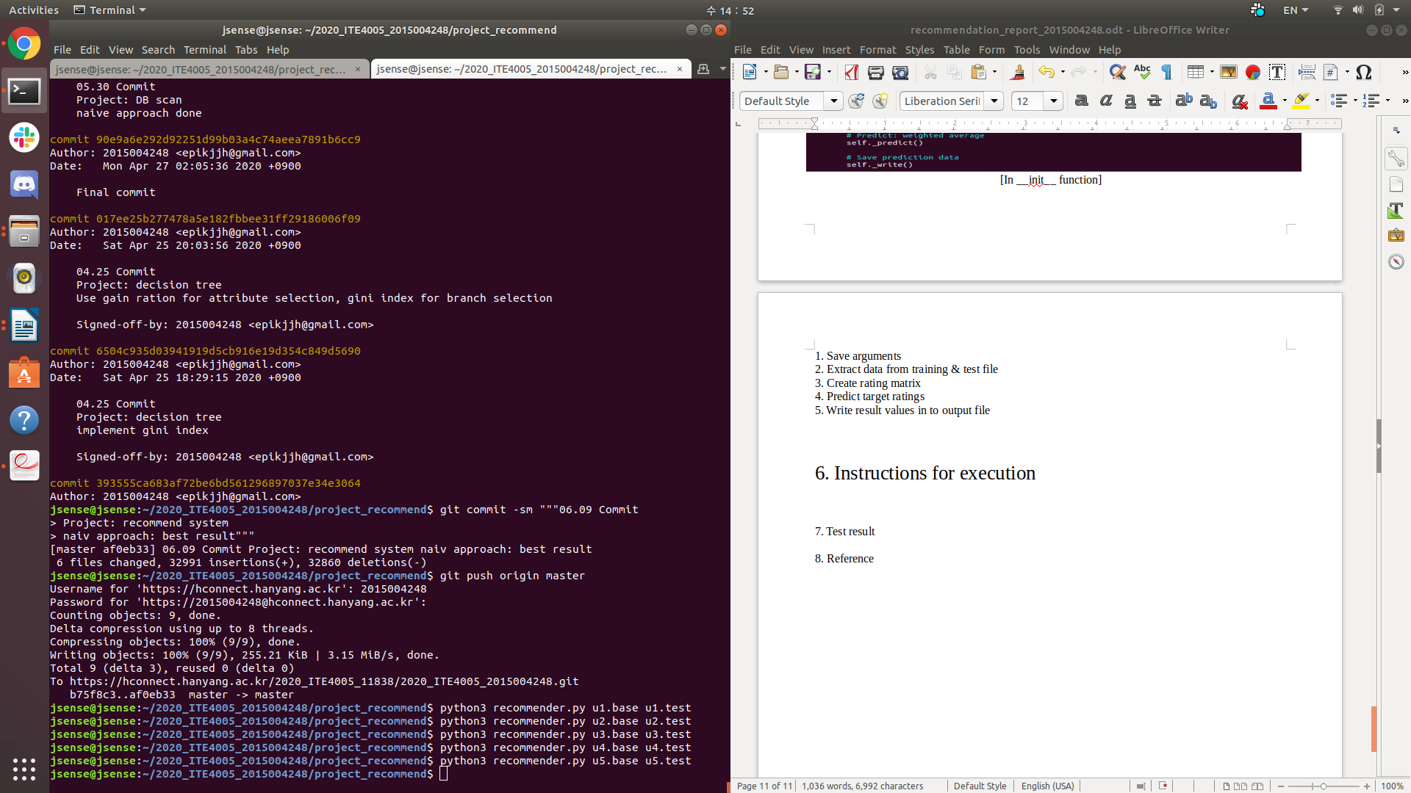
Type ‘python3 recommender.py “training data name” “test data name”’in terminal

7. Test result
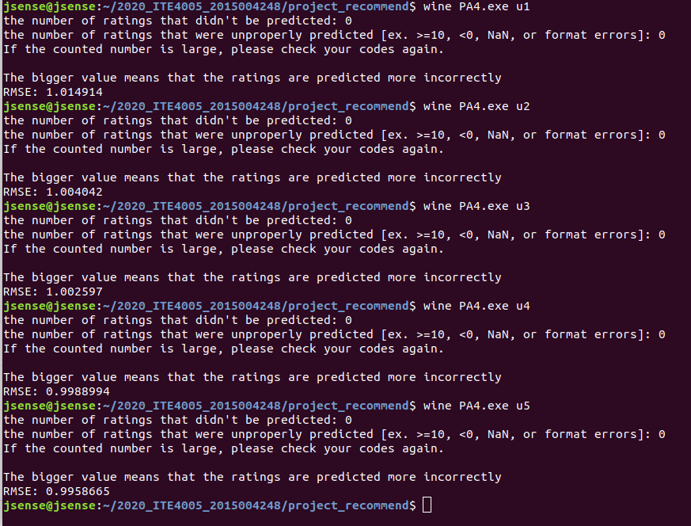
[Test result in Ubuntu]

8. Reference

[1] Jiawei Han. Data mining: concepts and techniques(3rd edition), 2000.

