Sleep-Wake and the Ictal State Classifier
(SWISC)
and associated analysis notebooks

Installation Instructions and Guide
Nov. 12, 2025
© Brandon James Harvey

Installation Instructions

For the purposes of this document, all paths will be relative to either the User Directory (Windows: “~\”, directs to “C:\Users\[Username]\”) or the “Using SWISC” folder (assumed to be current working directory – will be denoted as “..\Using SWISC\”, or “.\”.

For Pedersen Lab members:
“Using SWISC” is located in Herbert-Jasper\Lab\
Typically network-mounted as “Y:\”

Commands executed inside a terminal or notebook will be presented with the entire line in Consolas font like so:
cd Y:\Using SWISC\

[text] in brackets designates a user-preferred input. If this folder is referred back to, the same bracketed phrase will be used. For example [working folder] will always refer to the same folder throughout.

Part 1. Anaconda
What is Anaconda?
Anaconda is a package manager for Python which allows for simple use of environment files to install SWISC’s dependencies (packages which a codebase requires to be installed).

Installing Anaconda
On Windows:
The latest Anaconda installer as of the writing of this document (“Anaconda3-2024.06-1-Windows-x86_64.exe”), is located in the “Using SWISC/Anaconda” folder. This can be executed to install Anaconda and Anaconda Navigator (a launcher for Python programs) alongside various packages such as Jupyter Notebooks/Lab, Spyder IDE, and others.

Simply install Anaconda to your preferred folder (default: C:\Anaconda3\) by following the installation wizard as any other program.

On Linux:
Use “Anaconda3-2025.06-0-Linux-x86_64.sh”.

Installing the SWISC Environment
- Once Anaconda is installed, open Anaconda Prompt from your Start Menu.
- Execute
conda env create -f “Y:/Using SWISC/Environment/SWISC_env_250611.yml”
This will install the environment “SWISC_env” to your ~/Anaconda3/envs/ folder, along with all associated packages.
Note: this will take quite some time depending on machine configuration, as the packages required are large (~5 GB in size).

Starting the Environment
Once the environment is installed, you can enter it by either executing “Anaconda Prompt (SWISC_env)” which will appear as a Start Menu program, or opening the generic Anaconda Prompt and executing activate SWISC_env.

At this point, use cd to navigate to your desired parent folder and use mkdir [working folder] to create a folder. cd into this folder.

Execute the following command to copy the SWISC v1.5 folder to your desired destination:
xcopy “Y:/Using SWISC/SWISC v1.5” “./SWISC v1.6/” /E /I
Using the Classifier

Preparing .mat files
Using Spike2, execute the script found at ”Y:\Coding\smrx2mat\BatchSMRXtoMat.s2s” or
“Y:\Using SWISC\SMRXtoMat\BatchSMRXtoMat.s2s”.

Use: Have SMRX files named and organized as such:
\Parent folder\Cohort Name\Cohort Date Time_SequenceNumber.smrx
e.g.
Y:\Unprocessed\Kainic Acid\Spike2 Files\NPM665-668\NPM665-668 210614 151504_000.smrx

SMRX files’ channels are organized as follows:
1–EMG
1–HPC-L
1–ECog
1–HPC-R
2–EMG
…etc

For safety, copy the files you want to convert to another drive or location. Then create a folder at the same level as the cohort folders called “Mats”. Each folder should contain a folder with the name of a Cohort, then folders called “NoNo”, “SlNo”, “NoSz”, and “SzNo”. Each represents a different subset of sleep scoring progress. Make these for all cohorts.
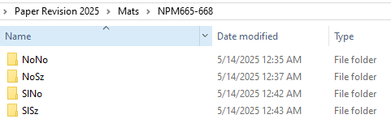

Run BatchSMRXtoMat.s2s in Spike2, and use the Parent folder (e.g. “Paper Revision 2025”) as the target when the dialog box pops up. All SMRX files converted into individual .mats for every mouse of every recording file. Mouse numbers are auto-generated based on the first mouse number in the cohort, or can be given individually. They will be auto-sorted into the appropriate subfolders.

The Mats folder here will be used as the Input Folder Path for the classifier’s preprocessing step.

Preprocessing
Jupyter Lab
Launch Jupyter Lab from inside the SWISC_env Anaconda Prompt with
jupyter lab, which will open the Jupyter Lab server in a tab in your default browser. This will open with its internal path set to the folder it was opened from, [working folder].

Open a new console
File -> New -> Console in Jupyter Lab

Execute run app_log.py to configure input parameters

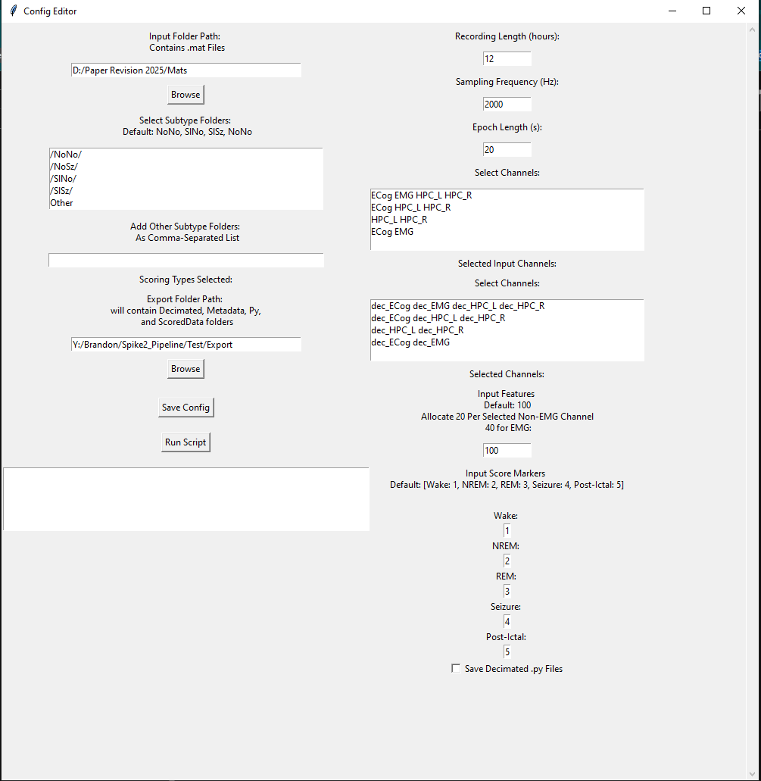

e.g.
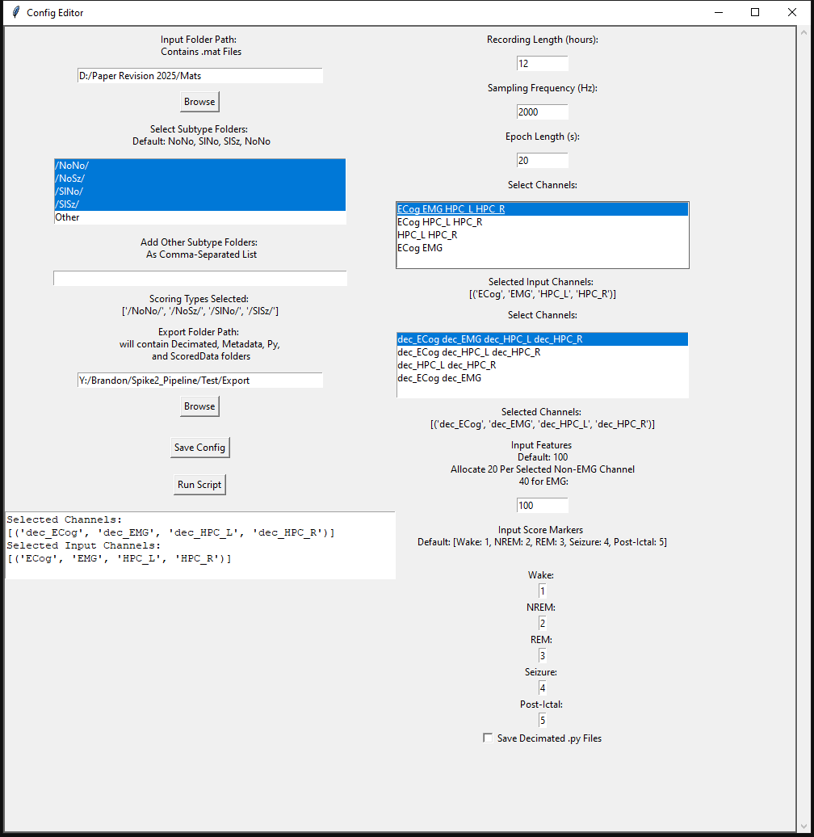
Then press “Save Config” to save the details to a config.py.
Clicking “Run Script” will execute the full processing pipeline with the selected configurations.

