|  |  |  |
| --- | --- | --- |
| Author: | Brian McBride |  |
| Contributors: | Paul Shabajee |  |
| Review: |  |  |

Project Impact Model

Ontology Overview

Version 0.4 ()  
07 January 2015

# Introduction

Large construction project can have a significant impact on the region surrounding them. These impacts may significantly affect the quality of life of people in the region. Some of these impacts will benefit people and some will impact them negatively.

This document is an introduction to an ontology that defines a vocabulary for describing such impacts and projects that may be proposed and implemented to mitigate them. This document is primarily intended to assist data consumers such as developers to quickly grasp the conceptual model underlying the data. This document is not reference documentation. Readers requiring reference documentation should consider the automatically generated [owldoc](http://data.sedgemoor.gov.uk/owldoc).

Requirements for an ontology are often described by defining questions that data using the ontology should be able to answer. These questions are often referred to as competency questions. Key competency questions for this ontology include:

1. What predicated impacts affect my community?
2. Which predicated impacts have no mitigation?
3. What proposals are there to mitigate impacts on a community?
4. What has been done to mitigate or offset the impacts on my community

# Core Concepts

A typical use of the core concepts and the relationships between them is illustrated in the following diagram:

Predicted

Impact

Project

impactOf

Community

impactsOn

Project

mitigates

Proposal

proposal

Agent

predictedBy

Resource

Source

resources

resources

mitigates

Document

describedBy

Item

operatesOn

Location

location

community

Figure 1 Core Concepts

The central concept is that of an *impact*. An impact is a consequence. It may, for example, be a consequence of a large scale construction project, but there are many kinds of things that may have an impact.

An impact has an impact on something. For example, an impact may have an impact on a community. However an impact can have an impact on a variety of different kinds of thing such as the environment or the economy.

A *predicted impact* is a prediction of an impact. A predicted impact is created by one or more agents, typically a local government organisation, the management of the impacting project or an interested third party.

There may be many predictions of the impacts of a project. Some of these will conflict. There are different approaches to predicting impacts that will produce different predictions for the same phenomena.

Impacts may, and many do, have an impact on a specific *community*. Roughly speaking, a community is a collection of people or organizations. The members of a community share some characteristics in common. For example, the residents of a village may be regarded as a community. The individual people in a community may vary over time.

A community may be related in some way to a particular location. It may be that residents of that community are resident in that location. However people in community may be related to the location in other ways. For example they may commute to or through that location or they may carry out some leisure activity at that location.

A community may also be restricted to particular classifications of people. Examples of such classifications include mothers and toddlers, commuters and rugby players.

Some impacts are negative and as a consequence *proposals* may be generated for projects to mitigate one or more impacts. Some of those proposals may be approved and result in the creation of *projects* to mitigate impacts.

A project may be designed to create something new, e.g. build a new bypass, or to modify something, e.g. widen a road or to destroy something. In each of these cases it said to *operate* on that thing.

Some projects may directly modify the impact in question, e.g. planting trees to reduce noise levels. Some projects may not directly modify an impact but may offset one or more impacts by improving the quality of life of the affected community in other ways.

Some activities, such as large construction projects, may provide a fund or other resources to be used to resource projects to mitigate the effect of the activity.

# Describing the Core Concepts

The following class diagram represents the core concepts and their properties in more detail.

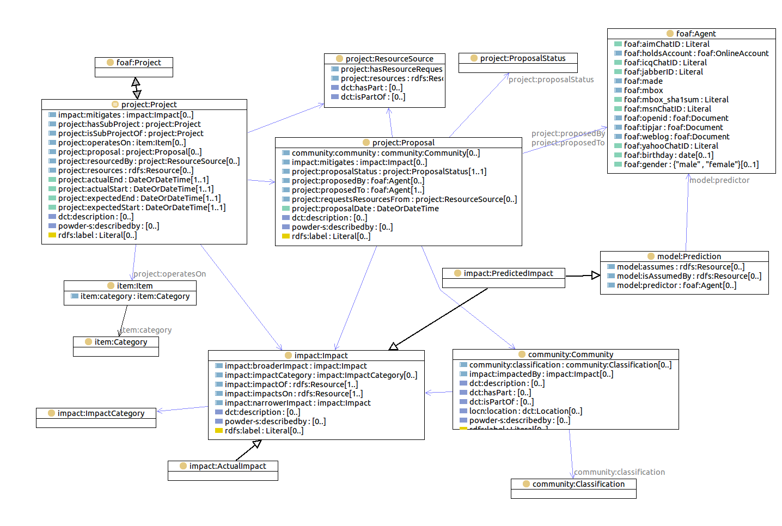

Figure 2 Class Diagram

## Common properties

This section describes common properties of several types of resources.

Resources may have a name, indicated by the property rdfs:label and a description indicated by the property dcterms:description.

The property wdrs:describedby may be used to relate a resource to another such as a document, set of documents or a fragment of a document that describes it.

A fragment of a document may be represented using Dublin Core terms. The fragment is a resource which may be related to the document of which it is a part using the property dcterms:part of. The property dcterms:identifier may be used to specify the an identifier such as a section or paragraph number. If no such identifier is available the property dcterms:description may be used to describe the fragment. This structure is represented in the following diagram:

Resource

Document

wdrs:describedby

dcterms:partOf

dcterms:identifier

1.2.3

dcterms:description

paras 3-5

on page 4

Figure 3 representing a fragment of a document

## Impacts

The class Impact is the superclass of the classes PredictedImpact and ActualImpact. A predicated impact is a prediction of an impact that may occur in the future. Its sister class is an actual impact.

This ontology provides vocabulary for relating impacts, both predicted and actual, to communities affected by the impact and to the projects that are responsible for causing the impact.

Impacts may have a narrower/broader structure, i.e. one impact may be a specialization of another. For example, increased delays on a particular roundabout may be a specialization of a more general impact of increased traffic congestion on a particular road.

The concept of impact provides a basis for potentially very rich descriptions of an impact. This ontology does not provide a vocabulary for describing the nature of the impact in detail. Instead it allows the linking of an impact to a document or document fragment that describes the impact. The wdrs:describedby property may be used to relate and impact to a description of that impact.

Impacts may fall into categories of impact. In principle, there may be many different categorization schemes for impacts. This model provides one categorization scheme.

## Communities

An instance of the class Community is a collection of people or organizations. Communities are described by an extensible collection of facets. Two facets are defined in this ontology, a location facet that limits the community to people or organizations at a particular location and a categorization facet that restricts the community to people or organizations in a particular category such as mothers and toddlers or commuters.

Communities also have a broader/narrower structure. The community of commuters from a particular village is part of the community of the village as a whole. The properties dcterms:partOf and dcterms:hasPart are used to represent this containment structure.

## Locations

A location is a place. Locations often have a name. This ontology uses the DCTerms concept of location which is that of a spatial region or a named place. A location has a single pair of latitude and longitude coordinates. These may be used to select where to display the location on a map. Typically these coordinates will be the centroid of the location, but this is not required.

Locations will commonly be related to reference vocabularies such as those provided by mapping agencies or gazetters. The owl:sameAs property and the GEO Sparql sfWithin property may be used for this purpose.

## Projects

Projects are activities. They are a very general concept with a wide variety of potential application and consequent opportunities for a rich vocabulary for describing them. They appear in two roles in this ontology; firstly as a cause of impacts and secondly as activities to mitigate the effects of impacts. Projects intended to mitigate the effect of another project, may themselves have further impacts.

A project can be a source of resources for other projects. For example, a large construction project might resource other projects and activities to mitigate its effects.

Projects will typically have a goal or primary purpose to create, modify or destroy something. The property project:operatesOn may be used to relate a project to one or more 'items' that the project is intended to create, destroy or modify. An 'item', in principle can be any resource. This ontology defines a vocabulary that allows the classification of items.

A project may be related to an impact it causes by the property impact:hasImpact and to an impact that it mitigates using by the property impact:mitigates.

This vocabulary also defines some basic properties for representing the expected and actual start and end times of projects.

## Project Proposals

A proposal is the action of making or submitting a proposal. A proposal may be related to one or more documents or a document set that describes what is proposed by the property wdsr:describedBy. A proposal may be related to a source of resources from which resources are sought by the project:requestsResourcesFrom property. A proposal may be related to impacts that it proposes to mitigate by the impact:mitigates property. A proposal may also be related to communities relevant to the proposal by one or more community:community properties.

The status of a proposal may be described using the project:proposalStatus property and the project:proposal-status controlled vocabulary.

A proposal is related to the agent or agents to whom the proposal is made by the project:proposedTo property and to the agent or agents making the proposal by the project:proposedBy property.

.

## Agents

Agents are entities such as people and organizations that are capable of intentional action. This ontology uses the class foaf:Agent as the class of agents and provides no further vocabulary beyond the common properties of all resources for describing agents.

## Resource Sources

The class project:ResourceSource is the class of sources of resource, such as funding, for projects. The property project:resources may be used to relate a resource source to the projects that it resources. The property project:hasResourceRequest may be used to relate a resource to proposals or other requests for resources from that resource source.

## Categorization

The ontology defines concept classes and concept scheme instances for SKOS based classification hierarchies for the following:

* Items
* Agents
* Impacts
* Communities

The actual classification schemes used are not defined in the ontology but are defined in a reference set managed elsewhere.

# Versioning

Things change over time. Modelling to be able to describe the state of things at different times adds significant complexity to a model for both the data producer and the data consumer. Consequently, it should only be undertaken when necessary.

Where it is necessary to represent multiple versions of a resource, we will treat each version as a separate resource. Each version will have its own URI. This enables any resource to refer to a specific version.

Further, there is a URI that always refers to the current version of a versioned resource. This URI is linked to all previous versions of the resource. It serves as a generic name for the resource and as an anchor point from which all versions of a resource can be found. This structure is illustrated in the following diagram:

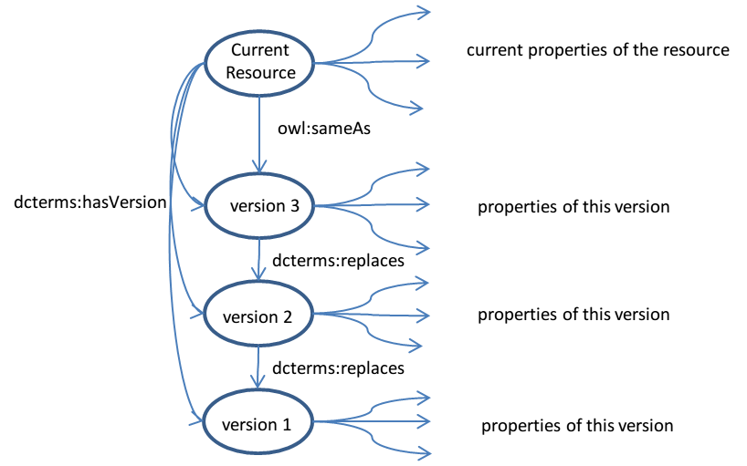

Figure 4 versioning a resource