ArkCloud — The Sprint Story
Sprint 4 (CI/CD + Azure) and Sprint 5 (AWS foundation, in progress)
This document tells the story of Sprints 4 and 5, in the order things actually happened: what was built, the real bugs found and fixed along the way, and how each step feeds into the next. Not a status report — the actual thread of decisions and discoveries that led to the result.
Document date: August 2, 2026

Sprint 4 — CI/CD + Azure
The story of a pipeline that turns green, and of an application that still has to learn to actually run behind that green.
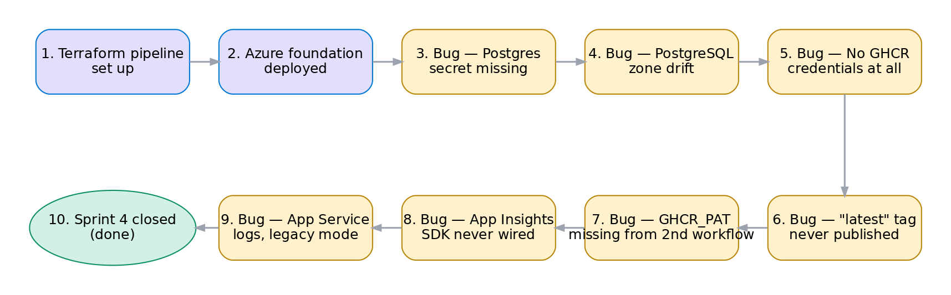
The Sprint 4 journey — ten steps, from setting up the pipeline to a verified close.
Chapter 1 — Setting the stage
It starts with the scaffolding: a full Terraform pipeline (fmt → tflint → Checkov → validate → plan → apply), with apply gated by manual approval on the GitHub production environment. Nothing is deployed yet, but the control mechanism is in place before the first resource exists.
Chapter 2 — The foundation, on paper
Then comes the first real apply: resource group, a four-subnet VNet, PostgreSQL Flexible Server, Key Vault, two App Services, Application Insights. On paper, everything is green. In reality, nothing is running yet — and that's where the story gets interesting.
Chapters 3 to 8 — Six bugs, one at a time
Bug 1 — The empty secret. POSTGRES_ADMIN_PASSWORD had never actually been set on the GitHub side. An empty secret rather than a missing one — visible only because it didn't show up masked as *** in the logs. Fixed with a single command.
Bug 2 — The zone Azure picks on its own. Azure chooses PostgreSQL's availability zone itself at creation time, but Terraform, which had never tracked that value, sees "no zone configured" as a diff on every apply — and the Azure API rejects that change outside of an HA failover. The fix: explicitly tell Terraform to stop caring.
Bug 3 — The image that couldn't be pulled. The bug that took the longest to isolate: both App Services are running, but neither can pull a real image. docker_registry_username/password are empty. Diagnosis runs through Kudu logs, a false lead on GHCR package visibility, a copy-paste mistake with the token, a PowerShell quoting quirk — until a local docker pull confirms the PAT itself is valid, isolating the problem to Terraform.
Bug 4 — The tag that never existed. Once the GHCR pull is wired up: the default tag is latest, which has never existed on the registry. docker pull returns a 404, not a 401 — a detail that makes all the difference between "not authorized" and "doesn't exist." Fixing the default to dev also surfaces a real architectural gap: two separate apply paths that can step on each other if their defaults ever diverge.
Bug 5 — The secret set in only one of two places. A lesson in GitHub Actions: the GHCR_PAT secret, set in only one of the two workflows that run Terraform, breaks the second one with "No value for required variable" on the next image deploy. env: blocks never propagate between workflow files, even within the same repo.
Bug 6 — The telemetry that never arrives. The Application Insights connection string has been correctly wired on the Terraform side from the start, but no telemetry line ever shows up. The cause: Azure's "codeless" auto-instrumentation only works for its own managed runtime stacks, not a custom Docker image. The SDK has to be explicitly added to the application code.
Chapter 9 — The seventh bug, found while trying to close
With those six bugs fixed, Sprint 4 looks done. But the closure itself surfaces a seventh problem, discovered while verifying that audit logs actually flow: Key Vault and PostgreSQL send their logs within minutes, both App Services send nothing at all, even after thirty minutes. Azure's legacy diagnostic settings destination mode is documented as the least reliable pipeline specifically for App Services — switching to Dedicated mode fixes it within minutes.
Chapter 10 — The close
The sprint ends on real verification, not a green status for show: every piece — continuous deployment, application telemetry, audit logs — confirmed by a direct query against the data, not just against an apply that didn't fail.

Sprint 5 — AWS foundation (in progress)
The story of a second cloud joining the first without duplicating its governance — and of a story that, at least once, repeated itself before moving on.
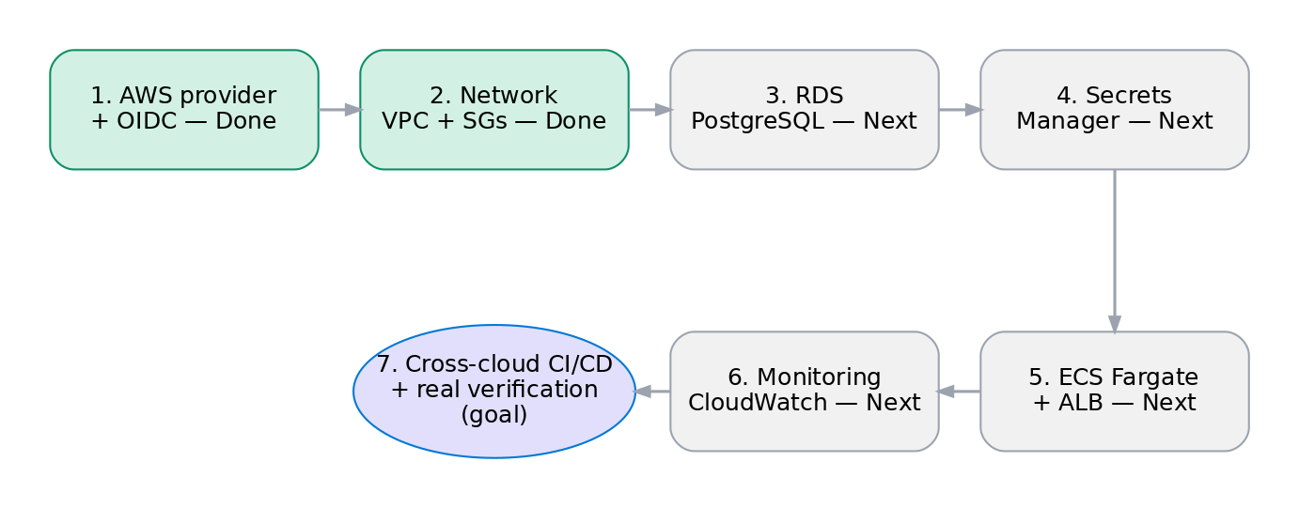
The Sprint 5 journey — two steps done and verified, five ahead, one closing goal.
Sprint 5 picks up where Sprint 4 left off, but with a constraint Azure never had: this isn't starting from zero, it's adding a second cloud into the same Terraform state, the same review discipline, without duplicating the governance already put in place.
Step 1 — AWS provider and OIDC (done)
Before a single AWS resource exists, GitHub Actions needs to authenticate without a static secret — the exact same principle as the Azure federation in Sprint 4. Except the story repeated itself almost exactly: the first IAM trust policy, written with the repo:OWNER/REPO:... format, was rejected with "Not authorized to perform sts:AssumeRoleWithWebIdentity." The cause was already known — this repo was created after GitHub's cutover to the immutable, numeric-ID-based sub format — but it had to be rediscovered in practice, this time on the AWS side, via a debug step that decodes the real JWT instead of guessing twice. Once repo:epiph11@183244781/ArkCloudInfra@1302325611:... was in place, authentication worked on the first try.
Step 2 — The network (done)
This is the foundation everything else will sit on: nothing can exist before a VPC, subnets, and security groups exist to host it. The key decision here was to reproduce the same trust boundary as on the Azure side (public / application / database), while embracing a real difference in model — AWS security groups have no explicit "Deny" rule, unlike Azure NSGs. PostgreSQL's isolation comes from an absence (the database security group never mentions Blazor's security group), not from a rule that explicitly forbids it. This is where things stand right now: network in place, verified in CI, ready to host what comes next.
Step 3 — RDS PostgreSQL (next)
It only needs the network (private database subnets) to exist — no dependency on the image registry or on ECS. That's why it comes before ECS in the real order, even though the original roadmap numbers it after: better to have the database running before wiring containers to it.
Step 4 — Secrets Manager (next)
The AWS counterpart to the Key Vault pattern already in place in ArkCloud.API — the application code won't need to change at all, only the source of the secret changes depending on the cloud.
Step 5 — ECS Fargate and the Application Load Balancer (next)
This is the first point where the image registry becomes a blocker — ECS needs to pull an image from somewhere. The call made was to start on ECR (AWS's native registry, zero friction) rather than wait for the JFrog Artifactory migration the roadmap calls for, so the whole sprint doesn't stall on standing up an external tool. JFrog is still planned, just as a separate piece of work.
Step 6 — CloudWatch monitoring (next)
The counterpart to Application Insights and Azure's diagnostic settings — except this time, Sprint 4's experience (SDK never wired, Dedicated mode needed for App Service logs) gives a head start: a wired pipe won't be mistaken for data actually arriving, and it'll be verified with a real query, not just a green apply.
Step 7 — Cross-cloud CI/CD and real verification (closing goal)
The close, mirroring Sprint 4's: not a green GitHub Actions status, but confirmation that containers are actually running, serving real traffic, and that logs are actually flowing — the same standard of proof applied to both clouds.

