Financial Performance Prediction Report
Final notebook, OOF validation, blend search, accounting postprocessing, and submission packaging.

1. Executive Summary
Best OOF blend mean R2: 0.857226605158
Selected accounting adjustment: none
Final experiment: M6_oof_blend
Best baseline / candidate chain: B4 -> M3/M4 -> M6 blend -> M7 accounting check
Submission rows/cols: 406 / 10

2. Environment and Raw Input Freeze
All automation was run in Conda environment QuantEnv with Python Python 3.10.20. Missing optional packages remain: xgboost, lightgbm, optuna, jupyter.

Raw file freeze manifest
name | size_bytes | sha256
train.csv | 3455035 | fc0d1fab1ed7b597cc900e1e724dc4847814fba7aa04dd722e21fbbb0d0f7049
test.csv | 816771 | a1003ff8a6f90a971e17d473781fff84621131f342f0e3d0fb2b0b59b886d7b6
sample_submission.csv | 9291 | 874682cab231f9e48b6c038ac4859213ebf70453bf390ce94de31273da8dc1e6
data_dictionary.txt | 7425 | ba3697c21555558bb831d33da97b35b420558f2494530dc6763b85eaf30ca128
说明.docx | 15737 | c4e71f313214b7fe2fe1542d53a58ad75621e2f09875d501c18184e247819db6

3. Data Audit and EDA

Schema summary
dataset | rows | cols | id_unique | missing_cells | missing_rate | numeric_cols | object_cols | feature_cols | target_cols
train | 1624 | 212 | True | 19283 | 0.056008 | 208 | 4 | 202 | 9
test | 406 | 203 | True | 5791 | 0.070264 | 199 | 4 | 202 | 0
sample_submission | 406 | 10 | True | 0 | 0.000000 | 10 | 0 | 0 | 0

Quarter-level missing rate summary
quarter | avg_missing_rate | median_missing_rate | max_missing_rate | min_missing_rate | observed_columns
Q1 | 0.013822 | 0.004926 | 0.147783 | 0.000000 | 17
Q2 | 0.016140 | 0.007389 | 0.156158 | 0.000000 | 17
Q3 | 0.031237 | 0.014778 | 0.193596 | 0.000000 | 17
Q4 | 0.018603 | 0.009852 | 0.143350 | 0.000000 | 17
Q5 | 0.021066 | 0.010345 | 0.142857 | 0.000000 | 17
Q6 | 0.028224 | 0.016256 | 0.155665 | 0.000000 | 17
Q7 | 0.119502 | 0.106897 | 0.254680 | 0.000000 | 17
Q8 | 0.038598 | 0.026601 | 0.153695 | 0.000000 | 17
Q9 | 0.082295 | 0.071921 | 0.181773 | 0.000000 | 17
Q10 | 0.128919 | 0.123153 | 0.200493 | 0.000000 | 17

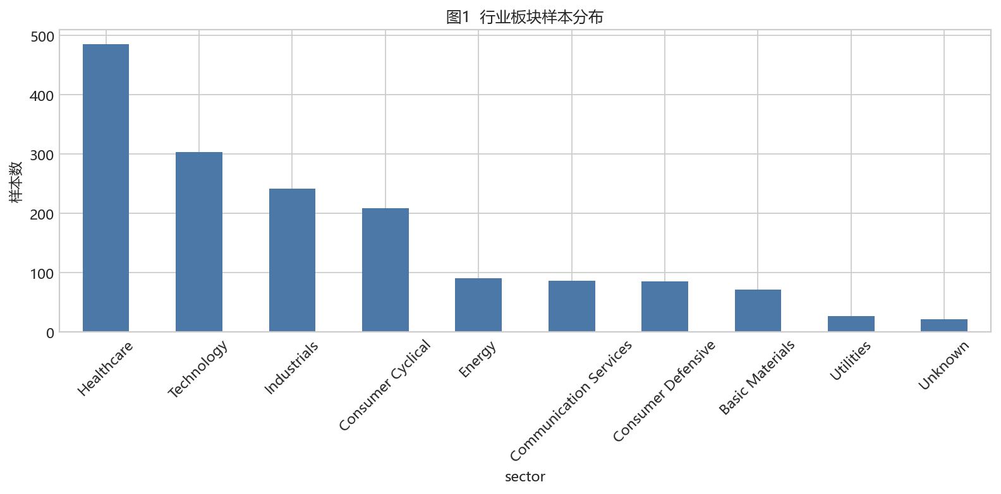
Figure 1. Sector sample distribution.
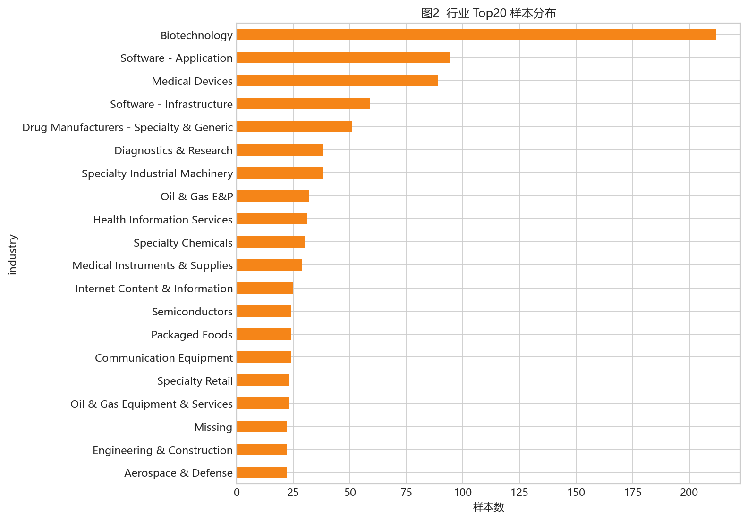
Figure 2. Top-20 industry sample counts.
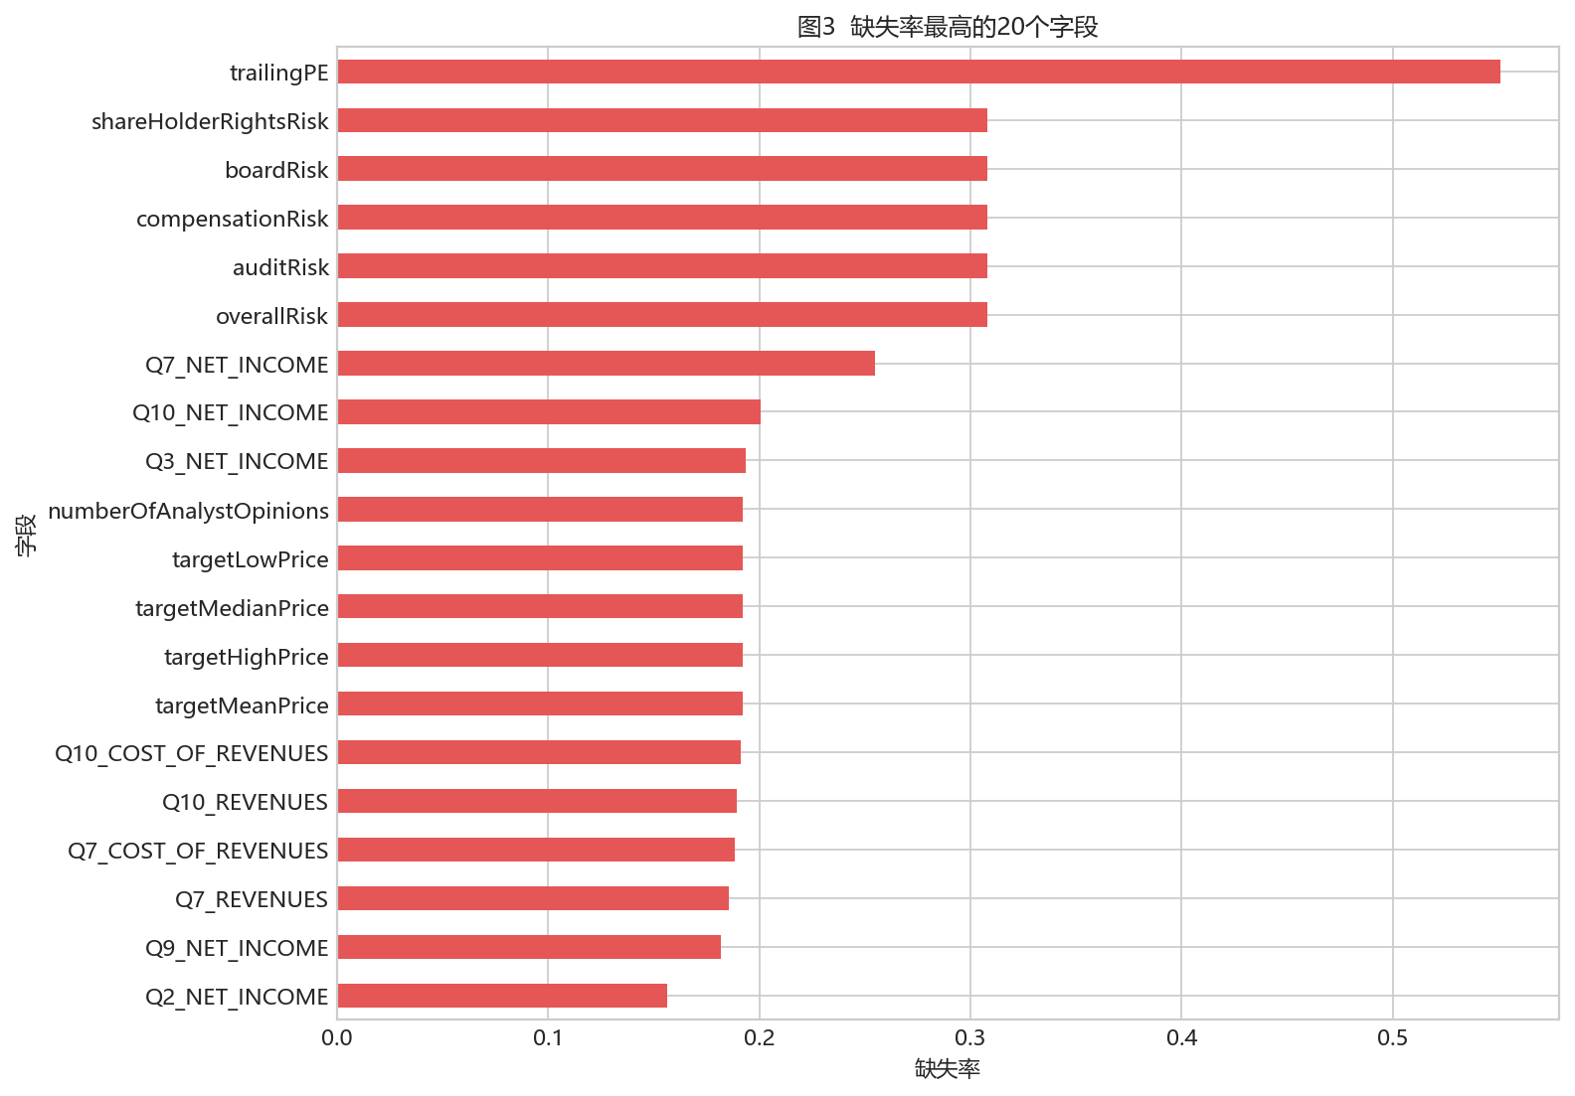
Figure 3. Top-20 missing-rate columns.
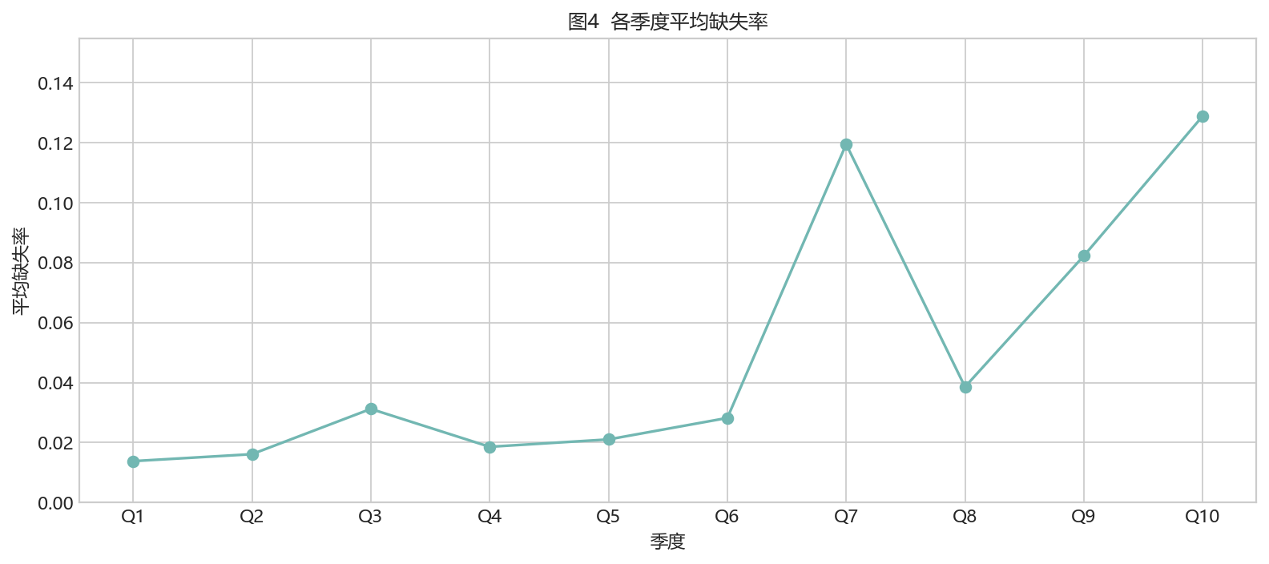
Figure 4. Mean missing rate by quarter.
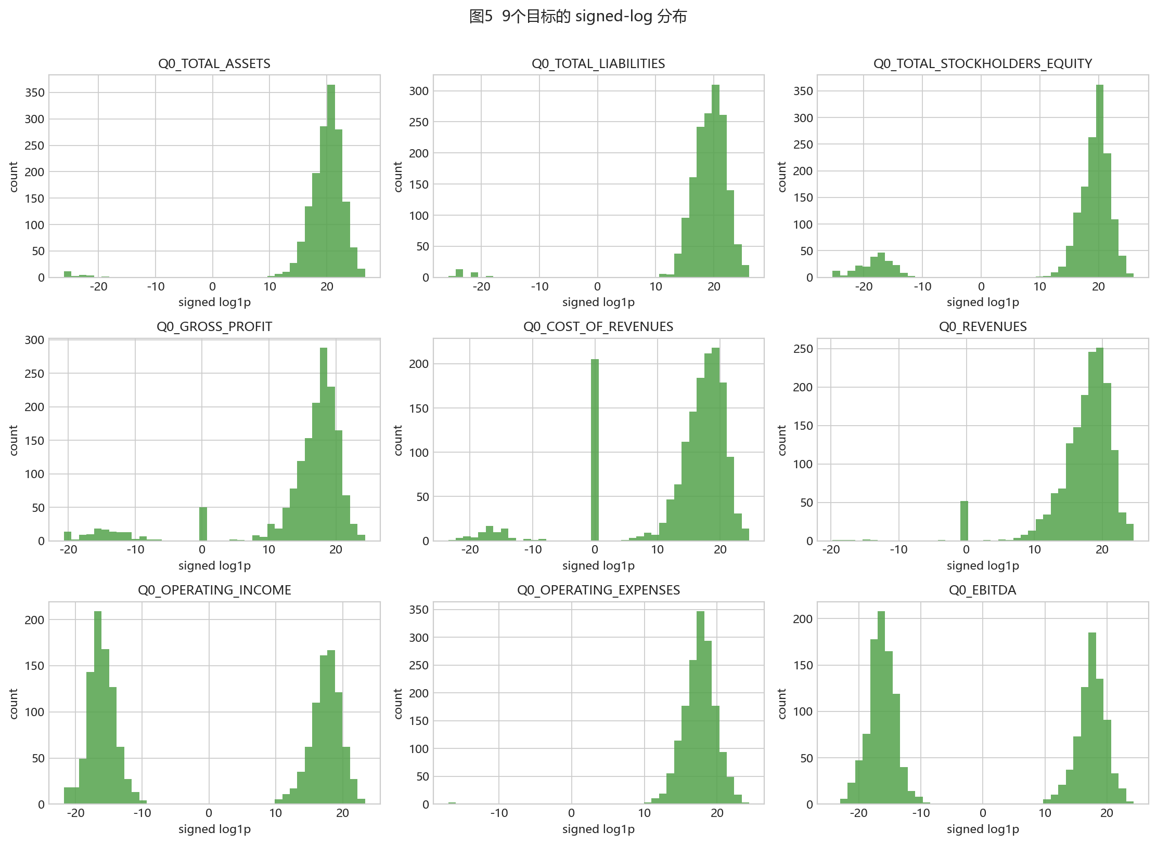
Figure 5. Signed-log target distributions.
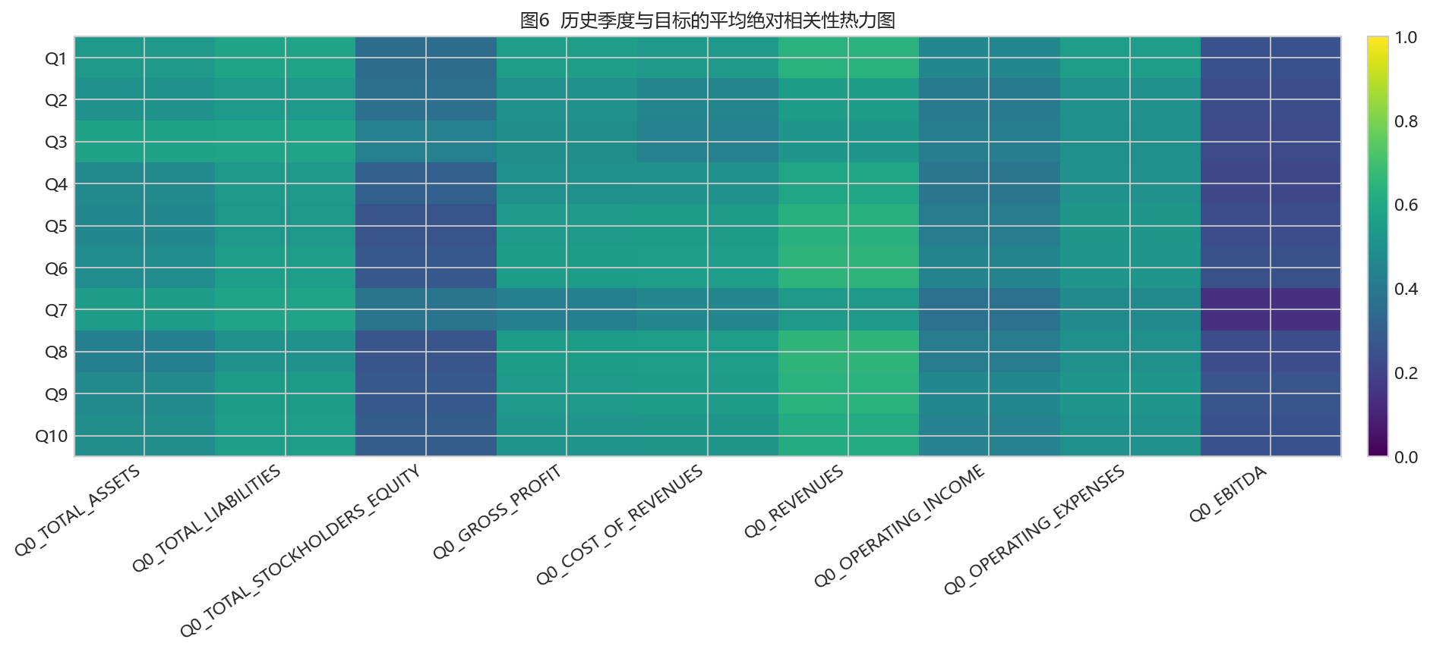
Figure 6. Lag correlation heatmap.
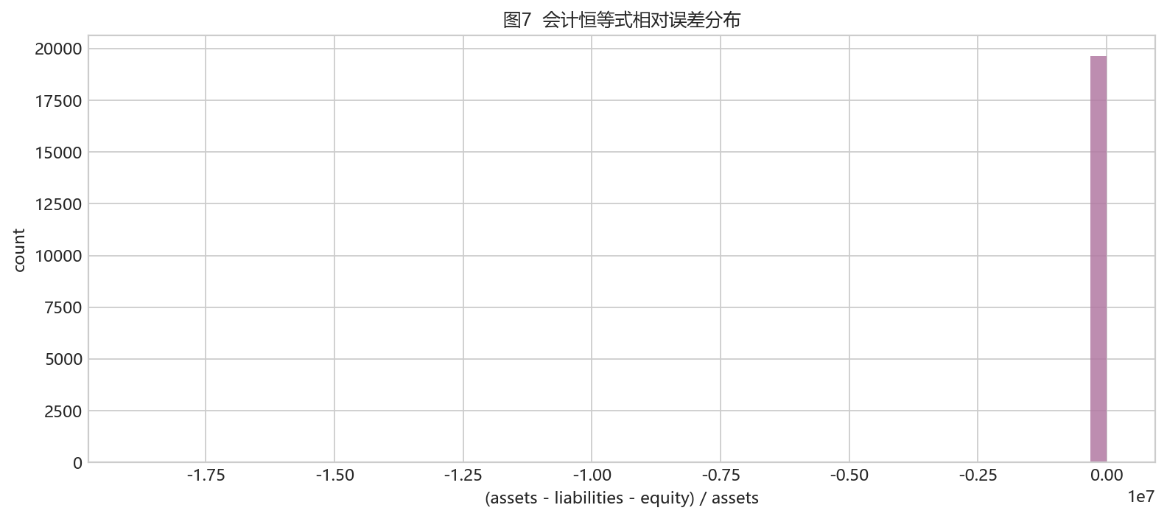
Figure 7. Accounting identity error distribution.
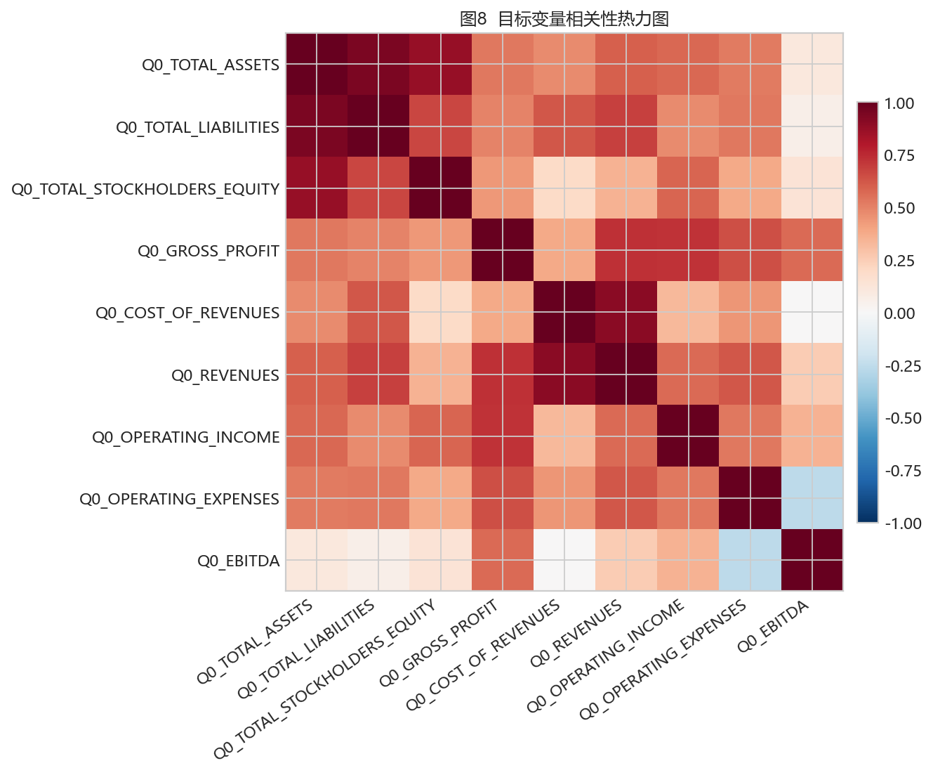
Figure 8. Target correlation heatmap.

4. Modeling and Validation

Selected experiment summary
experiment_id | model_name | target_strategy | mean_r2 | fold_mean_r2_std | runtime_seconds
M7_accounting_postprocess | AccountingPostprocess | none | 0.857227 | 0.049048 | 5.491926
M6_oof_blend | OOFWeightedBlend | per_target_oof_blend | 0.857227 | 0.049048 | 5.491926
M4_catboost_residual_history_metadata_engineered | CatBoostRegressor | residual | 0.825250 | 1.120254 | 330.111681
B4 | B4_baseline | nan | 0.783083 | 0.129085 | 2.092509
M1_ridge_history_raw | Ridge | direct | 0.731390 | 0.190283 | 6.598222
M3_catboost_direct_history_metadata_engineered | CatBoostRegressor | direct | 0.609040 | 0.433507 | 554.514580
M2_hgb_history_raw | HistGradientBoostingRegressor | direct | 0.497172 | 0.114549 | 107.401618

Per-target OOF blend weights
target | members | weights | oof_r2 | coarse_step | fine_step | fine_radius
Q0_TOTAL_ASSETS | B4,M3,M4 | 0.00,0.40,0.60 | 0.703489 | 0.050000 | 0.010000 | 0.050000
Q0_TOTAL_LIABILITIES | B4,M3,M4 | 0.00,0.00,1.00 | 0.911213 | 0.050000 | 0.010000 | 0.050000
Q0_TOTAL_STOCKHOLDERS_EQUITY | B4,M3,M4 | 0.00,1.00,0.00 | 0.400867 | 0.050000 | 0.010000 | 0.050000
Q0_GROSS_PROFIT | B4,M3,M4 | 0.00,0.00,1.00 | 0.984133 | 0.050000 | 0.010000 | 0.050000
Q0_COST_OF_REVENUES | B4,M3,M4 | 0.00,0.00,1.00 | 0.964448 | 0.050000 | 0.010000 | 0.050000
Q0_REVENUES | B4,M3,M4 | 0.30,0.00,0.70 | 0.972883 | 0.050000 | 0.010000 | 0.050000
Q0_OPERATING_INCOME | B4,M3,M4 | 0.00,0.00,1.00 | 0.826807 | 0.050000 | 0.010000 | 0.050000
Q0_OPERATING_EXPENSES | B4,M3,M4 | 0.97,0.03,0.00 | 0.987441 | 0.050000 | 0.010000 | 0.050000
Q0_EBITDA | B4,M3,M4 | 0.00,0.00,1.00 | 0.963759 | 0.050000 | 0.010000 | 0.050000

Accounting postprocessing candidates
adjustment | mean_r2 | r2_Q0_TOTAL_ASSETS | r2_Q0_TOTAL_LIABILITIES | r2_Q0_TOTAL_STOCKHOLDERS_EQUITY | r2_Q0_GROSS_PROFIT | r2_Q0_COST_OF_REVENUES | r2_Q0_REVENUES | r2_Q0_OPERATING_INCOME | r2_Q0_OPERATING_EXPENSES | r2_Q0_EBITDA
none | 0.857227 | 0.703489 | 0.911213 | 0.400867 | 0.984133 | 0.964448 | 0.972883 | 0.826807 | 0.987441 | 0.963759
balance_sheet_equity | 0.836744 | 0.703489 | 0.911213 | 0.216526 | 0.984133 | 0.964448 | 0.972883 | 0.826807 | 0.987441 | 0.963759
gross_profit_identity | 0.854654 | 0.703489 | 0.911213 | 0.400867 | 0.960980 | 0.964448 | 0.972883 | 0.826807 | 0.987441 | 0.963759
operating_income_identity | 0.362620 | 0.703489 | 0.911213 | 0.400867 | 0.984133 | 0.964448 | 0.972883 | -3.624653 | 0.987441 | 0.963759
income_statement_identity | 0.342141 | 0.703489 | 0.911213 | 0.400867 | 0.960980 | 0.964448 | 0.972883 | -3.785815 | 0.987441 | 0.963759
balance_and_income_identity | 0.321658 | 0.703489 | 0.911213 | 0.216526 | 0.960980 | 0.964448 | 0.972883 | -3.785815 | 0.987441 | 0.963759

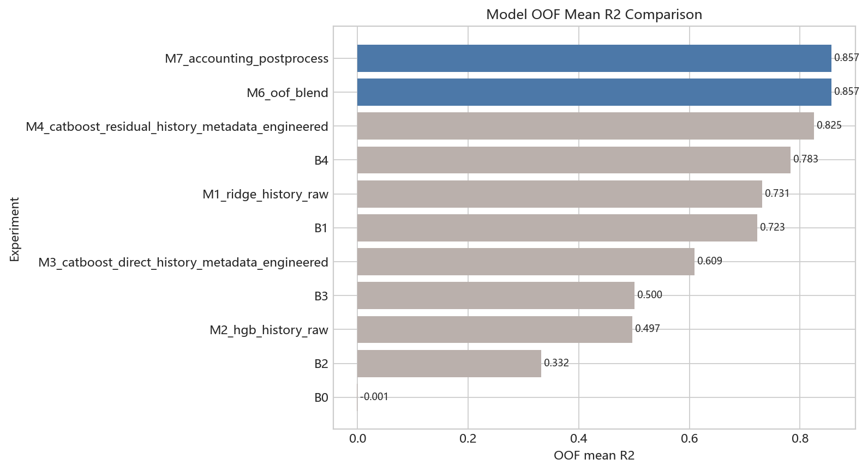
Figure 9. Model OOF mean R2 comparison.
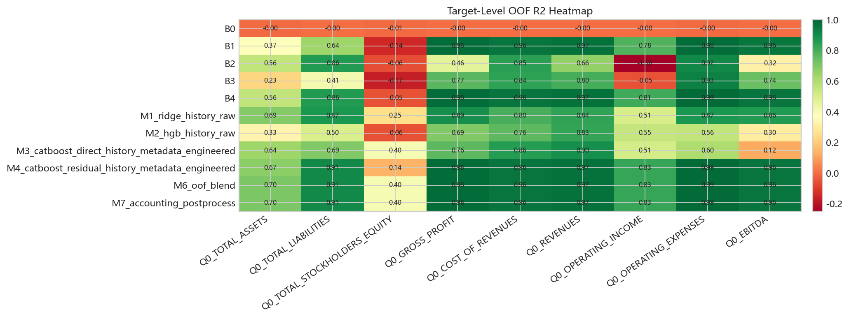
Figure 10. Target-level OOF R2 heatmap.
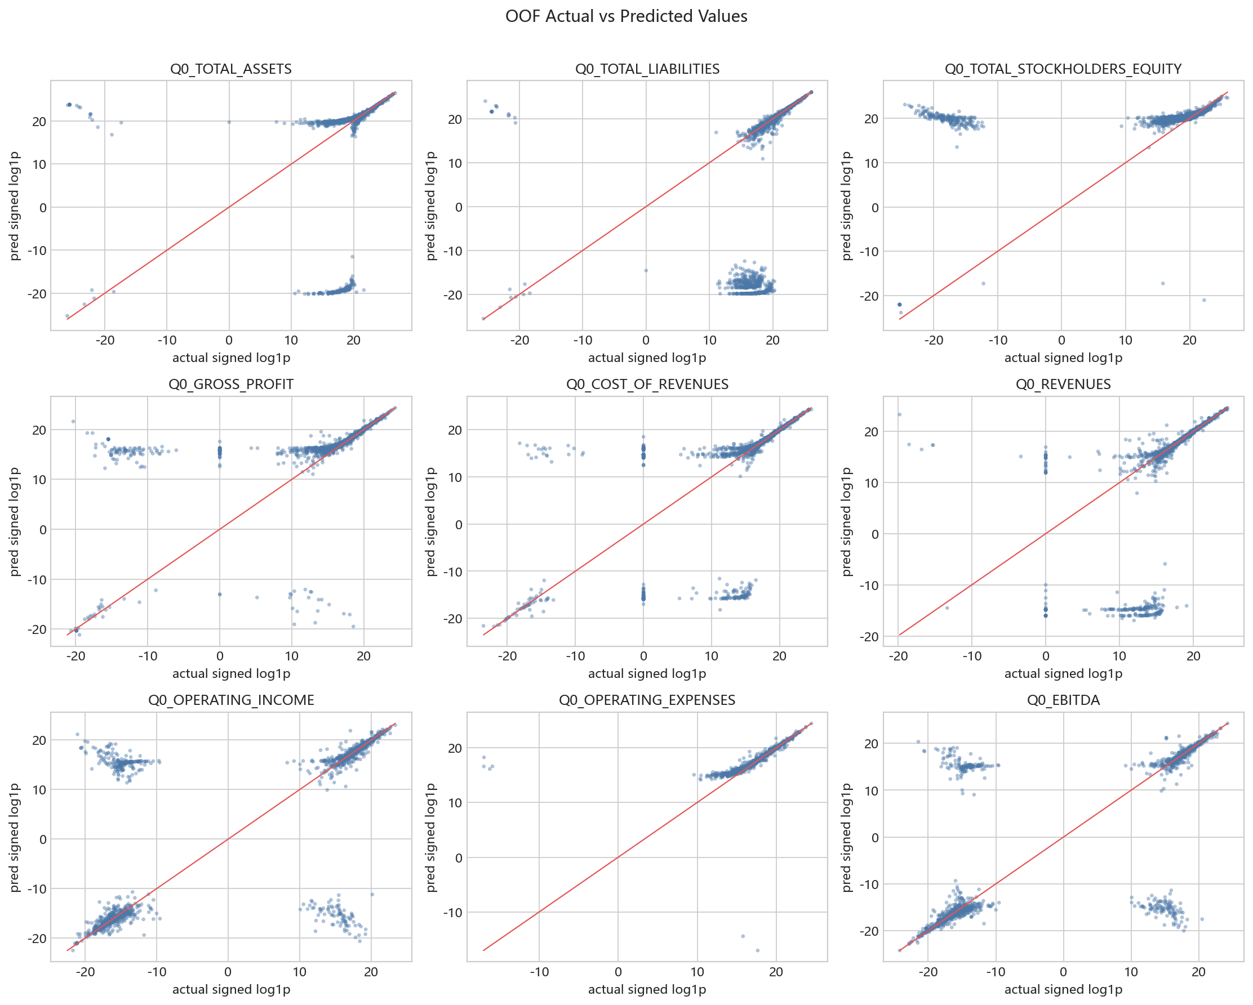
Figure 11. OOF actual-vs-predicted scatter plots.
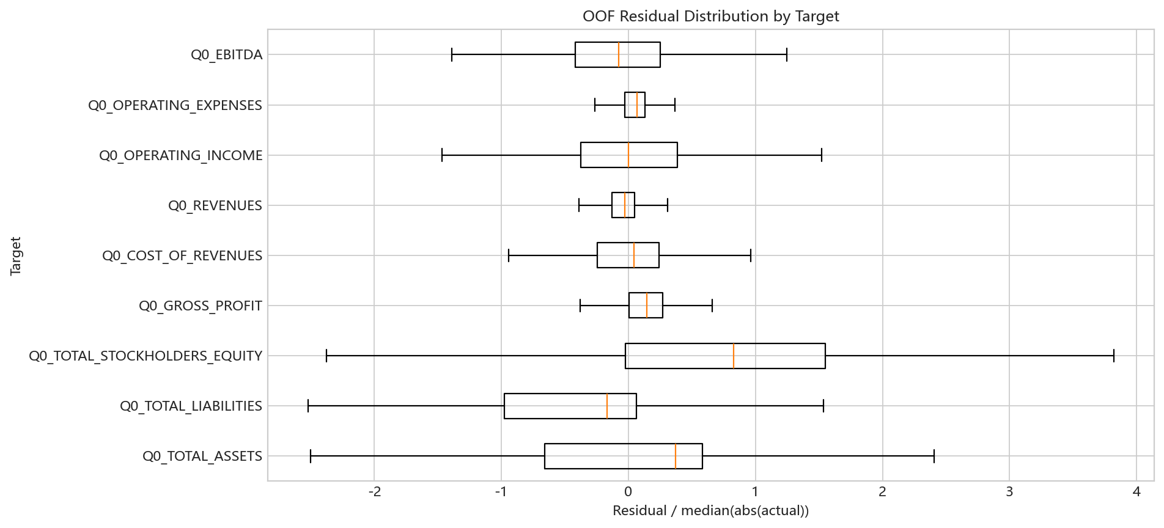
Figure 12. OOF residual distribution by target.
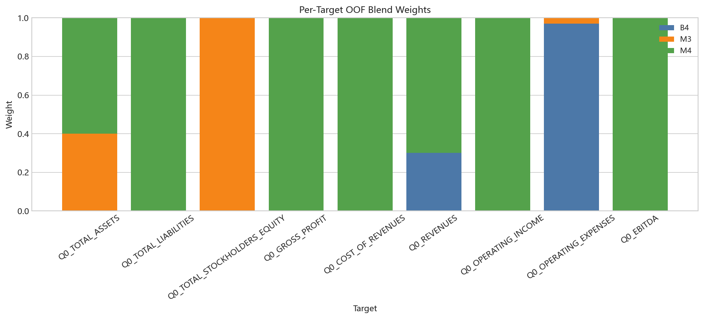
Figure 13. Per-target OOF blend weights.

5. Final Submission and Reproducibility
The final submission matches the sample template exactly with SHA256 c8c777fb68ca7d363e218b8ff09d4d7eb2e189f92084523779bc0de9c947e97f. The notebook and report are designed to be reproducible from the frozen raw inputs and saved results tables.

Key reproducibility command chain:
- conda run -n QuantEnv python scripts/check_environment.py
- conda run -n QuantEnv python scripts/bootstrap.py
- conda run -n QuantEnv python scripts/audit_data.py
- conda run -n QuantEnv python scripts/run_baselines.py
- conda run -n QuantEnv python scripts/run_sklearn_models.py
- conda run -n QuantEnv python scripts/run_catboost_models.py
- conda run -n QuantEnv python scripts/train_final.py
- conda run -n QuantEnv python scripts/build_final_figures.py
- conda run -n QuantEnv python scripts/build_notebook.py
- conda run -n QuantEnv python scripts/build_report.py
- conda run -n QuantEnv python scripts/export_report_pdf.py
- conda run -n QuantEnv python scripts/package_delivery.py
- conda run -n QuantEnv python scripts/validate_delivery.py

